**Automation testSuite for the ‘Empirix’ Cloud Platform**

**Approach –**

Our approach is to cover all the test cases in the given browsers i.e. Chrome, Firefox & Edge parallely. The default language option in the ‘Empirix’ Website keeps changing, we will perform a language change to get the results if needed.

We have created 3 python scripts which takes help of the respective webdrivers (Chrome, Gecko & Edge). Also, we have created a Jenkins Pipeline project in which with the help of Groovy language we have called all the 3 scripts in the different nodes. We had to create a ‘slave’ node to hook one of the browsers with it when all the tests runs parallely as the ‘master’ is already having 2 nodes. Below in the left we can find 3 nodes i.e. 2 master & 1 slave which we used for our internal tests.

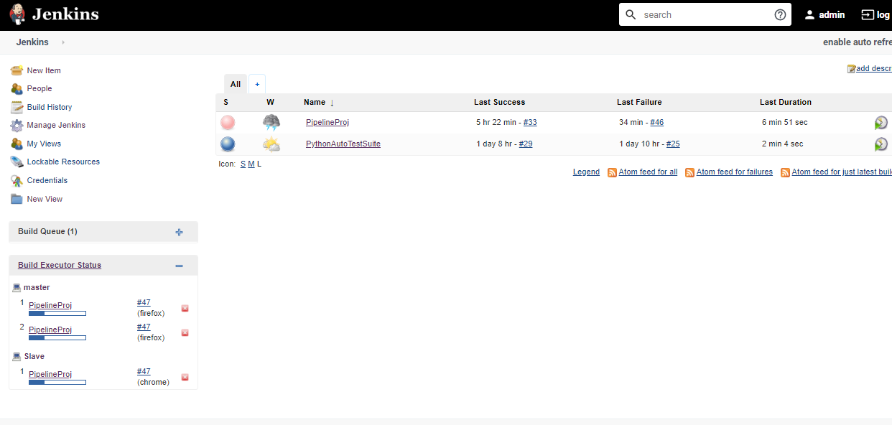

**How to Run –**

1. Downloaded & Installed a pipeline plugin : Manage Jenkins 🡪 Manage Plugins 🡪Install Pipeline Plugin.

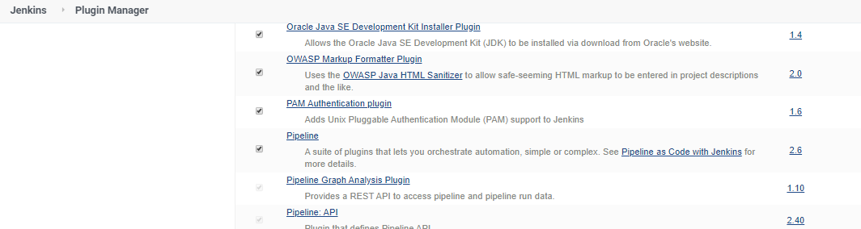

1. Created a new Pipeline Project : Selected a Pipeline project from the list 🡪Given a name to the project & clicked ‘OK’.

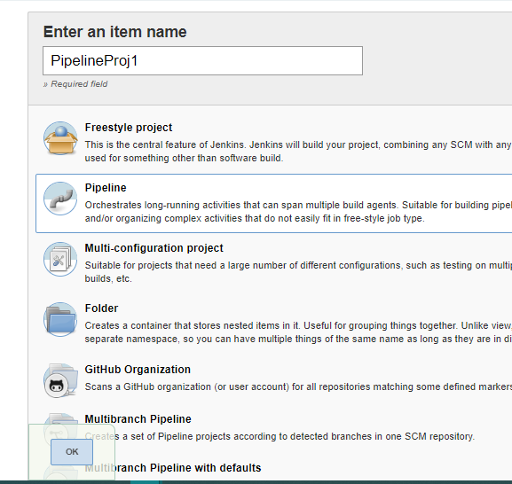

1. Added a Groovy-script in the Pipeline script definition area and Saved the project. The script contained the paths of all the Python files which needs to be executed on different nodes.

Ex – Firefox & Edge on ‘master’ nodes , Chome on the ‘slave’ node.

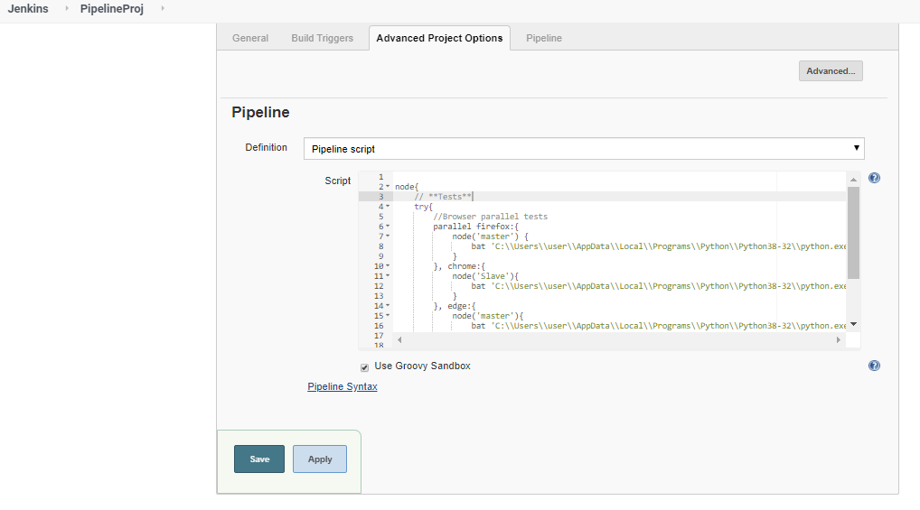

Also, we have created a separate node which executes Jenkins – Junit plugin to create .xml Test-Reports after the test execution.

1. Once we have created & saved the Pipeline project, we can execute the Parallel testSuite with the help of clicking ‘Build Now’ command given in the left side of out Jenkins project.

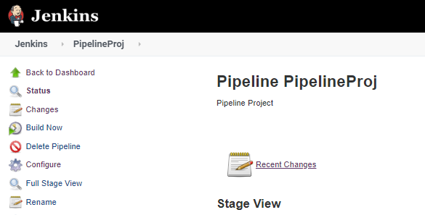

1. Below we can check the Jenkins console logs for the verification of parallel execution of the testSuite on all the 3 browsers(Chrome, Firefox & Edge).

