SPORTS ENGLISH
Background of the Study
Theories and approaches for teaching English language have evolved significantly through time due to a number of variables but finding the best strategies and techniques of how to teach English is a continuing issue and challenge for researchers and professionals in the field of English Language Teaching.In this regard, the English for Specific Purposes approach, with its practical implications, plays a crucial role in helping ELT practitioners in designing courses that learners can benefit from. Day and Krzanowski (2011) define ESP as the practice of teaching and learning the unique language skills and language systems required by certain learners for a specific goal. ESP differs from General English in that it focuses on the specific needs of a certain group of learners. “The main concerns of ESP have been needs analysis, text analysis, and preparing learners to communicate effectively in the tasks prescribed by their study or work situation” (Dudley-Evans & St John,1998, as cited in Basturkmen 2010, p.2), that is to say, when developing an ESP course, it is vital to address the individual needs of target groups of learners in order to help them develop effective communication skills in the setting in which they will use the language. The term "target group" refers to a group of learners who have similar educational or professional aims, such as a group of businesspeople, medical students, or tourism majors. Therefore, we can define ESP as a broad field that includes subfields such as English for Academic Purposes (EAP), English for Medical Purposes (EMP), English for Business Purposes (EBP), English for Legal Purposes (ELP), and English for Sociocultural Purposes (ESCP) (Belcher, 2009, as cited in Isık-Tas et al., 2019). Because ESP places such a strong emphasis on the teaching of particular language and communication skills, the design of an ESP course often involves a step in which course designers determine the particular language and skills that will be required by the group of language learners. The content of the ESP course is established and improved with the help of the language and skills identified by the target group of learners, and the phrase "needs analysis" or “needs assessment” refers to this procedure (Basturkmen, 2010). This research highlights the value of needs assessments and ESP training and focuses on the field of Sports English in ESP.

Statement of the Problem
Despite the fact that the number of Turkish national athletes who represent our country in international competitions, travel abroad to play in foreign countries, and train with foreign coaches and athletes is growing by the day, the challenge they face with the English language, particularly Sports English terminology, in communicating with other professionals in their fields remains unresolved. Given this reality, an English program should be designed to help these athletes with the English language abilities they need. The individual needs of these athletes must be determined in great depth in order to develop such a program. A complete needs analysis should be conducted in this regard. However, one for the specific English language needs of Turkish national athletes has not been conducted. In this regard, this particular case study which investigates specific English language needs of Turkish national athletes has a crucial role to play.
Purpose of the Study
The primary goal of this research is to explore the particular English language needs of Turkish national athletes who attend Sports English course supported by the government and a private association. The research also looks at specific cases in which Turkish national athletes confront problems in international competitions. The research takes into account language obstacles Turkish national athletes face when they take part in international competitions. It also investigates the particular language skills that athletes need the most. Moreover, it examines the challenges Turkish national athletes experience in international games. The study looks at the instances in which Turkish national athletes need Sports English terminology. It also identifies the problems they experience when they need to use Sports English terminology.
In the light of this, the study aims to address the following research question:
1. What are the specific English language needs of Turkish national athletes who attend the Sports English course?

Research Design
Case studies investigate a limited in time or space case and explore for contextual information about the case's environment, and to present a complete picture of the situation, it is necessary to collect extensive material from numerous sources (Creswell, 2013), and in this study, a qualitative case study approach was adopted to investigate the specific English language needs of Turkish national athletes who prepare for the Olympics and voluntarily attend the Sports English course supported by the government and a private association.
As Yin (2003b) suggests, there are three types of case studies, categorized according to their main purpose: exploratory, descriptive, or explanatory. Yin (2003b) also describes, a descriptive case study presents a complete description of a phenomenon within its context (p.5). The specific English language needs of Turkish national athletes in a Sports English course considering the perceptions of Turkish national athletes, coaches, and English teachers, the approach used in this study is one of a descriptive case study.
According to Yin (2003b), a basic categorization scheme for the types of questions is the familiar series: "who", "what", "where", "how", and "why" in case study research. In this study, the research question was formed accordingly. As Yin (2003) indicates, one of the most important sources of case study information is the interview. Moreover, interviews allow researchers to investigate phenomena that are not directly observable, such as learners' self-reported perceptions, attitudes, beliefs, and statements about their own emotions (Mackey & Gass, 2022, p.312). In light of this, semi-structured individual interviews were conducted to collect data in the research design process to gather intensive data; participants' ideas, emotions, and beliefs about the specific English language needs of Turkish national athletes.
The purpose of using interviews was to learn more about learners' present situation (lacks), learning situation (wants), and target situation (necessities) with reference to the Sports English course. At first, the interview questions were developed for three separate participant groups using the Hutchinson and Waters framework for needs analysis. An expert, who has research experience in needs analysis, checked the interview questions. After that, the questions were piloted on a group of national athletes, and the final version of the questions prior to the interviews was revised. In order to gather data from various sources, English teachers, national athletes, and coaches were selected as interviewees to increase the validity and credibility of the results of this particular study. Content analysis was carried out to examine the data gathered from the interviews.
Research Setting
The study took place at a Sports English course supported by the government and a private association. The aim of the course is to help Turkish national athletes who are preparing for the Olympics with general English and Sports English. Participants were invited to a face-to-face session with their English teachers to meet other athletes and the teachers at the beginning of the course, and they were also informed about the aim and the content of the course, and how to benefit from the course. However, the classes are held online two days a week, and participation was voluntary for the national athletes. The course is planned to continue until the Olympics takes place in 2024 in Paris. At the beginning of the course, a placement test prepared by the teachers who teach the course was set by them, and the classes were arranged accordingly. The content of the course was designed, and materials were prepared by a group of English teachers who are competent in curriculum and material design and teaching in the course at the same time. The course design includes both General English and Sports English content. Lower-level classes had more General English content at the beginning of the course while higher-level classes had more Sports English content.
Participants
The criteria for the participants to be chosen are below.
• For English teachers: to teach general English/Sports English to national athletes
• For national athletes: to attend international competitions in foreign countries, to participate in the Turkish National Team
• For coaches: to attend international competitions in foreign countries with national athletes, to participate in the Turkish National Team as a coach
Table 1 Detailed Information about Participant English Teachers
Participants | Teaching experience with national athletes | Level of national athletes they teach
English Teacher 1 | 6 months/2 days a week | Pre-Intermediate/Intermediate
English Teacher 2 | 6 months/2 days a week | Pre-Intermediate/Intermediate
English Teacher 3 | 6 months/2 days a week | Elementary
English Teacher 4 | 8 months/2 days a week | Beginner/Elementary
English Teacher 5 | 8 months/2 days a week | Beginner/Elementary

Table 2 Detailed Information about Participant Turkish National Athletes
Participants | Age | Level | Education | Type of sports
Athlete 1 | 21 | Elementary | University student/Faculty of Sports Science | Individual sports
Athlete 2 | 21 | Beginner | University student/Faculty of Sports Science | Individual sports
Athlete 3 | 22 | Elementary | University student/Faculty of Sports Science | Individual sports
Athlete 4 | 20 | Elementary | University student/Faculty of Sports Science | Individual sports
Athlete 5 | 19 | Pre-Intermediate | University student/Faculty of Sports Science | Team sports
Athlete 6 | 19 | Intermediate | University student/Faculty of Sports Science | Team sports

Table 3 Detailed Information about Participant Coaches
Participants | Experience with national athletes | Type of sports
Coach 1 | 10 years | Individual sports
Coach 2 | 7 years | Individual sports
Coach 3 | 4 years | Team sports
Coach 4 | 5 years | Team sports

Data Collection Tool
Semi-structured interviews were made to collect data in the present study. Individual interviews were conducted in this research since they are ideal for interviewing participants who are not hesitant to speak, who are articulate, and who can share ideas comfortably (Creswell, 2012, p.218). Face-to-face interviews took place where it would be comfortable for the volunteer participants (see Table 4).
As Mackey and Gass (2022) suggest depending on the research question and the resources available, interviews can also be conducted in the learner's L1, thus interviews with the national athletes and the coaches were conducted in Turkish. Interviews with Turkish English teachers were carried out in Turkish, whereas English was used for the interviews with native English teachers.
Table 4 Summary of Data Collection Process
Participants | Source of data | Length of the interviews | Data collection period
English Teachers | Individual Interview | 30-40 minutes | April and May 2022
National Athletes | Individual Interview | 30-40 minutes | May and June 2022
Coaches | Individual Interview | 30-40 minutes | May and June 2022

It was challenging for Turkish national athletes and coaches to find time for the interviews since they had to go to international competitions and train for the competitions. Therefore, the interviews were carried out over two months period, which was a little bit longer than the planned time.
The semi-structured interview questions were formed considering the framework that Hutchinson and Waters use to define target needs and learning needs (Hutchinson & Waters, 1987). Ten interview questions were created for three different groups of participants using the Hutchinson and Waters framework for the needs analysis. The interview questions for the various participant groups all adhere to the same framework while examining the unique English language requirements of Turkish national athletes. Interviews were conducted according to the guide to get responses to all the questions. But occasionally, when it was felt that a topic needed more debate, there were talks outside the interview guide.
Before the interviews, participants read the consent forms and signed them. The volunteer participants were informed about the recording process and the interviews were recorded with the kind permission of the volunteer participants. While doing the interviews, brief notes were also made. The recordings of the interviews were transcribed, and an expert, who has experience in transcription and proofreading, checked the transcription to ensure the accuracy of the data. It was found that the transcription was accurate.
Data Analysis
In this study, thematic analysis was employed as the primary method for analyzing the qualitative data collected through semi-structured interviews. Following the six-phase framework proposed by Braun and Clarke (2006), the analysis proceeded through the stages of familiarizing with the data, generating initial codes, searching for themes, reviewing themes, defining and naming themes, and producing the final report.
To support and systematize this process, Python was used as a computational tool across two scripts: analiz.py for data extraction and tabulation, and gorsellestir.py for visualization. Interview transcripts from the three participant groups—coaches, athletes, and teachers—were stored as plain text files and manually annotated with thematic tags in the format [code]excerpt[/code], following the coding scheme developed during the thematic analysis process.
In analiz.py, the re module was used to extract coded segments from each transcript. Specifically, the regular expression pattern r'\[(\w+)\](.*?)\[/\1\]' was applied using re.findall() to locate all tagged excerpts and retrieve both the code label and the corresponding text. The extracted codes were then organized using Python's collections.defaultdict, which grouped excerpts by participant group and code label. A pandas DataFrame was constructed from these grouped records, and the groupby() method was applied to compute the frequency of each code per participant group. The resulting frequency table was exported to an Excel file using pandas' to_excel() function.
The visualization pipeline in gorsellestir_q1.py produced three publication-ready figures using matplotlib and pandas. First, a thematic map (Figure 1) was constructed using matplotlib's FancyBboxPatch to render a hierarchical diagram connecting the research question to the four themes and their associated codes with frequency counts. Second, a formatted summary table (Table 5) was generated by sorting the pandas DataFrame by total frequency in descending order and rendering each row as a styled text object within a matplotlib axes. Third, a grouped bar chart (Figure 2) was produced using numpy arrays to position bars by theme and participant group, with matplotlib's bar() function rendering the comparison across coaches, athletes, and teachers. An additional script, gorsellestir.py, generated complementary visualizations including a stacked horizontal bar chart, a heatmap using imshow(), a theme-cluster grouped bar chart, and a donut chart using the pie() function with the wedgeprops parameter to create the hollow center.
The combination of Braun and Clarke's (2006) thematic analysis framework with this Python-based computational pipeline ensured that the coding and frequency analysis were conducted systematically and transparently. While the identification and interpretation of themes remained a qualitative, researcher-driven process grounded in close reading of the interview data, the Python scripts provided a reproducible method for quantifying code frequencies and producing consistent visualizations that are embedded in the Results section of this paper.

Results
Thematic analysis of semi-structured interviews with coaches (n=3), teachers (n=3), and athletes (n=3) yielded 14 codes distributed across 88 total coded segments. Following Braun and Clarke's (2006) six-phase framework, four overarching themes were identified: (1) Oral Communication Needs, (2) Domain-Specific Language, (3) Real-World Contexts Abroad, and (4) Motivation and Professional Goals. Figure 1 presents the thematic map illustrating the hierarchical relationship between themes and their constituent codes; frequency distributions by participant group are summarised in Figures 2–4 and Table 5.

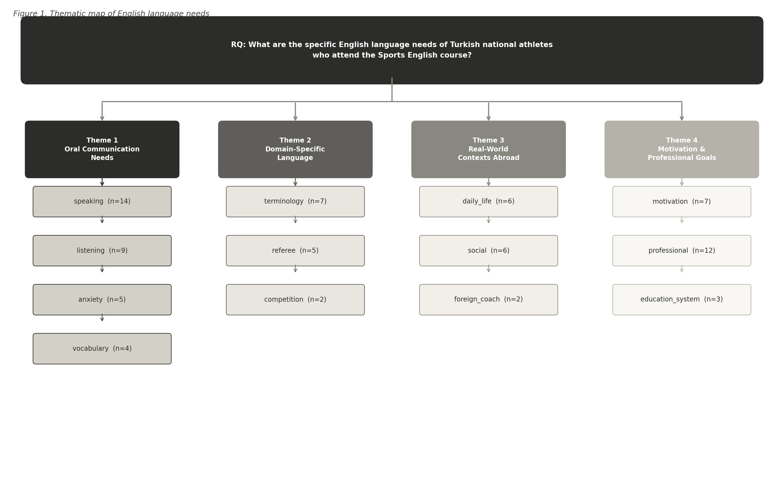
Figure 1. Thematic map produced via gorsellestir_q1.py showing four emergent themes and associated codes.
Theme 1: Oral Communication Needs
The most prominent theme, Oral Communication Needs, comprised four codes: speaking (n=14), listening (n=9), anxiety (n=5), and vocabulary (n=4), accounting for 32 coded segments in total. Speaking was the single most frequently coded item across all participant groups (coaches: 4, athletes: 7, teachers: 3), indicating a near-universal concern with productive oral communication. Athletes contributed the highest number of speaking codes, reflecting their direct experience of communication breakdown in international competition contexts (see Figure 2 and Table 5).
We cannot express ourselves. The International Weightlifting Federation asked me to record a video in English, but I had to tell them I did not speak English. That was a very difficult situation for me. (Athlete)
Coaches confirmed this pattern from an observational standpoint, emphasising that spoken communication was the most critical and most deficient skill:
Speaking is the most important skill in practical terms, because if you can speak you can make yourself understood. The most important thing, in my view, is having that practical ability to communicate orally. (Coach)
Listening comprehension (n=9) was the second most coded item within this theme. Athletes reported that comprehension difficulties arose not only from limited vocabulary knowledge but also from the cognitive load of sustained listening during high-pressure situations:
Even when I know the words, I cannot string sentences together. Someone starts talking and I try to focus, but once I hit a word I cannot translate, I lose concentration and miss most of what they are saying. (Athlete)
Communication anxiety (n=5) was coded primarily from teacher and athlete data (teachers: 3, athletes: 2), suggesting that coaches perceived anxiety as a student or athlete characteristic rather than their own concern. Athletes described inhibitory anxiety that prevented speaking even when comprehension was partial:
I actually understand what the other person means, but I cannot speak. I cannot form sentences; I cannot put the words together. (Athlete)
Vocabulary gaps (n=4) were identified by teachers and athletes as an underlying cause of broader communicative breakdown. Teachers noted that without sufficient vocabulary, even targeted sport-specific instruction could not compensate for general language deficiencies:
If they have no vocabulary at all, or only a very limited one, they cannot manage even basic communication. Nobody can speak a language with terminology alone. (Teacher)

Theme 2: Domain-Specific Language
The second theme captured the specialised linguistic demands of the sports environment through three codes: terminology (n=7), referee communication (n=5), and competition language (n=2), totalling 14 coded segments. Terminology was distributed across all three participant groups (coaches: 3, athletes: 3, teachers: 1), and participants consistently described sport-specific lexis as distinct from general everyday English and therefore requiring targeted instruction (see Figure 2).
We have sport-specific terms of our own. Athletes do not know them at all—they have no command of them whatsoever. For instance, there is a term called 'stealing' in our sport, but most athletes have never heard of it. (Coach)
Athletes also described terminology as sport-dependent, with terms varying across disciplines and not corresponding directly to Turkish equivalents:
Things like committing a foul or making an incorrect move—the way you describe them in a sports context is different, in my view. We say it one way in Turkey, but nobody else understands it. (Athlete)
Referee communication (n=5) represented a particularly high-stakes sub-domain in which linguistic failure had direct competitive consequences. Coaches reported observing athletes unable to defend themselves against incorrect official decisions:
They cannot even stand up for their own rights. During a match, if an incorrect decision is made or there is something they need to protest, they simply cannot express it. (Coach)
Competition language (n=2) was coded exclusively from coach interviews, suggesting that the broader discourse of competition contexts—strategy, opposition analysis, and in-game communication—was more salient to practitioners observing athletes than to athletes themselves.

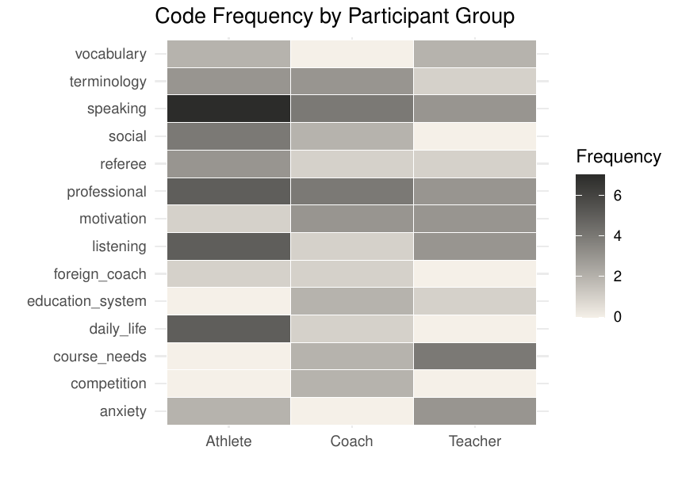
Figure 2. Code frequency by participant group (coaches, athletes, teachers) across all 14 codes.

Theme 3: Real-World Contexts Abroad
The third theme encompassed English language use in international settings beyond the playing field, comprising three codes: daily life (n=6), social interaction (n=6), and foreign coach communication (n=2), totalling 14 segments. Athletes contributed the largest share of data within this theme (daily life: 5 of 6 segments; social: 4 of 6 segments), reflecting their direct exposure to the practical demands of international travel and competition environments (see Figure 3).
Daily-life communication difficulties abroad (n=6) ranged from airport navigation to medical emergencies during training camps. Athletes described situations in which the absence of English proficiency created practical vulnerabilities:
We have a really hard time at airports. We go to doping control, for example, and we struggle there too. Our opponents say something to us and we cannot respond—we just stand there. (Athlete)
I had injured my knee or my wrist. I needed to ask for ice. Neither side could explain anything to the other. It becomes a real problem in an emergency. (Athlete)
Social interaction in international sports contexts (n=6) was identified as both an interpersonal challenge and a missed opportunity for professional networking. Athletes described the inability to form relationships with international peers despite shared sporting contexts:
When we try to make friends from other countries, it does not work out, because our English is simply not good enough. (Athlete)
Coaches framed social interaction as foundational to competitive success, noting that relationships built through English communication could facilitate professional advancement:
It is mostly about social relationships. If you build those connections, you can find the pathways to success as well. (Coach)
The foreign coach code (n=2) specifically addressed the desire to communicate with non-Turkish coaching staff during camps and training exchanges. An athlete illustrated the frustration of wanting to engage with foreign expertise but lacking the language to do so:
We want to talk to foreign coaches—to ask them things like 'How do you train? What do your sessions look like?'—but we cannot ask those questions. (Athlete)

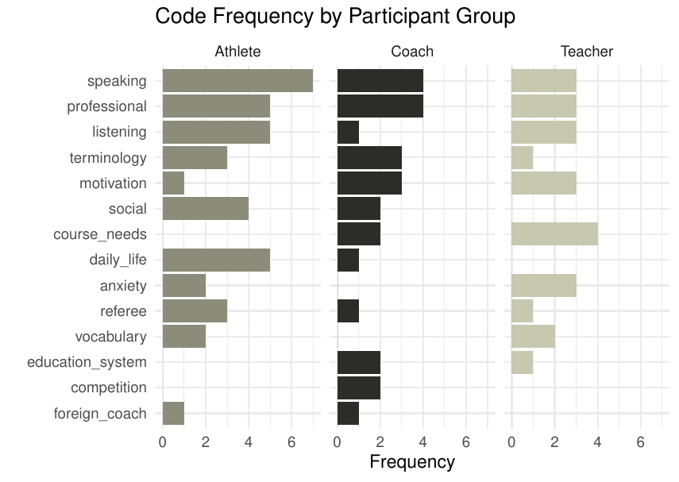
Figure 3. Individual-level code frequency distribution across the nine participants.

Theme 4: Motivation and Professional Goals
The fourth theme, Motivation and Professional Goals, was the second most data-rich theme, comprising three codes: professional development (n=12), motivation (n=7), and education system critique (n=3), totalling 22 segments. Professional development was the most frequently coded item in the entire dataset (coaches: 4, athletes: 5, teachers: 3), indicating that the perceived link between English proficiency and career advancement was shared across all stakeholder groups (see Figure 4).
In my view, the most important thing for athletes, coaches, and administrators to establish themselves in the international arena is English. (Coach)
Athletes articulated professional goals in terms of international competition, transfer opportunities, and media engagement. Career aspirations were consistently cited as primary motivators for learning English:
I really want to go to the Olympics. If I win a medal there and need to give a speech, I want to be able to deliver it in English. (Athlete)
Say an athlete transfers to a foreign club. If they do not speak English, no one will want them—they simply cannot go. Athletes who speak English are the ones who are sought after. (Coach)
Motivation (n=7) was expressed primarily in terms of extrinsic, goal-oriented drivers. Teachers observed that athletes who had accumulated international experience demonstrated markedly higher motivation toward language learning, as encounters with English in authentic settings made its utility visible:
Students who have taken part in more international competitions and spent more time in training camps abroad show noticeably higher motivation. Watching a Swiss athlete and a French athlete communicate with each other in English also motivates our own athletes. (Teacher)
The education system code (n=3; coaches: 2, teachers: 1) reflected a structural critique of Turkish EFL education, with participants suggesting that grammar-oriented curricula were misaligned with the communicative needs of athletes. Coaches in particular advocated for an earlier, more communicative approach to English instruction:
In our country, English education at higher levels is not oriented toward speaking but toward grammar, and as a result our children—and we as a country—are struggling because of this. (Coach)
Taken together, the four themes point to a coherent pattern: Turkish athletes, coaches, and sports teachers perceive English primarily as an instrument of oral, real-world, and professional communication rather than as a grammatical or academic subject, and they identify substantial unmet needs across speaking, listening, domain-specific language, and the social and professional contexts that international sport participation demands (see Table 5 and Figure 5).

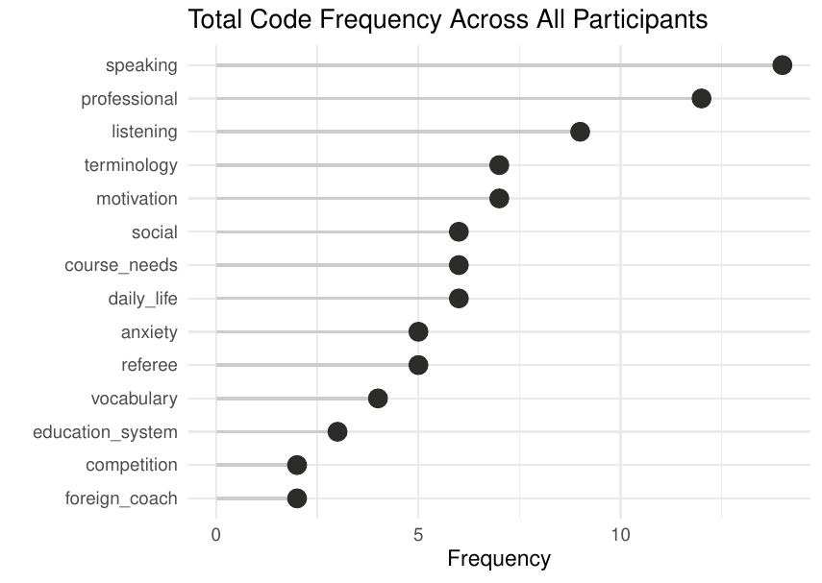
Figure 4. Total code frequency across all participant groups (n=88 segments).

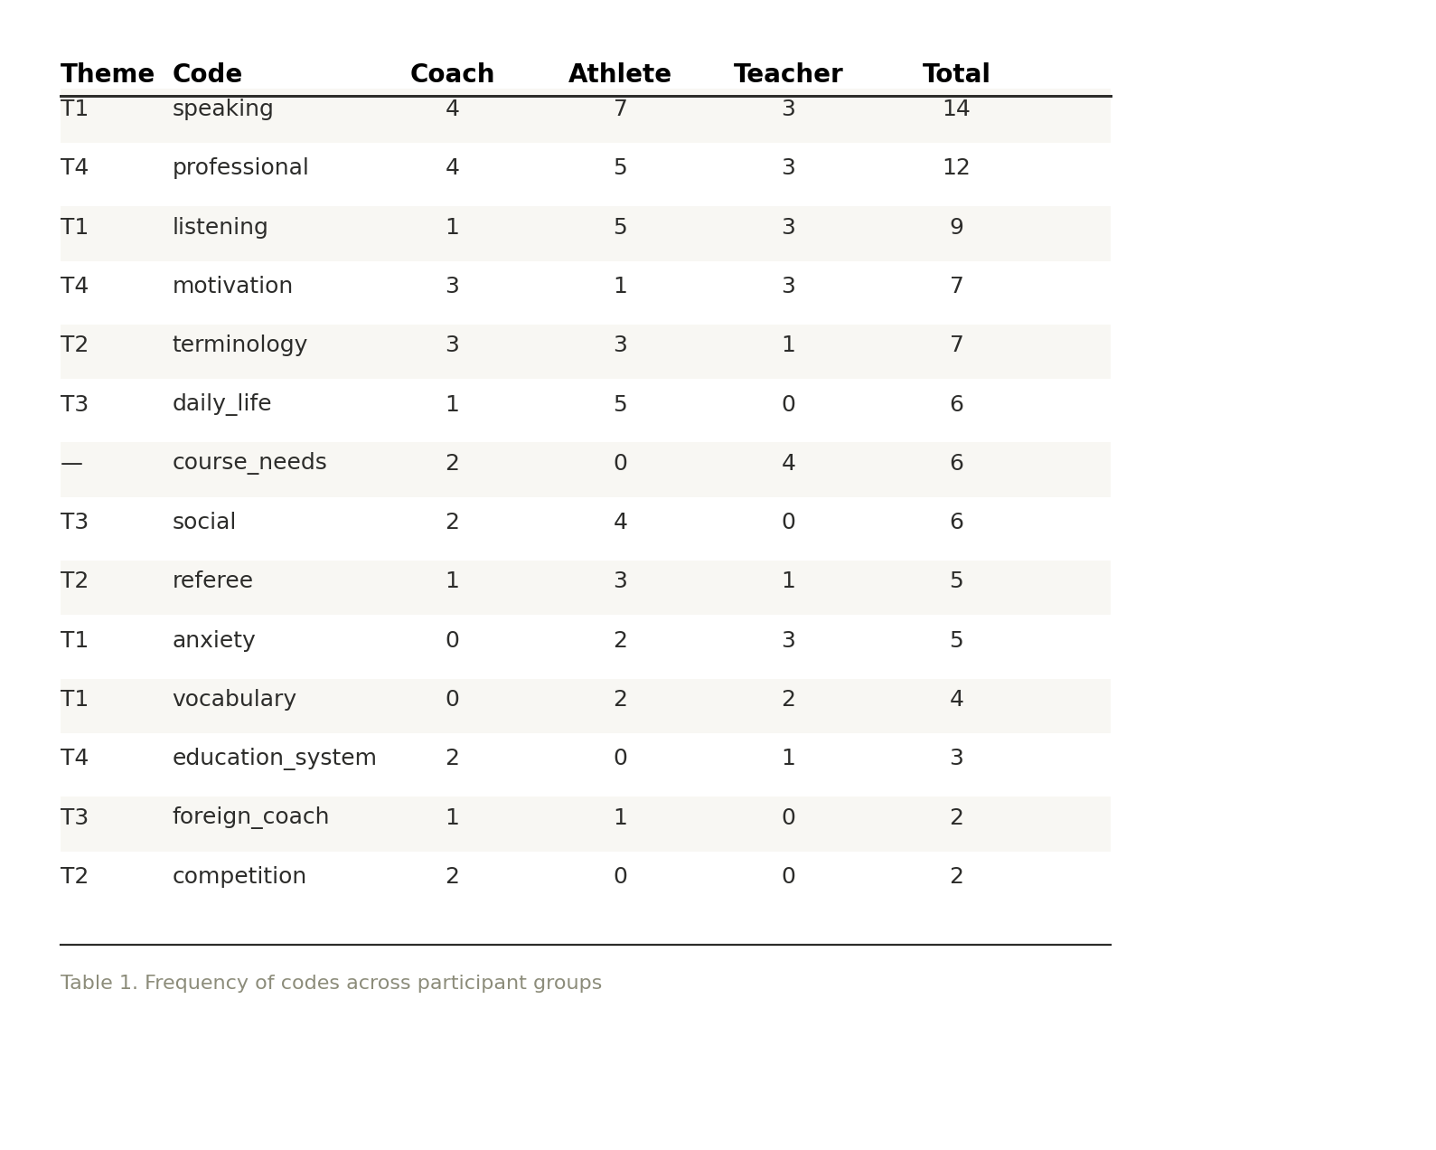 Figure 5. Summary of code frequencies by participant group and theme membership.
Table 5. Summary of code frequencies by participant group and theme membership.

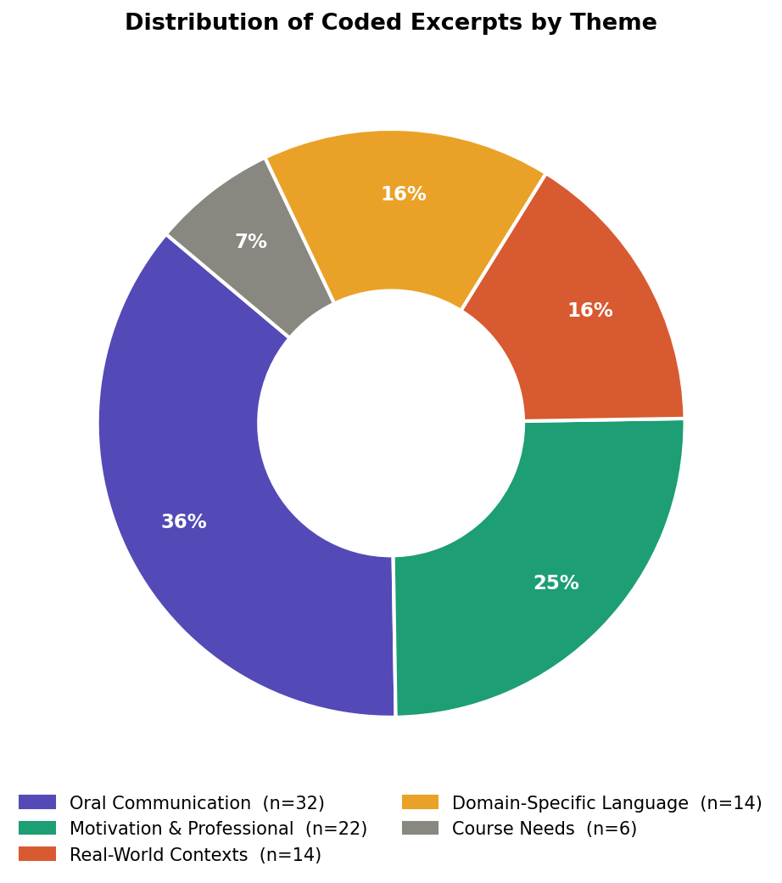
Figure 6. Proportional distribution of coded segments across the four themes.

Discussion
This study aimed to explore the specific English language needs of Turkish national athletes attending a government- and association-supported Sports English course. In light of the findings, the research question “What are the specific English language needs of Turkish national athletes who attend the Sports English course?” can be addressed through four main themes: Oral Communication Needs, Domain-Specific Language, Real-World Contexts Abroad, and Motivation and Professional Goals.
The findings reveal that speaking is the most frequently coded need across all participant groups, and this result is consistent with the ESP literature, which places communicative competence at the centre of language instruction for professional settings (Day & Krzanowski, 2011). In this regard, athletes in particular reported a significant inability to express themselves in English during international competitions, which is in line with what Hutchinson and Waters (1987) describe as target situation needs, that is, the language demands that learners encounter in the actual contexts in which they need to use the language. The fact that athletes were the most vocal group about speaking difficulties, while coaches confirmed these difficulties from an observational standpoint, suggests that oral communication is not only a perceived need but a consistently observed gap in real-world settings.
The second theme, Domain-Specific Language, which is defined as Sports English terminology by athletes and coaches, points to the fact that sport-specific terminology constitutes a separate and critical language need for this group of learners. Participants from all three groups emphasized that general English instruction is not sufficient for athletes who need to communicate with referees, negotiate competition decisions, or exchange sport-specific knowledge with foreign coaches. This finding supports Basturkmen’s (2010) argument that ESP courses must be built around the specific communicative demands of the target group and that general English instruction cannot replace domain-specific language instruction. In this regard, the inability of athletes to communicate with referees or to defend themselves against incorrect official decisions illustrates the high-stakes nature of language competence in competitive sports environments.
The third theme indicates that the English language needs of Turkish national athletes are not limited to the competition context but extend to a wide range of real-world situations abroad, including daily communication at airports, medical situations, and social interaction with international peers. Despite the fact that social interaction is often treated as a secondary concern in EFL settings, the findings suggest that for athletes who travel internationally on a regular basis, it is an essential communicative domain that has a direct impact on both their performance and their professional development. In this regard, the inability to form relationships with foreign athletes and coaches was described by participants as both a social disadvantage and a missed professional opportunity.
The fourth theme, Motivation and Professional Goals, indicates that the link between English proficiency and career advancement is a powerful motivating factor for athletes, coaches, and teachers alike. In line with the needs analysis framework proposed by Hutchinson and Waters (1987), which distinguishes between what learners need to do with the language (necessities), what they lack (lacks), and what they want (wants), the findings suggest that participants are strongly aware of their language deficiencies and equally aware of the professional goals that English proficiency could help them achieve. At the same time, the critique of the Turkish education system that emerged from coach and teacher data points to a structural problem in which grammar-oriented curricula have left athletes underprepared for the communicative demands of international sport. This finding is particularly relevant for ESP course designers, who must take into account not only the target situation needs but also the learning situation in which participants have developed their current level of English.
In light of all these findings, it can be argued that a well-designed Sports English course for Turkish national athletes should prioritize speaking and listening skills, incorporate sport-specific terminology from early stages, integrate real-world communicative scenarios into course content, and build on participants’ professional motivations as a resource for engagement and sustained learning.

REFERENCES
Basturkmen, H. (2010). Developing courses in English for specific purposes. Springer.
Braun, V., & Clarke, V. (2006). Using thematic analysis in psychology. Qualitative Research in Psychology, 3(2), 77–101.
Creswell, J. W. (2012). Educational research: Planning, conducting, and evaluating quantitative and qualitative research (4th ed.). Boston, MA: Pearson.
Creswell, J. W. (2013). Qualitative inquiry & research design: Choosing among five approaches (3rd ed.). Thousand Oaks, CA: SAGE.
Day, J., & Krzanowski, M. (2011). Teaching English for specific purposes: An introduction. Cambridge: Cambridge University Press.
Dudley-Evans, T. (2001). English for specific purposes. In R. Carter & D. Nunan (Eds.), The Cambridge guide to teaching English to speakers of other languages (pp. 131-136). Cambridge: Cambridge University Press.
Hutchinson, T., & Waters, A. (1987). English for specific purposes: A learner-centred approach. Cambridge: Cambridge University Press.
Kenny, N., Işık-Taş, E. E., & Jian, H. (Eds.). (2019). English for specific purposes instruction and research: Current practices, challenges and innovations. Springer Nature.
Mackey, A., & Gass, S. M. (2022). Second language research: Methodology and design. Routledge.
Yin, R. K. (2003). Case study research: Design and methods. Thousand Oaks, CA: Sage.

