PRACTICAL N0. 15
Aim: To study the steps for hiding and extract any text file behind an image file/audio file using command prompt
Steps:
Create a new folder in C drive eg: Stegano
Download an image file (.jpg,png..) and a text (.txt) file save it in Stegano folder
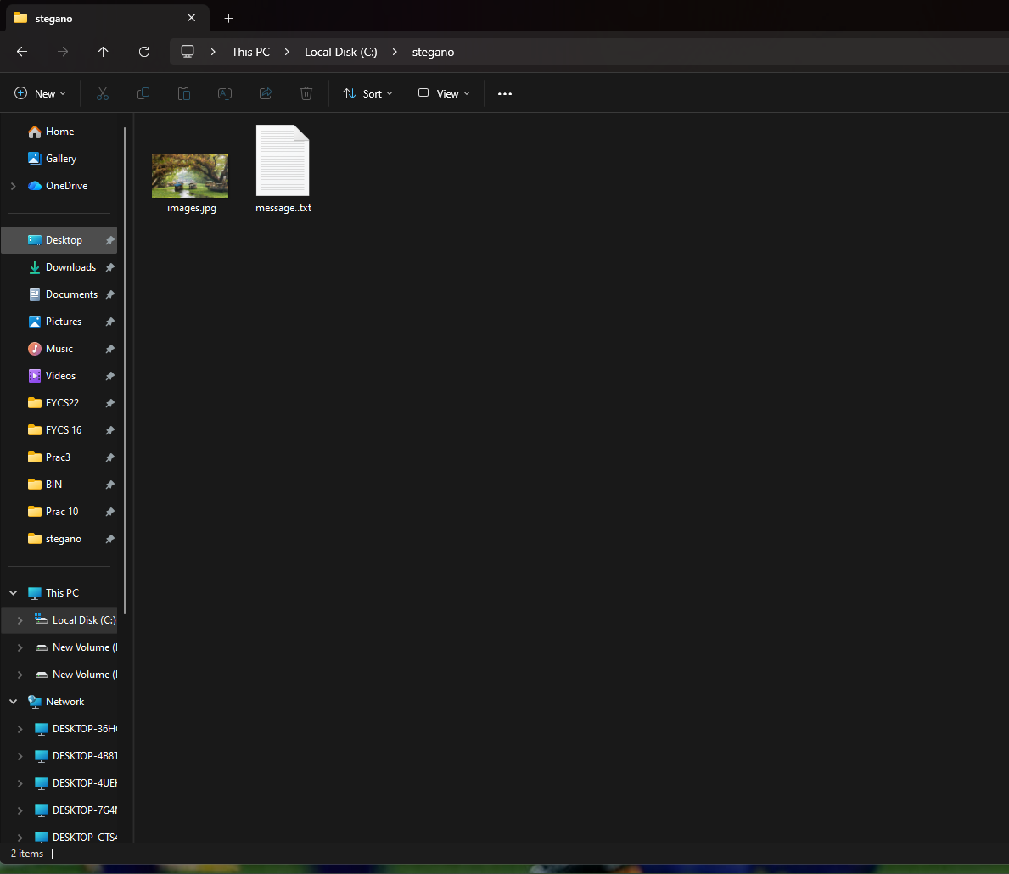

Open Command prompt and execute the following commands

Change directory to Stegano folder, created earlier in C drive

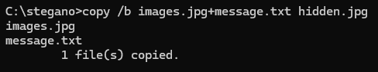
Copy image file and text file collectively in a new file using same extension as downloaded image , eg. Hidden.jpg

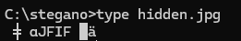

Execute the command and view the size of files in the Stegano folder
