PRACTICAL NO. 3

Aim: Creating a keylogger with Python
- Write a Python script that captures and logs keystrokes from a target system.
- Execute the keylogger script and observe the logged keystrokes.

Theory:
A keylogger (keystroke logger) is a surveillance tool or malware that secretly records every key pressed on a keyboard. It monitors and stores sensitive inputs like passwords, emails, and credit card details, transmitting them back to an unauthorized third party.

Code:
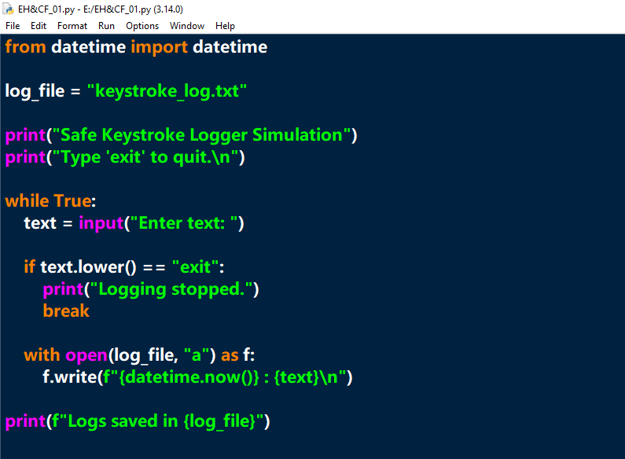

Output:
