PRACTICAL NO. 4
AIM: Run and Analyze the output of the following commands in Linux-
- ifconfig
- ping
- netstat
- traceroute
THEORY:
- ifconfig (Interface Configuration) is a command-line utility used in Unix-like operating systems to view, configure, and manage network interface.
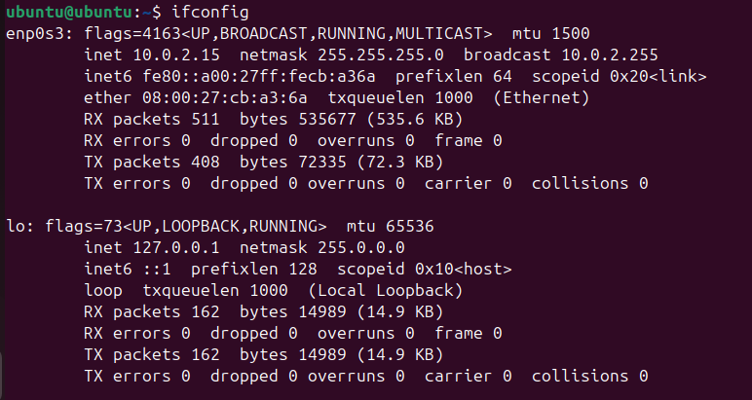
- The ping command is a universal command-line utility used to test the reachability of a host on an Internet Protocol (IP) network and measure the round-trip time (latency) for data packets sent from the originating computer to a destination computer.
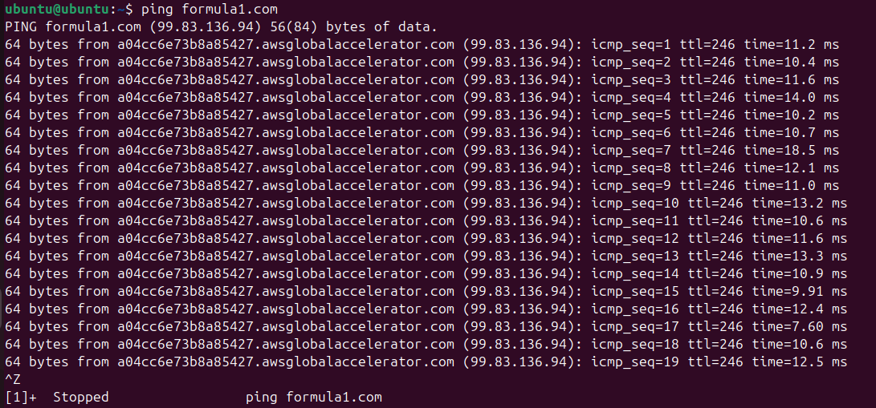
- netstat (Network Statistics) is a command-line tool used to display active TCP and UDP connections, listening ports, routing tables, and interface statistics.
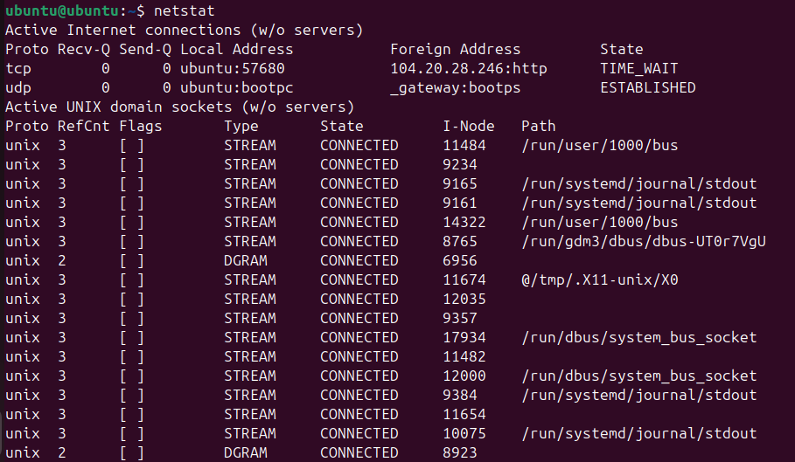
- Traceroute is a network diagnostic tool used to map the path your data packets take to reach a destination. It measures the latency and identifies every router (hop) along the route, helping you pinpoint network bottlenecks or connection.
