Practical no: 05
Aim: Perform command in nmap

- nmap –sA –T4 scanme.nmap.org
nmap -sA -T4 <target>
Performs an ACK scan to determine whether firewall rules are filtering ports.
Uses Timing Template 4 (Aggressive) to speed up the scan.
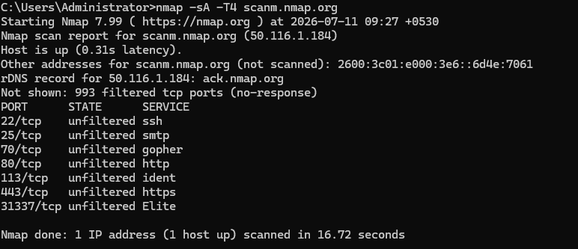

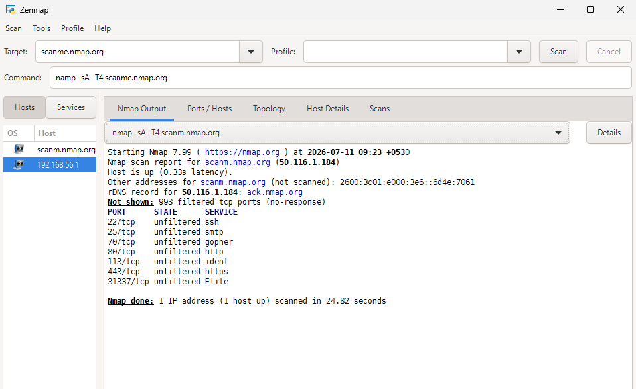

- nmap -p 22,113,139 192.168.56.1

nmap -p 22,113,139 <target>
Scans only the specified ports: 22 (SSH), 113 (Ident), and 139 (NetBIOS Session Service).
Reports whether these selected ports are open, closed, or filtered.

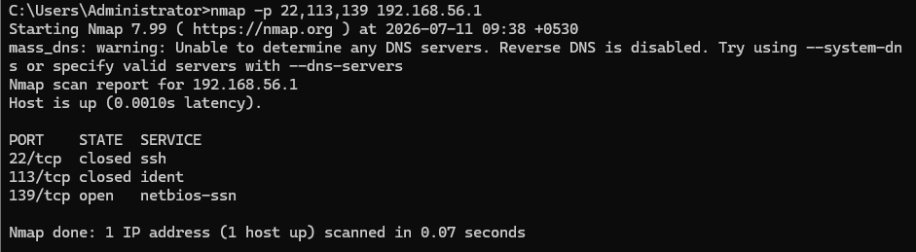

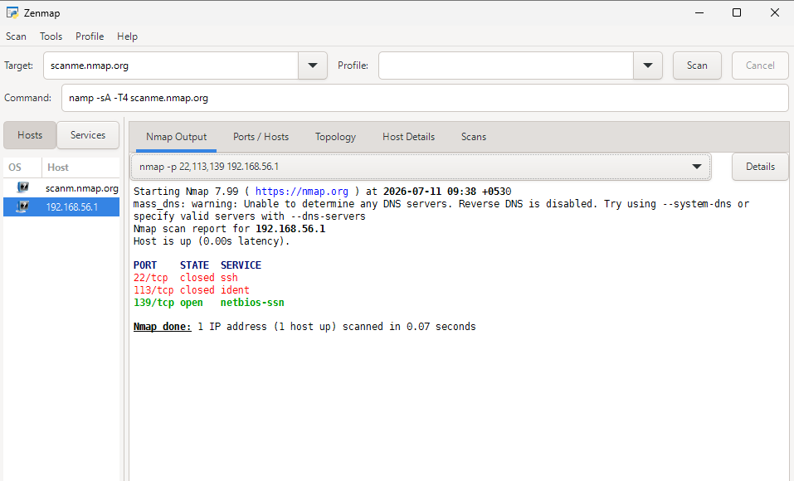

- nmap -sF -T4 192.168.56.1

nmap -sF -T4 <target>
Performs a FIN scan by sending TCP FIN packets to probe port states.
Uses Timing Template 4 (Aggressive) for faster scanning.

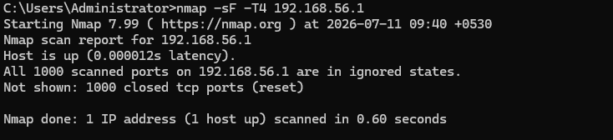

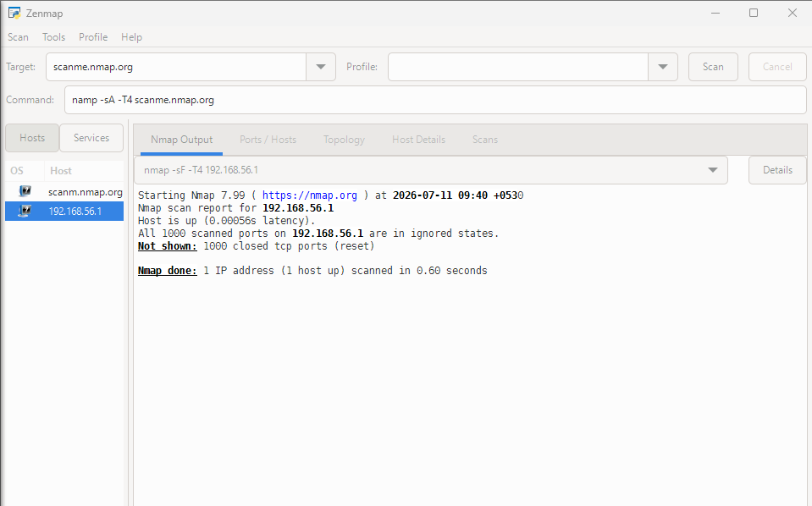

- nmap -sN -p 22 192.168.56.1

nmap -sN -p 22 <target>
Performs a NULL scan on port 22, sending a TCP packet with no flags set.
Helps identify whether the port is open or filtered on systems that follow RFC behavior.

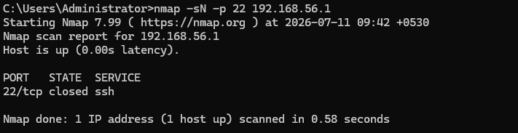

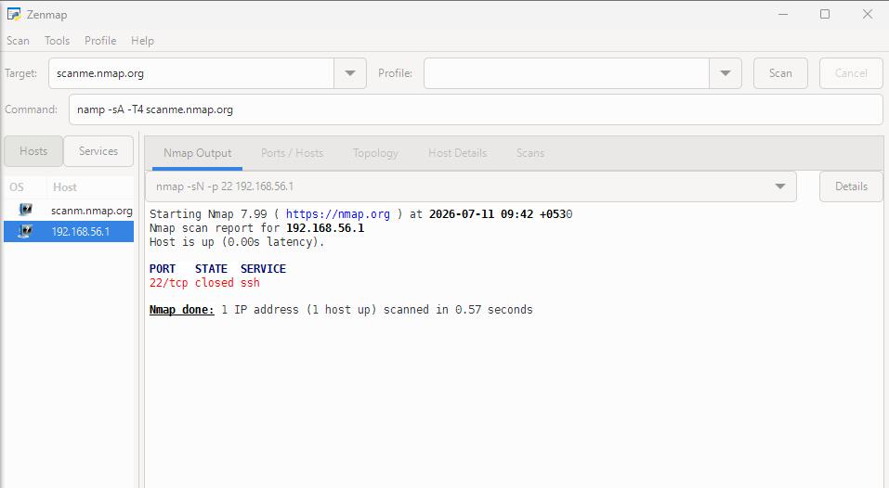

- nmap -sX -T4 192.168.56.1

nmap -sX -T4 <target>
Performs an Xmas scan, sending TCP packets with the FIN, PSH, and URG flags set.
Uses Timing Template 4 (Aggressive) to complete the scan more quickly.

