XAMPP DOWNLOAD
On browser search xampp download and download xampp

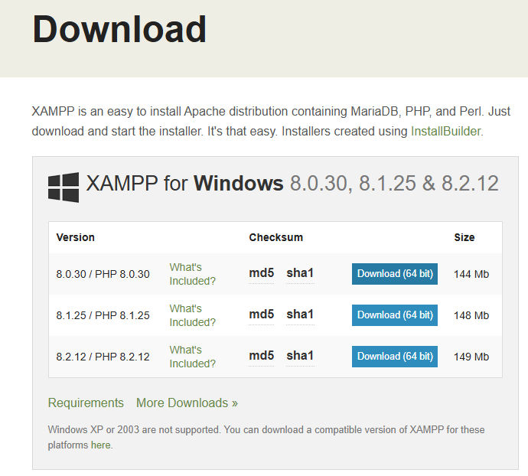
Click on yes and continue installation

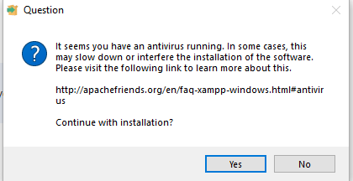
Click on next
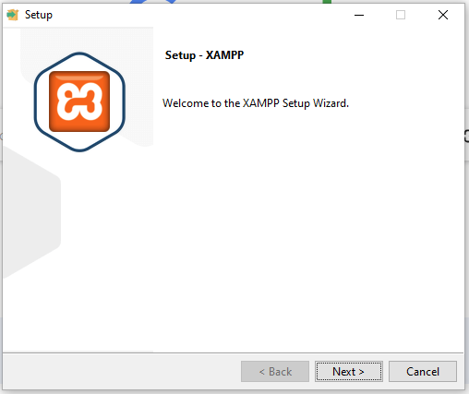
Click on next
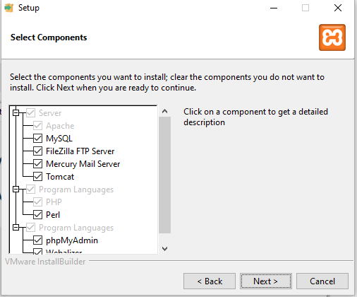
Click on next
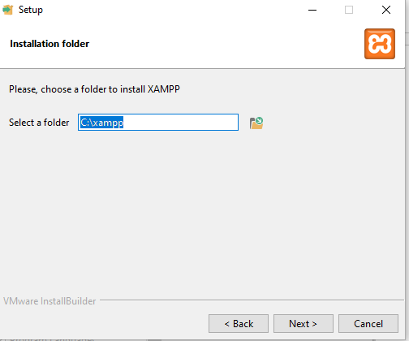
Click on next
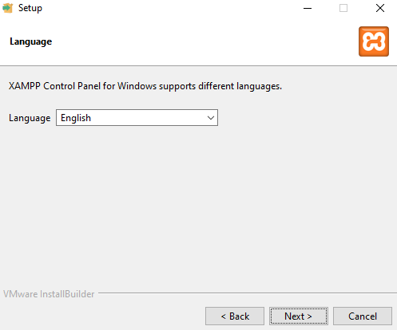
Click on next
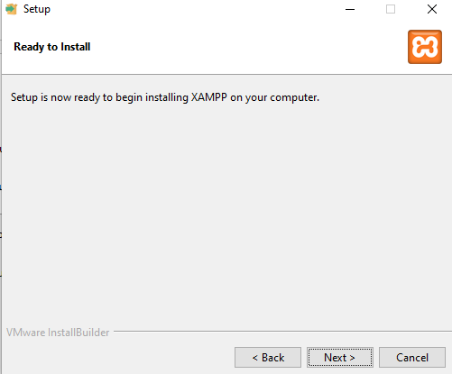

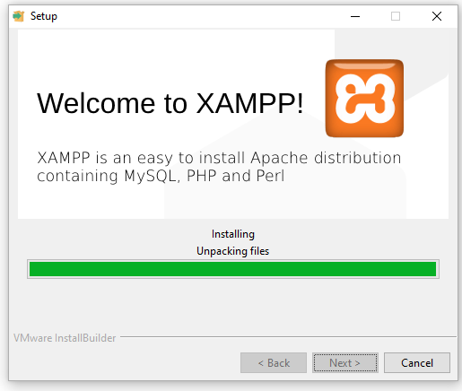
Click on finish
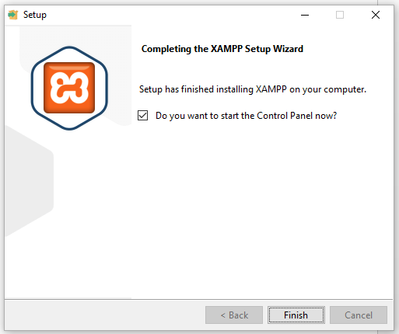
Click on start button of apache and mysql both
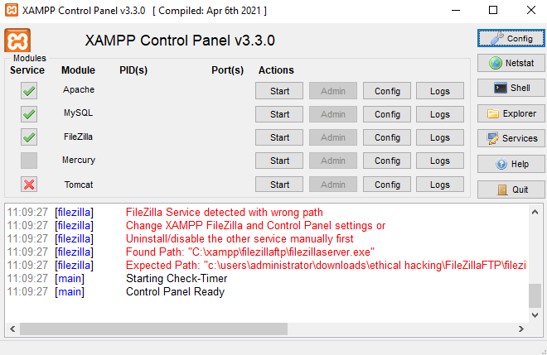

DVWA DOWNLOAD
Download dvwa from github
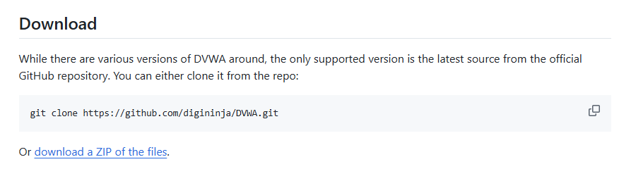
Extract the zip file
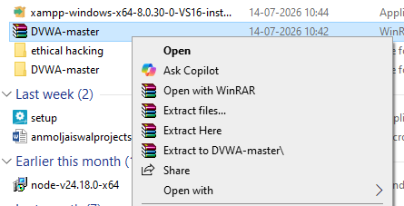
After extracting dvwa master file open that file. After opeing dvwa-master file there is another dvwa-master rename that file to dvwa

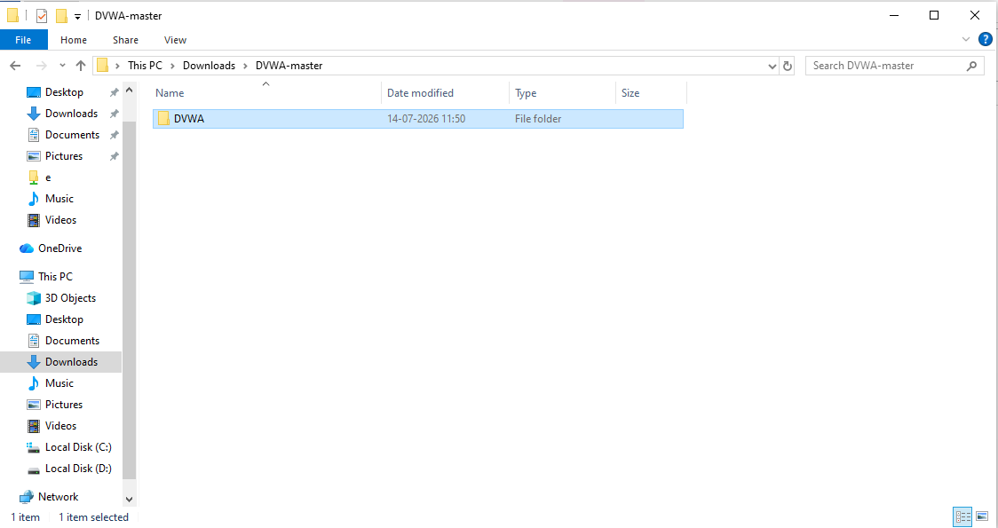
Copy that renamed folder and go to the xmapp file location

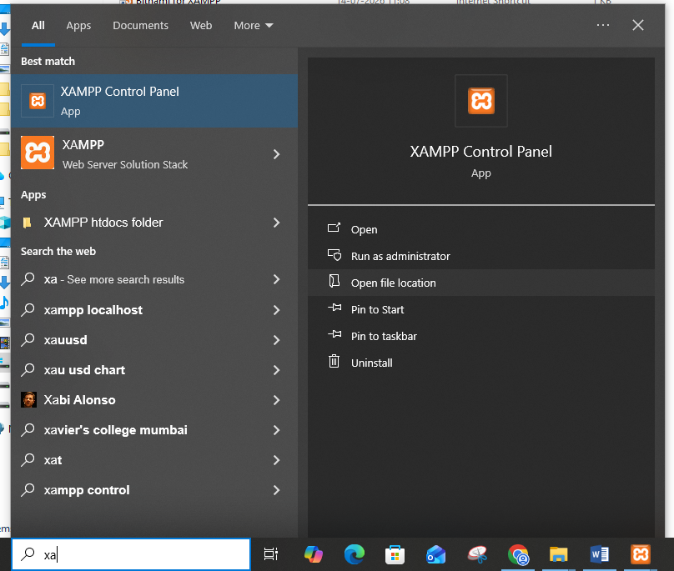
Go to htdocs folder and paste renamed file
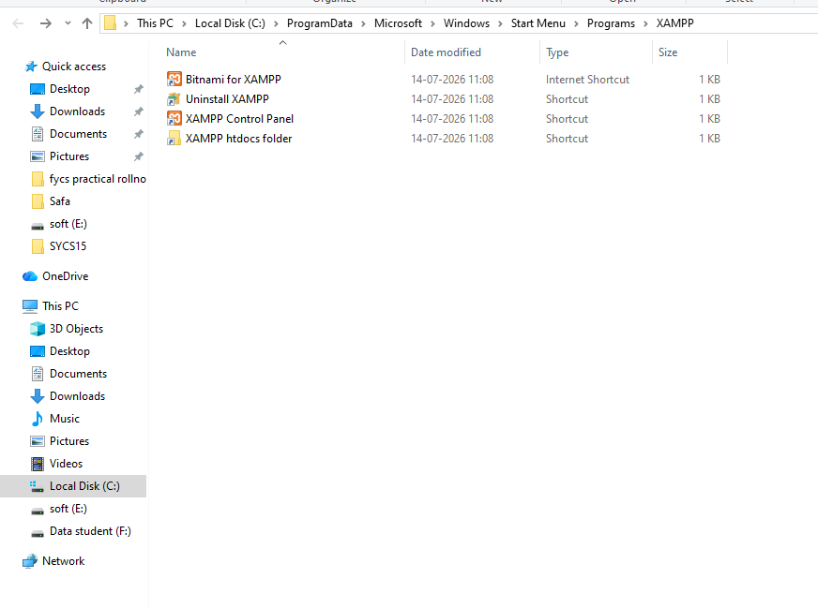
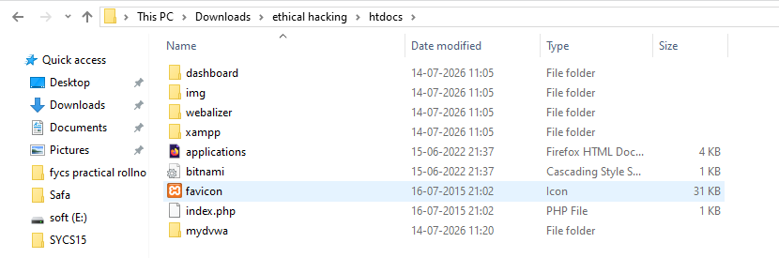
After you pasted the DVWA to htdocs
Go to browser type localhost/DVWA
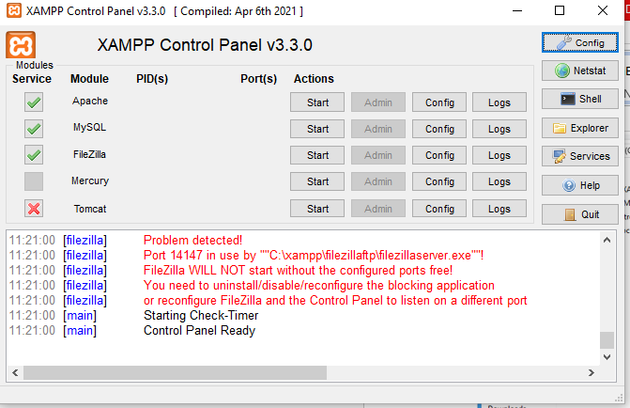
Rename the config file just remove .dist and save it
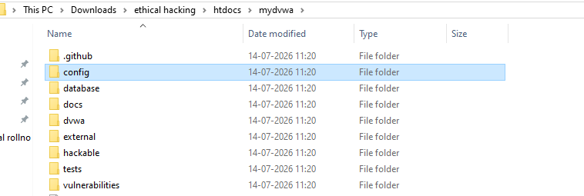
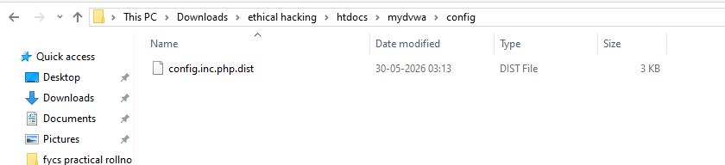
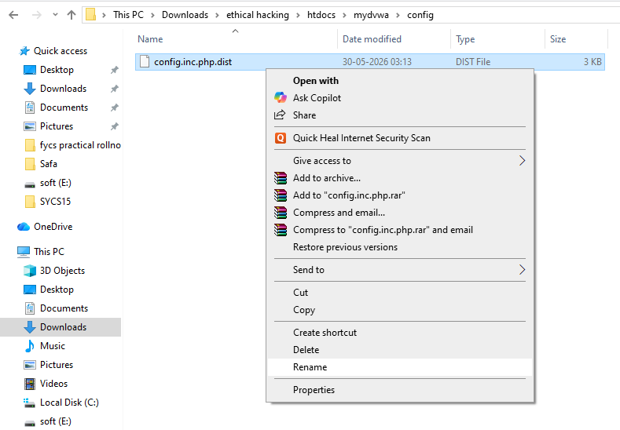
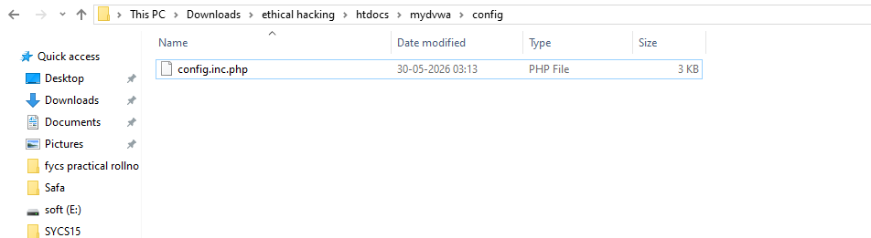
Again type localhost/DVWA/login.php
You will get access denied
Now again open config file in the notepad copy database user and password server will be 127.0.0.1 port will be 3306
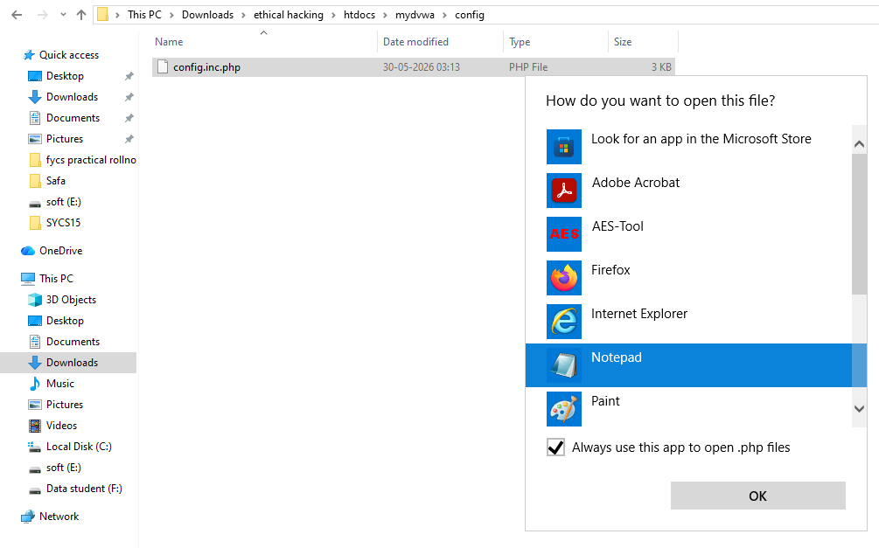
Now go to xammp the open admin of MySQL

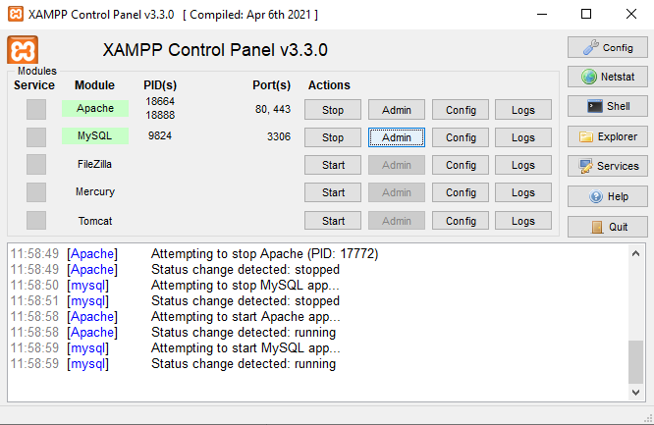
Click on new enter database name as dvwa then go to privileges add user account
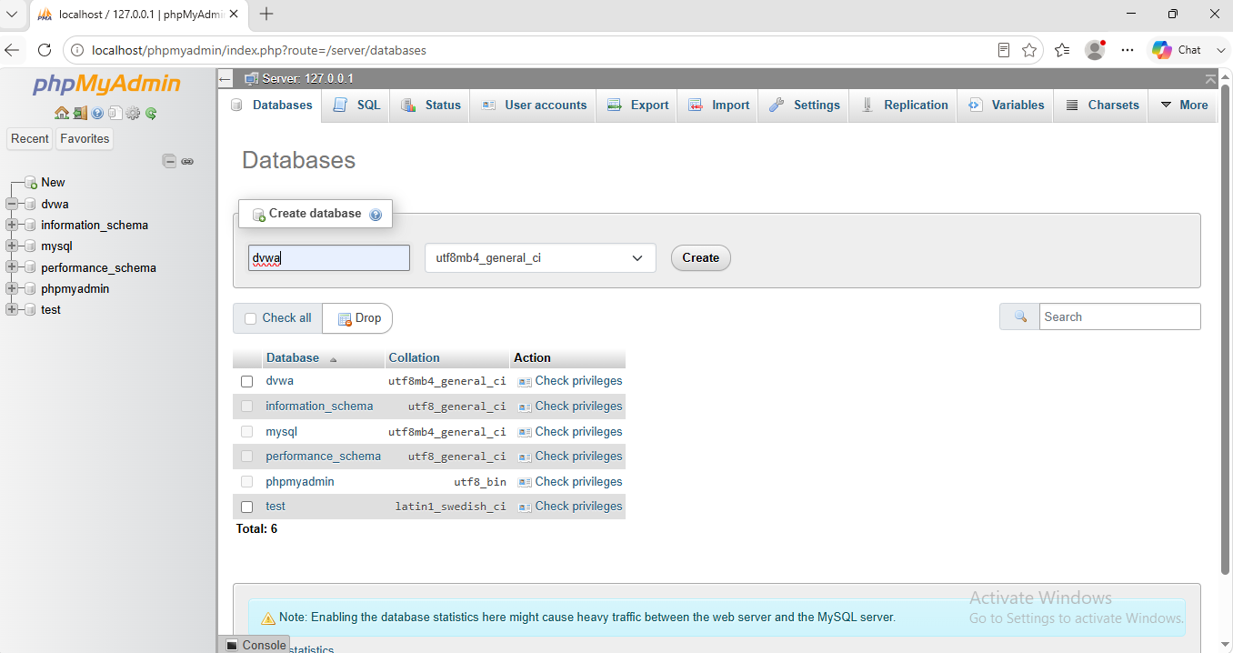
Enter copied user account and password
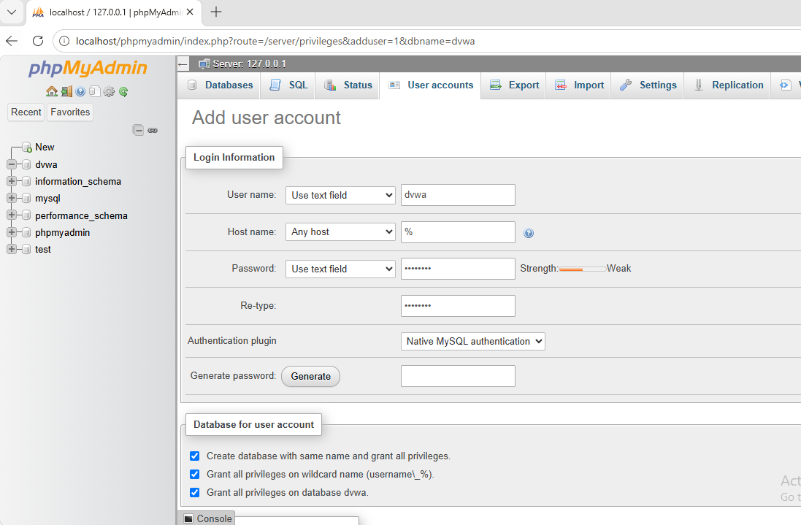
Check the checkbox grant all privileges on db dvwa
Click on go

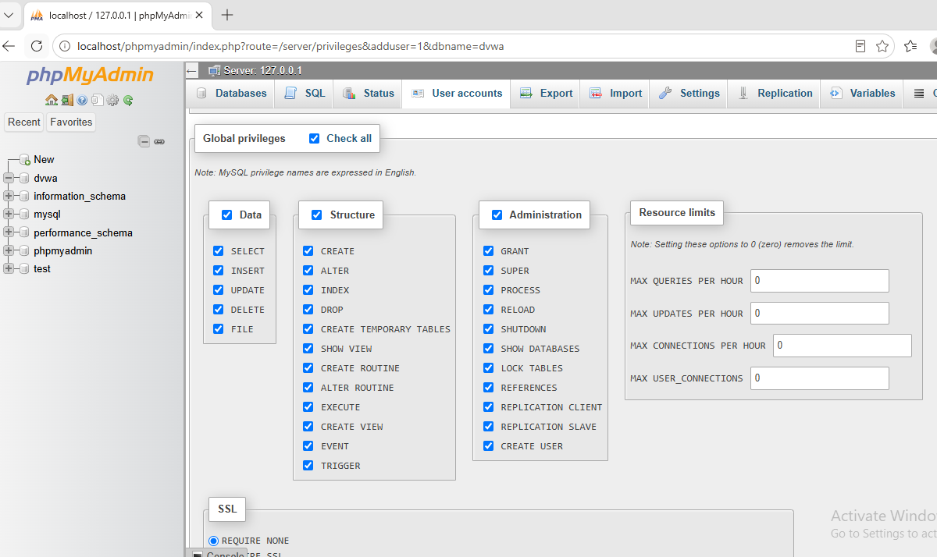
Now click on go and new user will be added.
Now again browse localhost/dvwa/login.php
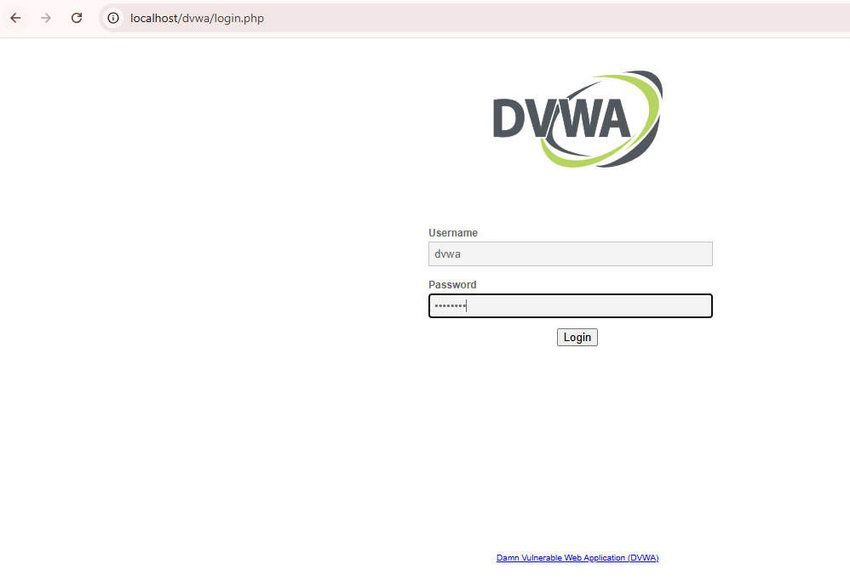
Now click login then click create/ Reset database

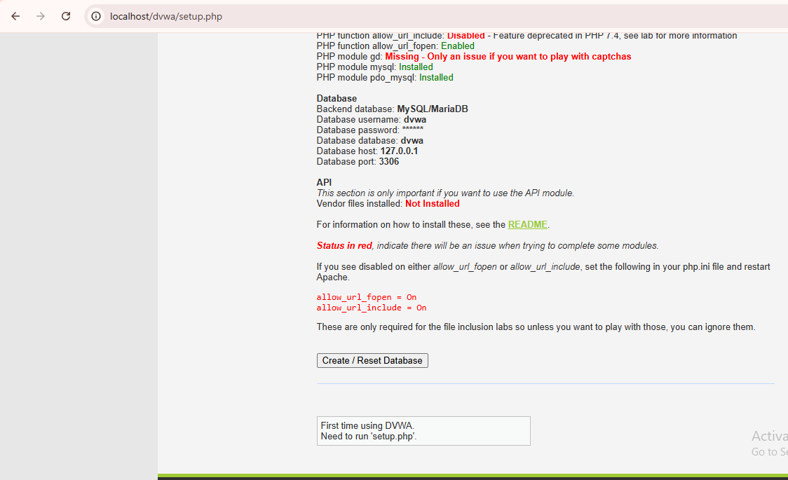
After that again go back to login page and then enter user as admin and password as password

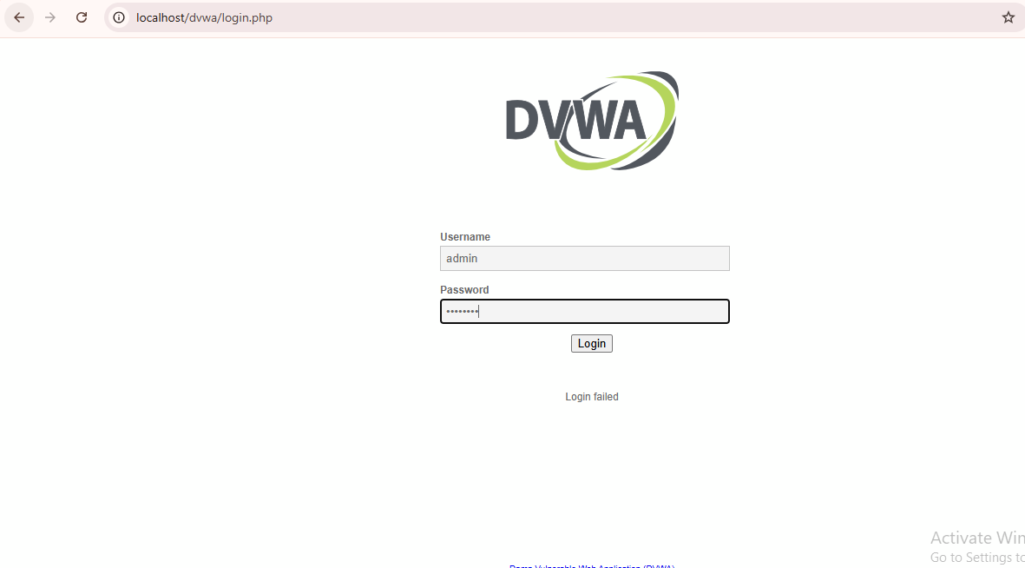
Now multiple red u see so fix it
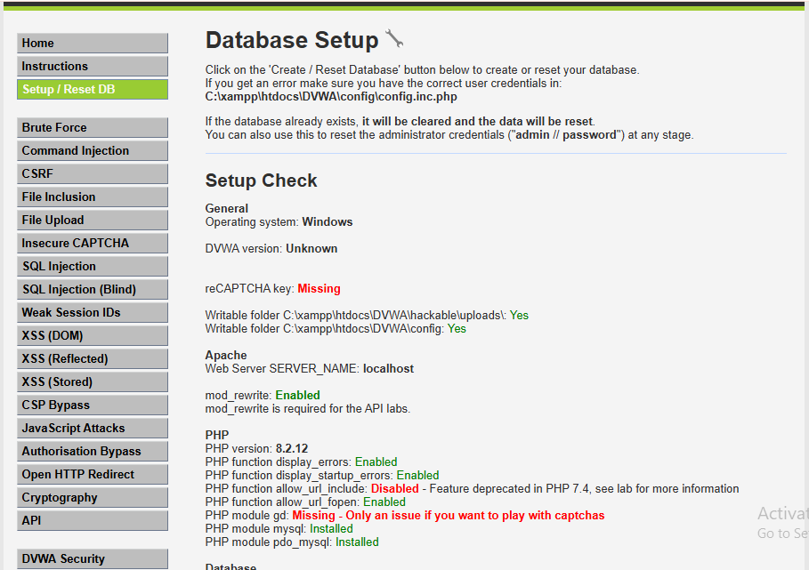
Go to xammp click on config of Apache and select php.ini

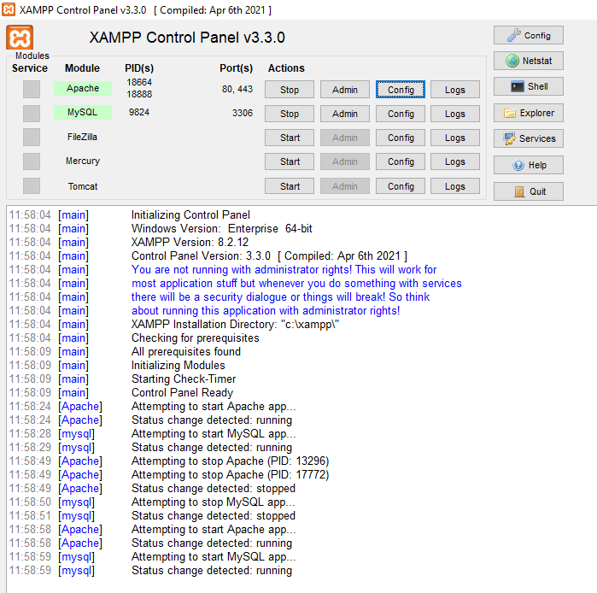
In the notepad search of allow_url_include make it 'on'
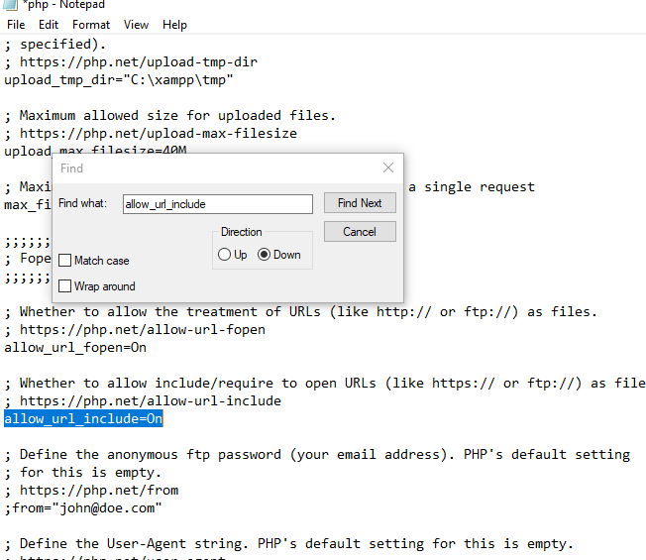
Search GD now remove the semicolon from the start
Save it stop and start apache u will enabled now

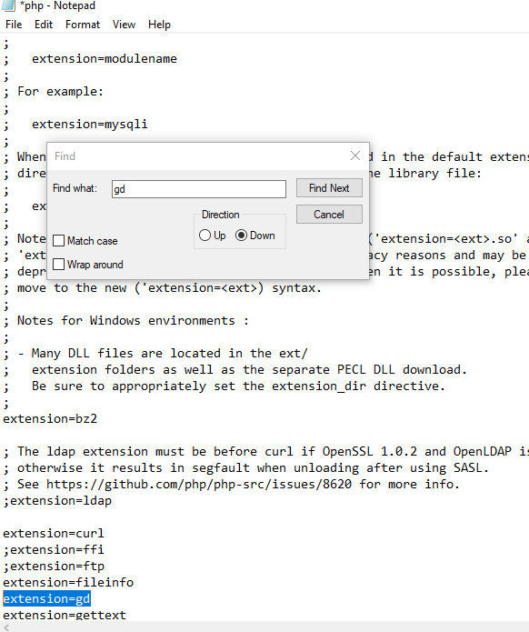
Now go to DVWA security the level is impossible now make it to low and submit
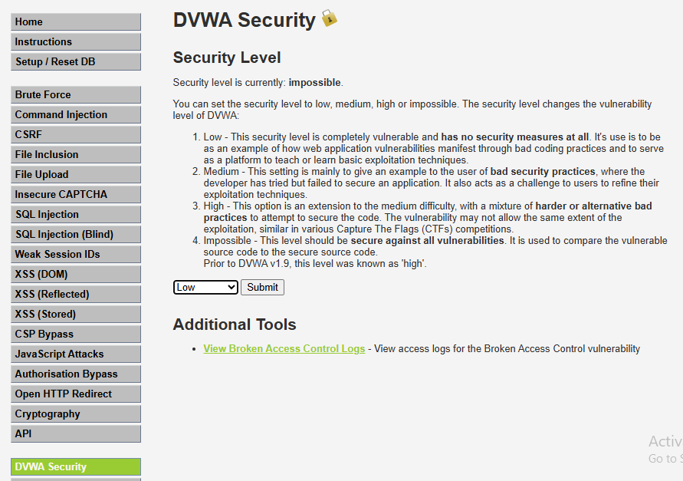
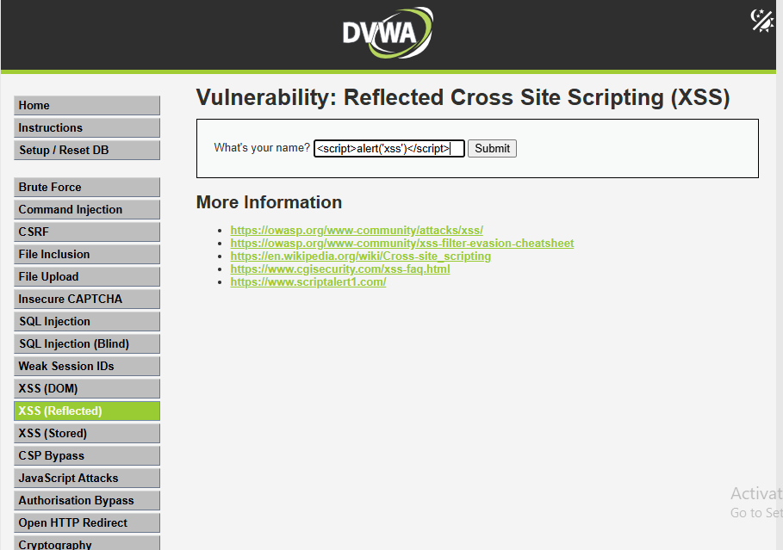
Output:
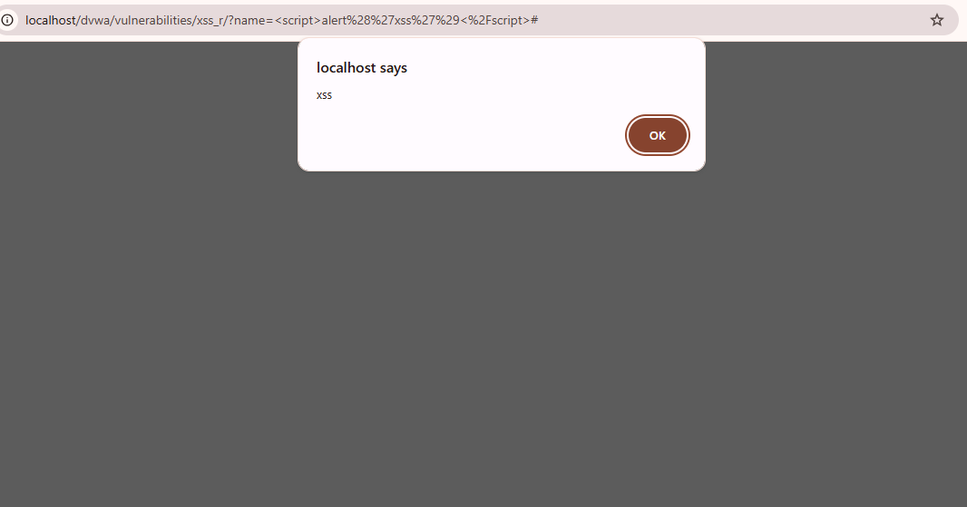
If mysql port is busy then follow following steps:
