PRACTICAL NO.7
AIM : Use Nemesy to launch a DoS attack against a target system or network.
Observe the impact of the attack on the target’s availability and performance.

THEORY : A Denial-of-Service (DoS) attack is a cyberattack in which an attacker seeks to make a machine or network resource unavailable to its intended users by temporarily or indefinitely disrupting services of a host connected to the Internet.
This is achieved by either flooding the targeted machine or resource with superfluous requests to overload systems and prevent some or all legitimate requests from being fulfilled, or by sending information that triggers a crash.
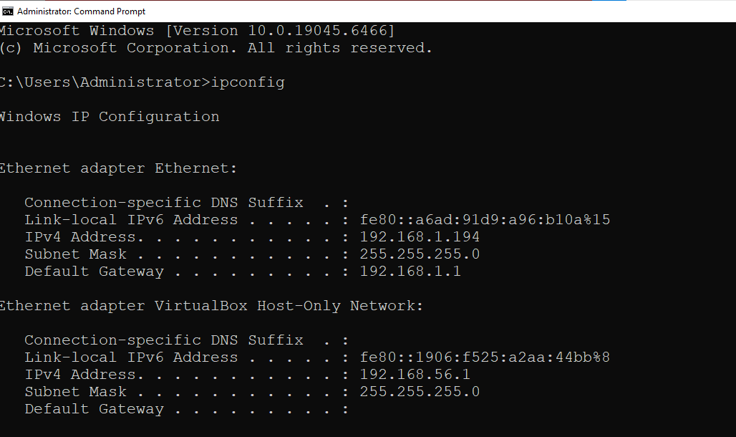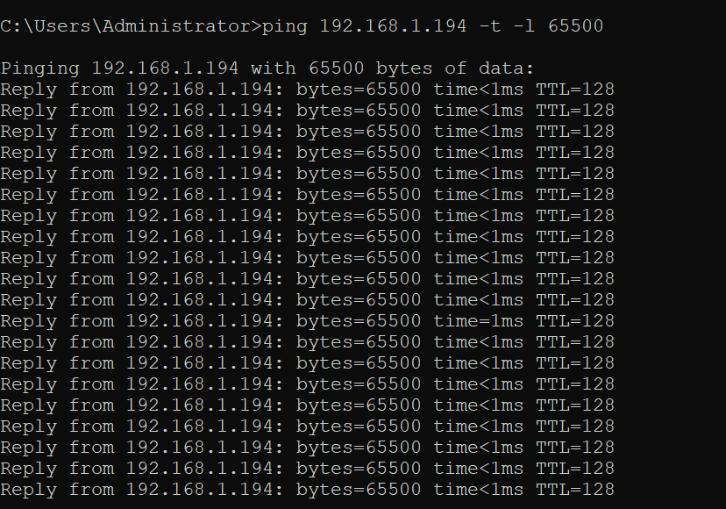

Open Oracle VM Virtual Box and Create New Virtual Machine :
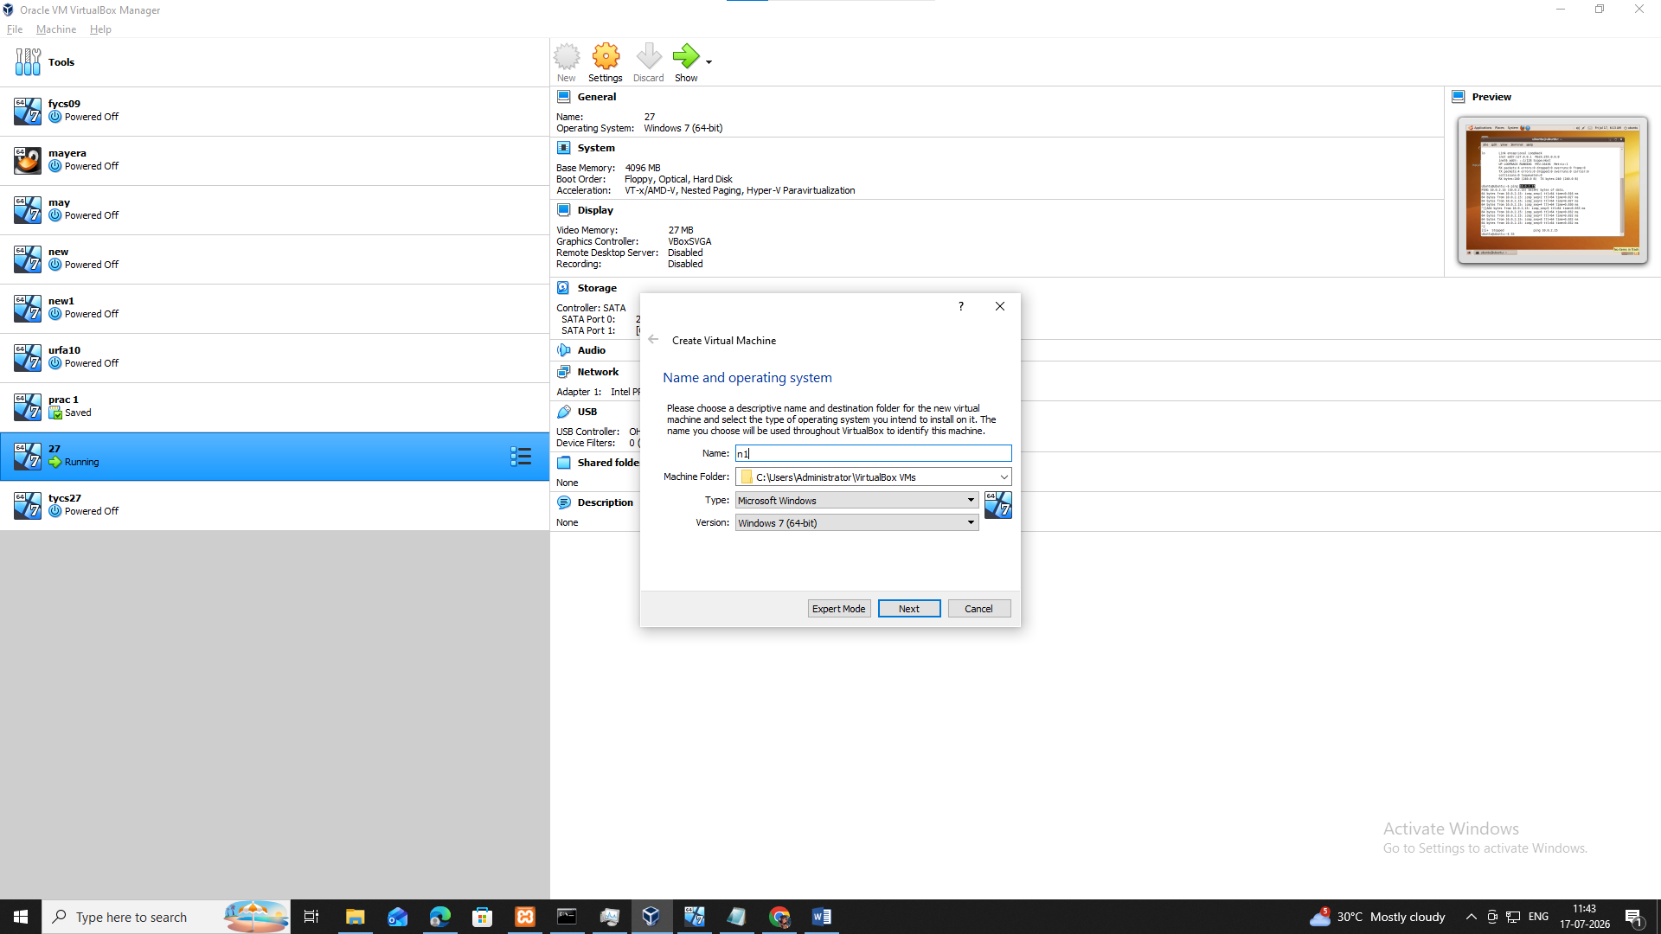
Go to the Terminal and type the following command :
