Practical No.: 8
Aim: Session Impersonation with Firefox and Tamper Data
- Install and configure the Tamper Data add-on in Firefox.
- Intercept and modify HTTP requests to impersonate a user’s session.

What is Tamper Data?
Tamper Data lets you intercept, view, and modify HTTP/HTTPS requests in real time — directly from your browser. Inspired by the classic Tamper Data extension, this modern rewrite brings back the ability to inspect and manipulate web traffic without relying on external proxy tools.

What is Session Impersonation?
Impersonation provides a method for a privileged user to: Assume the role of another user without ending the session of the privileged user. Temporarily assume the identity of another user.

1) Download and install Mozilla Firefox by following the on-screen installation instructions.
2) Open Firefox and click the Extensions (Puzzle) icon .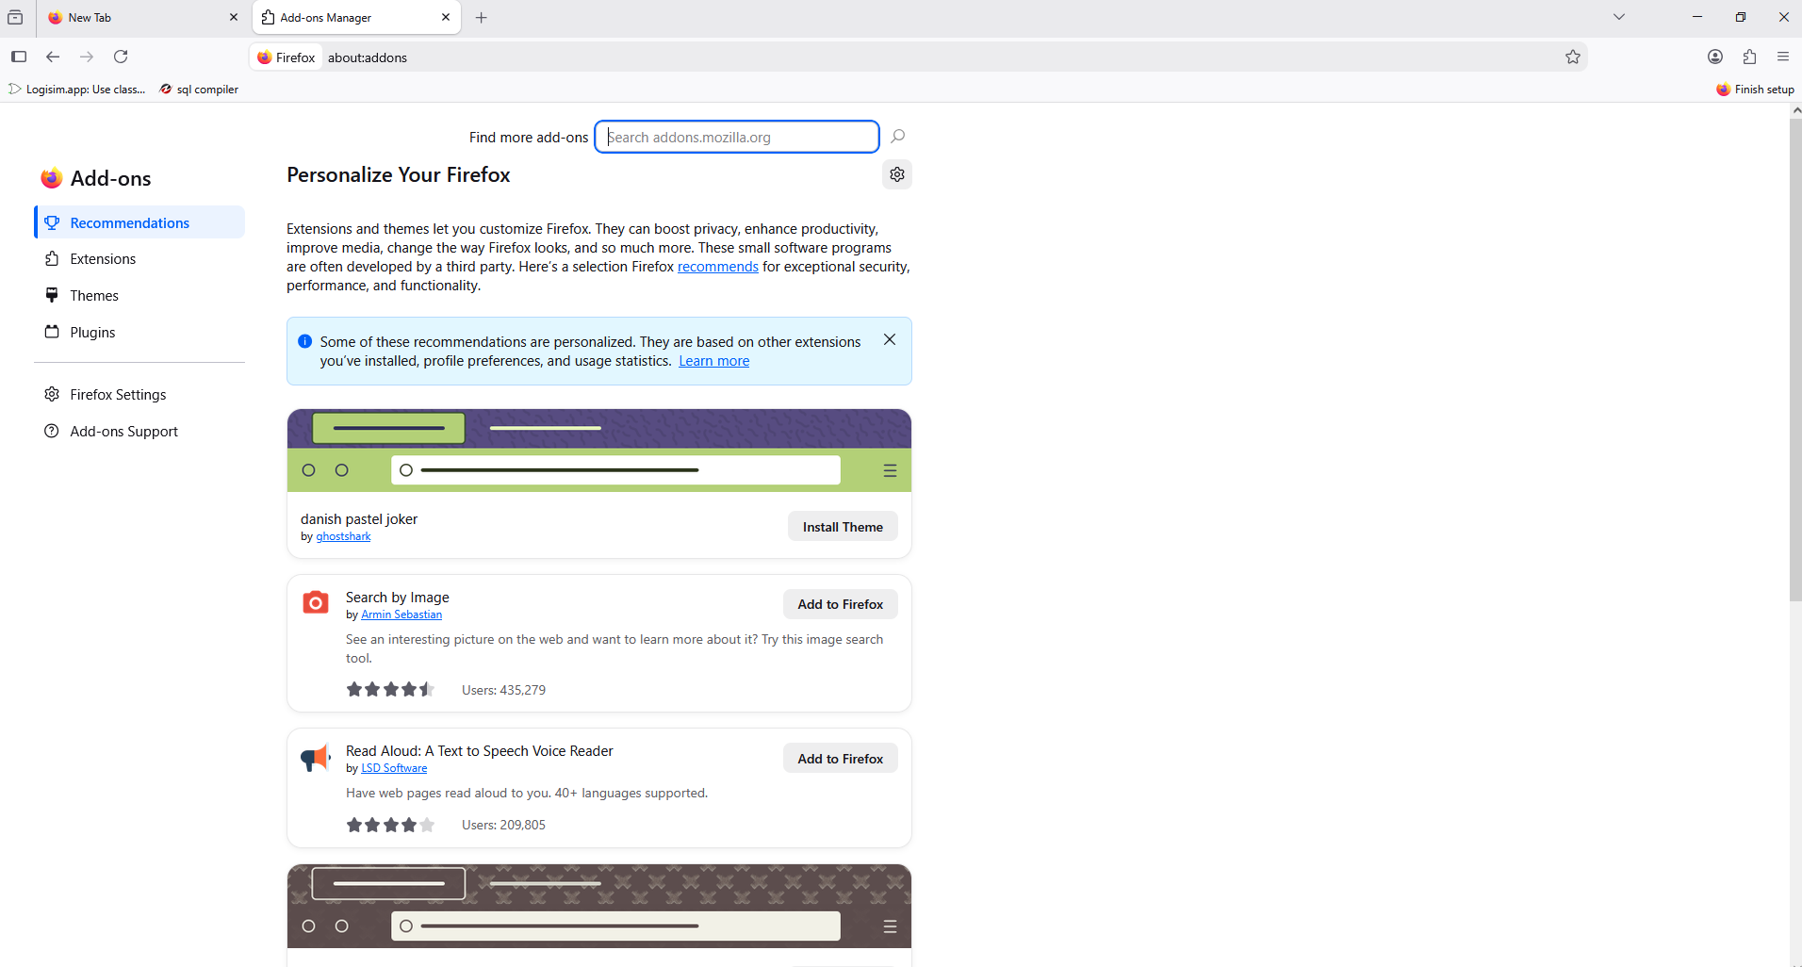
3) Search for "Tamper Data" in the Add-ons store.
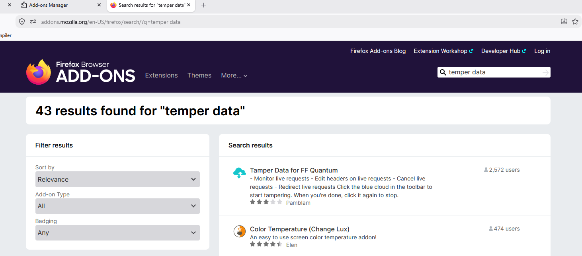
4) Click Add to Firefox and install the Tamper Data extension.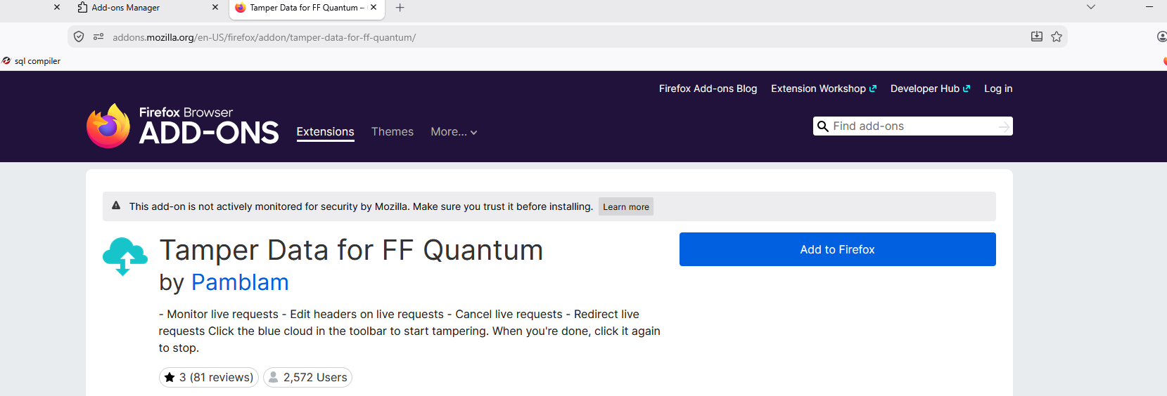

5) Check the Allow Extension To Run In Private Windows Box.
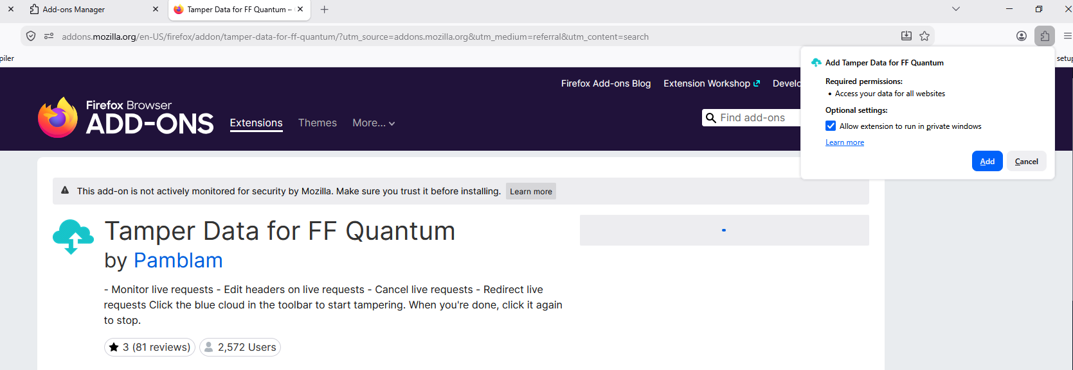

7) Check the Run Extension in Toolbar Box.
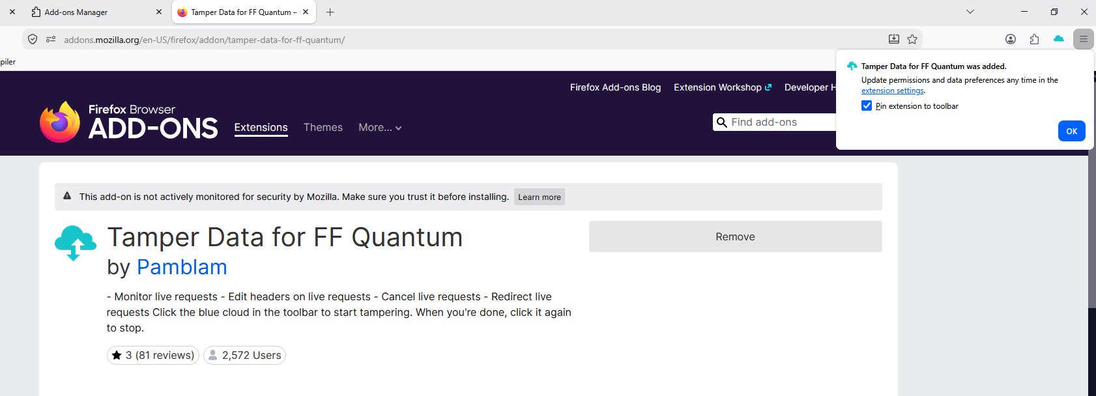

8) Open the vulnerable test website http://testaspnet.vulnweb.com/login.aspx in the Firefox itself.
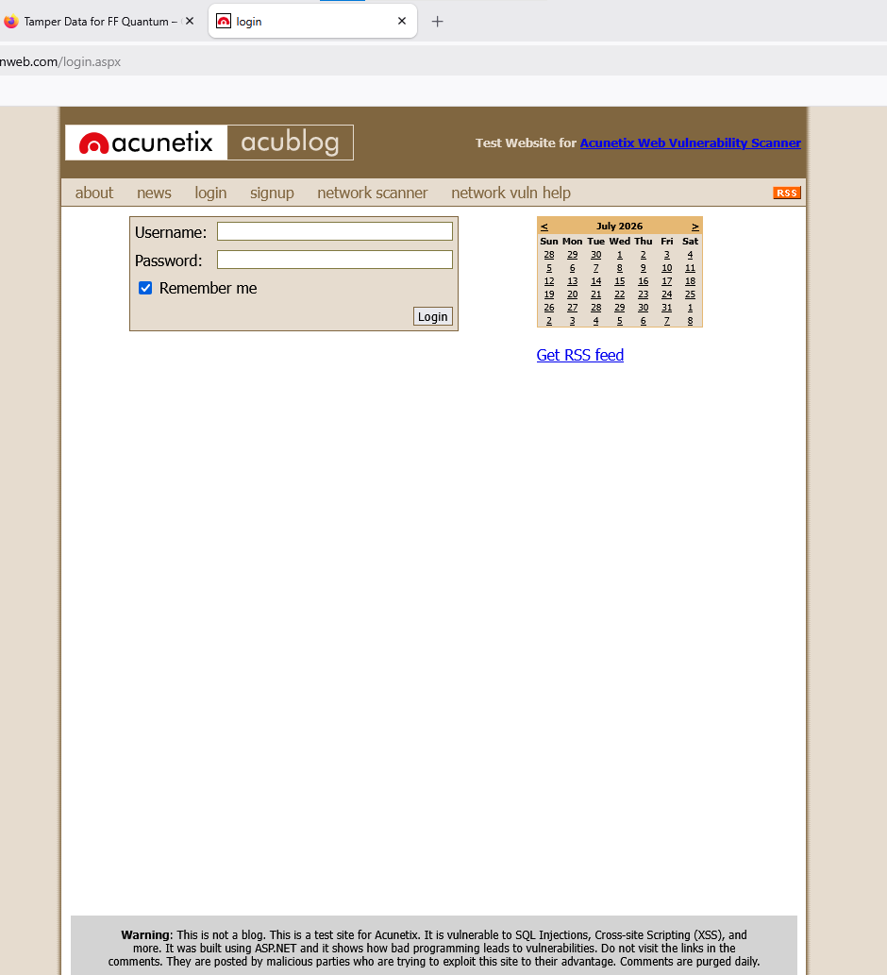

9) If you click on any button or try to log in, no action will be performed. To proceed, click the Tamper Data (Cloud) icon on the Firefox toolbar. A new window will open. Scroll to the bottom of the window and click Start Tamper.
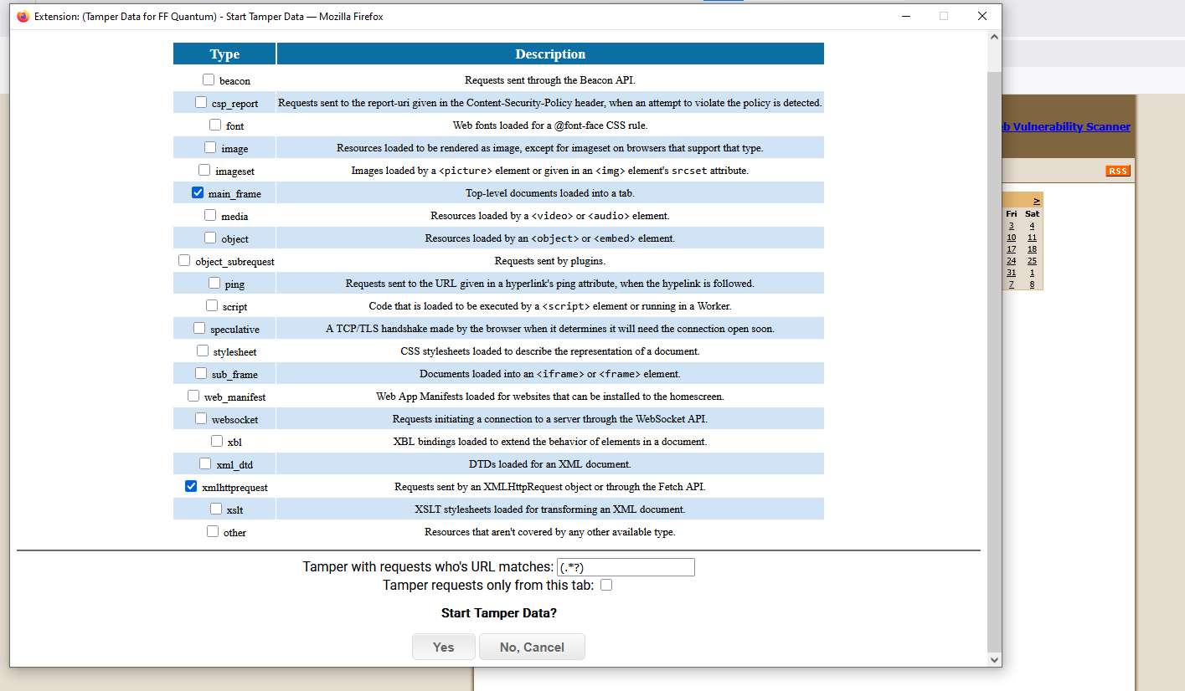

10) Now enter username as admin and enter any password as you wish.
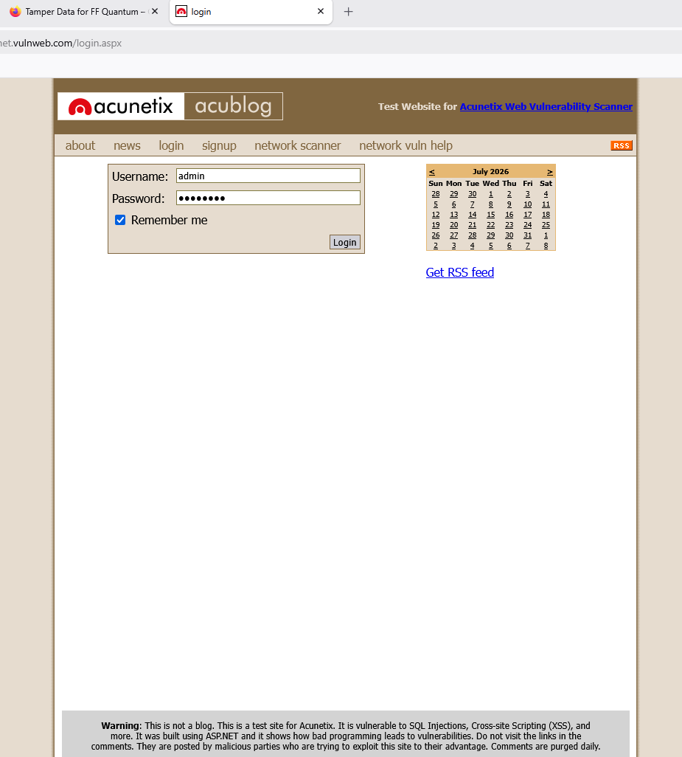

11) Now click on Network Scanner. A window will open, scroll down and click on OK.
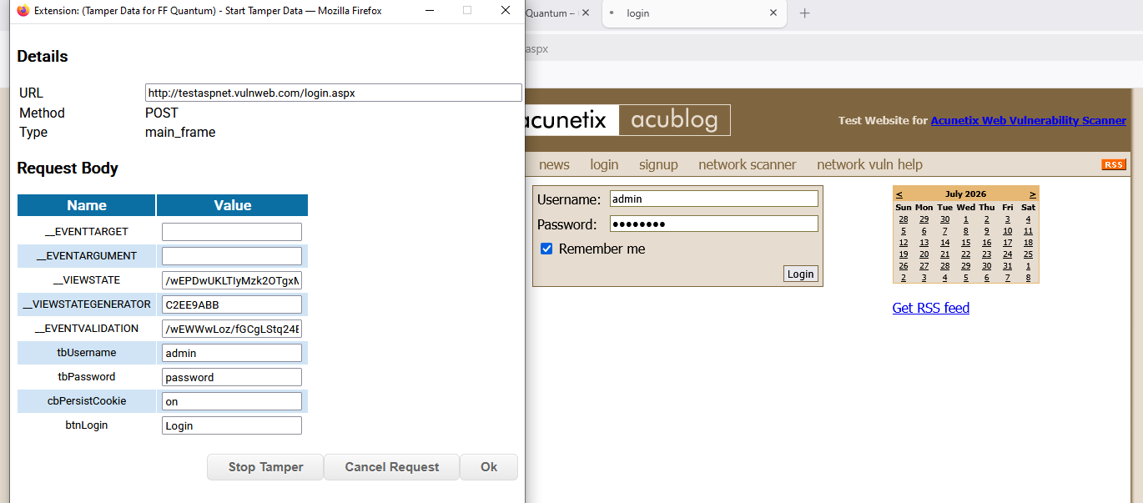

12) After clicking on OK a new window will open. Scroll Down and Edit Upgrade Insecure Requests and Enter any number you wish for example here we enter 5.Click on OK.
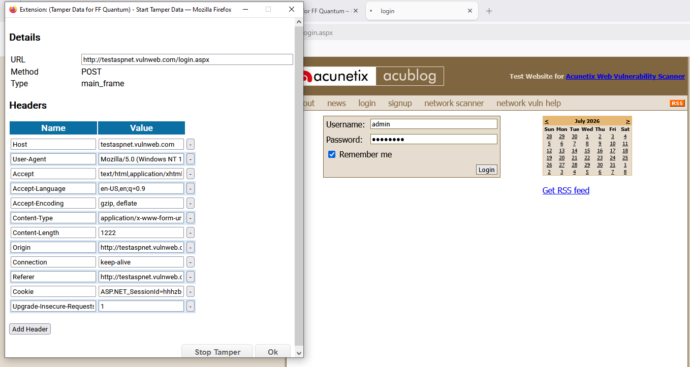
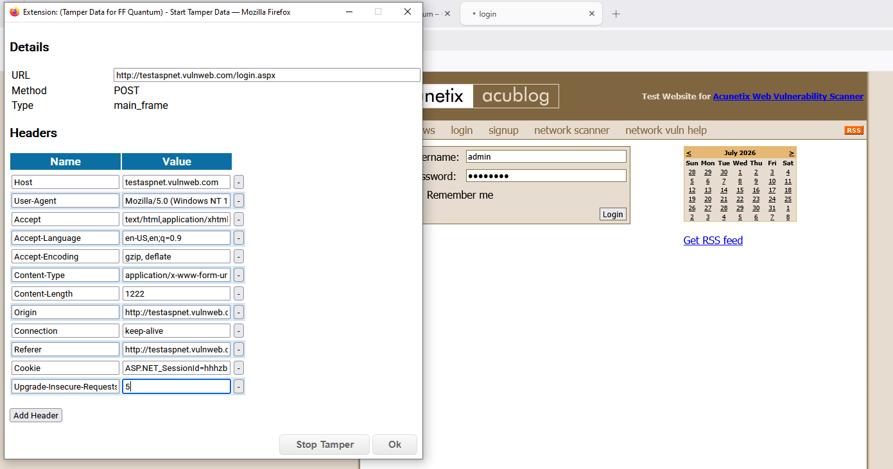

13) Go to Network Scanner.
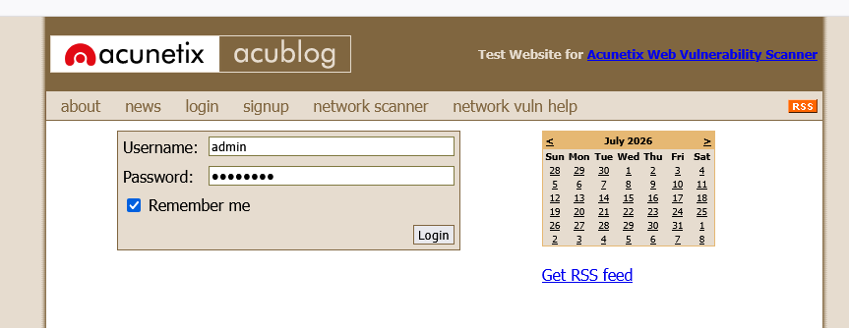

14) This will open a Window click on OK.
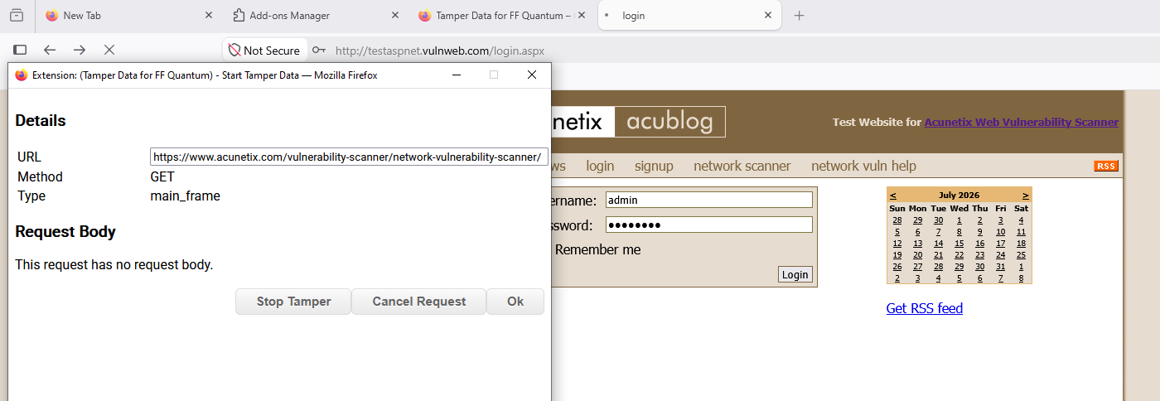

16) A window will open, where we have to click on Upgrade Insecure Requests and edit it and make it 5. Repeat this step for 4 to 5 times.
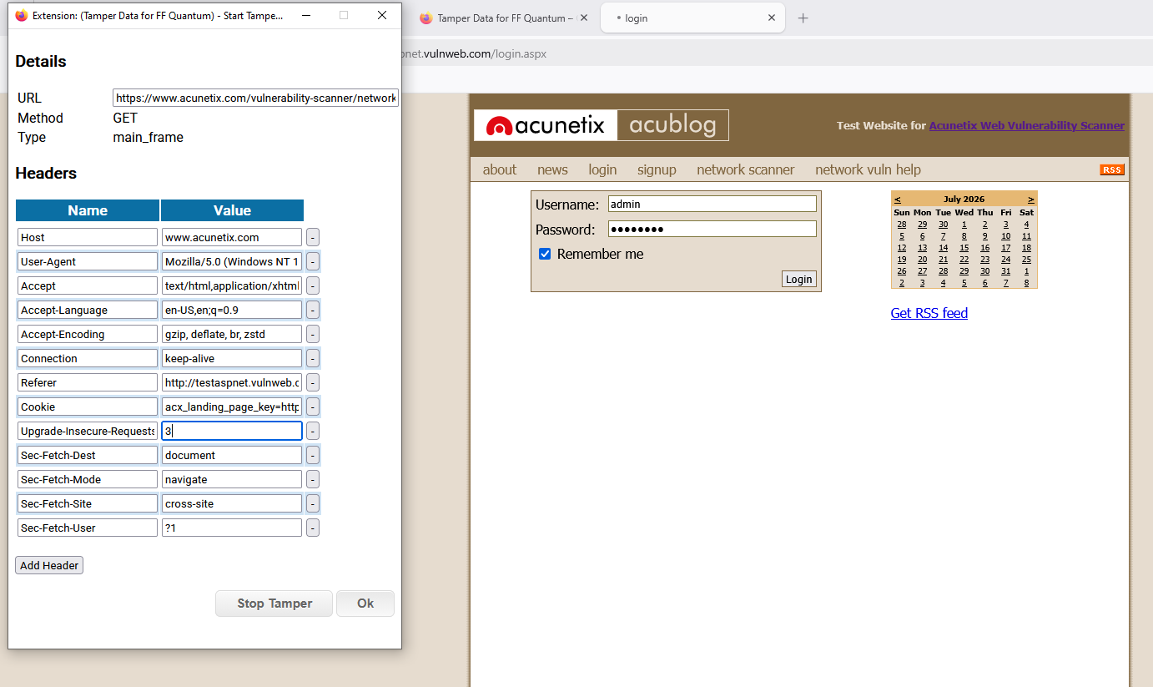

17) This will result in multiple popups where we check if the modified request works as another user's session.
