PRACTICAL NO. 9
AIM: To find last connected USB on your system (USB Forensics)
USBDeview is a free, lightweight Windows utility by NirSoft that lists all USB devices currently and previously connected to your computer. It displays detailed device data, lets you safely disconnect or uninstall old device drivers, and allows you to enable or disable specific USB ports or hardware.

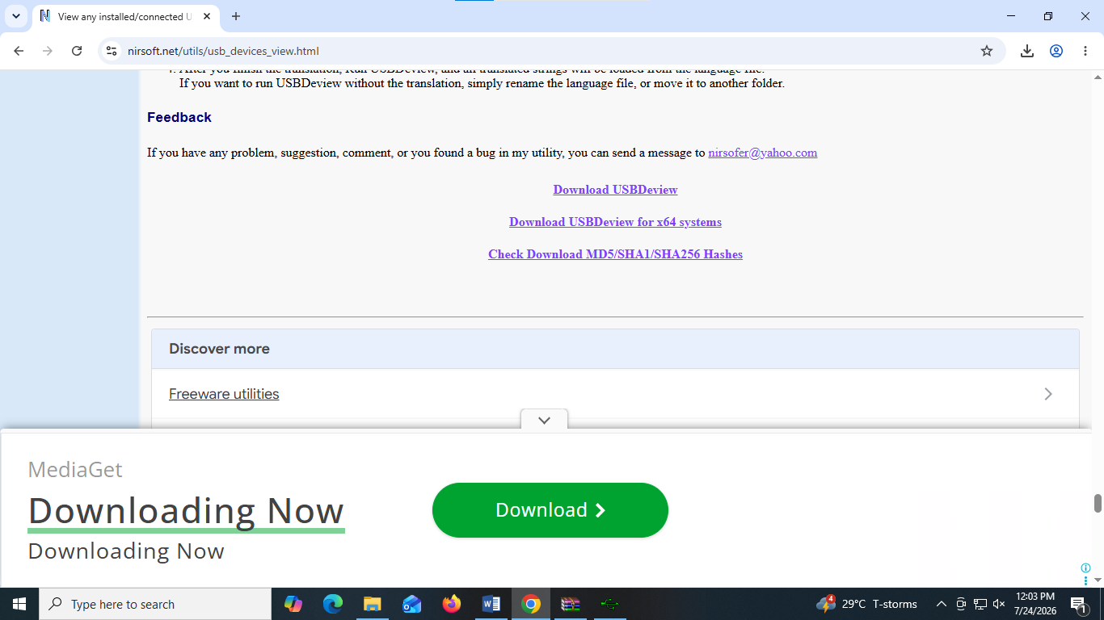
Download USBDeview or type this url : https://www.nirsoft.net/utils_devices_view.html

Double click on the installed zip file and Go to USBDevice.exe :
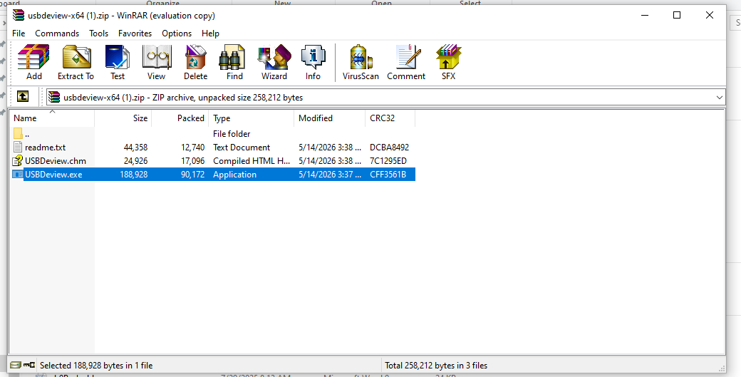

Detailed history of USB devices connected :
