**Selected_2 Project**

Supervised By: Dr. Wessam EL Behaidy



**Selected CS2**

**Spring 2023**

Cover Sheet

**==> Team Number : 7**

|  |  |  |
| --- | --- | --- |
| **#** | **Student Name (in ARABIC)** | **Student ID** |
| **1** | مريم محمد سليمان عباس | 202000884 |
| **2** | ضحي حسانين محمد الصاوي | 202000472 |
| **3** | فيروز ايهاب رضا عبد الحميد | 202000648 |
| **4** | كريم اشرف السيد جبريل | 202000661 |
| **5** | ابراهيم عصام محمود عبد الرحمن | 202000005 |
| **6** | شريف شعبان محمود عبد الغفار | 202000436 |

Sign language recognition



The dataset used

===> **Name Dataset**

Sign language recognition

===> **Link Dataset** <https://www.kaggle.com/datasets/gauravduttakiit/sign-language-recognition>

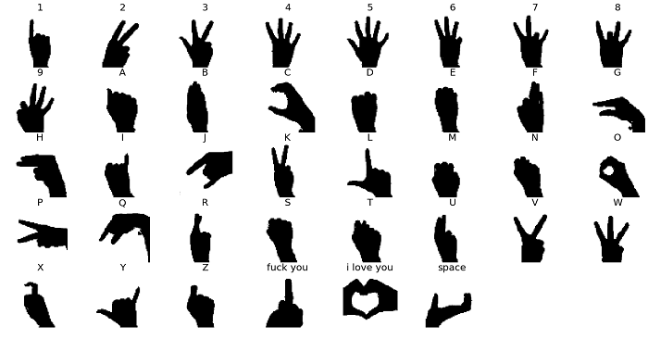

**Contents**

**Part Ⅰ: Paper Detalis…………..……..………5**

**Part Ⅱ: Project Description ………..………8**

1. **Paper Detalis :**
2. The paper " Two-Stream Mixed Convolutional Neural Network for American Sign Language Recognition" was **published** in **the journal IEEE Access in 2020**.

The **authors** of the paper are Xiaoyu Liu, Yifan Zhang, and Yifan Zhang.

**b.** The paper proposes a two-stream mixed convolutional neural network (CNN) for American Sign Language (ASL) recognition. Where **two datasets were used** in the paper

1. MNIST Dataset.

2. ASL Dataset.

In the paper, four CNN models are used, namely :

* LeNet
* AlexNet
* RestNet18
* RestNet50

LeNet

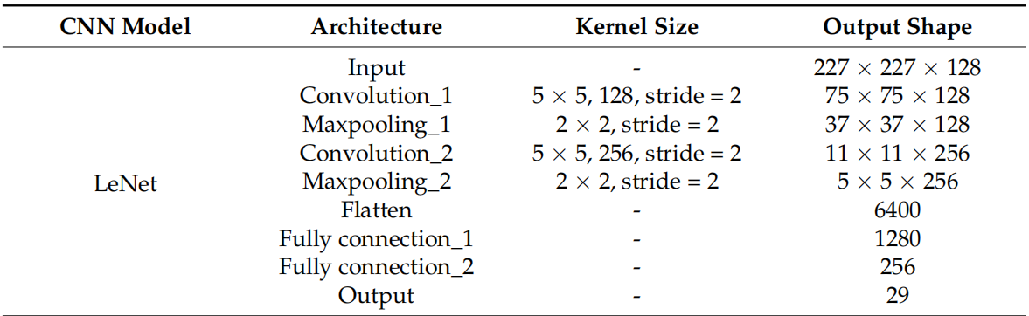

AlexNet

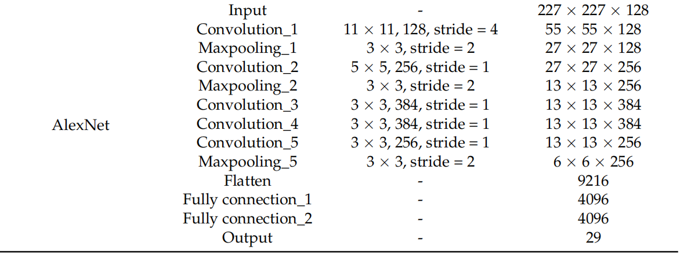

RestNet18

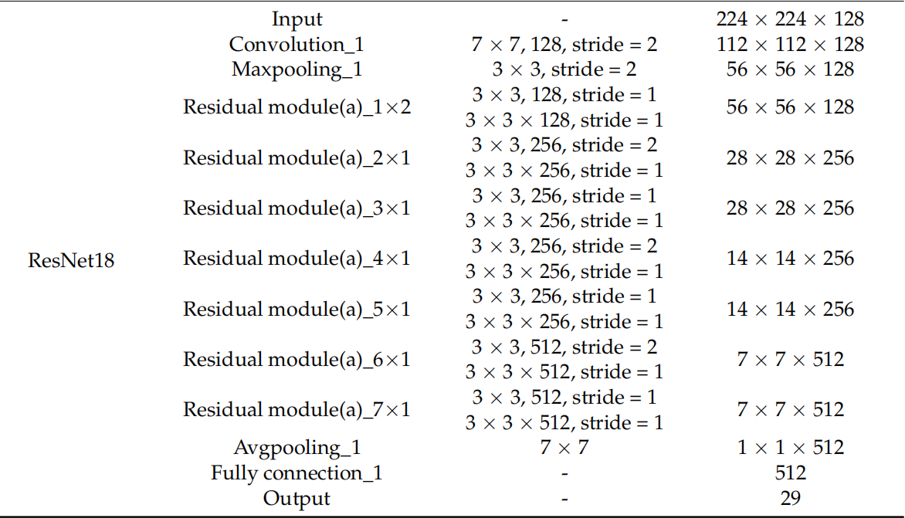

RestNet50

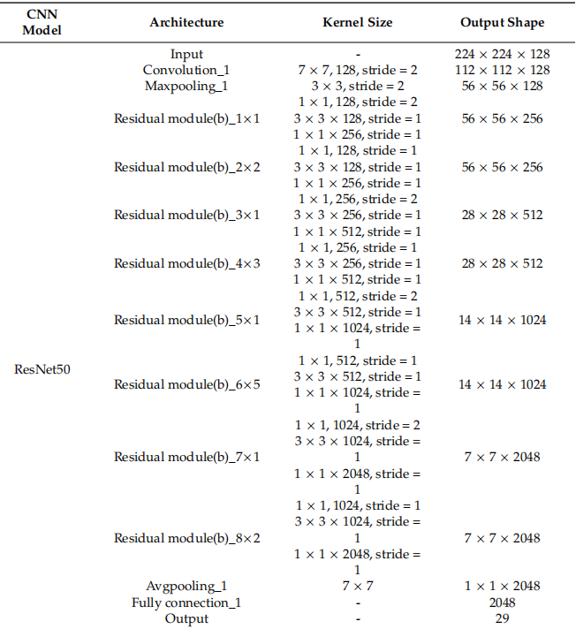

**Results is Models**

MNIST Dataset ASL Alphabet Dataset

Accuracy Precision Accuracy Precision

**LeNet** 89.31% 88.72% 88.43% 87.68% **AlexNet** 94.74% 89.95% 93.64% 88.46%

**RestNet18** 98.13% 94.16% 96.94% 93.77%

**RestNet50** 98.88% 95.15% 97.41% 94.01%

**2. Project Description :**

**a.** General Information on the selected dataset:

There are several datasets available for sign language recognition, but one of the most commonly used is the American Sign Language (ASL) dataset.

The sign language recognition dataset can be found at this

Link:[<https://www.kaggle.com/datasets/gauravduttakiit/sign-language-recognition>]

This dataset contains a total of 23347 images of hand gestures representing the 26 letters of the English alphabet in American Sign Language. The images are grayscale and have a dimension of 227 x 227 pixels.

This is a classification dataset with 29 classes, each representing a letter of the alphabet. The labels for the classes are A, B, C, D, E, F, G, H, I, J, K, L, M, N, O, P, Q, R, S, T, U, V, W, X, Y, Z , del, space, nothing

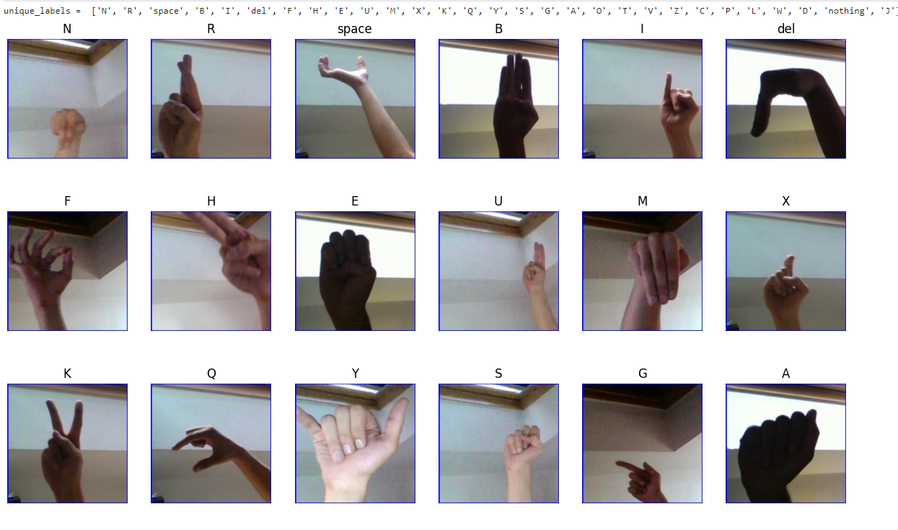

**b.** Implementation details :

* The ratio used for training 85% and testing 15%

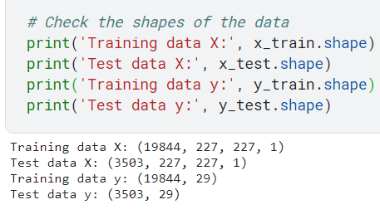

* block diagram of the implemented LeNet model :

Input (227, 227, 1)

MaxPooling2D (pool size=(2, 2), stride=(2, 2))

Conv2D(128filters, kernel size=(5,5), stride=(2,2), activation='relu')

Output(29)

Conv2D(256 filters,kernel size=(5,5), stride=(2,2), activation='relu')

Dense(29 units, activation='softmax')

Dense(1280 units, activation='relu')

Flatten

MaxPooling2D (pool size=(2,2), stride=(2, 2))

Dense(256 units, activation='relu')

* Tim application of two CNN models on the data (LeNet , AlexNet)

Hyperparameters used in model :

1. LeNet

the hyperparameters used in the modelLeNet :

**filters :** The number of filters in each convolutional layer. In modelLeNet, the number of filters used in the convolutional layers are 128 and 256.

**kernel_size :** The size of the convolutional kernel. In

modelLeNet, the kernel sizes used in the convolutional layers are (5, 5) for both layers.

**strides:** The stride of the convolutional kernel. In modelLeNet, the strides used in the convolutional layers are (2, 2) for both layers.

**activation :** The activation function used in each layer. In

modelLeNet, the activation function used in all layers except the output layer is ReLU, and the activation function used in the output layer is softmax.

**pool_size :** The size of the pooling window. In modelLeNet, the pool sizes used in the pooling layers are (2, 2) for both layers.

**units:** The number of units in each fully connected layer. In modelLeNet, the number of units used in the fully connected layers are 1280, 256, and classes.

optimizer: The optimizer used to train the model. In

modelLeNet, the optimizer used is Adam.

**loss :** The loss function used to train the model. In modelLeNet, the loss function used is categorical cross-entropy.

**metrics :** The evaluation metric used to evaluate the model. In modelLeNet, the evaluation metric used is accuracy.

1. AlexNet

the hyperparameters used in the modelAlex :

**filters:** The number of filters in each convolutional layer In modelAlex, the number of filters used in the convolutional layers are 128, 256, 384, 384, and 256.

**kernel_size:** The size of the convolutional kernel. In modelAlex, the kernel sizes used in the convolutional layers are (11, 11), (5, 5), (3, 3), (3, 3), and (3, 3).

**strides:** The stride of the convolutional kernel. In modelAlex, the strides used in the convolutional layers are (4, 4), (1, 1), (1, 1), (1, 1), and (1, 1).

**activation:** The activation function used in each layer. In

modelAlex, the activation function used in all layers except the output layer is ReLU, and the activation function used in the output layer is softmax.

**pool_size:** The size of the pooling window. In modelAlex, the pool sizes used in the pooling layers are (3, 3) for all layers.

**units:** The number of units in each fully connected layer. In modelAlex, the number of units used in the fully connected layers are 4096, 4096, and classes

**optimizer:** The optimizer used to train the model. In modelAlex, the optimizer used is Adam.

**loss:** The loss function used to train the model. In modelAlex, the loss function used is categorical cross-entropy.

**metrics :** The evaluation metric used to evaluate the model. In modelAlex, the evaluation metric used is accuracy.

**c.** Results details :

LeNet Model

