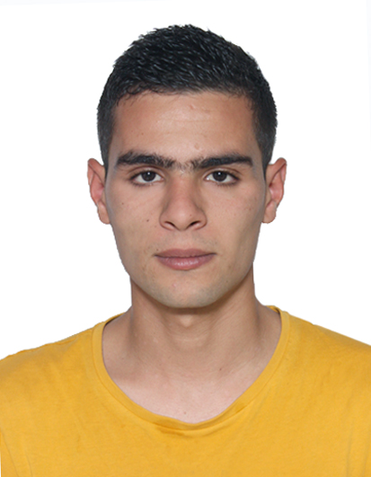
Medjralou Abd eraouf

Date and birth place : 22-08-1992 - Bourouba El harrach- Algiers

Nationality : Algerian

Adress: 53 cite alzina 1 n°03 -Bordj el Kiffan – algiers

Tél :0657 28 58 64
E-mail:raouf000081@gmail.com

LANGUES

English: Very Good
(understanding – writing – speacking)
French : Good
Arabic : perfect

FORMATIONS

year : 2010

Scientifique Baccalauriate

year ; 2015

-University degree ( Bac+3) Archives and data technology

Profesional experiance

- 1 year at the National Airport Management Establishment (EGSA) as a Study Officer (Documentalist)
- 6 months practical internship in the National Library (Legal Deposit)
- . 3 months as a receptionist in roza Hotel (D.E.B)
- Advanced computer skills (No degree)
- National service obligations (have passed Army service

Character : .Versatile, Good Team work . Serious . Quick learner .good communication skills .

