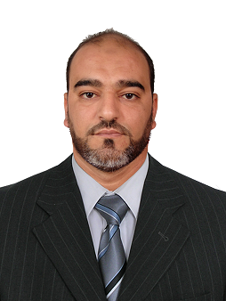
Curriculum Vitae
NAME / FIRST NAME : Ikhlef eschouf Fethi
DATE AND PLACE OF BIRTH : 07/09/1979 à Mouzaïa.
POSITION HELD : Trainer.

personal information
Adresse  Teléphone  E- mail |  | Domaine 13 Mouzaïa 09210, W : BLIDA , ALGERIE.  0 670 05 00 35.  Fethi9903@yahoo.fr
education
JUNE 1999  SEPT 1999  JUNE 2004  Nov 2017 |  | Electronic bachelor.  Department of Electrical Engineering and Electronics (Ex- INELEC),  University of Boumerdes, Algeria.  Diploma of Applied University Study (DEUA)  Sector: Electrical and Electronic Engineering Option: Control and Control  End-of-Study Subject:  "DESIGN AND REALIZATION OF A MOBILE ROBOT"  Training of PC 350-8 in Komatsu UK
profissional experience
FROM: 06/2003  TO : 08/2003  from: 01/2005  to :08/2006 |  |  | Trainee in Industrial Maitenance.  Semoulerie Industrielle de la Mitidja (SIM)  Maintenance Agent  Semoulerie Industrielle de la Mitidja (SIM)  Tasks : Electronic/Electrical/Mechanical Maintenance and Installation of control panels.
from : 28/10/2006  to :  31/01/2007 |  |  | RAZEL ALGERIE (French company)  Industrial electrician and maintenance of production equipment  Reinforcement of 02 tunnels SNTF of 300 meters
from : 17/07/2007  to  31/07/2010  FROM : 27/04/2011 TO :  14/11/2011 |  |  | Electromechanician at the hotel SAFIR MAZAFRAN
industrial maintenance at groupe haddad ETRHB base oued smar

(maintenance-Electronics/Electricity/mechanics/publicworks machinery)
from : 15/11/2011
to : 04/11/2012

06/11/2012
TO THIS DAY
 |  |  | Engineer in charge of Maintenance within SOPI couscous mama (Electronic Maintenance / Electricity / Mechanics and Installation of Control Cabinets).
 |  |  | Trainer at GH KOMATSU (Public works machines) on thermal engines / transmission system / hydraulic system / periodic maintenance / scanner system
Informatics tools
Bureautique : Word, Excel, Power point ….
Programmation : Pascale, Assembly language of the Z-80
Languages
French  english |  |  | native Language  LANGUAGE OF STUDY AT THE DEPARTMENT.

