Cv Chemical Engineering
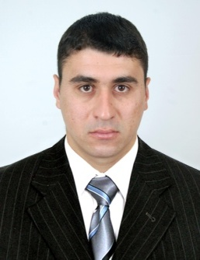
Name & First Name: HATHAT Mohammed Address: city elnajah n 04 relizane
Date of Birth: 05/11/1985
Place of birth: Oued rhiou (Relizane)
Marital status: Single Tel. N °: 07 93 97 99 26
National Service: Clear Email: hathat27@yahoo.fr

Graduate

• 2010 - 2012: Master of Chemical Engineering at the University of Science and Technology (Mostaganem)
• 2007 - 2010: Bachelor of Chemical Engineering at the University of Science and Technology (Mostaganem)
• 2005: Technical Baccalauréat

WORK EXPERIENCE

• June - August 2012: End of Study Project - Study of the furnace operation of the propane desasphalting
(a Arzew Oran Refinery)
- June - August 2010: Final project - Principle of production of bolts and fittings (to the Algerian Society of Mechanical Industries)
- Unit Performance & Instrumentation Analysis
- Refinery Process Flow Diagrams
• Since February 2013 laboratory assistant at the dairy
- Control of difenrente produced and chemical materials
• Write reports and documents detailing the results of the tests.

language

Arabic "read, written, spoken" well
• French "read, written, spoken" average
• English "read, written, spoken" average

Other information

• Knowledge of computers: Windows, Microsoft Office (Word, Excel, PowerPoint)
• Dynamic and serious element
• Sense of responsibility and availability
• Ability to work on building sites and team spirit.
• Able to work both day and night.
• Good physical and psychological fitness
• Ability to work in a group and in stressful situations

