|  |  |
| --- | --- |
| **,PERSONAL INFORMATION** | **Hadid Mohamed Amine**   ,Cité Rabia TAHAR Bab ezzouar Algiers, |

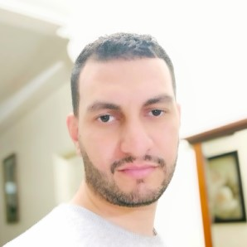 0551403586

 hadid.medamine@gmail.com

Date of Birth : 20/01/1991

Marital Status : Single

Nationality : Algerian

Known Languages : English French and Arabic

|  |  |
| --- | --- |
| **CAREER OBJECTIVE** | Hard-working with proven leadership and organizational skills, and minute attention to detail. Seeking to apply my abilities to fill the internship role in your company. I am a dedicated team player who can be relied upon to help your company achieve its goals. |

**EXPERIENCE Spa condor electronic** *2015 - 2017*

Sales executive

Client welcoming

Sales

Invoices

And stock control

**SARL agility logistics** *may2018 - December 2018*

Inventory controller/ transport coordinator

Cycle count

Segregation

Warehouse operations ERP system using

**SARL aramex** *April 2018 - Sep 2019*

Customer service executive senior

Outlook using

Replying client

Inform client about all the tasks and operations at the warehouse

Inbound and outbound process on system ERP

Warehouse operations

Cycle count

Segregation and team manage

**Spa ontex can hygiene** *Sep 2019 - Mar 2020*

Warehouse operations supervisor

Team manager

Cycle count

Segregation

Inbound and outbound operations

|  |  |
| --- | --- |
| **University of Algeria**  Communication and journalism  **Edsp Algiers**  Transport and logistics warehousing | 2008-2012 2017 |
| Managing  floor operations inbound and outbound. warehousing operations |  |

**EDUCATION**

**ACTIVITIES** Sports Reading