|  |
| --- |
| Curriculum Vitae |

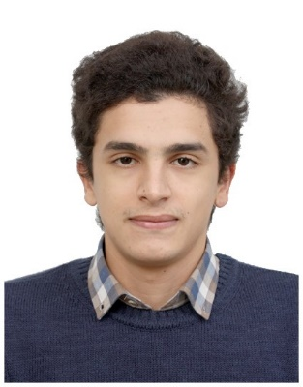

PERSONAL INFORMATION

Name & Age: Hazreche Mouloud, 25.

City of Residence: Bab Ezzouar – Algiers, Algeria.

Mobile n°: (+213)667 – 330 – 335

E-mail: Hazreche.m@gmail.com

Driver’s License: Available.

PROFILE

A diligent Corporate Finance graduate, specializing in Management Accounting with relevant professional experience obtained during an internship, acquiring valuable insight into the world of financial analytics.

Flexible and industrious, balancing between different competing priorities, having worked part-time for four years in a multitude of domains, the latest and current as an English language trainer.

Aiming to secure a position relevant to my major which will provide a platform to showcase gained skills and knowledge as well as be an opportunity for progression.

|  |
| --- |
| Education |

2014 — 2019 Bachelor’s Degree in Financial Science & Accounting

**University of Algiers 3**

* Major: Corporate Finance.
* Relevant Courses: Corporate Finance, Management Control, Management Accounting.
* Final Year Project: Management Accounting Internship.

2011 — 2014 Baccalaureate in Management, Accounting & Finance

**Abane Ramdan High School**

|  |
| --- |
| Professional Experience |

03/2019 – Current English Trainer

**In-tuition Group** – Said Hamdine, Algiers.

Key Responsibilities:

* Plan, prepare and present rich lessons to different learners of varying ages, based on their needs and level and within the CEFR and Eaquals standards of excellence.
* Track and maintain the progression of assigned classes, write advancement reports.
* Tightly work with the academic team to assess and discuss the curriculums.

08/2018 – 09/2018 Team Leader & Interpreter

**Beumeur Group**, GmbH – Algiers International Airport

Key Responsibilities:

* Establish a bridge of communication between foreign engineers and local workers.
* Act as the team interpreter to translate commands and requests in English.
* Distribute and supervise tasks and duties.

12/2016 – 02/2017 Analytical Accounting Internship

**Sonatrach**, Spa – GPL Division

Worked within the Analytics Department to observe and report.

* Wrote a 50 pages internship report as a final year project.

|  |
| --- |
| Trainings & Certifications |

* Dale Carnegie ® Communication and Leadership Training Certification

**IN-tuition Group** – Said Hamdine, Algiers

* Propell® TOEFL iBT ® Trainer Certification

**Educational Testing Service** – Algiers

* Apprenticeship in Baking and Pastry

**El Gato Bakery** – Dar El Beida

|  |
| --- |
| Skills & Interests |

* Spoken Languages: English (**Fluent**), French (**Semi-Fluent**), and Arabic (**Native**).
* Online trainings: PHP Basics, JavaScript Basics, HTML5 & CSS3.
* Software Mastery: Adobe Photoshop, Adobe Illustrator, Adobe Premier Pro, MS Office Suit.
* Other Skills: Web Design, Graphics Design, Advanced IT knowledge.
* Interests; Hiking, Wild camping, Natural sight-seeing, Web and graphics design, Baking and gourmet cuisine.

