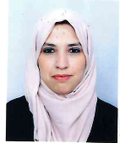

Bachelor's degree in English from Algiers University 2.

20112014

Master’s Degree in English from Algiers University 2.

20142016

Import / Export assistant training at Almas (Aviation Training Institute in Algeria).

2017

2018

**EDUCATION**

**2018**

**MAYA HERIDA**

**CONTACT**

heridamaya@yahoo.fr

🖂

(+213) 551 01 87 42

🕿

Algiers, Algeria

🏠

**SKILLS**

Microsoft Word

Powerpoint

Excel

**WORK EXPERIENCE**

**LANGUAGES**

Full time English teacher at Berlitz.

2018

2019

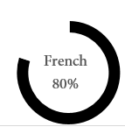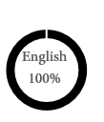

-Charged with International Relations at an import company) for two years (02), tasks were: maintaining a good contact between the provider and the management as well as different kinds of department. In addition to Placing orders and follow them up to the reception. wor

2016

2018

