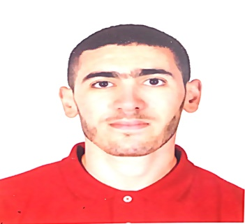**PERSONAL DETAILS**

Merouane GUEDADA

Marital Status: single.

Date of birth: 04/08/1993.

Nationality: Algerian.

Home address: lot idrissi n°17 bouzareah Algiers.

Mobile: 0558 507 442.

Passeport : N° 132127597

E-mail: [merouane9@outlook.com](mailto:merouane9@outlook.com) .

**EMPLOYMENT HISTORY**

**Start date: 08-11-2017**

Job: site engineer at HUAWEI TELECOMMUNICATIONS ALGERIA

(AT FTTX Modernization Project)

Technical follow-up of FTTX optical fiber project works

Coordination of works sub-contractor owner

Design change support in region of AT FTTx project

OSS data follow-up and troubleshooting in west region of AT FTTx project

**EDUCATION**

**Sept 2011-jun 2012** petit bois high school bouzareah:

A-levels in mathematic.

**September 2012** Certificate of Completion in Computer Science.

**Sept 2012-jun2013** first year core curriculum in mathematics and computer science at faculty of science M’hamed bouguera’s university. Boumerdes.

**Sept 2013-jun 2014** blocked year.

**Sept 2014-jun 2015** second year specialization in financial mathematics.

faculty of science, M’hamed bouguera’s university. Boumerdes

Graduation year:

Started: **2016-10-18**  third year specialization in financial mathematics.

faculty of science, M’hamed bouguera’s university. Boumerdes

finished: **2017-07-30** obtaining a bachelor’s degree in financial mathematics.

**LANGUAGES**

Mother tongue: Arabic.

Good oral and written fluency in French.

Good oral and written fluency in English.

**COMPUTER KNOWLEDGE**

Computer literate: word, excel, windows system, power point.

Also programmation software as DEV C++, matlab, camel and databases software as EasyPhp.

FTTX project knowledge (qualified in ODN software as OTDR, power meter)

AutoCAD: electrical engineering (wiring diagrams)

**ADDITIONNAL INFORMATION**

Outside work I have a general interest in martial arts, sports, and cinema. I also enjoy traveling and cooking sometimes.

**PERSONAL QUALITIES**

Strongly motivated.

Reliable.

Work well with others.

Good communicator.

Sense of organization, analysis and listening.

Adaptable and flexible.