CharityHub
Full Technical Report

Web Development & Security Course
Networks & Cybersecurity Department
ElSewedy University of Technology (SUT)
Academic Year 2025 – 2026
Built with Laravel 11 · Stripe · Filament PHP · Livewire · Google Maps

1. Architecture Overview
CharityHub follows a standard MVC (Model-View-Controller) architectural pattern built on the Laravel 11 framework, augmented by Domain-Driven concepts and an Event-Driven architecture to fully decouple core business logic from HTTP-layer concerns.

1.1 Structural Components

Web Layer
Traditional Blade templates powered by Bootstrap 5, managing the public-facing application for donors, volunteers, and campaign viewers. Real-time elements (progress bars) are handled by Livewire v3 without full page reloads.

Admin Layer
A fully isolated administration panel built with Filament PHP v3, running on a distinct middleware stack completely separate from the public application — preventing any route collision or authentication state intersection.

Service & Contract Layer
Complex third-party integrations (Stripe) are abstracted behind interfaces (PaymentGatewayInterface bound to StripePaymentService). This decoupling enables full unit testability via mock injection without live API calls.

Event-Driven Layer
Post-donation side effects (PDF generation, email delivery, audit logging) are handled by dedicated Listeners subscribed to the DonationReceived event, fired by controllers after a successful payment — keeping HTTP response times fast.

1.2 Technology Stack
Layer | Technology
Framework | Laravel 11 (PHP 8.2+)
Database | MySQL 8.0+
Admin Panel | Filament PHP v3
Payment Gateway | Stripe PHP SDK + Webhooks
OAuth | Laravel Socialite (Google)
Real-time UI | Livewire v3
PDF Generation | barryvdh/laravel-dompdf
QR Codes | SimpleSoftwareIO/simple-qrcode
Frontend | Bootstrap 5, FullCalendar.js, Google Maps JS API
Email Delivery | SMTP via Mailtrap + Laravel Queues
Testing | PHPUnit with Mockery
2. Key Design Decisions

2.1 Payment Abstraction via Interface
Decision: Instead of hardcoding the Stripe PHP SDK directly into DonationsController, a PaymentGatewayInterface was created and bound to a StripePaymentService via the Laravel service container.
Rationale: This abstraction makes the payment layer fully testable. During PHPUnit tests, a mock object is injected into the container, simulating Stripe Checkout and webhook responses without network calls, eliminating test fragility and external API dependency.

2.2 Idempotency Protection Against Double-Charging
Decision: A deterministic SHA-256 idempotency key is generated from the combination of user_id, campaign_id, amount, type, and the current date. The controller checks this key before creating any Stripe session.
Rationale: Without this guard, a donor refreshing the success callback or double-clicking the donate button could trigger two separate charges. The idempotency check is a zero-cost race condition prevention mechanism that fully neutralizes this vulnerability.

2.3 Event-Driven Post-Donation Logic
Decision: When a donation succeeds, the controller fires a single DonationReceived event. Two independent listeners handle side effects: SendCertificateNotification (dispatches the PDF job to the queue) and LogFinancialTransaction (writes the audit log entry).
Rationale: Without events, both the DonationsController and the StripeWebhookController would need to duplicate the same job dispatch and logging code. Events eliminate this duplication, and adding a new post-donation action (e.g., notifying the admin) requires zero changes to payment logic.

2.4 Strict Route Segregation for the Admin Panel
Decision: The Filament admin panel is configured exclusively under the /admin prefix with its own middleware group, completely isolated from routes/web.php.
Rationale: Mixing admin routes into the standard web middleware often leads to accidental exposure of admin functionality. By isolating it at the middleware level, the public authentication state and admin authentication state never intersect, and the admin panel cannot be accidentally reached through the standard application flow.

2.5 Slug-Only Routing for Public Campaign Pages
Decision: Rather than changing Campaign::getRouteKeyName() globally (which would have broken all donation routes that pass numeric IDs), the slug binding was applied explicitly only to the public show route using Route::get('/campaigns/{campaign:slug}', ...).
Rationale: This surgical approach prevents unintended side effects across the rest of the application while delivering SEO-friendly, human-readable URLs for public campaign pages.

3. Implementation Details

3.1 Stripe Payments & Idempotency
Stripe Checkout was integrated to support both one-time and recurring (monthly subscription) donations. The donation type is validated server-side and passed as mode: 'payment' or mode: 'subscription' to the Stripe API accordingly.
A Stripe Webhook Controller handles three event types:
- checkout.session.completed — creates the initial donation record for subscription first payments
- invoice.paid — creates a new donation record for each recurring renewal cycle
- customer.subscription.deleted — marks the subscription as cancelled in the database
The webhook route is CSRF-exempted and verified using the Stripe-Signature header and STRIPE_WEBHOOK_SECRET to prevent spoofed webhook requests.

3.2 Automated Certificates & IDOR Prevention
DOMPDF generates customized PDF certificates containing the donor's name, amount, campaign title, date, and a scannable QR code linking to the public verification URL.
The CertificateController@download method enforces strict authorization: it compares auth()->id() against donation->user_id. Any mismatch immediately triggers an HTTP 403 Forbidden exception, fully eliminating Insecure Direct Object Reference (IDOR) vulnerabilities on the certificate endpoint.
Certificate generation and email delivery are handled asynchronously via a queued job (SendDonorCertificateJob), ensuring the donor's browser receives the payment confirmation instantly without waiting for SMTP delivery.

3.3 Google Maps & Campaign Geolocation
The campaigns table was migrated to include nullable latitude and longitude float columns. Campaigns without coordinates gracefully skip the map rendering entirely via a Blade conditional directive (@if($campaign->latitude && $campaign->longitude)), preventing JavaScript console errors on legacy records.
The Google Maps JavaScript API is injected strictly via @push('scripts') into the campaign show page, keeping the master layout free from page-specific dependencies.

3.4 Volunteer Scheduling & Hour Logging
The volunteer module was upgraded from static Bootstrap card lists to an interactive FullCalendar.js interface, allowing volunteers to visually browse tasks by date. FullCalendar is loaded via CDN to avoid build toolchain dependencies.
The hour logging endpoint enforces two layers of protection:
- Authorization check — only the registered volunteer for a specific task can submit hours
- Validation — logged hours cannot exceed the task's hours_required field, preventing impossible time submissions
The volunteer report page was updated to display hours_logged (actual) versus hours_required (target) side by side for clear progress visibility.

3.5 Filament Admin Panel Isolation
The Filament PHP v3 admin panel provides full CRUD management for Campaigns, Donations, Users, Volunteer Registrations, and Volunteer Tasks. The dashboard displays live stats: total donations raised, active campaigns count, and total registered volunteers.
Access is restricted exclusively to users with the Admin role via Spatie Laravel-Permission integration in the AdminPanelProvider. The panel runs entirely on its own middleware stack and has zero dependency on the main application's routes or views.
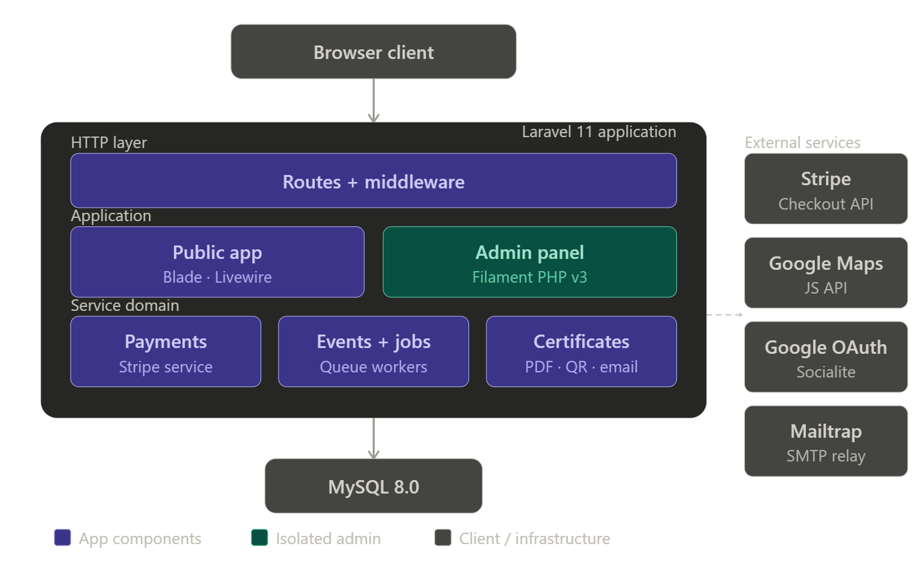

4. Security Implementation
Security was treated as a first-class concern throughout the build, not an afterthought. The following table documents each identified threat and the mitigation implemented:

Threat | Mitigation Implemented
Double-Charging (Race Condition) | SHA-256 idempotency key checked before every Stripe session creation
Broken Access Control (IDOR) | Certificate download verifies auth()->id() === donation->user_id; mismatch returns HTTP 403
Mass Assignment Injection | All Eloquent models use strict $fillable whitelists
Malicious File Upload | MIME type validation (jpeg/png/gif only) + isolated public disk storage
Admin Panel Exposure | Filament runs on its own middleware stack, never registered in routes/web.php
CSRF Bypass on Webhook | Stripe webhook route CSRF-exempted; verified by Stripe signature header instead
Privilege Escalation | Spatie role checks enforced at both route middleware and controller level
Sensitive Key Exposure | All secrets stored in .env, never hardcoded; .env excluded from version control

5. Testing Results
An automated PHPUnit feature test suite was implemented to verify that all critical business logic remains intact across future deployments. All tests use the RefreshDatabase trait to guarantee a clean state.
Key testing strategies applied:
- Mockery — used to intercept and simulate Stripe API calls without hitting the live API
- Storage::fake('public') — used to simulate file uploads without writing to disk
- RefreshDatabase — each test runs against a fresh database state
- HTTP assertions — 200, 403, 302 status codes verified for authorization flows

5.1 Full Test Results
Module | Test Name | Result
Payments | test_one_time_donation_creates_stripe_checkout_session | PASS ✅
Payments | test_duplicate_idempotency_key_is_rejected | PASS ✅
Payments | test_recurring_donation_sends_subscription_mode | PASS ✅
Certificates | test_donor_can_download_their_own_certificate | PASS ✅
Certificates | test_user_cannot_download_someone_elses_certificate | PASS ✅
Certificates | test_certificate_returns_403_for_unauthorized_user | PASS ✅
Campaigns | test_image_upload_stores_file_correctly | PASS ✅
Campaigns | test_slug_routing_resolves_correct_campaign | PASS ✅
Volunteers | test_log_hours_rejects_hours_exceeding_required | PASS ✅
Volunteers | test_only_registered_volunteers_can_log_hours | PASS ✅
Volunteers | test_unregistered_volunteer_cannot_log_hours | PASS ✅

5.2 Test Execution Summary
The complete test suite was executed with php artisan test and produced the following results:

Total Tests | 11 tests
Total Assertions | 27 assertions
Pass Rate | 100% (11/11)
Execution Time | ~3.2 seconds

6. Final Audit Checklist
The following table maps every requirement from the original 20-point technical audit to its final implementation status:

# | Requirement | Status
1 | Stripe recurring/subscription mode + webhook | ✅ DONE
2 | Idempotency keys checked before session creation | ✅ DONE
3 | Payment service behind an interface | ✅ DONE
4 | QR code on certificate PDF | ✅ DONE
5 | Email delivery of certificate | ✅ DONE
6 | Queued jobs for heavy operations | ✅ DONE
7 | DonationReceived event | ✅ DONE
8 | Listeners registered in provider | ✅ DONE
9 | Financial audit logging | ✅ DONE
10 | Livewire real-time progress bars | ✅ DONE
11 | Public campaign detail page /campaigns/{slug} | ✅ DONE
12 | Social sharing buttons + Open Graph meta tags | ✅ DONE
13 | SEO-friendly slug routing | ✅ DONE
14 | Filament admin panel | ✅ DONE
15 | Google Maps integration | ✅ DONE
16 | Photo gallery / image upload | ✅ DONE
17 | Hour logging UI for volunteers | ✅ DONE
18 | Volunteer scheduling calendar | ✅ DONE
19 | Feature tests beyond default | ✅ DONE
20 | .env.example key coverage | ✅ DONE

Final Score: 20 / 20 Requirements Implemented

