
COMPUTER
ENGINEERING

Submitted by:
Amr Edris, 22-101097

Image encryption and Signature
Technical Documentation for Computer Security
Instructors: Dr. Hisham Dahshan, Eng. Shaymaa ElKaliouby

Table of Contents
No table of contents entries found.

1. Introduction

1.1 Project Overview
The objective of this project is to implement and analyze a comprehensive security workflow for image data, focusing on three core pillars of cryptography:
- Confidentiality: Utilizing the AES-128 block cipher across four distinct modes of operation (ECB, CBC, CFB, and OFB) to secure image data.
- Integrity and Authenticity: Implementing a digital signature scheme using RSA-2048 and SHA1 hashing to ensure the encrypted image has not been altered and originates from a verified source.
- Statistical Analysis: Evaluating the quality of encryption using the NIST Randomness Test Suite to quantify how effectively different cipher modes transform structured image data into unpredictable noise.

1.2 Environment Setup
The project was developed and executed in a cloud-based Python environment to ensure reproducibility and high-performance computation.
- Development Platform: Google Colab (Python Notebook) / Oracle Ubuntu Virtual Machine.
- Core Libraries:
  - PyCryptodome: Used for all cryptographic operations, including AES encryption, RSA key generation, and SHA1 hashing.
  - Pillow: Utilized for rendering and displaying the BMP images within the notebook environment, handling the specific challenges of displaying encrypted binary data.
  - NIST Statistical Test Suite (STS): Deployed within a Virtual Machine to perform rigorous randomness testing on the resulting ciphertexts.

2. Task 1: Image Encryption (AES-128)

2.1 Plaintext Selection and Preparation
For this task, the original plaintext file is an image of a cat wearing a sombrero hat.

To demonstrate the visual effects of different encryption modes, the image was converted to a 24-bit Bitmap (BMP) format.
The choice of BMP is critical because it is an uncompressed format with a predictable 54-byte header. By isolating this header and only encrypting the raw pixel data, the resulting file remains a valid image that can be opened by standard viewing programs, allowing us to "see" the encryption.

Step 1: Reading the Image and Splitting the Header
The image was read as raw binary data. The first 54 bytes were stored as the header, and the remaining bytes were isolated as the pixels for encryption.
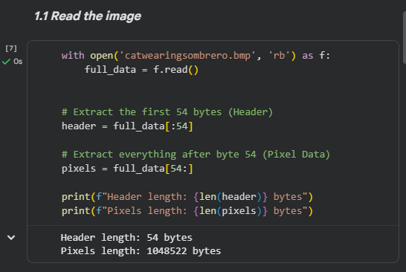

To satisfy the block size requirements of AES, padding was implemented to bring the plaintext data to the nearest 16-byte multiple.
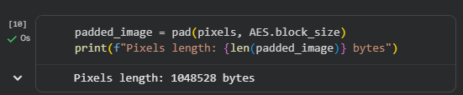
Increased by 6 bytes

2.2 Key and IV Generation
A 128-bit symmetric key was generated to perform the encryption. To maximize security, I created a distinct 128-bit Initialization Vector (IV) for each mode (CBC, CFB, and OFB). By using a unique IV for every operation, I ensured that the patterns in the plaintext were scrambled differently in each mode, preventing any overlapping data patterns.
Key:
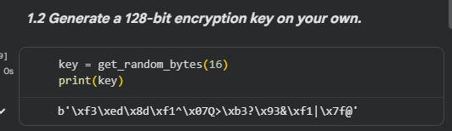
CBC IV:
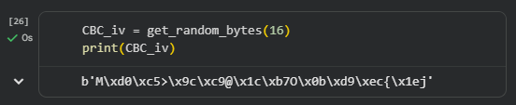

The same method was used to generate the other keys for CFB, and OFB

2.3 Implementation of AES Modes
AES-128 was applied to the pixel data using four distinct modes of operation: ECB, CBC, CFB, and OFB.
Encryption Execution
For each mode, a new AES cipher object was created. For ECB, only the key was used, while the other modes utilized the generated IV. After encryption, the original 54-byte header was prepended to the ciphertext, and the resulting bytes were saved as a new .bmp file.
for ECB
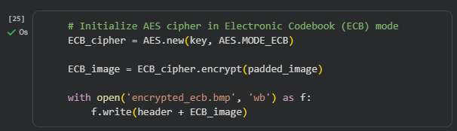

For other modes that needed an IV (CBC for example)
This is also applied for CFB and OFB
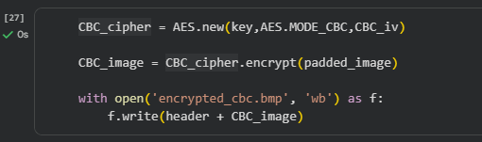

2.4 Results and Visual Comparison and Observations
After saving the files, I used the Pillow library to display the results. Due to the addition of padding bytes, the files were slightly larger than the original, leading to a "truncated image" warning in some viewers. This was resolved by setting ImageFile.LOAD_TRUNCATED_IMAGES = True.
Observation: The black bar at the top of the encrypted images is a result of AES padding. They shifted the image data out of its original alignment. BMP files require every row to be perfectly aligned to a 4-byte "stride." This small shift caused the image viewer to misread the start of every row, eventually "running out" of data at the top. The viewer fills this empty space with zeros, which appear as black pixels.

ECB
 | 

Observation: Even after encryption, the structures and patterns of the original image remain clearly visible. This demonstrates the primary weakness of ECB mode: it encrypts identical plaintext blocks into identical ciphertext blocks. Because it lacks chaining or an IV, it fails to provide adequate data diffusion, leaking significant visual information.

CBC
 | 

CFB
 | 

OFB
 | 

Observation: Unlike ECB, these modes produce a completely randomized output with no visible structures, proving that the use of an Initialization Vector (IV) and chaining mechanisms successfully provides high data diffusion and hides all patterns within the original image.

3. Task 2: Digital Signature (RSA & SHA1)

3.1 RSA Key Pair Generation
To implement the signature, I generated an RSA-2048 key pair. This asymmetric approach provides two distinct keys:
- Private Key (d, n): Kept secret by the sender (Alice). It is used to generate the digital signature.
- Public Key (e, n): Shared openly. It allows the receiver (Bob) to verify that the signature was created by the corresponding private key.
A 2048-bit key length was chosen as it currently provides a strong balance between computational efficiency and security against brute-force attacks.
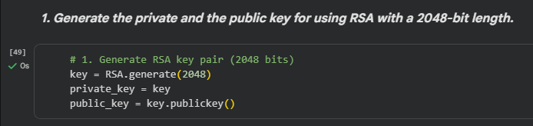

3.2 Hashing the Ciphertext
Before signing, the CBC-encrypted image from Task 1 was processed through the SHA-1 (Secure Hash Algorithm 1).
- Purpose: This creates a 160-bit "digital fingerprint" or message digest of the encrypted data.
- Integrity: SHA-1 is highly sensitive; even a single-bit change in the ciphertext would result in a completely different hash value, ensuring that any tampering is immediately detectable during verification.
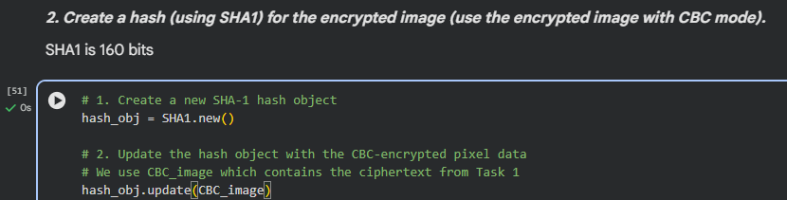
3.3 Signing and Verification Process
Signing the "Fingerprint" Not the Image
In this implementation, the RSA private key is used to sign the hash (fingerprint) rather than the entire image file.
- Efficiency: Signing a small 160-bit hash is significantly faster than performing RSA exponentiation on a large image file.
- Security: This method is mathematically just as secure as signing the whole file. Because the hash is unique to the image, the signature is effectively bound to the data. If the image is altered, the hash changes, and the original signature will no longer match.

The Role of the Private Key:
The signature (S) is created using the private key (d) and the hash (M) through the mathematical operation:
$$S=M^{d} mod n$$
This "seals" the fingerprint with the sender's identity.
The Mathematical Verification:
The receiver uses the Public Key (e, n) to "unlock" the signature and recover the original hash (M'):
$$M^{'}=S^{e} mod n$$
The system then compares this recovered hash (M') with a locally calculated hash of the received image.
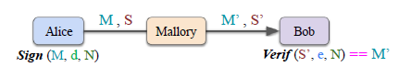
Code
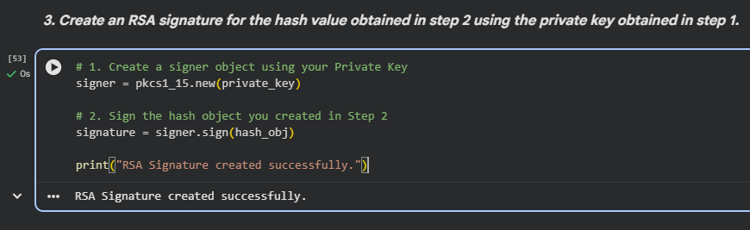
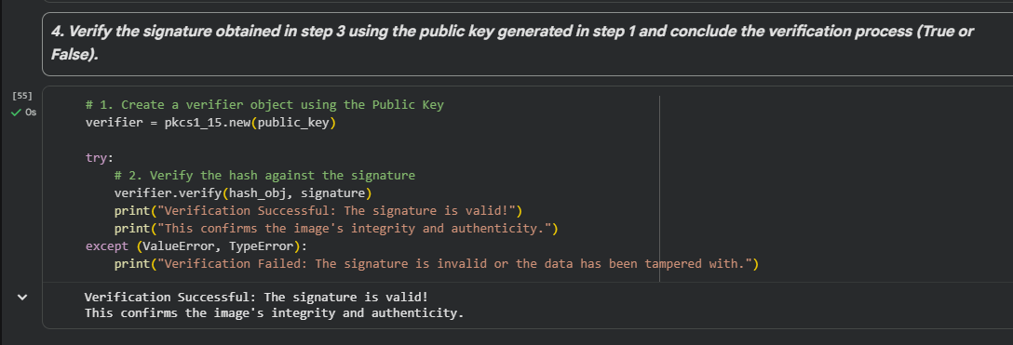

The verification was performed using the pkcs1_15 standard. The process resulted in a Success/True output, confirming two critical security properties:
- Authenticity: The signature could only have been created by the holder of the private key.
- Integrity: The encrypted image remained unchanged during the process.

4. Task 3: Statistical Randomness Analysis
- 4.1 NIST Test Suite Setup: How the suite was configured in the VM.
- 4.2 Test Execution on Original vs. Encrypted Data: Presentation of the p-values for all modes.
- 4.3 Comparative Analysis:
  - Which mode achieved the highest randomness?
  - Why did the original image fail the tests?

5. Interesting and Surprising Observations
- Note: This is a specific requirement in your prompt.
- Discuss the Header Mismatch/Truncation issue we encountered.
- Discuss how encryption affects file size.
- Any unexpected NIST test failures.

6. Conclusion
- Summary of how the three tasks combine to create a secure system for image transmission.

