
GameMetrics
Data-driven insights for successful launches.

Team Members:
Kareem Abdulmajeed Mohamed (223101278)
Fares Mohamed Elsaeed (223101266)
Amr Nader Mohamed (223101261)

Course: Software Engineering
Teaching Assistant: Eng. Ahmed Elshenawy
Supervisor: Dr. Waleed Mohamed
Overview
An end-to-end system built to classify new games made by developers or publishers on whether they will be great viral hits or not. Each game is classified by a Machine Learning model based on features such as:
- Price (in GBP)
- Genres
- English Support
- Platforms (Windows, Mac, or Linux)
Additionally, three extra features are predicted using a Large Language Model trained specifically on predicting the following three features:
- Hype Score (how interesting the game is at first look of the description)
- Story Score (whether there’s a proper story or not)
- Nostalgia Score (if the game is unique and memorable or cliché and forgettable)
The system integrates these two models into a Python backend with a Web frontend to allow developers and publishers alike to search for games in the database or to test out their un-released games against the models.

Functional Requirements
- The system must be a website.
- The website must allow users to add metadata information of their un-released games.
- The website must contain a general database of Games (mainly Steam Games) that’s searchable by different attributes.
- The website must contain a tool “Successful Game Predictor” for intelligently predicting whether a game from its price, genres, English support availability, and platforms will be a successful game or not.
- The “Successful Game Predictor” could recommend similar games to the one tested on the models by comparing genres and prices of similar games.
- The website should contain another tool “Game Description Analyzer” that takes the game’s initial description as input and provides scores such as whether it’s hype, contains a good story, and is memorable or not.
- The “Game Description Analyzer” could recommend games with similar descriptions based on their scores in the database as well.
- A new user must create a new account if they want to use the prediction tools through a sign-up page.
- Users can log in into their accounts through a log in page.

Non-functional Requirements
- The website must implement industry-standard security protocols, including secure password hashing (e.g., bcrypt) for user accounts, HTTPS encryption for data.
- The website must guarantee an uptime of at least 99%, ensuring constant access to the database and prediction APIs.
- The website must feature a user interface that adapts seamlessly to desktop, tablet, and mobile web browsers.
- The backend must be capable of maintaining optimal tool inference speeds while simultaneously handling up to 10,000 concurrent logged-in users.

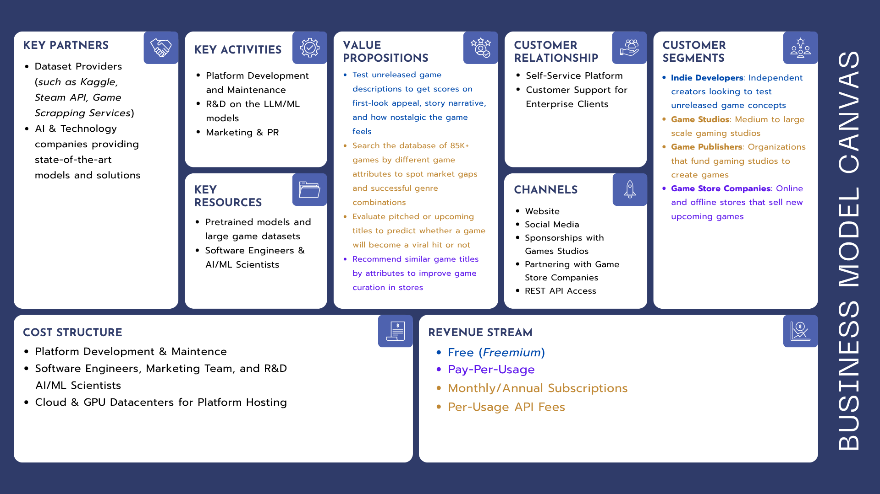
Business Model Canvas
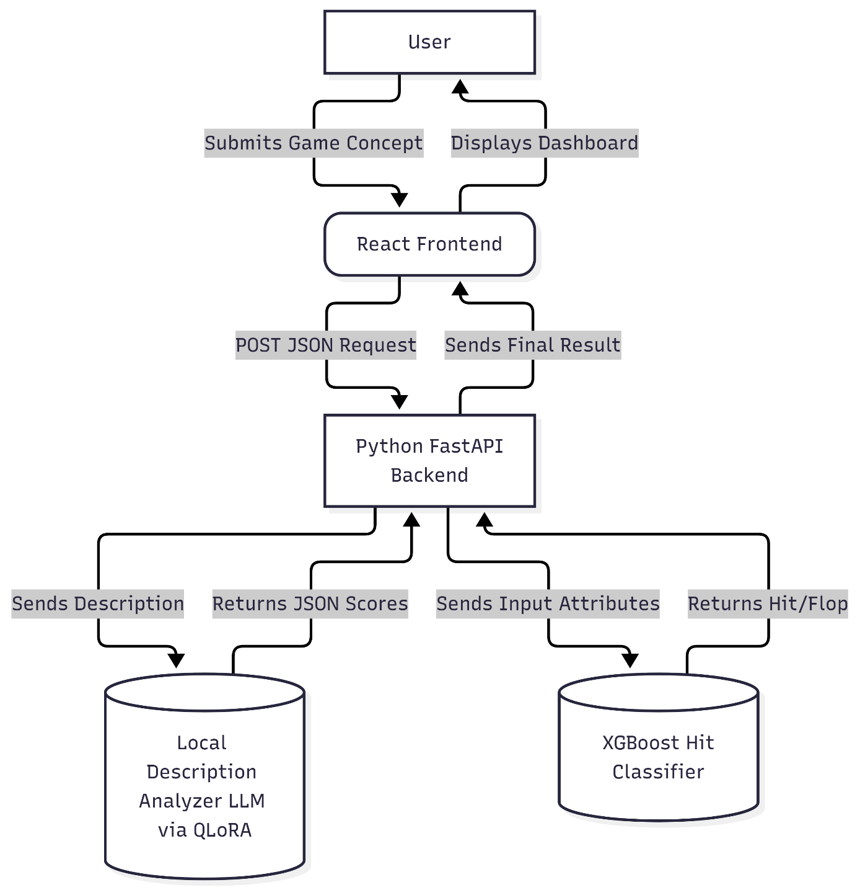
Architecture Diagram

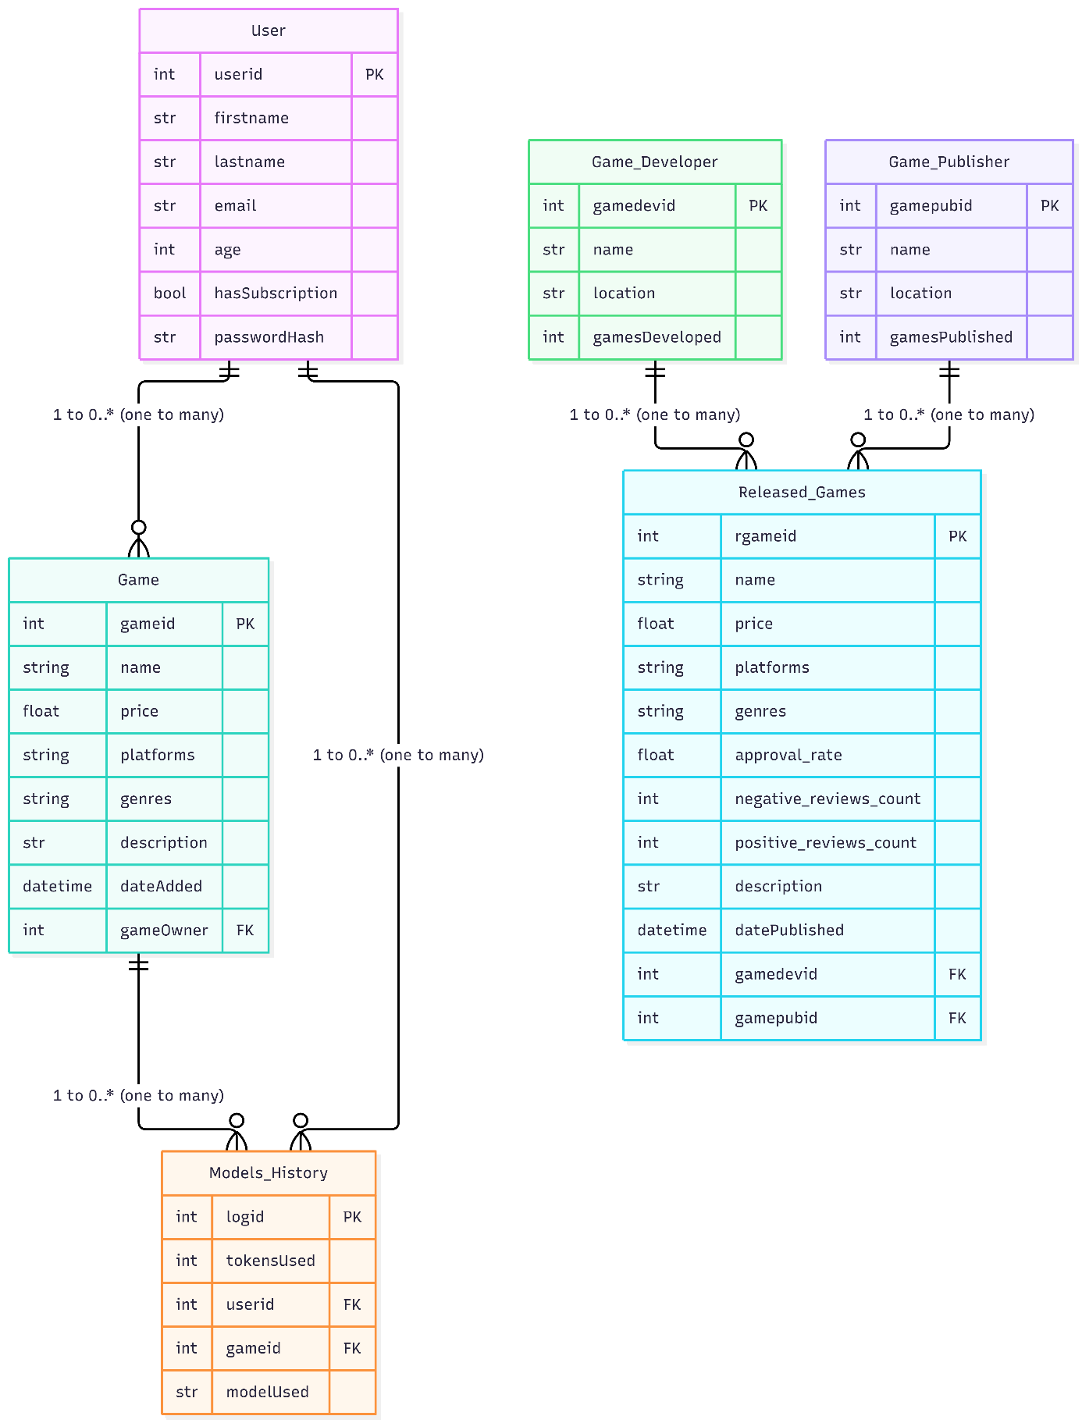
1. Entity Relationship Diagram
2. Use Case Diagram
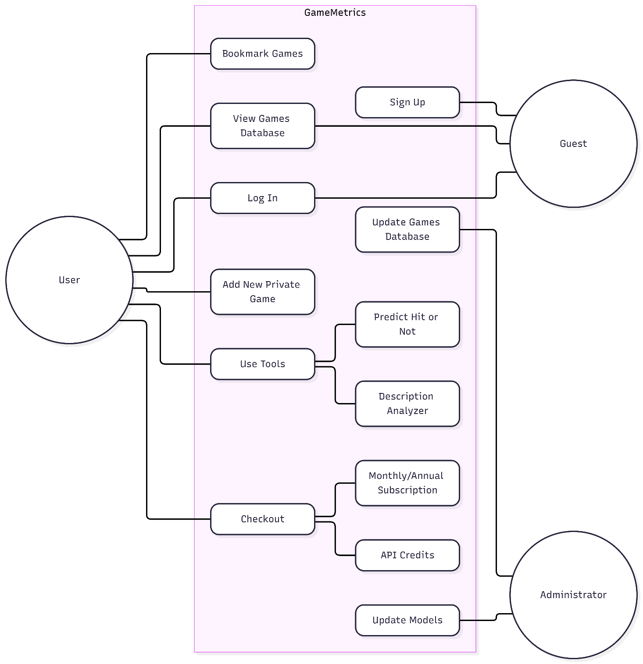

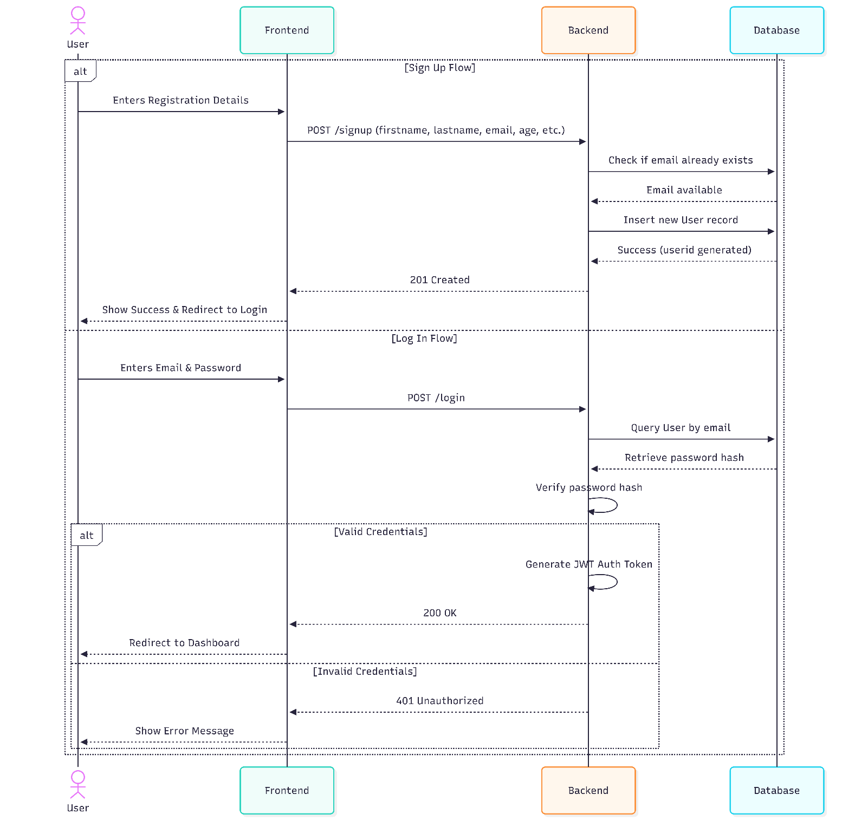
3. Sequence Diagram 1 (Login & Sign Up)

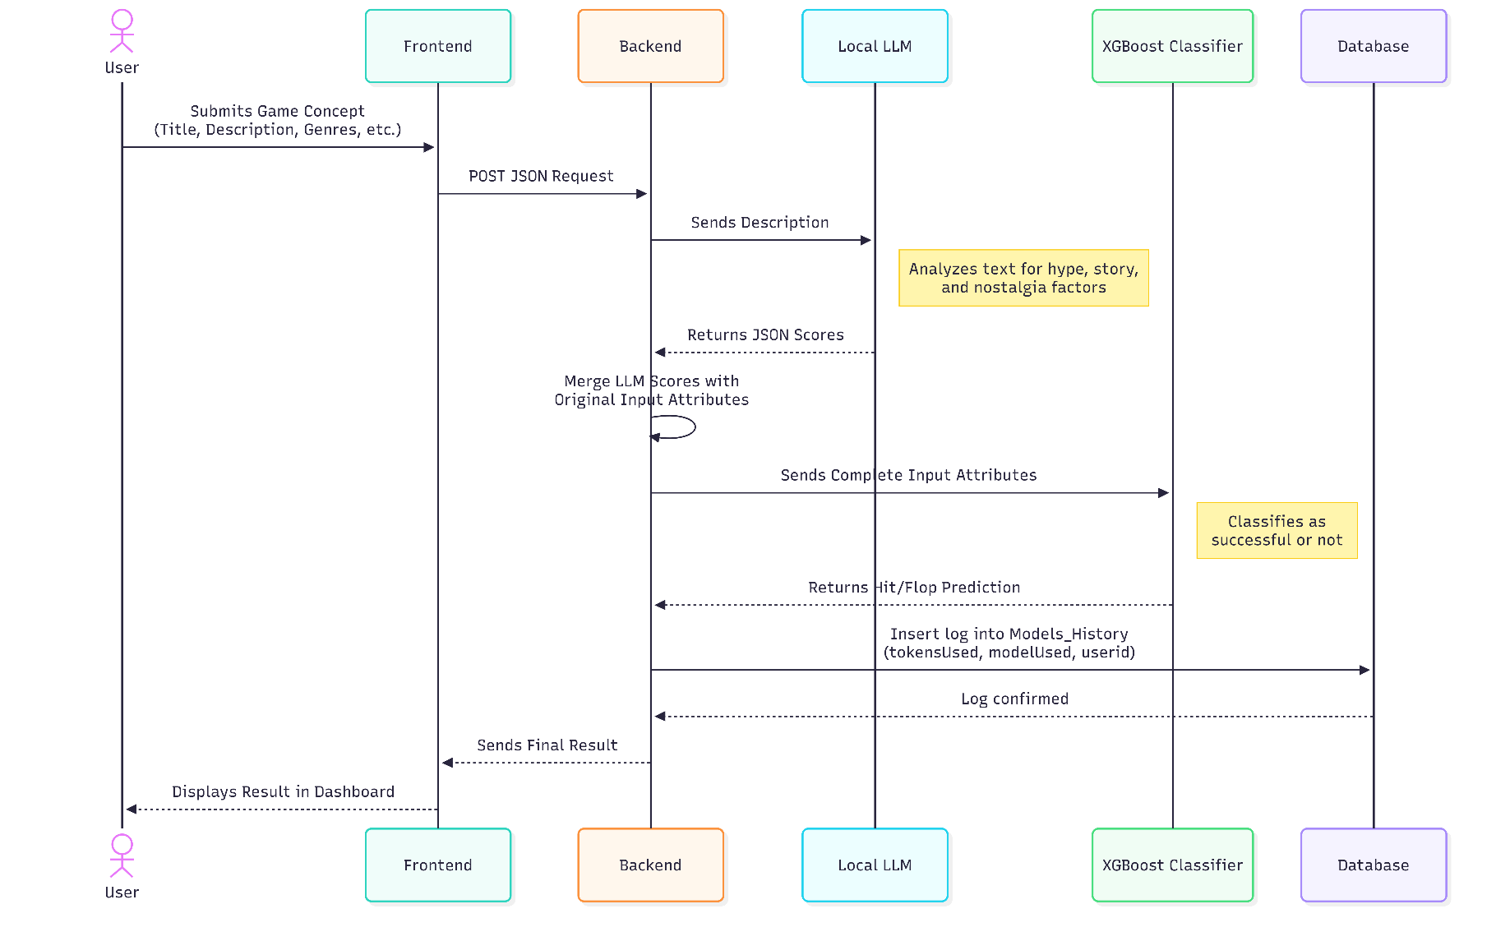
4. Sequence Diagram 2 (Models Usage)
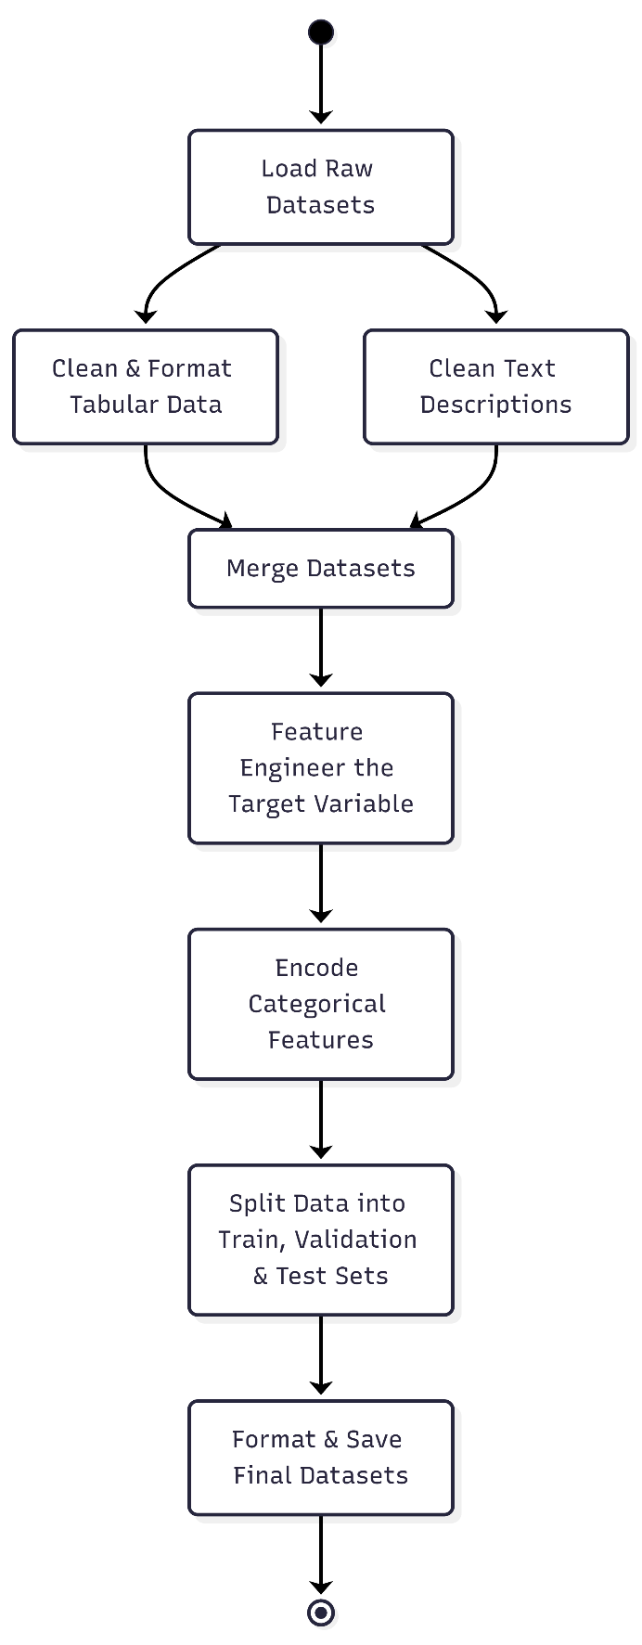
5. Flowchart

