**1- Basic Filtering:**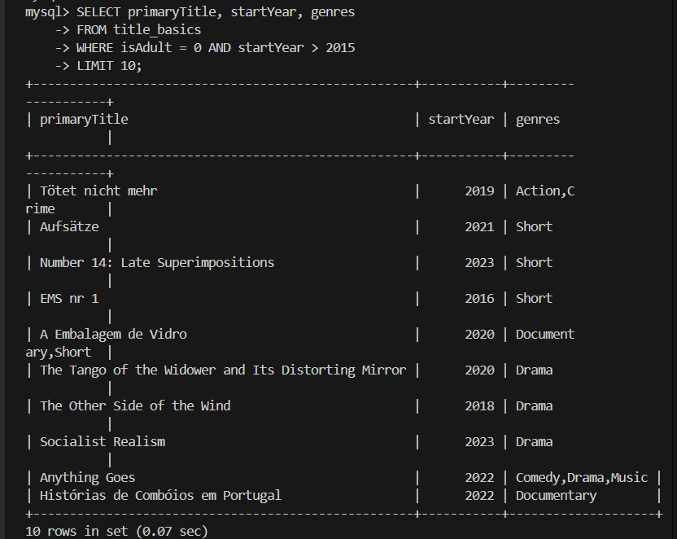

**2- Sorting:**

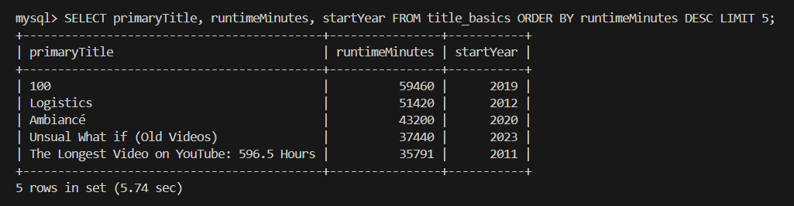

**3- Aggregate Functions:**

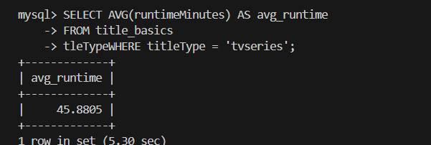

**4- Genre Analysis:**

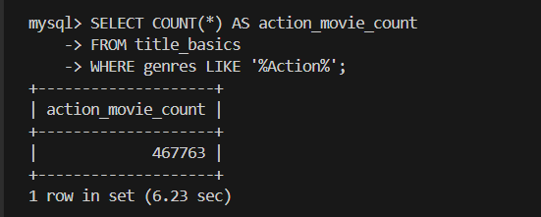

**5- Run Queries for name.basics:**

**1- Simple Selection**

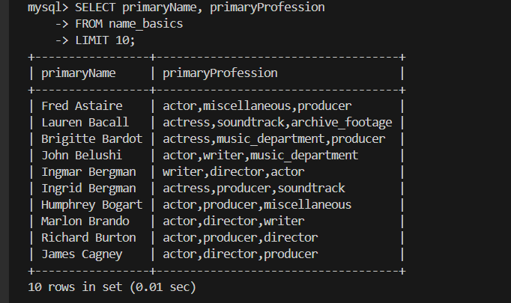

**2- Filtering by Year:**

**(the output is so long I cant take a screenshot for it):**

SELECT primaryName, birthYear

FROM name_basics

WHERE birthYear < 1950;

**3- Handling NULL Values:**

**(The output is too long too)**

SELECT primaryName, birthYear

FROM name_basics

WHERE deathYear IS NULL;

**4- Analyzing Professions:**

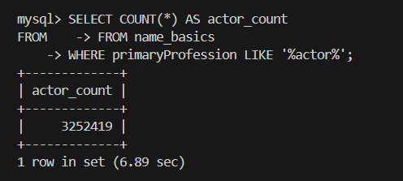

**5- Tasks Combining title.basics and name.basics**

**Known Titles**

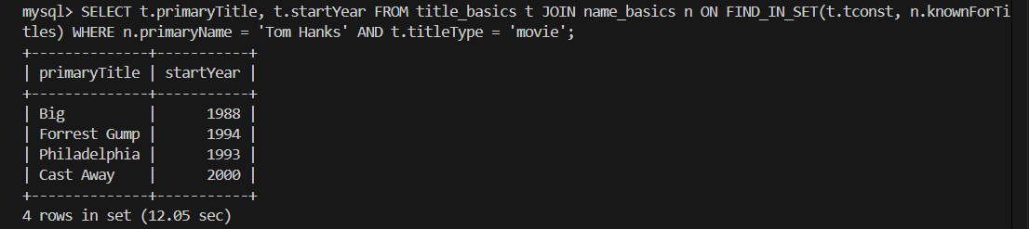

**6- Longest Known Titles:**

My laptop didn’t handle the pressure for this query.

SELECT t.primaryTitle, t.runtimeMinutes

FROM title_basics t

JOIN name_basics n ON FIND_IN_SET(t.tconst, n.knownForTitles)

WHERE t.runtimeMinutes IS NOT NULL

ORDER BY t.runtimeMinutes DESC

LIMIT 5;