SMART SERVICE: AN AI-ASSISTED MOBILE APPLICATION FOR CONNECTING CUSTOMERS WITH SERVICE PROVIDERS

Senior Project
by

Mira Youssef, 72030174
Hussein Mansour, 42030321

Submitted to the School of Engineering of the
Lebanese International University
Beirut, Lebanon
in partial fulfillment of the requirements for the degree of

BACHELOR OF SCIENCE IN COMPUTER AND COMMUNICATION ENGINEERING
Fall 2026-2027

Approved by:
Supervisor

Dr. Hussein Nasrallah

Committee Member

Dr. TBA

DEDICATION

To our families and friends, whose continuous support, patience, and encouragement made this work possible. Their belief in us provided the motivation to overcome challenges and move forward throughout this project.
We also dedicate this work to everyone who uses technology to improve access to trusted local services, hoping that Smart Service contributes to safer, faster, and more transparent service experiences.

Hussein Mansour, Mira Youssef

ACKNOWLEDGMENT

We express our sincere gratitude to our supervisor, Dr. Hussein Nasrallah, for his guidance, constructive observations, and continued encouragement throughout the development of this graduation project. We also thank the faculty members of the School of Engineering at the Lebanese International University for the technical foundation and academic discipline that supported this work. Finally, we acknowledge our families and colleagues for their patience, feedback, and motivation during the design, implementation, testing, and documentation of Smart Service.
ABSTRACT

Smart Service is a cross-platform mobile application designed to connect customers with nearby household-service providers in a structured, secure, and transparent manner. The system supports customer and service-provider roles, JWT-based authentication, provider service and availability management, GPS-assisted discovery, request assignment, real-time request updates, service-lifecycle tracking, optional request images, and customer ratings. Explainable rule-based analysis classifies request priority and generates preliminary price and duration estimates without replacing the customer's provider-selection decision or the provider's final assessment. The mobile client is built with React Native and Expo, while the server uses Node.js, Express, MongoDB Atlas, Mongoose, and Socket.IO. Geographic coordinates are stored as GeoJSON points and used for distance-based provider discovery. The resulting prototype demonstrates an integrated architecture for managing the complete service-request workflow while protecting account credentials and limiting sensitive location disclosure. The project provides a practical foundation for later work on broader service categories, deployment-scale evaluation, and additional communication features.
TABLE OF CONTENTS

Mira Youssef, 72030174 2
CHAPTER 1 INTRODUCTION 8
1.1 Background 8
1.2 Problem Statement 9
1.3 General overview of the project 10
1.4 Thesis Outline 11
CHAPTER 2 Survey of Existing Methods and Similar Systems 13
2.1 Introduction 13
2.2 System 1: Taskrabbit 13
2.3 System 2: Angi 14
2.4 System 3: Urban Company 15
2.5 Systems Comparison 15
2.6 Conclusion and Motivation 1
CHAPTER 3 System Design 3
3.1 Introduction 3
3.2 Requirements and Specification Analysis 3
3.2.1 Functional Requirements 3
3.2.2 Use Case Diagrams 3
3.3 System Architecture 3
3.4 Class Diagrams 4
3.5 Sequence Diagrams 4
3.6 Activity Diagrams 5
3.7 Entity-Relationship (ER) Diagrams 5
3.8 Non-Technical Aspects 5
3.8.1 Financial Viability 5
3.8.2 Stakeholders 6
3.8.3 Scope 6
3.8.4 Risks 6
3.8.5 Schedule and Milestones 6
3.8.6 Ethical and Social Considerations 7
3.8.7 Environmental and Sustainability Considerations 7
3.8.8 Relevant Standards 7
3.9 Conclusion 7
CHAPTER 4 Implementation/Simulation and Testing 8
4.1 Introduction 8
4.2 Implementation Tools 8
4.3 Implementation Summary 8
4.4 Test Cases and Acceptance Criteria 8
4.5 Conclusion 8
CHAPTER 5 Conclusion and Future Work 9
5.1 Conclusion 9
5.2 Future Work 9

LIST OF FIGURES

Figure ‎3-1- System Architecture 4
Figure ‎3-2- Cost Benefit Analysis 6
Figure ‎3-3- Scheduling Tasks and Milestones 7
LIST OF TABLES

Table 2-1 Comparison based on graphical interface and usability 16
Table 2-2 Comparison based on content and functionality 17
Table 2-3 Comparison based on core features 1

LIST OF SYMBOLS

AI : Artificial Intelligence
API : Application Programming Interface
DB : Database
ERD : Entity–Relationship Diagram
GPS : Global Positioning System
HTTP : Hypertext Transfer Protocol
JWT : JSON Web Token
LIU : Lebanese International University
REST : Representational State Transfer
UI : User Interface
UML : Unified Modeling Language
URL : Uniform Resource Locator

INTRODUCTION

Background
Mobile service marketplaces reduce the effort required to identify, compare, and contact service providers who offer work at a customer’s location. Instead of relying only on informal recommendations, customers can describe their needs through structured digital platforms and review relevant information about available providers. Effective service discovery depends on several factors, including provider skills, availability, service categories, pricing information, geographic location, and customer feedback.
A modern service marketplace requires a reliable mobile architecture capable of supporting multiple user roles and providing a consistent experience across different devices. Cross-platform development frameworks such as React Native allow developers to create mobile applications using reusable React components while targeting multiple platforms [3]. Frameworks such as Expo provide access to device capabilities, including location services, which are essential for applications that rely on geographic context [4].
Location-aware service discovery also requires efficient geographic data representation and processing. GeoJSON provides a standardized format for representing geographic information through coordinate-based data [5]. Database systems such as MongoDB support geographic queries and indexing mechanisms that enable proximity-based searches between users and service providers [6]. These capabilities allow service platforms to improve matching accuracy by considering the location of both customers and providers.
Since service marketplaces involve interactions between different users and handle sensitive information, security and trust are important considerations. Authentication mechanisms, role-based access control, and controlled request workflows help ensure reliable communication between customers and service providers. Technologies such as JSON Web Tokens (JWT) provide a standardized method for representing authentication information between clients and servers [7], while secure password-hashing techniques help protect stored user credentials [8].
Beyond basic service matching, intelligent assistance can improve the decision-making process during service requests. Smart Service introduces AI-assisted features that analyze customer descriptions to provide an initial indication of request priority and service estimation using explainable rule-based methods. These features aim to support users while maintaining human control over final decisions, as the system does not replace professional inspection, automatically assign providers, or determine final service prices.

Problem Statement
Customers requiring household maintenance services, such as electrical work, plumbing, or air-conditioning repair, often face difficulties in identifying reliable and available service providers. Existing approaches may provide fragmented information about provider availability, offered services, location, and previous customer experiences, making the selection process inefficient. A simple directory of providers does not represent the operational status of service requests, while direct communication alone does not ensure a reliable workflow from request creation to service completion. Established service marketplaces show that provider profiles, customer reviews, pricing information, and location context are important parts of service selection [1], [2], [13].
Service providers also face challenges in efficiently presenting their available services, managing their availability, and receiving relevant requests from potential customers. Without a structured platform, providers may receive unsuitable requests or lack a clear mechanism for managing accepted and rejected service opportunities.

Therefore, the main challenge addressed by this project is the design and development of a role-aware mobile platform that establishes a structured and transparent connection between customers and eligible nearby service providers. The system must support location-based discovery, maintain controlled request states, preserve customer choice, and ensure that both users can follow the progress of a service request through a reliable workflow. GeoJSON and MongoDB geospatial indexing provide a standardized technical basis for proximity-aware discovery [5], [6].
Another challenge is the interpretation of customer-provided descriptions, which may vary in language, detail, and urgency. A maintenance request describing a critical issue should be distinguishable from a routine request, while any automated analysis should remain transparent and should not replace professional evaluation. Therefore, the system requires an explainable approach that assists users by providing preliminary information while keeping final decisions under human control.
Smart Service addresses these challenges by providing an integrated mobile application that combines service discovery, provider interaction, request lifecycle management, location-based matching, and explainable AI-assisted analysis within a unified workflow.

General overview of the project
Smart Service is an AI-assisted mobile application designed to connect customers requiring household maintenance services with nearby service providers. The system supports two main user roles: customers and service providers, allowing both parties to interact through a structured service-request workflow.
Customers can create service requests by selecting the required service category, describing the issue, optionally providing additional information, and sharing their location. The system uses this information to identify suitable providers based on service requirements and geographic proximity, while allowing customers to make the final selection.
Service providers can create profiles by specifying their offered services, availability, and location information. They can receive relevant requests, decide whether to accept or reject them, and update the progress of accepted services through a controlled workflow until completion.
The system also includes AI-assisted analysis modules that process customer descriptions to provide preliminary information about request priority and expected service characteristics. These features are designed to support decision-making through transparent analysis while preserving human control over the final service decisions.
The proposed platform integrates a mobile application, backend services, database management, location-based matching, request lifecycle management, provider interaction, and feedback mechanisms into a unified service marketplace workflow.

Thesis Outline
This report is organized into five chapters covering the background, related systems, design, implementation, and evaluation of the proposed Smart Service platform.
Chapter 1 introduces the service marketplace problem, explains the motivation behind developing Smart Service, presents the general overview of the proposed system, and defines the project scope and objectives.
Chapter 2 presents a survey of existing service marketplace systems and related approaches. It reviews similar platforms, analyzes their main characteristics, compares their capabilities with the proposed solution, and identifies the motivation for developing Smart Service.
Chapter 3 describes the system design of the proposed platform. It presents the system requirements, functional specifications, architecture, design diagrams, data model, and other design considerations related to the development of the system.
Chapter 4 presents the implementation of Smart Service. It explains the technologies used, development process, implementation of the mobile application, backend services, database integration, AI-assisted analysis modules, and the main user interfaces of the developed system.
Chapter 5 concludes the report by summarizing the achieved objectives, discussing the results and limitations of the project, and presenting possible future improvements and extensions.

Survey of Existing Methods and Similar Systems

Introduction
This chapter presents a survey of existing home-service marketplace platforms to identify common approaches, available features, and potential limitations in current solutions. The purpose of this review is to understand how existing systems address service discovery, provider selection, location-based matching, user interaction, and service management.
Three established platforms are examined: Taskrabbit, Angi, and Urban Company. These systems are analyzed based on their documented features and workflows to identify the capabilities commonly provided by service marketplace applications.
The reviewed systems are compared with Smart Service based on relevant criteria, including usability, functionality, service discovery methods, provider interaction, and additional decision-support features. The comparison helps identify existing limitations and motivates the design choices adopted in the proposed platform.

System 1: Taskrabbit
Taskrabbit is a service marketplace platform that connects customers with independent service providers across different categories. The platform allows customers to select a service category, provide task details and location information, review available provider profiles, compare relevant information such as skills, experience, hourly rates, and customer reviews, and select a suitable provider [1].
The platform focuses on customer-driven provider selection by allowing users to evaluate available providers before requesting a service. Providers can define their skills, service areas, availability, and other profile information, helping customers make more informed decisions when selecting a suitable professional [9][10].
Taskrabbit demonstrates several important characteristics of service marketplace applications, including provider discovery, profile-based selection, location awareness, pricing information, and customer feedback mechanisms. However, the reviewed materials do not establish features equivalent to Smart Service’s explainable bilingual request prioritization or rule-based preliminary service estimation from customer descriptions [11].

System 2: Angi
Angi is a home-service marketplace platform that helps customers find, research, and hire professionals for different home improvement and maintenance services. The platform supports professional discovery, service research, cost information, quote requests, and customer reviews to assist users in selecting suitable service providers [2].
Angi focuses on connecting customers with professionals by providing access to service information, provider details, and pricing-related guidance. The platform supports a broader home-improvement context by covering various types of projects and professional services.
Angi demonstrates important features of service marketplace platforms, including professional search, customer reviews, service information, and cost-related assistance. However, the reviewed materials do not establish some of the specific features implemented in Smart Service, such as explicit provider acceptance and rejection states, deterministic request-priority analysis, or a controlled service-request lifecycle [2].

System 3: Urban Company
Urban Company is a technology-enabled home-services marketplace that connects customers with service professionals for at-home services. The platform focuses on enabling professionals to deliver services while emphasizing service quality, professional preparation, customer satisfaction, and reliable fulfillment [13].
The platform follows a more managed-service approach, where platform processes contribute to maintaining service standards and improving customer trust. Its features include professional enablement, service quality mechanisms, ratings, and fulfillment management.
Urban Company demonstrates the importance of provider quality management and customer trust within service marketplace applications. However, the reviewed information does not establish some of the specific capabilities implemented in Smart Service, such as explainable bilingual request prioritization, customer-controlled nearby-provider selection, or the use of optional request images for service analysis.

Systems Comparison
The reviewed platforms demonstrate different approaches to connecting customers with service providers. To identify the strengths and limitations of existing solutions, the selected systems are compared with Smart Service based on usability, functionality, service discovery methods, provider interaction, and additional decision-support capabilities.
The comparison focuses on documented features of the reviewed platforms and the implemented capabilities of Smart Service. Commercial systems are evaluated only according to publicly available information, while Smart Service features are based on the developed prototype.
Table 2-1 presents a comparison based on graphical interface and usability aspects, including mobile-oriented workflows, provider information visibility, role-specific navigation, and user interaction features.
Table 2-2 compares the systems based on content and functionality, including service discovery, location support, pricing information, reviews, and provider workflows.
Table 2-3 presents a comparison of core features that are directly related to the objectives of Smart Service, such as GPS-based provider matching, request lifecycle management, optional problem images, explainable priority analysis, and preliminary service estimation.
The comparison shows that existing platforms successfully address important aspects of service discovery and provider interaction. However, Smart Service focuses on combining several additional capabilities into one workflow, including customer-controlled provider selection, location-based filtering, controlled request states, and explainable AI-assisted analysis.
These differences motivate the development of Smart Service as an academic prototype that explores a transparent and structured approach to connecting customers with nearby service providers while maintaining human control over service decisions.
Table 2-1. Comparison based on graphical interface and usability.
Criterion | Task rabbit | Angi | Urban Company | Smart Service
Mobile-oriented service flow | ✔ | ✔ | ✔ | ✔
Provider profile/ratings visible | ✔ | ✔ | Quality/rating  emphasis | ✔
Customer directly chooses provider | ✔ | Available in directory/booking  flows | Not established by reviewed source | ✔
Simple role-specific navigation | Separate  client/Tasker apps | Home  owner/pro experiences | Customer/  professional experiences | Separate navigation trees
Accessible status message | Not  assessed | Not  assessed | Not  assessed | Partially implemented; WCAG review  remains

Table 2-2. Comparison based on content and functionality.
Criterion | Task Rabbit | Angi | Urban Company | Smart Service
Service discovery | Category /address search | Professional search and booking | At- home service marketplace | Three service categories
Location input/support | Task address and work area | Local professional matching | On- time at-home fulfillment | GPS +  Geo JSON  proximity
Price information | Hourly rate and pricing guidance | Upfront pricing/cost research | Service marketplace pricing | Initial rule-based range only
Reviews | Integrated reviews | Home owner reviews | Ratings/ quality thresholds | One rating per completed request
Provider workflow | Skills, work area, schedule | Professional opportunities/leads | Professional enablement | Services, location, availability,  lifecycle

Table 2-3. Comparison based on core features.
Feature | Task Rabbit | Angi | Urban Company | Smart Service
GPS-distance ordered  candidates | Not established | Local matching; ordering not  established | Not established | Yes, MongoDB  $geoNear
Provider accept/reject  offer | Scheduling confirmation  documented | Mutual lead interest documented | Not established | Yes
Detailed request status lifecycle | Not established | Not established | Fulfillment emphasized | Yes, five  post-acceptance states
Optional problem  image | Not  established | Not  established | Not  established | Yes, local Multer upload
Emergency priority explanation | Not established | Not established | Not established | Yes, English/Arabic  rules
Problem-based price/duration estimate | Pricing guidance, not equivalent | Cost/upfront pricing, not equivalent | Not established | Yes; preliminary only
Customer retains provider selection | Yes | Supported in relevant  flows | Not established | Yes; AI never assigns

Conclusion and Motivation
The reviewed systems demonstrate the value of category-based search, location context, provider profiles, ratings, price information, and structured marketplace participation. Their scale and operational maturity exceed the current academic prototype. The comparison nevertheless identifies a coherent project motivation: combine transparent customer selection, provider-controlled acceptance, GPS-radius filtering, explicit lifecycle validation, bilingual emergency prioritization, and an explainable initial estimate in one inspectable workflow.
Smart Service is not intended to duplicate every commercial function. It deliberately excludes payment, chat, background-verification infrastructure, traffic routing, and automatic provider assignment. Its contribution is a focused engineering demonstration in which analysis remains explainable, authorization is role-specific, customer choice is preserved, and database state transitions can be tested directly.

System Design

Introduction
This chapter defines the design of Smart Service. It translates the project objectives into functional requirements, role-specific use cases, a client-server architecture, interaction and activity models, a MongoDB data design, and non-technical considerations. The design reflects the implemented React Native and Expo mobile client, Node.js and Express backend, MongoDB Atlas persistence, JWT authentication, Socket.IO communication, GPS-based discovery, explainable priority and estimation services, push notifications, and controlled service-request lifecycle.

Requirements and Specification Analysis
Smart Service has two authenticated roles: customer and service provider. Shared requirements include registration, login, automatic session restoration, secure logout, role-based navigation, and privacy-safe data access. Customer operations create and monitor service requests; provider operations configure offered services and availability, respond to offers, share a live location during active work, and advance requests through authorized states. Server operations validate input, protect routes, enforce ownership, persist state atomically, and emit real-time and push events after successful database updates.

Functional Requirements
ID | Customer requirement
C1 | Register, log in, restore a session, and log out securely.
C2 | Create a request with service type, meaningful description, GPS coordinates, and an optional image.
C3 | View explainable priority, preliminary price range, and estimated duration.
C4 | Discover eligible nearby providers and retain final provider selection.
C5 | Monitor offer responses and lifecycle progress in real time with polling fallback.
C6 | View temporary live provider location only during authorized active sharing.
C7 | Rate a completed request once and remove eligible historical requests from the personal list.
Table 3-1. Customer functional requirements.
Table 3-1 summarizes the operations available to an authenticated customer.
ID | Provider requirement
P1 | Select one or more supported service types and save a normal profile location.
P2 | Change availability only when service and location prerequisites are satisfied.
P3 | Receive only assigned offered and active requests.
P4 | Accept or reject an offered request using atomic ownership checks.
P5 | Advance accepted work in the exact order: on the way, arrived, in progress, completed.
P6 | Start and stop foreground live-location sharing for an assigned active request.
P7 | View aggregate ratings and privacy-safe customer reviews.
Table 3-2. Service-provider functional requirements.
Table 3-2 defines the provider profile, offer-response, lifecycle, and feedback requirements.
ID | Server requirement
S1 | Validate input and enforce JWT authentication, role authorization, ownership, and safe responses.
S2 | Hash passwords and never return credentials or stored hashes.
S3 | Store customer and provider points in GeoJSON longitude-latitude order with 2dsphere indexes.
S4 | Filter discovery by role, service type, availability, location, radius, and rejection history.
S5 | Use expected-current-state filters for offer responses and lifecycle transitions.
S6 | Emit Socket.IO and push events only after MongoDB persistence succeeds.
S7 | Keep exact coordinates restricted to authorized participants and active sharing conditions.
Table 3-3. Server-side functional and security requirements.
Table 3-3 summarizes the backend validation, persistence, authorization, geospatial, and communication requirements.

Use Case Diagrams
The principal customer use cases are account access, service-request creation, provider discovery and selection, progress monitoring, live tracking, rating, and personal-list cleanup. Provider use cases include profile configuration, location capture, availability management, offer response, lifecycle updates, live-location sharing, review access, and cleanup. Both roles depend on the same authenticated backend boundary.
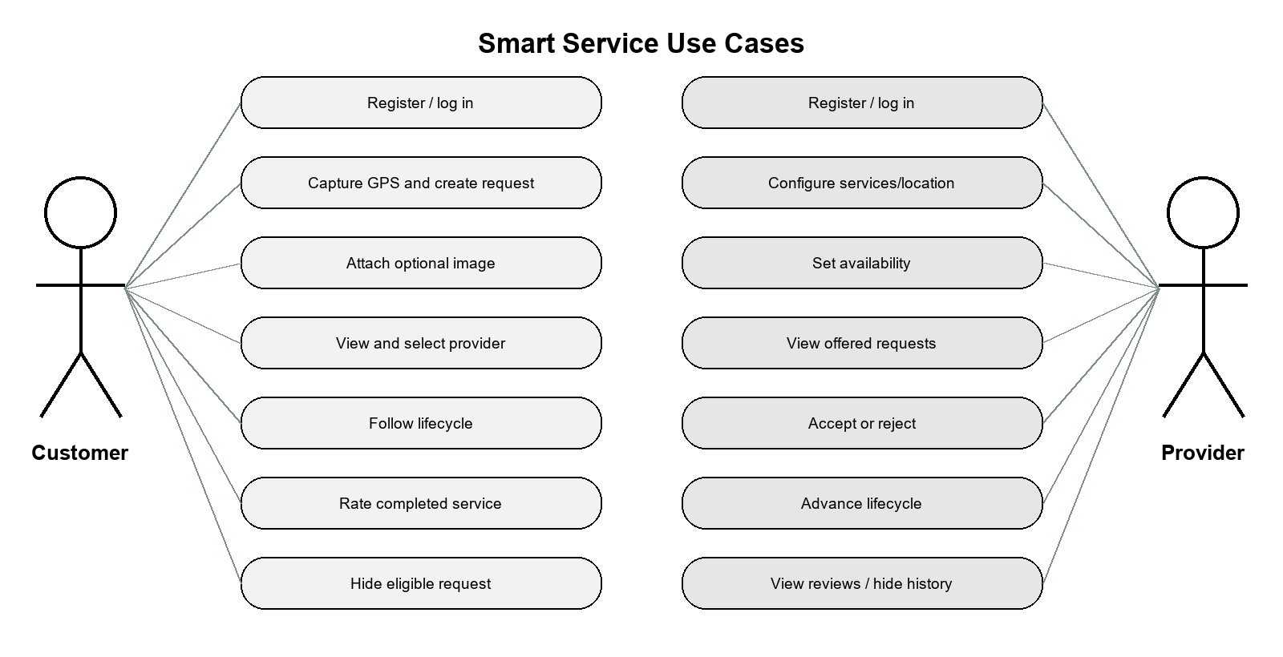
Figure 3-1. Customer and service-provider use-case diagram.
Figure 3-1 separates the responsibilities of the customer and provider while showing the common Smart Service system boundary.

System Architecture
Smart Service follows a client-server architecture. The Expo React Native client renders role-specific interfaces, captures permitted device data, stores the JWT using SecureStore on Android and iOS, and communicates with the backend over HTTP and Socket.IO. Express route modules delegate to controllers and services. Mongoose maps application entities to MongoDB Atlas. Uploaded request images are stored locally by the development backend and exposed through a controlled static path. Expo Notifications complements Socket.IO for background awareness.
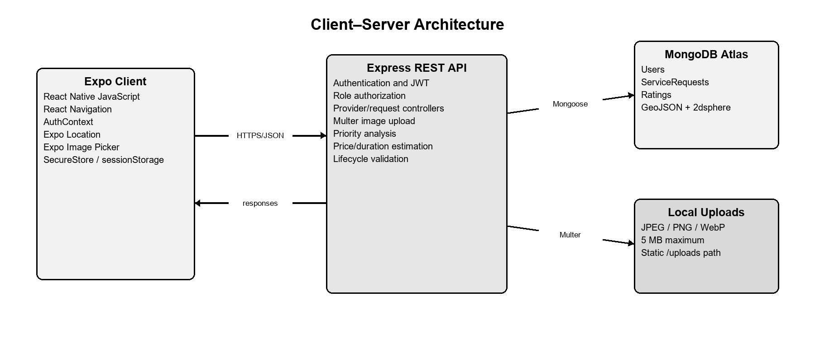
Figure 3-2. Smart Service client-server system architecture.
Figure 3-2 shows the Expo client, protected Express and Socket.IO server, MongoDB Atlas database, local upload storage, and Expo notification service.

Class Diagrams
The domain design centers on User, ServiceRequest, and Rating. User represents both roles and stores provider-only service, availability, rating, profile-location, and push-token fields. ServiceRequest records the customer, optional selected provider, service details, request state, locations, analysis, estimation, offer history, lifecycle timestamps, rating reference, and per-user visibility flags. Rating enforces one customer evaluation per completed request.
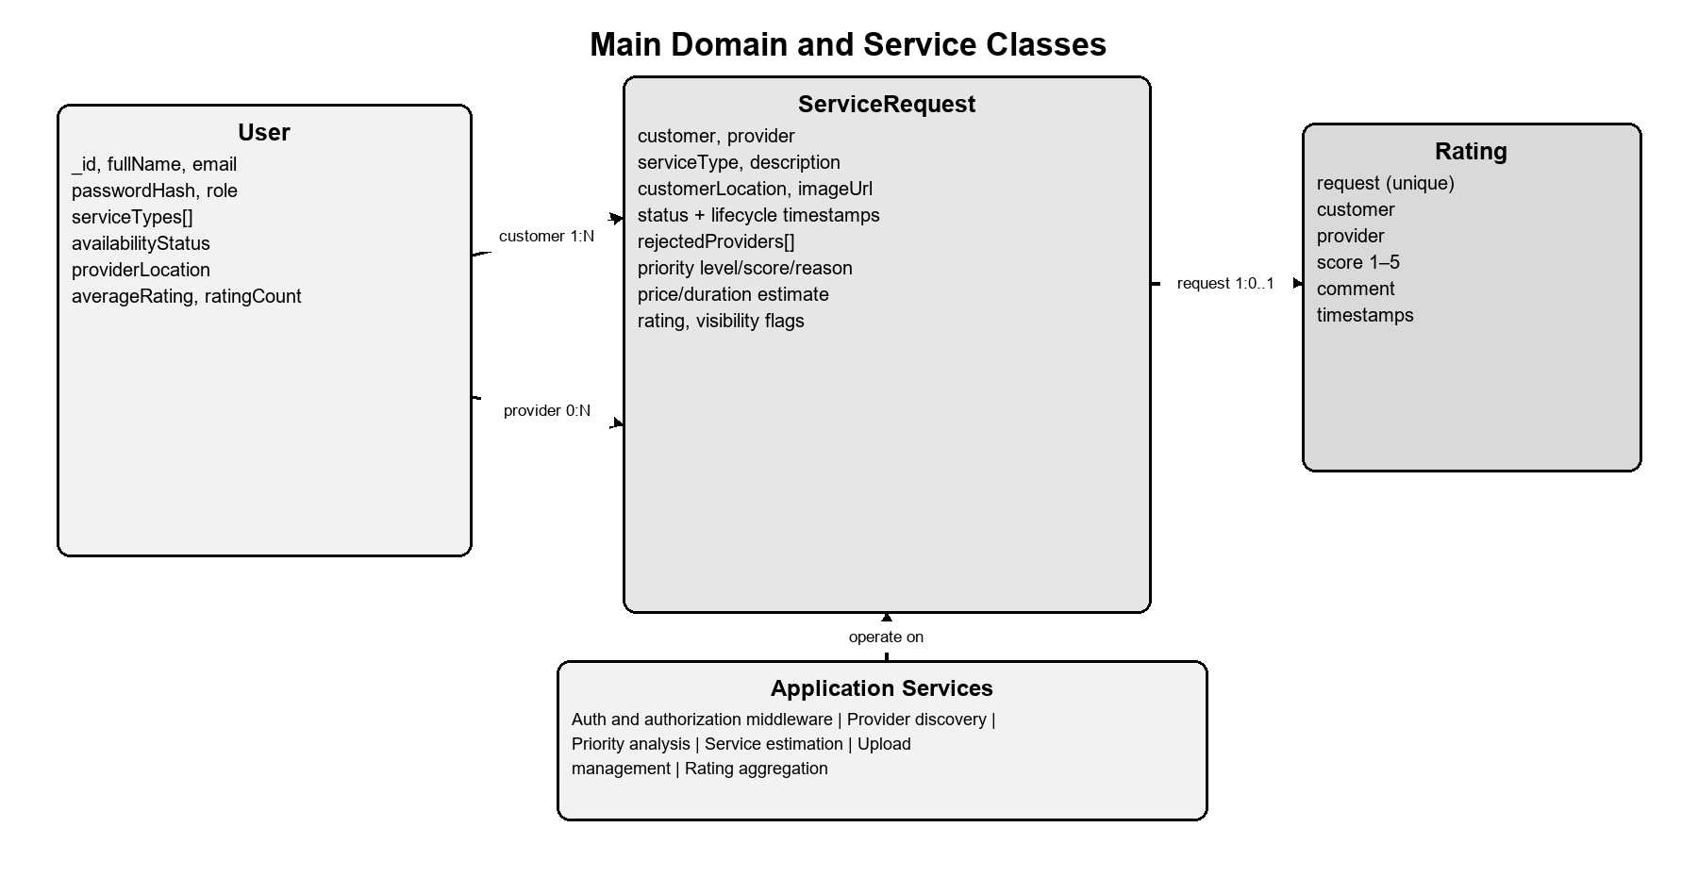
Figure 3-3. Main class and domain-model diagram.
Figure 3-3 presents the principal domain objects and their important relationships.

Sequence Diagrams
The primary sequence begins when a customer submits validated request data. The backend constructs the GeoJSON point, performs priority and estimation analysis, and persists the request. The customer retrieves eligible providers, selects one, and creates an offered state. The assigned provider accepts or rejects. Acceptance changes the provider to busy and enables ordered lifecycle updates; completion records the final timestamp, stops temporary sharing, and restores availability only when all prerequisites remain satisfied.
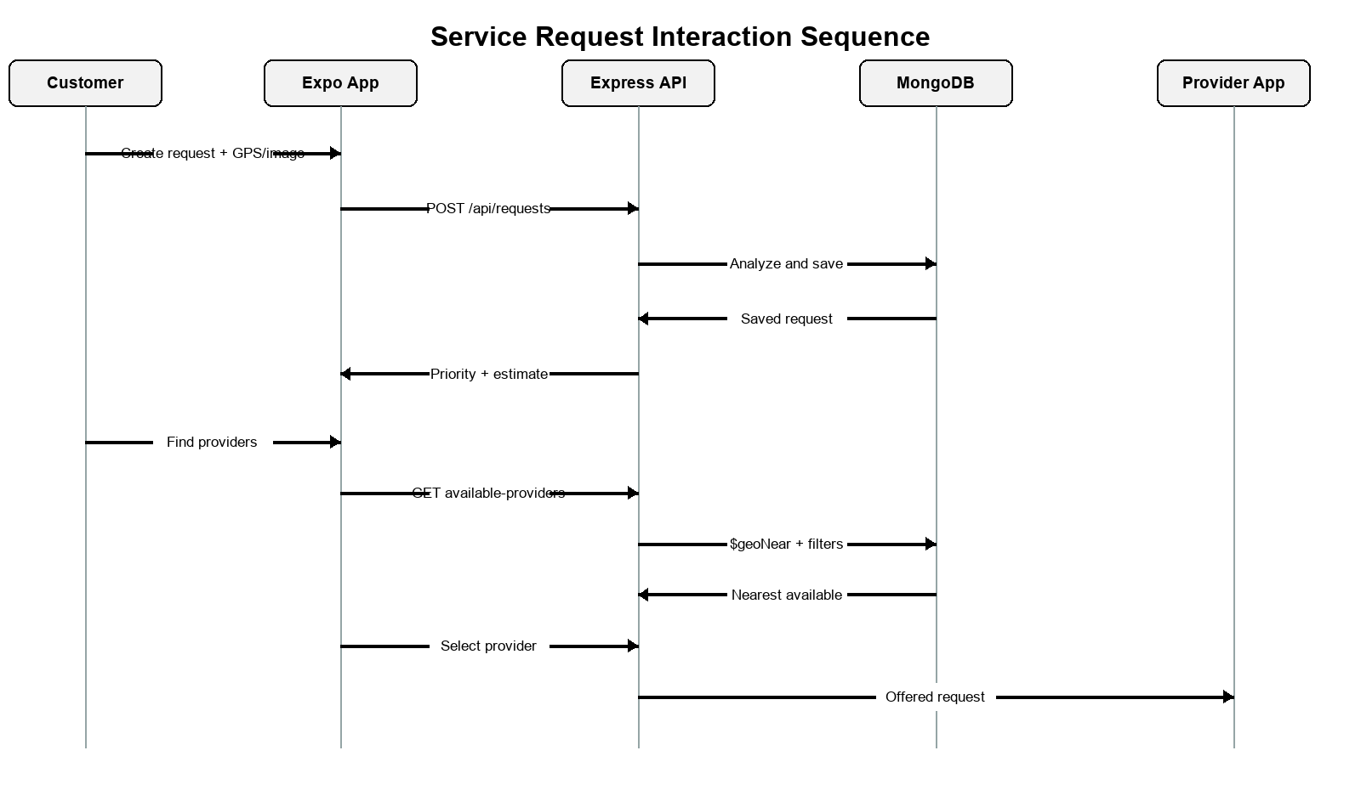
Figure 3-4. Service-request interaction sequence diagram.
Figure 3-4 illustrates the interaction among customer, backend, database, provider, and real-time communication components.

Activity Diagrams
The lifecycle allows pending or rejected requests without a provider to receive a new offer. An offered request can be accepted or rejected only by the assigned provider. Active work advances through accepted, on the way, arrived, in progress, and completed. Atomic database filters reject repeated, skipped, reversed, conflicting, or unauthorized transitions.
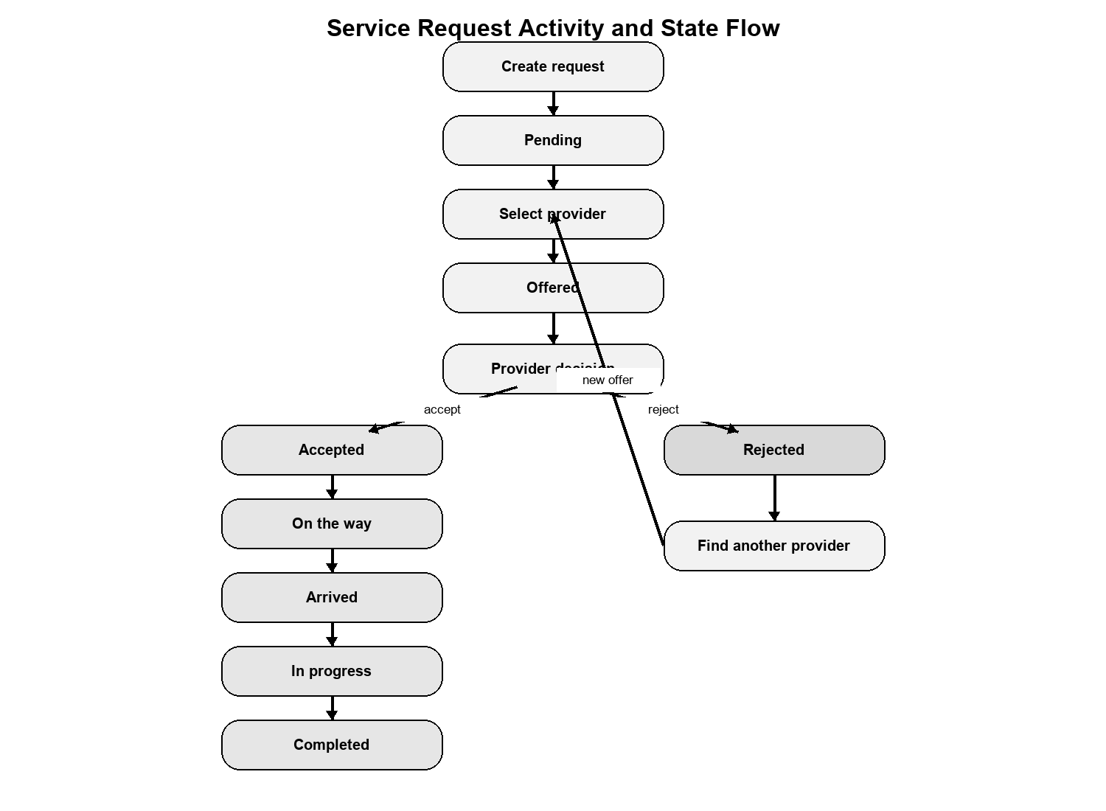
Figure 3-5. Service-request lifecycle activity diagram.
Figure 3-5 shows the permitted offer, rejection, acceptance, active-service, and completion paths.

Entity-Relationship (ER) Diagrams
MongoDB stores users, service requests, and ratings in separate collections. A customer can own many requests; a provider can be assigned many historical requests but should have only controlled active work; and each completed request can reference at most one rating. User references also preserve rejected-provider history and the latest rejection without duplicating private profile data.
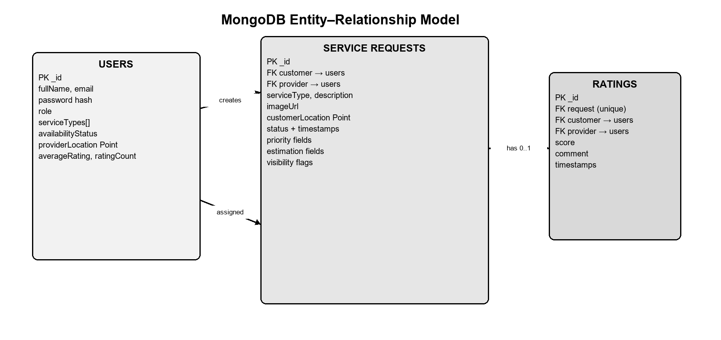
Figure 3-6. MongoDB entity-relationship diagram.
Figure 3-6 presents the cardinalities and references connecting users, requests, and ratings.

Non-Technical Aspects

Financial Viability
The prototype uses open-source frameworks, an Expo development workflow, MongoDB Atlas development resources, and local image storage. Direct academic-development cost is therefore limited mainly to internet access, development hardware, Android testing, optional cloud services, and future production deployment. Commercial operation would additionally require hosting, monitoring, storage, mapping, notification, support, legal, and provider-verification budgets.
Cost area | Prototype approach | Production consideration
Mobile and backend frameworks | Open source | Maintenance and upgrade effort
Database | Atlas development tier | Scalable managed cluster
Images | Local development storage | Durable cloud object storage
Maps and routing | OSM web map and native map | Restricted keys, quotas, and routing fees
Notifications | Expo push service | Delivery monitoring and operational support
Table 3-4. Prototype financial assumptions.
Table 3-4 distinguishes current academic costs from likely production expenses.
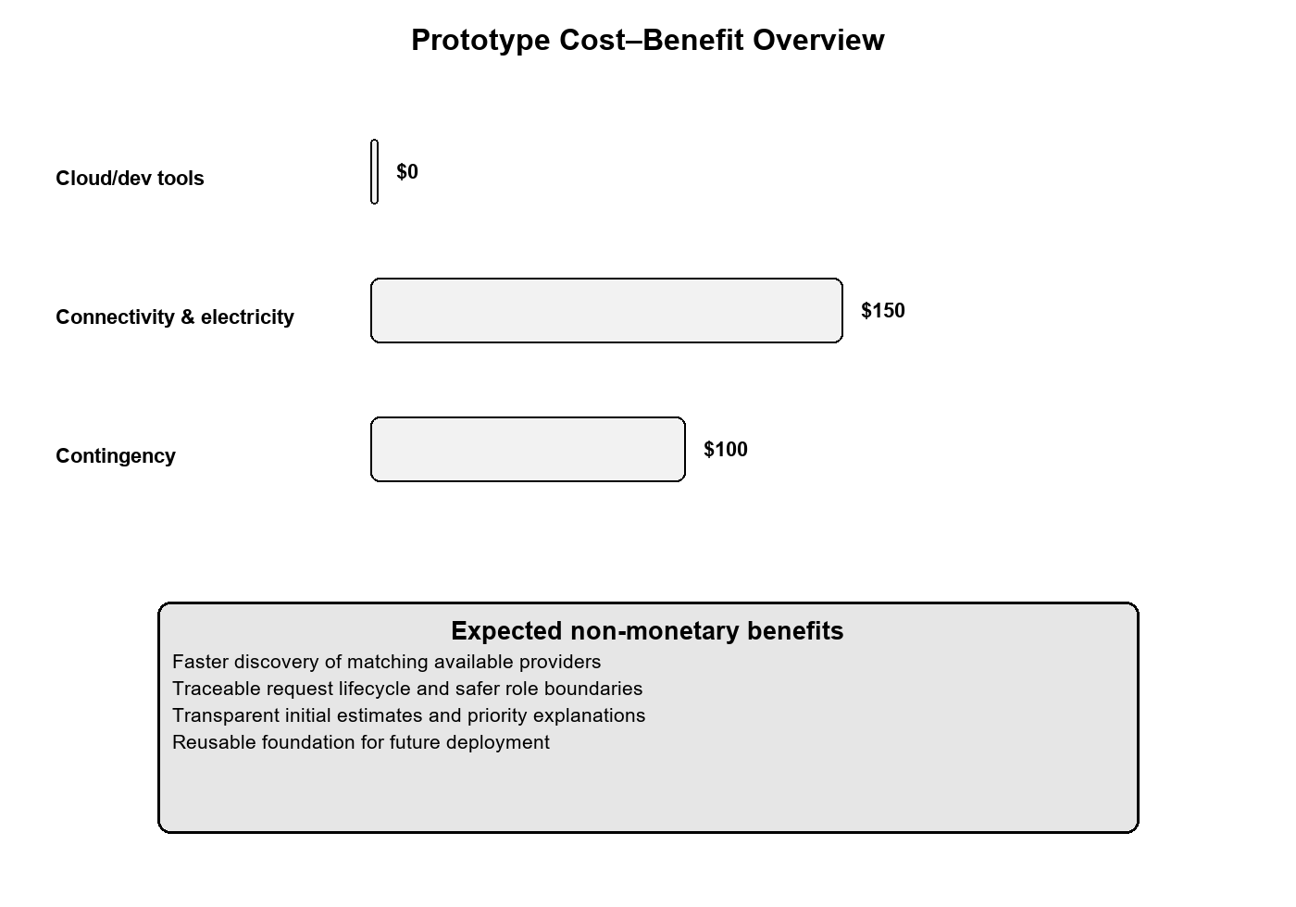
Figure 3-7. Prototype cost-benefit overview.
Figure 3-7 summarizes the expected benefits of structured service discovery relative to prototype implementation costs.

Stakeholders
Stakeholder | Primary interest
Customers | Reliable discovery, privacy, transparency, progress visibility, and safe feedback.
Service providers | Relevant offers, clear availability control, fair reviews, and manageable workflows.
Project team | Correct implementation, maintainability, testing evidence, and academic completion.
University and supervisor | Engineering quality, ethical conduct, documentation, and demonstrable results.
Future operator | Security, scalability, support, compliance, and sustainable operating cost.
Table 3-5. Principal project stakeholders.
Table 3-5 identifies who benefits from, influences, or is affected by Smart Service.

Scope
The implemented scope includes customer and provider accounts, JWT sessions, provider service and availability configuration, GPS capture, three service categories, request images, rule-based bilingual priority analysis, preliminary price and duration estimates, nearby discovery, customer provider selection, provider acceptance or rejection, controlled lifecycle progression, Socket.IO updates with polling fallback, optional foreground live sharing, push notifications, ratings, and per-user historical cleanup. Payment, chat, traffic routing, continuous background tracking, automatic provider assignment, and generative-AI decisions are outside the current scope.

Risks
Risk | Impact | Mitigation
Inaccurate browser GPS | Incorrect distance estimates | Prefer physical-device GPS and display that arrival estimates are approximate.
Unauthorized access | Privacy or integrity loss | JWT verification, role middleware, ownership checks, and safe response projection.
Conflicting updates | Invalid lifecycle state | Atomic expected-state updates and disabled duplicate UI actions.
Network interruption | Delayed updates | Socket reconnection, polling fallback, retained data, and retry states.
Rule misclassification | Misleading priority or estimate | Explainable bounded rules, test cases, and explicit non-binding warnings.
Local image storage | Loss during production redeployment | Use durable object storage before production release.
Table 3-6. Principal project risks and mitigations.
Table 3-6 records technical and operational risks together with their planned controls.

Schedule and Milestones
Milestone | Main output
Requirements and planning | Roles, workflows, scope, and technology selection
Foundation | Expo navigation, Express API, MongoDB connection, registration, and login
Core marketplace | Provider profile, requests, GPS discovery, selection, and offer response
Service lifecycle | Atomic statuses, real-time events, live location, and notifications
Decision support | Priority and estimation rules with English and Arabic tests
Quality and documentation | Ratings, cleanup, UI consistency, testing, report, and demonstration
Table 3-7. Schedule and milestone summary.
Table 3-7 groups the project work into incremental deliverables.
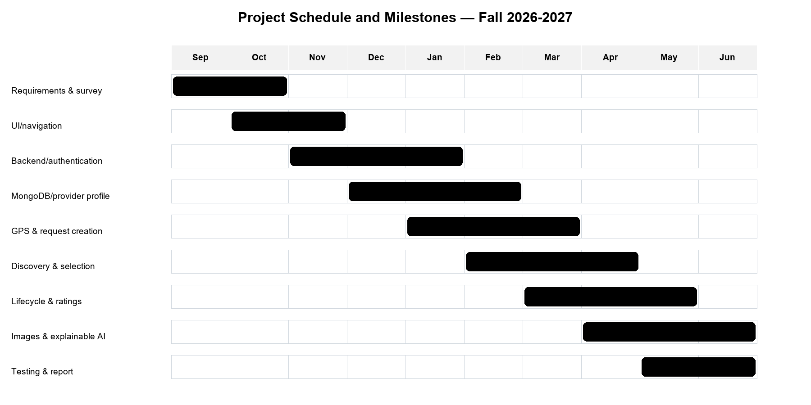
Figure 3-8. Project schedule and milestones.
Figure 3-8 visualizes the sequence and overlap of the main implementation activities.

Ethical and Social Considerations
Smart Service minimizes location disclosure, never publishes credentials, keeps the customer in control of provider selection, and labels automated outputs as preliminary. Ratings are restricted to completed owned requests. Exact provider coordinates are unavailable during discovery and are shared only with the authorized customer during an active request. Future deployment should define consent, retention, dispute resolution, provider verification, abuse reporting, moderation, and account-deletion policies.

Environmental and Sustainability Considerations
The application has no direct industrial environmental process, but digital infrastructure consumes energy and hardware resources. Efficient queries, bounded polling, event-driven updates, modest image sizes, responsible retention, and managed hosting can reduce unnecessary processing and storage. Matching nearby providers may also reduce avoidable travel, although this benefit requires field evaluation.

Relevant Standards
Standard or guidance | Relevance
RFC 7946 | GeoJSON point representation and longitude-latitude coordinate order
RFC 7519 | JSON Web Token representation
OWASP password-storage guidance | Secure password hashing and credential protection
WCAG 2.2 | Accessible labels, readable contrast, focus behavior, and responsive interfaces
HTTP and REST conventions | Consistent methods, status codes, authorization headers, and resource routing
Table 3-8. Relevant standards and implementation guidance.
Table 3-8 connects the design to standards and recognized engineering guidance cited in the report.

Conclusion
This chapter transformed the Smart Service objectives into a complete design. The requirements separate customer, provider, and server responsibilities; the diagrams describe architecture, interactions, lifecycle, and persistence; and the non-technical analysis defines scope, stakeholders, risks, schedule, ethics, sustainability, and relevant standards. These design decisions provide the basis for the implementation and testing activities described in Chapter 4.

Implementation/Simulation and Testing

Introduction
This paragraph is meant to introduce the topics to be covered in this chapter.

Implementation Tools
List the tools used for implementing the system. This includes hardware, compilers, IDE, frameworks, CASE tools, etc...

Implementation Summary
Description of detailed implementation steps. Demonstrate the typical code fragments (details of implementation, e.g. source code listings must be included in an appendix and saved on an accompanying CD/DVD)

Test Cases and Acceptance Criteria
Describe the test cases used and the acceptance criteria.

Conclusion
This paragraph in meant to draw conclusions highlighting the main ideas in this chapter.

Conclusion and Future Work

Conclusion
Any concluding remarks, lesson learned, etc…

Future Work
Describe the opportunities for expanding the work done in this thesis.
APPENDIX A:
Implementation Details

Any details not fit in chapter 5: e.g. detailed calculation, complex algorithms, etc…

APPENDIXB:
USER Manual

Fill in the instruction manual for using the application.

APPENDIXC:
deployment and configuration Manual

Outline the deployment and configuration details in addition to any troubleshooting techniques.

REFERENCES
[1] | John Smith and John Doe, "Wireless Sensor Networks," IEEE Transaction on Mobile Computing , vol. 1, no. 2, p. 12, 05 2010.
[2] | John Smith et al., How to add IEEE Reference style to Microsoft Word, Beirut, Lebanon: LIU, 2011.
[1] Taskrabbit Support, “How Do I Hire a Tasker?” [Online]. Available: https://support.taskrabbit.com/hc/en-us/articles/46260422073755-How-Do-I-Hire-a-Tasker.
[2] Angi, “Frequently Asked Questions.” [Online]. Available: https://www.angi.com/faq/.
[3] Meta Platforms, “React Native: Introduction.” [Online]. Available: https://reactnative.dev/docs/getting-started.
[4] Expo, “Location — Expo SDK 57 Documentation.” [Online]. Available: https://docs.expo.dev/versions/v57.0.0/sdk/location/.
[5] H. Butler et al., “The GeoJSON Format,” RFC 7946, Aug. 2016. [Online]. Available: https://www.rfc-editor.org/info/rfc7946/.
[6] MongoDB, “Geospatial Queries and 2dsphere Indexes.” [Online]. Available: https://www.mongodb.com/docs/manual/geospatial-queries/.
[7] M. Jones, J. Bradley, and N. Sakimura, “JSON Web Token (JWT),” RFC 7519, May 2015. [Online]. Available: https://datatracker.ietf.org/doc/html/rfc7519.
[8] OWASP Foundation, “Password Storage Cheat Sheet.” [Online]. Available: https://cheatsheetseries.owasp.org/cheatsheets/Password_Storage_Cheat_Sheet.html.
[9] Taskrabbit, “How It Works.” [Online]. Available: https://www.taskrabbit.com/.
[10] Taskrabbit Support, “How Do I Become a Tasker?” [Online]. Available: https://support.taskrabbit.com/hc/en-us/articles/46260467885979-How-Do-I-Become-a-Tasker.
[11] Taskrabbit, “How Pricing Guidance Works on Taskrabbit,” Apr. 13, 2022. [Online]. Available: https://www.taskrabbit.com/blog/how-pricing-guidance-works-on-taskrabbit/.
[12] Angi, “What’s the Difference Between Opportunities and Leads?” [Online]. Available: https://intercom.help/angi/en/articles/6229338-what-s-the-difference-between-opportunities-and-leads.
[13] Urban Company, “Service Professional Enablement.” [Online]. Available: https://investorrelations.urbancompany.com/announcements-and-highlights/service-professional-enablement.

