SMART SERVICE: AN AI-ASSISTED MOBILE APPLICATION FOR CONNECTING CUSTOMERS

WITH SERVICE PROVIDERS
Senior Project by

Mira Youssef, 72030174
Hussein Mansour, 42030321

Submitted to the School of Engineering of the Lebanese International University
Nabatieh, Lebanon
in partial fulfillment of the requirements for the degree of

BACHELOR OF SCIENCE IN COMPUTER AND COMMUNICATION
ENGINEERING Summer 2026

Approved by:
Supervisor
Dr. Hussein Nasrallah

Committee Member

DEDICATION

To our families and friends, whose continuous support, patience, and encouragement made this work possible. Their belief in us provided the motivation to overcome challenges and move forward throughout this project.
We also dedicate this work to everyone who strives to make roads safer through innovation and technology, hoping that our efforts contribute to a smarter and safer driving future.

Hussein Mansour, Mira Youssef
ACKNOWLEDGMENT

We express our sincere gratitude to our supervisor, Dr. Hussein Nasrallah, for his guidance, constructive observations, and continued encouragement throughout the development of this graduation project. We also thank the faculty members of the School of Engineering at the Lebanese International University for the technical foundation and academic discipline that supported this work. Finally, we acknowledge our families and colleagues for their patience, feedback, and motivation during the design, implementation, testing, and documentation of Smart Service.

ABSTRACT

Smart Service is an AI-assisted mobile application that connects customers who require household maintenance with nearby service providers in three initial categories: electrical work, plumbing, and air-conditioning. The system consists of a JavaScript React Native application developed with Expo, a Node.js and Express REST API, and a MongoDB Atlas database. Customers can register, authenticate, capture their current GPS location, describe a problem, attach an optional image, and discover available providers who offer the required service within a configurable radius. Results are ordered by straight-line distance and show provider ratings and an approximate arrival time. The customer retains the decision to select a provider, while the provider may accept or reject the offer and advance an accepted request through controlled lifecycle states. Completed services can be rated, and both participants can remove eligible historical requests from their own lists through soft deletion. Two explainable rule-based analysis modules classify urgency and produce an initial price range and duration estimate from the service type and bilingual English/Arabic descriptions. These modules do not select a provider, charge a customer, or replace professional inspection. The implemented prototype demonstrates role-based authentication, geospatial filtering, state validation, local image handling, feedback aggregation, and transparent decision support in a unified mobile workflow.

TABLE OF CONTENTS
Chapter 1: Introduction
Chapter 2: Survey of Existing Methods and Similar Systems
Chapter 3: System Design
Chapter 4: Implementation and Testing
Chapter 5: Conclusion and Future Work
References
LIST OF FIGURES
Figure 3-1. Customer and provider use-case diagram.
Figure 3-2. Smart Service client–server system architecture.
Figure 3-3. Main class and domain-model diagram.
Figure 3-4 models the primary request sequence. The customer client sends the
Figure 3-4. Service-request interaction sequence diagram.
Figure 3-5. Service-request lifecycle activity diagram.
Figure 3-6 presents the logical relationships among the three MongoDB collections. A
Figure 4-1. Smart Service login interface.
Figure 4-2. Smart Service registration interface.
Figure 4-3. Customer home interface.
Figure 4-4. GPS-enabled service-request creation interface.
Figure 4-5. Customer request list with priority and estimation results.
Figure 4-6. Nearby available-provider discovery interface.
Figure 4-7. Completed-service rating interface.
Figure 4-8. Provider profile, service, GPS, and availability interface.
Figure 4-9. Provider incoming and active request interface.
Figure 4-10. Provider reviews interface.
LIST OF TABLES
Table 2-1. Comparison based on graphical interface and usability.
Table 2-2. Comparison based on content and functionality.
Table 2-3. Comparison based on core features.
Table 3-1. Customer functional requirements.
Table 3-2. Provider functional requirements.
Table 3-3. Server functional requirements.
LIST OF SYMBOLS AND ABBREVIATIONS

AI — Artificial Intelligence
API — Application Programming Interface
DB — Database
ERD — Entity–Relationship Diagram GPS — Global Positioning System HTTP — Hypertext Transfer Protocol JWT — JSON Web Token
LIU — Lebanese International University REST — Representational State Transfer UI — User Interface
UML — Unified Modeling Language
URL — Uniform Resource Locator

CHAPTER 1 INTRODUCTION

Background

Mobile service marketplaces reduce the effort required to identify, compare, and contact people who provide work at a customer’s location. Instead of depending only on informal recommendations, a customer can describe a need through a structured interface and review information about matching providers. Established marketplaces demonstrate that provider skills, availability, price information, location, and reviews are central to service discovery. Taskrabbit, for example, officially describes a flow in which customers choose a category, enter an address, compare profiles by skills, hourly rate, and reviews, and then select a Tasker [1]. Angi similarly supports researching local professionals, booking services,
requesting quotes, and consulting cost information [2].

A cross-platform mobile architecture is appropriate for such a system because the same interface must support customers and providers on multiple devices. React Native allows application interfaces to be expressed through React components while targeting native platforms [3]. Expo adds managed access to device capabilities; its Location module
supports foreground permission requests and current-position acquisition [4]. Smart Service

uses these capabilities for one-time coordinate capture rather than continuous tracking.

Location-aware discovery requires a consistent geographic data representation. GeoJSON represents a point using longitude followed by latitude, and RFC 7946 defines the interoperable format [5]. MongoDB supports GeoJSON points, spherical distance
calculations, and 2dsphere indexes; its $geoNear stage can return an ordered stream based on proximity [6]. These facilities allow Smart Service to filter by role, selected service, current
availability, valid location, rejection history, and a configurable radius before sorting

candidates by straight-line distance.

Security and traceability are also necessary because request data belongs to identifiable participants. Smart Service hashes passwords using bcrypt and issues seven-day JSON Web Tokens containing only the user identifier and role. RFC 7519 defines JWT as a compact claims representation [7], while OWASP advises that passwords should be stored
with deliberately slow password-hashing algorithms rather than as plaintext [8]. Role

middleware separates customer-only and provider-only operations, and lifecycle updates use expected-state checks to prevent skipping or repeating transitions.
The term AI-assisted in this project refers to explainable, deterministic analysis rather than generative AI. English and Arabic problem descriptions are normalized and evaluated against configured indicators. One service assigns a priority level and reason; another assigns a bounded initial price range, duration, currency, and explanation. Urgent wording by itself does not raise the price. The provider must inspect the problem and confirm the final price, and the customer always chooses the provider.

Problem Statement

Customers who need electricians, plumbers, or air-conditioning technicians may face fragmented information about who is currently available, what services each person offers, how far away the provider is, and whether earlier customers were satisfied. A simple directory does not represent the operational state of a request, while direct messaging alone does not enforce a reliable sequence from an offer to completion. Providers likewise need a concise mechanism to state their offered services and availability, receive relevant work, and avoid being shown for categories they do not perform. Established service marketplaces demonstrate the importance of structured provider profiles, ratings, location context, and customer-directed selection [1], [2], [13].
The project problem is therefore to design a role-aware mobile system that creates a trustworthy, inspectable connection between a customer request and an eligible nearby provider. The system must preserve customer choice, disclose only safe information before

acceptance, prevent unauthorized status changes, and keep both participants informed through authenticated real-time communication with polling fallback. It must also handle device location permission, inconsistent connectivity, duplicate actions, rejected offers, historical cleanup, and optional images without exposing passwords, tokens, database credentials, or exact provider coordinates in discovery results.
A secondary problem is that free-text descriptions vary in language and detail. A severe flood or electrical sparks should be visually distinguished from routine maintenance, but a software estimate must not pretend to replace professional judgment. Smart Service addresses this with transparent keyword rules, bounded outputs, human-readable reasons, and explicit warnings. The analysis prioritizes requests for provider presentation; it does not automatically assign a provider, authorize payment, or establish a final service price.

General Overview of the Project

Smart Service has two authenticated roles. A customer registers or logs in, selects electrician, plumber, or air-conditioning service, writes a meaningful description, optionally selects one JPEG, PNG, or WebP image, and captures a foreground GPS position. When the backend creates the request, it constructs the GeoJSON location, performs priority and service estimation, and stores the results. The customer’s request list displays status, analysis, estimate, location presence, provider information, lifecycle progress, rating state, and eligible cleanup actions.

Thesis Outline

This report is organized into five chapters. Chapter 1 introduces the problem, objectives, scope, and enabling technologies. Chapter 2 reviews Taskrabbit, Angi, and Urban Company and compares their documented capabilities with Smart Service. Chapter 3 presents requirements, architecture, data relationships, workflows, planning, risks, and standards. Chapter 4 describes implementation and testing through the completed customer and provider workflows. Chapter 5 concludes the project and identifies future improvements.

information, then compares their documented functions with Smart Service. Chapter 3 specifies functional requirements, diagrams the implemented architecture and data model, explains the request workflow, and examines financial, stakeholder, scope, risk, schedule, ethical, environmental, and standards considerations. Implementation testing and final conclusions will be addressed in later report stages and are intentionally not presented as Chapters 4 and 5 here.

CHAPTER 2

SURVEY OF EXISTING METHODS AND SIMILAR SYSTEMS

Introduction

This chapter reviews three established home-service marketplaces to identify common interaction patterns and unresolved design opportunities. Only capabilities established by the reviewed official sources are treated as verified. A blank or “Not established” comparison entry means that the selected source did not provide sufficient evidence; it does not prove that the commercial system lacks the feature.

Similar System 1: Taskrabbit

Taskrabbit connects customers with independent Taskers across multiple service categories. Its official hiring guidance instructs customers to select a category, provide the task address, review local Tasker profiles, and compare skills, experience, hourly rates, and category-specific reviews before selecting a Tasker [1]. The platform supports scheduling and
task details, and its public overview describes integrated chat, payment, tipping, and reviews [9].
Taskrabbit strongly demonstrates customer-directed provider selection and profile comparison. Taskers can define skills, location, availability slots, and a work-area map [10].
Pricing is provider-controlled, while the platform may offer market-based pricing guidance [11]. The reviewed materials did not establish explainable emergency-text prioritization
comparable to Smart Service, nor did they establish a bilingual rule that produces a request-specific initial duration estimate from the problem description.

Similar System 2: Angi

Angi positions itself as a platform for finding, booking, and hiring skilled home professionals, researching costs, requesting quotes, and consulting homeowner reviews [2].
Search results present professional information, ratings, and profile links. Angi also reports transparent upfront pricing for services booked and paid through its platform and supplies a project cost center based on project data [2].
The Angi workflow covers a wider home-improvement planning context than the three-category Smart Service prototype. Recent official professional guidance describes location-and-service matching between homeowner projects and professional opportunities [12]. However, the reviewed public documentation does not establish the same explicit
customer-controlled offer state, provider rejection history, deterministic request priority analysis, or five-state field-service lifecycle implemented by Smart Service.

Similar System 3: Urban Company

Urban Company is a technology-enabled home-services marketplace whose stated mission includes enabling service professionals to deliver at-home services [13]. Its public
material emphasizes professional enablement, training, service quality, minimum rating expectations, and on-time fulfillment. These concerns are directly relevant to provider quality and customer trust.
Urban Company illustrates a managed-service approach in which platform processes influence professional preparation and quality assurance. The reviewed official sources establish attention to ratings and fulfillment, but do not establish the same explainable bilingual keyword prioritization, customer-selected nearby-provider list, or locally stored optional request image used in the current Smart Service implementation. Smart Service

remains a prototype and does not claim the scale, verification programs, support infrastructure, or commercial maturity of Urban Company.

Methods/Systems Comparison

Tables 2-1 through 2-3 compare documented characteristics. Smart Service entries are

verified from the inspected source code and captured running interface. Commercial-system entries are deliberately conservative and are limited to the cited official materials.
Table 2-1. Comparison based on graphical interface and usability.
Table 2-1 compares graphical-interface and usability characteristics.

Criterion | Task rabbit | Angi | Urban Company | Smart Service
Mobile-oriented service flow | ✔ | ✔ | ✔ | ✔
Provider profile/ratings visible | ✔ | ✔ | Quality/rating  emphasis | ✔
Customer directly chooses provider | ✔ | Available in directory/booking  flows | Not established by reviewed source | ✔
Simple role-specific navigation | Separate  client/Tasker apps | Home  owner/pro experiences | Customer/  professional experiences | Separate navigation trees
Accessible status message | Not  assessed | Not  assessed | Not  assessed | Partially implemented; WCAG review  remains
Table 2-2. Comparison based on content and functionality.
Table 2-2 compares documented content and functionality.

Criterion | Task Rabbit | Angi | Urban Company | Smart Service
Service discovery | Category /address search | Professional search and booking | At- home service marketplace | Three service categories
Location input/support | Task address and work area | Local professional matching | On- time at-home fulfillment | GPS +  Geo JSON  proximity
Price information | Hourly rate and pricing guidance | Upfront pricing/cost research | Service marketplace pricing | Initial rule-based range only
Reviews | Integrated reviews | Home owner reviews | Ratings/ quality thresholds | One rating per completed request
Provider workflow | Skills, work area, schedule | Professional opportunities/leads | Professional enablement | Services, location, availability,  lifecycle

Table 2-3. Comparison based on core features.
Table 2-3 summarizes the core-feature comparison.

Feature | Task Rabbit | Angi | Urban Company | Smart Service
GPS-distance ordered  candidates | Not established | Local matching; ordering not  established | Not established | Yes, MongoDB  $geoNear
Provider accept/reject  offer | Scheduling confirmation  documented | Mutual lead interest documented | Not established | Yes
Detailed request status lifecycle | Not established | Not established | Fulfillment emphasized | Yes, five  post-acceptance states
Optional problem  image | Not  established | Not  established | Not  established | Yes, local Multer upload
Emergency priority explanation | Not established | Not established | Not established | Yes, English/Arabic  rules
Problem-based price/duration estimate | Pricing guidance, not equivalent | Cost/upfront pricing, not equivalent | Not established | Yes; preliminary only
Customer retains provider selection | Yes | Supported in relevant  flows | Not established | Yes; AI never assigns

Conclusion and Motivation

The reviewed systems demonstrate the value of category-based search, location context, provider profiles, ratings, price information, and structured marketplace participation. Their scale and operational maturity exceed the current academic prototype. The comparison nevertheless identifies a coherent project motivation: combine transparent customer selection, provider-controlled acceptance, GPS-radius filtering, explicit lifecycle validation, bilingual emergency prioritization, and an explainable initial estimate in one inspectable workflow.
Smart Service is not intended to duplicate every commercial function. It deliberately excludes payment, chat, background-verification infrastructure, traffic routing, and automatic provider assignment. Its contribution is a focused engineering demonstration in which analysis remains explainable, authorization is role-specific, customer choice is preserved, and database state transitions can be tested directly.

CHAPTER 3 SYSTEM DESIGN

Introduction

This chapter translates the project goals into verified functional requirements and design models. The diagrams are derived from the inspected application rather than copied from the report template. They describe the deployed software boundaries, principal domain entities, API-mediated interactions, lifecycle states, and MongoDB relationships, followed by the non-technical considerations required by the template.

Requirements and Specification Analysis

Smart Service follows a role-based client–server model. Every protected API operation first verifies a Bearer JWT and then applies customer or provider authorization. Customer and provider screens share authentication state through AuthContext, while request-oriented screens reload on focus and poll every five seconds. The backend remains authoritative for ownership, coordinates, eligible providers, request state, rating uniqueness, and list visibility.

Functional Requirements

Table 3-1. Customer functional requirements.
Table 3-1 summarizes customer functional requirements.

D | Customer requirement | Implementation evidence
1 | Register and authenticate | Register/Login screens; /api/auth routes;  JWT context
2 | Capture one current location | Expo Location foreground permission
3 | Create categorized request | POST /api/requests; service enum and  description validation

D | Customer requirement | Implementation evidence
4 | Attach at most one optional image | Expo Image Picker; Multer type/size  controls
5 | View nearby matching available  providers | $geoNear, 50 km default, service/status  filters
6 | Select one provider | Atomic select-provider endpoint; customer  ownership
7 | Observe provider response/lifecycle | Five-second focused polling and progress  timeline
8 | View priority and initial estimate | Shared priority badge and estimate component
9 | Rate completed request once | Unique Rating request reference and ownership checks
10 | Hide eligible history from own list | Per-customer soft visibility flag
Table 3-2. Provider functional requirements.
Table 3-2 summarizes provider functional requirements.

D | Provider requirement | Implementation evidence
1 | Register and authenticate as  provider | Role enum, JWT, provider navigation
2 | Select offered service types | Validated electrician/plumber/AC array
3 | Save current location and  availability | Provider GeoJSON endpoint and profile  validation
4 | Receive assigned offered/active  requests | Provider-only request aggregation
5 | Accept or reject offered request | Atomic response endpoint
6 | Advance exact lifecycle order | Expected-current-status atomic update
7 | View customer-safe request data | No pre-acceptance email/exact coordinates
8 | View priority, estimate, and  reviews | Shared analysis cards and ratings endpoint
9 | Hide eligible history from own list | Per-provider soft visibility flag
Table 3-3. Server functional requirements.
Table 3-3 summarizes server functional requirements.

D | Server requirement | Implementation evidence
1 | Authentication and role  authorization | JWT middleware and authorizeRoles
2 | Persist users, requests, ratings | Mongoose schemas and MongoDB Atlas
3 | Validate geographic coordinates | Server builds Point [longitude, latitude]
4 | Filter and rank providers | Role/service/status/location/rejection filters
5 | Protect request state transitions | Atomic conditions and conflict responses
6 | Manage images safely | Unique names, MIME allowlist, 5 MB  maximum
7 | Analyze priority and service  estimate | Centralized deterministic rule services
8 | Aggregate ratings | Provider average rounded to one decimal  place

Use Case Diagrams

Figure 3-1 separates customer and provider goals while showing that both roles

depend on the same authenticated system boundary. Provider selection remains a customer use case; analysis produces supporting information but does not execute that decision.
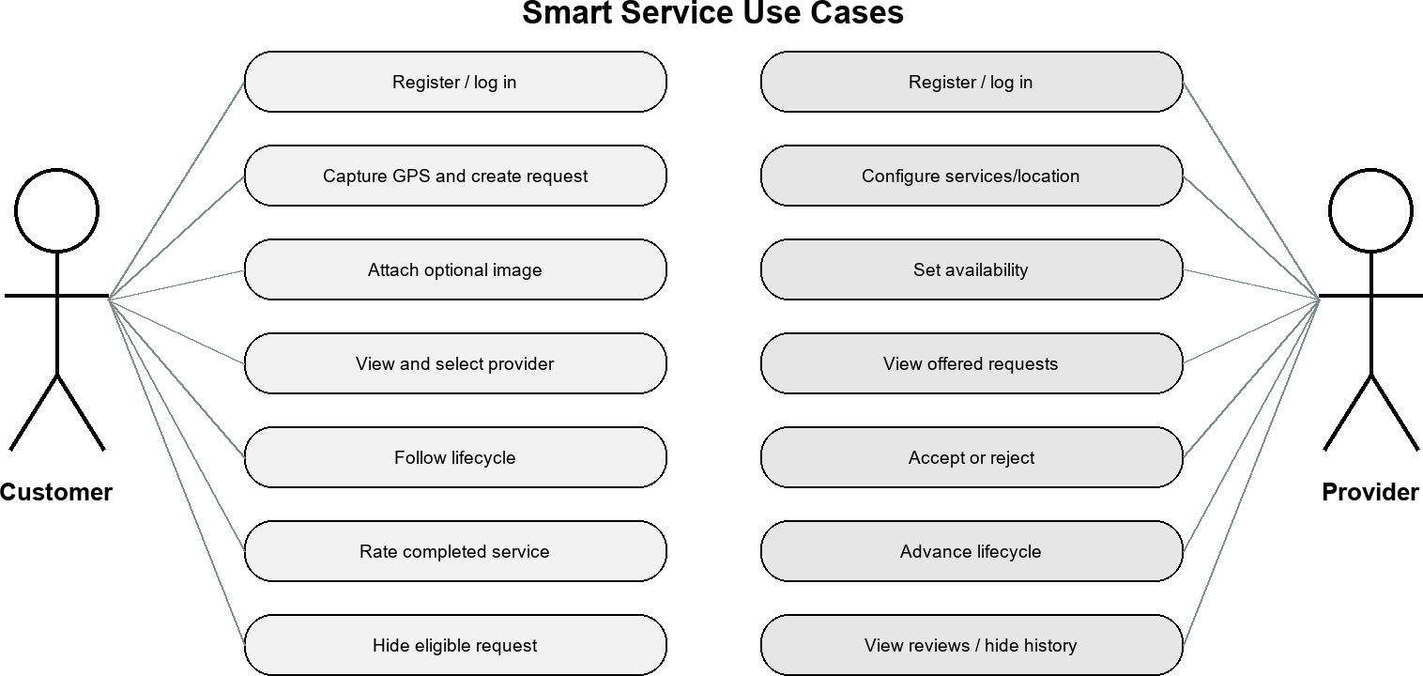

Figure 3-1. Customer and provider use-case diagram.

System Architecture

The architecture in Figure 3-2 has four principal runtime elements. The Expo client

owns presentation, navigation, permission prompts, transient form state, secure token storage, and polling. The Express API owns validation, authorization, workflow rules, analysis, and response shaping. MongoDB Atlas stores structured entities and supports spherical proximity operations. The backend uploads directory stores the optional image file and is exposed through a static Express route. No database URI or JWT secret is included in the mobile environment.

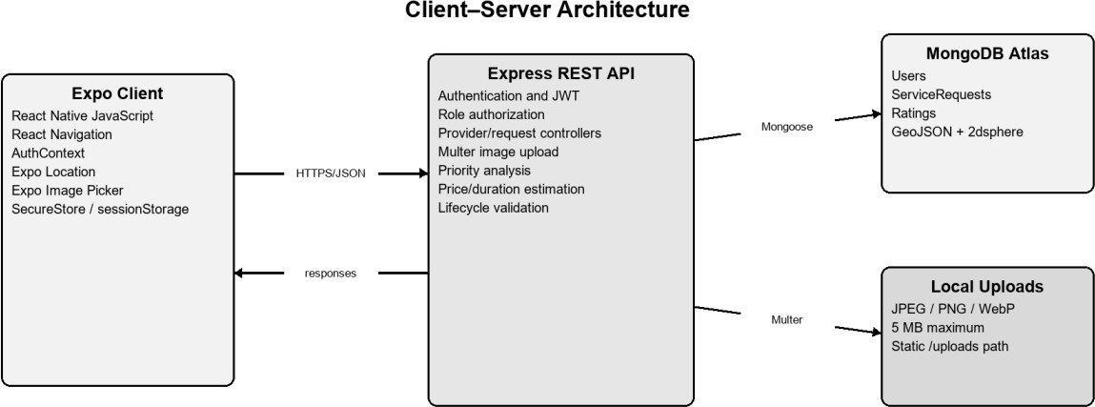

Figure 3-2. Smart Service client–server system architecture.
Communication uses JSON for ordinary requests and multipart/form-data when a service request includes an image. The mobile client sends only latitude and longitude; the server constructs the GeoJSON point. Protected requests carry the JWT in the Authorization header as a Bearer token. CORS is enabled for development. Production deployment would additionally require HTTPS, restrictive CORS origins, managed object storage, monitoring, backup policy, and secret management.

Class Diagrams

Because the implementation uses JavaScript modules and Mongoose rather than a classical object-oriented hierarchy, Figure 3-3 is a domain-oriented class diagram. It shows
stored model properties and the application services that operate on them. Password is excluded from normal queries. ServiceRequest contains both workflow state and immutable analysis outputs generated at creation time; old requests without estimates are displayed as unavailable rather than silently migrated.

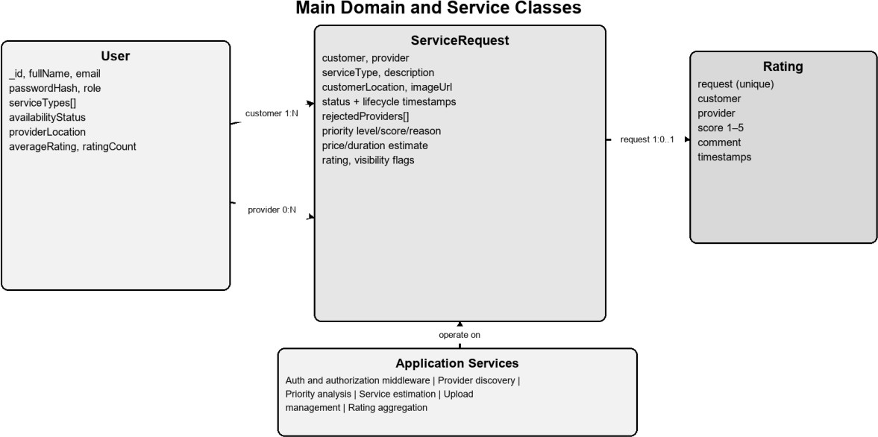

Figure 3-3. Main class and domain-model diagram.

Sequence Diagrams

Figure 3-4 models the primary request sequence. The customer client sends the
validated request to Express, which computes priority and estimate, creates GeoJSON, and stores the document. Provider discovery invokes a spherical MongoDB aggregation. Selection creates an offer for one provider; the provider’s separate navigation then obtains that offer. Subsequent acceptance, rejection, lifecycle, and rating operations follow the same authenticated API boundary.

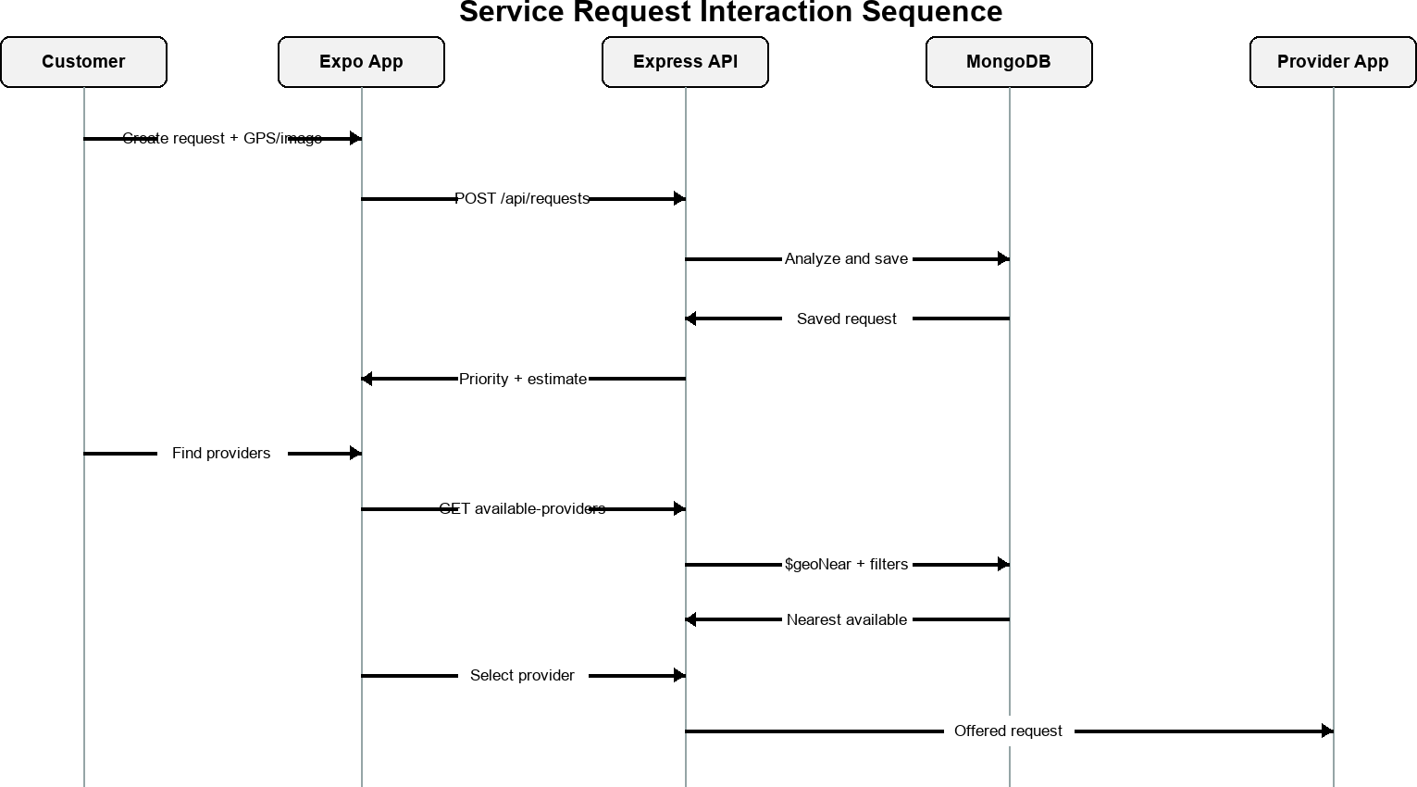

Figure 3-4. Service-request interaction sequence diagram.

Activity Diagrams

The activity diagram in Figure 3-5 emphasizes state validity. Pending and rejected

requests with no provider may enter provider selection. A selected request becomes offered. Rejection clears the provider, preserves rejection history, and lets the customer search again. Acceptance begins the one-way operational sequence. The controller rejects skipped, reversed, repeated, completed, cancelled, or foreign-provider transitions by requiring the expected current status in the database update condition.

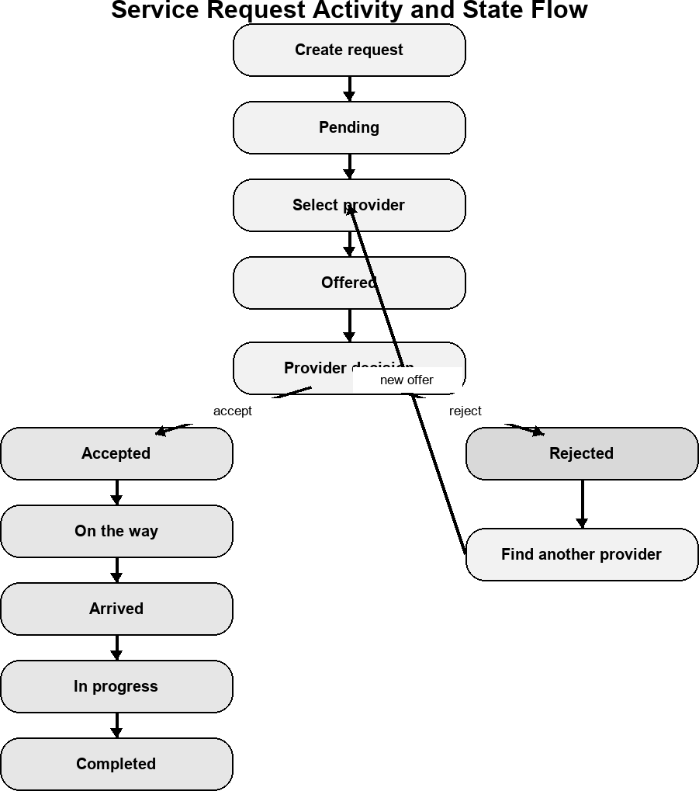

Figure 3-5. Service-request lifecycle activity diagram.

Entity-Relationship Diagrams

Figure 3-6 presents the logical relationships among the three MongoDB collections. A

CHAPTER 4

IMPLEMENTATION AND TESTING

Introduction
This chapter presents the implemented Smart Service interfaces and verifies the principal customer and service-provider workflows. The Expo React Native client communicates with a Node.js and Express backend backed by MongoDB Atlas. Authentication uses JSON Web Tokens, Socket.IO delivers authorized real-time updates, and polling remains a fallback. Sensitive passwords, tokens, database credentials, and API keys are not displayed.

Authentication Interfaces

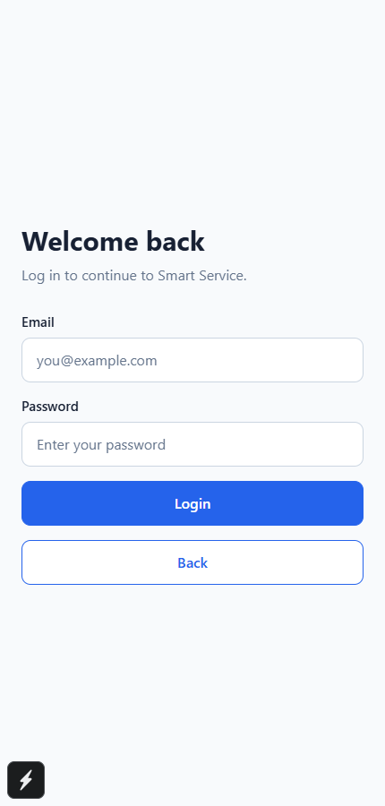
Figure 4-1. Smart Service login interface.
Figure 4-1 shows the shared login form and concealed password input used by both account roles.
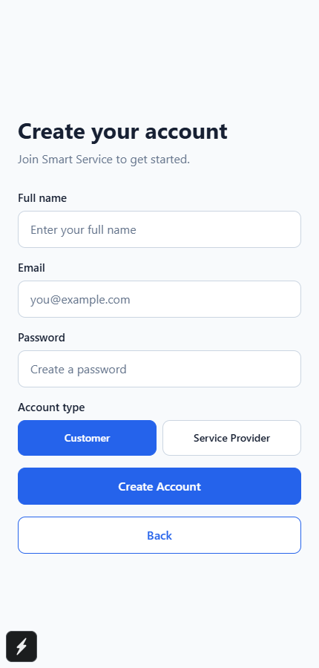
Figure 4-2. Smart Service registration interface.
Figure 4-2 shows account creation with full name, email, password, and account-role selection.

Customer Workflow

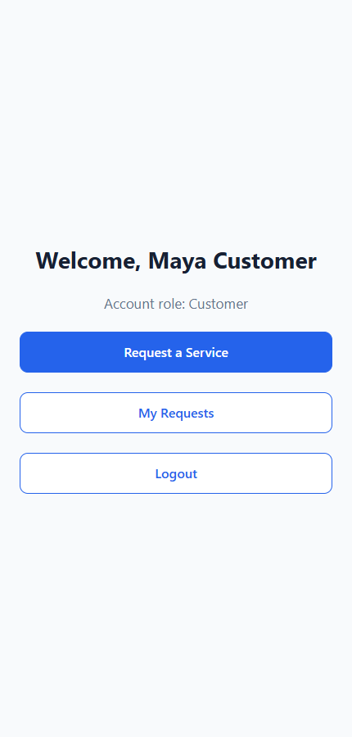
Figure 4-3. Customer home interface.
Figure 4-3 provides access to request creation and the customer request history.
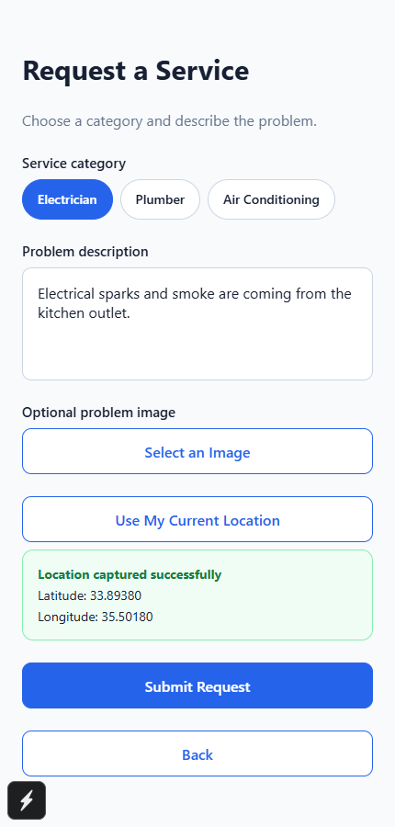
Figure 4-4. GPS-enabled service-request creation interface.
Figure 4-4 shows service selection, problem description, optional image handling, and one-time GPS capture.
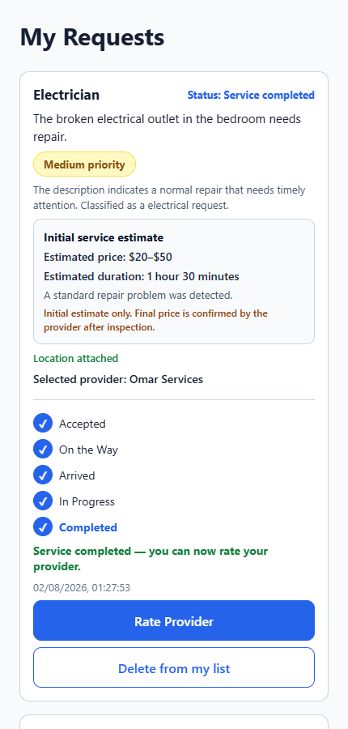
Figure 4-5. Customer request list with priority and estimation results.
Figure 4-5 presents request state, explainable priority, initial price and duration estimation, and lifecycle progress.
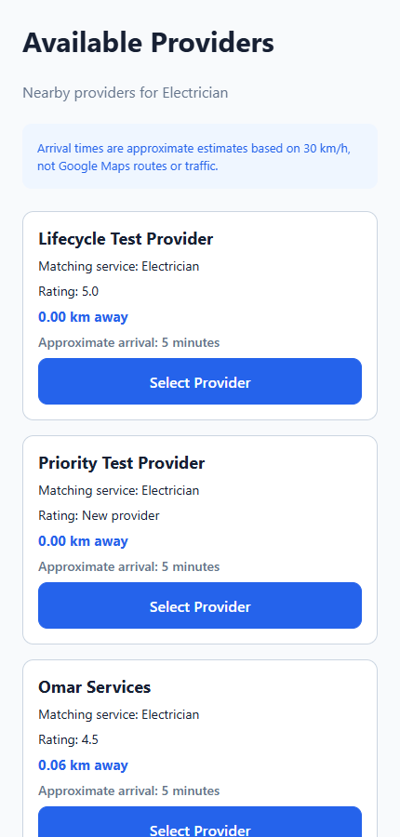
Figure 4-6. Nearby available-provider discovery interface.
Figure 4-6 shows privacy-safe matching provider information ordered by geospatial distance.
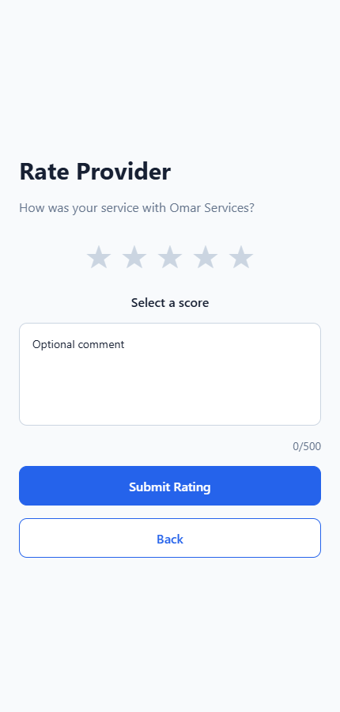
Figure 4-7. Completed-service rating interface.
Figure 4-7 allows the owning customer to submit one score and an optional review after completion.

Service-Provider Workflow

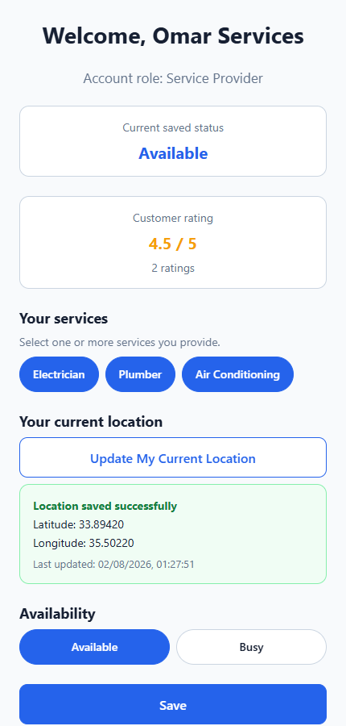
Figure 4-8. Provider profile, service, GPS, and availability interface.
Figure 4-8 shows provider service selection, saved profile location, availability, rating, and navigation controls.
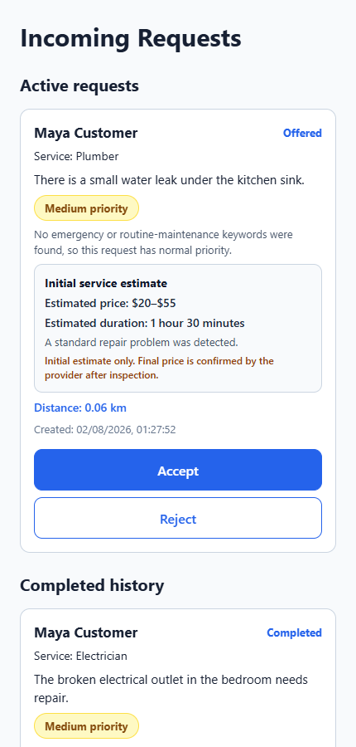
Figure 4-9. Provider incoming and active request interface.
Figure 4-9 presents offered and active work with accept, reject, lifecycle, and live-sharing controls.
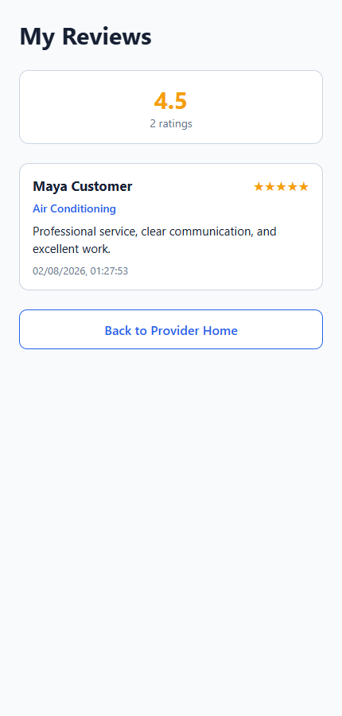
Figure 4-10. Provider reviews interface.
Figure 4-10 presents the average rating, rating count, and privacy-safe customer reviews.

Real-Time Communication and Testing
Authenticated Socket.IO rooms deliver request and lifecycle events only to authorized participants. Live provider coordinates are shared only during an accepted active request and are cleared when sharing stops. Express route modules protect the corresponding server operations [15]. Testing covers authentication, role authorization, provider discovery, request transitions, rejection history, priority analysis, estimation, ratings, Socket.IO authorization, push-notification construction, and location privacy. Interface review also considers WCAG guidance [14].

Conclusion
The implementation demonstrates the complete workflow from authentication and request creation to provider discovery, controlled lifecycle progression, optional live tracking, completion, and customer feedback.

CHAPTER 5

CONCLUSION AND FUTURE WORK

Conclusion
Smart Service demonstrates a role-aware mobile marketplace for electricians, plumbers, and air-conditioning providers. It combines protected authentication, customer-controlled provider selection, GeoJSON discovery, explainable request analysis, atomic lifecycle transitions, Socket.IO updates, optional live location sharing, push notifications, and post-completion ratings while preserving human decision authority.

Future Work
Future work may include production cloud image storage, road-network routing, traffic-aware arrival estimates, stronger provider verification, broader accessibility evaluation, deployment automation, and larger usability and performance studies. Payment, chat, and generative-AI assistance require additional privacy, security, moderation, and consent analysis.

REFERENCES
[1] Taskrabbit Support, ?How Do I Hire a Tasker?? [Online]. Available: https://support.taskrabbit.com/hc/en-us/articles/46260422073755-How-Do-I-Hire-a-Tasker. Accessed: Aug. 2, 2026.
[2] Angi, ?Frequently Asked Questions.? [Online]. Available: https://www.angi.com/faq/. Accessed: Aug. 2, 2026.
[3] Meta Platforms, ?React Native: Introduction.? [Online]. Available: https://reactnative.dev/docs/getting-started. Accessed: Aug. 2, 2026.
[4] Expo, ?Location ? Expo SDK 57 Documentation.? [Online]. Available: https://docs.expo.dev/versions/v57.0.0/sdk/location/. Accessed: Aug. 2, 2026.
[5] H. Butler et al., ?The GeoJSON Format,? RFC 7946, Aug. 2016. [Online]. Available: https://www.rfc-editor.org/info/rfc7946/.
[6] MongoDB, ?Geospatial Queries and 2dsphere Indexes.? [Online]. Available: https://www.mongodb.com/docs/manual/geospatial-queries/.
[7] M. Jones, J. Bradley, and N. Sakimura, ?JSON Web Token (JWT),? RFC 7519, May 2015. [Online]. Available: https://datatracker.ietf.org/doc/html/rfc7519.
[8] OWASP Foundation, ?Password Storage Cheat Sheet.? [Online]. Available: https://cheatsheetseries.owasp.org/cheatsheets/Password_Storage_Cheat_Sheet.html.
[9] Taskrabbit, ?How It Works.? [Online]. Available: https://www.taskrabbit.com/.
[10] Taskrabbit Support, ?How Do I Become a Tasker?? [Online]. Available: https://support.taskrabbit.com/hc/en-us/articles/46260467885979-How-Do-I-Become-a-Tasker.
[11] Taskrabbit, ?How Pricing Guidance Works on Taskrabbit,? Apr. 13, 2022. [Online]. Available: https://www.taskrabbit.com/blog/how-pricing-guidance-works-on-taskrabbit/.
[12] Angi, ?What?s the Difference Between Opportunities and Leads?? [Online]. Available: https://intercom.help/angi/en/articles/6229338-what-s-the-difference-between-opportunities-and-leads.
[13] Urban Company, ?Service Professional Enablement.? [Online]. Available: https://investorrelations.urbancompany.com/announcements-and-highlights/service-professional-enablement.
[14] W3C, ?Web Content Accessibility Guidelines (WCAG) 2.2,? Dec. 12, 2024. [Online]. Available: https://www.w3.org/TR/WCAG22/.
[15] Express.js, ?Basic Routing.? [Online]. Available: https://expressjs.com/en/starter/basic-routing.html.

