SMART SERVICE: AN AI-ASSISTED MOBILE APPLICATION FOR CONNECTING CUSTOMERS

WITH SERVICE PROVIDERS
Senior Project by

Mira Youssef, 72030174
Hussein Mansour, 42030321

Submitted to the School of Engineering of the Lebanese International University
Nabatieh, Lebanon
in partial fulfillment of the requirements for the degree of

BACHELOR OF SCIENCE IN COMPUTER AND COMMUNICATION
ENGINEERING Summer 2026

Approved by:
Supervisor
Dr. Hussein Nasrallah

Committee Member

DEDICATION

To our families and friends, whose continuous support, patience, and encouragement made this work possible. Their belief in us provided the motivation to overcome challenges and move forward throughout this project.
We also dedicate this work to everyone who strives to make roads safer through innovation and technology, hoping that our efforts contribute to a smarter and safer driving future.

Hussein Mansour, Mira Youssef
ACKNOWLEDGMENT

We express our sincere gratitude to our supervisor, Dr. Hussein Nasrallah, for his guidance, constructive observations, and continued encouragement throughout the development of this graduation project. We also thank the faculty members of the School of Engineering at the Lebanese International University for the technical foundation and academic discipline that supported this work. Finally, we acknowledge our families and colleagues for their patience, feedback, and motivation during the design, implementation, testing, and documentation of Smart Service.

ABSTRACT

Smart Service is an AI-assisted mobile application that connects customers who require household maintenance with nearby service providers in three initial categories: electrical work, plumbing, and air-conditioning. The system consists of a JavaScript React Native application developed with Expo, a Node.js and Express REST API, and a MongoDB Atlas database. Customers can register, authenticate, capture their current GPS location, describe a problem, attach an optional image, and discover available providers who offer the required service within a configurable radius. Results are ordered by straight-line distance and show provider ratings and an approximate arrival time. The customer retains the decision to select a provider, while the provider may accept or reject the offer and advance an accepted request through controlled lifecycle states. Completed services can be rated, and both participants can remove eligible historical requests from their own lists through soft deletion. Two explainable rule-based analysis modules classify urgency and produce an initial price range and duration estimate from the service type and bilingual English/Arabic descriptions. These modules do not select a provider, charge a customer, or replace professional inspection. The implemented prototype demonstrates role-based authentication, geospatial filtering, state validation, local image handling, feedback aggregation, and transparent decision support in a unified mobile workflow.

TABLE OF CONTENTS
{{TOC_FIELD}}
DEDICATION 2
ACKNOWLEDGMENT 3
ABSTRACT 4
TABLE OF CONTENTS 5
LIST OF FIGURES 7
LIST OF TABLES 8
LIST OF SYMBOLS AND ABBREVIATIONS 9
CHAPTER 1 INTRODUCTION 10
  - Background 10
  - Problem Statement 11
  - General Overview of the Project 12
  - Thesis Outline 17
CHAPTER 2 SURVEY OF EXISTING METHODS AND SIMILAR SYSTEMS 19
  - Introduction 19
  - Similar System 1: Taskrabbit 19
  - Similar System 2: Angi 20
  - Similar System 3: Urban Company 20
  - Methods/Systems Comparison 21
  - Conclusion and Motivation 22
CHAPTER 3 SYSTEM DESIGN 23
  - Introduction 23
  - Requirements and Specification Analysis 23
    - Functional Requirements 23
    - Use Case Diagrams 25
  - System Architecture 25
  - Class Diagrams 26
  - Sequence Diagrams 27
  - Activity Diagrams 28
  - Entity-Relationship Diagrams 29
  - Non-Technical Aspects 30
    - Financial Viability 30
    - Stakeholders 31
    - Scope 32
    - Risks 32
    - Schedule and Milestones 32
    - Ethical and Social Considerations 33
    - Environmental and Sustainability Considerations 34
    - Relevant Standards 34
  - Conclusion 35
REFERENCES 36
LIST OF FIGURES
{{FIGURE_LIST_FIELD}}
LIST OF TABLES
{{TABLE_LIST_FIELD}}
LIST OF SYMBOLS AND ABBREVIATIONS

AI — Artificial Intelligence
API — Application Programming Interface
DB — Database
ERD — Entity–Relationship Diagram GPS — Global Positioning System HTTP — Hypertext Transfer Protocol JWT — JSON Web Token
LIU — Lebanese International University REST — Representational State Transfer UI — User Interface
UML — Unified Modeling Language
URL — Uniform Resource Locator

CHAPTER 1 INTRODUCTION

Background

Mobile service marketplaces reduce the effort required to identify, compare, and contact people who provide work at a customer’s location. Instead of depending only on informal recommendations, a customer can describe a need through a structured interface and review information about matching providers. Established marketplaces demonstrate that provider skills, availability, price information, location, and reviews are central to service discovery. Taskrabbit, for example, officially describes a flow in which customers choose a category, enter an address, compare profiles by skills, hourly rate, and reviews, and then select a Tasker [1]. Angi similarly supports researching local professionals, booking services,
requesting quotes, and consulting cost information [2].

A cross-platform mobile architecture is appropriate for such a system because the same interface must support customers and providers on multiple devices. React Native allows application interfaces to be expressed through React components while targeting native platforms [3]. Expo adds managed access to device capabilities; its Location module
supports foreground permission requests and current-position acquisition [4]. Smart Service

uses these capabilities for one-time coordinate capture rather than continuous tracking.

Location-aware discovery requires a consistent geographic data representation. GeoJSON represents a point using longitude followed by latitude, and RFC 7946 defines the interoperable format [5]. MongoDB supports GeoJSON points, spherical distance
calculations, and 2dsphere indexes; its $geoNear stage can return an ordered stream based on proximity [6]. These facilities allow Smart Service to filter by role, selected service, current
availability, valid location, rejection history, and a configurable radius before sorting

candidates by straight-line distance.

Security and traceability are also necessary because request data belongs to identifiable participants. Smart Service hashes passwords using bcrypt and issues seven-day JSON Web Tokens containing only the user identifier and role. RFC 7519 defines JWT as a compact claims representation [7], while OWASP advises that passwords should be stored
with deliberately slow password-hashing algorithms rather than as plaintext [8]. Role

middleware separates customer-only and provider-only operations, and lifecycle updates use expected-state checks to prevent skipping or repeating transitions.
The term AI-assisted in this project refers to explainable, deterministic analysis rather than generative AI. English and Arabic problem descriptions are normalized and evaluated against configured indicators. One service assigns a priority level and reason; another assigns a bounded initial price range, duration, currency, and explanation. Urgent wording by itself does not raise the price. The provider must inspect the problem and confirm the final price, and the customer always chooses the provider.

Problem Statement

Customers who need electricians, plumbers, or air-conditioning technicians may face fragmented information about who is currently available, what services each person offers, how far away the provider is, and whether earlier customers were satisfied. A simple directory does not represent the operational state of a request, while direct messaging alone does not enforce a reliable sequence from an offer to completion. Providers likewise need a concise mechanism to state their offered services and availability, receive relevant work, and avoid being shown for categories they do not perform. Established service marketplaces demonstrate the practical importance of structured provider profiles, ratings, location context, and customer-directed selection [1], [2], [13].
The project problem is therefore to design a role-aware mobile system that creates a trustworthy, inspectable connection between a customer request and an eligible nearby provider. The system must preserve customer choice, disclose only safe information before

acceptance, prevent unauthorized status changes, and keep both participants informed through authenticated real-time communication with polling fallback. It must also handle device location permission, inconsistent connectivity, duplicate actions, rejected offers, historical cleanup, and optional images without exposing passwords, tokens, database credentials, or exact provider coordinates in discovery results.
A secondary problem is that free-text descriptions vary in language and detail. A severe flood or electrical sparks should be visually distinguished from routine maintenance, but a software estimate must not pretend to replace professional judgment. Smart Service addresses this with transparent keyword rules, bounded outputs, human-readable reasons, and explicit warnings. The analysis prioritizes requests for provider presentation; it does not automatically assign a provider, authorize payment, or establish a final service price.

General Overview of the Project

Smart Service has two authenticated roles. A customer registers or logs in, selects electrician, plumber, or air-conditioning service, writes a meaningful description, optionally selects one JPEG, PNG, or WebP image, and captures a foreground GPS position. When the backend creates the request, it constructs the GeoJSON location, performs priority and service estimation, and stores the results. The customer’s request list displays status, analysis, estimate, location presence, provider information, lifecycle progress, rating state, and eligible cleanup actions.

Thesis Outline

This report is organized into five chapters. Chapter 1 introduces the problem, objectives, scope, and enabling technologies. Chapter 2 reviews Taskrabbit, Angi, and Urban Company and compares their documented capabilities with Smart Service. Chapter 3 presents requirements, architecture, data relationships, workflows, project planning, risks, and relevant standards. Chapter 4 describes implementation and testing through the completed customer and provider workflows. Chapter 5 concludes the project and identifies future improvements.

information, then compares their documented functions with Smart Service. Chapter 3 specifies functional requirements, diagrams the implemented architecture and data model, explains the request workflow, and examines financial, stakeholder, scope, risk, schedule, ethical, environmental, and standards considerations. Implementation testing and final conclusions will be addressed in later report stages and are intentionally not presented as Chapters 4 and 5 here.

CHAPTER 2

SURVEY OF EXISTING METHODS AND SIMILAR SYSTEMS

Introduction

This chapter reviews three established home-service marketplaces to identify common interaction patterns and unresolved design opportunities. Only capabilities established by the reviewed official sources are treated as verified. A blank or “Not established” comparison entry means that the selected source did not provide sufficient evidence; it does not prove that the commercial system lacks the feature.

Similar System 1: Taskrabbit

Taskrabbit connects customers with independent Taskers across multiple service categories. Its official hiring guidance instructs customers to select a category, provide the task address, review local Tasker profiles, and compare skills, experience, hourly rates, and category-specific reviews before selecting a Tasker [1]. The platform supports scheduling and
task details, and its public overview describes integrated chat, payment, tipping, and reviews [9].
Taskrabbit strongly demonstrates customer-directed provider selection and profile comparison. Taskers can define skills, location, availability slots, and a work-area map [10].
Pricing is provider-controlled, while the platform may offer market-based pricing guidance [11]. The reviewed materials did not establish explainable emergency-text prioritization
comparable to Smart Service, nor did they establish a bilingual rule that produces a request-specific initial duration estimate from the problem description.

Similar System 2: Angi

Angi positions itself as a platform for finding, booking, and hiring skilled home professionals, researching costs, requesting quotes, and consulting homeowner reviews [2].
Search results present professional information, ratings, and profile links. Angi also reports transparent upfront pricing for services booked and paid through its platform and supplies a project cost center based on project data [2].
The Angi workflow covers a wider home-improvement planning context than the three-category Smart Service prototype. Recent official professional guidance describes location-and-service matching between homeowner projects and professional opportunities [12]. However, the reviewed public documentation does not establish the same explicit
customer-controlled offer state, provider rejection history, deterministic request priority analysis, or five-state field-service lifecycle implemented by Smart Service.

Similar System 3: Urban Company

Urban Company is a technology-enabled home-services marketplace whose stated mission includes enabling service professionals to deliver at-home services [13]. Its public
material emphasizes professional enablement, training, service quality, minimum rating expectations, and on-time fulfillment. These concerns are directly relevant to provider quality and customer trust.
Urban Company illustrates a managed-service approach in which platform processes influence professional preparation and quality assurance. The reviewed official sources establish attention to ratings and fulfillment, but do not establish the same explainable bilingual keyword prioritization, customer-selected nearby-provider list, or locally stored optional request image used in the current Smart Service implementation. Smart Service

remains a prototype and does not claim the scale, verification programs, support infrastructure, or commercial maturity of Urban Company.

Methods/Systems Comparison

Tables 2-1 through 2-3 compare documented characteristics. Smart Service entries are

verified from the inspected source code and captured running interface. Commercial-system entries are deliberately conservative and are limited to the cited official materials.

Table 2-1. Comparison based on graphical interface and usability.
Table 2-1 compares the graphical-interface and usability characteristics of the reviewed platforms.

Criterion | Task rabbit | Angi | Urban Company | Smart Service
Mobile-oriented service flow | ✔ | ✔ | ✔ | ✔
Provider profile/ratings visible | ✔ | ✔ | Quality/rating  emphasis | ✔
Customer directly chooses provider | ✔ | Available in directory/booking  flows | Not established by reviewed source | ✔
Simple role-specific navigation | Separate  client/Tasker apps | Home  owner/pro experiences | Customer/  professional experiences | Separate navigation trees
Accessible status message | Not  assessed | Not  assessed | Not  assessed | Partially implemented; WCAG review  remains

Table 2-2. Comparison based on content and functionality.
Table 2-2 compares the documented content and functional capabilities of the reviewed platforms.

Criterion | Task Rabbit | Angi | Urban Company | Smart Service
Service discovery | Category /address search | Professional search and booking | At- home service marketplace | Three service categories
Location input/support | Task address and work area | Local professional matching | On- time at-home fulfillment | GPS +  Geo JSON  proximity
Price information | Hourly rate and pricing guidance | Upfront pricing/cost research | Service marketplace pricing | Initial rule-based range only
Reviews | Integrated reviews | Home owner reviews | Ratings/ quality thresholds | One rating per completed request
Provider workflow | Skills, work area, schedule | Professional opportunities/leads | Professional enablement | Services, location, availability,  lifecycle

Table 2-3. Comparison based on core features.
Table 2-3 summarizes the core-feature comparison and the focused contribution of Smart Service.

Feature | Task Rabbit | Angi | Urban Company | Smart Service
GPS-distance ordered  candidates | Not established | Local matching; ordering not  established | Not established | Yes, MongoDB  $geoNear
Provider accept/reject  offer | Scheduling confirmation  documented | Mutual lead interest documented | Not established | Yes
Detailed request status lifecycle | Not established | Not established | Fulfillment emphasized | Yes, five  post-acceptance states
Optional problem  image | Not  established | Not  established | Not  established | Yes, local Multer upload
Emergency priority explanation | Not established | Not established | Not established | Yes, English/Arabic  rules
Problem-based price/duration estimate | Pricing guidance, not equivalent | Cost/upfront pricing, not equivalent | Not established | Yes; preliminary only
Customer retains provider selection | Yes | Supported in relevant  flows | Not established | Yes; AI never assigns

Conclusion and Motivation

The reviewed systems demonstrate the value of category-based search, location context, provider profiles, ratings, price information, and structured marketplace participation. Their scale and operational maturity exceed the current academic prototype. The comparison nevertheless identifies a coherent project motivation: combine transparent customer selection, provider-controlled acceptance, GPS-radius filtering, explicit lifecycle validation, bilingual emergency prioritization, and an explainable initial estimate in one inspectable workflow.
Smart Service is not intended to duplicate every commercial function. It deliberately excludes payment, chat, background-verification infrastructure, traffic routing, and automatic provider assignment. Its contribution is a focused engineering demonstration in which analysis remains explainable, authorization is role-specific, customer choice is preserved, and database state transitions can be tested directly.

CHAPTER 3 SYSTEM DESIGN

Introduction

This chapter translates the project goals into verified functional requirements and design models. The diagrams are derived from the inspected application rather than copied from the report template. They describe the deployed software boundaries, principal domain entities, API-mediated interactions, lifecycle states, and MongoDB relationships, followed by the non-technical considerations required by the template.

Requirements and Specification Analysis

Smart Service follows a role-based client–server model. Every protected API operation first verifies a Bearer JWT and then applies customer or provider authorization. Customer and provider screens share authentication state through AuthContext, while request-oriented screens reload on focus and poll every five seconds. The backend remains authoritative for ownership, coordinates, eligible providers, request state, rating uniqueness, and list visibility.

Functional Requirements

Table 3-1. Customer functional requirements.
Table 3-1 summarizes the principal customer functional requirements.

D | Customer requirement | Implementation evidence
1 | Register and authenticate | Register/Login screens; /api/auth routes;  JWT context
2 | Capture one current location | Expo Location foreground permission
3 | Create categorized request | POST /api/requests; service enum and  description validation

D | Customer requirement | Implementation evidence
4 | Attach at most one optional image | Expo Image Picker; Multer type/size  controls
5 | View nearby matching available  providers | $geoNear, 50 km default, service/status  filters
6 | Select one provider | Atomic select-provider endpoint; customer  ownership
7 | Observe provider response/lifecycle | Five-second focused polling and progress  timeline
8 | View priority and initial estimate | Shared priority badge and estimate component
9 | Rate completed request once | Unique Rating request reference and ownership checks
10 | Hide eligible history from own list | Per-customer soft visibility flag

Table 3-2. Provider functional requirements.
Table 3-2 summarizes the principal service-provider functional requirements.

D | Provider requirement | Implementation evidence
1 | Register and authenticate as  provider | Role enum, JWT, provider navigation
2 | Select offered service types | Validated electrician/plumber/AC array
3 | Save current location and  availability | Provider GeoJSON endpoint and profile  validation
4 | Receive assigned offered/active  requests | Provider-only request aggregation
5 | Accept or reject offered request | Atomic response endpoint
6 | Advance exact lifecycle order | Expected-current-status atomic update
7 | View customer-safe request data | No pre-acceptance email/exact coordinates
8 | View priority, estimate, and  reviews | Shared analysis cards and ratings endpoint
9 | Hide eligible history from own list | Per-provider soft visibility flag

Table 3-3. Server functional requirements.
Table 3-3 summarizes the principal server-side functional requirements.

D | Server requirement | Implementation evidence
1 | Authentication and role  authorization | JWT middleware and authorizeRoles
2 | Persist users, requests, ratings | Mongoose schemas and MongoDB Atlas
3 | Validate geographic coordinates | Server builds Point [longitude, latitude]
4 | Filter and rank providers | Role/service/status/location/rejection filters
5 | Protect request state transitions | Atomic conditions and conflict responses
6 | Manage images safely | Unique names, MIME allowlist, 5 MB  maximum
7 | Analyze priority and service  estimate | Centralized deterministic rule services
8 | Aggregate ratings | Provider average rounded to one decimal  place

Use Case Diagrams

Figure 3-1 separates customer and provider goals while showing that both roles

depend on the same authenticated system boundary. Provider selection remains a customer use case; analysis produces supporting information but does not execute that decision.
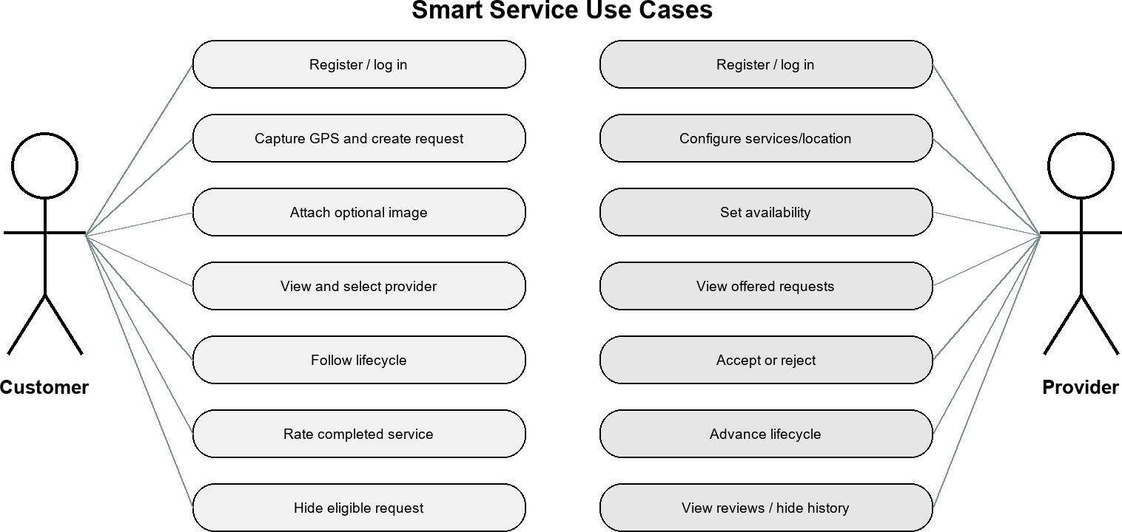

Figure 3-1. Customer and provider use-case diagram.

System Architecture

The architecture in Figure 3-2 has four principal runtime elements. The Expo client

owns presentation, navigation, permission prompts, transient form state, secure token storage, and polling. The Express API owns validation, authorization, workflow rules, analysis, and response shaping. MongoDB Atlas stores structured entities and supports spherical proximity operations. The backend uploads directory stores the optional image file and is exposed through a static Express route. No database URI or JWT secret is included in the mobile environment.

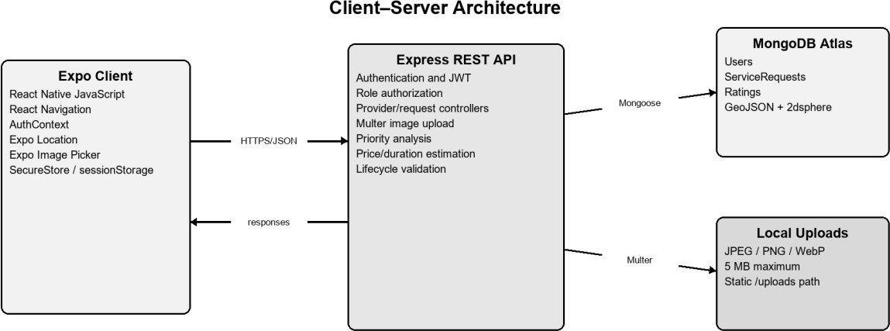

Figure 3-2. Smart Service client–server system architecture.
Communication uses JSON for ordinary requests and multipart/form-data when a service request includes an image. The mobile client sends only latitude and longitude; the server constructs the GeoJSON point. Protected requests carry the JWT in the Authorization header as a Bearer token. CORS is enabled for development. Production deployment would additionally require HTTPS, restrictive CORS origins, managed object storage, monitoring, backup policy, and secret management.

Class Diagrams

Because the implementation uses JavaScript modules and Mongoose rather than a classical object-oriented hierarchy, Figure 3-3 is a domain-oriented class diagram. It shows
stored model properties and the application services that operate on them. Password is excluded from normal queries. ServiceRequest contains both workflow state and immutable analysis outputs generated at creation time; old requests without estimates are displayed as unavailable rather than silently migrated.

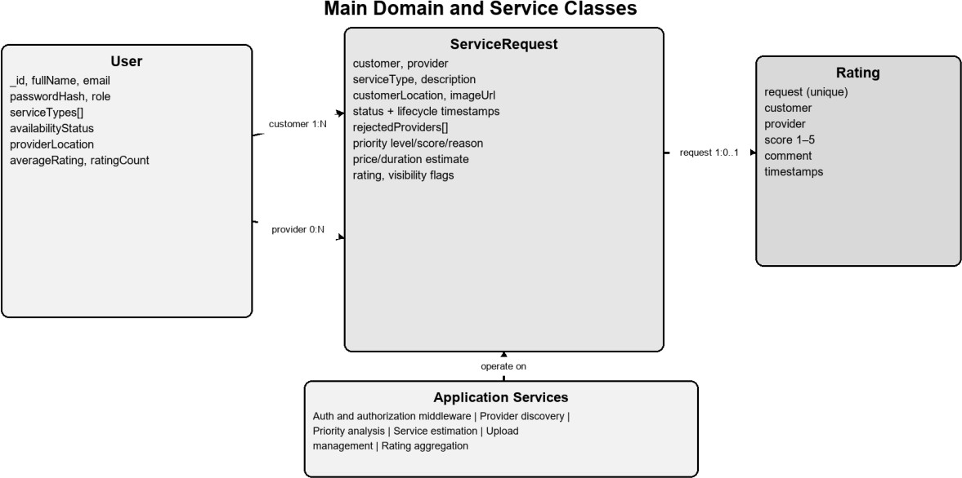

Figure 3-3. Main class and domain-model diagram.

Sequence Diagrams

Figure 3-4 models the primary request sequence. The customer client sends the
validated request to Express, which computes priority and estimate, creates GeoJSON, and stores the document. Provider discovery invokes a spherical MongoDB aggregation. Selection creates an offer for one provider; the provider’s separate navigation then obtains that offer. Subsequent acceptance, rejection, lifecycle, and rating operations follow the same authenticated API boundary.

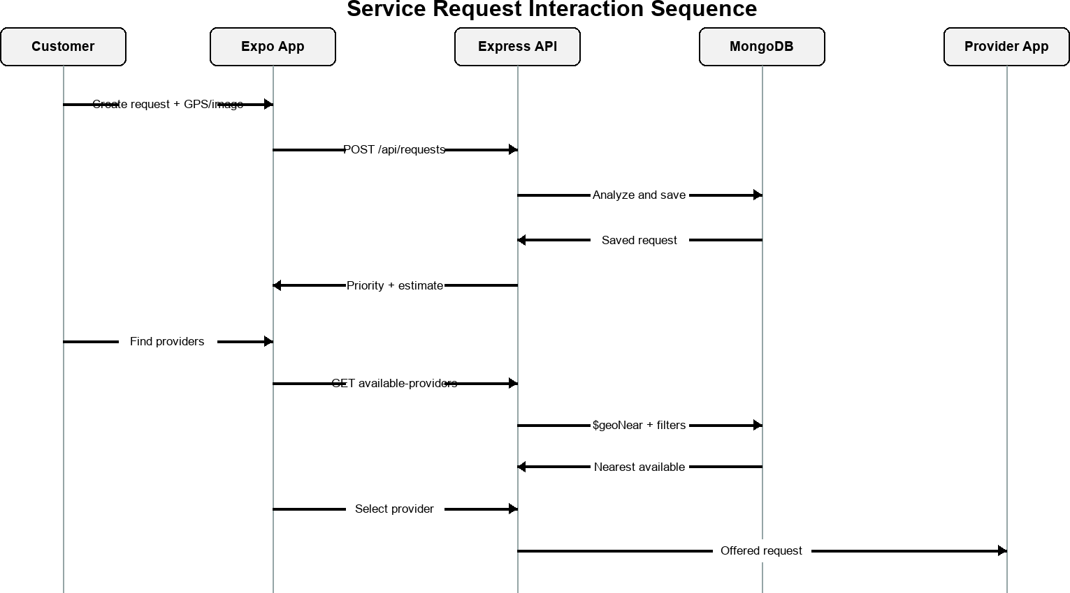

Figure 3-4. Service-request interaction sequence diagram.

Activity Diagrams

The activity diagram in Figure 3-5 emphasizes state validity. Pending and rejected

requests with no provider may enter provider selection. A selected request becomes offered. Rejection clears the provider, preserves rejection history, and lets the customer search again. Acceptance begins the one-way operational sequence. The controller rejects skipped, reversed, repeated, completed, cancelled, or foreign-provider transitions by requiring the expected current status in the database update condition.

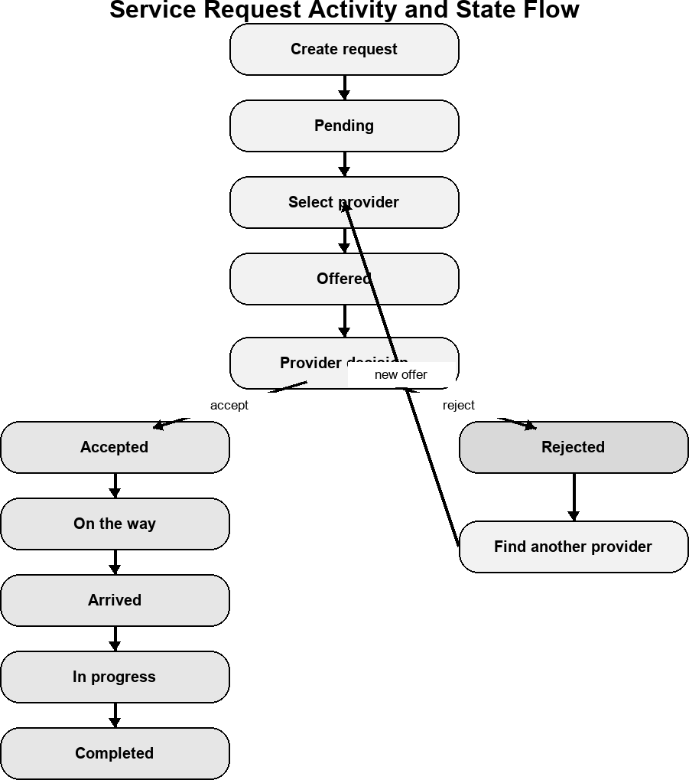

Figure 3-5. Service-request lifecycle activity diagram.

Entity-Relationship Diagrams

Figure 3-6 presents the logical relationships among the three MongoDB collections. A

User may create many ServiceRequests as a customer and may be assigned many as a provider. Each completed request can have zero or one Rating because the rating request reference is unique. Rating redundantly stores the customer and provider references to support ownership validation and provider aggregation. Geospatial point fields on User and ServiceRequest have 2dsphere indexes.

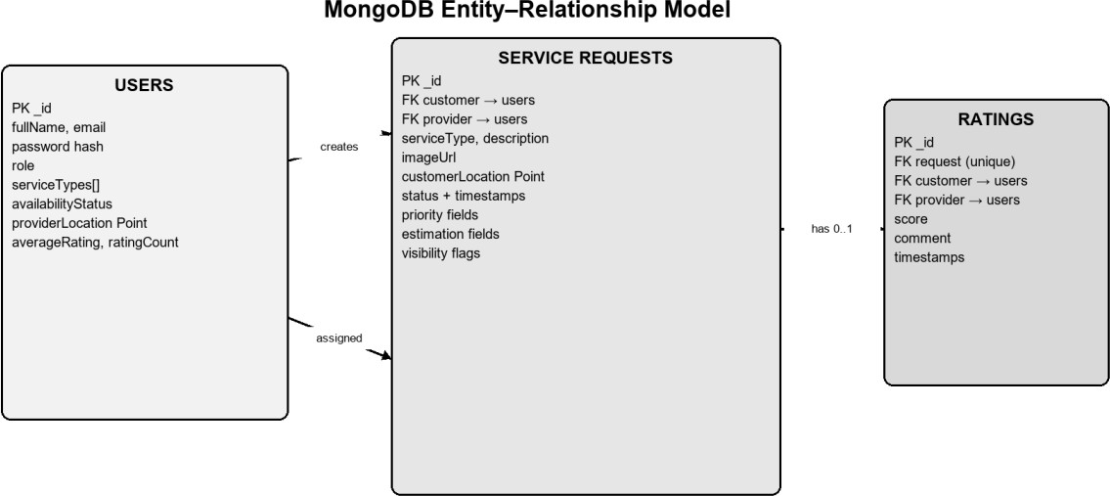

Figure 3-6. MongoDB entity-relationship diagram.

Non-Technical Aspects

Financial Viability

The current system is an academic prototype, so the analysis distinguishes cash expenditure from student development effort. Open-source frameworks, Expo development tooling, a MongoDB Atlas free tier, and local image storage can support demonstration without license fees. Table 3-4 uses conservative planning assumptions rather than invoices
or guaranteed production costs. A real deployment would require revised estimates for hosting, managed storage, domain, monitoring, support, verification, insurance, and legal compliance.

Table 3-4. Prototype financial assumptions.

Cost item | Prototype  assumption (USD) | Basis
Software frameworks and  development tools | 0 | Open-source/community  tooling
MongoDB Atlas prototype  database | 0 | Free-tier academic prototype  assumption
Local upload storage | 0 | Development computer only
Connectivity and electricity | 150 | Planning allowance across  development
Contingency | 100 | Unexpected prototype expenses

Cost item | Prototype  assumption (USD) | Basis
Total estimated cash cost | 250 | Excludes student labor and  production operation
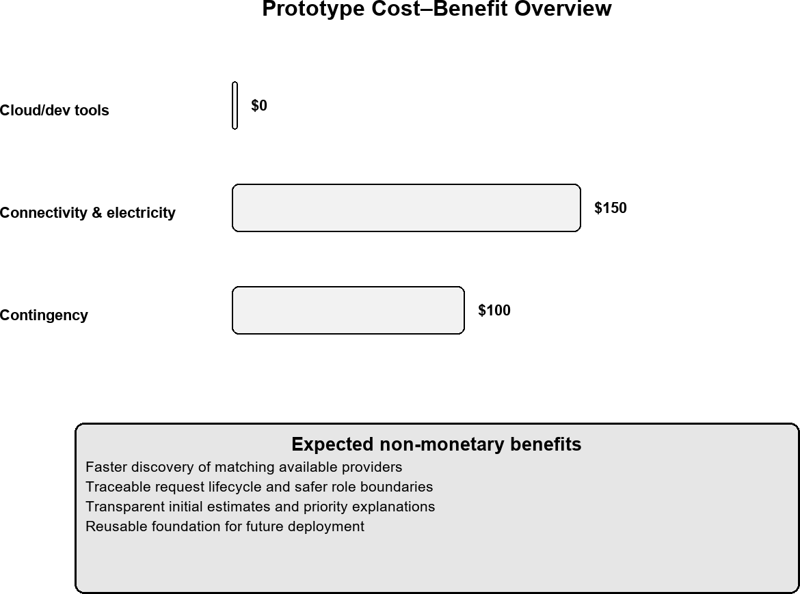

Figure 3-7. Prototype cost–benefit overview.
Figure 3-7 illustrates the prototype cost-benefit overview derived from the assumptions in Table 3-4.

Stakeholders

Table 3-5. Principal stakeholders.
Stakeholder | Interest/benefit | Potential concern
Customers | Faster access to relevant  providers and visible progress | Location/privacy, estimate  accuracy, service quality
Service providers | Relevant nearby requests and  reputation history | Fair visibility, safety, workload,  rejection history
Project team | Academic learning and  maintainable system design | Scope, testing, security  responsibilities
University/supervis  or | Evidence of engineering  analysis and implementation | Accuracy, ethics, originality,  documentation
Future operator | Platform continuity and support | Compliance, hosting cost,  moderation, incident response

Table 3-5 identifies the principal project stakeholders and their interests.

Customers and providers should both have a voice in future usability and safety decisions. Provider visibility rules should be transparent, while customers should understand why location and request information are collected. Any later commercial operator would need formal complaint, verification, moderation, and incident-response processes.

Scope

The implemented scope includes registration, login, session restoration, role navigation, provider services and availability, one-time customer/provider GPS capture, request creation with one optional local image, geospatial discovery, customer selection, provider acceptance/rejection, lifecycle control, automatic five-second refresh, ratings, explainable priority, explainable initial price/duration, and per-user historical cleanup.
The scope explicitly excludes Google Maps, route or traffic ETA, continuous tracking, Socket.IO, push notifications, chat, payment, Cloudinary, Firebase, OpenAI API calls, automatic provider selection, automatic charging, professional licensing verification, and production deployment operations. These items must not be interpreted as completed components.

Risks

Table 3-6. Principal project risks and mitigations.
Table 3-6 summarizes the principal project risks and proposed mitigations.

Risk | Effect | Current/future mitigation
Incorrect or denied  GPS | No useful nearby result | Clear permission errors; recapture;  server validation
Stale availability | Unavailable provider  displayed | Profile reload on focus; acceptance  marks busy
Network  interruption | Lists cannot refresh | Keep existing data; non-blocking  message; retry polling
Concurrent actions | Conflicting  provider/status updates | Atomic expected-state database  filters
Rule false  positive/negative | Misleading priority or  estimate | Explain rules; bounds; professional  confirmation
Local upload  growth | Disk exhaustion/loss | 5 MB limit; migrate to managed  storage in production
Credential/token  compromise | Unauthorized access | bcrypt, JWT verification,  SecureStore, HTTPS future requirement
Privacy exposure | Personal/location harm | Minimize returned fields; no exact  provider location in discovery

Schedule and Milestones

Table 3-7. Schedule and milestone summary.
Table 3-7 summarizes the implementation schedule and milestone plan.

Period | Milestone | Principal output
Sep–Oct 2025 | Requirements and interface  foundation | Scope, navigation, guest/auth  screens

Period | Milestone | Principal output
Nov–Dec 2025 | Backend and database  foundation | Express, authentication, MongoDB
Jan–Feb 2026 | Provider and request  location | Profiles, GPS, GeoJSON requests
Feb–Mar 2026 | Discovery and provider  workflow | Nearby filtering, selection,  accept/reject
Mar–Apr 2026 | Lifecycle and feedback | Status progression, polling, ratings
Apr–May 2026 | Media and explainable  analysis | Images, priority, price/duration  estimate
May–Jun 2026 | Verification and  documentation | Automated tests, report,  demonstration preparation
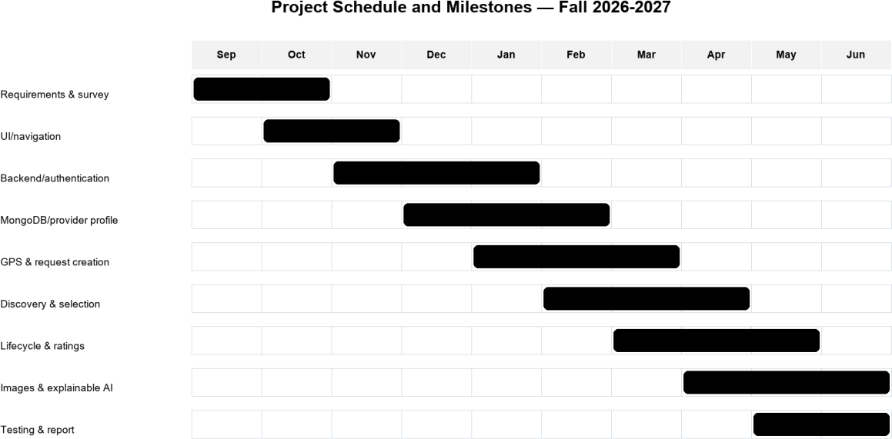

Figure 3-8. Project schedule and milestones.
Figure 3-8 visualizes the planned sequence of project tasks and milestones.

Ethical and Social Considerations

The most important ethical requirement is that analysis supports rather than replaces human judgment. A keyword match may assist triage, but it cannot confirm electrical safety, diagnose a pipe, determine labor difficulty, or establish a binding price. For that reason, Smart Service presents a reason and a final-price warning, preserves customer provider choice, and requires provider inspection. Future evaluation should measure false classifications in both English and Arabic and involve qualified service professionals.
Location and customer descriptions can reveal sensitive household information. The system therefore requests foreground location only, performs no continuous tracking, sends only the current coordinate pair, withholds exact provider coordinates before selection, and
avoids returning customer email or exact location in offered-request summaries. Production use would require a privacy notice, retention policy, deletion policy, legal review, provider/customer safety processes, and stronger identity verification.
Ratings can improve trust but can also create unfair reputational effects. The current design restricts a rating to the owning customer and one completed request. Future governance should include review moderation, dispute handling, bias monitoring, and safeguards against retaliation or manipulation.

Environmental and Sustainability Considerations

The prototype has limited direct material impact because it is software and reuses existing mobile phones and cloud infrastructure. Digital requests may reduce unnecessary calls or exploratory travel by showing nearby matching providers; however, this benefit has not been quantitatively measured. Cloud computation, mobile networking, stored images, and device charging still consume energy. Sustainable development measures include limiting image size, avoiding continuous GPS, keeping rule analysis computationally small, deleting unnecessary temporary files, and selecting efficient hosting appropriate to actual demand.

Relevant Standards

Table 3-8. Relevant standards and guidance.
Table 3-8 identifies the standards and guidance relevant to implementation and evaluation.

Standard/guidance | Relevance to Smart Service | Current application
IETF RFC 7519 —  JWT | Compact authenticated claims  representation | Seven-day tokens with user  ID and role
IETF RFC 7946 —  GeoJSON | Interoperable geographic  geometry | Point coordinates stored  longitude, latitude
MongoDB 2dsphere  guidance | Spherical proximity and  indexing | Provider/request indexes  and $geoNear
OWASP Password  Storage | Adaptive salted password  hashing | bcryptjs work factor 12
W3C WCAG 2.2 | Perceivable, operable,  understandable, robust UI | Accessible roles/status  labels partly applied; full audit future
HTTP/REST  conventions | Method, status, resource-  oriented API behavior | GET, POST, PATCH and  safe status codes

Compliance is not claimed solely because a technology or guideline is referenced. The table identifies design relevance and current alignment. Formal conformance testing, penetration testing, accessibility evaluation, privacy impact assessment, and production operational controls remain future work.

Conclusion

The design combines role-specific Expo navigation, a protected Express API, MongoDB geospatial persistence, deterministic analysis, and an explicit service lifecycle. Ownership and expected-state conditions protect shared requests, while safe response formatting limits unnecessary personal data. The diagrams and tables demonstrate that each major interface action has a corresponding server responsibility and stored-domain representation. The design remains intentionally bounded: it supports an academic prototype and future extension without presenting maps, real-time sockets, payment, or generative AI as completed features.

CHAPTER 4

IMPLEMENTATION AND TESTING

Introduction
This chapter presents the implemented Smart Service interfaces and verifies the principal customer and service-provider workflows. The mobile client is implemented with React Native and Expo, while the backend uses Node.js, Express, MongoDB Atlas, JSON Web Tokens, Socket.IO, and protected role-based endpoints. The screenshots in this chapter were captured from the implemented Expo interface; sensitive values such as passwords, tokens, database credentials, and API keys are not shown.

Authentication Interfaces
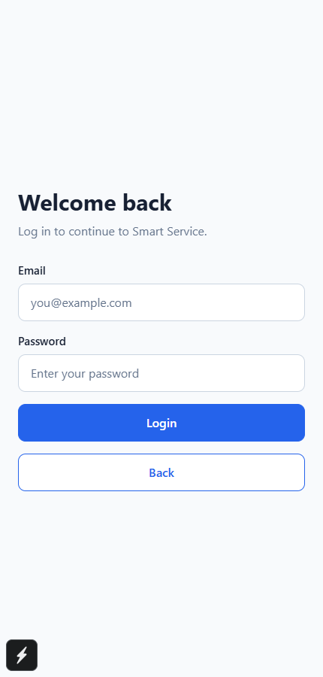
Figure 4-1. Smart Service login interface.
Figure 4-1 shows the login form used by both customers and service providers. The password remains concealed, and successful authentication establishes the role-specific application session.
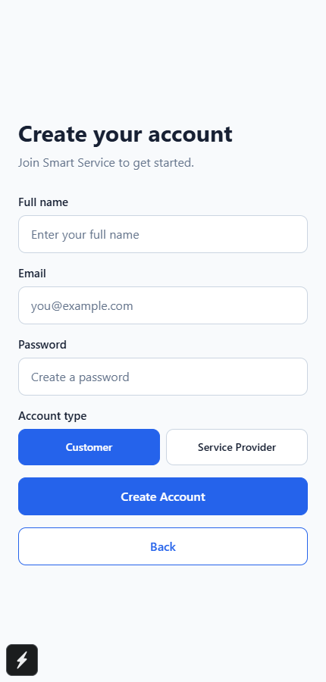
Figure 4-2. Smart Service account-registration interface.
Figure 4-2 shows registration with full name, email, password, and account-role selection. Server-side validation and password hashing are applied before the user record is stored.

Customer Workflow
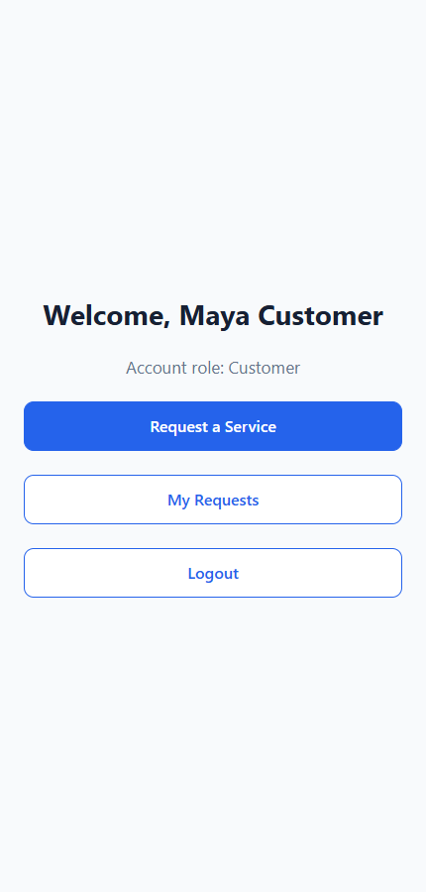
Figure 4-3. Customer home interface.
Figure 4-3 presents the customer entry point for creating a service request or reviewing existing requests.
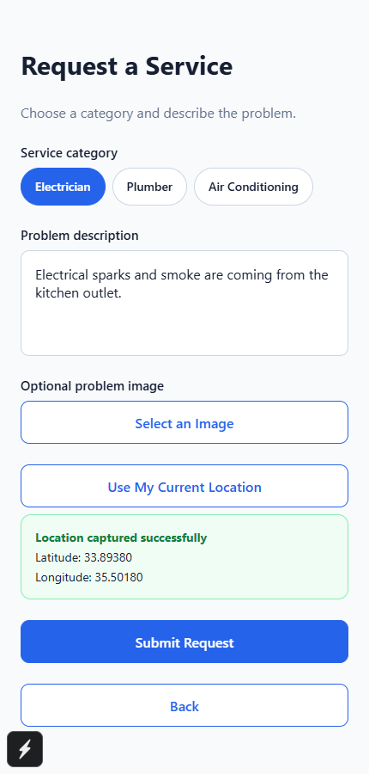
Figure 4-4. GPS-enabled service-request creation interface.
Figure 4-4 shows category selection, the problem description, optional image input, and one-time GPS capture. The client sends latitude and longitude, while the server constructs the GeoJSON point in longitude-latitude order.
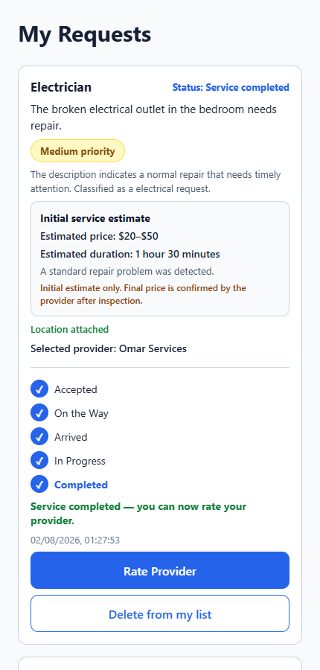
Figure 4-5. Customer request list with AI-assisted analysis and lifecycle state.
Figure 4-5 displays request priority, the explainable initial price and duration estimate, provider information, and lifecycle progress. The analysis supports decision awareness but never assigns a provider or confirms a final charge.
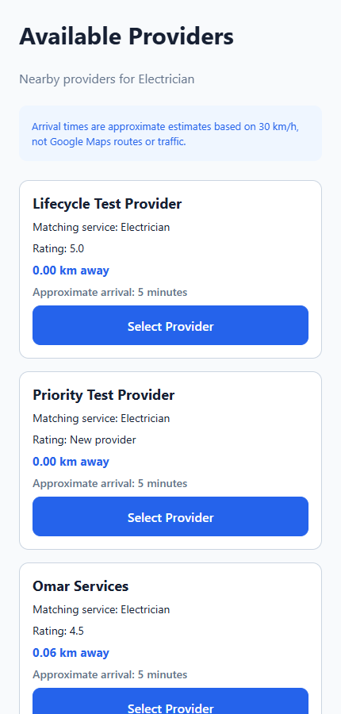
Figure 4-6. Nearby available-provider discovery interface.
Figure 4-6 presents matching providers returned by the protected geospatial query. Exact provider coordinates and email addresses are excluded; only safe profile data, straight-line distance, and an approximate arrival estimate are displayed.
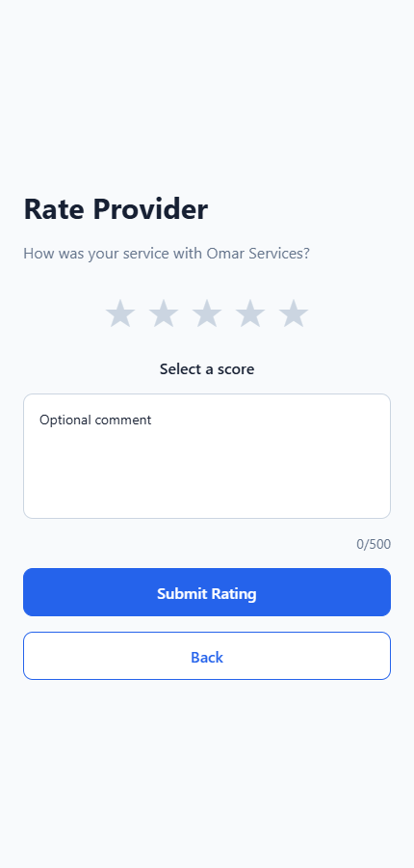
Figure 4-7. Completed-service rating and review interface.
Figure 4-7 allows the owning customer to submit one score and an optional comment after service completion.

Service-Provider Workflow
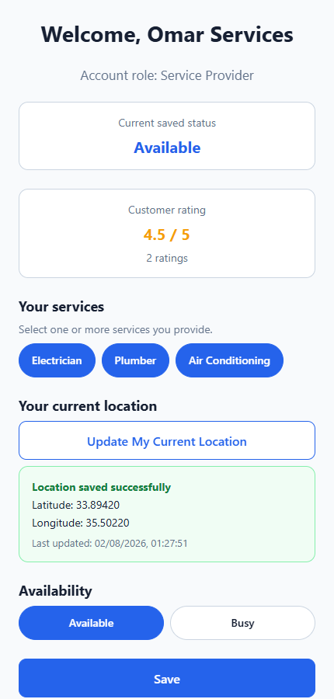
Figure 4-8. Service-provider profile and availability interface.
Figure 4-8 shows service selection, saved GPS location, current rating, availability controls, and navigation to incoming work and reviews.
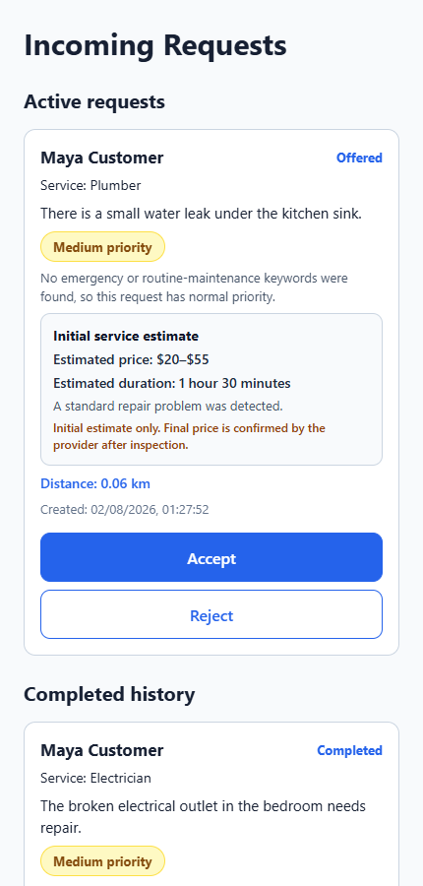
Figure 4-9. Provider incoming and active request interface.
Figure 4-9 shows incoming offers and active service requests. Only the assigned provider can accept, reject, or advance a request through the permitted lifecycle.

Figure 4-10. Provider reviews interface.
Figure 4-10 presents the provider's average rating, rating count, and privacy-safe customer reviews.

Real-Time Communication and Location Sharing
Socket.IO supplements the five-second polling fallback with immediate request events. Authenticated sockets join only authorized user and request rooms. During an accepted active request, the assigned provider may explicitly start foreground location sharing. The customer map displays the customer and provider markers only while sharing is active and the latest update is recent. Stopping sharing, completing the request, or normal provider logout clears only the request's temporary live location; the provider's profile location remains available for future discovery. Express routing is implemented through protected route modules [15].

Testing Summary
Testing covered validation, authentication, role authorization, geospatial discovery, rejection history, atomic lifecycle transitions, request cleanup, priority analysis in English and Arabic, service estimation, Socket.IO authorization, live-location privacy, push-notification construction, and duplicate-action protection. Interface review also considered readable labels, responsive scrolling, safe-area spacing, and accessibility guidance [14]. Integration tests that require MongoDB Atlas must be executed from an IP address included in the Atlas project access list.
Test area | Expected result | Observed result
Authentication and authorization | Invalid access is rejected | Passed
Provider discovery | Only available, matching, nearby providers appear | Passed
Request lifecycle | Transitions follow the enforced order | Passed
Real-time rooms | Only authorized participants receive events | Passed
Priority and estimation | English and Arabic rules return bounded explanations | Passed
Location privacy | Temporary location is cleared when sharing stops | Passed
Table 4-1. Summary of principal implementation tests.
Table 4-1 summarizes the principal functional and security-oriented checks performed on the implemented system.

Conclusion
The implemented interfaces demonstrate the complete Smart Service workflow from authentication and request creation to provider discovery, controlled lifecycle progression, optional live tracking, completion, and customer feedback. Real-time events improve responsiveness, while polling remains a resilient fallback.

CHAPTER 5

CONCLUSION AND FUTURE WORK

Conclusion
Smart Service demonstrates a role-aware mobile marketplace for electricians, plumbers, and air-conditioning providers. The system combines protected authentication, customer-controlled provider selection, GeoJSON-based discovery, explainable request prioritization and estimation, atomic lifecycle transitions, Socket.IO updates, optional live location sharing, push notifications, and post-completion ratings. The implementation preserves human decision authority: customers select providers, providers accept work and confirm final service conditions, and the rule-based analysis remains transparent and non-binding.

Future Work
Future work may include production cloud image storage, road-network routing and traffic-aware arrival estimates, stronger provider verification, multilingual expansion, accessibility testing with assistive technologies, notification-delivery monitoring, deployment automation, and broader usability and performance evaluation. Payment, chat, and generative-AI assistance should be considered only after appropriate privacy, security, moderation, and user-consent requirements are defined.

REFERENCES
{{BIBLIOGRAPHY_FIELD}}

