SMART SERVICE: AN AI-ASSISTED MOBILE APPLICATION FOR
CONNECTING CUSTOMERS WITH SERVICE PROVIDERS
Senior Project
by
Mira Youssef, 72030174
Hussein Mansour, 42030321
Submitted to the School of Engineering of the
Lebanese International University
Nabatieh, Lebanon
in partial fulfillment of the requirements for the degree of
BACHELOR OF SCIENCE IN COMPUTER AND COMMUNICATION
ENGINEERING
Fall 2026-2027
Approved by:
Supervisor | Committee Member
Dr. Hussein Abdallah | ________________________

DEDICATION
Mira Youssef dedicates this work to her family, whose patience, encouragement, and confidence made every difficult stage achievable, and to every learner who turns persistence into meaningful engineering.
Mira Youssef
Hussein Mansour dedicates this project to his family and mentors for their constant support, and to all service professionals whose daily work inspired the purpose and practical direction of Smart Service.
Hussein Mansour

ACKNOWLEDGMENT
We express our sincere gratitude to our supervisor, Dr. Hussein Abdallah, for his guidance, constructive observations, and continued encouragement throughout the development of this graduation project. We also thank the faculty members of the School of Engineering at the Lebanese International University for the technical foundation and academic discipline that supported this work. Finally, we acknowledge our families and colleagues for their patience, feedback, and motivation during the design, implementation, testing, and documentation of Smart Service.

ABSTRACT
Smart Service is an AI-assisted mobile application that connects customers who require household maintenance with nearby service providers in three initial categories: electrical work, plumbing, and air-conditioning. The system consists of a JavaScript React Native application developed with Expo, a Node.js and Express REST API, and a MongoDB Atlas database. Customers can register, authenticate, capture their current GPS location, describe a problem, attach an optional image, and discover available providers who offer the required service within a configurable radius. Results are ordered by straight-line distance and show provider ratings and an approximate arrival time. The customer retains the decision to select a provider, while the provider may accept or reject the offer and advance an accepted request through controlled lifecycle states. Completed services can be rated, and both participants can remove eligible historical requests from their own lists through soft deletion. Two explainable rule-based analysis modules classify urgency and produce an initial price range and duration estimate from the service type and bilingual English/Arabic descriptions. These modules do not select a provider, charge a customer, or replace professional inspection. The implemented prototype demonstrates role-based authentication, geospatial filtering, state validation, local image handling, feedback aggregation, and transparent decision support in a unified mobile workflow.

TABLE OF CONTENTS
DEDICATION 2
ACKNOWLEDGMENT 3
ABSTRACT 4
TABLE OF CONTENTS 5
LIST OF FIGURES 7
LIST OF TABLES 8
LIST OF SYMBOLS AND ABBREVIATIONS 9
CHAPTER 1 INTRODUCTION 10
1.1 Background 10
1.2 Problem Statement 11
1.3 General Overview of the Project 12
1.4 Thesis Outline 17
CHAPTER 2 SURVEY OF EXISTING METHODS AND SIMILAR SYSTEMS 19
2.1 Introduction 19
2.2 Similar System 1: Taskrabbit 19
2.3 Similar System 2: Angi 20
2.4 Similar System 3: Urban Company 20
2.5 Methods/Systems Comparison 21
2.6 Conclusion and Motivation 22
CHAPTER 3 SYSTEM DESIGN 23
3.1 Introduction 23
3.2 Requirements and Specification Analysis 23
3.2.1 Functional Requirements 23
3.2.2 Use Case Diagrams 25
3.3 System Architecture 25
3.4 Class Diagrams 26
3.5 Sequence Diagrams 27
3.6 Activity Diagrams 28
3.7 Entity-Relationship Diagrams 29
3.8 Non-Technical Aspects 30
3.8.1 Financial Viability 30
3.8.2 Stakeholders 31
3.8.3 Scope 32
3.8.4 Risks 32
3.8.5 Schedule and Milestones 32
3.8.6 Ethical and Social Considerations 33
3.8.7 Environmental and Sustainability Considerations 34
3.8.8 Relevant Standards 34
3.9 Conclusion 35
REFERENCES 36

LIST OF FIGURES
Figure 1-1. Guest access, registration, and login interfaces. 13
Figure 1-2. Customer home, GPS-enabled request creation, and request list. 14
Figure 1-3. Nearby available-provider discovery with distance and approximate arrival. 15
Figure 1-4. Customer rating and provider review interfaces. 17
Figure 1-5. Provider profile configuration and incoming-request interface. 16
Figure 3-1. Customer and provider use-case diagram. 25
Figure 3-2. Smart Service client–server system architecture. 26
Figure 3-3. Main class and domain-model diagram. 27
Figure 3-4. Service-request interaction sequence diagram. 28
Figure 3-5. Service-request lifecycle activity diagram. 29
Figure 3-6. MongoDB entity-relationship diagram. 30
Figure 3-7. Prototype cost–benefit overview. 31
Figure 3-8. Project schedule and milestones. 33

LIST OF TABLES
Table 2-1. Comparison based on graphical interface and usability. 21
Table 2-2. Comparison based on content and functionality. 21
Table 2-3. Comparison based on core features. 22
Table 3-1. Customer functional requirements. 23
Table 3-2. Provider functional requirements. 24
Table 3-3. Server functional requirements. 24
Table 3-4. Principal stakeholders. 31
Table 3-5. Prototype financial assumptions. 30
Table 3-6. Principal project risks and mitigations. 32
Table 3-7. Schedule and milestone summary. 32
Table 3-8. Relevant standards and guidance. 34

LIST OF SYMBOLS AND ABBREVIATIONS
AI — Artificial Intelligence
API — Application Programming Interface
DB — Database
ERD — Entity–Relationship Diagram
GPS — Global Positioning System
HTTP — Hypertext Transfer Protocol
JWT — JSON Web Token
LIU — Lebanese International University
REST — Representational State Transfer
UI — User Interface
UML — Unified Modeling Language
URL — Uniform Resource Locator

CHAPTER 1 INTRODUCTION

1.1 Background
Mobile service marketplaces reduce the effort required to identify, compare, and contact people who provide work at a customer’s location. Instead of depending only on informal recommendations, a customer can describe a need through a structured interface and review information about matching providers. Established marketplaces demonstrate that provider skills, availability, price information, location, and reviews are central to service discovery. Taskrabbit, for example, officially describes a flow in which customers choose a category, enter an address, compare profiles by skills, hourly rate, and reviews, and then select a Tasker [1]. Angi similarly supports researching local professionals, booking services, requesting quotes, and consulting cost information [2].
A cross-platform mobile architecture is appropriate for such a system because the same interface must support customers and providers on multiple devices. React Native allows application interfaces to be expressed through React components while targeting native platforms [3]. Expo adds managed access to device capabilities; its Location module supports foreground permission requests and current-position acquisition [4]. Smart Service uses these capabilities for one-time coordinate capture rather than continuous tracking.
Location-aware discovery requires a consistent geographic data representation. GeoJSON represents a point using longitude followed by latitude, and RFC 7946 defines the interoperable format [5]. MongoDB supports GeoJSON points, spherical distance calculations, and 2dsphere indexes; its $geoNear stage can return an ordered stream based on proximity [6]. These facilities allow Smart Service to filter by role, selected service, current availability, valid location, rejection history, and a configurable radius before sorting candidates by straight-line distance.
Security and traceability are also necessary because request data belongs to identifiable participants. Smart Service hashes passwords using bcrypt and issues seven-day JSON Web Tokens containing only the user identifier and role. RFC 7519 defines JWT as a compact claims representation [7], while OWASP advises that passwords should be stored with deliberately slow password-hashing algorithms rather than as plaintext [8]. Role middleware separates customer-only and provider-only operations, and lifecycle updates use expected-state checks to prevent skipping or repeating transitions.
The term AI-assisted in this project refers to explainable, deterministic analysis rather than generative AI. English and Arabic problem descriptions are normalized and evaluated against configured indicators. One service assigns a priority level and reason; another assigns a bounded initial price range, duration, currency, and explanation. Urgent wording by itself does not raise the price. The provider must inspect the problem and confirm the final price, and the customer always chooses the provider.

1.2 Problem Statement
Customers who need electricians, plumbers, or air-conditioning technicians may face fragmented information about who is currently available, what services each person offers, how far away the provider is, and whether earlier customers were satisfied. A simple directory does not represent the operational state of a request, while direct messaging alone does not enforce a reliable sequence from an offer to completion. Providers likewise need a concise mechanism to state their offered services and availability, receive relevant work, and avoid being shown for categories they do not perform.
The project problem is therefore to design a role-aware mobile system that creates a trustworthy, inspectable connection between a customer request and an eligible nearby provider. The system must preserve customer choice, disclose only safe information before acceptance, prevent unauthorized status changes, and keep both participants informed despite the absence of real-time sockets. It must also handle device location permission, inconsistent connectivity, duplicate actions, rejected offers, historical cleanup, and optional images without exposing passwords, tokens, database credentials, or exact provider coordinates in discovery results.
A secondary problem is that free-text descriptions vary in language and detail. A severe flood or electrical sparks should be visually distinguished from routine maintenance, but a software estimate must not pretend to replace professional judgment. Smart Service addresses this with transparent keyword rules, bounded outputs, human-readable reasons, and explicit warnings. The analysis prioritizes requests for provider presentation; it does not automatically assign a provider, authorize payment, or establish a final service price.

1.3 General Overview of the Project
Smart Service has two authenticated roles. A customer registers or logs in, selects electrician, plumber, or air-conditioning service, writes a meaningful description, optionally selects one JPEG, PNG, or WebP image, and captures a foreground GPS position. When the backend creates the request, it constructs the GeoJSON location, performs priority and service estimation, and stores the results. The customer’s request list displays status, analysis, estimate, location presence, provider information, lifecycle progress, rating state, and eligible cleanup actions.
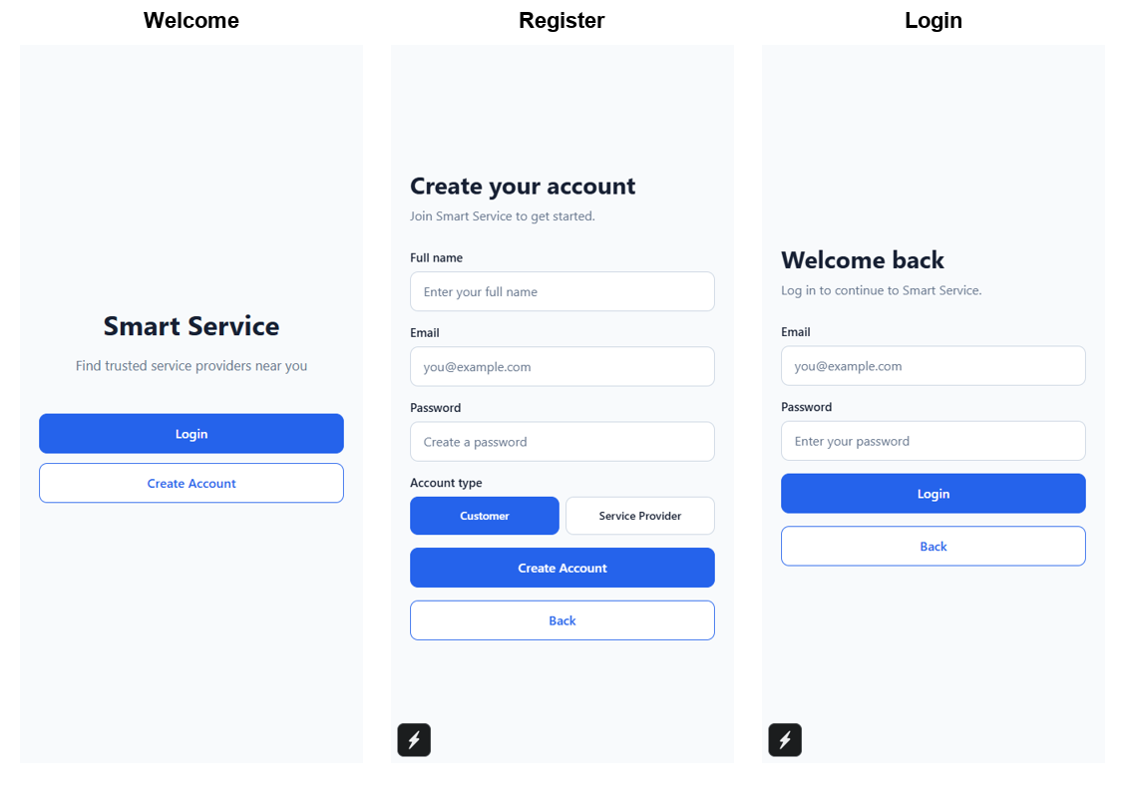
Figure 1-1. Guest access, registration, and login interfaces.
Figure 1-1 shows the genuine Expo Web guest workflow used by both account types. The navigation tree is replaced after authentication, so an authenticated user cannot return to Login through the Back action. Tokens use SecureStore on Android and iOS and sessionStorage only as a web-development fallback.
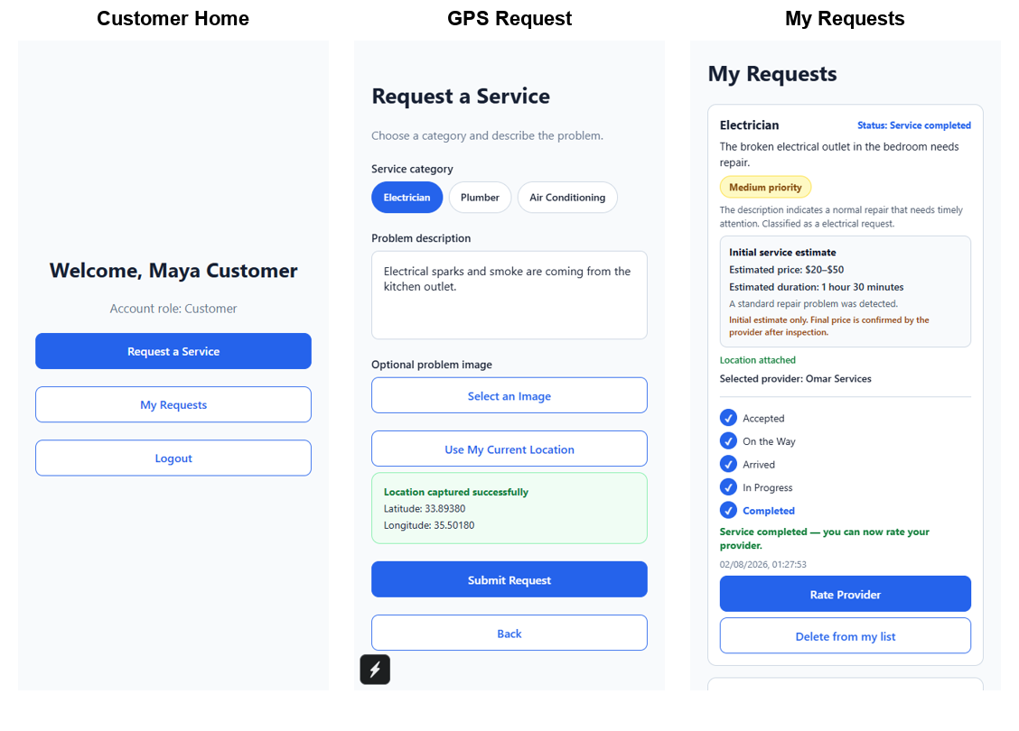
Figure 1-2. Customer home, GPS-enabled request creation, and request list.
As illustrated in Figure 1-2, the customer workflow combines service selection, optional image input, one-time GPS capture, and a request list. New requests require valid coordinates, but older database records with null locations remain valid. Background polling refreshes request information every five seconds while the list screen is focused and stops when the screen loses focus.
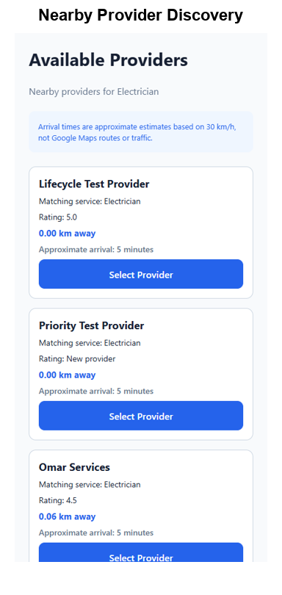
Figure 1-3. Nearby available-provider discovery with distance and approximate arrival.
The discovery result in Figure 1-3 includes only providers with the provider role, available status, matching service, valid location, and no previous rejection for that request. Exact provider coordinates and email are withheld. Distance is calculated by MongoDB, and arrival time is a clearly labeled approximation based on 30 km/h with a five-minute minimum; it is not a route or traffic prediction.
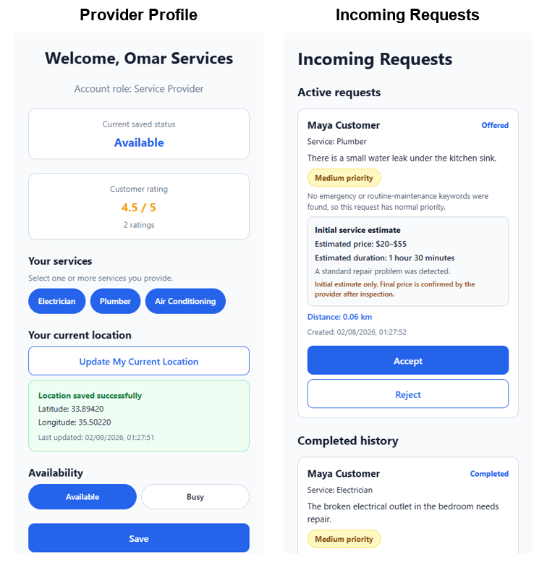
Figure 1-5. Provider profile configuration and incoming-request interface.
The provider profile and incoming-request views appear in Figure 1-5. A provider must save at least one service and a location before becoming available. Offered requests may be accepted or rejected. Acceptance marks the provider busy; rejection preserves history and permits the customer to find another provider. Accepted work advances only through accepted, on the way, arrived, in progress, and completed. Completion can restore availability when service and location requirements remain satisfied.
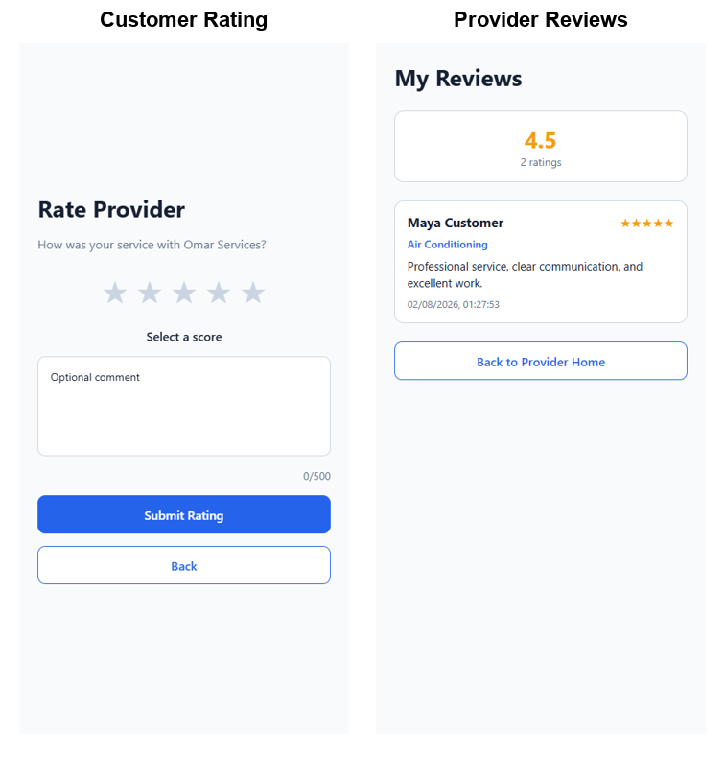
Figure 1-4. Customer rating and provider review interfaces.
After completion, the owning customer may submit one score from one to five and an optional comment. The backend prevents duplicate ratings, records the rating reference, and recalculates the provider average to one decimal place. Figure 1-4 shows the rating and provider-review interfaces. Neither participant permanently deletes the shared request through list cleanup; separate hidden flags remove eligible rejected, completed, or cancelled records only from that participant’s view.

1.4 Thesis Outline
This preliminary report contains three completed chapters. Chapter 1 introduces the service-marketplace problem, project objectives, implemented scope, and principal technologies. Chapter 2 surveys Taskrabbit, Angi, and Urban Company using official information, then compares their documented functions with Smart Service. Chapter 3 specifies functional requirements, diagrams the implemented architecture and data model, explains the request workflow, and examines financial, stakeholder, scope, risk, schedule, ethical, environmental, and standards considerations. Implementation testing and final conclusions will be addressed in later report stages and are intentionally not presented as Chapters 4 and 5 here.

CHAPTER 2 SURVEY OF EXISTING METHODS AND SIMILAR SYSTEMS

2.1 Introduction
This chapter reviews three established home-service marketplaces to identify common interaction patterns and unresolved design opportunities. Only capabilities established by the reviewed official sources are treated as verified. A blank or “Not established” comparison entry means that the selected source did not provide sufficient evidence; it does not prove that the commercial system lacks the feature.

2.2 Similar System 1: Taskrabbit
Taskrabbit connects customers with independent Taskers across multiple service categories. Its official hiring guidance instructs customers to select a category, provide the task address, review local Tasker profiles, and compare skills, experience, hourly rates, and category-specific reviews before selecting a Tasker [1]. The platform supports scheduling and task details, and its public overview describes integrated chat, payment, tipping, and reviews [9].
Taskrabbit strongly demonstrates customer-directed provider selection and profile comparison. Taskers can define skills, location, availability slots, and a work-area map [10]. Pricing is provider-controlled, while the platform may offer market-based pricing guidance [11]. The reviewed materials did not establish explainable emergency-text prioritization comparable to Smart Service, nor did they establish a bilingual rule that produces a request-specific initial duration estimate from the problem description.

2.3 Similar System 2: Angi
Angi positions itself as a platform for finding, booking, and hiring skilled home professionals, researching costs, requesting quotes, and consulting homeowner reviews [2]. Search results present professional information, ratings, and profile links. Angi also reports transparent upfront pricing for services booked and paid through its platform and supplies a project cost center based on project data [2].
The Angi workflow covers a wider home-improvement planning context than the three-category Smart Service prototype. Recent official professional guidance describes location-and-service matching between homeowner projects and professional opportunities [12]. However, the reviewed public documentation does not establish the same explicit customer-controlled offer state, provider rejection history, deterministic request priority analysis, or five-state field-service lifecycle implemented by Smart Service.

2.4 Similar System 3: Urban Company
Urban Company is a technology-enabled home-services marketplace whose stated mission includes enabling service professionals to deliver at-home services [13]. Its public material emphasizes professional enablement, training, service quality, minimum rating expectations, and on-time fulfillment. These concerns are directly relevant to provider quality and customer trust.
Urban Company illustrates a managed-service approach in which platform processes influence professional preparation and quality assurance. The reviewed official sources establish attention to ratings and fulfillment, but do not establish the same explainable bilingual keyword prioritization, customer-selected nearby-provider list, or locally stored optional request image used in the current Smart Service implementation. Smart Service remains a prototype and does not claim the scale, verification programs, support infrastructure, or commercial maturity of Urban Company.

2.5 Methods/Systems Comparison
Tables 2-1 through 2-3 compare documented characteristics. Smart Service entries are verified from the inspected source code and captured running interface. Commercial-system entries are deliberately conservative and are limited to the cited official materials.
Table 2-1. Comparison based on graphical interface and usability.
Criterion | Taskrabbit | Angi | Urban Company | Smart Service
Mobile-oriented service flow | Verified | Verified | Verified | Verified Expo UI
Provider profile/ratings visible | Verified | Verified | Quality/rating emphasis | Verified
Customer directly chooses provider | Verified | Available in directory/booking flows | Not established by reviewed source | Verified
Simple role-specific navigation | Separate client/Tasker apps | Homeowner/pro experiences | Customer/professional experiences | Separate navigation trees
Accessible labels/status messages | Not assessed | Not assessed | Not assessed | Partially implemented; WCAG review remains

Table 2-2. Comparison based on content and functionality.
Criterion | Taskrabbit | Angi | Urban Company | Smart Service
Service discovery | Category/address search | Professional search and booking | At-home service marketplace | Three service categories
Location input/support | Task address and work area | Local professional matching | On-time at-home fulfillment | GPS + GeoJSON proximity
Price information | Hourly rate and pricing guidance | Upfront pricing/cost research | Service marketplace pricing | Initial rule-based range only
Reviews | Integrated reviews | Homeowner reviews | Ratings/quality thresholds | One rating per completed request
Provider workflow | Skills, work area, schedule | Professional opportunities/leads | Professional enablement | Services, location, availability, lifecycle

Table 2-3. Comparison based on core features.
Feature | Taskrabbit | Angi | Urban Company | Smart Service
GPS-distance ordered candidates | Not established | Local matching; ordering not established | Not established | Yes, MongoDB $geoNear
Provider accept/reject offer | Scheduling confirmation documented | Mutual lead interest documented | Not established | Yes
Detailed request status lifecycle | Not established | Not established | Fulfillment emphasized | Yes, five post-acceptance states
Optional problem image | Not established | Not established | Not established | Yes, local Multer upload
Emergency priority explanation | Not established | Not established | Not established | Yes, English/Arabic rules
Problem-based price/duration estimate | Pricing guidance, not equivalent | Cost/upfront pricing, not equivalent | Not established | Yes; preliminary only
Customer retains provider selection | Yes | Supported in relevant flows | Not established | Yes; AI never assigns

2.6 Conclusion and Motivation
The reviewed systems demonstrate the value of category-based search, location context, provider profiles, ratings, price information, and structured marketplace participation. Their scale and operational maturity exceed the current academic prototype. The comparison nevertheless identifies a coherent project motivation: combine transparent customer selection, provider-controlled acceptance, GPS-radius filtering, explicit lifecycle validation, bilingual emergency prioritization, and an explainable initial estimate in one inspectable workflow.
Smart Service is not intended to duplicate every commercial function. It deliberately excludes payment, chat, background-verification infrastructure, traffic routing, and automatic provider assignment. Its contribution is a focused engineering demonstration in which analysis remains explainable, authorization is role-specific, customer choice is preserved, and database state transitions can be tested directly.

CHAPTER 3 SYSTEM DESIGN

3.1 Introduction
This chapter translates the project goals into verified functional requirements and design models. The diagrams are derived from the inspected application rather than copied from the report template. They describe the deployed software boundaries, principal domain entities, API-mediated interactions, lifecycle states, and MongoDB relationships, followed by the non-technical considerations required by the template.

3.2 Requirements and Specification Analysis
Smart Service follows a role-based client–server model. Every protected API operation first verifies a Bearer JWT and then applies customer or provider authorization. Customer and provider screens share authentication state through AuthContext, while request-oriented screens reload on focus and poll every five seconds. The backend remains authoritative for ownership, coordinates, eligible providers, request state, rating uniqueness, and list visibility.

3.2.1 Functional Requirements
Table 3-1. Customer functional requirements.
ID | Customer requirement | Implementation evidence
C1 | Register and authenticate | Register/Login screens; /api/auth routes; JWT context
C2 | Capture one current location | Expo Location foreground permission
C3 | Create categorized request | POST /api/requests; service enum and description validation
C4 | Attach at most one optional image | Expo Image Picker; Multer type/size controls
C5 | View nearby matching available providers | $geoNear, 50 km default, service/status filters
C6 | Select one provider | Atomic select-provider endpoint; customer ownership
C7 | Observe provider response/lifecycle | Five-second focused polling and progress timeline
C8 | View priority and initial estimate | Shared priority badge and estimate component
C9 | Rate completed request once | Unique Rating request reference and ownership checks
C10 | Hide eligible history from own list | Per-customer soft visibility flag

Table 3-2. Provider functional requirements.
ID | Provider requirement | Implementation evidence
P1 | Register and authenticate as provider | Role enum, JWT, provider navigation
P2 | Select offered service types | Validated electrician/plumber/AC array
P3 | Save current location and availability | Provider GeoJSON endpoint and profile validation
P4 | Receive assigned offered/active requests | Provider-only request aggregation
P5 | Accept or reject offered request | Atomic response endpoint
P6 | Advance exact lifecycle order | Expected-current-status atomic update
P7 | View customer-safe request data | No pre-acceptance email/exact coordinates
P8 | View priority, estimate, and reviews | Shared analysis cards and ratings endpoint
P9 | Hide eligible history from own list | Per-provider soft visibility flag

Table 3-3. Server functional requirements.
ID | Server requirement | Implementation evidence
S1 | Authentication and role authorization | JWT middleware and authorizeRoles
S2 | Persist users, requests, ratings | Mongoose schemas and MongoDB Atlas
S3 | Validate geographic coordinates | Server builds Point [longitude, latitude]
S4 | Filter and rank providers | Role/service/status/location/rejection filters
S5 | Protect request state transitions | Atomic conditions and conflict responses
S6 | Manage images safely | Unique names, MIME allowlist, 5 MB maximum
S7 | Analyze priority and service estimate | Centralized deterministic rule services
S8 | Aggregate ratings | Provider average rounded to one decimal place

3.2.2 Use Case Diagrams
Figure 3-1 separates customer and provider goals while showing that both roles depend on the same authenticated system boundary. Provider selection remains a customer use case; analysis produces supporting information but does not execute that decision.
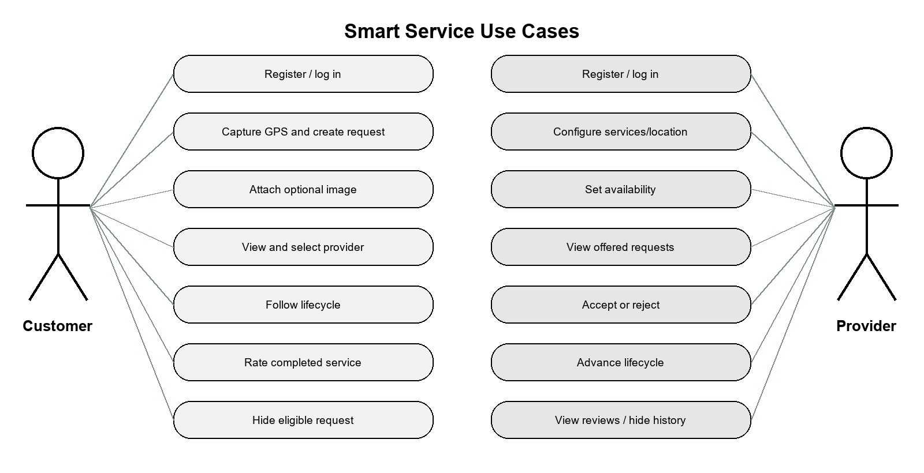
Figure 3-1. Customer and provider use-case diagram.

3.3 System Architecture
The architecture in Figure 3-2 has four principal runtime elements. The Expo client owns presentation, navigation, permission prompts, transient form state, secure token storage, and polling. The Express API owns validation, authorization, workflow rules, analysis, and response shaping. MongoDB Atlas stores structured entities and supports spherical proximity operations. The backend uploads directory stores the optional image file and is exposed through a static Express route. No database URI or JWT secret is included in the mobile environment.
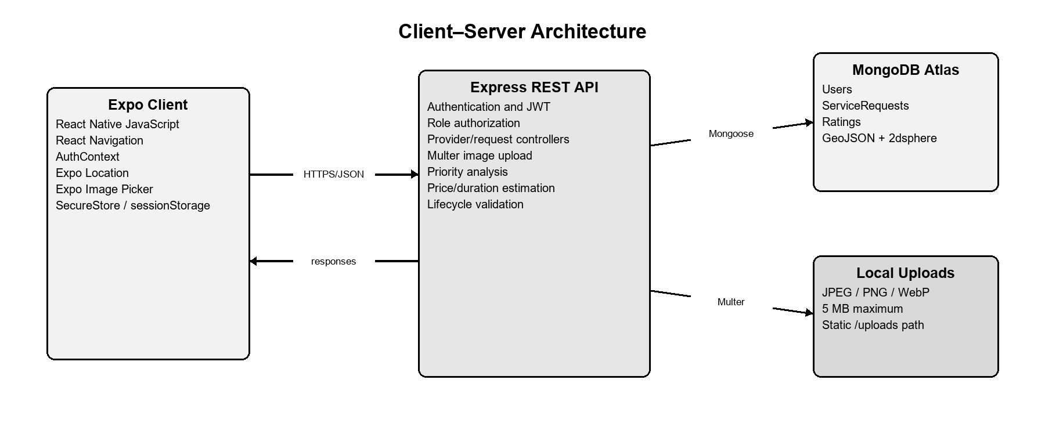
Figure 3-2. Smart Service client–server system architecture.
Communication uses JSON for ordinary requests and multipart/form-data when a service request includes an image. The mobile client sends only latitude and longitude; the server constructs the GeoJSON point. Protected requests carry the JWT in the Authorization header as a Bearer token. CORS is enabled for development. Production deployment would additionally require HTTPS, restrictive CORS origins, managed object storage, monitoring, backup policy, and secret management.

3.4 Class Diagrams
Because the implementation uses JavaScript modules and Mongoose rather than a classical object-oriented hierarchy, Figure 3-3 is a domain-oriented class diagram. It shows stored model properties and the application services that operate on them. Password is excluded from normal queries. ServiceRequest contains both workflow state and immutable analysis outputs generated at creation time; old requests without estimates are displayed as unavailable rather than silently migrated.
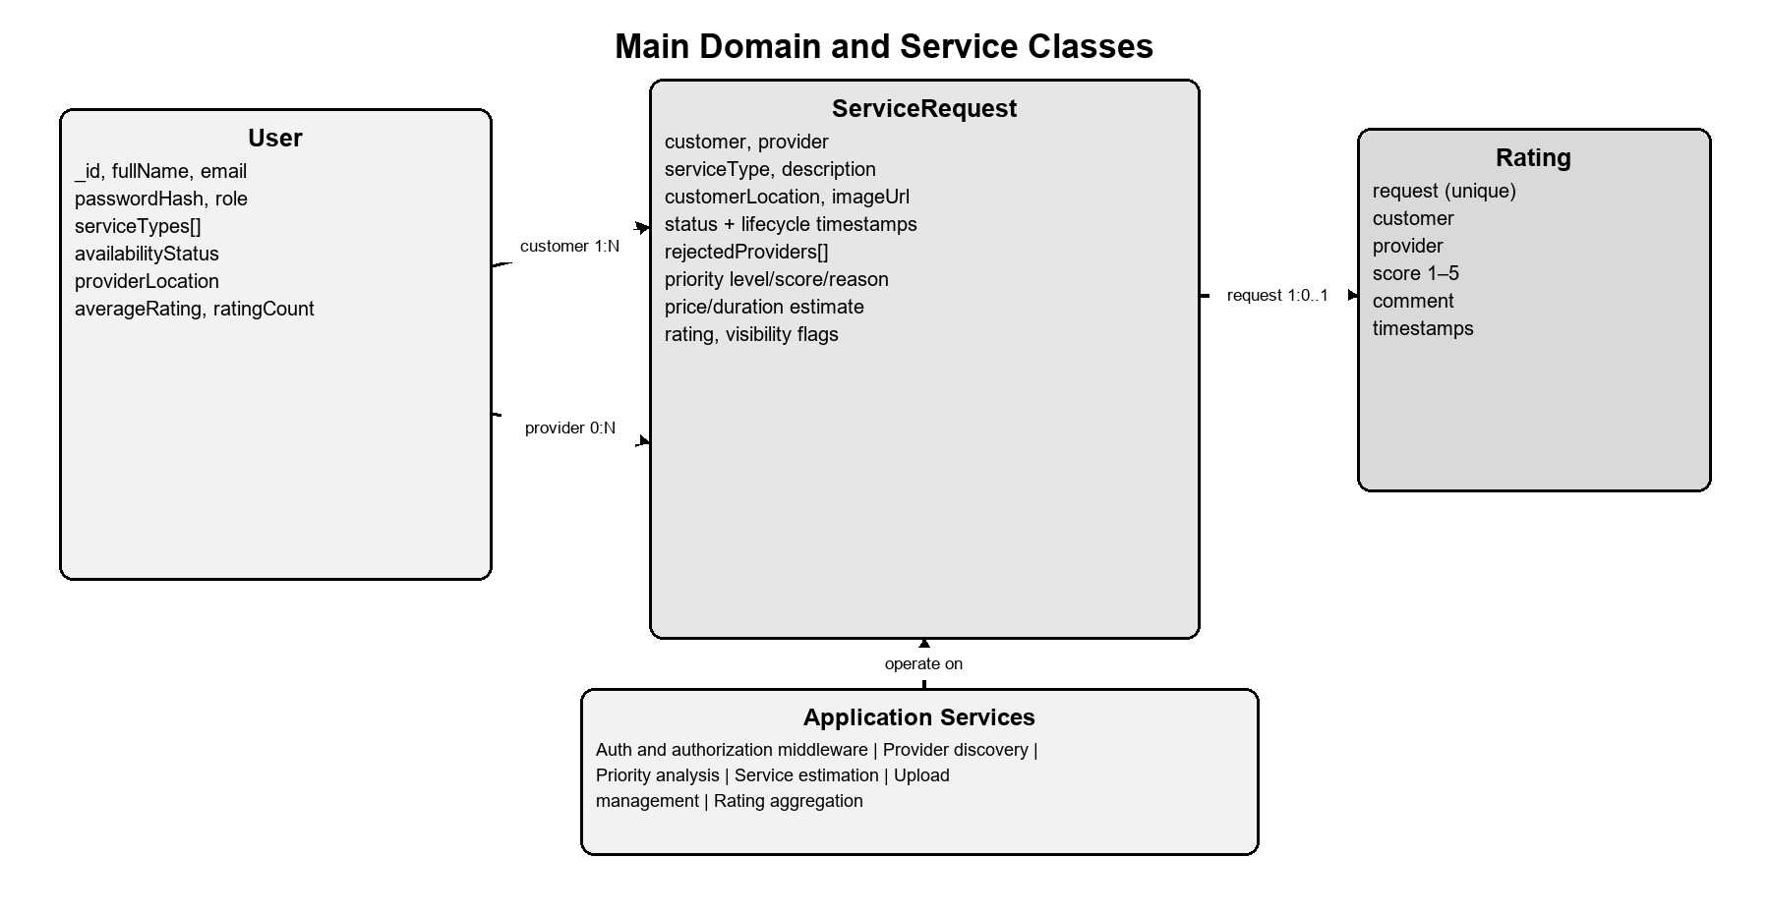
Figure 3-3. Main class and domain-model diagram.

3.5 Sequence Diagrams
Figure 3-4 models the primary request sequence. The customer client sends the validated request to Express, which computes priority and estimate, creates GeoJSON, and stores the document. Provider discovery invokes a spherical MongoDB aggregation. Selection creates an offer for one provider; the provider’s separate navigation then obtains that offer. Subsequent acceptance, rejection, lifecycle, and rating operations follow the same authenticated API boundary.
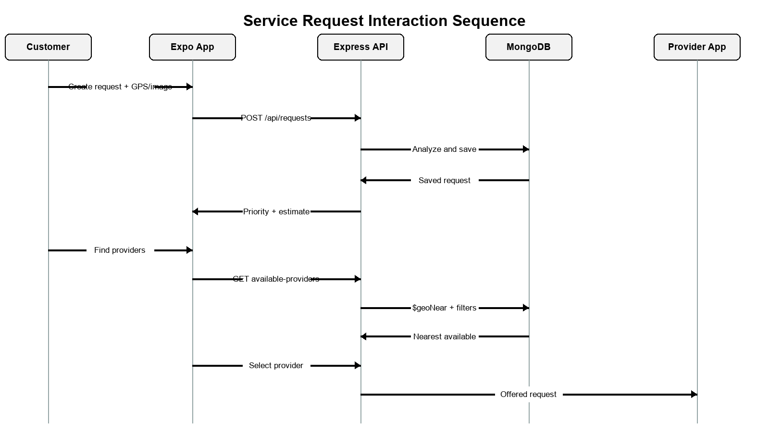
Figure 3-4. Service-request interaction sequence diagram.

3.6 Activity Diagrams
The activity diagram in Figure 3-5 emphasizes state validity. Pending and rejected requests with no provider may enter provider selection. A selected request becomes offered. Rejection clears the provider, preserves rejection history, and lets the customer search again. Acceptance begins the one-way operational sequence. The controller rejects skipped, reversed, repeated, completed, cancelled, or foreign-provider transitions by requiring the expected current status in the database update condition.
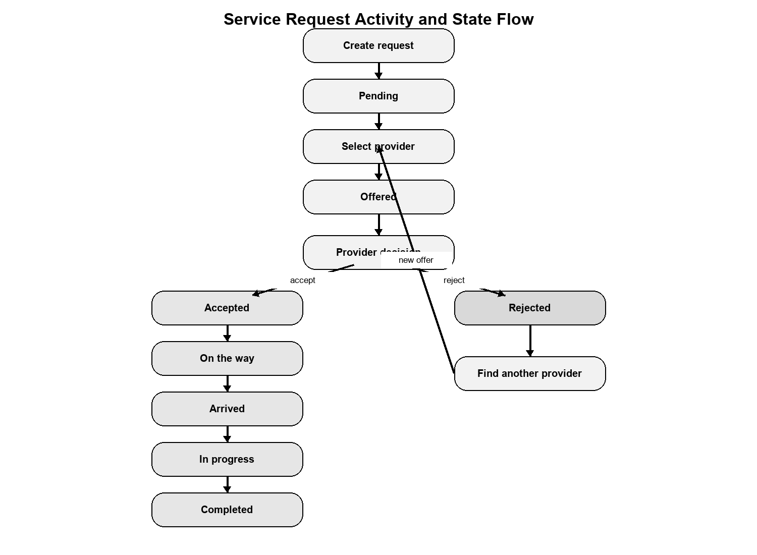
Figure 3-5. Service-request lifecycle activity diagram.

3.7 Entity-Relationship Diagrams
Figure 3-6 presents the logical relationships among the three MongoDB collections. A User may create many ServiceRequests as a customer and may be assigned many as a provider. Each completed request can have zero or one Rating because the rating request reference is unique. Rating redundantly stores the customer and provider references to support ownership validation and provider aggregation. Geospatial point fields on User and ServiceRequest have 2dsphere indexes.
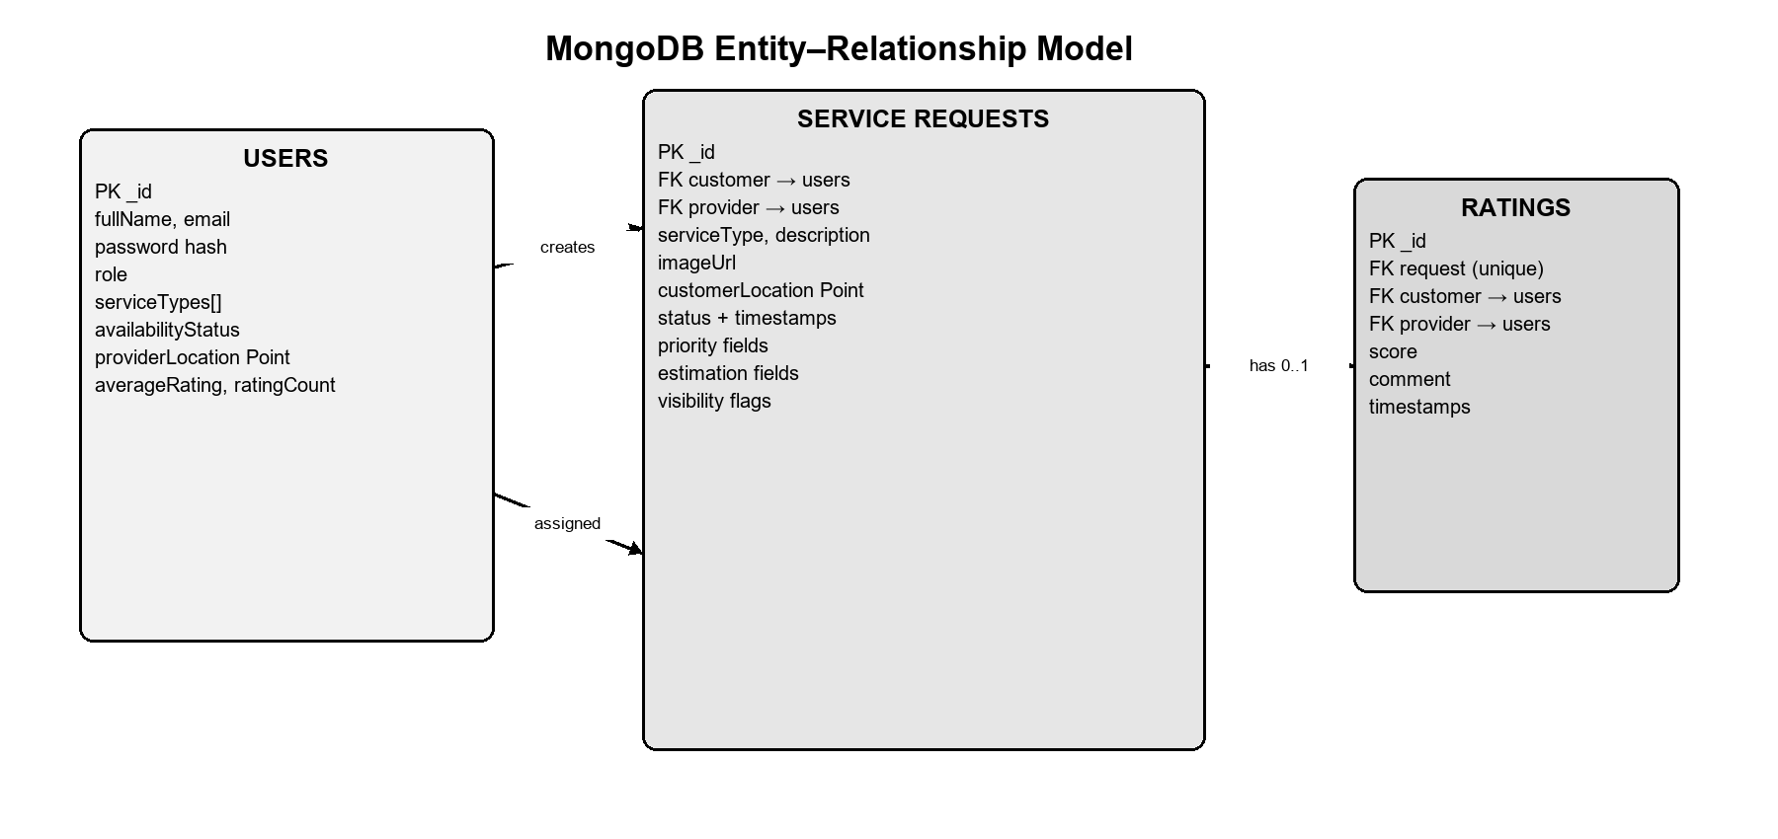
Figure 3-6. MongoDB entity-relationship diagram.

3.8 Non-Technical Aspects

3.8.1 Financial Viability
The current system is an academic prototype, so the analysis distinguishes cash expenditure from student development effort. Open-source frameworks, Expo development tooling, a MongoDB Atlas free tier, and local image storage can support demonstration without license fees. Table 3-5 uses conservative planning assumptions rather than invoices or guaranteed production costs. A real deployment would require revised estimates for hosting, managed storage, domain, monitoring, support, verification, insurance, and legal compliance.
Table 3-5. Prototype financial assumptions.
Cost item | Prototype assumption (USD) | Basis
Software frameworks and development tools | 0 | Open-source/community tooling
MongoDB Atlas prototype database | 0 | Free-tier academic prototype assumption
Local upload storage | 0 | Development computer only
Connectivity and electricity | 150 | Planning allowance across development
Contingency | 100 | Unexpected prototype expenses
Total estimated cash cost | 250 | Excludes student labor and production operation

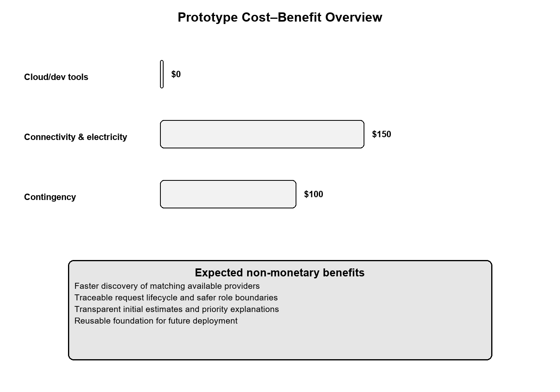
Figure 3-7. Prototype cost–benefit overview.

3.8.2 Stakeholders
Table 3-4. Principal stakeholders.
Stakeholder | Interest/benefit | Potential concern
Customers | Faster access to relevant providers and visible progress | Location/privacy, estimate accuracy, service quality
Service providers | Relevant nearby requests and reputation history | Fair visibility, safety, workload, rejection history
Project team | Academic learning and maintainable system design | Scope, testing, security responsibilities
University/supervisor | Evidence of engineering analysis and implementation | Accuracy, ethics, originality, documentation
Future operator | Platform continuity and support | Compliance, hosting cost, moderation, incident response

Customers and providers should both have a voice in future usability and safety decisions. Provider visibility rules should be transparent, while customers should understand why location and request information are collected. Any later commercial operator would need formal complaint, verification, moderation, and incident-response processes.

3.8.3 Scope
The implemented scope includes registration, login, session restoration, role navigation, provider services and availability, one-time customer/provider GPS capture, request creation with one optional local image, geospatial discovery, customer selection, provider acceptance/rejection, lifecycle control, automatic five-second refresh, ratings, explainable priority, explainable initial price/duration, and per-user historical cleanup.
The scope explicitly excludes Google Maps, route or traffic ETA, continuous tracking, Socket.IO, push notifications, chat, payment, Cloudinary, Firebase, OpenAI API calls, automatic provider selection, automatic charging, professional licensing verification, and production deployment operations. These items must not be interpreted as completed components.

3.8.4 Risks
Table 3-6. Principal project risks and mitigations.
Risk | Effect | Current/future mitigation
Incorrect or denied GPS | No useful nearby result | Clear permission errors; recapture; server validation
Stale availability | Unavailable provider displayed | Profile reload on focus; acceptance marks busy
Network interruption | Lists cannot refresh | Keep existing data; non-blocking message; retry polling
Concurrent actions | Conflicting provider/status updates | Atomic expected-state database filters
Rule false positive/negative | Misleading priority or estimate | Explain rules; bounds; professional confirmation
Local upload growth | Disk exhaustion/loss | 5 MB limit; migrate to managed storage in production
Credential/token compromise | Unauthorized access | bcrypt, JWT verification, SecureStore, HTTPS future requirement
Privacy exposure | Personal/location harm | Minimize returned fields; no exact provider location in discovery

3.8.5 Schedule and Milestones
Table 3-7. Schedule and milestone summary.
Period | Milestone | Principal output
Sep–Oct 2025 | Requirements and interface foundation | Scope, navigation, guest/auth screens
Nov–Dec 2025 | Backend and database foundation | Express, authentication, MongoDB
Jan–Feb 2026 | Provider and request location | Profiles, GPS, GeoJSON requests
Feb–Mar 2026 | Discovery and provider workflow | Nearby filtering, selection, accept/reject
Mar–Apr 2026 | Lifecycle and feedback | Status progression, polling, ratings
Apr–May 2026 | Media and explainable analysis | Images, priority, price/duration estimate
May–Jun 2026 | Verification and documentation | Automated tests, report, demonstration preparation

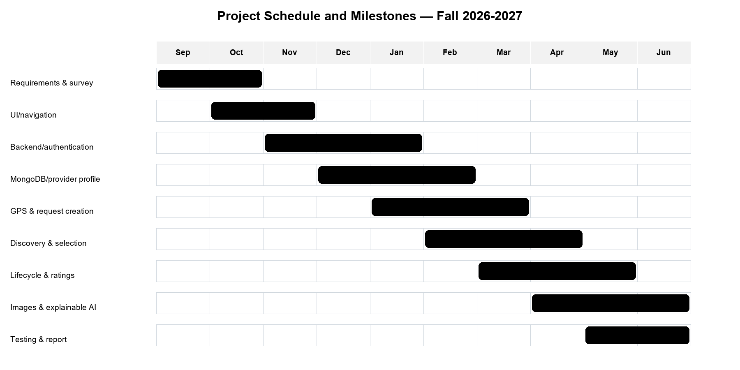
Figure 3-8. Project schedule and milestones.

3.8.6 Ethical and Social Considerations
The most important ethical requirement is that analysis supports rather than replaces human judgment. A keyword match may assist triage, but it cannot confirm electrical safety, diagnose a pipe, determine labor difficulty, or establish a binding price. For that reason, Smart Service presents a reason and a final-price warning, preserves customer provider choice, and requires provider inspection. Future evaluation should measure false classifications in both English and Arabic and involve qualified service professionals.
Location and customer descriptions can reveal sensitive household information. The system therefore requests foreground location only, performs no continuous tracking, sends only the current coordinate pair, withholds exact provider coordinates before selection, and avoids returning customer email or exact location in offered-request summaries. Production use would require a privacy notice, retention policy, deletion policy, legal review, provider/customer safety processes, and stronger identity verification.
Ratings can improve trust but can also create unfair reputational effects. The current design restricts a rating to the owning customer and one completed request. Future governance should include review moderation, dispute handling, bias monitoring, and safeguards against retaliation or manipulation.

3.8.7 Environmental and Sustainability Considerations
The prototype has limited direct material impact because it is software and reuses existing mobile phones and cloud infrastructure. Digital requests may reduce unnecessary calls or exploratory travel by showing nearby matching providers; however, this benefit has not been quantitatively measured. Cloud computation, mobile networking, stored images, and device charging still consume energy. Sustainable development measures include limiting image size, avoiding continuous GPS, keeping rule analysis computationally small, deleting unnecessary temporary files, and selecting efficient hosting appropriate to actual demand.

3.8.8 Relevant Standards
Table 3-8. Relevant standards and guidance.
Standard/guidance | Relevance to Smart Service | Current application
IETF RFC 7519 — JWT | Compact authenticated claims representation | Seven-day tokens with user ID and role
IETF RFC 7946 — GeoJSON | Interoperable geographic geometry | Point coordinates stored longitude, latitude
MongoDB 2dsphere guidance | Spherical proximity and indexing | Provider/request indexes and $geoNear
OWASP Password Storage | Adaptive salted password hashing | bcryptjs work factor 12
W3C WCAG 2.2 | Perceivable, operable, understandable, robust UI | Accessible roles/status labels partly applied; full audit future
HTTP/REST conventions | Method, status, resource-oriented API behavior | GET, POST, PATCH and safe status codes

Compliance is not claimed solely because a technology or guideline is referenced. The table identifies design relevance and current alignment. Formal conformance testing, penetration testing, accessibility evaluation, privacy impact assessment, and production operational controls remain future work.

3.9 Conclusion
The design combines role-specific Expo navigation, a protected Express API, MongoDB geospatial persistence, deterministic analysis, and an explicit service lifecycle. Ownership and expected-state conditions protect shared requests, while safe response formatting limits unnecessary personal data. The diagrams and tables demonstrate that each major interface action has a corresponding server responsibility and stored-domain representation. The design remains intentionally bounded: it supports an academic prototype and future extension without presenting maps, real-time sockets, payment, or generative AI as completed features.

REFERENCES
[1] Taskrabbit Support, “How Do I Hire a Tasker?” [Online]. Available: https://support.taskrabbit.com/hc/en-us/articles/46260422073755-How-Do-I-Hire-a-Tasker. Accessed: Aug. 2, 2026.
[2] Angi, “Frequently Asked Questions.” [Online]. Available: https://www.angi.com/faq/. Accessed: Aug. 2, 2026.
[3] Meta Platforms, “React Native: Introduction.” [Online]. Available: https://reactnative.dev/docs/getting-started. Accessed: Aug. 2, 2026.
[4] Expo, “Location — Expo SDK 57 Documentation.” [Online]. Available: https://docs.expo.dev/versions/v57.0.0/sdk/location/. Accessed: Aug. 2, 2026.
[5] H. Butler et al., “The GeoJSON Format,” RFC 7946, Aug. 2016. [Online]. Available: https://www.rfc-editor.org/info/rfc7946/. Accessed: Aug. 2, 2026.
[6] MongoDB, “Geospatial Queries and 2dsphere Indexes.” [Online]. Available: https://www.mongodb.com/docs/v8.2/geospatial-queries/. Accessed: Aug. 2, 2026.
[7] M. Jones, J. Bradley, and N. Sakimura, “JSON Web Token (JWT),” RFC 7519, May 2015. [Online]. Available: https://datatracker.ietf.org/doc/html/rfc7519. Accessed: Aug. 2, 2026.
[8] OWASP Foundation, “Password Storage Cheat Sheet.” [Online]. Available: https://cheatsheetseries.owasp.org/cheatsheets/Password_Storage_Cheat_Sheet.html. Accessed: Aug. 2, 2026.
[9] Taskrabbit, “How It Works.” [Online]. Available: https://www.taskrabbit.com/. Accessed: Aug. 2, 2026.
[10] Taskrabbit Support, “How Do I Become a Tasker?” [Online]. Available: https://support.taskrabbit.com/hc/en-us/articles/46260467885979-How-Do-I-Become-a-Tasker. Accessed: Aug. 2, 2026.
[11] Taskrabbit, “How Pricing Guidance Works on Taskrabbit,” Apr. 13, 2022. [Online]. Available: https://www.taskrabbit.com/blog/how-pricing-guidance-works-on-taskrabbit/. Accessed: Aug. 2, 2026.
[12] Angi, “What’s the Difference Between Opportunities and Leads?” [Online]. Available: https://intercom.help/angi/en/articles/6229338-what-s-the-difference-between-opportunities-and-leads. Accessed: Aug. 2, 2026.
[13] Urban Company, “Service Professional Enablement.” [Online]. Available: https://investorrelations.urbancompany.com/announcements-and-highlights/service-professional-enablement. Accessed: Aug. 2, 2026.
[14] W3C, “Web Content Accessibility Guidelines (WCAG) 2.2,” Dec. 12, 2024. [Online]. Available: https://www.w3.org/TR/WCAG22/. Accessed: Aug. 2, 2026.
[15] Express.js, “Basic Routing.” [Online]. Available: https://expressjs.com/en/starter/basic-routing/. Accessed: Aug. 2, 2026.

