
Intro To Database Project Report

Group Members:

Name: Kareem Mohamed Abdelghany Elramady
ID: 2406247728

Name: Youssef Abdulmonem Mohamed
ID: 2406249130

Name: Mazen Mohamed Mamoun
ID: 2406242070

Name: Mohammed Adel Mohammed
ID: 2406246774

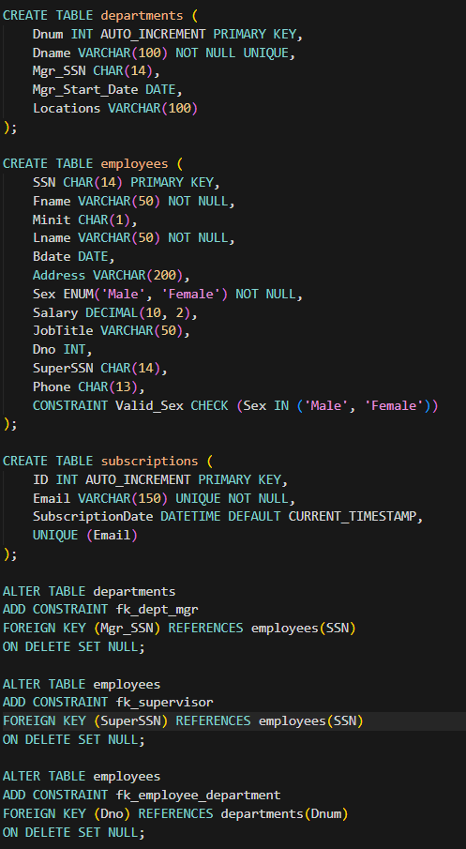
- DDL

- First, we got Departments of the company with 5 attributes with different constrains containing 1 Primary Key & 1 Foreign Key referring to the SSN of the employees.

- Secondly, we got the employees with 12 attributes also with different constrains containing 1 Primary Key & 2 Foreign Keys one referring to the department number and the other to the SSN of the employees. Also making sure that the input Sex is valid through the constraint named Valid_Sex.

- Thirdly, we got subscriptions table that contains the emails of the subscribers saved with unique IDs to differentiate them.

- Lastly, we got the Foreign keys as an additional altered constraints to avoid collisions between employees table and departments table.

- DML
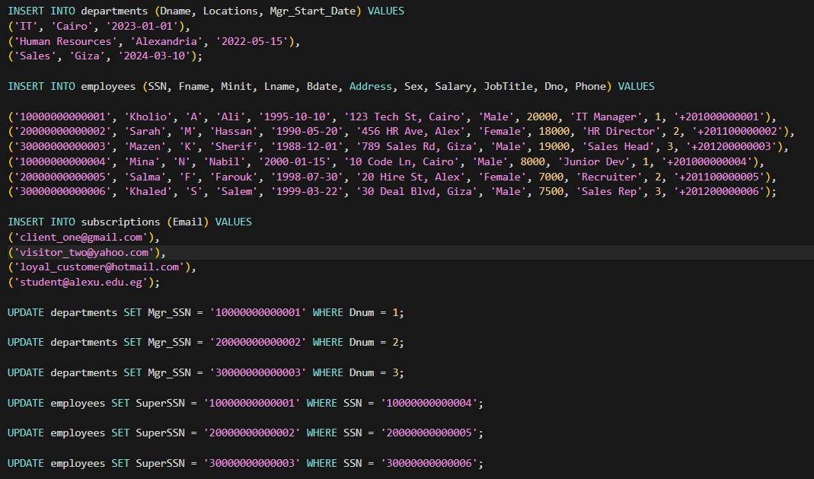

- Firstly, we insert some departments, employees, and subscribers saving them without SuperSSN or Dno or MgrSSN to avoid collisions with FKs.

- Secondly, we update the tables with the Dno & SuperSSn & MgrSSN after adding the employees and departments.

- Simple GUI
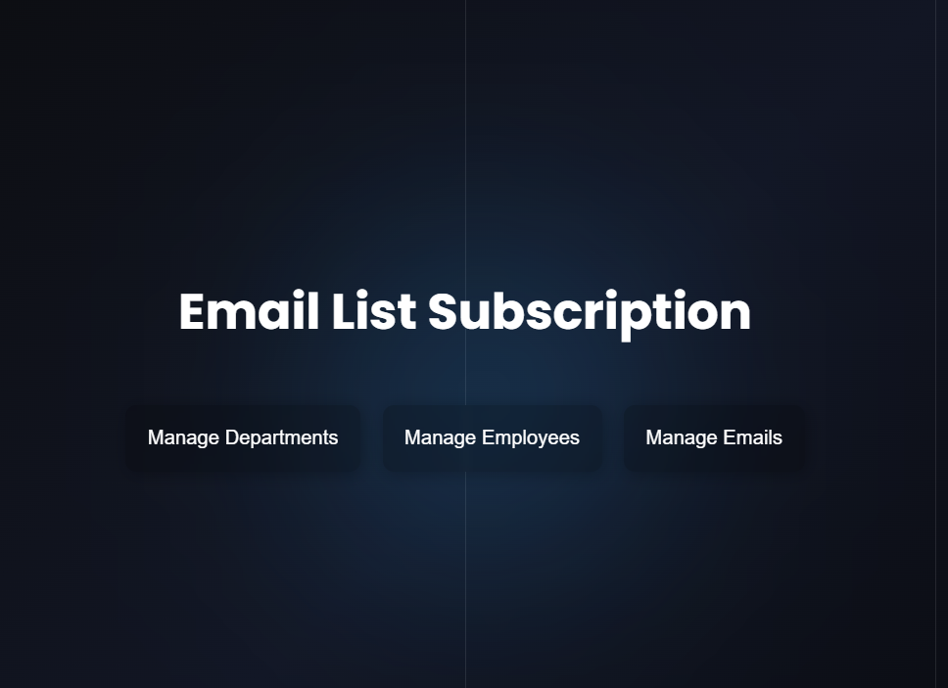

- Implementing a simple working GUI with PHP & CSS & JS.

- 3 Buttons to manipulate with: Departments, Employees, and Emails.

- It is allowed to add, remove, import, and export Emails.

- We also can update, add, and remove Departments & Employees.

