Kareem Weaver
Phase Two Report

This is the first interface the user will see
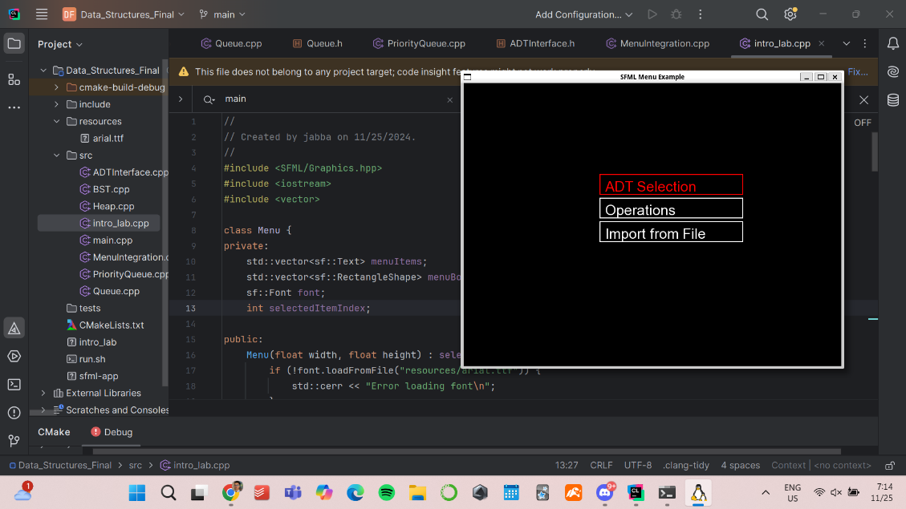

Navigate > ADT Selection
- Tree
- Queue
- PQ
- BST
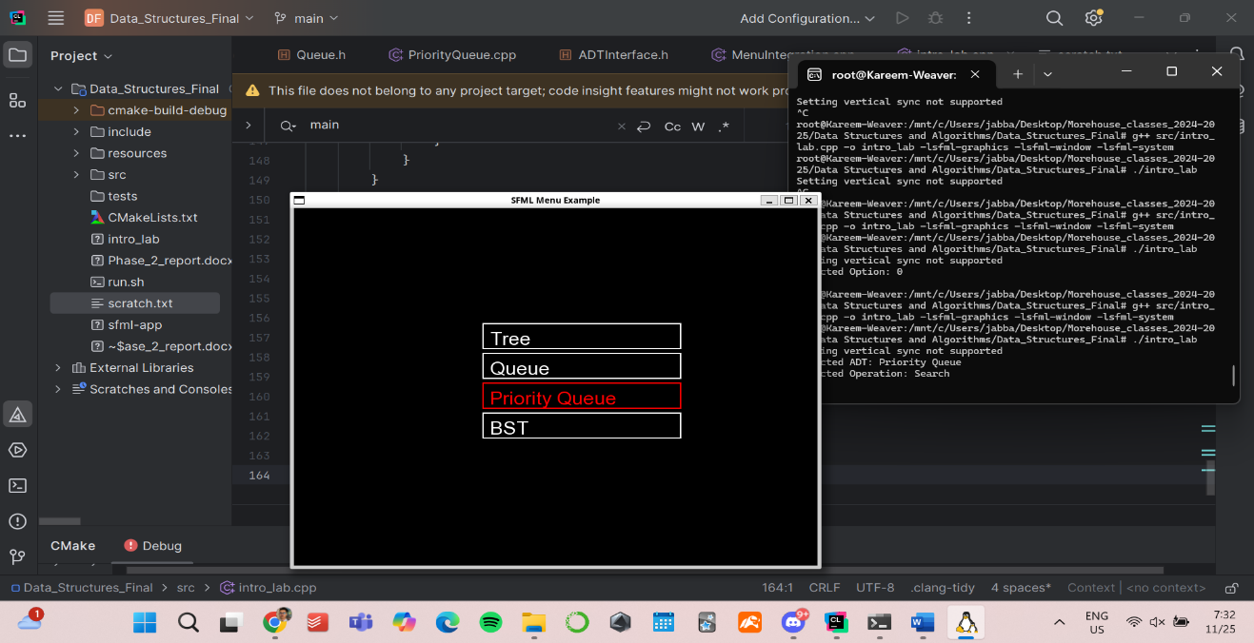
Nagivate > Import from File: output in terminal
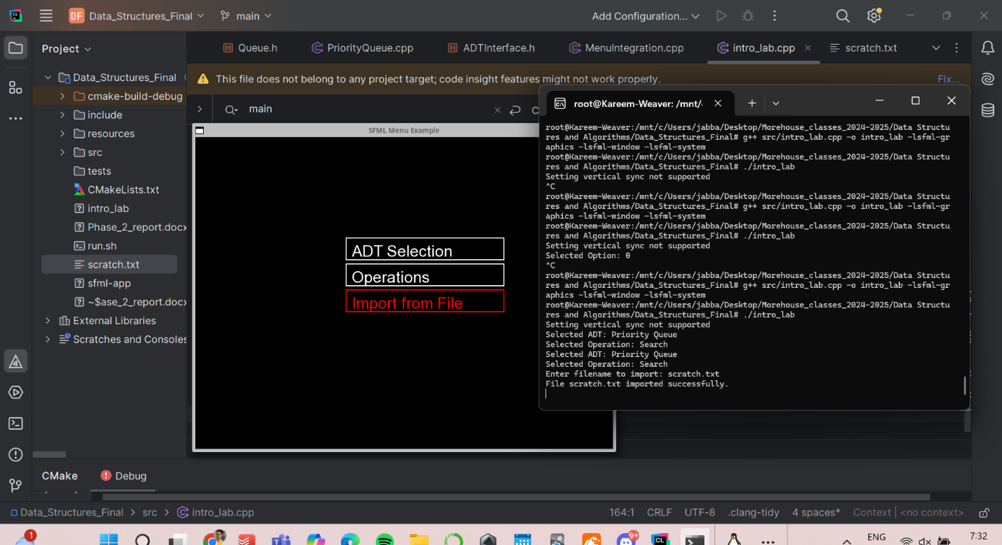

Navigate Operations >
- Insert
- Delete
- Search
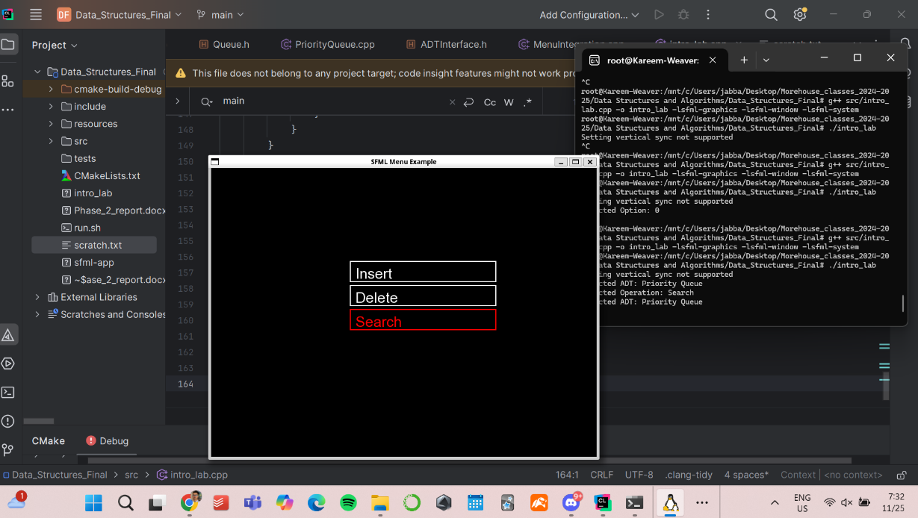

Here is the flowchart. I have not implement “Back to Main menu” and Return t Main menu.
