- Lint run:
All works good ✅✅
2-functionallity of the code:
the code works good it passes all test cases I made

3-test cases:
This testbench verifies the output_ctrl module by first checking that reset correctly clears the out_waddr counter to 0 and holds out_we low. It then asserts fmt_valid and checks that out_waddr increments correctly (1 → 6 → 16 across several clock cycles) while out_we stays high, confirming the counter and write-enable logic work together during normal streaming. Next, it deasserts fmt_valid and checks that the counter holds its value and out_we drops to 0, verifying the module correctly pauses on invalid input. Finally, it asserts fmt_last with fmt_valid to check that the counter reaches its final value (17), out_we pulses high, and done asserts for one cycle then clears — confirming correct end-of-frame behavior — before re-asserting reset to confirm the module returns cleanly to its initial state. All 18 checks in the log passed.
4-log
# pass: the rst works good and the counter = 0
# pass: the output write enable = 0
# pass: the counter works good and the counter = 1
# pass: the output write enable = 1
# pass: the counter works good and the counter = 6
# pass: the output write enable = 1
# pass: the counter works good and the counter = 16
# pass: the output write enable = 1
# pass: the counter works good and the counter = 16
# pass: the output write enable = 0
# pass: the counter works good and the counter = 17
# pass: the output write enable = 1
# pass: the done signal = 1
# pass: the counter works good and the counter = 17
# pass: the output write enable = 0
# pass: the done signal = 0
# pass: the rst works good and the counter = 0
# pass: the output write enable = 0
# ** Note: $stop : output_ctrl_tb.sv(153)
# Time: 227 ns Iteration: 0 Instance: /output_ctrl_tb
5-Waveform:

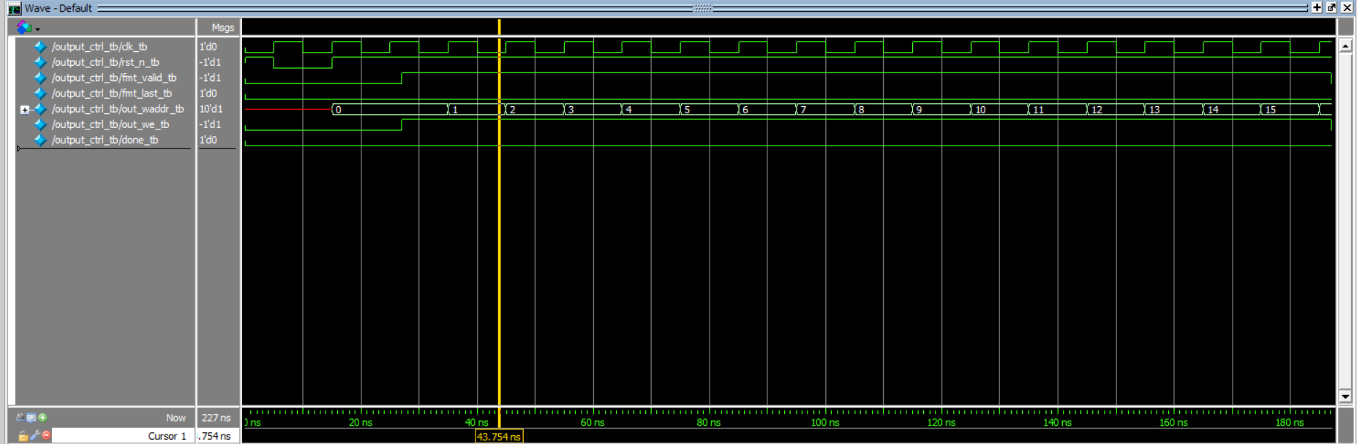
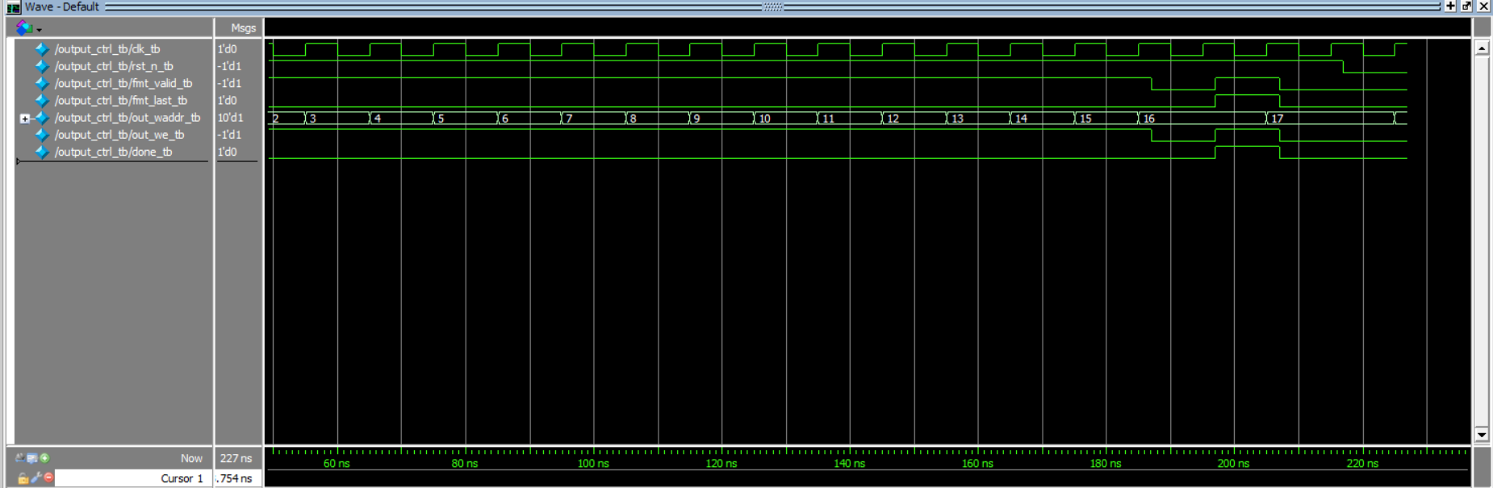

Great work Roaa, keep it up 👏👏

