- Lint run:
wait on that warning
2-functionallity of the code:
the code works good it passes all test cases I made

3-test cases:
All 26 checks passed, 0 failures. Here's the breakdown:
Write-phase checks (11 total) — verify output_rdata stays at 0 while a write is in progress:
- Addresses written: 1023, 0, 963, 63, 999, 828, 734, 598, 47, 605, 615
- All 11 → PASS
Read-back checks, first pass (11 total) — verify each written address reads back the correct data:
- addr 1023 → 65535 ✓
- addr 0 → 0 ✓
- addr 963 → 65520 ✓
- addr 63 → 4095 ✓
- addr 999 → 63743 ✓
- addr 828 → 63984 ✓
- addr 734 → 63866 ✓
- addr 598 → 15230 ✓
- addr 47 → 63671 ✓
- addr 605 → 61843 ✓
- addr 615 → 36611 ✓
- All 11 → PASS
Overwrite phase (5 writes) — same 5 of the original addresses (1023, 0, 963, 63, 999) rewritten with new data, again checking rdata=0 during write:
- All 5 → PASS
Read-back checks after overwrite (5 total) — verify the new values landed correctly:
- addr 1023 → 65295 ✓
- addr 0 → 3312 ✓
- addr 963 → 62460 ✓
- addr 63 → 3187 ✓
- addr 999 → 63513 ✓
- All 5 → PASS
4-log
Loading sv_std.std

Loading work.output_mem_tb(fast)

Loading work.output_mem(fast)

PASS: rdata=0 while writing addr=1023

PASS: rdata=0 while writing addr=0

PASS: rdata=0 while writing addr=963

PASS: rdata=0 while writing addr=63

PASS: rdata=0 while writing addr=999

PASS: rdata=0 while writing addr=828

PASS: rdata=0 while writing addr=734

PASS: rdata=0 while writing addr=598

PASS: rdata=0 while writing addr=47

PASS: rdata=0 while writing addr=605

PASS: rdata=0 while writing addr=615

PASS: addr=1023 exp=65535 got=65535

PASS: addr=0 exp=0 got=0

PASS: addr=963 exp=65520 got=65520

PASS: addr=63 exp=4095 got=4095

PASS: addr=999 exp=63743 got=63743

PASS: addr=828 exp=63984 got=63984

PASS: addr=734 exp=63866 got=63866

PASS: addr=598 exp=15230 got=15230

PASS: addr=47 exp=63671 got=63671

PASS: addr=605 exp=61843 got=61843

PASS: addr=615 exp=36611 got=36611

PASS: rdata=0 while writing addr=1023

PASS: rdata=0 while writing addr=0

PASS: rdata=0 while writing addr=963

PASS: rdata=0 while writing addr=63

PASS: rdata=0 while writing addr=999

PASS: addr=1023 exp=65295 got=65295

PASS: addr=0 exp=3312 got=3312

PASS: addr=963 exp=62460 got=62460

PASS: addr=63 exp=3187 got=3187

PASS: addr=999 exp=63513 got=63513

** Note: $stop : output_mem_tb.sv(121)

Time: 180 ns Iteration: 0 Instance: /output_mem_tb

Break in Module output_mem_tb at output_mem_tb.sv line 121
5-Waveform:
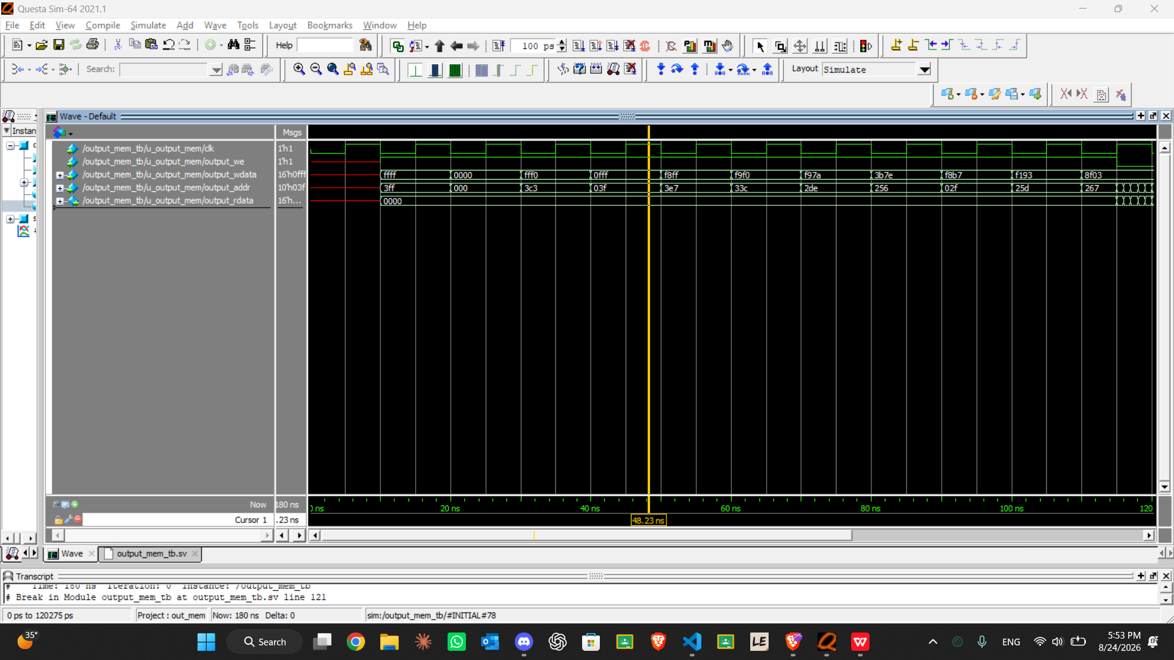
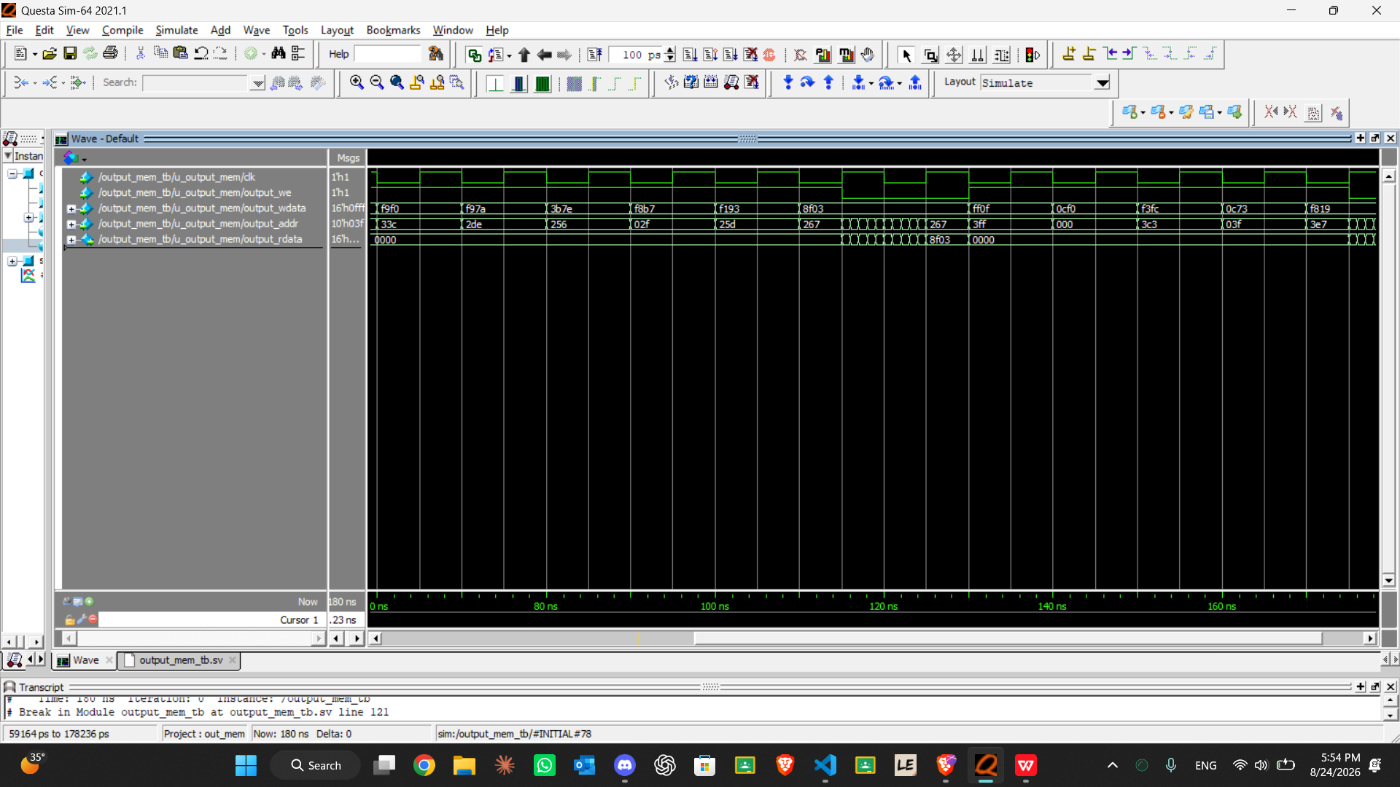

Great work Roaa, keep it up 👏👏

