- lint run
Frist I run lint there was no big errors just simple warnings and solved one which was the bit num in the assigned value when the num is -ve it must be a zero and the second ones were no assigned default values for both N and PROD_W but I did not edit them I left them alone.

- Specs viloataions
the specs asks for the relu_enable but it was commentened please review the specs again and see if you want to edit the specs or will keep the specs with no changes and remove the comment from it I see if we use enable It may save some power when we are not using the block anymore.

- functionallity of the code
the code works good it passes all test cases I made

- test cases I used
- All zeros ✅
- All ones ✅
- -ve num ✅
- +ve num ✅
- All output signals works good ✅

5-log syntax of my simulations
# End time: 04:20:11 on Aug 24,2026, Elapsed time: 0:01:12
# Errors: 3, Warnings: 6
# vsim -voptargs="+acc" relu_tb
# Start time: 04:20:11 on Aug 24,2026
# ** Note: (vsim-3813) Design is being optimized due to module recompilation...
# Loading sv_std.std
# Loading work.relu_tb(fast)
# Loading work.relu(fast)
# ** Warning: (vsim-3015) [PCDPC] - Port size (19) does not match connection size (22) for port 'conv_result'. The port definition is at: relu.sv(8).
# Time: 0 ps Iteration: 0 Instance: /relu_tb/dut File: relu_tb.sv Line: 10
# ** Warning: (vsim-3015) [PCDPC] - Port size (19) does not match connection size (22) for port 'relu_result'. The port definition is at: relu.sv(13).
# Time: 0 ps Iteration: 0 Instance: /relu_tb/dut File: relu_tb.sv Line: 10
# PASS: +ve passthrough. exp=56 got=56
# PASS: -ve clamp. exp=0 got=0
# PASS: zero passthrough. exp=0 got=0
# PASS: all-ones clamp. exp=0 got=0
# PASS: +ve num stays same & last relu works good. exp= 262143 got=262143
# ** Note: $finish : relu_tb.sv(94)
# Time: 14 ns Iteration: 0 Instance: /relu_tb
# 1
# Break in Module relu_tb at relu_tb.sv line 94
7-the waveform
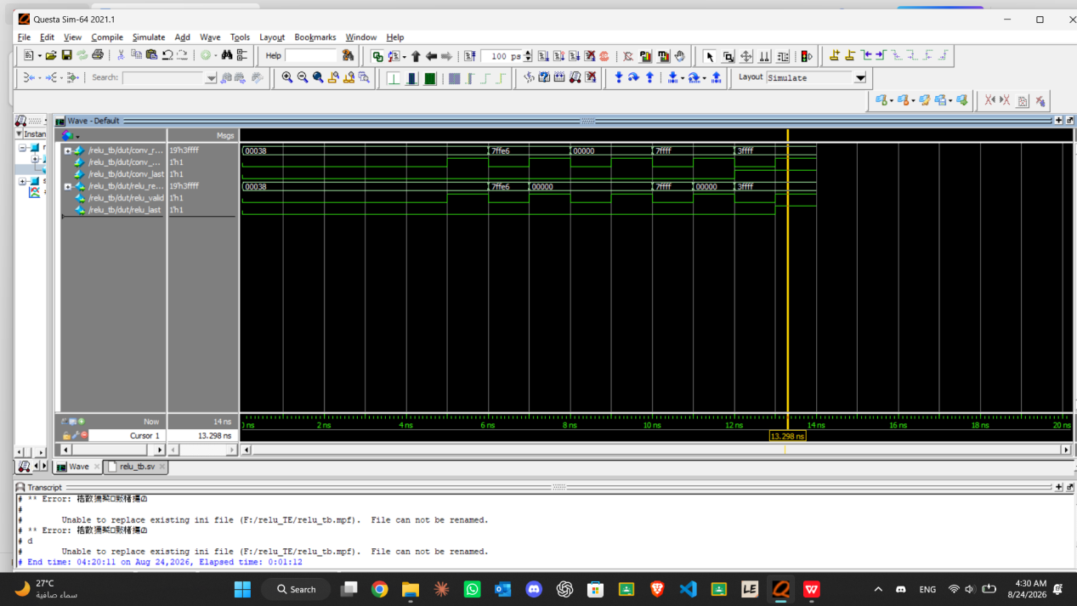
Great work kareem keep it up 👏👏

بس برده مين الصنايعي الي كان شغال هنا قبلي

