Early-Stage Pancreatic Cancer Detection
Using K-Nearest Neighbors Classification on Clinical Urinary Biomarker Data
A Data Mining Course Project Report
Department of Computer Science and Engineering (AI/ML)
Team Members
Vansh Pratap Singh — 23261A6659
Ch. Rohan — 23261A6609
Keywords: K-Nearest Neighbors, Pancreatic Cancer, Urinary Biomarkers, SMOTE, Class Imbalance, Medical Data Mining
Table of Contents
Abstract 1
1. Introduction 2
2. Literature Survey 3
2.1 Medical Literature: Urinary Biomarker Panels for Pancreatic Cancer 3
2.2 Machine Learning Literature: K-Nearest Neighbors Classification 3
2.3 Supporting Literature 4
3. Proposed Methodology and Pipeline Architecture 5
3.1 Preprocessing 5
3.2 Class Imbalance Handling 5
3.3 Model: K-Nearest Neighbors Classification 6
3.4 Evaluation Metrics 7
4. Implementation: Code and Execution Output 8
4.1 Model Training Code (knn_pipeline.py) 8
4.2 Evaluation Code (knn_pipeline.py) 8
4.3 Captured Execution Output 9
5. Results and Discussion 10
5.1 Confusion Matrix Analysis 10
5.2 ROC Curve Analysis 11
5.3 Feature Importance Analysis 12
5.4 Comparison with Prior Literature 12
6. Limitations 13
7. Conclusion and Future Work 14
References 14
Research Paper A 15
Research Paper B 16
List of Figures
Figure 1. End-to-end pipeline architecture 5
Figure 2. K-Nearest Neighbors classification mechanism 6
Figure 3. Confusion matrix on the held-out test set 10
Figure 4. One-vs-rest ROC curves on the held-out test set 11
Figure 5. KNN permutation feature importance 12
List of Tables
Table 1. Per-class precision, recall, F1-score, and support 10
Table 2. Permutation importances compared with Debernardi et al. [1] 13

Abstract
Pancreatic ductal adenocarcinoma (PDAC) has one of the lowest five-year survival rates of any cancer because it is almost always diagnosed late, after the window for curative surgery has closed, and no low-cost screening test exists for the general population. A non-invasive, urine-based biomarker test could close this gap. This project builds an end-to-end machine learning pipeline that classifies patients as Control (healthy), Benign (non-cancerous pancreatic or hepatobiliary disease), or PDAC from urinary and plasma biomarkers (CA19-9, creatinine, LYVE1, REG1B, TFF1, REG1A) plus age, sex, and sample-collection metadata.
K-Nearest Neighbors (KNN) is the sole data mining technique, with no other model families and no deep learning. The pipeline addresses target leakage (two fields only known after diagnosis are excluded), class imbalance (SMOTE applied inside each cross-validation fold plus distance-weighted voting), feature scale (KNN is distance-based, so all numeric features are standardized), and hyperparameter selection (GridSearchCV over stratified 5-fold cross-validation, optimizing macro-F1). Quality is reported with accuracy, precision, recall, F1-score, and one-vs-rest ROC-AUC, with particular attention to recall because a missed PDAC case is the costliest error for a screening tool.
The model reaches 81.4% test accuracy and a macro ROC-AUC of 0.945 on a held-out partition never used for training or tuning. PDAC is never mistaken for a healthy Control, and most residual error lies on the Benign-versus-Control and Benign-versus-cancer boundaries. Because KNN has no built-in importance measure, permutation importance identifies REG1B, TFF1, and plasma CA19-9 as the most informative biomarkers, consistent with the clinical literature. The report covers the literature, the pipeline architecture, key code with its output, results, limitations, and future work.

1. Introduction
Pancreatic cancer remains one of the most lethal malignancies in oncology. The overwhelming majority of cases are diagnosed after the disease has progressed beyond the point of curative surgical resection, which is the single largest contributor to its poor prognosis. Unlike cancers with established screening protocols (e.g., breast, cervical, or colorectal cancer), no low-cost, widely deployable screening test exists for pancreatic cancer in the general population. Because early-stage PDAC is frequently asymptomatic, a non-invasive biomarker-based test capable of flagging at-risk individuals before symptom onset would represent a meaningful clinical advance.
Urine is an attractive medium for such a test: collection is non-invasive, inexpensive, and does not require specialized clinical infrastructure. Prior clinical research has identified a small panel of urinary proteins — including LYVE1, REG1B, and TFF1 — that, in combination with the established serum marker CA19-9 and a creatinine-based normalization control, show measurable diagnostic value for distinguishing PDAC patients from healthy controls and from patients with benign pancreatic or hepatobiliary conditions. This project builds a supervised classification pipeline around exactly this biomarker panel, using K-Nearest Neighbors as the sole data mining technique, and evaluates how well such a panel can be exploited by a distance-based classifier for three-way diagnostic classification.
Section 2 surveys the medical and machine learning literature behind the design. Section 3 describes the methodology and pipeline. Section 4 shows key code and its console output. Section 5 presents results and compares them with prior literature. Section 6 covers limitations and Section 7 concludes. The first pages of the two principal papers follow the references.

2. Literature Survey
This section reviews the clinical research on urinary biomarker panels for pancreatic cancer and the machine learning literature on the nearest-neighbor rule, the project's sole classification technique, plus a few supporting references.

2.1 Medical Literature: Urinary Biomarker Panels for Pancreatic Cancer
Debernardi et al. (2020) [1] report a case–control study of 590 retrospectively collected urine specimens from six centres: 183 controls, 208 patients with benign hepatobiliary disease (119 with chronic pancreatitis) and 199 patients with PDAC (102 stage I–II, 97 stage III–IV). The authors assayed three urinary proteins — LYVE1, TFF1 and REG1B, which replaced REG1A from the group's earlier panel — and combined them with urinary creatinine and age in PancRISK, a logistic regression model that labels each patient's risk of PDAC as “normal” or “elevated”. All three proteins were significantly higher in PDAC urine than in benign and control samples at every stage (Kruskal–Wallis, p < 0.0001); substituting REG1B for REG1A improved detection of resectable (stage I–II) disease; and adding plasma CA19-9 improved the panel further (AUC 0.992 for stage I–II PDAC versus controls). The authors name the small number of stage I–IIA samples (n = 27) and the variability of commercial ELISA kits as their main limitations.
This study shaped the present project in three ways. First, it supplied the core feature set: the urinary proteins LYVE1, REG1B and TFF1, urinary creatinine, age and plasma CA19-9. This project also keeps REG1A, the marker that REG1B replaced in [1], and adds sex, cohort and sample-origin metadata. Second, its three diagnostic groups — control, benign hepatobiliary disease and PDAC — define the three-class problem addressed here; [1] compares PDAC with controls and with benign samples separately, so a single three-way classifier extends its design rather than replicating it. Third, PancRISK is itself a multivariable logistic regression, which motivated testing whether a non-parametric, distance-based classifier can extract more from the same variables.

2.2 Machine Learning Literature: K-Nearest Neighbors Classification
Cover and Hart (1967) [2] formalized the nearest-neighbor decision rule: a new sample is assigned the class of the most similar stored sample, with similarity measured by a distance in feature space. Their central result is that, as the number of stored samples grows, the error rate of the nearest-neighbor rule is bounded above by twice the Bayes error rate, the lowest error any classifier can achieve. This gives a simple, assumption-light classifier a precise theoretical guarantee. The k-nearest-neighbor extension takes a vote among the k closest samples, which smooths out the effect of individual noisy points.
This work is the direct algorithmic foundation of the present project in two ways. First, the assignment for this variant specifies KNN as the sole permitted data mining technique (no ensembling with other model families, no deep learning); the rule of [2] is what scikit-learn's KNeighborsClassifier implements. Because the rule depends entirely on distances, the preprocessing standardizes every numeric feature so that no biomarker dominates merely because of its units, and the hyperparameter grid in Section 3.3 varies the neighbourhood size k, the vote weighting, and the distance metric. Second, the method is non-parametric and has no training step or built-in feature ranking, so this project answers its clinical question (“which biomarkers matter most?”) with permutation importance computed on the held-out set: shuffle one variable, measure the loss in macro-F1. Section 3.3 illustrates the voting mechanism.

2.3 Supporting Literature
Two further references informed secondary design decisions. Chawla et al. (2002) [3] introduced the Synthetic Minority Over-sampling Technique (SMOTE), which generates synthetic examples of the minority class along line segments joining existing minority-class nearest neighbors, rather than simply duplicating them. SMOTE is used in this project's training pipeline, applied only within each cross-validation fold, to counteract the mild class imbalance across the Control, Benign, and PDAC groups. Siegel et al. (2023) [4] report updated cancer incidence and survival statistics, including the consistently poor five-year survival rate for pancreatic cancer relative to other major cancers; these figures motivate the clinical framing given in Section 1 and Section 6.

3. Proposed Methodology and Pipeline Architecture
The complete pipeline consists of five stages, illustrated in Figure 1: data loading, preprocessing, model training (with class-imbalance handling and hyperparameter tuning folded in), evaluation, and inference on new samples. The data, cleaning, leakage removal, scaling and train/test split are identical to those of the project's Random Forest variant, so the two are directly comparable. K-Nearest Neighbors is used as the sole data mining technique across the entire pipeline — no ensembling with other model families and no deep learning are used at any stage.
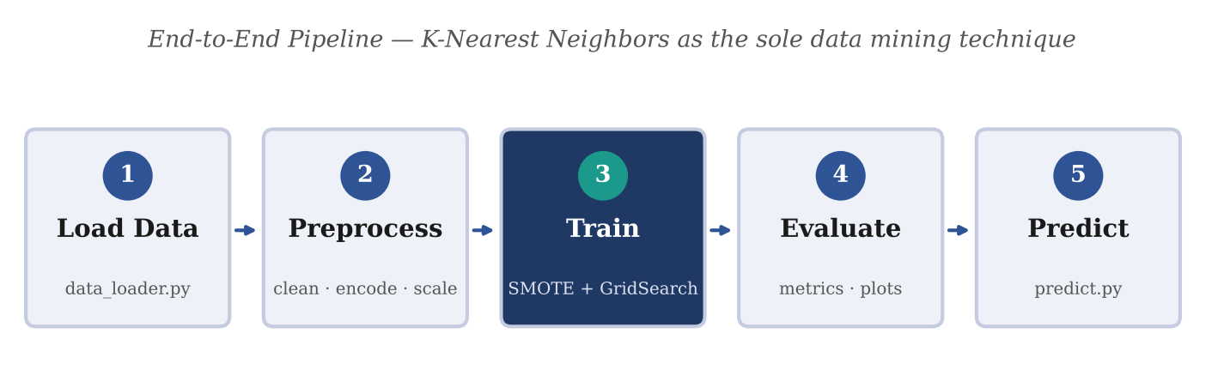
Figure 1. End-to-end pipeline architecture. K-Nearest Neighbors (stage 3) is the only data mining technique used.

3.1 Preprocessing
- Target-leakage removal: two raw fields — disease stage and benign-condition sub-type — are dropped before modeling, since both are only recorded after a diagnosis has already been made and would therefore leak the target label into the model rather than reflect genuine predictive signal.
- Missing-value imputation: CA19-9 and REG1A, which have real assay-driven missingness, are median-imputed using statistics computed on the training fold only.
- Categorical encoding: sex, patient cohort, and sample origin are one-hot encoded.
- Feature scaling: numeric features are standardized (zero mean, unit variance).
- Stratified 80/20 train–test split, preserving class proportions in both partitions.

3.2 Class Imbalance Handling
Following Chawla et al. [3], SMOTE is applied to oversample the minority classes during training. Critically, SMOTE is embedded inside an imblearn pipeline so that resampling is refit independently on each cross-validation fold's training portion; this prevents synthetic samples generated from one fold from leaking into another fold's validation data, which would otherwise produce an optimistic bias in cross-validated performance estimates. Distance-weighted voting (weights = 'distance') is also searched during tuning as a complementary way of limiting the influence of distant neighbours; KNN itself has no class-weight parameter.

3.3 Model: K-Nearest Neighbors Classification
Following Cover and Hart [2], a K-Nearest Neighbors classifier is trained as the sole data mining technique specified for this project. KNN is an instance-based method: it stores the (standardized, SMOTE-balanced) training samples and, to classify a new patient, finds the k training samples closest to it by distance and predicts the class that wins the vote among them. With distance weighting, closer neighbours count for more. Because there is no model to fit, all of the work happens at prediction time, and the quality of the classifier depends on the choice of k, the metric, and a sensible feature scaling, as illustrated in Figure 2.
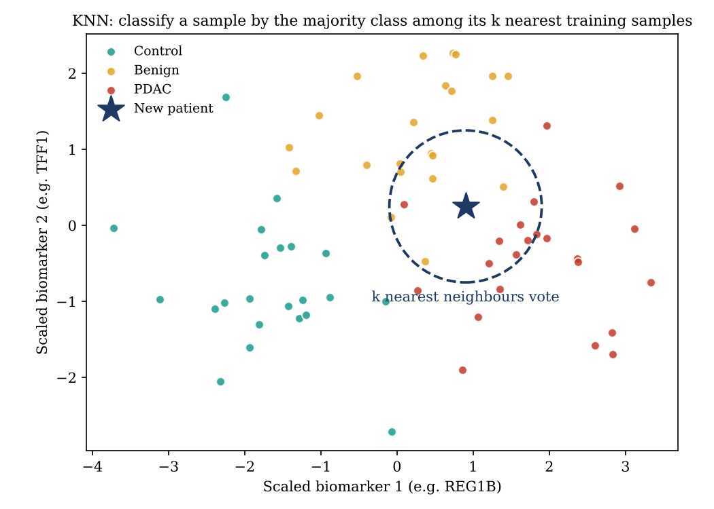
Figure 2. K-Nearest Neighbors classification mechanism: a new patient is assigned the majority (or distance-weighted) class among its k nearest training samples.
Hyperparameters are tuned via GridSearchCV over stratified 5-fold cross-validation, optimizing macro-averaged F1-score — which weights all three diagnostic classes equally, appropriate given that missing a minority PDAC case is clinically more costly than an error on the majority classes. The search space covers the neighbourhood size (n_neighbors ∈ {3, 5, 7, 9, 11, 15, 21, 31, 41}), the vote weighting (weights ∈ {uniform, distance}), and the Minkowski power of the distance (p ∈ {1, 2}, i.e. Manhattan or Euclidean) — 36 candidate combinations evaluated across 5 folds, for 180 total model fits. The best configuration (n_neighbors = 31, weights = 'distance', p = 1) achieved a cross-validated macro-F1 of 0.844. The complete training procedure, as actually executed, is listed in Section 4.

3.4 Evaluation Metrics
Model quality is quantified with five complementary metrics, each capturing a different aspect of classification performance:
- Accuracy = (TP + TN) / Total — the overall fraction of correct predictions; can be misleading on its own under class imbalance.
- Precision = TP / (TP + FP) — of samples predicted as a given class, the fraction that truly belong to it.
- Recall (sensitivity) = TP / (TP + FN) — of samples that truly belong to a class, the fraction correctly identified; the critical metric for a screening tool, since a false negative (a missed PDAC case) is the costliest possible error.
- F1-score = 2 · Precision · Recall / (Precision + Recall) — the harmonic mean of precision and recall; reported here as macro-F1, which averages the F1-score across all three classes with equal weight.
- ROC-AUC (one-vs-rest) — sweeps every possible decision threshold and plots the True Positive Rate against the False Positive Rate for each class treated as positive-vs-rest; the Area Under the Curve (0–1) summarizes ranking quality independent of any single threshold, with 0.5 corresponding to random guessing and 1.0 to perfect separation.
The held-out test partition is used exclusively for final evaluation and is never accessed during training or hyperparameter selection, so the metrics reported in Section 5 reflect genuine generalization performance rather than training fit. Because KNN exposes no internal importance measure, feature importance is computed by permutation: each variable is shuffled in turn on the test set (30 repeats) and the mean drop in macro-F1 is recorded.

4. Implementation: Code and Execution Output
This section reproduces the key parts of the code that trains and evaluates the model, together with the real console output of the run behind the results in Section 5. The full script is knn/knn_pipeline.py in the project repository; it reuses the shared preprocessing in src/preprocess.py.

4.1 Model Training Code (knn_pipeline.py)
The training code builds an imblearn pipeline chaining SMOTE and the KNN classifier (so resampling is refit per cross-validation fold rather than once globally) and runs the GridSearchCV hyperparameter search described in Section 3.3. The best pipeline is then fitted on the full training split and saved.
PARAM_GRID = {
"knn__n_neighbors": [3, 5, 7, 9, 11, 15, 21, 31, 41],
"knn__weights": ["uniform", "distance"],
"knn__p": [1, 2], # 1 = Manhattan, 2 = Euclidean
}

def build_pipeline() -> ImbPipeline:
return ImbPipeline([
("smote", SMOTE(random_state=RANDOM_STATE)),
("knn", KNeighborsClassifier()),
])

def train_model(X_train, y_train):
cv = StratifiedKFold(n_splits=5, shuffle=True, random_state=RANDOM_STATE)
search = GridSearchCV(build_pipeline(), PARAM_GRID, scoring="f1_macro",
cv=cv, n_jobs=-1, verbose=1)
return search.fit(X_train, y_train)
Code Listing 1. knn_pipeline.py — key excerpt (hyperparameter grid, SMOTE + KNN pipeline, and GridSearchCV). Imports and persistence code are omitted.

4.2 Evaluation Code (knn_pipeline.py)
The evaluation code computes accuracy, the per-class classification report, and macro ROC-AUC on the held-out test set only, then computes permutation importance for the feature-importance figure reproduced in Section 5.
def compute_metrics(model, X_test, y_test):
y_pred = model.predict(X_test)
y_proba = model.predict_proba(X_test)
report = classification_report(y_test, y_pred, target_names=CLASS_NAMES, output_dict=True)
y_bin = label_binarize(y_test, classes=[0, 1, 2])
auc = roc_auc_score(y_bin, y_proba, average="macro", multi_class="ovr")
return {"accuracy": accuracy_score(y_test, y_pred), "roc_auc_macro_ovr": auc,
"classification_report": report}, y_pred, y_proba, y_bin

# KNN has no feature_importances_, so use permutation importance:
perm = permutation_importance(model, X_test, y_test, scoring="f1_macro",
n_repeats=30, random_state=RANDOM_STATE)
Code Listing 2. knn_pipeline.py — key excerpt (metric computation and permutation importance on the held-out test set). Plotting and I/O code are omitted.

4.3 Captured Execution Output
Condensed console output of python knn/knn_pipeline.py (data-loading messages omitted). All randomness uses a fixed random_state, so re-running reproduces this output.
[knn] Running GridSearchCV (SMOTE + KNN, 5-fold CV, macro-F1)...
Fitting 5 folds for each of 36 candidates, totalling 180 fits

[knn] Best CV macro-F1: 0.8435
[knn] Best hyperparameters: {'knn__n_neighbors': 31, 'knn__p': 1, 'knn__weights': 'distance'}

[knn] Accuracy: 0.8136
[knn] Macro ROC-AUC (OvR): 0.9452

[knn] Classification report:
precision recall f1-score support

Control 0.81 0.78 0.79 37
Benign 0.73 0.73 0.73 41
PDAC 0.90 0.93 0.91 40

accuracy 0.81 118

[knn] Top 5 most important biomarkers (permutation):
REG1B: 0.1702
TFF1: 0.0890
plasma_CA19_9: 0.0550
LYVE1: 0.0453
sample_origin_LIV: 0.0139
Output 1. Captured console output of `python knn/knn_pipeline.py`.

5. Results and Discussion
The tuned KNN classifier achieved a best cross-validated macro-F1 of 0.844 during grid search. On the held-out test partition (118 samples, never used in training or tuning), the model achieved the following per-class performance:
Table 1. Per-class precision, recall, F1-score, and support on the held-out test set.
Class | Precision | Recall | F1-score | Support
Control | 0.806 | 0.784 | 0.795 | 37
Benign | 0.732 | 0.732 | 0.732 | 41
PDAC | 0.902 | 0.925 | 0.914 | 40

Overall test accuracy was 81.4%, with a macro-averaged one-vs-rest ROC-AUC of 0.945 and a macro-F1 of 0.813.

5.1 Confusion Matrix Analysis
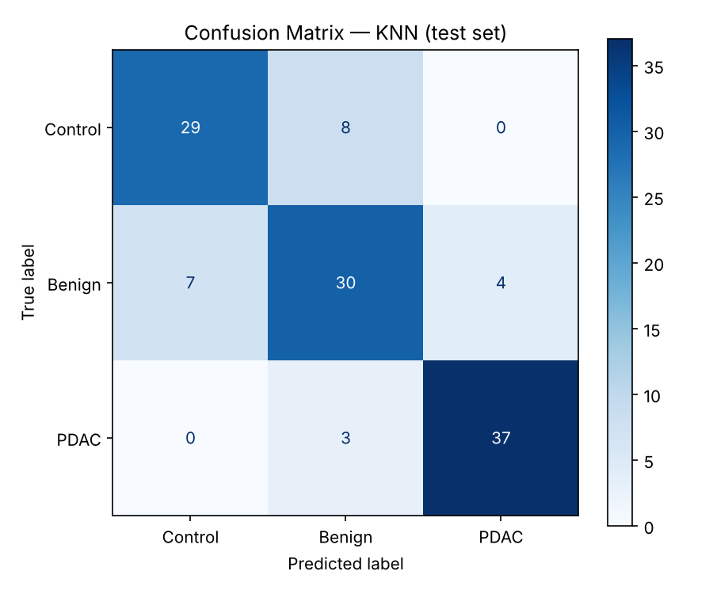
Figure 3. Confusion matrix on the held-out test set (rows = true label, columns = predicted label).
The confusion matrix's diagonal represents correct predictions; off-diagonal cells represent misclassifications. Two properties stand out. First, PDAC is never confused with Control (0 of 40 PDAC samples predicted as Control) — the clinically critical distinction for an early-screening use case, since it means the model never mistakes a cancer patient for a fully healthy one. Second, the errors that do occur differ in clinical cost: 3 PDAC samples were predicted as Benign (false negatives), which is the costliest error type in a screening context because a missed PDAC case delays treatment; by contrast, 4 Benign samples were predicted as PDAC (false positives), a comparatively low-cost error since it triggers additional, safe clinical workup rather than a missed diagnosis. The largest source of error is the Control–Benign boundary: 8 Control samples were predicted Benign and 7 Benign samples were predicted Control, plausibly because benign hepatobiliary disease, including chronic pancreatitis, produces biomarker values overlapping those of healthy urine and, in part, of PDAC [1].

5.2 ROC Curve Analysis
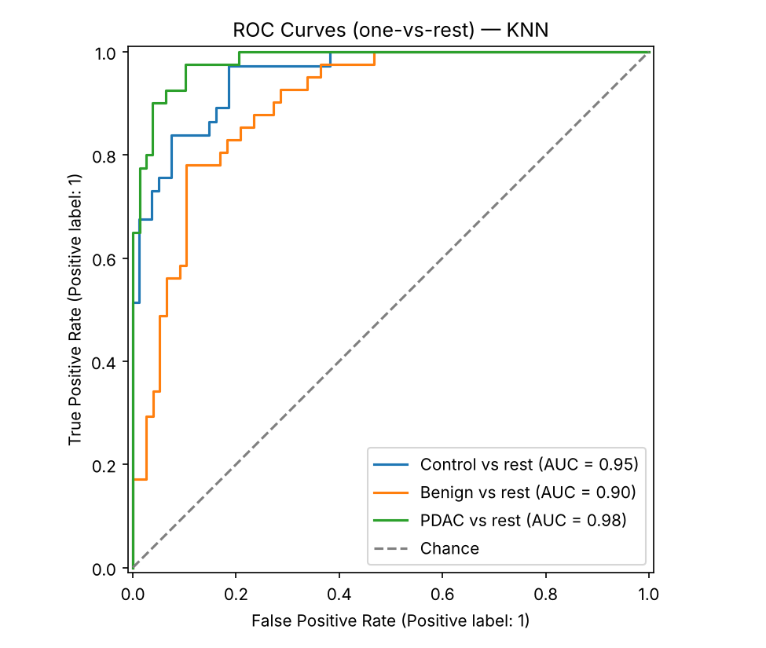
Figure 4. One-vs-rest ROC curves for each diagnostic class on the held-out test set.
Each curve treats one diagnostic class as positive against the other two combined, sweeping the decision threshold from 0 to 1. PDAC is the best-separated class, with a per-class AUC of 0.98, followed by Control at 0.96; Benign has the lowest per-class AUC at 0.90, mirroring the confusion-matrix finding that Benign is the hardest class to isolate. The resulting macro-averaged AUC of 0.945 means that, averaged across the three classes, a randomly chosen true-positive sample is ranked above a randomly chosen true-negative sample 94.5% of the time — a good result for a classifier with no learned parameters, though lower than the Random Forest variant of this project on the same split (accuracy 91.5%, macro-AUC 0.983).

5.3 Feature Importance Analysis
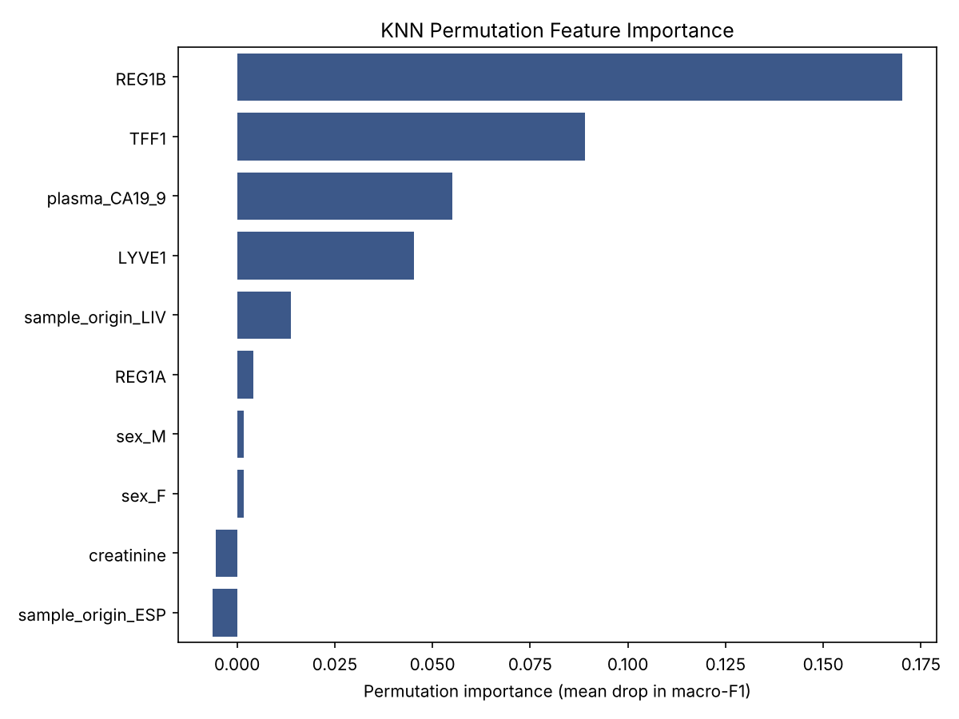
Figure 5. KNN permutation feature importance (mean drop in macro-F1 when a feature is shuffled on the test set), ranking which biomarkers the model relies on most.
Permutation importance ranked REG1B (0.170), TFF1 (0.089), and plasma CA19-9 (0.055) as the three most important features, followed by LYVE1 (0.045). REG1A (0.004), creatinine, sex, and most cohort and sample-origin indicators contributed essentially nothing; the largest of these was the sample-origin LIV indicator (0.014), and several values are slightly negative, i.e. indistinguishable from zero. This is reassuring, since it suggests the model relies on the biomarker measurements rather than on collection-site artifacts or demographic shortcuts. Permutation importance is computed on only 118 test samples, so small differences between lower-ranked features should not be over-interpreted.

5.4 Comparison with Prior Literature
Debernardi et al. [1] do not rank their markers by importance, so this comparison is qualitative. They report that LYVE1, REG1B and TFF1 are all significantly higher in PDAC urine than in benign and control samples, that substituting REG1B for REG1A improved detection of stage I–II disease, and that plasma CA19-9 adds complementary information to the urinary panel. Table 2 sets the KNN's permutation importances beside these findings:
Table 2. This project's KNN permutation importances alongside the findings Debernardi et al. [1] report for the same biomarkers.
Biomarker | Permutation importance (this project) | Finding in Debernardi et al. [1]
REG1B | 0.170 (rank 1) | Higher in PDAC than in benign and control urine (p < 0.0001); replaced REG1A in the improved panel
TFF1 | 0.089 (rank 2) | Higher in PDAC than in benign and control urine (p < 0.0001)
Plasma CA19-9 | 0.055 (rank 3) | Complementary to the urinary panel; combined AUC 0.992 for stage I–II PDAC versus controls
LYVE1 | 0.045 (rank 4) | Higher in PDAC than in benign and control urine (p < 0.0001)
REG1A | 0.004 (rank 6) | Marker of the group's earlier panel; superseded by REG1B

The two sets of results point the same way: the urinary proteins and CA19-9 that [1] finds elevated or complementary in PDAC are the variables the KNN relies on most, while the cohort and site metadata carry little weight. This is consistent with, but does not independently confirm, the clinical findings: importance measures how much the model uses a variable, not whether that variable is clinically valid.

6. Limitations
- Sample size (n = 590) is modest by machine learning standards, though consistent with typical clinical biomarker study cohorts such as [1].
- Evaluation relies on a single stratified train/test split; repeated cross-validated reporting would tighten confidence intervals on the metrics in Section 5.
- KNN has no built-in importance measure, and permutation importance on a small test set is noisy; repeating it over cross-validation folds would give more stable rankings. KNN is also sensitive to the scaling and to irrelevant features, and its prediction cost grows with the size of the training set.
- No external, site-held-out validation cohort was used; given that samples originate from multiple collection sites, leave-one-cohort-out validation would better estimate cross-site generalization.
- The clinically most important group, early-stage PDAC, is small: [1] itself had only 27 stage I–IIA samples, so any early-detection claim rests on few cases.
- The biomarkers are measured with commercial ELISAs whose performance varies between kit versions [1]; assay variability between sites could affect any model trained on these values.

7. Conclusion and Future Work
This project demonstrates that a K-Nearest Neighbors classifier, trained on the urinary and plasma biomarker panel established by Debernardi et al. [1] and built on the nearest-neighbor rule of Cover and Hart [2], can distinguish Control, Benign, and PDAC diagnostic groups with 81.4% accuracy and a macro-averaged ROC-AUC of 0.945. Confusion-matrix and ROC analysis show that the model never mistakes PDAC for Control, with the majority of residual error on the Control–Benign and Benign-vs-cancer boundaries. Permutation importance identifies REG1B, TFF1, and CA19-9 as the most informative biomarkers, the proteins and plasma marker that [1] reports as elevated in, or complementary for, PDAC. On the same data and split, the Random Forest variant of this project scored higher (91.5% accuracy, macro-AUC 0.983), so KNN is a useful, simple baseline rather than the best performer. Future work should prioritize (i) SHAP-based or fold-wise permutation importance, (ii) leave-one-cohort-out validation across collection sites, (iii) a focused evaluation on early-stage-only PDAC (Stage I/II) detection, the highest-value use case, and (iv) probability calibration if model outputs are to inform an actual clinical decision threshold.

References
[1] S. Debernardi, H. O'Brien, A. S. Algahmdi, et al., “A combination of urinary biomarker panel and PancRISK score for earlier detection of pancreatic cancer: A case–control study,” PLOS Medicine, vol. 17, no. 12, e1003489, 2020.
[2] T. M. Cover and P. E. Hart, “Nearest neighbor pattern classification,” IEEE Transactions on Information Theory, vol. 13, no. 1, pp. 21–27, 1967.
[3] N. V. Chawla, K. W. Bowyer, L. O. Hall, and W. P. Kegelmeyer, “SMOTE: Synthetic Minority Over-sampling Technique,” Journal of Artificial Intelligence Research, vol. 16, pp. 321–357, 2002.
[4] R. L. Siegel, K. D. Miller, N. S. Wagle, and A. Jemal, “Cancer statistics, 2023,” CA: A Cancer Journal for Clinicians, vol. 73, no. 1, pp. 17–48, 2023.
[5] F. Pedregosa, G. Varoquaux, A. Gramfort, et al., “Scikit-learn: Machine Learning in Python,” Journal of Machine Learning Research, vol. 12, pp. 2825–2830, 2011.

Research Paper A: A combination of urinary biomarker panel and PancRISK score for earlier detection of pancreatic cancer: A case–control study,
S. Debernardi, H. O'Brien, A. S. Algahmdi, et al., “A combination of urinary biomarker panel and PancRISK score for earlier detection of pancreatic cancer: A case–control study,” PLOS Medicine, vol. 17, no. 12, e1003489, 2020. First page shown; click the title above to open the complete paper (https://doi.org/10.1371/journal.pmed.1003489).
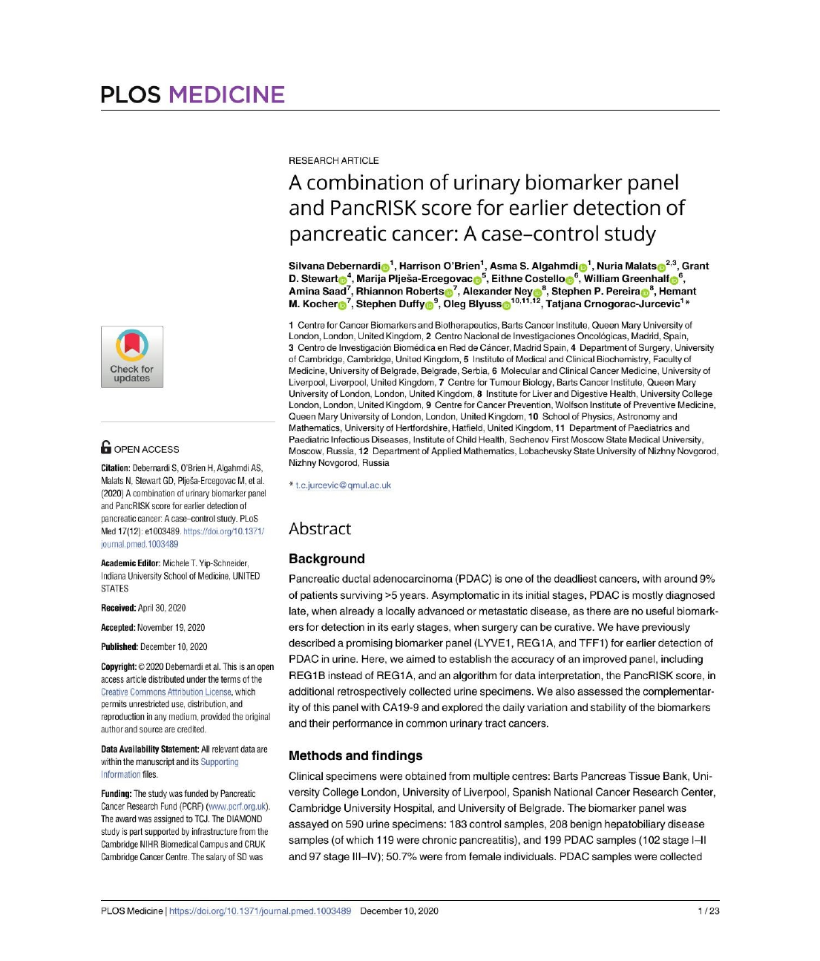

Research Paper B: Nearest neighbor pattern classification
T. M. Cover and P. E. Hart, “Nearest neighbor pattern classification,” IEEE Transactions on Information Theory, vol. 13, no. 1, pp. 21–27, 1967. Click the title above to open the complete paper (https://doi.org/10.1109/TIT.1967.1053964). The first page is not reproduced here because the paper's PDF was not available when this report was prepared.

