Freight Rate Prediction
Machine Learning Engineer assessment: approach, validation and results
Karim Mamdouh

1. Summary
- Task: predict posted_rate for 12,000 loads dated Nov–Dec 2025, using 48,000 labelled loads from Jan–Oct 2025. This is a forecasting problem, so every evaluation trains on the past and tests on later months.
- Model: a hybrid of LightGBM, which captures the load-level structure, and a small linear "market level" component (market index, time trend, quarter-end ramp) that can extrapolate in time. A shrunken lane effect is added on top. The target is log(rate).
- Result on the Sep–Oct hold-out (trained on Jan–Aug): MAPE 1.74%, MAE $39.5, compared with 2.43% for a plain LightGBM and 3.74% for a $/mile baseline. Across 3 rolling time folds the mean MAPE is 1.71%.
- Data quality: 677 corrupted rates (1.4%), negative and capped weights, missing weight/market_index, clamped coordinates, and 8 cities in validation that never appear in training. Each is handled explicitly (Section 3).
- quote_signal is excluded. It behaves differently in validation than in training, and adding it made 2 of the 3 time folds worse.

2. Key findings from the data
Distance explains most of the price (correlation 0.91 with rate), but not linearly: short hauls cost much more per mile. At equal distance, Reefer costs more than Flatbed, which costs more than Dry Van. Weight has a small positive effect.
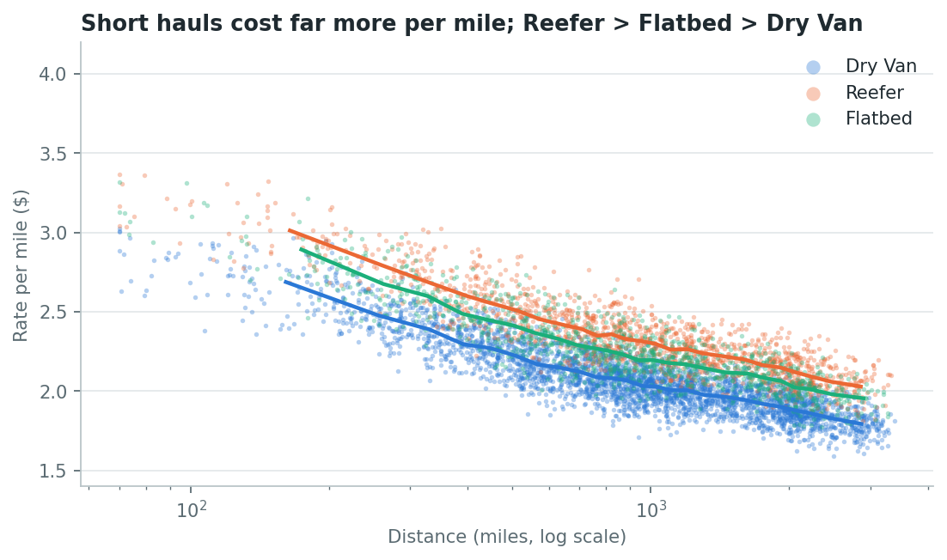
Figure 1. Rate per mile by distance and equipment (sample of loads; lines are binned medians).
After removing distance and equipment, the daily price level moves over time in three ways (Figure 2):
- market_index is a daily market level. Within a day its std is 0.025, against 0.17 overall. It also has a strong weekly cycle that the price level follows.
- An upward drift of about 6–7% per year at the same market_index. For example, January and September have similar market_index values, but September prices are about 5% higher.
- A quarter-end ramp: prices climb through March, June and September and reset at the start of the next quarter.
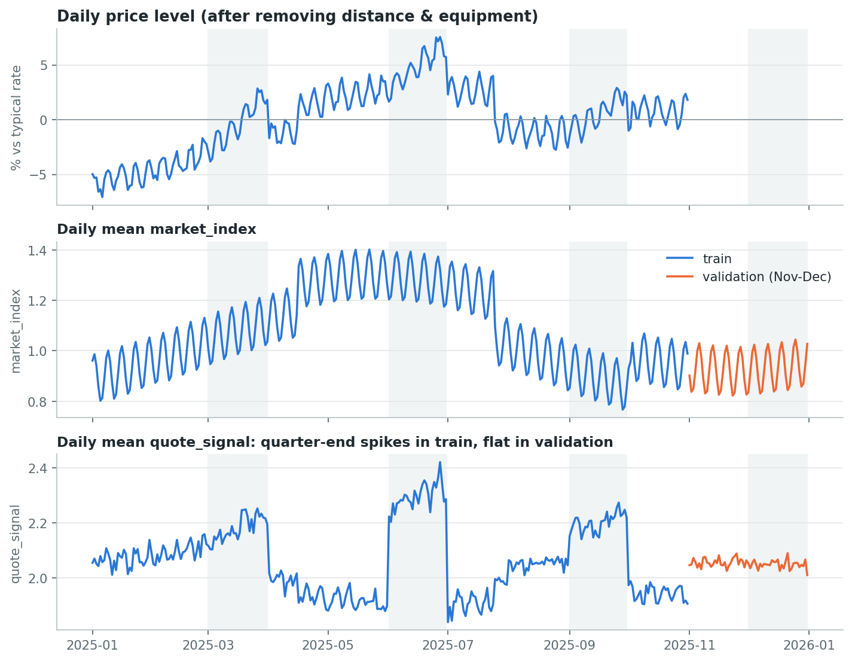
Figure 2. Daily price level (top), market_index (middle) and quote_signal (bottom). Shaded = quarter-end months.

3. Data-quality issues and how they were handled
Issue | Extent | Handling
Corrupted posted_rate (0.2–0.5× or 2–7× the normal rate for that distance/equipment) | 677 rows (1.4%) | Flagged with a robust per-equipment curve; removed from training only. There is an empty gap between |log residual| 0.25 and 0.6 (Figure 3), so the 0.40 threshold is not sensitive.
Negative weight (e.g. −23,937 lb) | 292 train / 145 val | Sign error: these rows price exactly like the positive weight, so abs() is used.
Weight capped at 47,500 lb | 1,204 train / 301 val | Kept, plus a weight_capped flag.
Missing weight | 300 / 165 | Per-equipment median from training, plus a weight_missing flag.
Missing market_index | 374 / 249 | Mean market_index of all loads on the same date (it is a daily variable).
Clamped coordinates (lat 25.5 / lon −69.5) | 2,052 / 669 rows | Coordinates are constant per city, so they still identify the city; geometry comes from distance, which is clean.
8 cities in validation never seen in training | 1,447 val rows (12%) | No city-ID features; coordinates generalise, and the lane effect defaults to 0. Tested explicitly (Section 4).
quote_signal distribution shift | all rows | Excluded from the model (Section 5).

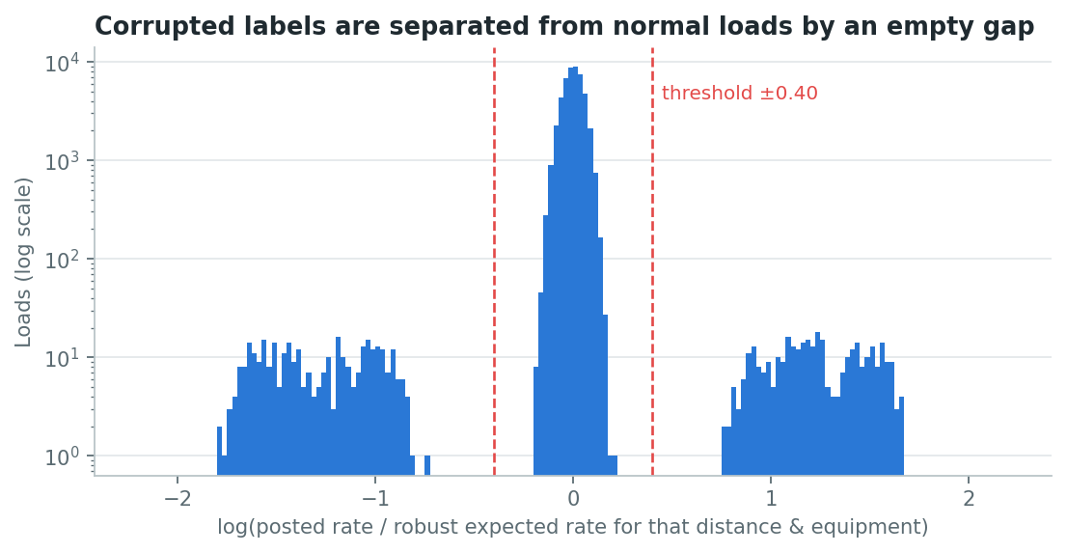
Figure 3. Log residual of each rate against a robust distance/equipment curve. Corrupted labels form two separate clusters.

4. Validation approach and data split
validation.csv covers Nov–Dec 2025, and the labelled data ends on 31 Oct 2025. The real job is therefore to predict the two months after the training data. A random split would put October loads in training and test on January, which hides any failure to follow the market forward in time. All model choices were made on time-based splits:
- Main hold-out: train Jan–Aug, test Sep–Oct. These are two unseen months, the same horizon as Nov–Dec.
- Rolling-origin folds (expanding window): test Jul–Aug, Aug–Sep and Sep–Oct, each trained only on earlier data. This checks the result is stable across windows, including the sharp market drop in late July.
- Unseen-city stress test: 8 random cities are removed from training entirely, and the model is scored on Sep–Oct loads that touch them. This mimics the 8 new cities in validation.csv.
- Cleaning without leakage: imputation statistics are fitted on the training fold only. Corrupted labels are removed from training folds, and test metrics are reported both on clean rows and on all rows.
For contrast, a random 80/20 split was also run. It makes the plain LightGBM look almost as good as the final model (1.61% against 1.53% MAPE). On the time split the gap is 2.43% against 1.74%. The split choice decides which model wins, which is why the random split was not used for selection.
Split | Plain LightGBM MAPE | Final model MAPE
Random 80/20 (optimistic, not used) | 1.61% | 1.53%
Time: train Jan–Aug, test Sep–Oct | 2.43% | 1.74%
Time: mean of 3 rolling folds | 2.87% | 1.71%

Unseen cities: MAPE 2.25% on 2,477 loads touching held-out cities, against 1.77% between seen cities. Accuracy degrades only modestly for new cities.

5. Model

Structure
log(rate) = LightGBM(load features) + [b0 + b1·log(market_index) + b2·trend + b3·quarter_end_ramp] + lane_effect
- Log target: errors in freight scale with the size of the load, so this treats a 3% miss equally on short and long hauls, and predictions are always positive.
- LightGBM learns the non-linear load-level structure: distance curve, equipment × distance, weight, city effects via coordinates, market_index, day of week.
- Linear market-level part: trees predict a flat value beyond the last date they have seen, so they cannot follow the upward trend into Nov–Dec. A linear trend term and a quarter-end ramp (0 outside Mar/Jun/Sep/Dec, rising from 0 to 1 through those months) can.
- Lane effect: each lane's mean residual is shrunk towards 0 with a pseudo-count of 10. Unseen lanes get 0.
- The three parts are fitted by backfitting (3 rounds): trees on the remainder of the other parts, then the linear part, then the lane effects.
Coefficients when trained on Jan–Aug: trend +6.3% per year, quarter-end ramp +4.1% by the last day of the quarter. (The market-index effect is shared between the trees and the linear term.)

Why quote_signal is excluded
In training, quote_signal is higher on short hauls and for Reefer/Flatbed, and it jumps during quarter-end months, which suggests it is partly derived from the price. In validation it is flat across distance, equipment and dates, with a narrower spread (std 0.22 vs 0.29). A model relying on it would be using a relationship that is absent when predictions are made. Adding it made the Jul–Aug and Aug–Sep folds much worse (Table 2).
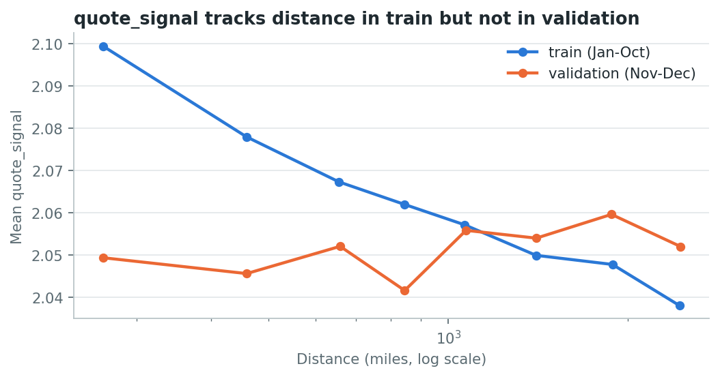
Figure 4. Mean quote_signal by distance: a clear pattern in training, none in validation.

6. Results
Table 1: Sep–Oct hold-out, trained on Jan–Aug. Metrics on clean rows; the last column includes the corrupted labels.
Model | MAE ($) | MAPE | RMSE ($) | Bias | MAPE incl. outliers
Hybrid (final) | 39.5 | 1.74% | 57.1 | -0.51% | 4.26%
Hybrid + quote_signal | 40.1 | 1.78% | 58.0 | -0.66% | 4.29%
Hybrid, no lane effect | 41.5 | 1.82% | 59.9 | -0.49% | 4.35%
Hybrid, no quarter-end ramp | 50.2 | 2.13% | 76.0 | -1.55% | 4.63%
Plain LightGBM (all raw features) | 57.9 | 2.43% | 86.1 | -1.73% | 4.92%
Baseline: $/mile by equipment x distance | 83.4 | 3.74% | 115.8 | -0.72% | 6.26%

Table 2: MAPE on rolling-origin folds (each trained only on earlier months).
Model | Test 2025-07–2025-08 | Test 2025-08–2025-09 | Test 2025-09–2025-10 | Mean
Hybrid (final) | 1.77% | 1.60% | 1.74% | 1.71%
Hybrid + quote_signal | 2.71% | 2.32% | 1.78% | 2.27%
Hybrid, no lane effect | 1.81% | 1.69% | 1.82% | 1.77%
Hybrid, no quarter-end ramp | 3.58% | 1.97% | 2.13% | 2.56%
Plain LightGBM (all raw features) | 3.38% | 2.81% | 2.43% | 2.87%
Baseline: $/mile by equipment x distance | 3.85% | 3.72% | 3.75% | 3.77%

Every ingredient earns its place: removing the quarter-end ramp or the lane effect, or adding quote_signal, makes results worse. Figure 6 shows the main remaining weakness. The model trained on Jan–Aug underpredicts October by about 1%, because prices did not fall back after the September quarter-end as much as after June. The final model is retrained on all data including October, so it learns this level.
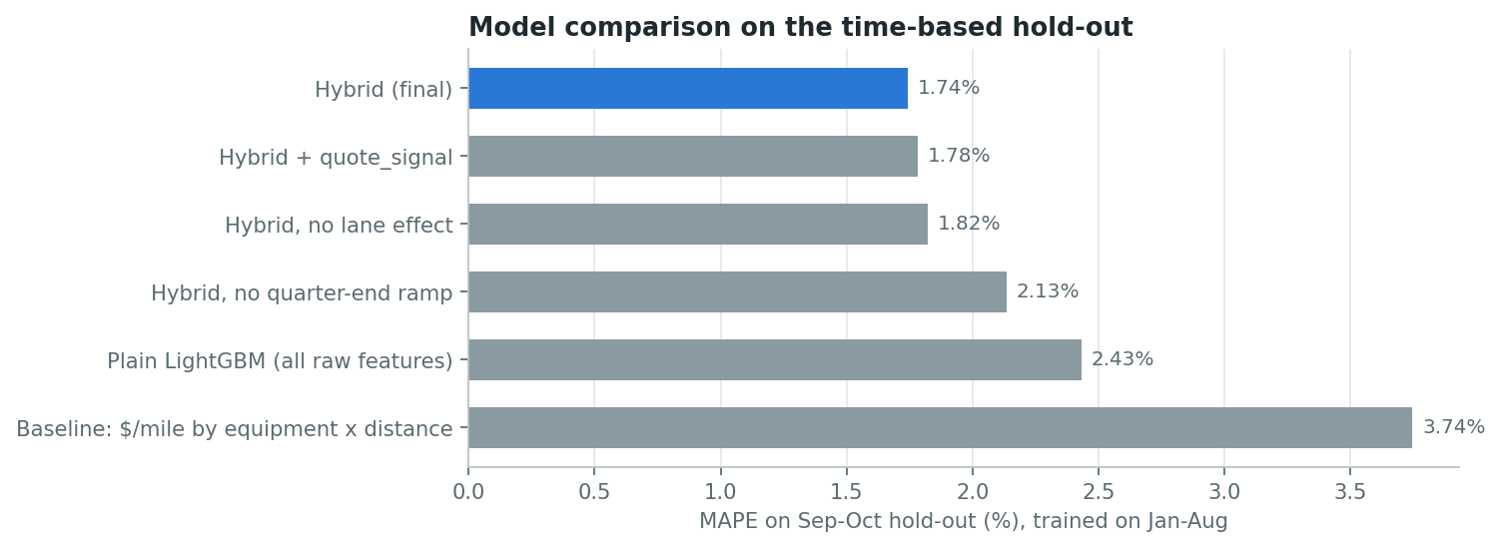
Figure 5. Hold-out MAPE by model.
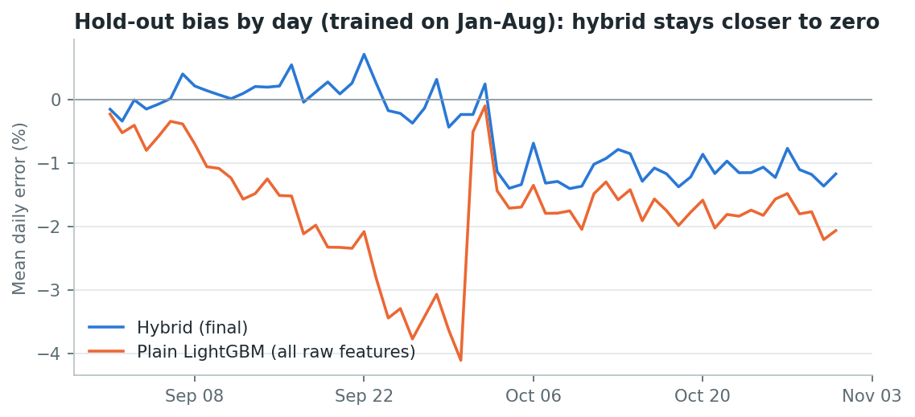
Figure 6. Mean daily % error on the hold-out.

7. Final model and predictions
The final model is trained on all 47,323 clean labelled rows (Jan–Oct) and predicts the 12,000 loads in validation.csv. validation_predictions.csv keeps the template's load_id order and contains exactly load_id,predicted_rate (all positive, no gaps). Missing market_index values in validation are filled from the same-day mean of validation rows. The 8 new cities are handled through their coordinates.

8. December prediction chart
Fixed inputs: Lexington → Fort Wayne, 360 miles, Dry Van, 32,000 lb; only the date changes. The chart inputs file has no market_index, quote_signal or coordinates, and score.py requires the original 7 columns. So the pipeline looks up the city coordinates from the data and uses the mean market_index of the validation loads on each December date. The predicted path therefore reflects:
- the weekly market_index cycle, which gives the weekly waves;
- the quarter-end ramp through December, which gives the upward slope (+3–4% by month end);
- the long-run trend.
Predictions range from about $834 to $888 (≈$2.32–2.47 per mile). That is consistent with recent loads on this lane, $778–865 for Dry Van in Sep–Oct.
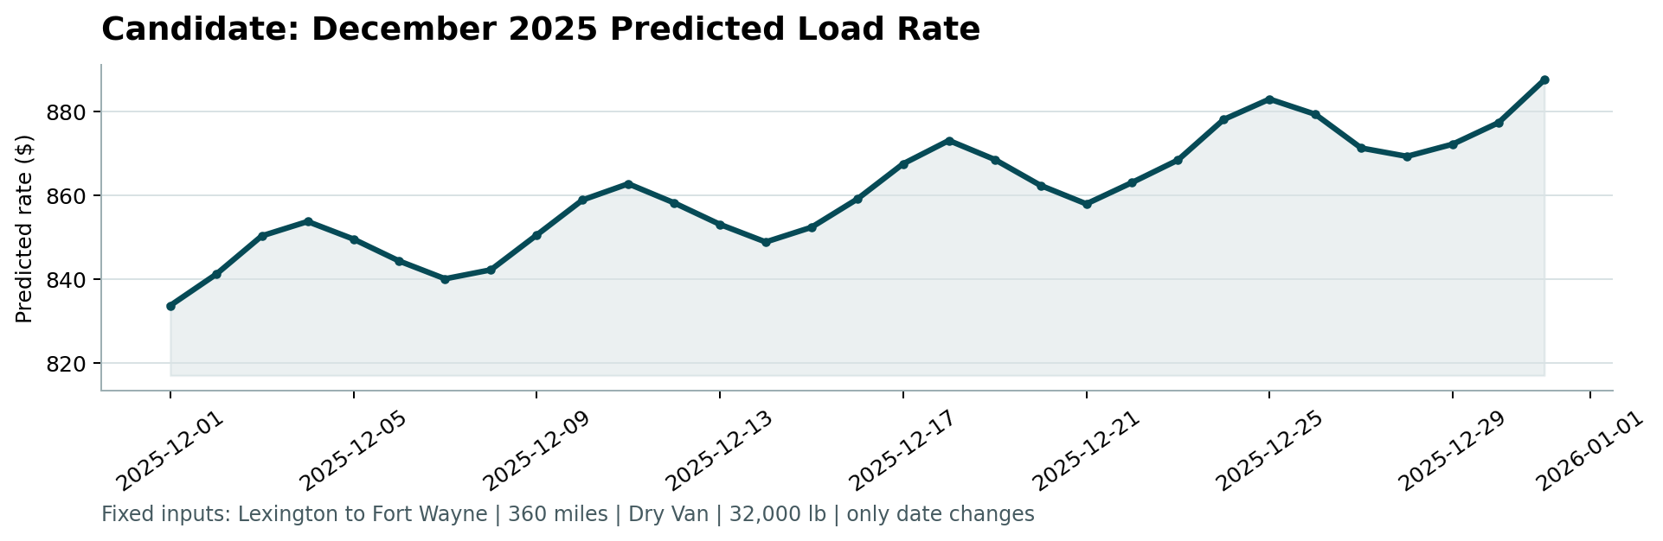
Figure 7. Produced by the provided score.py.

9. Limitations and next steps
- The December quarter-end ramp is assumed to behave like March, June and September. The data contains no December, and real December freight markets have holiday effects. With more history, a month-specific seasonal term would replace this assumption.
- The trend is extrapolated linearly two months ahead; it should be refreshed as new months are labelled (monthly retraining).
- Prediction intervals: quantile LightGBM, or conformal intervals calibrated on the rolling folds, would give a price range rather than a single price.
- quote_signal: worth revisiting if its definition is documented and confirmed to be available, unchanged, at quoting time.

10. Reproducing
pip install -r requirements.txt; python run_pipeline.py all; python score.py --predictions validation_predictions.csv --december-predictions data/december_chart_inputs.csv. See README.md for details. The full pipeline runs in about 3 minutes on a laptop.

