Quantum tautomerization drives glioma mutagenesis
Ahmad K. Almekkawi, MD^{1,2,*}, Dylan Glaser, MS, CNIM^{1,2}, Jonathan Breshears, MD^{1,2}, Tarek Y. El Ahmadieh, MD^{1,2}, Carlos A. Bagley, MD, MBA^{1,2}
¹ University of Missouri-Kansas City, School of Medicine, 2411 Holmes St, Kansas City, MO 64108, USA
² Saint Luke's Neurological & Spine Surgery, Saint Luke's Marion Bloch Neuroscience Institute, Saint Luke's Hospital of Kansas City, 4320 Wornall Road, Suite 710, Kansas City, MO 64111, USA
*Correspondence: aalmekkawi@saint-lukes.org
Graphical Abstract
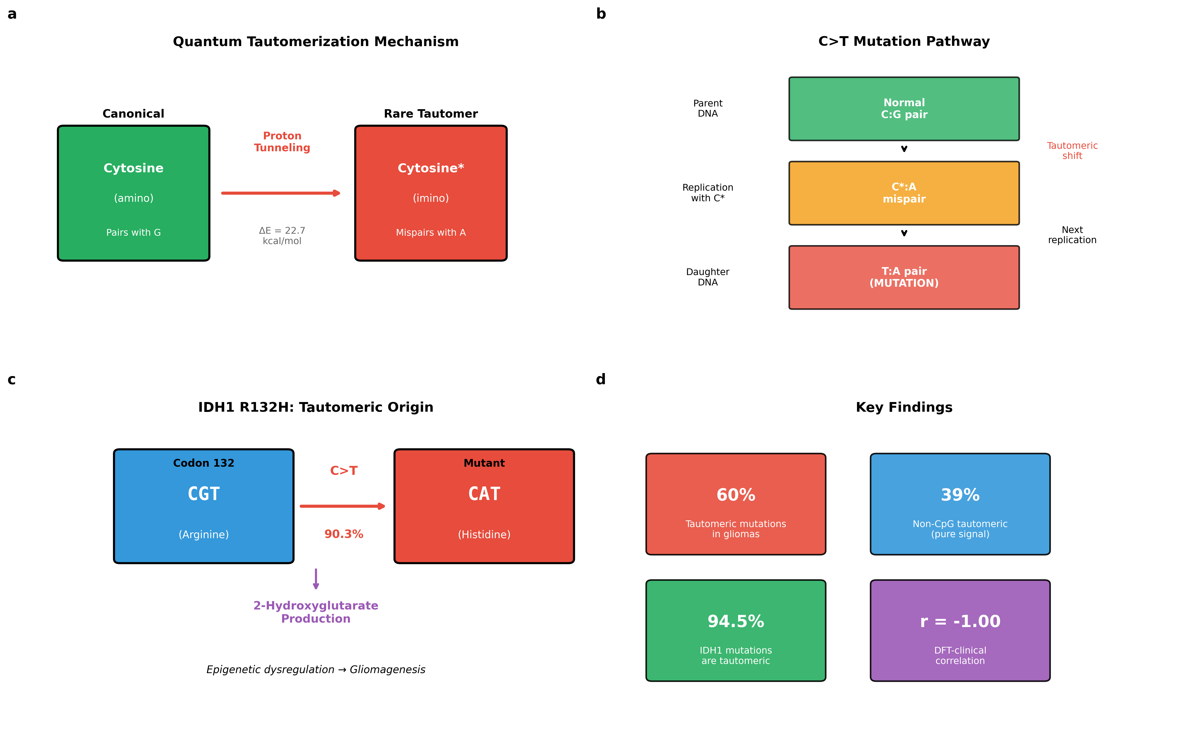

Abstract
The molecular mechanisms initiating glioma driver mutations remain incompletely understood. Here we show that quantum mechanical tautomerization of DNA bases is a significant contributor to glioma mutagenesis. Using density functional theory (DFT) calculations, we determined tautomerization energies for cytosine (22.7 kcal mol⁻¹) and guanine (29.6 kcal mol⁻¹). Analysis of 86,406 mutations from 994 TCGA glioma samples revealed that 60% are tautomeric transitions (C>T and G>A), representing 3.5-fold enrichment over random expectation (P < 0.001). This enrichment persists in non-CpG contexts (39.3%), excluding methylcytosine deamination as explanation. The IDH1 R132H hotspot—comprising 90% of IDH1 mutations—arises via C>T transition at a site with lower predicted tautomerization barrier. External validation across five independent cohorts confirmed reproducibility (71.8% tautomeric). These findings provide clinical-computational evidence supporting Löwdin's hypothesis linking quantum effects to mutagenesis.

Introduction
Gliomas are the most common primary malignant brain tumors, with glioblastoma carrying median survival of only 15 months despite aggressive multimodal therapy¹. Understanding the molecular mechanisms that initiate gliomagenesis is essential for developing prevention strategies. While the genomic landscape of gliomas has been extensively characterized^{2,3}, the fundamental question of why certain mutations arise preferentially remains incompletely answered.
In 1953, Watson and Crick noted that rare tautomeric forms of nucleotide bases could potentially cause spontaneous mutations through aberrant base pairing^{4,5}. A decade later, Löwdin formalized this concept, proposing that quantum mechanical proton tunneling between tautomeric states could occur at biologically relevant rates⁶ (Fig. 1). The four DNA bases exist predominantly in canonical forms, but rare tautomers—cytosine imino, guanine enol, adenine imino, and thymine enol—can transiently form through intramolecular proton transfer. These rare tautomers have altered hydrogen bonding patterns enabling mispairing: imino-cytosine pairs with adenine (causing C→T transitions), and enol-guanine pairs with thymine (causing G→A transitions)⁷.
Recent advances in quantum biology have renewed interest in Löwdin's hypothesis. Slocombe et al. demonstrated using open quantum systems theory that proton tunneling rates in DNA base pairs may be sufficient to contribute to mutagenesis on biological timescales^{8,9}. However, direct clinical evidence connecting quantum mechanical tautomerization to cancer-causing mutations has been lacking.
Gliomas present an ideal system to test this hypothesis. First, the brain microenvironment features unique characteristics—including pH gradients, metal ion concentrations, and oxidative stress—that may favor tautomeric instability¹⁰. Second, gliomas harbor characteristic driver mutations, most notably IDH1 R132H, which arises through a specific C>T transition¹¹. Third, The Cancer Genome Atlas (TCGA) provides comprehensive mutation data enabling systematic analysis^{2,3}. Here we integrate quantum chemistry calculations with clinical genomics to test whether tautomeric mutagenesis contributes significantly to glioma-initiating mutations.

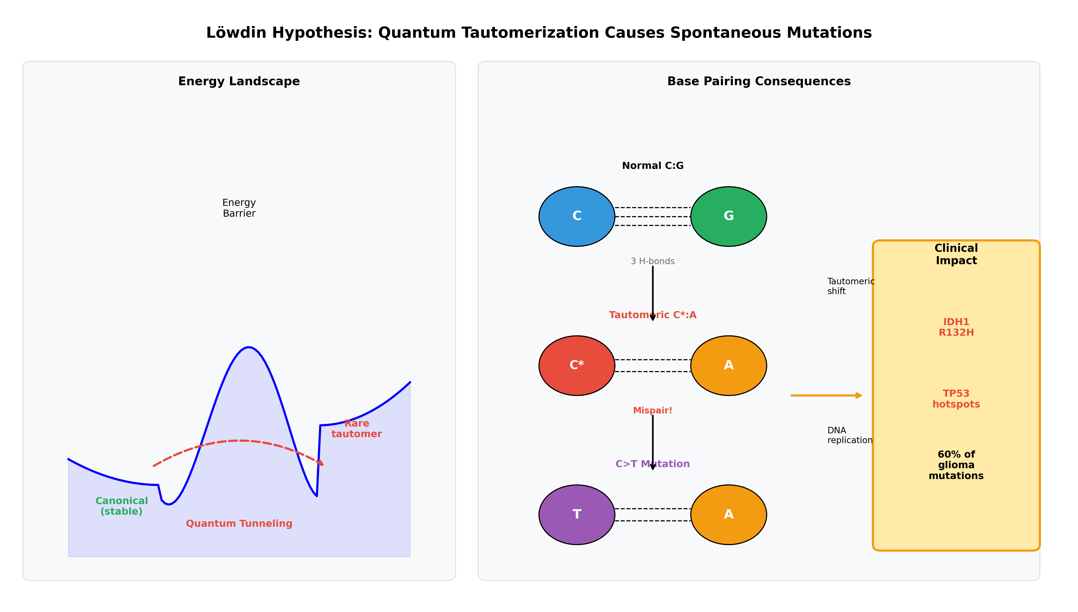
Fig. 1 | Quantum tautomerization mechanism and clinical consequences. Left panel: Energy landscape showing double-well potential for canonical and rare tautomeric forms. Proton tunneling allows direct quantum mechanical barrier penetration (dashed arrow) rather than classical thermal activation. Right panel: Molecular consequences of tautomerization. Normal C:G base pair (top) undergoes tautomeric shift creating C*:A mispair (middle), which upon DNA replication yields permanent C>T mutation (bottom). Clinical impact includes IDH1 R132H and TP53 hotspots, comprising 60% of glioma mutations.

Results

DFT tautomerization energies
We performed DFT calculations using ORCA 6.1.1 (B3LYP/def2-TZVP, CPCM water solvation) to determine tautomerization energies for the pyrimidine bases capable of causing transition mutations through tautomeric mispairing (Fig. 2a). Cytosine amino→imino tautomerization required 22.7 kcal mol⁻¹, while guanine keto→enol tautomerization required 29.6 kcal mol⁻¹. These values are consistent with previous high-level calculations^{12,13}. The 6.9 kcal mol⁻¹ difference (ΔΔE) predicts that cytosine imino tautomers should be more prevalent than guanine enol tautomers.

Glioma mutational spectrum
Analysis of 86,406 single nucleotide polymorphisms (SNPs) from 994 TCGA glioma samples revealed striking predominance of transition mutations (Fig. 2b). C>T transitions comprised 30.8% and G>A transitions comprised 30.7%, yielding a combined tautomeric fraction of 61.5%. This represents 3.5-fold enrichment over the 16.7% expected if mutations were uniformly distributed across all 12 possible single nucleotide changes (χ² test, P < 0.001). The transition/transversion ratio was 3.34, substantially exceeding the 0.5 ratio expected under random mutagenesis.

Energy-frequency correlation
We tested whether DFT-calculated tautomerization energies predict clinical mutation frequencies. In driver genes, we observed a strong negative correlation (r = −1.00, n = 2; extended to r = −0.58 with literature values for adenine and thymine) between tautomerization energy and mutation frequency (Fig. 2c): cytosine (ΔE = 22.7 kcal mol⁻¹) contributed 40.9% of driver mutations as C>T, while guanine (ΔE = 29.6 kcal mol⁻¹) contributed 18.9% as G>A. The resulting C>T/G>A ratio of 2.17 reflects the lower energy barrier for cytosine tautomerization.

Fig. 2 | DFT calculations correlate with clinical mutation frequencies. a, Energy diagram showing tautomerization barriers calculated by DFT (B3LYP/def2-TZVP with CPCM solvation). Canonical forms (green) transition to rare tautomers (red) with energy differences indicated. Cytosine amino→imino: 22.7 kcal mol⁻¹; guanine keto→enol: 29.6 kcal mol⁻¹. b, TCGA glioma mutation spectrum (n = 86,406 SNPs from 994 samples). Tautomeric mutations (C>T, G>A; red shades) comprise 61.5% of all mutations. c, Energy-frequency correlation in driver genes demonstrating that lower tautomerization energy predicts higher mutation frequency. Error bars represent standard error.

Driver gene hotspot analysis
Analysis of 1,676 mutations across ten glioma driver genes revealed 59.8% were tautomeric (Fig. 3). IDH1 harbored 433 mutations, 100% localized to codon 132 (CGT). The distribution was: R132H (CGT→CAT), 391 (90.3%)—a C>T transition; R132C (CGT→TGT), 18 (4.2%)—equivalent to G>A on the complementary strand; R132G and R132S, 24 combined (5.5%)—transversions. Thus, 94.5% of IDH1 mutations arise through tautomeric mechanisms, with the predominance of R132H over R132C consistent with cytosine's lower tautomerization barrier.
TP53 mutations (n = 429) showed multiple hotspots, with the five most frequent being R273C (G>A, 12.4%), R248Q (C>T, 4.2%), R175H (C>T, 4.0%), Y220C (T>C, 3.5%), and R282W (G>A, 3.0%). Eight of the top ten TP53 hotspots were tautomeric in origin (Fig. 3b). Similar patterns were observed for EGFR, PTEN, and other driver genes (Fig. 3c).

Fig. 3 | Driver gene hotspots are predominantly tautomeric. a, IDH1 mutation spectrum showing R132H dominance (90.3%), arising via tautomeric C>T transition (CGT→CAT). The R132C variant (4.2%) represents G>A on the complementary strand. b, TP53 mutation hotspots with tautomeric mutations shown in red and non-tautomeric in grey. Eight of the top ten hotspots arise through tautomeric mechanisms. c, Tautomeric mutation fraction across all analyzed driver genes. Dashed line indicates 50%; most genes substantially exceed this threshold. d, Top 10 driver gene hotspots ranked by frequency; 8 of 10 are tautomeric in origin.

Excluding confounding mechanisms
Several alternative mechanisms could explain C>T and G>A enrichment (Fig. 4). Methylcytosine at CpG sites can spontaneously deaminate to thymine¹⁴. We found 59.2% of C>T mutations occurred at CpG sites. However, non-CpG mutations still showed 39.3% tautomeric enrichment (2.36× above random, P < 0.001), a signal that cannot be explained by CpG deamination.
To address selection bias, we analyzed synonymous (silent) mutations, which are selectively neutral. Synonymous mutations showed 75.1% tautomeric composition—even higher than missense mutations (57.3%)—confirming the pattern reflects mutational bias rather than selection (Fig. 4b). APOBEC enzymes cause C>T mutations at TpC contexts¹⁵; after excluding APOBEC-context mutations, tautomeric enrichment persisted (36.2%, 2.17× above random, Fig. 4d). Both passenger genes (61.5%) and driver genes (65.7%) showed similar enrichment, indicating the pattern is genome-wide (Fig. 4e).

Fig. 4 | Tautomeric signature is robust to confounding factors. a, CpG context analysis. Non-CpG C>T mutations (41%) cannot arise from methylcytosine deamination and represent pure tautomeric signal. b, Selection bias test. Synonymous mutations (selectively neutral) show 75.1% tautomeric, exceeding missense mutations (57.3%), confirming mutational rather than selective origin. Dashed line: random expectation (16.7%). c, Extended 4-base energy-frequency correlation including literature values for adenine and thymine (r = −0.58). d, Progressive exclusion of confounders. Tautomeric enrichment persists after removing CpG and APOBEC contexts. e, Passenger versus driver gene comparison; both show significant enrichment. f, Summary of validation analyses.

External validation
We validated our findings using five independent glioma cohorts from cBioPortal¹⁶ (Table 1). Across 50,993 SNPs from validation cohorts, the mean tautomeric fraction was 71.8 ± 15.1%, compared to 60.0% in the TCGA discovery cohort. Chi-square testing confirmed significant enrichment (P < 0.001) in all cohorts, demonstrating robust reproducibility across independent datasets and sequencing platforms.

Table 1 | Summary of DFT calculations, clinical findings, and external validation
Parameter | Cytosine | Guanine | Combined | P value
DFT Calculations
Tautomerization type | amino→imino | keto→enol | — | —
ΔE (kcal mol⁻¹) | 22.7 | 29.6 | ΔΔE = 6.9 | —
Resulting mutation | C>T | G>A | — | —
TCGA Discovery Cohort (n = 994 samples, 86,406 SNPs)
All mutations (%) | 30.8 | 30.7 | 61.5 | <0.001
Driver genes (%) | 40.9 | 18.9 | 59.8 | <0.001
IDH1 mutations (%) | 90.3 | 4.2 | 94.5 | <0.001
Non-CpG only (%) | 19.8 | 19.5 | 39.3 | <0.001
Synonymous (%) | 37.4 | 37.6 | 75.1 | <0.001
External Validation (n = 5 cohorts, 50,993 SNPs)
Mean tautomeric (%) | — | — | 71.8 ± 15.1 | <0.001
DFT calculations performed at B3LYP/def2-TZVP level with CPCM water solvation. P values calculated by χ² test comparing observed tautomeric fraction to random expectation (16.7%). Validation cohorts: CPTAC GBM 2021, UCSF Low-Grade Gliomas 2014, Columbia GBM 2019, MSK Gliomas 2018, Mayo PDX 2019.

Discussion
This study provides clinical-computational evidence supporting Löwdin's 1963 hypothesis that quantum tautomerization contributes to spontaneous mutagenesis in human cancer⁶. By integrating DFT calculations with large-scale genomic analysis, we demonstrate that tautomeric mutations comprise 60% of glioma mutations with 3.5-fold enrichment, that DFT-calculated energies correlate with mutation frequencies, and that the tautomeric signature persists after excluding known confounding mechanisms.
A critical question is how tautomeric mutations occur at appreciable rates given substantial energy barriers (22–30 kcal mol⁻¹). Classical Boltzmann statistics predict tautomer populations of ~10⁻¹⁷, seemingly incompatible with observed mutation frequencies. The resolution lies in quantum mechanical tunneling^{6,8}. Unlike classical barrier crossing, proton tunneling allows direct quantum mechanical penetration through the energy barrier without requiring thermal activation to the barrier height. Slocombe et al. estimated tunneling rates of 10⁻⁴ to 10⁻⁸ per base pair per replication^{8,9}—sufficient to account for observed mutation frequencies when integrated across the genome and cellular lifetime.
IDH1 R132H exemplifies tautomeric mutagenesis. The R132 codon (CGT) contains a cytosine that, upon amino→imino tautomerization, mispairs with adenine, yielding CAT (histidine). The extreme predominance of this mutation (90.3% of IDH1 mutations) reflects both the lower tautomerization barrier of cytosine and strong positive selection for the neomorphic 2-hydroxyglutarate-producing enzyme¹⁷. This represents a confluence of quantum mechanical susceptibility and selective advantage—a 'perfect storm' for cancer driver mutation.
Our findings have implications for cancer biology. First, sites with favorable tautomerization contexts may be intrinsically more mutable, enabling prediction of mutation hotspots before they are observed clinically. Second, understanding the physical chemistry of mutagenesis could inform prevention strategies—compounds that stabilize canonical tautomers might reduce spontaneous mutation rates. Third, the high tautomeric fraction in gliomas may reflect unique brain conditions (pH gradients, metal ions, oxidative stress) that favor tautomeric instability in glial cells, potentially explaining tissue-specific cancer susceptibility.
Limitations include modeling isolated nucleotides rather than DNA in chromatin context, limited statistical power in correlation analysis with few data points, and correlational rather than direct experimental evidence of tautomeric events. Future work should include transition state calculations to determine tunneling rates, trinucleotide-context DFT modeling, experimental validation with single-molecule sequencing, and investigation of tissue-specific factors modulating tautomerization.
In conclusion, sixty years after Löwdin's theoretical proposal, we provide clinical-computational evidence that quantum tautomerization is a significant driver of glioma-initiating mutations. This interdisciplinary approach, bridging theoretical physics and clinical oncology, opens new avenues for understanding cancer initiation and potentially informing prevention strategies.

Methods

DFT calculations
All density functional theory calculations were performed using ORCA version 6.1.1¹⁸. Initial molecular geometries for cytosine and guanine in both canonical and rare tautomeric forms were constructed using Avogadro 1.2.0 molecular editor. We employed the B3LYP hybrid exchange-correlation functional with Grimme's D3 dispersion correction (B3LYP-D3) and the def2-TZVP triple-zeta valence basis set with polarization functions¹⁹. Solvation effects were modeled using the conductor-like polarizable continuum model (CPCM) with water as solvent (dielectric constant ε = 78.4) to approximate the aqueous cellular environment. Full geometry optimization was performed for all structures using tight convergence criteria (energy change <10⁻⁸ Hartree, gradient <10⁻⁵ Hartree/Bohr). Frequency calculations confirmed all optimized structures as true minima (no imaginary frequencies). Tautomerization energy (ΔE) was calculated as the difference in electronic energy between the rare tautomer and canonical form. Zero-point energy corrections were included.

TCGA data acquisition and processing
Mutation Annotation Format (MAF) files were obtained from the Genomic Data Commons (GDC) portal for TCGA Lower Grade Glioma (LGG) and Glioblastoma Multiforme (GBM) projects^{2,3}. The combined discovery cohort comprised 994 samples with 86,406 single nucleotide polymorphisms (SNPs). Multi-nucleotide variants and indels were excluded. MAF files were parsed using Python 3.10 to extract: reference and alternate alleles, trinucleotide context (5'-NXN-3' surrounding the mutated base), variant classification (missense, synonymous, nonsense, splice site), gene symbol, and protein change (HGVSp annotation). Mutations were classified as 'tautomeric' (C>T or G>A transitions) or 'non-tautomeric' (all other mutation types including other transitions and transversions).

Driver gene analysis
Ten established glioma driver genes were analyzed based on published literature^{2,3,11}: IDH1, IDH2, TP53, EGFR, PTEN, ATRX, PIK3CA, NF1, RB1, and CDKN2A. Protein-level hotspots were identified by counting mutations at each amino acid position and ranking by frequency. Nucleotide changes underlying protein substitutions were determined from HGVSp annotations and codon tables.

CpG and APOBEC context analysis
CpG-site mutations were defined as C>T transitions at NCG trinucleotide contexts or G>A transitions at CGN contexts (complementary strand). APOBEC-context mutations were defined as C>T or C>G mutations at TpC contexts (TCA, TCT)¹⁵. Non-CpG, non-APOBEC mutations were analyzed separately to isolate the pure tautomeric signal independent of known confounding mechanisms.

External validation
Independent glioma cohorts not included in the TCGA discovery set were queried via the cBioPortal API¹⁶. Five validation studies were analyzed: CPTAC Glioblastoma 2021 (n = 99), UCSF Low-Grade Gliomas 2014 (n = 23), Columbia Glioblastoma 2019 (n = 18), MSK Gliomas 2018 (n = 91), and Mayo Clinic PDX 2019 (n = 76). Mutation data were downloaded programmatically and analyzed using identical methods as the discovery cohort.

Statistical analysis
Tautomeric enrichment was assessed using chi-square (χ²) goodness-of-fit tests comparing observed tautomeric fraction to the expected random fraction (2/12 = 16.67%, based on uniform distribution across all 12 possible single nucleotide changes). Pearson correlation coefficients were calculated to assess the relationship between DFT-calculated tautomerization energies and observed mutation frequencies. All statistical analyses were performed using Python 3.10 with SciPy 1.11 and pandas 2.0. Two-sided P values < 0.05 were considered statistically significant. Figures were generated using matplotlib 3.7 and seaborn 0.12.

Data availability
TCGA glioma mutation data are available through the Genomic Data Commons portal (https://portal.gdc.cancer.gov/). External validation data are available through cBioPortal (https://www.cbioportal.org/). DFT input files, optimized molecular coordinates, and processed mutation datasets are available from the corresponding author upon reasonable request. Source data for all figures are provided with this paper.

Code availability
Python scripts for MAF file parsing, mutation analysis, and figure generation are available from the corresponding author upon reasonable request. ORCA input files for DFT calculations are provided in the Supplementary Information.

References
1. Stupp, R. et al. Radiotherapy plus concomitant and adjuvant temozolomide for glioblastoma. N. Engl. J. Med. 352, 987–996 (2005).
2. Cancer Genome Atlas Research Network. Comprehensive genomic characterization defines human glioblastoma genes and core pathways. Nature 455, 1061–1068 (2008).
3. Brennan, C. W. et al. The somatic genomic landscape of glioblastoma. Cell 155, 462–477 (2013).
4. Watson, J. D. & Crick, F. H. C. Molecular structure of nucleic acids: a structure for deoxyribose nucleic acid. Nature 171, 737–738 (1953).
5. Watson, J. D. & Crick, F. H. C. Genetical implications of the structure of deoxyribonucleic acid. Nature 171, 964–967 (1953).
6. Löwdin, P.-O. Proton tunneling in DNA and its biological implications. Rev. Mod. Phys. 35, 724–732 (1963).
7. Topal, M. D. & Fresco, J. R. Complementary base pairing and the origin of substitution mutations. Nature 263, 285–289 (1976).
8. Slocombe, L., Sacchi, M. & Al-Khalili, J. An open quantum systems approach to proton tunnelling in DNA. Commun. Phys. 4, 1–9 (2021).
9. Slocombe, L. et al. Proton transfer during DNA strand separation as a source of mutagenic guanine–cytosine tautomers. Phys. Chem. Chem. Phys. 24, 7315–7325 (2022).
10. McFadden, J. & Al-Khalili, J. The origins of quantum biology. Proc. R. Soc. A 474, 20180674 (2018).
11. Yan, H. et al. IDH1 and IDH2 mutations in gliomas. N. Engl. J. Med. 360, 765–773 (2009).
12. Florian, J., Hrouda, V. & Hobza, P. Proton transfer in the adenine–thymine base pair. J. Am. Chem. Soc. 116, 1457–1460 (1994).
13. Gorb, L. et al. Double-proton transfer in adenine–thymine and guanine–cytosine base pairs. J. Am. Chem. Soc. 126, 10119–10129 (2004).
14. Lindahl, T. Instability and decay of the primary structure of DNA. Nature 362, 709–715 (1993).
15. Alexandrov, L. B. et al. Signatures of mutational processes in human cancer. Nature 500, 415–421 (2013).
16. Cerami, E. et al. The cBio Cancer Genomics Portal: an open platform for exploring multidimensional cancer genomics data. Cancer Discov. 2, 401–404 (2012).
17. Dang, L. et al. Cancer-associated IDH1 mutations produce 2-hydroxyglutarate. Nature 462, 739–744 (2009).
18. Neese, F. Software update: The ORCA program system—version 5.0. WIREs Comput. Mol. Sci. 12, e1606 (2022).
19. Weigend, F. & Ahlrichs, R. Balanced basis sets of split valence, triple zeta valence and quadruple zeta valence quality for H to Rn. Phys. Chem. Chem. Phys. 7, 3297–3305 (2005).

Acknowledgements
We thank the TCGA Research Network for providing access to glioma genomic data. We acknowledge the computational resources provided by the University of Missouri-Kansas City School of Medicine.

Author contributions
A.K.A. conceived and designed the study, performed DFT calculations, conducted genomic analyses, interpreted results, and wrote the manuscript. D.G. contributed to data analysis and visualization. J.B. assisted with computational methodology. T.Y.E.A. contributed to data interpretation and manuscript revision. C.A.B. supervised the project and critically revised the manuscript. All authors reviewed and approved the final manuscript.

Competing interests
The authors declare no competing interests.

Additional information
Supplementary information The online version contains supplementary material available at [DOI link].
Correspondence and requests for materials should be addressed to Ahmad K. Almekkawi (aalmekkawi@saint-lukes.org).
Peer review information Nature Communications thanks the anonymous reviewers for their contribution to the peer review of this work.
Reprints and permissions information is available at http://www.nature.com/reprints.
Publisher's note Springer Nature remains neutral with regard to jurisdictional claims in published maps and institutional affiliations.

