**Name Project : *An application to solve the problem of expatriates*** ***in finding housing inside or outside the university .***

**Name manager : Barakat Adel Hamdan Younas.**

**Team of project :**

**1 – Barakat Adel Hamdan Younas.(software)**

**2- Khaled Othman Abdelrahem haredy.(software)**

**3- Salah Al-Din Abdel Wakeel Mohamed Hemdan.(software)**

**4- Salem Issa Mohamed Morsy.(software)**

**5-Mohamed Mostafa Talat Abd el-rady(general)**

**6-Mohamed Mahmoud Mohamed Mahmoud(general).**

**7-Mohamed Mostafa Abd el-samie. (general)**

**Project sponsor :Assuit university**

**Purpose of the project :**

**This application helps expatriate students to know the empty places at the university and the places near the university with determining prices and housing features .It saves students time in knowing the places in university housing . Student can book their places from anywhere in the republic after being accepted in the college .**

**Business case : Many expatriate students are not able to attend school because of housing and their lack of knowledge of empty places inside and outside the university .**

**This application helps them to know the largest number of empty places with specifying the address , features and prices , and the students must choose the appropriate for him and book it from anywhere within the country .**

**Tasks :**

**Have three domains ( people – process – Business environment)**

**1 – People domain deals with building leading supporting and promoting a project team .People domain has 14 tasks and 53 enablers.**

**2 – Process domain deals with project governance structure establishment ,Knowledge transfer for project continuity and project phases close out .Process covers project Execution ,Communications ,Risks ,Issues and Change Management .Process domain has 17 tasks and 61 enables .**

**3- Business environment domain covers project compliance Planning & Management and organizational Changing support .Business environment has 4 tasks and 19 enables.**

**Project *scop* :**

**1-Applications design.**

**2-Android application.**

**3-IOS application.**

**4-Web application.**

**Project objectives:**

**1-Save time for the students and owners of housing.**

**2-Facilitate student communication with the owners.**

**3-** **Reduce direct contact to maintain public safety.**  **Deliverables:**

**1-Design application.**

**2-Software industry.**

**3-application working on all platforms**

**( web, android, ios, macOS, windows).**

**security control**

**1.1**

**Beginning**

1.2

Software and hardware

**Website**

**Coding**

1.4

**The End**

|  |
| --- |
| **1.1.1**  **Requirements**  **1.1.2**  **Project Resources** |

|  |
| --- |
| 1.2.1  Check all hardware  1.2.2  Operating system  1.2.3  Write coding |

|  |
| --- |
| 1.3.1  Test function  1.3.2  Test Program |

|  |
| --- |
| 1.4.4  Publish |

Work Breakdown Structure (WBS) dictionary :

BEGINNING :

From 1\10\2021 to 20\10\2021

|  |  |
| --- | --- |
| 1.1.1 | Work package id : |
| Identify Requirement | Work package name: |
| Searching about requires from people and process and Business environment . | Description: |
| Project Manager with team | Person : |
| 1\10\2021 | Start date : |
| 15\10\2021 | End date : |

|  |  |
| --- | --- |
| 1.1.2 | Work package id : |
| * Identify resources | Work package name: |
| Searching about require Resources Software and Hardware ( PCs , software , cables …etc ) . | Description: |
| Project Manager with team | Person : |
| 16\10\2021 | Start date : |
| 20\10\2021 | End date : |

1.2 Designing :  
from 21\10\2021 To 30\11\2021

|  |  |
| --- | --- |
| 1.2.1 | Work package id : |
| check the pcs and software &requirement | Work package name: |
| Checking if the software appropriate for PCs , checking if there are problems in cables | Description: |
| Maintained workers | Person : |
| 21\10\2021 | Start date : |
| 25\10\2021 | End date : |

|  |  |
| --- | --- |
| 1.2.2 | Work package id : |
| Check operating system | Work package name: |
| Check all parts of operating system. | Description: |
| Manager project with team | Person : |
| 26\10\2021 | Start date : |
| 30\10\2021 | End date : |

|  |  |
| --- | --- |
| 1.2.3 | Work package id : |
| COODING. | Work package name: |
| Write code using any programming language. | Description: |
| Manager project with team. | Person : |
| 1\11\2021 | Start date : |
| 30\11\2021 | End date : |

* .3 Website coding :

from 1\12\2021 To 30\12\2021 .

|  |  |
| --- | --- |
| 1.3.1 | Work package id : |
| TEST | Work package name: |
| Checking functions that have been coded . | Description: |
| Programmers with Project manager | Person : |
| 1\12\2021 | Start date : |
| 10\12\2021 | End date : |

|  |  |
| --- | --- |
| 1.3.2 | Work package id : |
| TEST and TRAIN | Work package name: |
| Test the program by training groups and take feedback from them | Description: |
| Programmers | Person : |
| 11\12\2021 | Start date : |
| 30\12\2021 | End date : |

1.4 Publish:

from 1\1\2022 To 15 \1\2022

.

|  |  |
| --- | --- |
| 1.4.1 | Work package id : |
| Advertisement | Work package name: |
| Start to Advertise our APP on the internet | Description: |
| Upper management | Person : |
| 1\1\2022 | Start date : |
| 4\1\2022 | End date : |

|  |  |
| --- | --- |
| 1.4.2 | Work package id : |
| LAUNCHING | Work package name: |
| Publish our App on all App stores | Description: |
| Upper management | Person : |
| 5\1\2022 | Start date : |
| 15\1\2022 | End date : |

**Responsibilities Matrix:**

|  |  |  |  |  |  |
| --- | --- | --- | --- | --- | --- |
| Task\Member | Manager | Application   Developer | Network  Engineer | Tester | Project Expert |
| Create The Application | A | C | I | I |  |
| Test The Application | A | R | C | I |  |
| Install Hardware | C | I | R |  |  |
| Test The Hardware | I | C | C | R |  |
| Package The Application | R | C |  | A | C |
| Test The Application release | I |  |  | A | R |
| Push The Project To  Workstation | A | C |  | R | C |

**RACI:**

- Responsible: Person who is completing the task.- Accountable: Person who is making decisions and taking actions on the task(s).- Consulted: Person who will be communicated with regarding the decision-making process and specific tasks.- Informed: Person who will be updated on decisions and actions during the project.

**Network Information :**

|  |  |  |  |
| --- | --- | --- | --- |
| ACTIVITY | DESCREPTION | PRECEDING ACTIVITY | ACTIVITY TIME |
| A | DEFINE REQUIRE MENT | NONE | 10 WORKDAYS |
| B | ASSIGN TEAM | A | 5 |
| C | DESIGN HARDWARE | A | 25 |
| D | CODE SOFTWARE | B | 15 |
| E | BUILD & TESTHARDWARE | C | 50 |
| F | DEVELOPTENT REQUIREMENTS | C | 15 |
| G | TEST SOFTWARE | D | 35 |
| H | INTEGRATE SYSTEM | E.F.G | 15 |

**Project Network:**

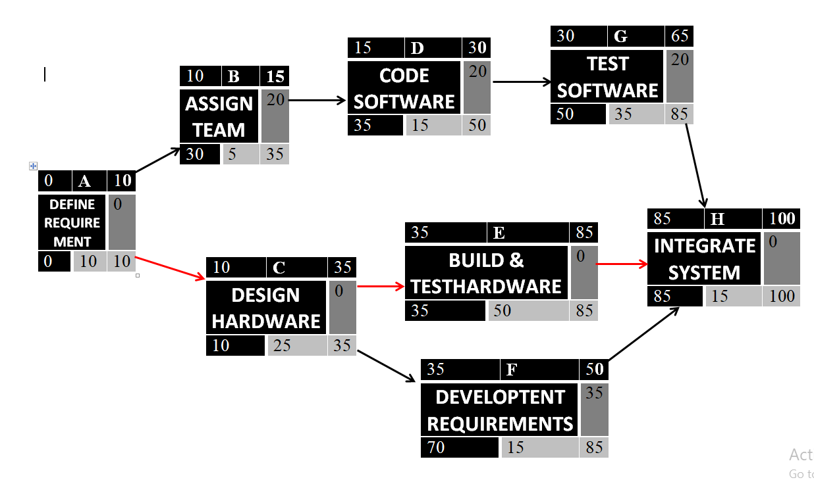

**A,C,E,H**

|  |  |  |  |  |  |  |  |  |  |  |  |  |  |  |  |  |  |  |  |  |  |  |
| --- | --- | --- | --- | --- | --- | --- | --- | --- | --- | --- | --- | --- | --- | --- | --- | --- | --- | --- | --- | --- | --- | --- |
| **ID** | **RES** | **DUR** | **ES** | **LF** | **SL** | **0** | **1** | **2** | **3** | **4** | **5** | **6** | **7** | **8** | **9** | **10** | **11** | **12** | **13** | **14** | **15** | **16** |
| **A** | **1** | **1** | **0** | 1 | 0 | 1 |  |  |  |  |  |  |  |  |  |  |  |  |  |  |  |  |
| **B** | **1** | **1** | 1 | 2 | 0 |  | 1 |  |  |  |  |  |  |  |  |  |  |  |  |  |  |  |
| **C** | **2** | **3** | 2 | 5 | 2 |  |  | 2 | 2 | SL | SL |  |  |  |  |  |  |  |  |  |  |  |
| **D** | **1** | **2** | 5 | 7 | 0 |  |  |  |  |  | 1 | 1 |  |  |  |  |  |  |  |  |  |  |
| **E** | **2** | **2** | 7 | 9 | 1 |  |  |  |  |  |  |  | 2 | 0 |  |  |  |  |  |  |  |  |
| **F** | **1** | **2** | 9 | 11 | 0 |  |  |  |  |  |  |  |  |  | 1 | 1 |  |  |  |  |  |  |
| **G** | **2** | **3** | 11 | 14 | 1 |  |  |  |  |  |  |  |  |  |  |  | 2 | 2 | 2 | SL |  |  |
| **H** | **1** | **2** | 14 | 16 | 0 |  |  |  |  |  |  |  |  |  |  |  |  |  |  |  | 1 | 1 |
| **Total Resource Load** | | | | | | 1 | 1 | 2 | 2 | 0 | 1 | 1 | 2 | 0 | 1 | 1 | 2 | 2 | 2 | 0 | 1 | 1 |
| **Resource Available** | | | | | | **2** | **2** | **2** | **2** | **2** | **2** | **2** | **2** | **2** | **2** | **2** | **2** | **2** | **2** | **2** | **2** | **2** |

**project resources :**

**1)Hardware :4 laptops,2 servers.**

**2) Software : Software licenses.**

**3)Staff : 3 design developer,3 Android developer.**

**Budget :Maximum 15,000 $ 1.Design : around 1500$2.software : -windows application about 3500$ -android application3500$ at most**

**-IOS application 4000$ 3. Database 2500$**

**Constraints**

**-The project should not exceed $ 15,000.**

**-Buy any cell phone or any computer from dell**

**-The application area should be small so that expatriates who have weak phones can download it.**

**Assumption :**

**-Anyone working on this project required of him will finish on time.**

**- All important stakeholders will attend the designated meetings**

**- All team members will complete the project to the end .**

**Risk management:**

|  |  |  |
| --- | --- | --- |
| **Solutions** | **Sub causes** | **Main causes** |
| ensuring the team_members and taking the feedbace of customers in every step. | 1)the time for the project was initially incorrectly calculated and set  2) the project manager does not properly track employees  3) lack of resources | **a) Bad use of time** |
| Determine the budget for each task from the beginning | 1) the budget was initially calculated incorrectly.  2) unplanned project expansion. | **b) Incorrect budget estimation** |
| The project manager must be in constant contact with the members and have leadership qualities | 1. Poor communication between manager and members 2. Poor communication between members and each other 3. lackof leadership and analytical skills | **c) Weak management** |
| Choosing professional cadres capable of doing this task | 1) too complex multi-part project.  2) lack of professionalism and knowledge of team members  3) changes in software requirements | **d) Weakness of coding** |
| Maintain up-to-date documentation.  On board new or replacement stakeholders with a learning guide | Though unlikely, occasionally a stakeholder or development team member must leave a project unexpectedly | **e)Few human resoursese** |