TECHMASTER ACADEMY
Phase 03 · Project 03
Optimized Spam Detection System
Model Evaluation Report
Client: Email Service Provider
Dataset: SMS Spam Collection (UCI / Kaggle)
Best Model: Optimized SVM — 97.87% Test Accuracy
August 2026

Table of Contents
- 1. Executive Summary
- 2. Project Overview
- 3. Dataset
- 4. Methodology
- 5. Model Training & Evaluation
- 6. Final Model Comparison
- 7. Recommended Model
- 8. Limitations & Recommendations
- 9. Conclusion

1. Executive Summary
This report presents the results of the Optimized Spam Detection System project developed as part of TechMaster Academy — Phase 03. The objective was to build a machine learning model capable of automatically classifying SMS/email messages as Spam or Ham (legitimate) for an Email Service Provider client, in order to improve user experience and reduce exposure to unwanted or malicious content.
Five models were trained and compared on the SMS Spam Collection dataset (5,572 messages): Naive Bayes, Logistic Regression, Support Vector Machine (default), a hyperparameter-optimized SVM (via GridSearchCV), and Random Forest. The optimized SVM achieved the best overall performance, with 97.87% test accuracy and the highest spam-detection F1-score (0.91), and was selected as the final recommended model.

2. Project Overview

2.1 Goal
Build an optimized machine learning model that automatically classifies incoming messages as Spam or Ham with high accuracy, reducing manual review effort and protecting users from unwanted or malicious content.

2.2 Client Brief
Client: Email Service Provider. Goal: automatically classify incoming emails as Spam or Ham with high accuracy to improve the end-user experience.

2.3 Technology Stack
- Language: Python
- Libraries: Pandas, NumPy, Scikit-learn, Matplotlib
- Dataset format: CSV

3. Dataset
The project uses the SMS Spam Collection Dataset, sourced from the UCI Machine Learning Repository (Kaggle mirror). The raw file contains 5,572 rows and 5 columns:
- v1 — message label ("ham" or "spam")
- v2 — the raw message text
- 3 unnamed columns — almost entirely empty, dropped during cleaning
Class distribution in the raw data: Ham 4,825 messages (86.59%), Spam 747 messages (13.41%) — a moderately imbalanced dataset, typical for spam-filtering problems.
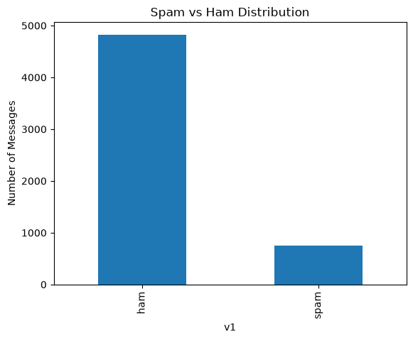
Figure 1 — Spam vs. Ham distribution (raw dataset)

4. Methodology

4.1 Data Cleaning
- Dropped the 3 unnamed, largely empty columns.
- Renamed columns: v1 → Label, v2 → Message.
- Removed 403 duplicate rows, reducing the dataset from 5,572 to 5,169 rows.
- Encoded labels numerically: ham = 0, spam = 1.
- Post-cleaning class distribution: Ham 4,516 (87.4%), Spam 653 (12.6%).

4.2 Text Preprocessing
A cleaning function was applied to every message to standardize the text before feature extraction:
- Converted all text to lowercase.
- Removed URLs (http/https/www patterns).
- Removed non-alphabetic characters and digits.
- Collapsed repeated whitespace and trimmed the result.

4.3 Feature Extraction
Cleaned messages were converted into numerical features using TF-IDF (Term Frequency–Inverse Document Frequency) vectorization, producing 8,450 features across 5,169 messages.

4.4 Train/Test Split
The data was split 80% / 20% into training and test sets using stratified sampling to preserve class balance, resulting in 4,135 training messages and 1,034 test messages.

5. Model Training & Evaluation
Five classification models were trained on the TF-IDF features and evaluated on the same held-out test set (1,034 messages: 903 Ham, 131 Spam). The table below summarizes accuracy and spam-class performance for each model:
Model | Accuracy | Spam Precision | Spam Recall | Spam F1-score
Naive Bayes | 94.78% | 1.00 | 0.59 | 0.74
Logistic Regression | 95.45% | 0.99 | 0.65 | 0.78
SVM (default, RBF) | 97.20% | 0.99 | 0.79 | 0.88
Random Forest | 96.71% | 1.00 | 0.74 | 0.85
Optimized SVM (GridSearchCV) | 97.87% | 0.98 | 0.85 | 0.91

5.1 Naive Bayes
Naive Bayes reached 94.78% accuracy with perfect spam precision (1.00, no legitimate messages misclassified as spam) but the weakest spam recall (0.59) — meaning a large share of actual spam messages were missed.

5.2 Logistic Regression
Logistic Regression improved slightly on Naive Bayes (95.45% accuracy, spam recall 0.65), but still missed a significant portion of spam messages.

5.3 Support Vector Machine (default)
The default SVM (RBF kernel) reached 97.20% accuracy with a strong balance between spam precision (0.99) and recall (0.79).
 | Predicted Ham | Predicted Spam
Actual Ham | 902 | 1
Actual Spam | 28 | 103
Figure 2 — Confusion Matrix: SVM (default)

5.4 Optimized SVM (GridSearchCV)
Hyperparameters were tuned via 5-fold GridSearchCV over C, kernel, and gamma, optimizing for F1-score. The best configuration found was C=10, kernel=linear, gamma=scale (best cross-validation F1 = 0.896). On the test set, this model achieved 97.87% accuracy — the best of all five models — while lifting spam recall to 0.85 and spam F1-score to 0.91.
 | Predicted Ham | Predicted Spam
Actual Ham | 901 | 2
Actual Spam | 20 | 111
Figure 3 — Confusion Matrix: Optimized SVM
Compared to the default SVM, the optimized SVM caught 8 additional spam messages (111 vs. 103 true positives, cutting missed spam from 28 to 20 — a ~29% reduction) at the cost of just 1 extra legitimate message misclassified as spam (2 vs. 1).

5.5 Random Forest
Random Forest reached 96.71% accuracy with perfect spam precision (1.00, zero false positives) but a lower spam recall (0.74) than the SVM variants.
 | Predicted Ham | Predicted Spam
Actual Ham | 903 | 0
Actual Spam | 34 | 97
Figure 4 — Confusion Matrix: Random Forest

6. Final Model Comparison
Ranking all five models by test accuracy confirms the Optimized SVM as the top performer:
Rank | Model | Accuracy
1 | Optimized SVM | 97.87%
2 | SVM (default) | 97.20%
3 | Random Forest | 96.71%
4 | Logistic Regression | 95.45%
5 | Naive Bayes | 94.78%

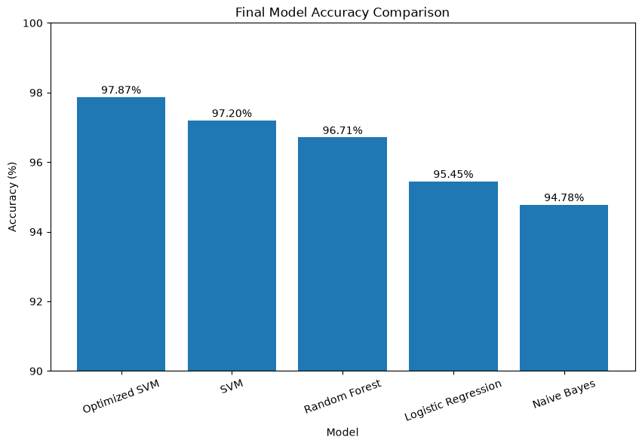
Figure 5 — Final model accuracy comparison

7. Recommended Model
The Optimized SVM (GridSearchCV-tuned, linear kernel, C=10) is recommended as the production model. It delivers the highest overall accuracy (97.87%) and the best trade-off between catching spam (recall 0.85) and not disrupting legitimate messages (only 2 false positives out of 903 Ham messages).
From a business perspective, missed spam (false negatives) directly affects user experience and security exposure, while legitimate messages wrongly flagged as spam (false positives) risk losing important user communication. The Optimized SVM minimizes both types of error better than any other model tested.

8. Limitations & Recommendations
A technical review of the project notebook surfaced the following gaps relative to the stated project deliverables. Addressing these is recommended before final submission:
- Model not saved: no code currently persists the trained model or the TF-IDF vectorizer (e.g., via joblib/pickle), even though "Save Best Model" and "Saved Model" are listed as required deliverables. Both the vectorizer and the classifier must be saved together for the model to be reusable in an app.
- Hardcoded comparison values: the final model-comparison table is built from literal numbers rather than referencing the accuracy variables computed earlier in the notebook. The current values do match the actual run, but the table will not auto-update if the notebook is re-run with different results.
- No documentation cells: the notebook contains only code cells — there are no Markdown headers or explanations separating the stages (EDA, cleaning, modeling, evaluation), which makes it harder to follow as a standalone report.
- Missing predict_proba support: the SVM models were trained without probability=True, so they cannot currently output a spam-probability score — a feature shown in the project's "Expected Output" example (e.g., "87% Spam probability").
- Preprocessing is minimal: text cleaning removes URLs and non-alphabetic characters, but does not remove stopwords or apply stemming/lemmatization — a likely quick win for feature quality.
- Relative dataset path: the notebook loads data from "../data/spam.csv", which assumes a fixed folder structure and will fail if the project is moved or shared without that structure.

9. Conclusion
The project successfully delivers a working spam-classification pipeline, from raw data cleaning through feature extraction, multi-model training, and hyperparameter optimization. The Optimized SVM model meets the project's accuracy and reliability goals and is recommended for deployment, pending the packaging steps noted in Section 8 (saving the model and vectorizer, and enabling probability outputs) to satisfy all stated project deliverables.

