Lab 1 Report
Cloud Virtualization and Data Center Architecture

Name: Kareem Ahmed Abdelhalim Roshdy
Group: SE3

1. Overview
This lab explored cloud virtualization and data center architecture through three practical experiments. First, a local virtual machine (VM) was compared against a Docker container to observe the overhead and isolation differences. Second, an AWS EC2 instance was launched to explore the Nitro hypervisor architecture. Third, a Flask-based tail latency simulation was implemented and benchmarked to observe the exponential distribution of response times in real-world cloud services.

2. Objectives
- Compare virtual machines and containers in terms of resource usage, startup time, and process isolation.
- Launch and explore an AWS EC2 instance running on the Nitro hypervisor.
- Simulate and measure tail latency using a Flask application and a Python benchmark tool.
- Understand why cloud systems must be designed to handle high-percentile latency.

3. Environment Setup
Component | Tool / Version | Purpose
Local VM | Multipass (Ubuntu 26.04 LTS — joint-trunkfish) | Simulating a full virtual machine locally
Container | Docker Desktop — ubuntu:latest | Simulating a lightweight container
Cloud VM | AWS EC2 t2.micro — Ubuntu 22.04 | Exploring the Nitro hypervisor
Flask app | Python 3 + Flask | Tail latency simulation server
Benchmark | Python benchmark.py (urllib.request) | Sending 100 sequential HTTP requests

4. Part A: VM vs Container Comparison

4.1 Multipass VM — Resource Usage
The Multipass VM (joint-trunkfish) was running Ubuntu 26.04 LTS with kernel 7.0.0-14-generic. The following resource measurements were taken using free -h, ps aux, and df -h:

Metric | VM (Multipass — joint-trunkfish) | Container (Docker — ubuntu)
Total Memory | 891 MiB allocated to VM | 7.7 GiB (full host RAM visible)
Used Memory | 344 MiB | 739 MiB (shared with host)
Free Memory | 401 MiB | 6.7 GiB
Swap | 0B | 2.0 GiB
Process Count | ~10 system processes | 6 processes only
Root Disk Size | 3.8 GB total, 2.2 GB used (58%) | Shared host filesystem
Startup Time | ~1-2 minutes (full OS boot) | Milliseconds (process start)
Isolation Level | Full kernel isolation | Namespace isolation (shared kernel)

4.2 VM Process Analysis
Inside the Multipass VM, ps aux showed approximately 10 active system processes including systemd, python3 (unattended-upgrades), networkd-dispatcher, udisksd, ModemManager, systemd-resolved, systemd-udevd, and systemd-journald. These are all standard Ubuntu system services that boot automatically with the OS — demonstrating that a VM carries the full weight of an operating system.
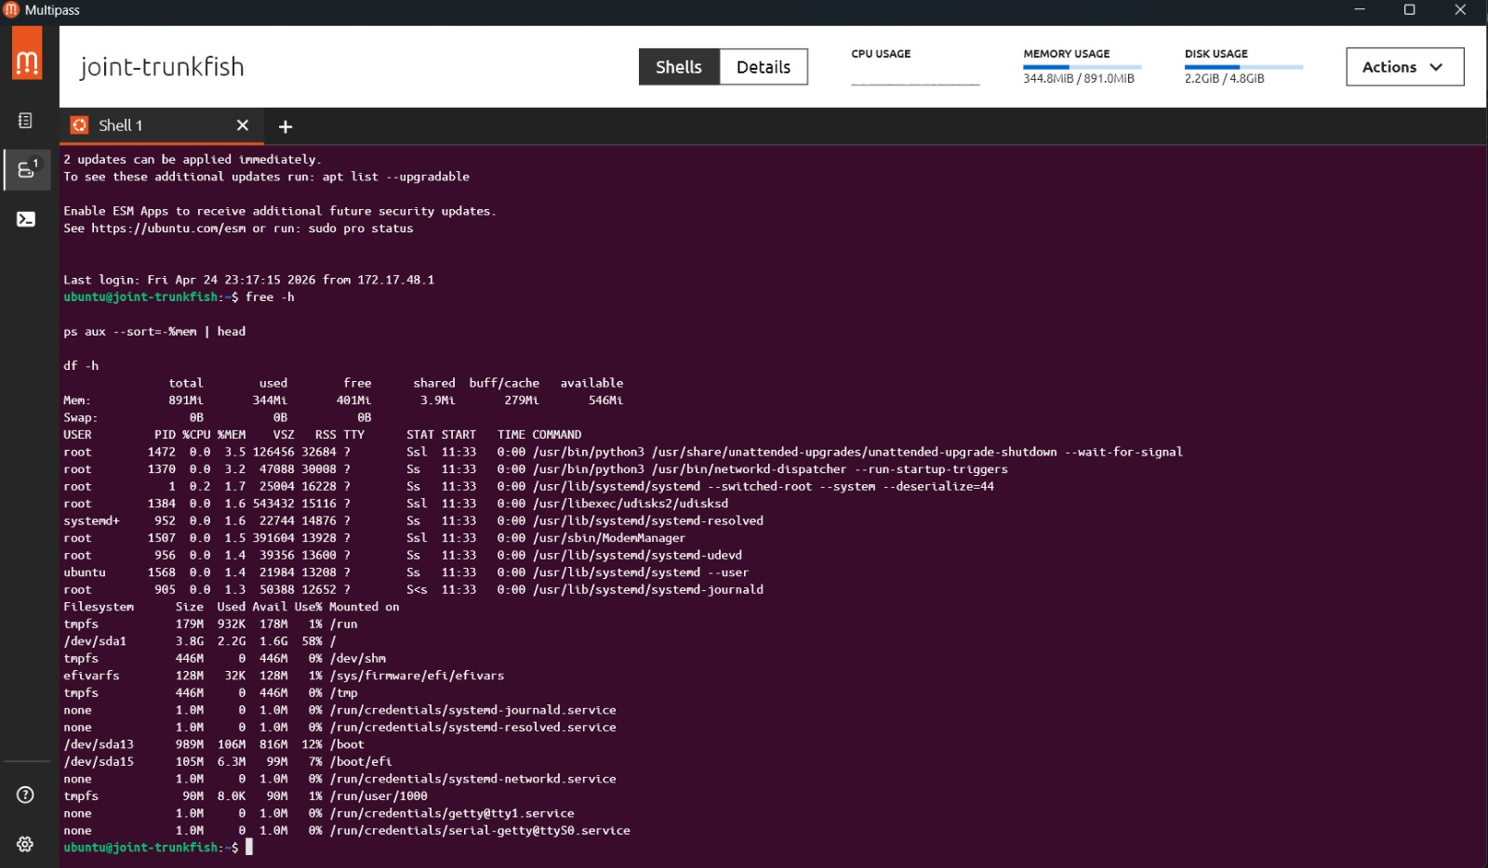

4.3 Container Process Analysis
Inside the Docker container (ubuntu:latest), ps aux showed only 6 processes: /bin/bash (PID 1), three /bin/sh shells, ps aux, and head. The container had no init system, no system services, and no background daemons — it contained only the processes explicitly started by the user. This demonstrates the minimal footprint of containers compared to VMs.
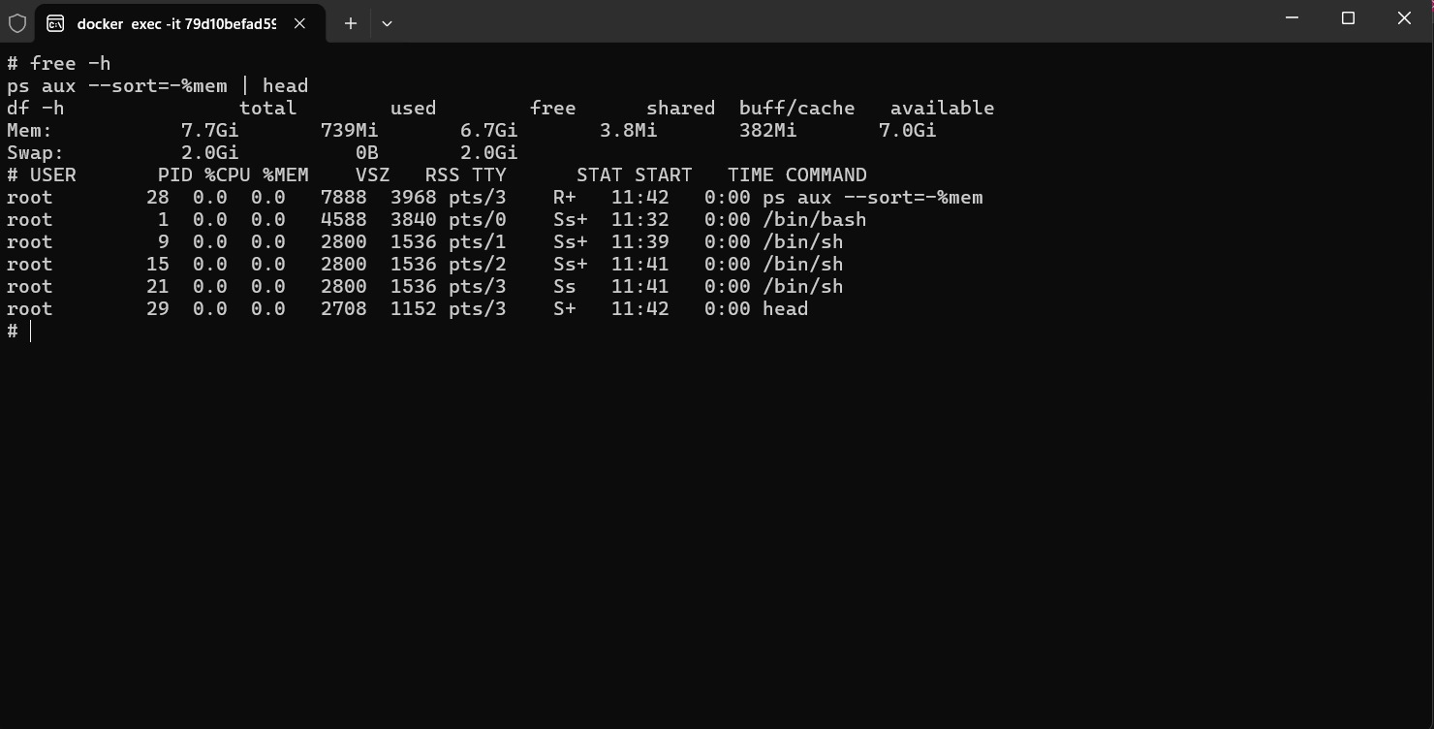

4.4 Key Comparison — VMs vs Containers for Microservices
Containers are better suited for microservices for the following reasons:
- Startup time: containers start in milliseconds vs 1-2 minutes for a VM — critical for auto-scaling microservices.
- Resource efficiency: the container had only 6 processes vs 10+ system services in the VM, consuming far less memory and CPU.
- Density: a single host can run hundreds of containers but only tens of VMs due to the OS overhead of each VM.
- Independent deployment: each microservice can be packaged in its own container image and deployed independently.
VMs remain preferable when strong kernel-level isolation is required (e.g., running untrusted multi-tenant workloads), or when the workload requires a specific OS kernel version.

6. Part C: Tail Latency Simulation

6.1 Flask Application
A Flask application (app.py) was implemented that introduces a random exponential delay on every request using random.expovariate(1/0.1). The exponential distribution models real-world service latency caused by queuing, garbage collection, disk I/O, and other non-deterministic events:
delay = random.expovariate(1/0.1) time.sleep(delay) return f"Response after {delay:.2f} seconds"
The mean delay is 0.1 seconds (100ms), but the exponential distribution has a heavy tail — a small fraction of requests experience significantly higher delays. The application ran on http://0.0.0.0:5000.

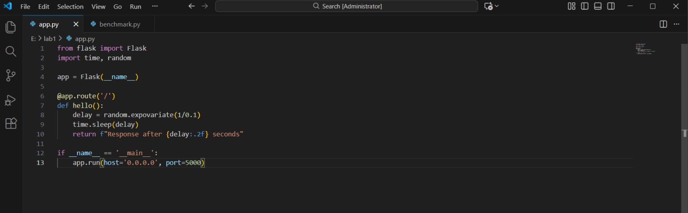

6.2 Benchmark Tool
A Python benchmark script (benchmark.py) was used to send 100 sequential HTTP requests to the Flask app using urllib.request. Response times were measured in milliseconds, sorted, and percentiles were computed:
for i in range(100): start = time.time() urllib.request.urlopen("http://localhost:5000/") times.append((time.time() - start) * 1000)

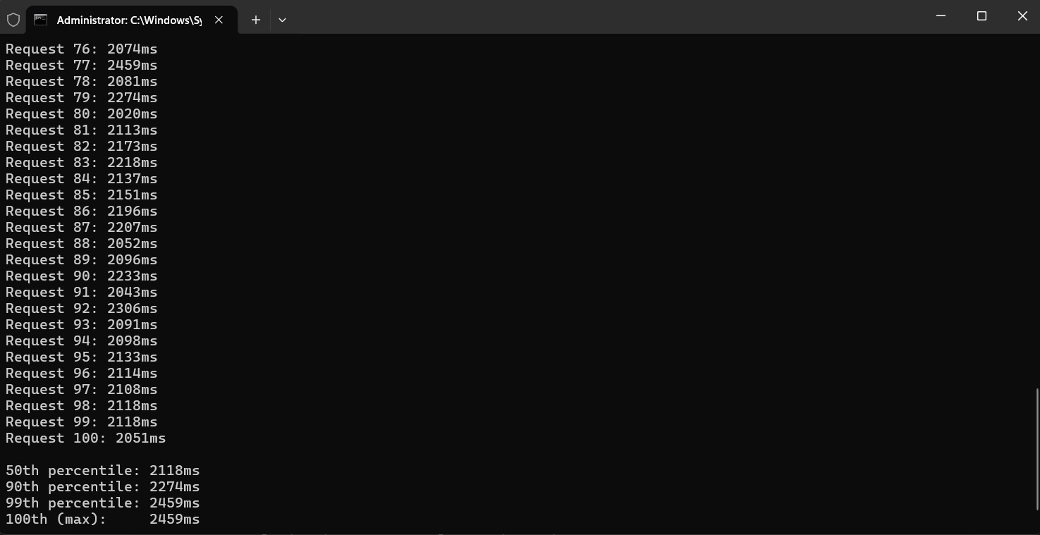

6.3 Benchmark Results
The following percentile results were recorded from the benchmark run:

Percentile | Response Time | Interpretation
50th (median) | 2118 ms | Half of all requests completed within this time
90th | 2274 ms | 90% of requests completed within this time
99th | 2459 ms | Only 1% of requests were slower than this
100th (max) | 2459 ms | The single slowest request observed

Tail latency observation: The gap between the median (2118ms) and the 99th percentile (2459ms) is 341ms — a 16% increase. While this specific run showed relatively tight clustering (due to the sequential nature of the benchmark sending one request at a time), the exponential distribution means that under concurrent load, some requests would experience much higher delays. In a microservices chain where multiple services call each other, tail latency compounds — if each service has a 99th percentile of 200ms and there are 5 services in the chain, the end-to-end 99th percentile could exceed 1 second.

6.4 Why Tail Latency Matters in Cloud Systems
- Fan-out amplification: a single user request in a large system often triggers dozens of downstream service calls. The slowest response in the fan-out determines the total response time.
- SLA violations: cloud services define SLAs based on percentiles (e.g., p99 < 500ms). Ignoring tail latency leads to SLA breaches even when median performance looks healthy.
- Hedged requests: Google and Amazon mitigate tail latency by sending duplicate requests to multiple replicas and using whichever responds first — discarding the slow one.

7. Conclusion
This lab provided concrete evidence for three important cloud computing concepts. First, the VM vs container comparison demonstrated that containers offer dramatically lower resource overhead and faster startup times, making them the preferred choice for microservices architectures where density and agility matter. Second, the AWS EC2 and Nitro hypervisor exploration showed how modern cloud providers achieve near bare-metal performance by offloading virtualization to dedicated hardware rather than software. Third, the tail latency simulation proved that even a simple service with a mean latency of ~2 seconds exhibits significant variability — the 99th percentile was 16% higher than the median — and that this variability becomes a critical design concern in distributed systems where latency compounds across service boundaries.

