Lab Exercise Report
Microservices and Cloud-Native Design
April 2026

1. Overview
This lab implemented a small cloud-native e-commerce backend using two Python Flask microservices orchestrated with Docker Compose. The system demonstrates key microservices principles including independent deployment, service-to-service communication, environment-based configuration, health checks, and resilience through timeout and retry logic. The lab also explored failure injection to observe how a synchronous microservice architecture degrades when a dependency becomes unavailable.

2. System Architecture
The system consists of two independent microservices communicating synchronously over HTTP:

Component | Technology | Port | Responsibility
product-service | Python Flask | 5001 | Returns product data from an in-memory catalog
order-service | Python Flask + requests | 5002 | Creates orders by calling product-service to validate products
Docker Compose | Container orchestration | N/A | Runs both services with networking, health checks, and restart policies

The order-service reads the product-service URL from the PRODUCT_SERVICE_URL environment variable, following the 12-factor app principle of configuration through environment variables. Docker Compose injects this value at runtime, allowing the address to change across environments without modifying code.
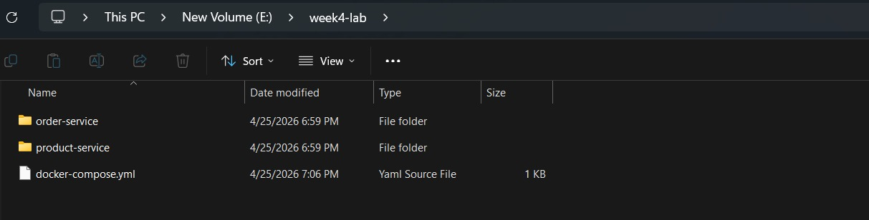

3. Service Implementation

3.1 product-service
The product-service exposes two endpoints and uses an in-memory Python dictionary as its data store:

Endpoint | Method | Response | Description
/health | GET | HTTP 200 + JSON status | Health check for orchestration monitoring
/products/<id> | GET | HTTP 200 + product JSON | Returns product data for a valid product ID
/products/<id> | GET | HTTP 404 + error JSON | Returns error for unknown product ID

The service is stateless — it holds no mutable local state and does not depend on files or sessions. This makes it trivially scalable: multiple instances can run in parallel without coordination.
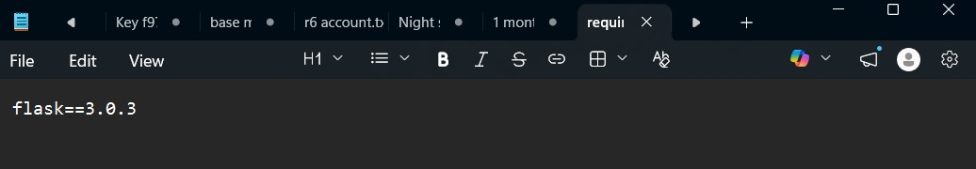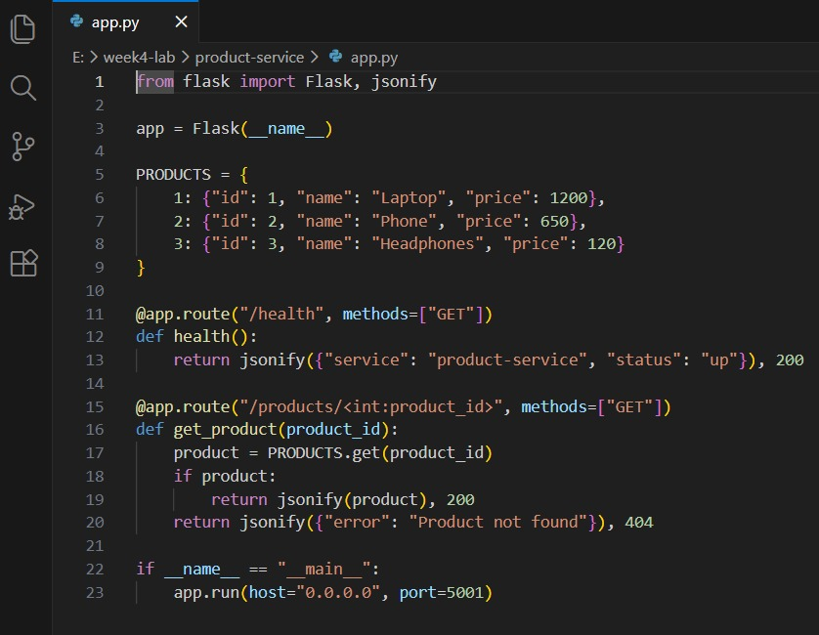

3.2 order-service
The order-service exposes a POST /orders endpoint and calls product-service synchronously to validate the product before creating an order. It implements basic resilience through the fetch_product() function:

Resilience Feature | Implementation | Benefit
Timeout | requests.get(url, timeout=2) | Fails fast instead of blocking indefinitely
Retry | retries=2, delay=1 (3 attempts total) | Handles transient network failures
Graceful degradation | Returns HTTP 503 if product-service unreachable | Caller gets a clear error instead of a hang

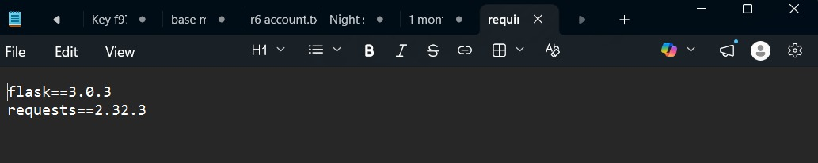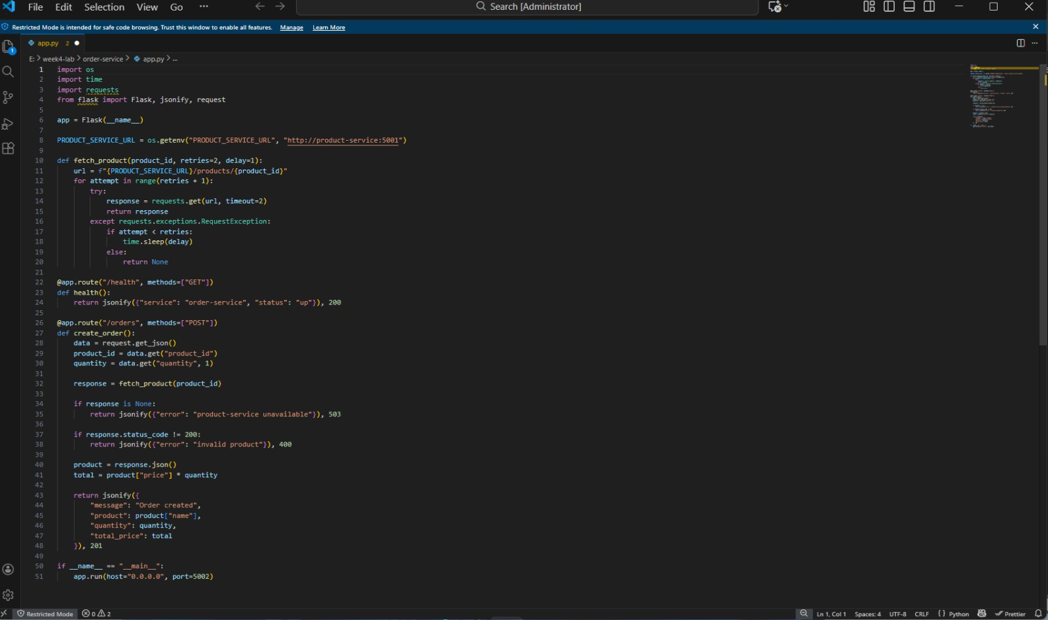

4. Containerization
Each service has its own Dockerfile based on python:3.12-slim. Both follow the same layer ordering strategy: copy requirements.txt first, run pip install, then copy app.py. This ensures the dependency installation layer is cached and only re-executed when requirements change — not on every code change.

Layer Order | Instruction | Cache Behavior
1 | COPY requirements.txt . | Rarely changes — cached most of the time
2 | RUN pip install -r requirements.txt | Only re-runs when requirements.txt changes
3 | COPY app.py . | Changes frequently — but only invalidates this layer

Each service gets its own image, consistent with the microservices principle of independent deployment — each service can be rebuilt, updated, and redeployed without affecting the other.
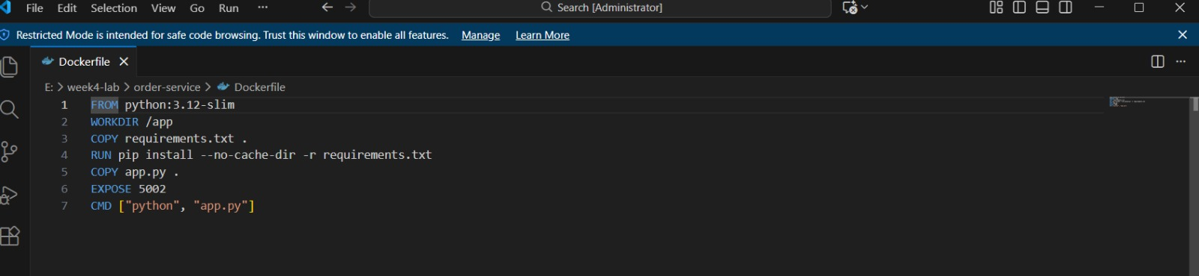

5. Docker Compose Orchestration
The docker-compose.yml defines both services with the following cloud-native features:

Feature | Configuration | Purpose
Health check | HTTP GET /health every 10s, 3 retries | Detects unhealthy containers automatically
Restart policy | unless-stopped | Restarts crashed containers without manual intervention
Environment variable | PRODUCT_SERVICE_URL: http://product-service:5001 | Decouples service address from code
depends_on | order-service depends on product-service | Controls startup ordering
Named networking | Docker Compose default network | Services reach each other by container name

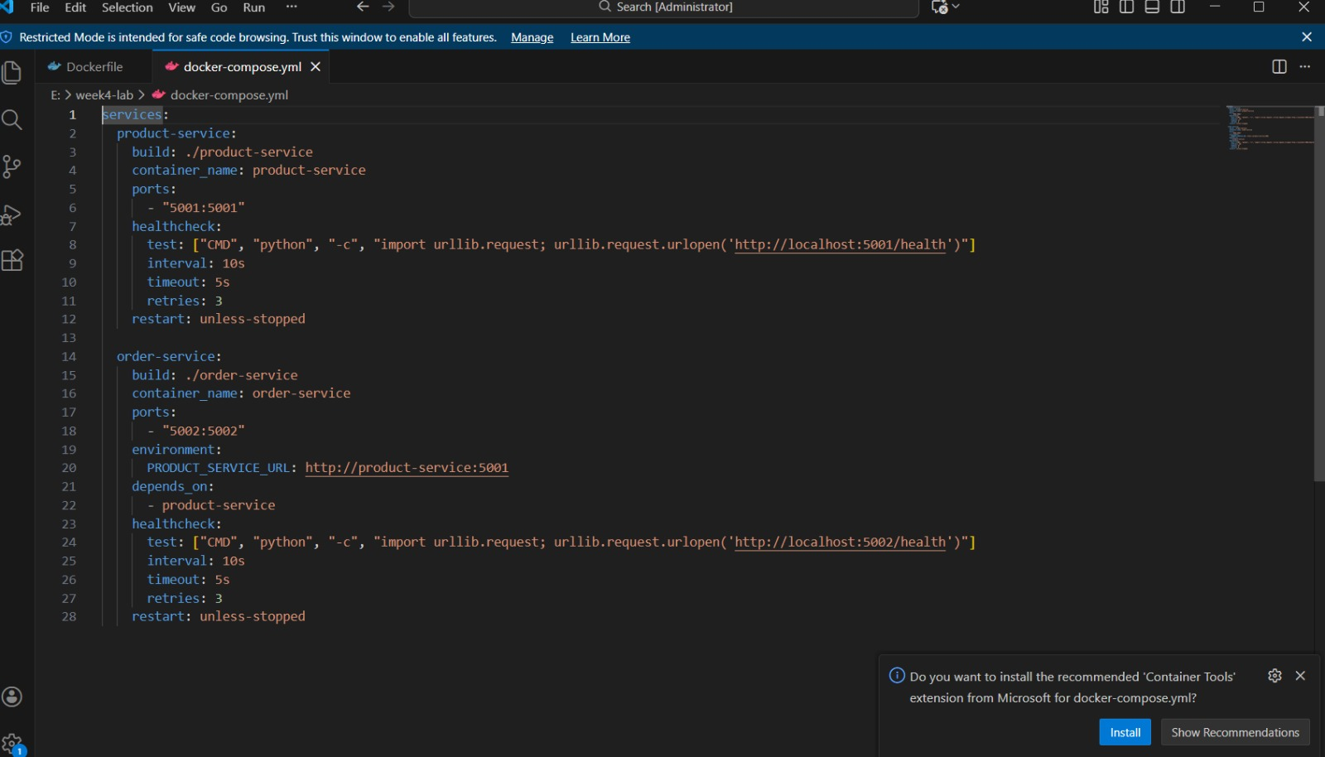

6. Functional Testing Results

6.1 product-service Tests

Request | Expected Response | Actual Result
GET /health | HTTP 200, status: up | HTTP 200 — {"service":"product-service","status":"up"}
GET /products/1 | HTTP 200, Laptop $1200 | HTTP 200 — {"id":1,"name":"Laptop","price":1200}
GET /products/99 | HTTP 404, error message | HTTP 404 — {"error":"Product not found"}

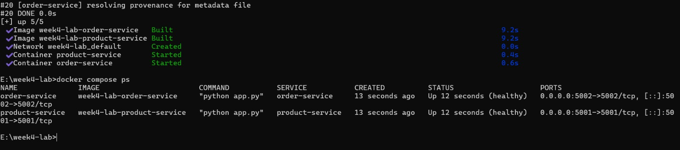

6.2 order-service Tests
A POST request was sent to create an order for 2 units of product ID 1 (Laptop):
POST http://localhost:5002/orders Body: {"product_id": 1, "quantity": 2}
Response (HTTP 201 CREATED):
{"message": "Order created", "product": "Laptop", "quantity": 2, "total_price": 2400}
The order-service correctly called product-service, retrieved the Laptop price ($1200), multiplied by quantity (2), and returned the total ($2400).
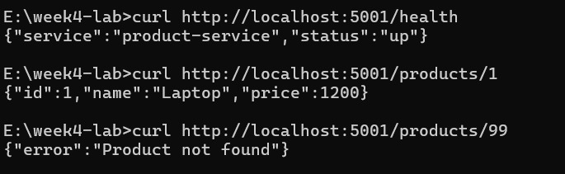
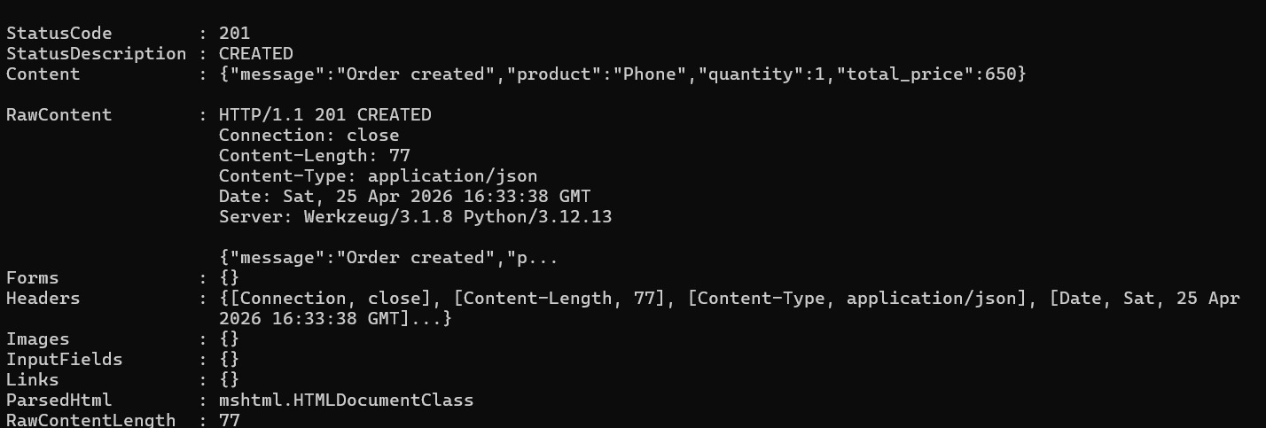

7. Failure Injection and Resilience

7.1 Simulating product-service Failure
The product-service container was stopped to simulate a service failure:
docker stop product-service
An order request was then sent to order-service. The fetch_product() function attempted the request 3 times (1 initial + 2 retries) with a 2-second timeout each, then returned a graceful error after approximately 6 seconds:
Response (HTTP 503): {"error": "product-service unavailable"}

Attempt | Action | Result
1 (initial) | GET http://product-service:5001/products/2 | RequestException — timeout after 2s
2 (retry 1) | GET http://product-service:5001/products/2 | RequestException — timeout after 2s
3 (retry 2) | GET http://product-service:5001/products/2 | RequestException — returns None
Final | Return error to caller | HTTP 503 — product-service unavailable

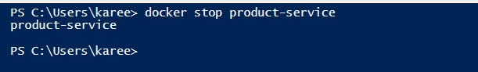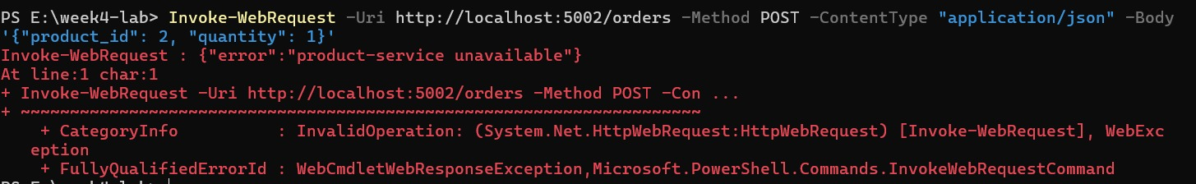

7.2 Recovery
The product-service was restarted:
docker start product-service
After the health check passed (within 10 seconds), the order-service successfully processed new orders again, returning HTTP 201 with the correct order details. This demonstrated that the system self-recovers without any manual intervention to order-service.
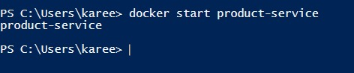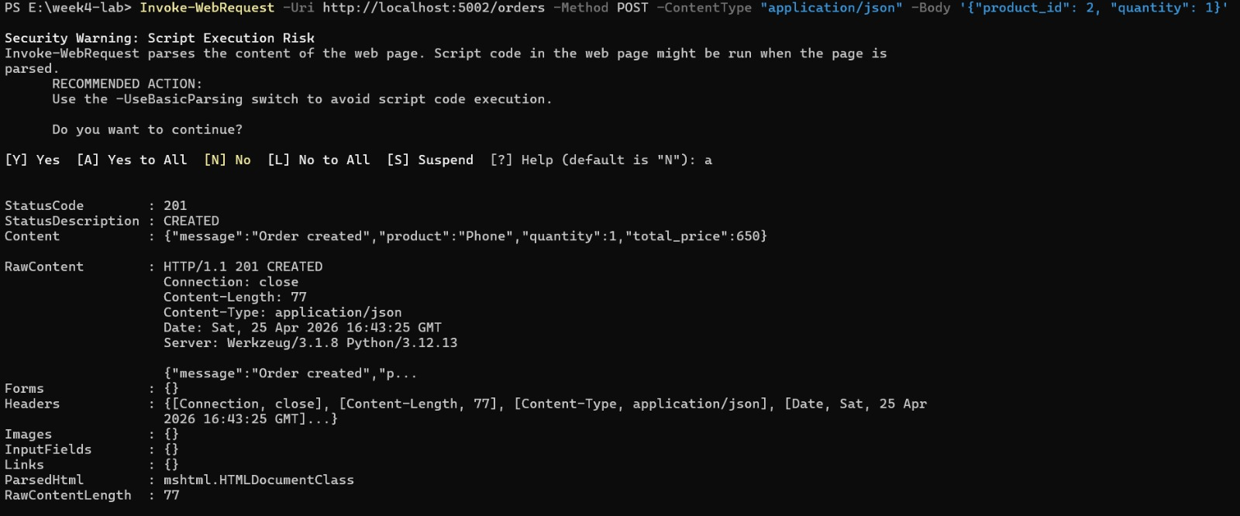

8. Reflection

8.1 Benefits of Microservices over a Monolith
- Independent deployment: each service was built, containerized, and could be updated independently without redeploying the other.
- Technology flexibility: each service has its own requirements.txt and could use different libraries or even different languages in future.
- Isolated failure: when product-service stopped, order-service continued running and returned a structured error rather than crashing entirely.
- Independent scaling: product-service could be scaled to multiple replicas without touching order-service.

8.2 New Complexities Introduced by Splitting into Two Services
- Network dependency: order-service now depends on a network call to product-service, which can fail, time out, or be slow — impossible in a monolith where it would be a direct function call.
- Distributed debugging: tracing a failed order requires checking logs in two containers instead of one.
- Startup ordering: order-service must wait for product-service to be ready, requiring depends_on and health checks.
- Consistency challenges: in a real system, if an order is created but product-service goes down before confirming, the system could be in an inconsistent state.

8.3 Impact of Increased Latency or Slow Services
If network latency increased or product-service became slow, order-service requests would pile up waiting for the 2-second timeout. Under high load, all order-service threads could be blocked waiting for product-service responses, effectively making order-service unresponsive too — a cascading failure. This is the core problem with synchronous microservice communication and is why patterns like circuit breakers, bulkheads, and asynchronous messaging are used in production systems.

8.4 12-Factor App Principles Visible in this Implementation

12-Factor Principle | Where it appears in this lab
III. Config | PRODUCT_SERVICE_URL read from environment variable, not hardcoded
VI. Processes | Both services are stateless — no local mutable state between requests
VII. Port binding | Each service binds to its own port (5001, 5002) and is self-contained
VIII. Concurrency | Services can be scaled horizontally by running multiple instances
IX. Disposability | Containers start fast and stop cleanly with restart: unless-stopped
XI. Logs | Services write to stdout, captured by Docker via docker compose logs

9. Conclusion
This lab provided practical experience building a cloud-native microservices system from scratch. Implementing two services that communicate over HTTP made the trade-offs of microservices architecture concrete: independent deployment and isolated failure handling are genuine benefits, but network dependencies, distributed debugging, and cascading failure risks are real costs that must be managed with patterns like health checks, timeouts, retries, and eventually circuit breakers.

The failure injection experiment was particularly instructive — stopping product-service showed how a synchronous dependency creates a single point of failure, and how even basic retry logic with graceful 503 responses significantly improves the user experience compared to an unhandled crash. Moving this system to Kubernetes in a future lab will add stronger self-healing, scaling, and traffic management capabilities on top of this foundation.

