Lab_4

Name: Karim Gamal Mahmoud Mohamed

ID : 21KGMM

* **Create a Customers table in Hbase with two column families namely CustomerInfo and ContactInfo with row key as customer_id**

First, we need to Create a Customers table in Hbase with two column families namely CustomerInfo and ContactInfo

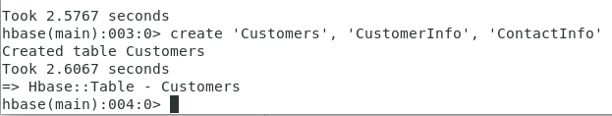

* Describe Customers Table after create it.

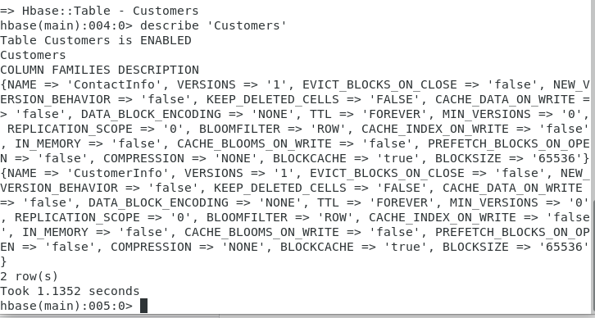

* **From the given MYSQL database named 'retail_db' within VM, import the data of Customers table into the Hbase Customers table.**
* for contactInfo column family
* ContactInfo (column family) with these columns customer_street, customer_city, customer_state, customer_zip

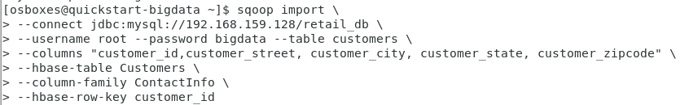

* Imported successfully:



* Showing the customers table data by using ‘scan’

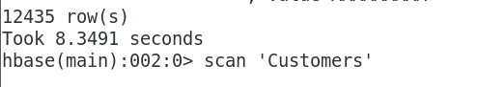

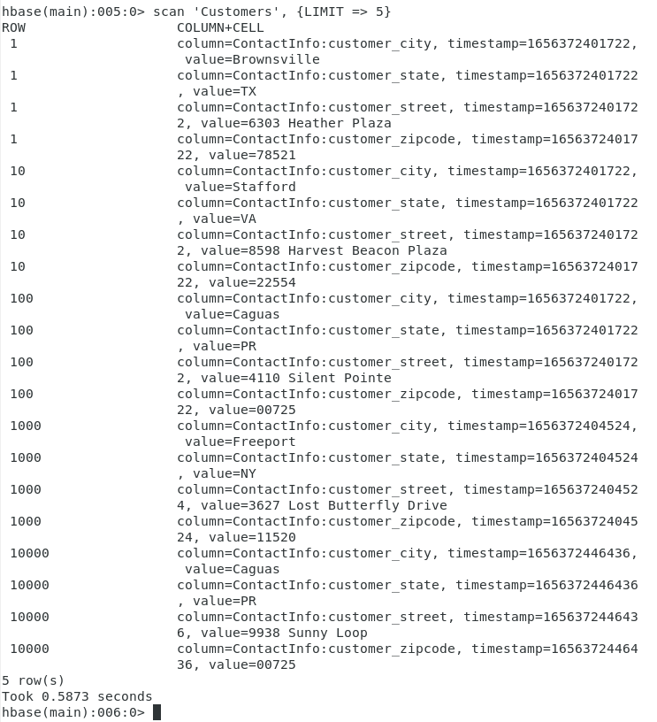

* **From the given MYSQL database named 'retail_db' within VM, import the data of Customers table into the Hbase Customers table.**
* For CustomertInfo column family
* CustomerInfo (column family) with these columns customer_fname, customer_lname, customer_email, customer_password



* Imported successfully:



* Showing the customers table data by using ‘scan’

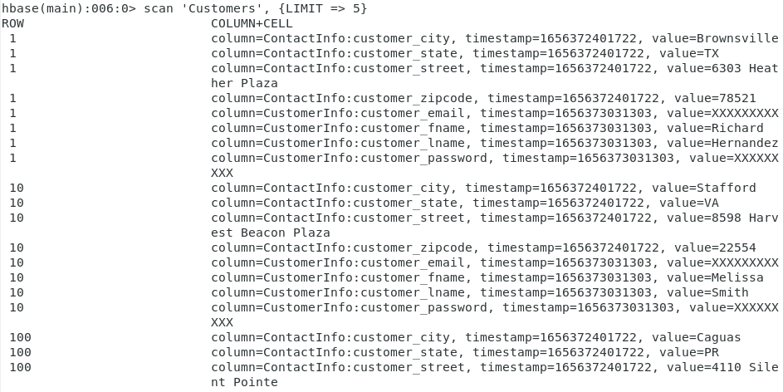

* **List top 10 records of NY and VA state from  the Hbase table.**
* We need to import the following:

import org.apache.hadoop.hbase.filter.CompareFilter

import org.apache.hadoop.hbase.filter.SingleColumnValueFilter

import org.apache.hadoop.hbase.filter.SubstringComparator

import org.apache.hadoop.hbase.util.Bytes

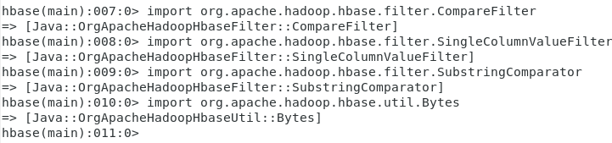

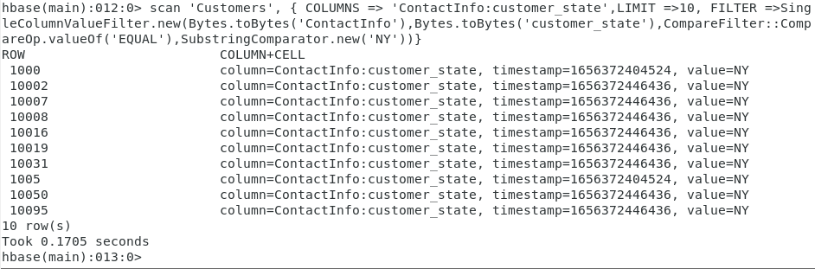

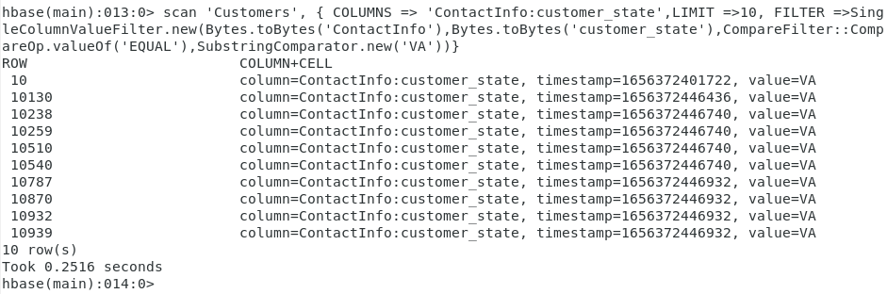

**Conclusion:**

In this lab, I used My SQL to manage a database (a retail database), then I presented tables, ran Hbase to create the tables "Customers," "CustomerInfo," and "ContactInfo," and last I imported data into HDFS from external datastores.

additionally, I demonstrated the records in the table Customer with limitations 5 in Hbase to demonstrate the entire process.

Going well, I finally listed the top 10 records for the states of NY and VA from the Hbase table.

once the three filters (CompareFilter, BinaryComparator, and SingleColumnValueFilter) have been installed.

**Sources :**

<https://www.javatpoint.com/mysql-commands-cheat-sheet>

<https://www.projectpro.io/recipes/connect-database-and-import-data-into-hbase-sqoop>

<https://stackoverflow.com/questions/7256100/scan-with-filter-using-hbase-shell>