MMORPG game

(massively multiplayer online role-playing game)

|  |  |
| --- | --- |
| احصاء و علوم الحاسب | أحمد سعيد عبد السميع |
| علوم حاسب | أحمد عبد الله فهيم |
| علوم حاسب | مصطفى عمرو حامد |
| علوم حاسب | كريم جمال محمود |
| علوم حاسب | سامي محمد سامي |

MMORPG game database

1) Goal and Description

Short for massively multiplayer online role-playing game it is a type of game genre. MMORPGs are online role-playing multiplayer games which allow thousands of gamers to play in the game's evolving virtual world at the same time via the Internet.

This database aims to let the game developer to be able to track players that play the game and track there status to provide better experience to the player by making it more fun and challenging. So the developer need to know:

- How many players interested in the game in which region

- Which Items players buy the most.

- How many characters each player has and which.

- What is the best player every character has.

- What items should be added to the game to improve characters.

- If there is some characters more powerful than others.

The data required for the MMORPG GAME database are :-

1) Each player’s ID and real name.

2) The date which the player creates his account on.

3) Each account’s last sign in date, password, username, and email.

4) Each server name, region, max players can sign up on the server and server’s status.

5) Each character that players have in there accounts and there name, type, level, experience points, max health and mana and gender.

6) The set of items each player carry, it’s max number of items, total defense points, total defense points and it’s ID.

7) every item the player can carry and either it’s dropped from a minion or bought from a store

8) Each minion’s name, health, damage dealt buy, type and number of coins dropped from it.

9) Every shop’s type.

---------------------------------------------------------------------------------------------------------

2) EER diagram:

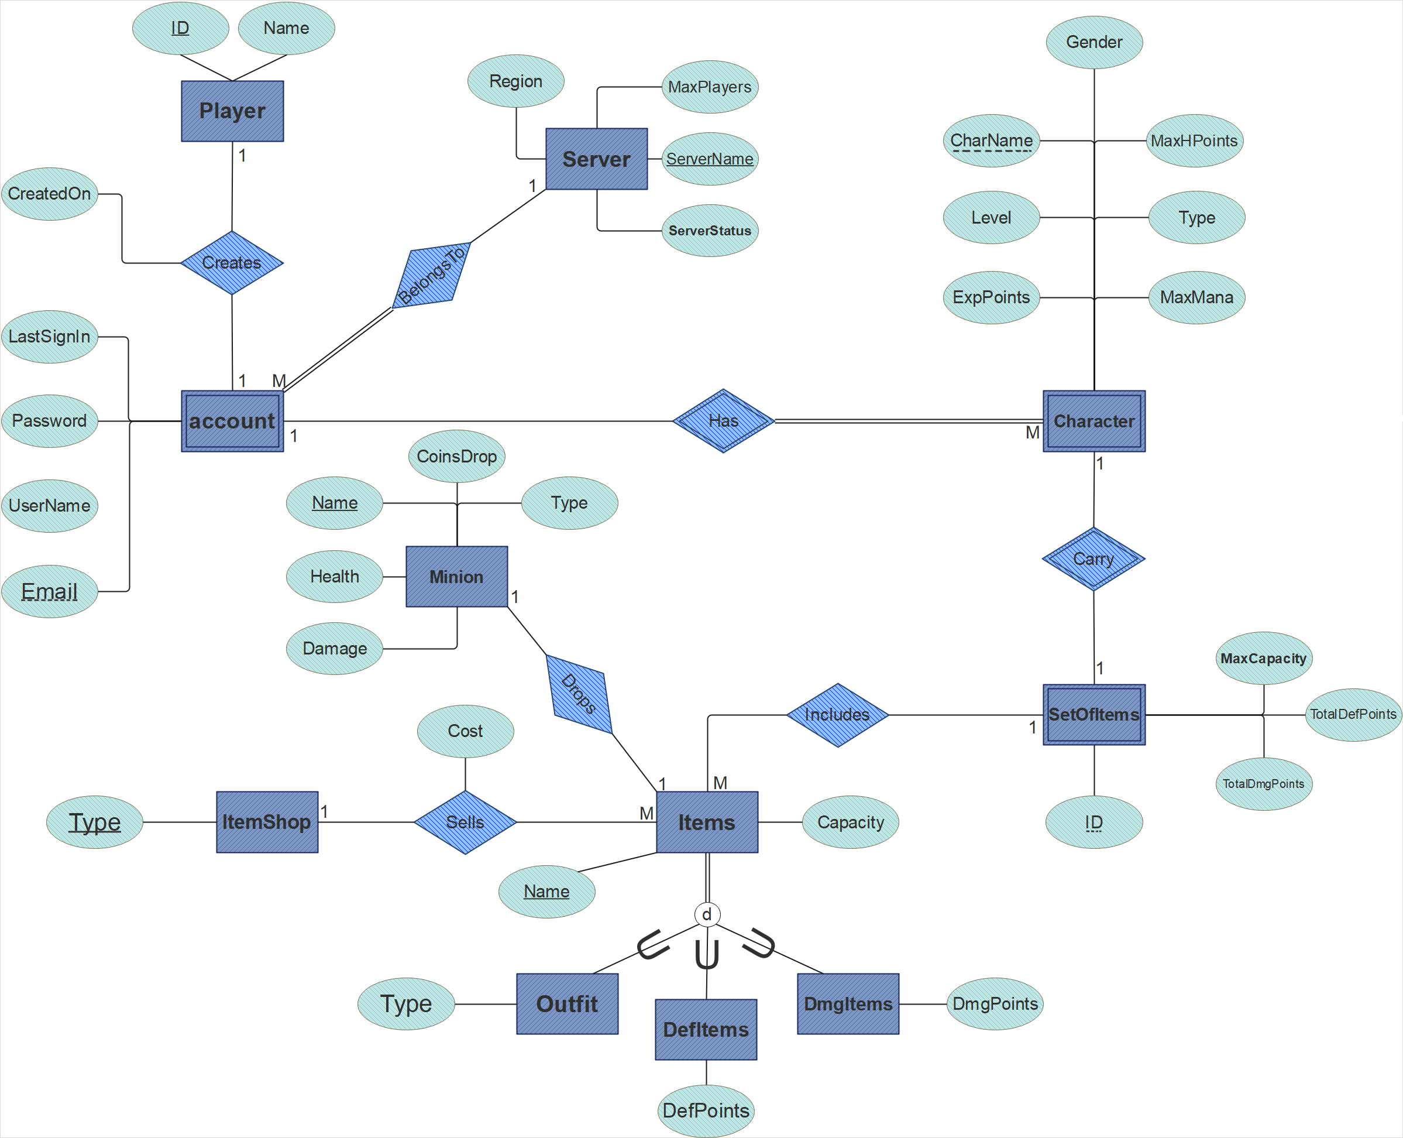

3) Relational model:

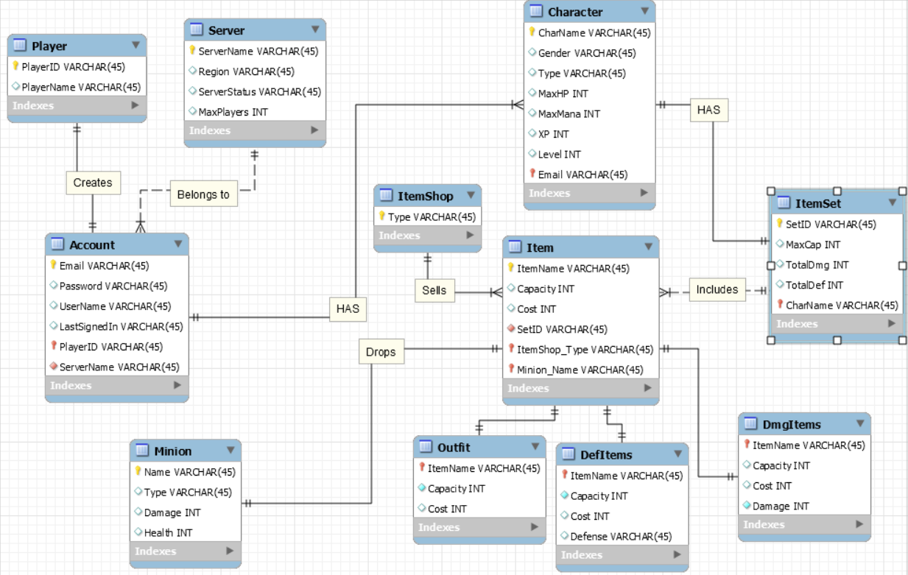

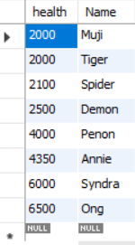4) Queries:

1) Retrieve all health of minion sort by health

SELECT health, Name

FROM minion

ORDER BY health ;

2) Retrieve the Numbers of items that each minion drops

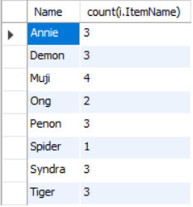

SELECT m.Name , count(i.ItemName)

FROM minion m , item i

WHERE m.Name = i.minion_Name

GROUP BY m.name;

3) Retrieve name of player who has third char ‘c’

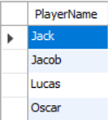

SELECT PlayerName

FROM Player

WHERE PlayerName like '__c%';

4) Retrieve all details of servers which takes more than 3000 player

https://cdn.discordapp.com/attachments/523479260669935617/524782297547800596/3.PNGSELECT *

FROM server

WHERE maxplayer > 3000

5) Retrieve totaldmg and totalDef of character whose name = 'Yasuo'

https://cdn.discordapp.com/attachments/523479260669935617/524782298718273546/4.PNGSELECT s.TotalDmg, s.TotalDef

FROM itemset s

WHERE s.CharName = 'Yasuo'

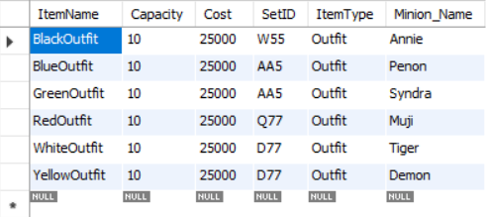6) Retrieve all details of items which have the lowest cost

SELECT *

FROM item

WHERE cost = ( SELECT min(cost)

FROM item

);

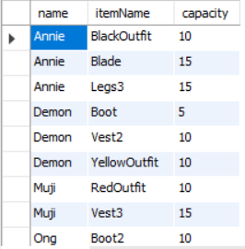7) Retrieve Item name, Minion name who drops an item which's capacity is between 5 and 15

SELECT m.name, i.itemName, i.capacity

FROM minion m , item i

WHERE m.name = i.minion_name AND i.capacity BETWEEN 5 AND 15;

8) Retrieve email and the server which the user play on it

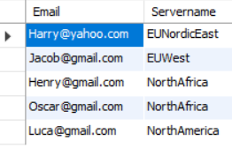

SELECT email , servername

FROM account ;

9) Retrieve the item which has max dmg points and the item which has max def points

(SELECT defense AS "def/dmgP", itemname

FROM defitems

WHERE defense = (SELECT max(defense) FROM defitems)

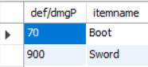)

UNION

(

SELECT damage, itemname

FROM dmgitems

WHERE damage = (SELECT max(damage) FROM dmgitems)

);

10) Retrieve the character name who's wearing a black outfit

https://cdn.discordapp.com/attachments/523479260669935617/524782328422203403/9.PNGSELECT i.charname, u.itemname

FROM item u natural join itemset i

WHERE u.itemname = 'blackoutfit';

11) Retrieve all data of Account who's Player ID=H6

SELECT *

FROM account

WHERE account.PlayerID= 'H6';

12) retrieve the sum and average of the cost of the items that every character has

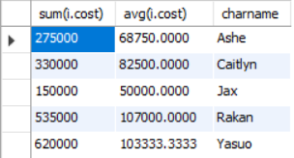

SELECT sum(i.cost) , avg(i.cost), s.charname

FROM item i NATRUAL JOIN itemset s

GROUP BY s.charname

13) retrieve the number of players in each server

SELECT count(PlayerID), servername

FROM account

GROUP BY servername;

14) using view retrieve the minion name, type, health and damage

along with the item name it drops, capacity, cost and type

CREATE view 'minitem' as

(

SELECT m.name, m.type, m.health, m.damage, i.itemname, i.capacity, i.cost, i.itemtype

FROM minion m INNER JOIN item i ON name = minion_name

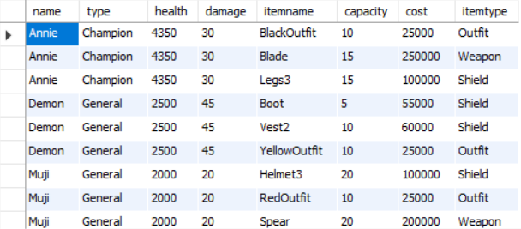)

SELECT *

FROM minitem;

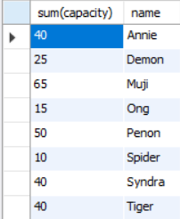15) use your view to retrieve the total item capacity that every minion drops

SELECT sum(capacity), name

FROM minitem

GROUP BY name ;

16) Change the cost of the item ‘bow’ to 175000

https://cdn.discordapp.com/attachments/523479260669935617/524782343538475008/16.PNGUPDATE items

SET cost = 175000

WHERE name = 'bow' ;

SELECT itemname, Cost

FROM item

WHERE itemname = 'bow';