Sprint 1
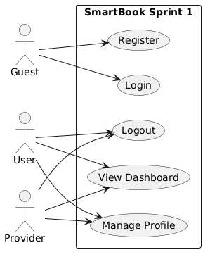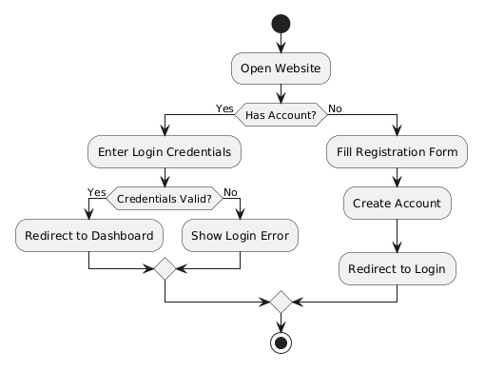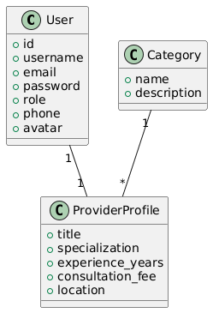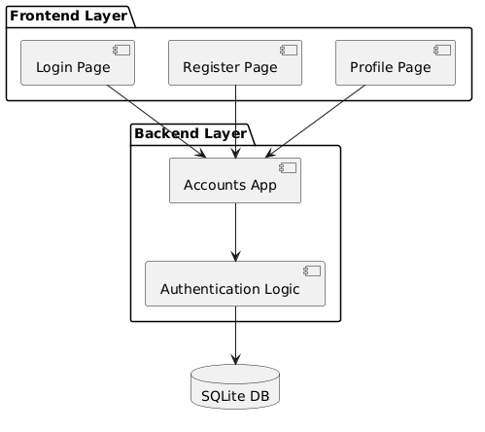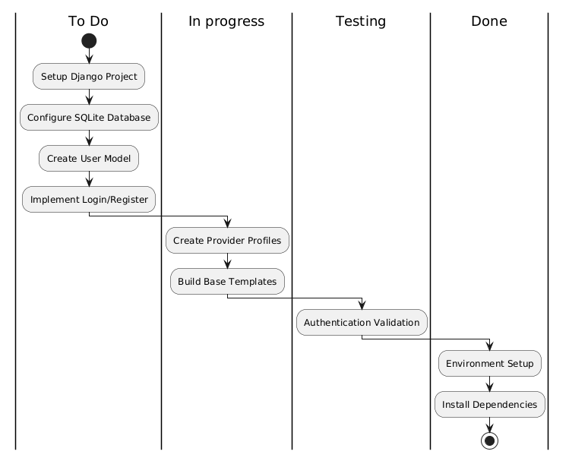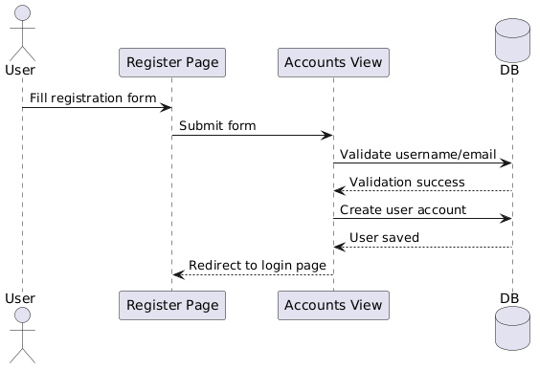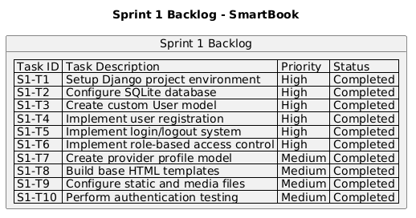
Sprint 1

During Sprint 1, the development team focused on preparing the core system architecture and implementing the authentication workflow. The team prioritized foundational features because all future booking and notification functionalities depend on secure user management and role-based access control.

The sprint planning session identified the following priorities:

Setting up the Django project structure
Configuring SQLite database integration
Creating the custom User model
Implementing login and registration functionality
Creating provider profile management
Designing the base frontend layout and navigation

Tasks were distributed among team members according to their specialization in backend development, frontend integration, and testing/documentation.

Potential risks identified during planning included database relationship complexity and authentication validation issues. To reduce these risks, the team decided to implement and test authentication modules incrementally.

(((((((((((((((((((((((((((((((((((SPRINT BACKLOG)))))))))))))))))))))))))))))))))

Sprint Planning

During Sprint 1, the development team focused on preparing the core system architecture and implementing the authentication workflow. The team prioritized foundational features because all future booking and notification functionalities depend on secure user management and role-based access control.

The sprint planning session identified the following priorities:

Setting up the Django project structure
Configuring SQLite database integration
Creating the custom User model
Implementing login and registration functionality
Creating provider profile management
Designing the base frontend layout and navigation

Tasks were distributed among team members according to their specialization in backend development, frontend integration, and testing/documentation.

Potential risks identified during planning included database relationship complexity and authentication validation issues. To reduce these risks, the team decided to implement and test authentication modules incrementally.
SPRINT 2
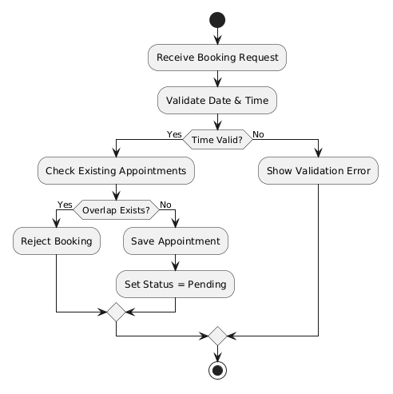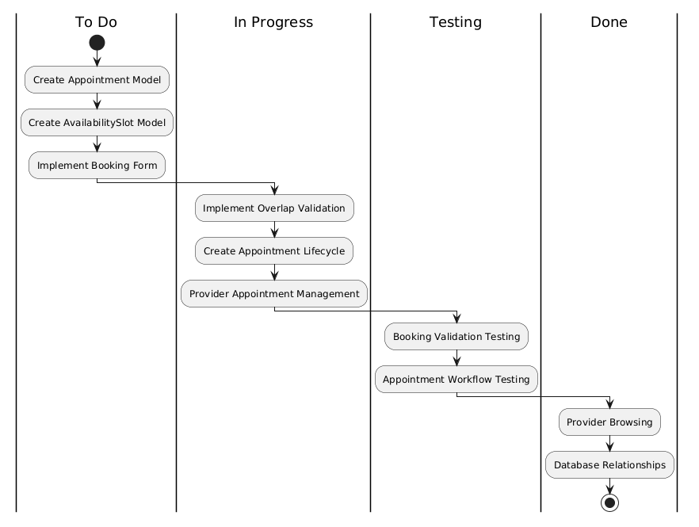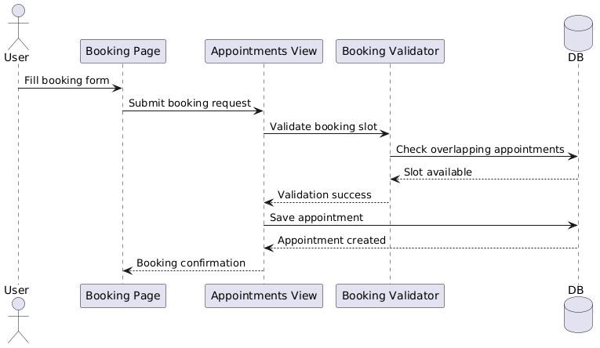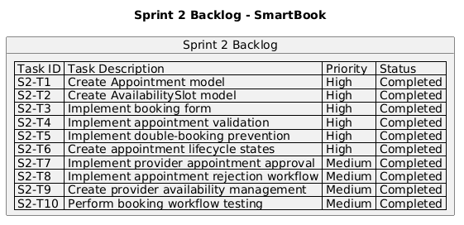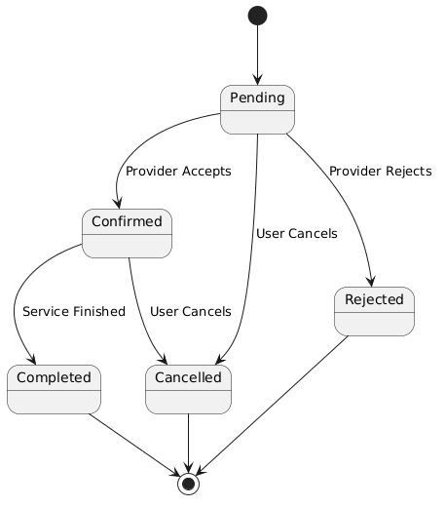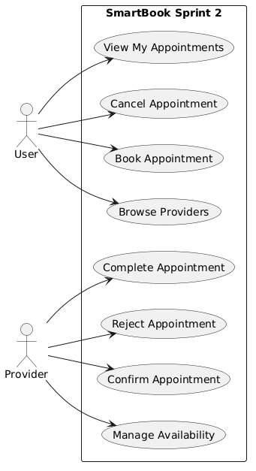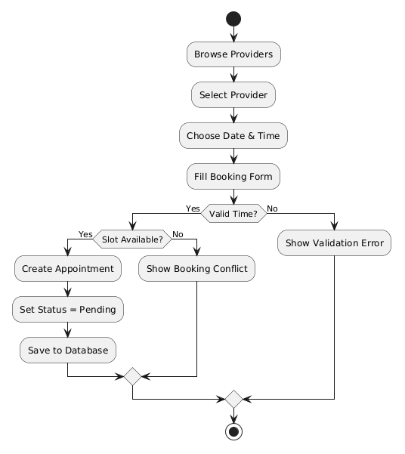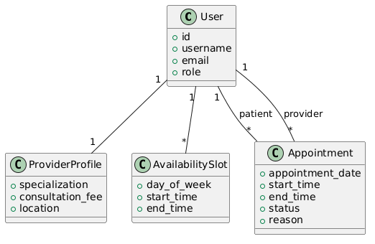
Sprint 2
Sprint Goal

The goal of Sprint 2 was to develop the core appointment booking engine of the SmartBook platform. This sprint focused on implementing provider availability management, appointment scheduling, booking validation, and appointment lifecycle management.

The sprint also aimed to ensure that the system could securely handle appointment requests while preventing double-booking conflicts through database validation and overlap detection mechanisms.

Sprint Duration

Sprint Number: Sprint 2
Duration: 1 Week
Start Date: Week 2
End Date: End of Week 2

(((((((((((((((((((((((((((((((((((SPRINT BACKLOG)))))))))))))))))))))))))))))))))

Sprint Planning

During Sprint 2, the team focused on building the central functionality of the SmartBook system, which is the appointment booking workflow. The sprint planning session identified booking management and validation logic as the highest priorities because they represent the core business logic of the platform.

The team planned to implement:

Appointment management
Provider availability slots
Booking forms and validation
Appointment lifecycle states
Provider approval/rejection workflow
Booking conflict prevention

Special attention was given to designing the overlap validation system to ensure that providers cannot receive multiple appointments during conflicting time slots.

Tasks were distributed among team members according to backend logic implementation, frontend integration, and testing responsibilities.

Potential risks identified during planning included complex time-slot validation and appointment state synchronization.

Sprint Review

At the end of Sprint 2, the team successfully completed the development of the core booking engine and appointment management workflow.

The system was able to:

Allow users to browse providers
Create appointment requests
Validate booking time slots
Prevent overlapping appointments
Manage provider availability
Allow providers to confirm or reject appointments
Handle appointment lifecycle transitions

The implemented booking validation logic successfully prevented scheduling conflicts and duplicate active appointments.

The following features were demonstrated during the sprint review:

Appointment creation workflow
Provider availability management
Appointment confirmation and rejection
Booking validation and overlap prevention
Appointment status transitions

Feedback received during the review suggested improving notification handling and enhancing dashboard usability in the next sprint.

Sprint Retrospective
What Went Well
The booking workflow was implemented successfully with minimal integration issues.
Double-booking prevention logic worked reliably during testing.
Team collaboration between backend and frontend development improved compared to Sprint 1.
Database relationships and appointment state management were completed efficiently.
Challenges Faced
Time-slot overlap validation required multiple test cases to ensure accuracy.
Managing appointment status transitions introduced additional complexity.
Synchronizing frontend booking forms with backend validation logic required additional debugging.
Improvements for Next Sprint
Increase automated testing coverage for booking scenarios.
Improve frontend feedback messages for booking errors.
Allocate more time for UI refinement and dashboard enhancements.
Conclusion

Sprint 2 successfully delivered the core appointment booking engine of the SmartBook platform. The system now supports secure and validated appointment scheduling, preparing the project for notifications, reviews, dashboards, and final system enhancements in Sprint 3.
SPRINT 3
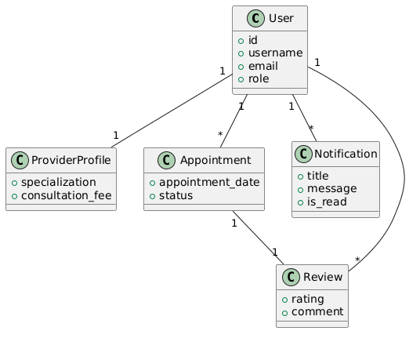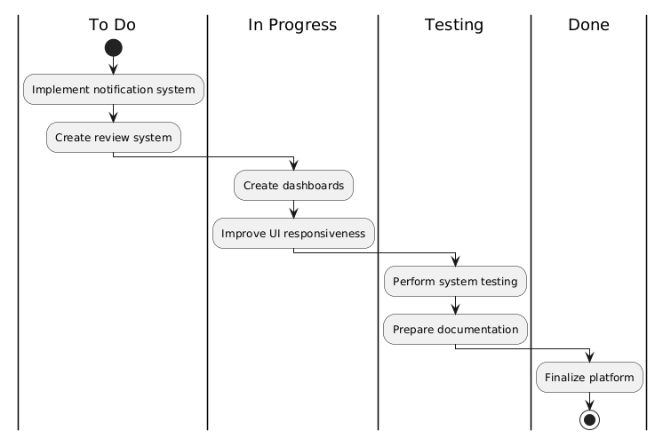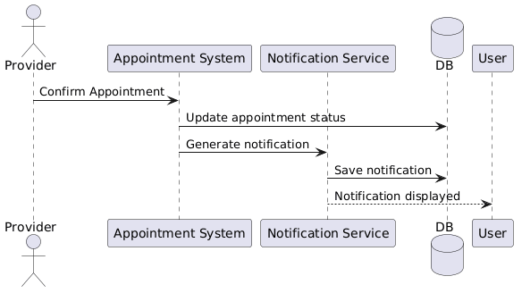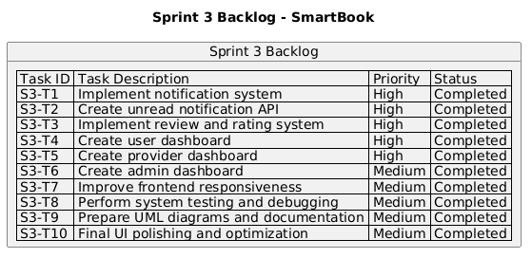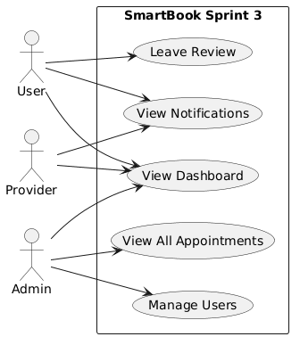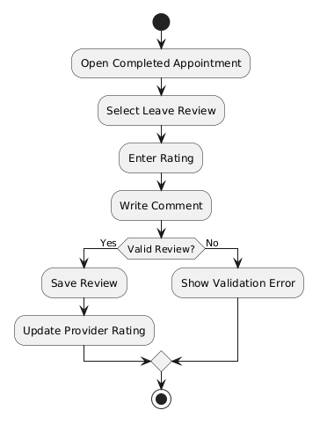
Sprint 3

Sprint Goal

The goal of Sprint 3 was to finalize the SmartBook platform by implementing the notification system, review and rating functionality, role-based dashboards, UI enhancements, and comprehensive testing.

This sprint focused on improving the overall user experience, increasing system usability, and preparing the platform for final deployment and presentation.

Sprint Duration

Sprint Number: Sprint 3
Duration: 1 Week
Start Date: Week 3
End Date: End of Week 3

Sprint Planning

During Sprint 3, the team focused on implementing advanced system features and refining the platform for final delivery. The sprint planning session prioritized user experience improvements, notification handling, dashboard functionality, and system testing.

The team planned to implement:

Real-time notification system
Notification unread count API
Review and rating system
User/provider/admin dashboards
UI responsiveness improvements
Bug fixing and optimization
Final testing and documentation

The sprint also included preparing UML diagrams, Scrum documentation, and presentation materials required for project submission.

Special attention was given to ensuring smooth integration between notifications, appointment updates, and dashboard interactions.

Potential risks identified during planning included notification synchronization and frontend responsiveness issues across different screen sizes.

(((((((((((((((((((((((((((((((((((SPRINT BACKLOG)))))))))))))))))))))))))))))))))

Sprint Review

At the end of Sprint 3, the SmartBook platform was fully completed and integrated successfully. The team finalized all remaining system modules and prepared the project for demonstration and submission.

The notification system successfully delivered real-time updates related to appointment actions, while the review system allowed users to leave ratings and feedback after completed appointments.

The implemented dashboards provided role-based functionality for users, providers, and administrators. UI responsiveness and frontend usability were also significantly improved during this sprint.

The following features were demonstrated during the sprint review:

Real-time notification handling
Notification unread count updates
Review and rating submission
User/provider/admin dashboards
Responsive frontend design
Final integrated system workflow

Feedback received during the review praised the modular system architecture, booking validation workflow, and clean user interface.

Sprint Retrospective
What Went Well
Notification and review systems were integrated successfully.
Final system testing identified and resolved multiple minor issues.
Team collaboration improved significantly across all modules.
The platform achieved a stable and professional final state.
Challenges Faced
Notification synchronization required additional frontend and backend coordination.
Dashboard responsiveness required multiple UI adjustments.
Final integration testing took longer than initially estimated.
Improvements for Future Projects
Begin integration testing earlier in development.
Improve estimation for frontend polishing tasks.
Increase automation in testing repetitive workflows.
Conclusion

Sprint 3 successfully finalized the SmartBook platform by completing advanced system features, improving user experience, and preparing the project for final presentation and deployment. The system was fully functional, stable, and aligned with all project requirements.

Full Project
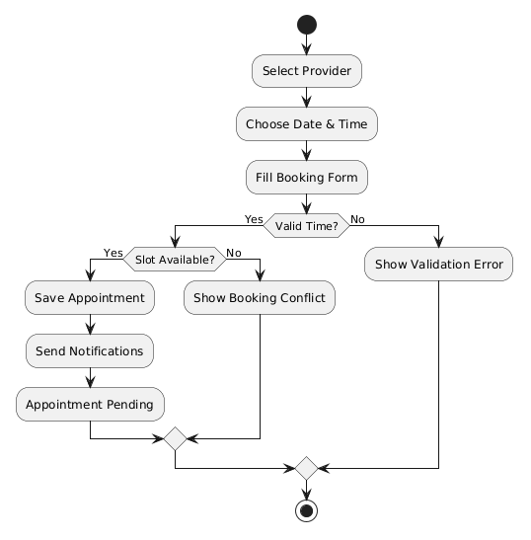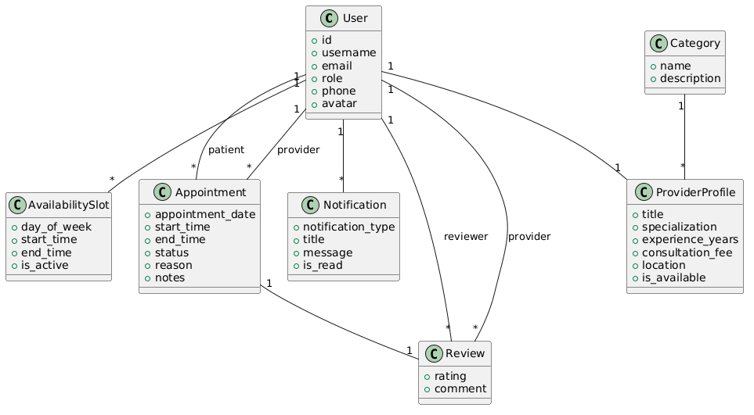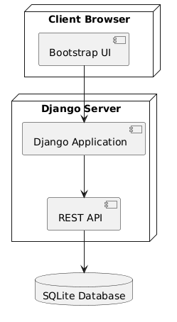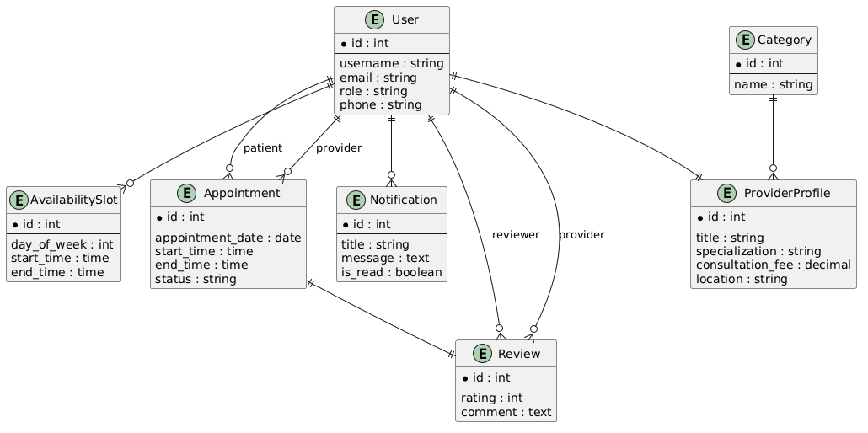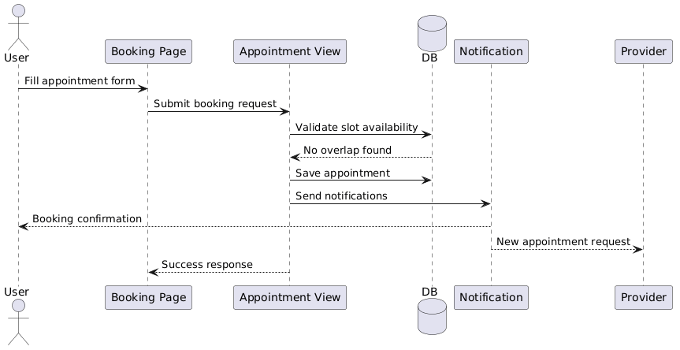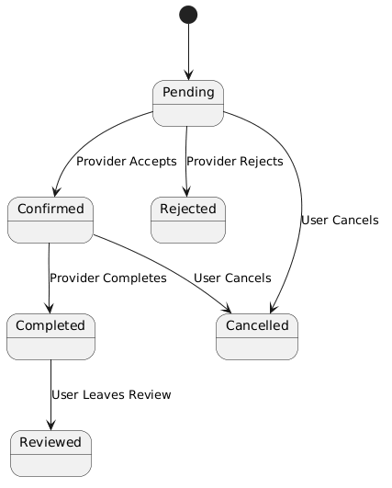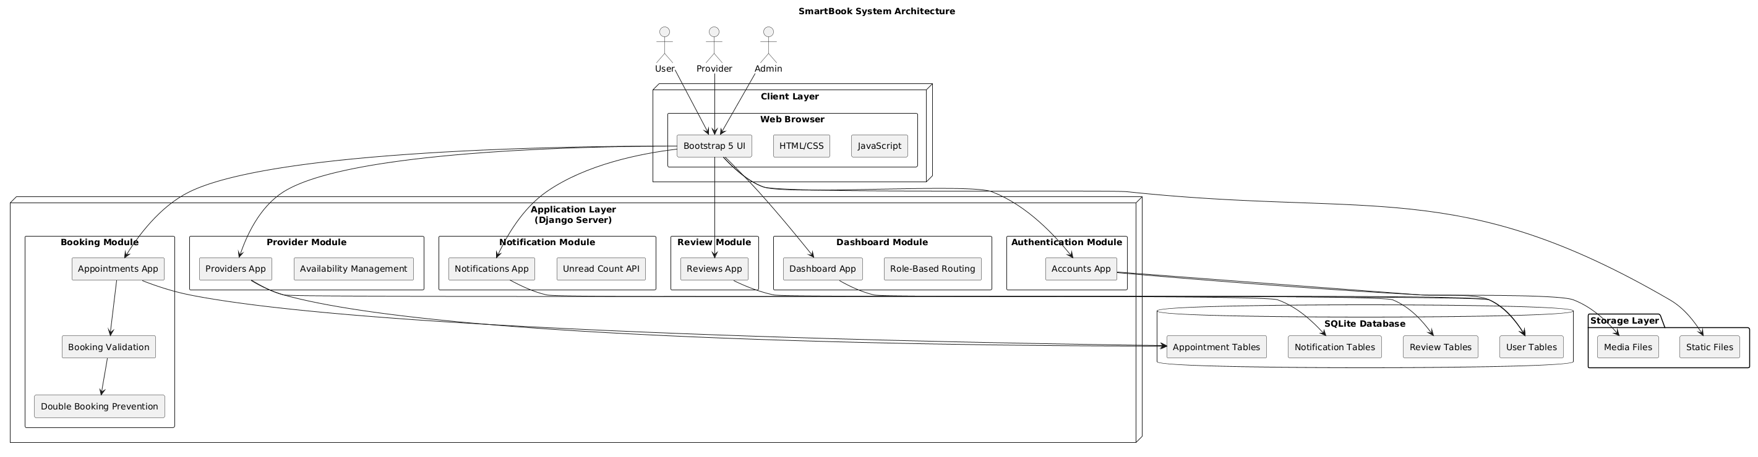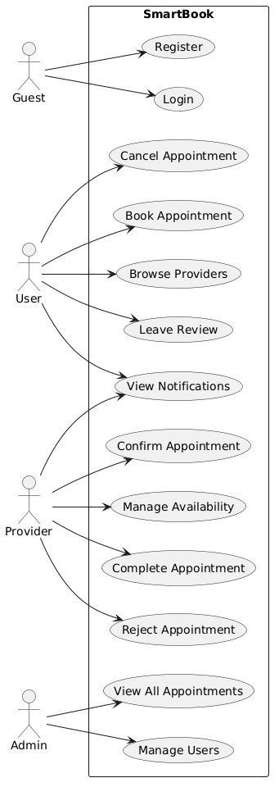
(SPRINTS)

SPRINT 1 — FOUNDATION & AUTHENTICATION
Main Goal

Build the system foundation and authentication.

Features Developed
Django project setup
Database setup
Custom User model
Login/Register
Role system
Provider profiles
Basic UI structure
Why this sprint makes sense

Because your entire project depends on:

users
authentication
roles
profiles

Without this, booking cannot exist.

===============================================================================================

SPRINT 2 — APPOINTMENT BOOKING SYSTEM
Main Goal

Develop the core booking workflow.

Features Developed
Appointment model
Booking form
Booking validation
Double-booking prevention
Availability slots
Appointment lifecycle
Provider approval/rejection
Why this sprint matters

This is your CORE BUSINESS LOGIC.

This is the most important sprint technically.

===============================================================================================

SPRINT 3 — ENHANCEMENTS & FINALIZATION
Main Goal

Improve user experience and finalize the platform.

Features Developed
Notifications
Reviews & ratings
Dashboards
UI polish
Testing
Bug fixing
Documentation
Responsive improvements
THIS STRUCTURE IS VERY IMPORTANT

Because now:

every sprint has a clear purpose
progression looks realistic
architecture matches sprint flow
presentation becomes easy