Unit 3: A Day in the City
English for Daily Life · Level: A2 · Tracks: [CORE] Warm-Up + Parts 1–6 · [PLUS] Parts 7–10
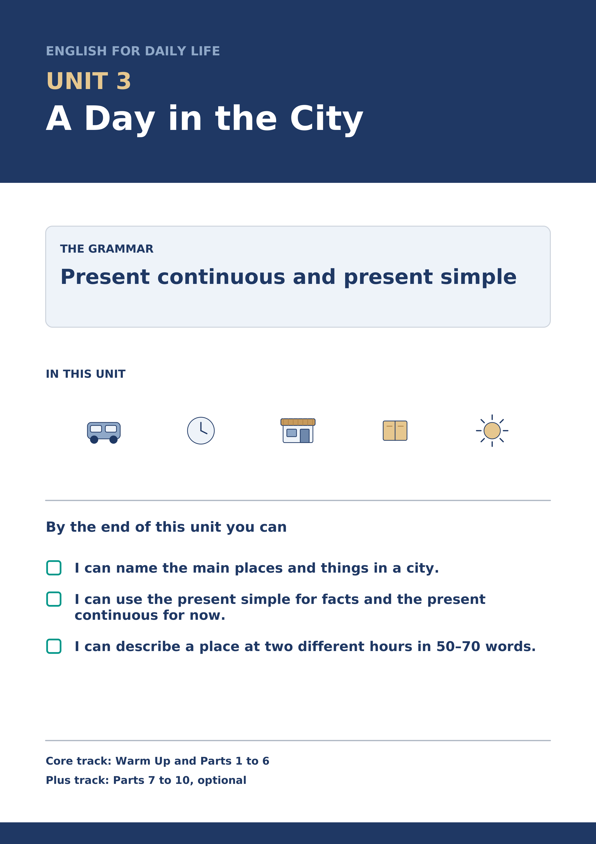
Warm Up
[CORE] Core track · in-class starter
Warm-up: City Words and Meanings
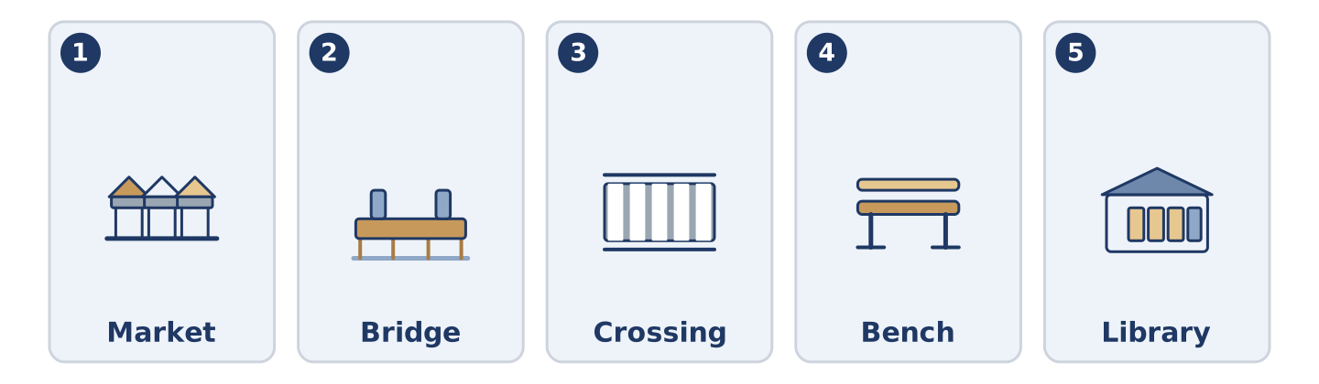
Figure 3.2 · The five warm-up words, and the thing each one means.
Match the words with their meanings. One meaning is not needed. Write the letter.
Column A
1. | Market | ____
2. | Bridge | ____
3. | Crossing | ____
4. | Bench | ____
5. | Library | ____
Column B
a) | a long seat in a park or a street
b) | a place where you borrow books
c) | a place where people sell food and other things from tables
d) | a shop that sells only bread
e) | a place to walk over a road or a river
f) | the place where you walk across a road
Warm-up: Talking About the City
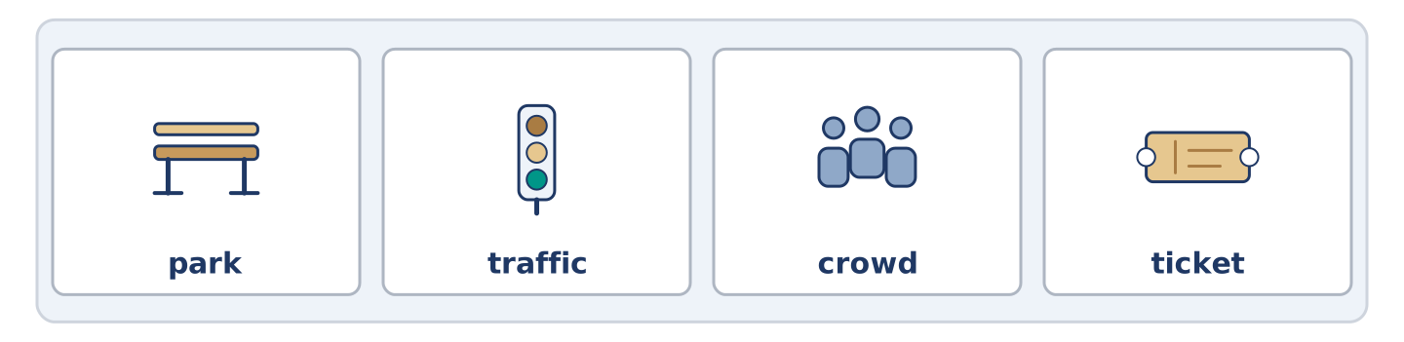
Figure 3.3 · The word bank for this task, in the order it is printed.
Complete the sentences using the words in the word bank.
Word bank: park | traffic | crowd | ticket
- At eight o’clock the ______________________ is slow and nobody moves.
- Dani buys a ______________________ for the bus every Monday.
- There is always a ______________________ outside the station at six.
- Mr Okonkwo sits in the ______________________ when the weather is good.
Warm-up: The Same Street, Two Hours
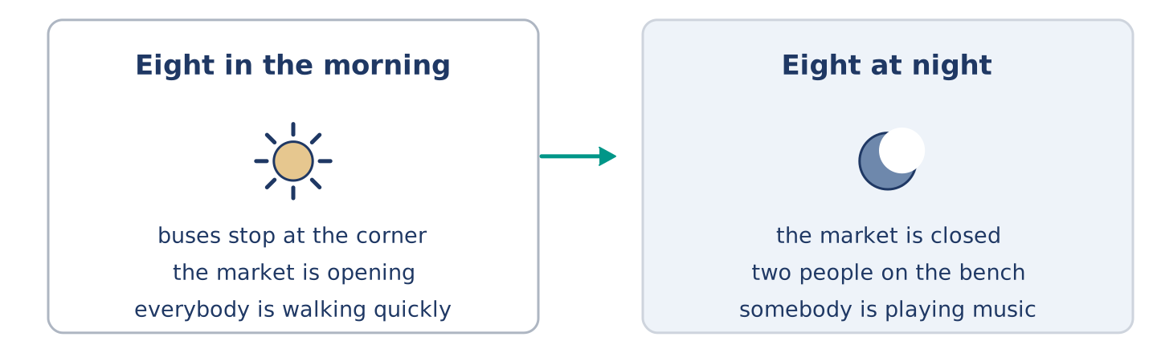
Figure 3.4 · Alder Street at eight in the morning and at eight at night.
Read the text and choose the correct answer.
At eight in the morning Alder Street is loud. Buses stop at the corner, the market is opening, and everybody is walking quickly. At eight at night the same street is almost quiet. The market is closed, two people are sitting on the bench, and somebody is playing music by the crossing. The street does not change. The city changes around it, twice a day, every day.
1. What is happening at eight in the morning?
○ A) The market is closing
○ B) Everybody is walking quickly
○ C) Two people are sitting on the bench
○ D) The street is quiet
2. What does the text say about the street?
○ A) It changes twice a day
○ B) It is always loud
○ C) It does not change
○ D) It is never quiet
Part 1 · Vocabulary and Terminology
[CORE] Core track · pre-class input
Part 1: City and Journey Terms
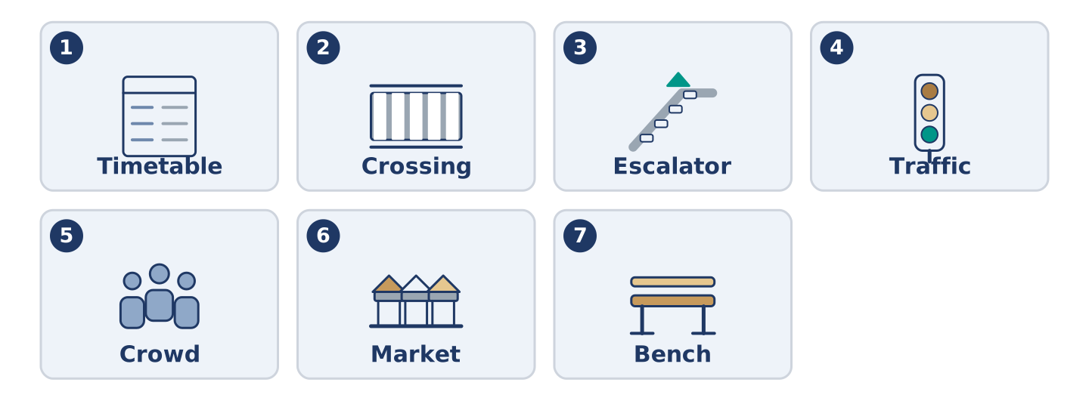
Figure 3.5 · The seven words of Column A, and what each one is.
Match the words with their meanings. One meaning is not needed. (0. is done for you.)
- Fare → the money you pay for one journey on a bus or a train.
Column A
1. | Timetable | ____
2. | Crossing | ____
3. | Escalator | ____
4. | Traffic | ____
5. | Crowd | ____
6. | Market | ____
7. | Bench | ____
Column B
a) | all the cars and buses on a road
b) | a lot of people in one place
c) | a list of the times buses or trains come
d) | moving stairs that carry you up or down
e) | the place where you walk across a road
f) | a place where people sell things from tables
g) | a long seat in a park or a street
h) | the money you pay to live somewhere
Gloss: fare = the money for one journey · timetable = a list of times · escalator = moving stairs · platform = the place beside the train where you stand
Part 1: Pronunciation
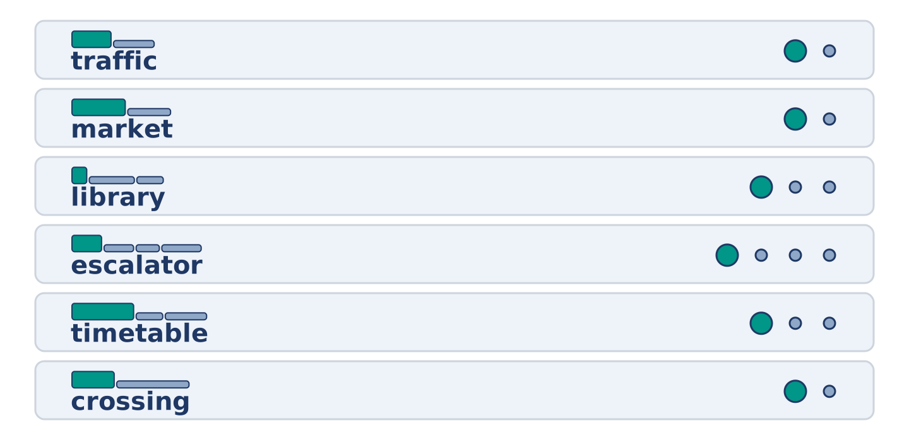
Figure 3.6 · Where the stress falls in six words of this unit.
🔊 Audio Track 3.1
Listen and practise these words. Say each word aloud and stress the loud syllable (CAPITALS).
traffic — TRA-ffic
market — MAR-ket
library — LI-bra-ry
escalator — ES-ca-la-tor
timetable — TIME-ta-ble
crossing — CRO-ssing
Then listen again to the long words. Escalator is four beats and library is three, but English speakers often say LI-bry. Say the slow form first, then the fast one, and notice which sound disappears.
Part 1: Six Places in the City
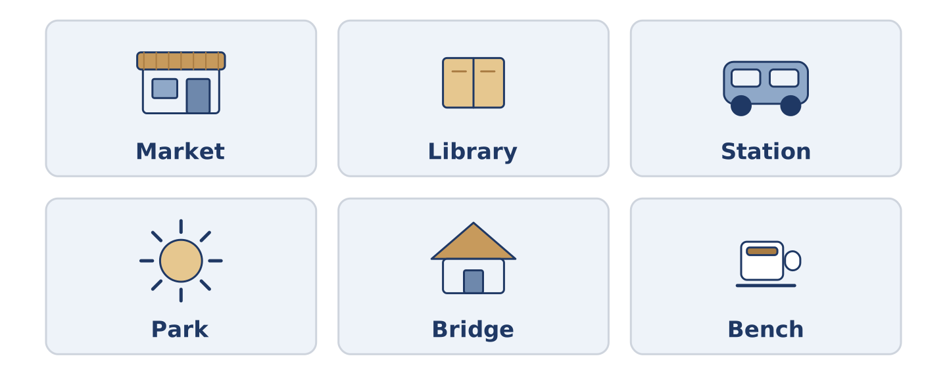
Figure 3.7 · Six places in a city and what you do at each.
Complete the table. Write what you do there and when it is busiest. (0. is done.)
Place | What you do there | Busiest at
Market | buy food | (example)
Library
Station
Park
- Market — buy food — early morning, when it opens.
Think about a city you know. There is more than one right answer, and you should be ready to say why you chose yours.
Part 1: On the Street
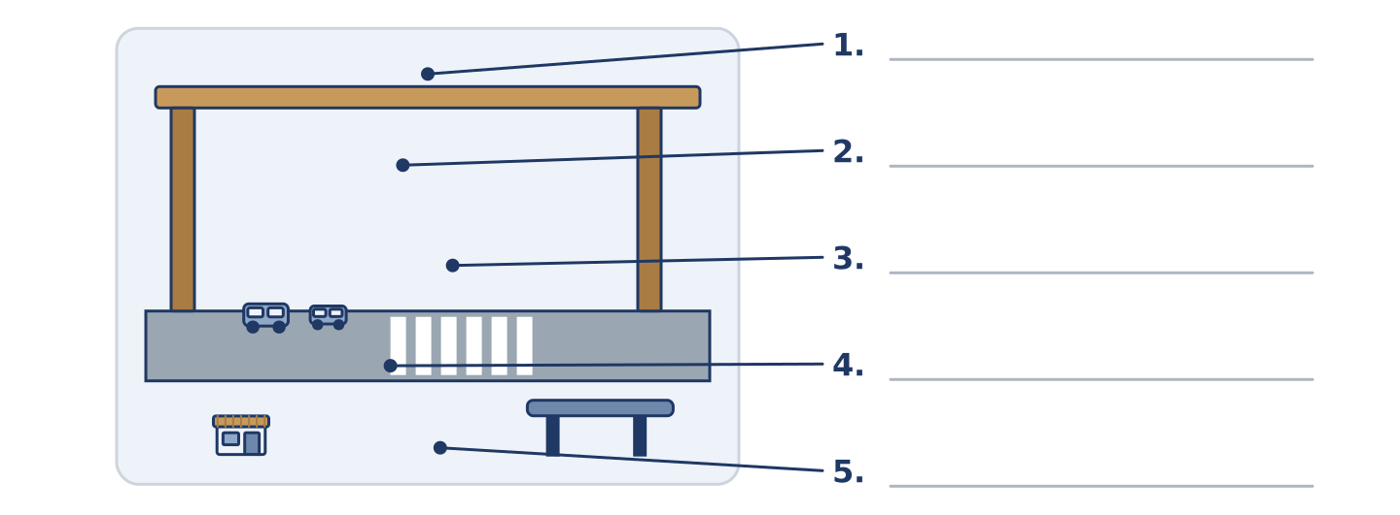
Figure 3.8 · On the street — write the correct word on each line.
Match the things on a street with their descriptions. One description is not needed. Write the letter.
Column A
1. | Crossing | ____
2. | Bench | ____
3. | Traffic | ____
4. | Bridge | ____
5. | Market | ____
Column B
a) | a place to walk over a road or a river
b) | tables in the street where people sell things
c) | the money you pay for one journey
d) | the black and white lines you walk across
e) | a long seat where you can wait or rest
f) | all the cars and buses on a road
Part 1: City Life — Multiple Choice
Read and choose the correct answer.
1. Moving stairs that carry you up or down are an…
○ A) escalator
○ B) entrance
○ C) crossing
○ D) timetable
2. A list of the times buses come is a…
○ A) fare
○ B) crowd
○ C) timetable
○ D) bench
3. The money you pay for one journey is the…
○ A) traffic
○ B) ticket
○ C) market
○ D) fare
Part 1: Vocabulary Fill-in
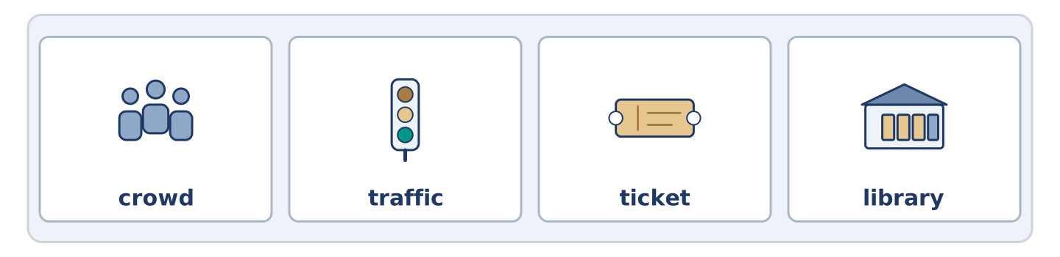
Figure 3.9 · The four words of the bank, in the order the task gives them.
Complete the sentences with the correct word.
Word bank: crowd | traffic | ticket | library
- Yuki is reading in the ______________________ , because her flat is cold.
- The ______________________ stops moving at half past five every day.
- There is a ______________________ at the bus stop, so Maya is waiting.
- Dani cannot find his ______________________ , and the bus is coming.
Part 1: Write About Your City (short)
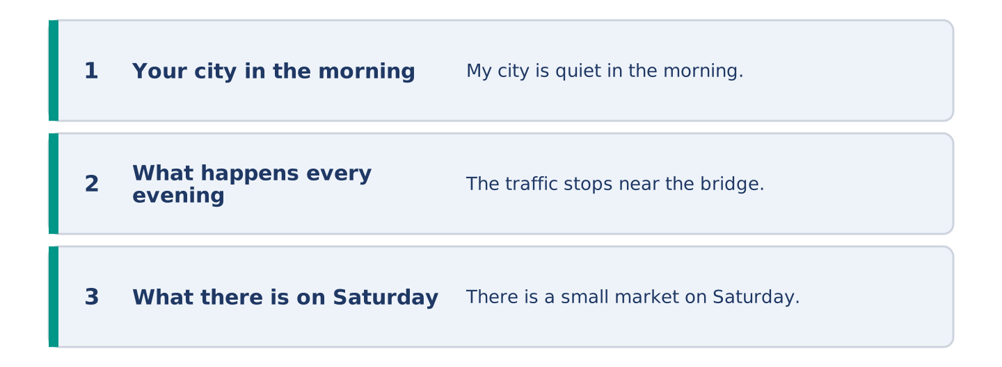
Figure 3.10 · The shape of your two or three sentences, with the model beside each step.
Write two or three sentences about the place where you live. Use three words from this unit.
Model — read this first:
My city is quiet in the morning and loud at six. The traffic stops near the bridge every evening, so I walk that part. There is a small market on Saturday, and I always buy two things I do not need.
Part 2 · Grammar — Present Continuous and Present Simple
[CORE] Core track · pre-class input
Part 2: Notice
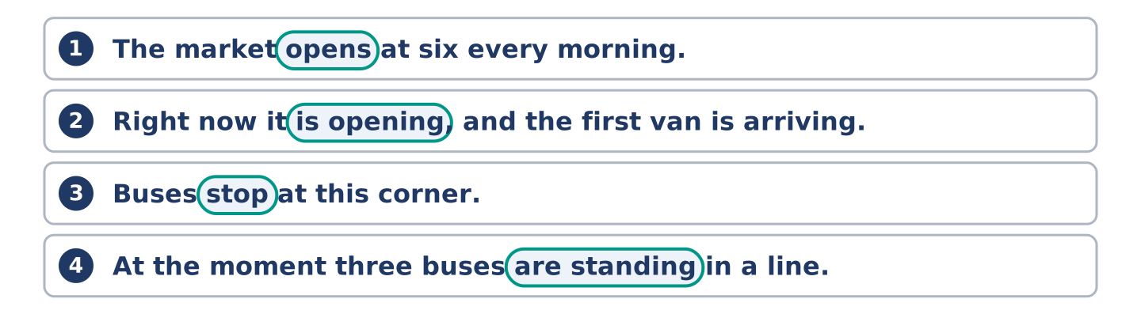
Figure 3.11 · Lines from the notice, with the target form ringed in each.
Read these lines about the city. Underline the verbs. Which are always true, and which are happening now?
The market opens at six every morning. Right now it is opening, and the first van is arriving. Buses stop at this corner. At the moment three buses are standing in a line. Mr Okonkwo reads on that bench every afternoon. Today he is reading there in the rain.
Three sentences are facts; three are about this minute. The time words tell you which.
Part 2: Grammar Focus Box
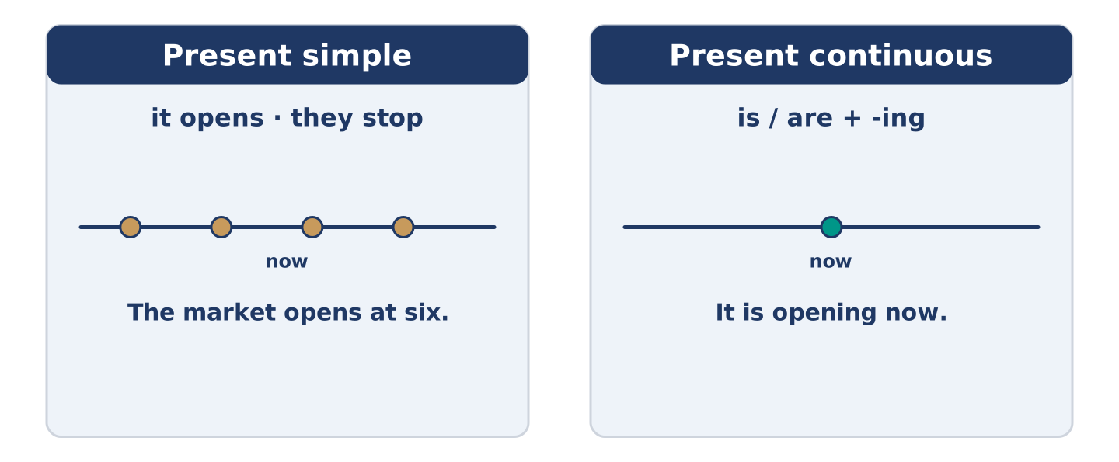
Figure 3.12 · Always true, or happening now: the same verb, two jobs.
 | Form | Use | Example
Present simple | it opens · they stop | a fact, a timetable, every day | The market opens at six.
Present continuous | is / are + -ing | this minute, in front of you | It is opening now.
Time words | every day · at the moment | they decide the tense | Today he is reading in the rain.
Stative verbs | know, want, like | no -ing form | I want a ticket.
Remember: a timetable takes the present simple: the bus leaves at six.
Watch out! ✗ The market is opening at six every day. → ✓ The market opens at six. (a fact). ✗ I am wanting a ticket. → ✓ I want a ticket. (no -ing).
Part 2: Controlled Practice
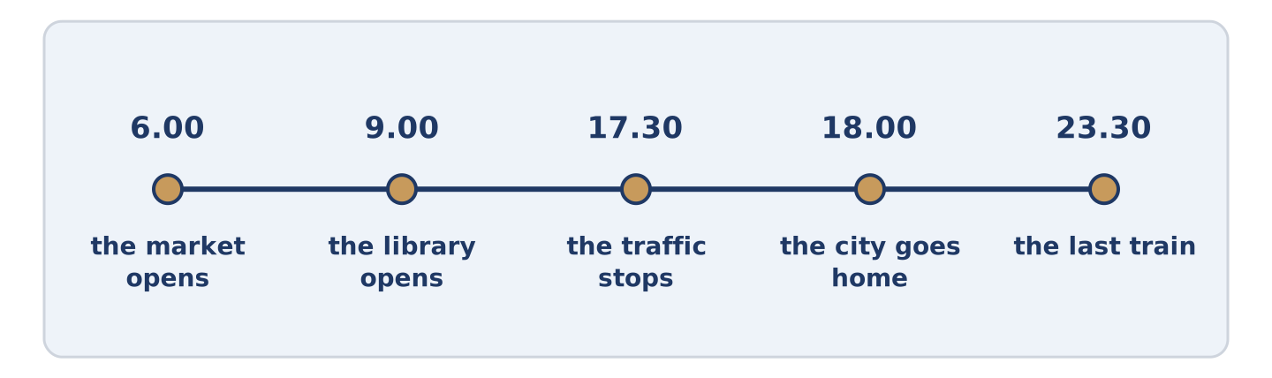
Figure 3.13 · One street, hour by hour: what happens, and what is happening.
Present simple or present continuous? (0. is done.)
- The market opens at six every morning. (open)
- Look — the first van ______________________ (arrive) now.
- Buses ______________________ (stop) at this corner every ten minutes.
- At the moment three buses ______________________ (stand) in a line.
- Mr Okonkwo ______________________ (read) on that bench every afternoon.
Part 2: Which Tense?
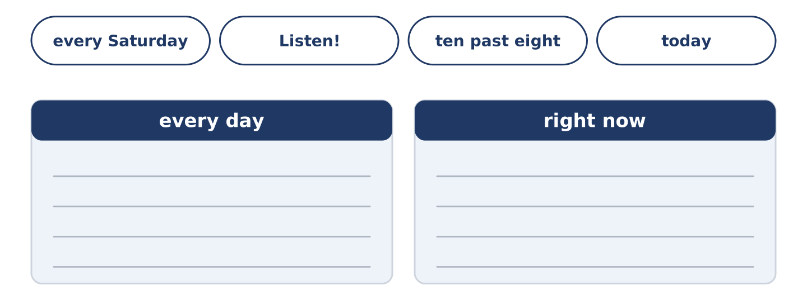
Figure 3.14 · The items of this task, and the bins they sort into.
Choose the correct form. (0. is done.)
- Every Saturday Amina opens at seven. (opens / is opening)
- Listen! Somebody ______________________ (plays / is playing) music by the crossing.
- The number 7 bus ______________________ (leaves / is leaving) at ten past eight.
- Today Yuki ______________________ (works / is working) in the library.
- Dani ______________________ (wants / is wanting) a cheaper fare.
Part 2: Correct the Sentence
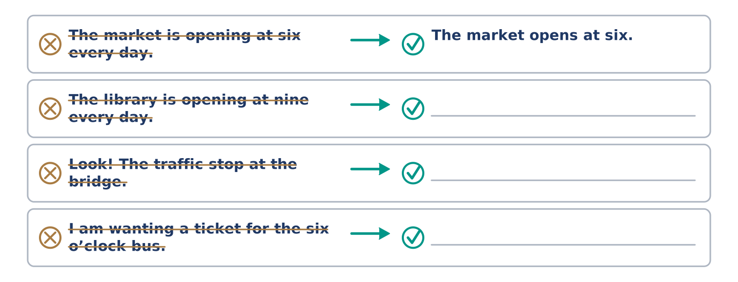
Figure 3.15 · One correction done for you, and the rest to write.
Each sentence has one grammar mistake. Write the correct sentence.
- The library is opening at nine every day.
- Look! The traffic stop at the bridge.
- I am wanting a ticket for the six o’clock bus.
- At the moment Maya wait at the crossing.
Part 2: Freer Practice
Write two sentences about your own city: one fact, and one about now.
Part 2: Grammar Review
Choose the correct sentence.
1. Which sentence is correct (a timetable)?
○ A) The bus is leaving at ten past eight every day.
○ B) The bus leaves at ten past eight every day.
○ C) The bus leave at ten past eight every day.
○ D) The bus leaving at ten past eight every day.
2. Which sentence is correct (now)?
○ A) Listen — somebody plays music.
○ B) Listen — somebody playing music.
○ C) Listen — somebody is play music.
○ D) Listen — somebody is playing music.
→ Harvest: you will see both tenses again in the Part 5 reading. Watch for the time words.
Part 3 · Listening
[CORE] Core track · pre-class input · scripts printed inline
Part 3: At the Bus Stop
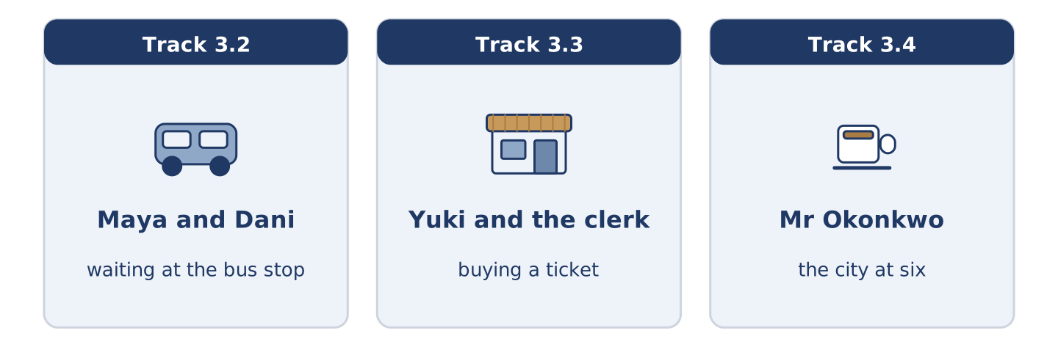
Figure 3.16 · The three listenings: who is speaking, and what about.
🔊 Audio Track 3.2
Before you listen: what do people say to each other at a bus stop?
Maya: Is the 7 coming? Dani: I think so. It says four minutes, but it’s said four minutes for a long time. Maya: It always does that. Dani: You’re off to work? Maya: Yes, but I’m starting late today, so I’m not running for once. Dani: I’m off to the library. My flat’s too cold to think in. My sister says hers is worse. Maya: Here it is. And it’s full, of course.
While you listen: write True, False, or Not Given. (0. is done.)
- Maya and Dani are at a bus stop. — True
- Maya is starting work late today. ____
- Dani is going to the market. ____
- Dani goes to the library every day. ____
Useful phrases: Is the 7 coming? · It always does that · I am going to…
Part 3: Buying a Ticket
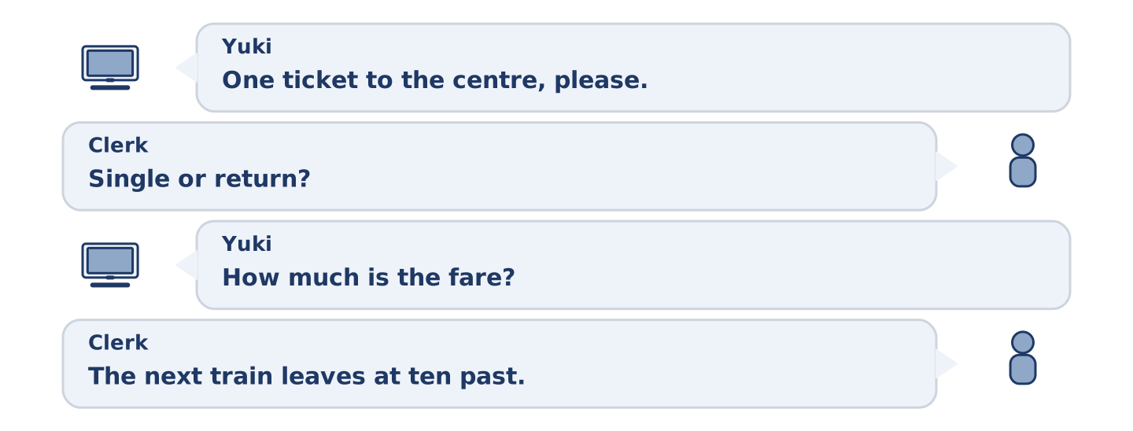
Figure 3.17 · The second listening, turn by turn.
🔊 Audio Track 3.3
Before you listen: what do you need to know before you buy a ticket?
Yuki: One ticket to the centre, please. Clerk: Single or return? Yuki: Return. How much is the fare? Clerk: Four forty. The next train leaves at ten past. Yuki: Which platform? Clerk: Platform two. The escalator is not working today, so use the stairs on the left. Yuki: Thank you. Is it usually this busy? Clerk: Every morning. You’ll get used to it.
While you listen: answer the questions. (0. is done.)
- What does Yuki want to buy? — A ticket to the centre.
- How much is the fare?
- Why does the clerk say to use the stairs?
- What does the clerk say about the crowd?
Part 3: The City at Six
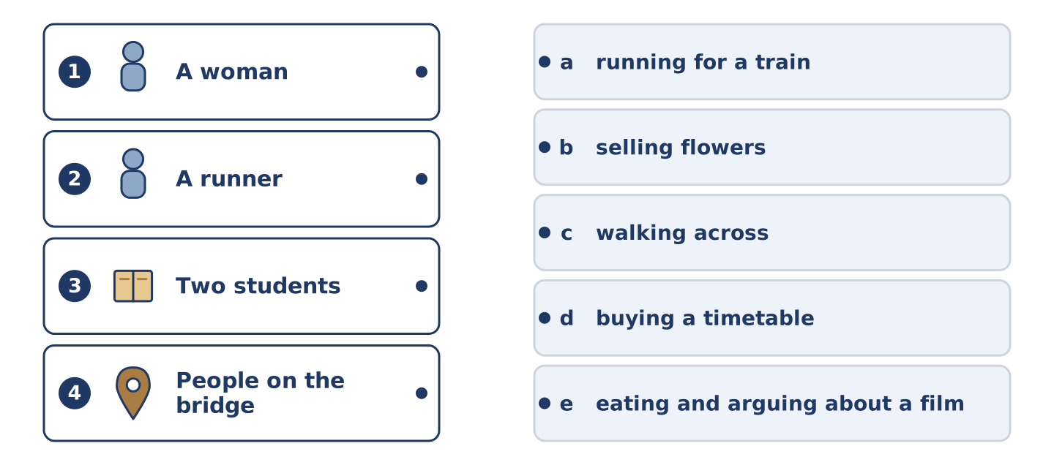
Figure 3.18 · Four on the left, five on the right, and one spare.
🔊 Audio Track 3.4
Before you listen: what is your city doing at six in the evening?
Mr Okonkwo: Six o’clock, and the city is going home. Maya is somewhere in it, and so is Amina. The traffic is not moving on the bridge, so people are walking across it instead. Outside the station a woman is selling flowers and almost nobody is buying them. A runner is going for a train, and he is not fast enough. On my bench two students are eating and arguing about a film. Every evening is the same evening, and no evening is.
While you listen: match each person with what they are doing. One action is not needed. (0. is done.)
- Mr Okonkwo → watching from his bench.
Useful phrases: A man is… · A woman is… · Two students are…
Column A
1. | A woman | ____
2. | A runner | ____
3. | Two students | ____
4. | People on the bridge | ____
Column B
a) | running for a train
b) | selling flowers
c) | walking across
d) | buying a timetable
e) | eating and arguing about a film
Part 4 · Speaking
[CORE] Core track · in-class output
Part 4: Talking About Your City
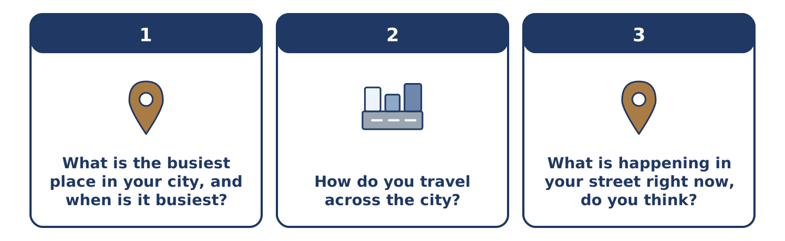
Figure 3.19 · The three questions as cards, to take one at a time.
Work with a partner. Ask and answer these questions.
- What is the busiest place in your city, and when is it busiest?
- How do you travel across the city? Is it the fastest way?
- What is happening in your street right now, do you think?
Useful language: It opens at… · Every morning… · Right now… · At the moment… · The busiest place is…
Part 4: Find the Difference (pairwork)
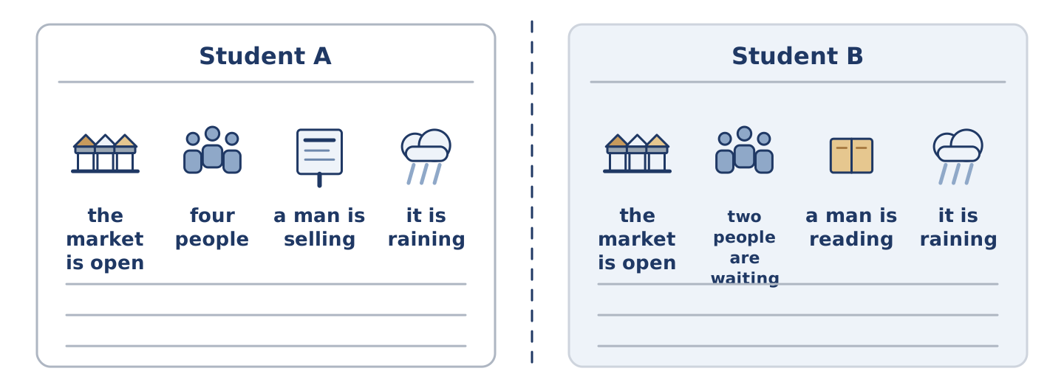
Figure 3.20 · Student A’s facts and Student B’s, with a fold between them.
Student A and Student B each have a picture of the same street. Ask questions and find three differences.
Useful questions: What is happening at the crossing? · Is the market open? · How many people are waiting? · What is the man doing?
Student A — your picture: the market is open · four people are waiting · a man is selling flowers · it is raining.
Student B — your picture: the market is open · two people are waiting · a man is reading a newspaper · it is raining.
Part 4: Asking the Way
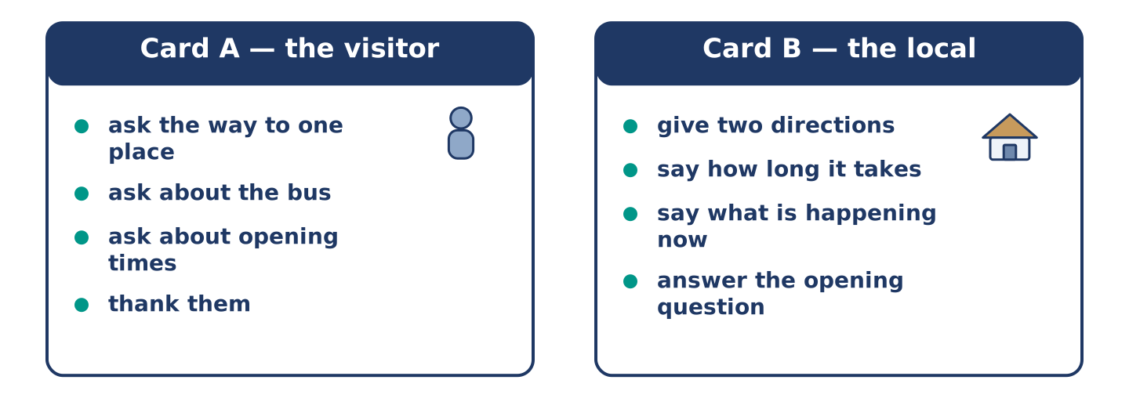
Figure 3.21 · Card A and Card B: what each of you has to say.
Work in pairs. Read the model, then use the cards.
Model exchange:
A: Excuse me, how do I get to the library? — B: Go over the bridge and turn left at the crossing. It is about ten minutes. — A: Is there a bus? — B: There is, but the traffic is terrible now. Walking is faster. — A: Thank you. Is it open on Sunday? — B: It opens at twelve on Sunday.
Useful language: Excuse me, how do I get to…? · Go over… · Turn left at… · It is about ten minutes · Walking is faster.
Card A — the visitor: ask the way to one place · ask about the bus · ask one question about opening times · thank them.
Card B — the local: give two directions · say how long it takes · say what is happening now that changes the answer · answer the opening question.
Your turn: run the dialogue, then swap roles.
Stretch [PLUS]: the visitor asks for a place you do not know — say so and offer a way to find out.
Part 4: Mini-Presentation
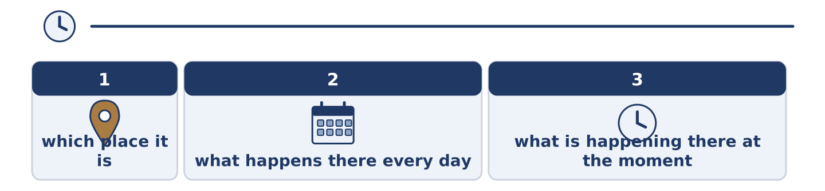
Figure 3.22 · The one-minute talk as two beats, each as wide as its share.
Prepare a short talk (about one minute). Describe one place in your city: what happens there every day, and what is happening there at the moment.
Part 5 · Reading
[CORE] Core track · pre-class input
Part 5: The City Has Two Clocks
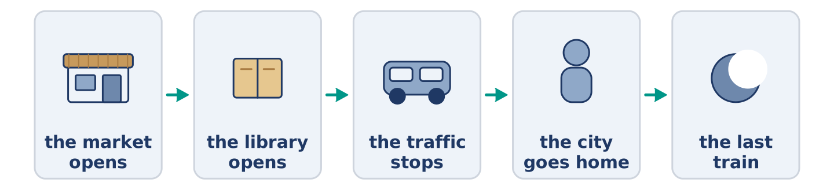
Figure 3.23 · One day in the city, hour by hour.
Before you read: is your city a different place at different hours?
Gloss: rush hour = the time when many people travel to or from work · queue = a line of people waiting · deliver = to bring things to a place
A city runs on two clocks at once. The first is the timetable: the market opens at six, the library at nine, the last train leaves at half past eleven. Somebody writes that clock down, and it almost never changes. The second clock is what people are actually doing, and it is different every day. At six the market opens, but today one van is late and half the tables are empty. At nine the library opens. This morning there is already a line of people outside, because it is cold. The woman at the door says it is never empty at that hour. Most of us live by the first clock and complain about the second. Night workers see a third city. The rest of us never meet it. A cleaner is washing the floor of an empty station. Somebody is delivering bread to a shop. It opens in four hours.
Answer the multiple-choice questions. (0. is done.)
- How many clocks does the text say a city runs on? — Two.
1. What is the first clock?
○ A) What people are doing now
○ B) The timetable
○ C) The weather
○ D) The night shift
2. Why is there a queue outside the library this morning?
○ A) Because a van is late
○ B) Because the market is closed
○ C) Because it is cold
○ D) Because the train is early
3. What do people who work nights see?
○ A) The same city as everybody else
○ B) A third city the rest of us never meet
○ C) A market that never opens
○ D) A library with no queue
Part 5: Vocabulary in Context
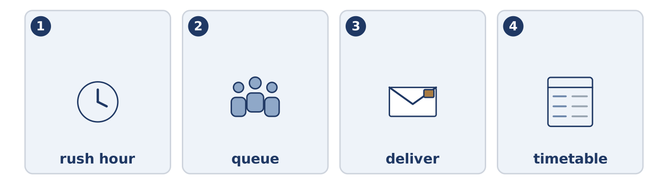
Figure 3.24 · The four words from the reading, drawn.
Match each word from the text with its meaning. One meaning is not needed. Write the letter.
Column A
1. | rush hour | ____
2. | queue | ____
3. | deliver | ____
4. | timetable | ____
Column B
a) | a line of people waiting
b) | a list of the times buses or trains come
c) | the time when many people travel to or from work
d) | to bring things to a place
e) | a long seat in a park
Part 5: Cities That Never Sleep
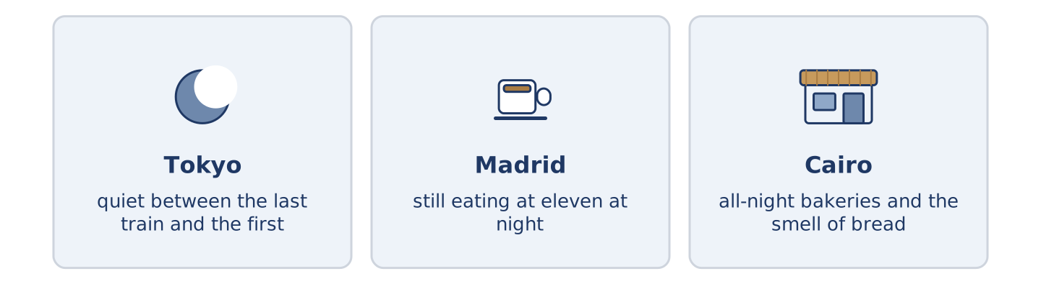
Figure 3.25 · The same hour in three cities.
Before you read: at midnight, what is still open where you live?
Gloss: all-night = open through the whole night · bakery = a shop that makes and sells bread
Some cities keep going after midnight and some do not. In Tokyo the last train is late and the first is early, and between them the city is quiet in a way that surprises visitors. In Madrid people are still eating at eleven. A grandmother orders coffee, and her street is busier then than at six. In Cairo there are all-night bakeries, and the smell of bread crosses an almost empty street. The hours are the same everywhere. What a city does with the dark is not.
Answer the questions. (0. is done.)
- Do all cities keep going after midnight? — No, they do not.
- What surprises visitors to Tokyo?
- When are the streets of Madrid busier?
- What crosses an almost empty street in Cairo?
Part 6 · Writing
[CORE] Core track · in-class / homework
Part 6: Describe a Place at Two Hours (50–70 words)
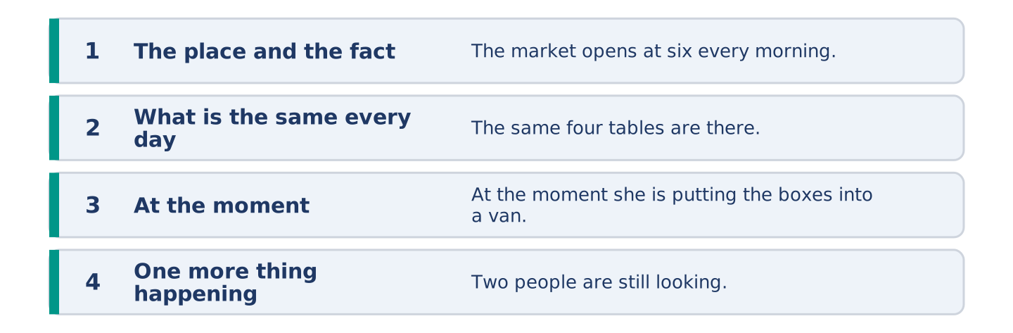
Figure 3.26 · The shape of the paragraph you are about to write.
Choose one place. Say what happens there every day, and what is happening there at the moment.
Model — read this first:
The market on Alder Street opens at six every morning and closes at two. The same four tables are there every day, and the woman on the corner sells only tomatoes. At the moment it is half past one, and she is putting the last boxes into a van. Two women are still looking, and she is pretending not to see them. (62 words)
Plan (fill in, then write): ___ opens at ___ every ___. The same ___ are there every day. At the moment ___ is ___. ___ is also ___.
Word bank: every morning | every day | at the moment | right now | opens | is opening
Check before you finish: ☐ one present-simple fact? ☐ one present-continuous sentence? ☐ two time words? ☐ 50–70 words?
Part 6: The Best Way to Cross a City (50–70 words)
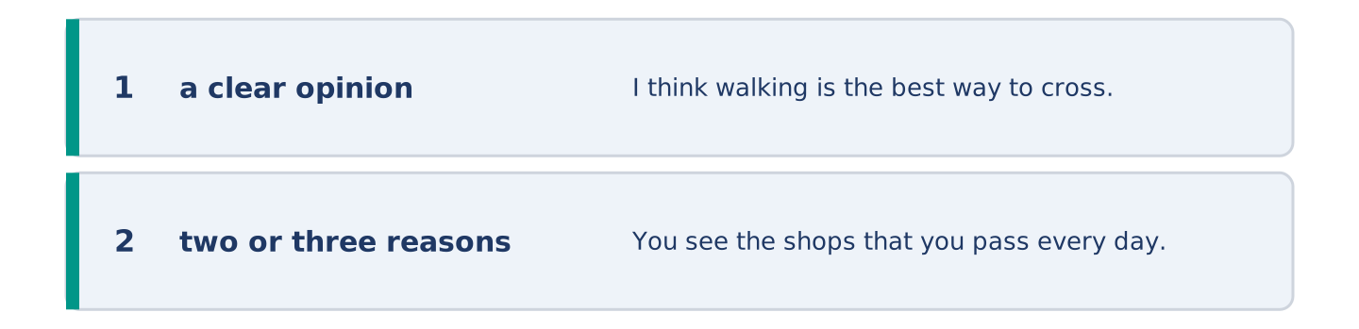
Figure 3.27 · The shape of the opinion paragraph, step by step.
What is the best way to travel across a city? Give your opinion and two or three reasons.
Model — read this first:
I think walking is the best way to cross a city, if you have the time. You see the shops that you pass every day on the bus and never notice. It is also the only way that is never late, because the traffic does not stop you. The problem is rain, and in my city it rains a lot. (60 words)
Word bank: I think… because… | it is faster | it is never late | however | in my opinion
Check before you finish: ☐ a clear opinion? ☐ two or three reasons? ☐ 50–70 words?
Part 6: A Message About Meeting (50–70 words)
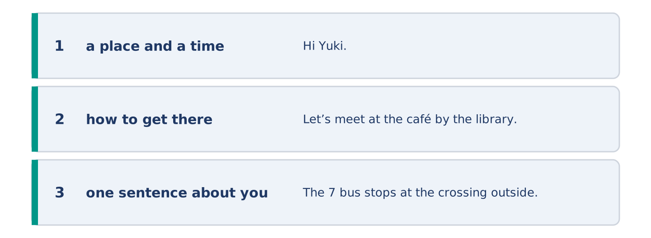
Figure 3.28 · The moves of the message, with a line of the model for each.
You are meeting a friend in the city. Write a short message: where, when, and how they get there.
Model — read this first:
Hi Yuki. Let’s meet at the café by the library on Saturday at eleven. The 7 bus stops at the crossing outside, and it comes every ten minutes. If you walk, go over the bridge and turn left — it is about fifteen minutes from your flat. I am working until half past ten, so do not worry if I am five minutes late. Maya (65 words)
Plan (fill in, then write): Let’s meet at ___ on ___ at ___. The ___ stops ___. If you walk, ___. ___
Check before you finish: ☐ a place and a time? ☐ how to get there? ☐ one sentence about you? ☐ 50–70 words?
Part 6: Reflection — My Favourite Hour (40–60 words)
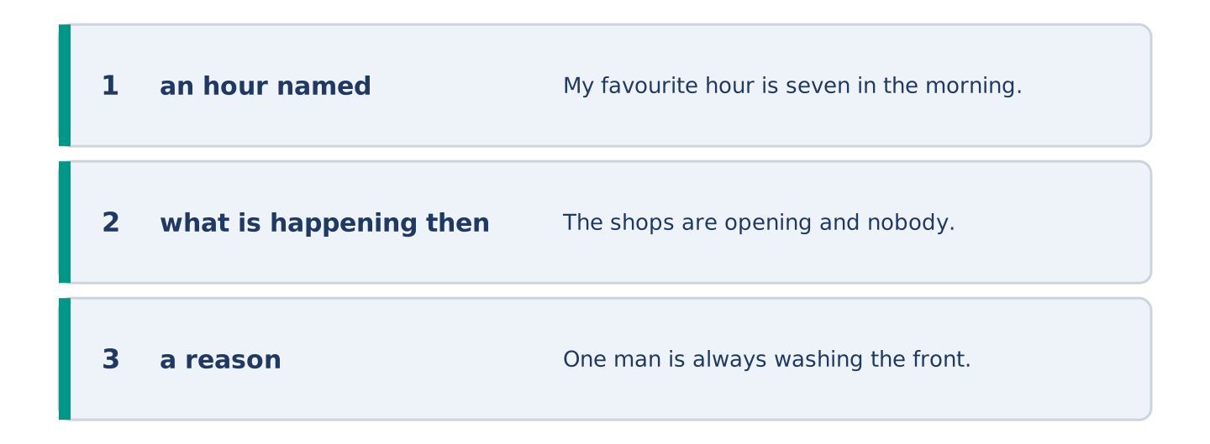
Figure 3.29 · The reflection, step by step.
Which hour of the day do you like best in your city, and why?
Model — read this first:
My favourite hour is seven in the morning, before the traffic starts. The shops are opening and nobody is in a hurry yet. One man is always washing the front of the café, and he always says good morning. By nine the whole street is somebody else’s. (47 words)
Check before you finish: ☐ an hour named? ☐ what is happening then? ☐ a reason? ☐ 40–60 words?
Part 7 · Real-World File — Getting Around
[PLUS] Plus track (optional) · stronger learners
7A: Phrase Bank
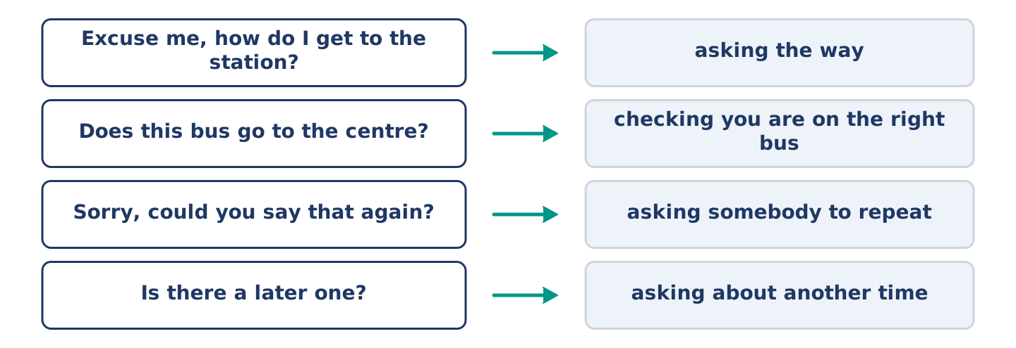
Figure 3.30 · What you say when you are lost, and what each thing does.
Match what a person says with its purpose. One purpose is not needed. Write the letter.
Column A
1. | “Excuse me, how do I get to the station?” | ____
2. | “Does this bus go to the centre?” | ____
3. | “Sorry, could you say that again?” | ____
4. | “Is there a later one?” | ____
Column B
a) | checking you are on the right bus
b) | asking the way
c) | asking somebody to repeat
d) | asking about another time
e) | complaining about the fare
7B: A Problem on the Way
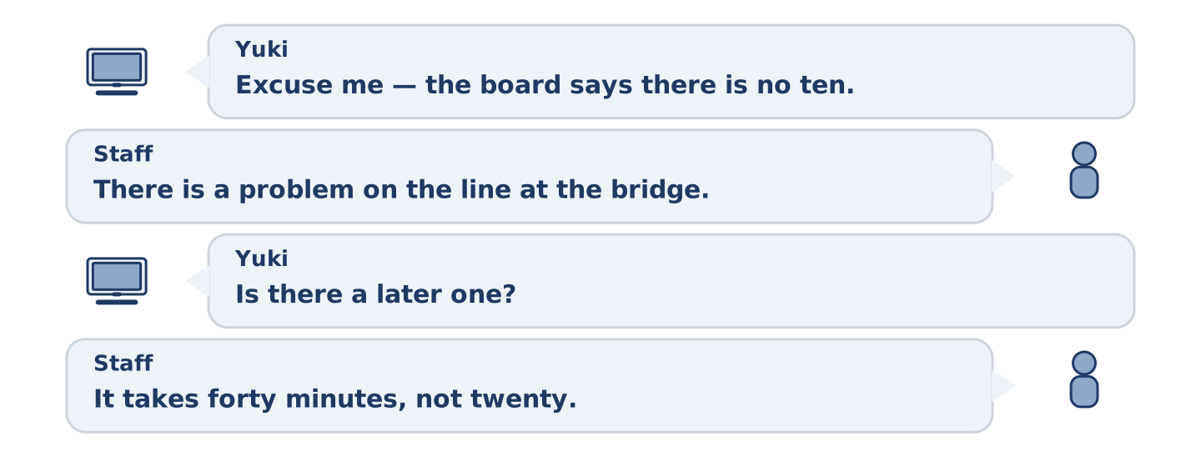
Figure 3.31 · The 7B exchange: who takes each turn.
🔊 Audio Track 3.5
Before you read: what do you do when the train you need is not running?
Yuki: Excuse me — the board says there is no ten past. Staff: It is. There is a problem on the line at the bridge. Yuki: Is there a later one? Staff: Half past, from platform four, but it is going the long way. It takes forty minutes, not twenty. Yuki: And the buses? Staff: The 7 and the 12 both go to the centre. The 12 is leaving in two minutes from outside. Yuki: Thank you — I am running, then.
Answer the questions. (0. is done.)
- Which train is not running? — The ten past.
- Why is that train not running?
- How long does the half past take?
- Which bus is leaving in two minutes?
7C: Controlled Practice — When a Journey Goes Wrong
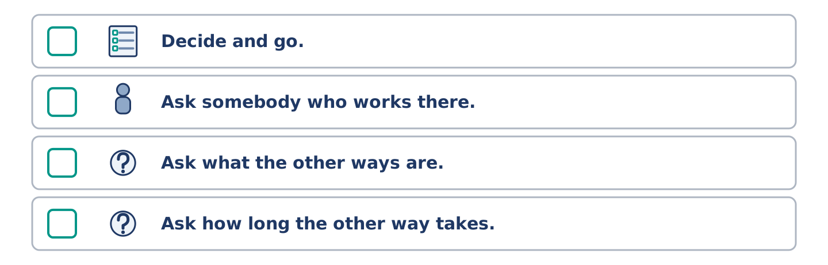
Figure 3.32 · The steps still to be numbered, as the task prints them.
Put the steps in order. Number them 1–5. (0. is done.)
- Read the board and see the problem. — 1
____ Decide and go.
____ Ask somebody who works there.
____ Ask what the other ways are.
____ Ask how long the other way takes.
7D: Role-Play — Asking About a Journey
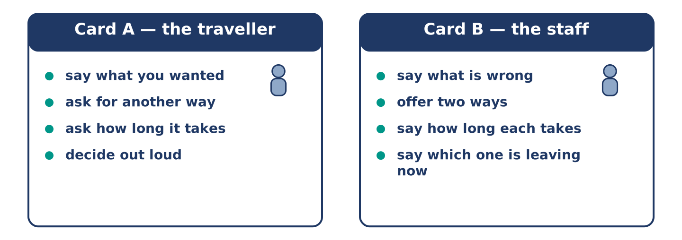
Figure 3.33 · The 7D cards: what each of you has to say.
In pairs. One is the traveller; one works at the station. Use the model and cards.
Model exchange: A: Excuse me — is the ten past running? — B: No. There is a problem at the bridge. — A: Is there a later one? — B: Half past, platform four, but it takes forty minutes. — A: Is there a bus? — B: The 12, outside, leaving now. — A: Thank you.
Card A — the traveller: say what you wanted · ask for another way · ask how long it takes · decide out loud.
Card B — the staff: say what is wrong · offer two ways · say how long each takes · say which one is leaving now.
Stretch [PLUS]: both ways are bad, and the traveller is late for something — stay calm and help them choose.
7E: Writing — A Message About a Delay (50–80 words)
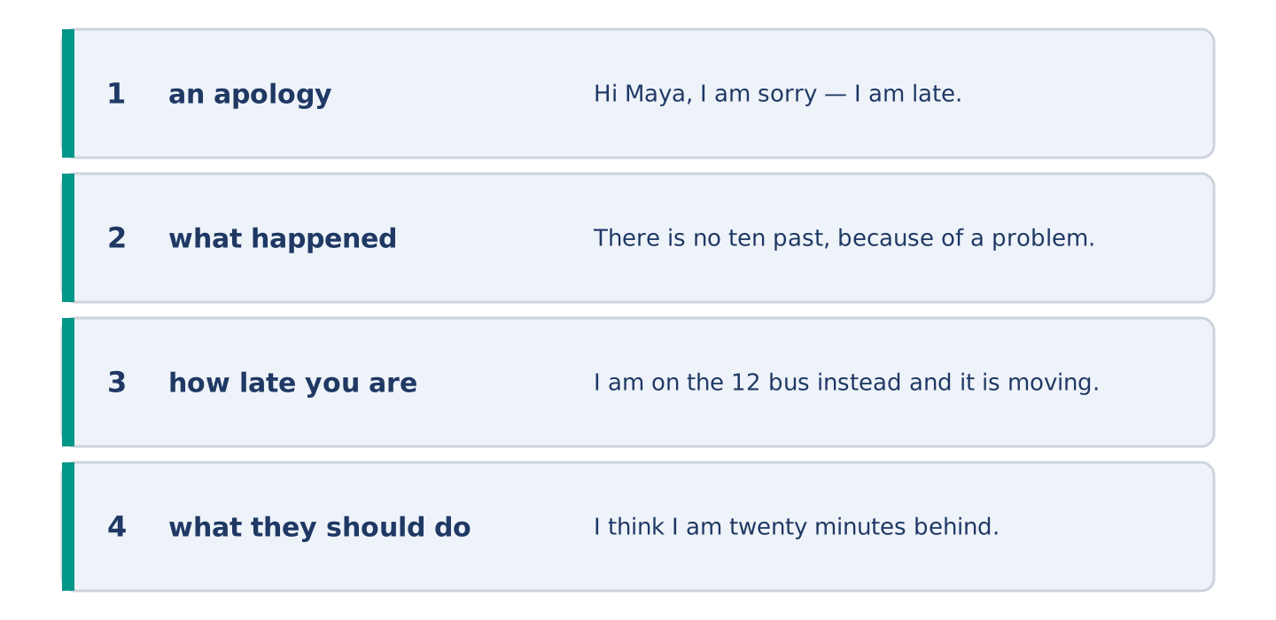
Figure 3.34 · The Part 7 note, with the model beside each line.
You are late because of a problem on the way. Write a short message to the person who is waiting.
Model — read this first:
Hi Maya, I am sorry — I am late. There is no ten past, because of a problem on the line at the bridge, and the next train goes the long way. I am on the 12 bus instead and it is moving, slowly. I think I am twenty minutes behind. Please order something and keep a seat for me. Yuki (61 words)
Check before you finish: ☐ an apology? ☐ what happened? ☐ how late you are? ☐ what they should do? ☐ 50–80 words?
Part 8 · Global Story — The Map That Was Wrong on Purpose
[PLUS] Plus track · pre-read / discuss
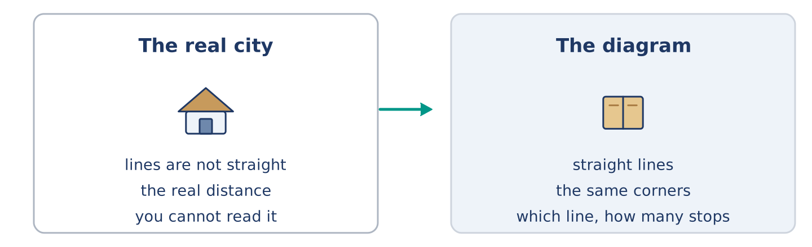
Figure 3.35 · The old map and the new one.
Before you read: can a map of a city be wrong and useful at the same time?
Gloss: underground = the train system under a city · diagram = a simple drawing that shows how things connect · scale = how a map’s size compares to the real size · cancelled = not running today
In Tokyo, like every big city, the underground map is not a picture of the city. It is a diagram. The lines are straight and the corners are all the same shape. The distance between two stations on paper has little to do with the real distance. The first map of this kind came from London, a long time ago. Its maker had an unusual job. He drew electric lines for a living. He drew the city the same way. People complained that it was wrong. It was. It was also the first map anybody could read on a moving train. Today almost every big city uses the same idea. The map is wrong about scale and right about the only three things a passenger needs: which line, which direction, how many stops.
Answer the questions. (0. is done.)
- Is an underground map a picture of the city? — No, it is a diagram.
- What was the job of the first person to draw a map of this kind?
- What did people complain about?
- What three things does the text say a passenger needs?
Part 8: Vocabulary in Context
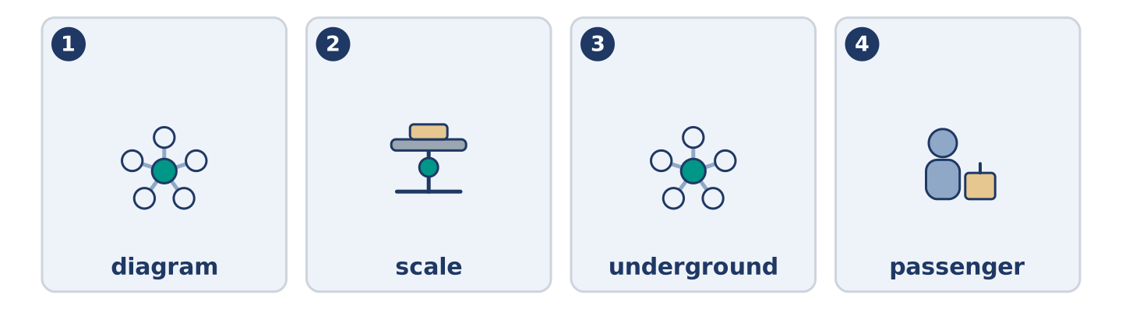
Figure 3.36 · The four words from the global story, drawn.
Match each word with its meaning. One meaning is not needed. Write the letter.
Column A
1. | diagram | ____
2. | scale | ____
3. | underground | ____
4. | passenger | ____
Column B
a) | the train system under a city
b) | a person travelling on a bus or a train
c) | how a map’s size compares to the real size
d) | a simple drawing that shows how things connect
e) | a line of people waiting
Part 8: Discussion
Talk with a partner. Use the frames.
Discussion frames: “This is similar to where I live because…” · “This is different from where I live because…” · “I think the most important thing is… because…”
Part 9 · Close to Home — The Bus That Changed Its Route
[PLUS] Plus track · pre-read / decide
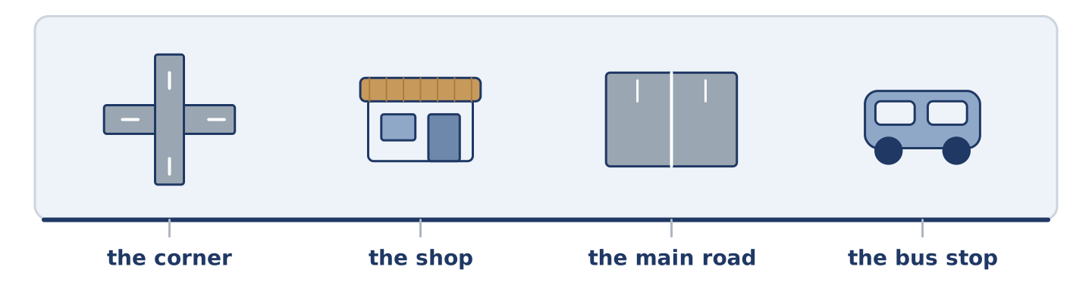
Figure 3.37 · The close-to-home reading, drawn along one street.
Before you read: what happens to a street when its bus stop moves?
For eleven years the 7 stopped at the corner of Alder Street, outside Amina’s shop. In March the bus company moved the stop two hundred metres, to the main road. The reason was the traffic: the corner is too small and the bus was blocking it twice an hour. Nobody argued with the reason. But two hundred metres is a long way with shopping, and Mr Okonkwo stopped going into town on Tuesdays. Amina noticed first. People waiting for the bus used to buy bread. Now they do not. She counted: eleven fewer customers a day, all of them between half past eight and nine. The bus is faster. The corner is clearer. And a shop with a bus stop outside it is now only a shop.
Answer the questions. (0. is done.)
- Where did the 7 stop for eleven years? — At the corner of Alder Street, outside Amina’s shop.
- Why did the bus company move the stop?
- What did Mr Okonkwo stop doing?
- How many fewer customers does Amina count, and when?
Part 9: Decision Task
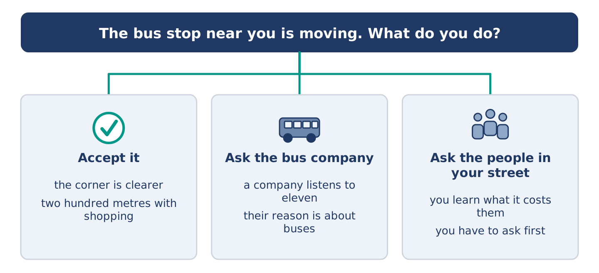
Figure 3.38 · Three ways to decide, and what each one costs.
A bus stop near you is moving. Should you (a) accept it, because the reason is good, (b) ask the bus company to think again, or (c) ask the people in your street what it costs them first? Decide and explain. Use the frame.
Answer frame: “I think I should ___ because ___. Also, ___. This is better than ___ because ___.”
Model — read this first:
I think I should ask the people in my street first, because at the moment I only know what it costs me. Also, a bus company listens to eleven people and not to one. This is better than accepting it straight away. Their reason is about buses, and nobody asked what the stop did for the street. (57 words)
Phrase bank: I think I should… · because… · Also,… · This is better than… · In my opinion…
Part 10 · Review and Can-Do
[CORE + PLUS] · homework / self-study
Part 10: Spiral Review
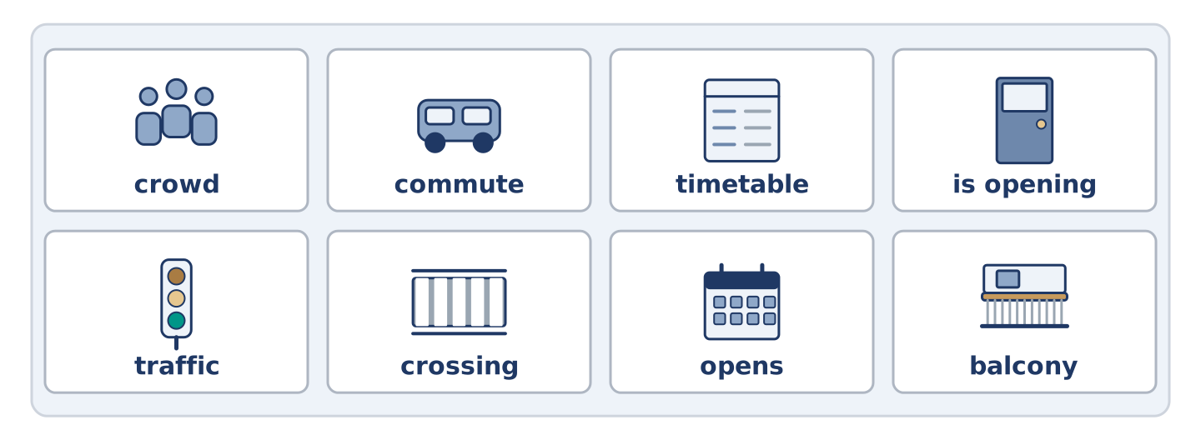
Figure 3.39 · The eight words of the review bank, in bank order.
Complete the review. (0. is done.)
- The money you pay for one journey is the fare.
Word bank: crowd | commute | timetable | is opening | traffic | crossing | opens | balcony
- A list of the times buses come is a ______________________ .
- The black and white lines you walk across are a ______________________ .
- All the cars and buses on a road are the ______________________ .
- A lot of people in one place is a ______________________ .
- “The market ______________________ at six every morning” — a fact.
- “Look, it ______________________ now” — this minute.
- (from Unit 2) A small outside floor with a wall is a ______________________ .
- (from Unit 1) The journey between your home and your work is your ______________________ .
Part 10: Can-Do
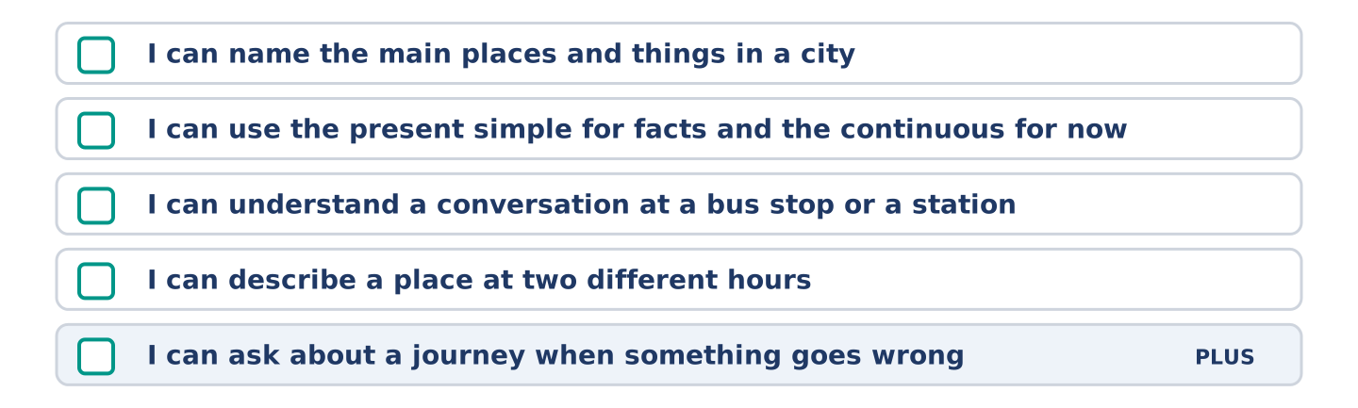
Figure 3.40 · What you can do at the end of this unit.
Can-Do checklist
☐ I can name the main places and things in a city.
☐ I can use the present simple for facts and the present continuous for now.
☐ I can understand a short conversation at a bus stop or a station.
☐ I can describe a place at two different hours in 50–70 words.
☐ I can ask about a journey when something goes wrong (Plus).
Part 10: Glossary
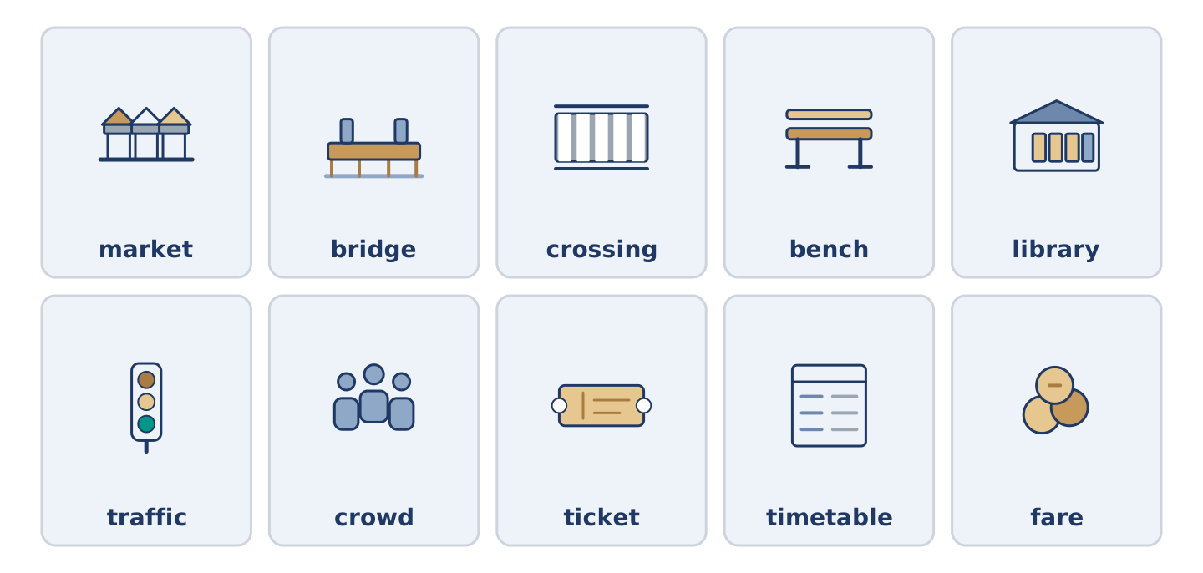
Figure 3.41 · All ten glossary words of Unit 3, one card each.
Unit 3 glossary (10 words)
market · bridge · crossing · bench · library · traffic · crowd · ticket · timetable · fare

