Unit 4: Food and Shopping
English for Daily Life · Level: A2 · Tracks: [CORE] Warm-Up + Parts 1–6 · [PLUS] Parts 7–10
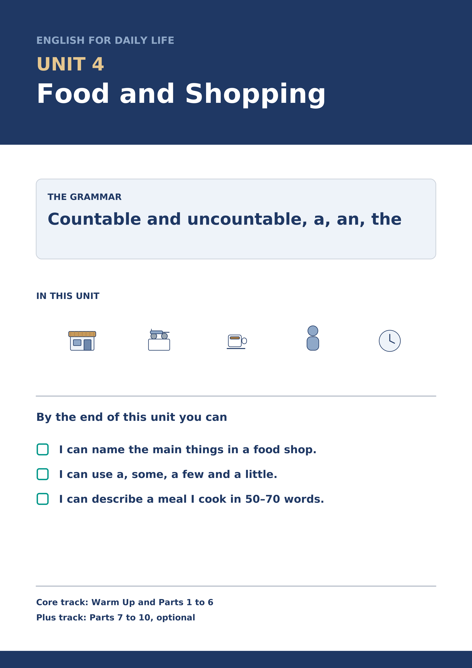
Warm Up
[CORE] Core track · in-class starter
Warm-up: Food Words and Meanings
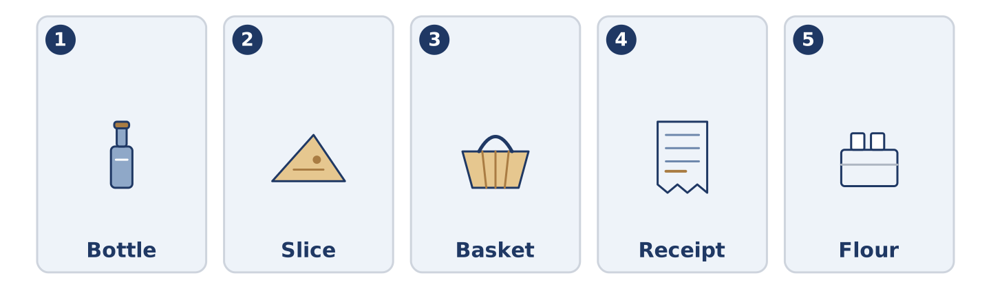
Figure 4.2 · The five warm-up words, and the thing each one means.
Match the words with their meanings. One meaning is not needed. Write the letter.
Column A
1. | Bottle | ____
2. | Slice | ____
3. | Basket | ____
4. | Receipt | ____
5. | Flour | ____
Column B
a) | a thin flat piece cut from bread or cheese
b) | the piece of paper that shows what you paid
c) | a tall glass or plastic container for milk or water
d) | a soft white powder you use to make bread
e) | a long seat in a park
f) | a light open bag you carry shopping in
Warm-up: Talking About Food
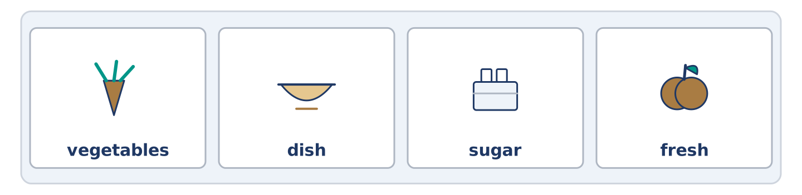
Figure 4.3 · The word bank for this task, in the order it is printed.
Complete the sentences using the words in the word bank.
Word bank: vegetables | dish | sugar | fresh
- Amina puts the ______________________ bread on the shelf at seven.
- Tomas does not take ______________________ in his tea any more.
- Dani buys ______________________ on Saturday and cooks them on Sunday.
- Yuki is making a ______________________ from her grandmother’s recipe.
Warm-up: Amina’s Shop
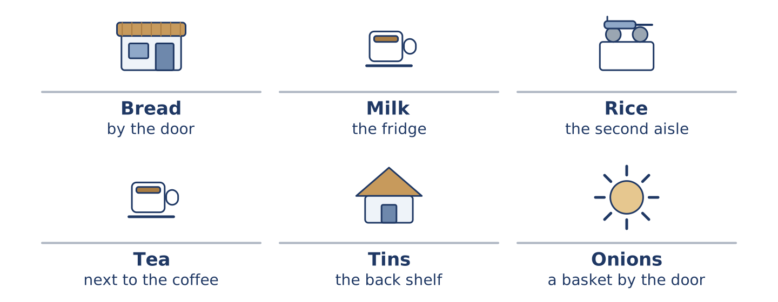
Figure 4.4 · Inside Amina’s shop: what she sells, and how much of it.
Read the text and choose the correct answer.
Amina’s shop is small, so she sells a little of everything and a lot of nothing. There is bread, milk, rice and tea. There are a few tins of beans and some fruit, and there is always a basket of onions by the door. She does not sell much meat, because there is no room for a fridge. The one small fridge holds the milk. People come in for one thing and leave with three.
1. What does Amina sell a lot of?
○ A) Meat
○ B) A little of everything
○ C) Only bread
○ D) Nothing at all
2. Why does she not sell much meat?
○ A) Nobody buys it
○ B) It is too expensive
○ C) There is not room for a fridge
○ D) She does not like it
Part 1 · Vocabulary and Terminology
[CORE] Core track · pre-class input
Part 1: Food and Shopping Terms
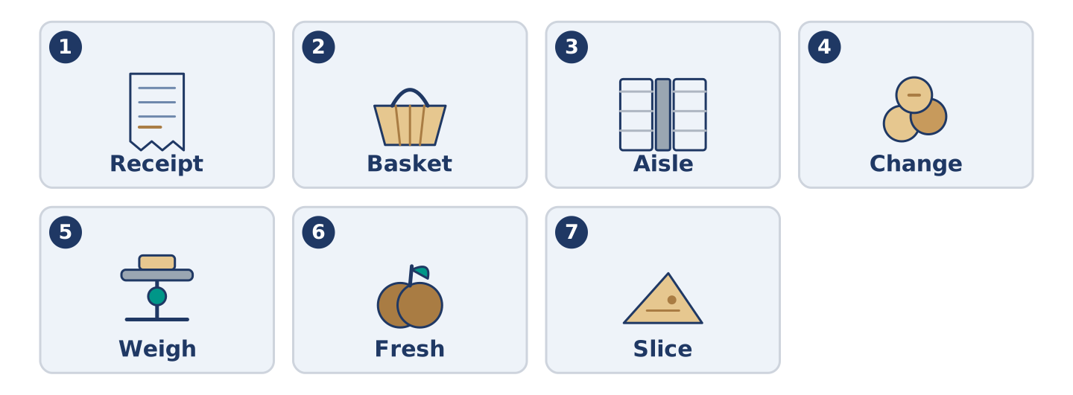
Figure 4.5 · The seven words of Column A, and what each one is.
Match the words with their meanings. One meaning is not needed. (0. is done for you.)
- Till → the machine where you pay, and the place in the shop where it stands.
Column A
1. | Receipt | ____
2. | Basket | ____
3. | Aisle | ____
4. | Change | ____
5. | Weigh | ____
6. | Fresh | ____
7. | Slice | ____
Column B
a) | a light open bag you carry shopping in
b) | made or picked today, not yesterday
c) | to find out how heavy something is
d) | the long space between two lines of shelves
e) | the money you get back when you pay too much
f) | the piece of paper that shows what you paid
g) | a thin flat piece cut from bread or cheese
h) | a list of the times buses come
Gloss: aisle = the space between two lines of shelves · weigh = to find out how heavy something is · receipt = the paper that shows what you paid · tin = a metal container for food · packet = a paper or plastic bag a shop sells things in
Part 1: Pronunciation
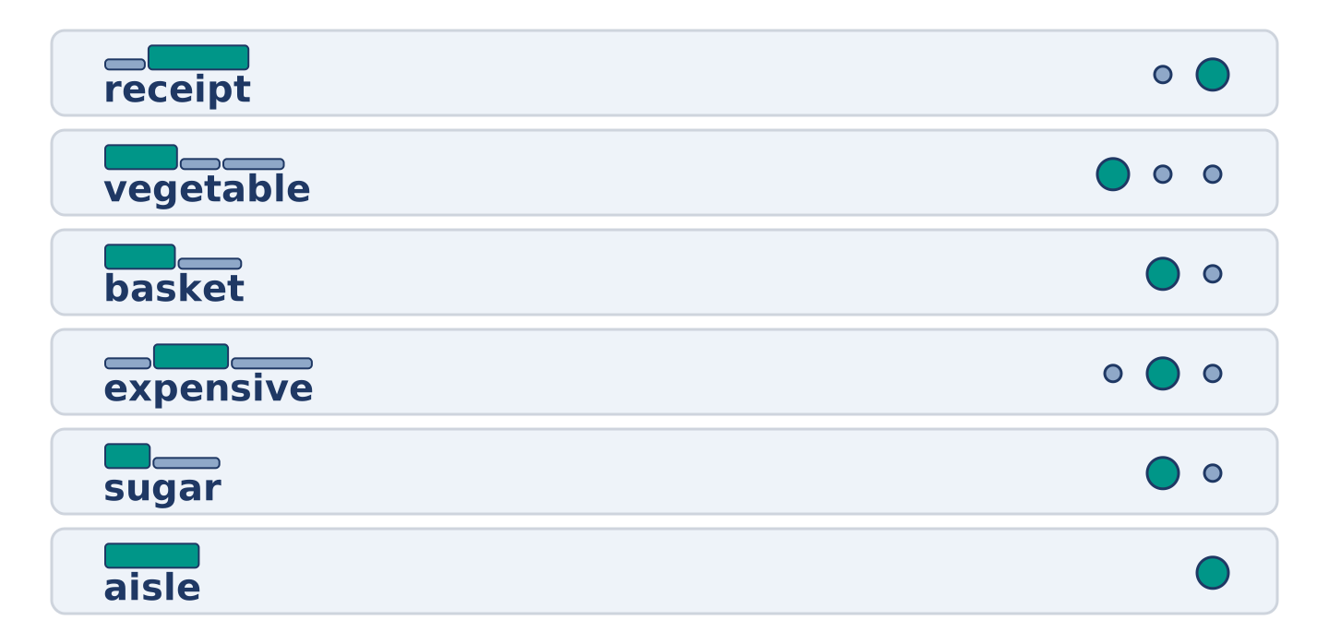
Figure 4.6 · Where the stress falls in six words of this unit.
🔊 Audio Track 4.1
Listen and practise these words. Say each word aloud and stress the loud syllable (CAPITALS).
receipt — re-CEIPT
vegetable — VEG-ta-ble
basket — BAS-ket
expensive — ex-PEN-sive
sugar — SU-gar
aisle — AISLE
Then listen again to the letters nobody says. Receipt has a p nobody says. Aisle has an s nobody says. Vegetable is written with four beats and said with three. English keeps letters long after it stops saying them.
Part 1: Six Things and How We Count Them
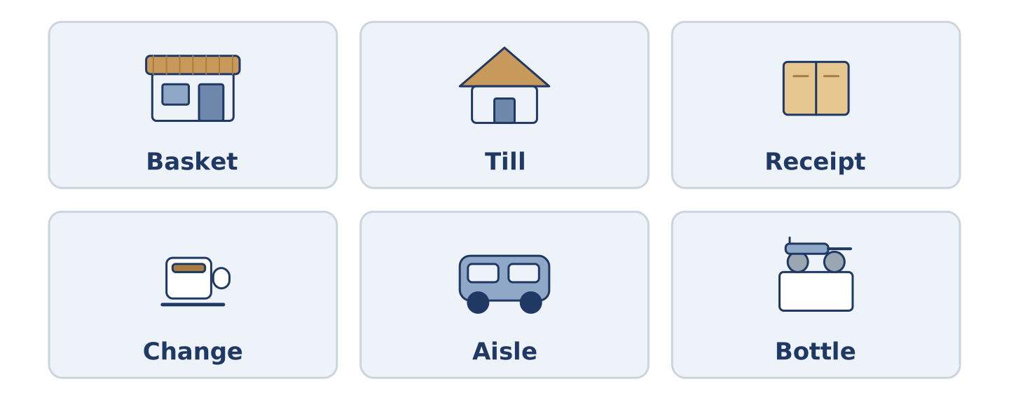
Figure 4.7 · Six things you buy, and the word you count them with.
Complete the table. Write the word you count it with and where you find it. (0. is done.)
Thing | We say | Where in the shop
Milk | a bottle of milk | (example)
Bread
Rice
Tea
- Milk — a bottle of milk — the fridge at the back. (We say a packet of tea and a kilo of rice.)
Some things we count and some we measure. There is more than one right answer, and you should be ready to say why you chose yours.
Part 1: At the Till
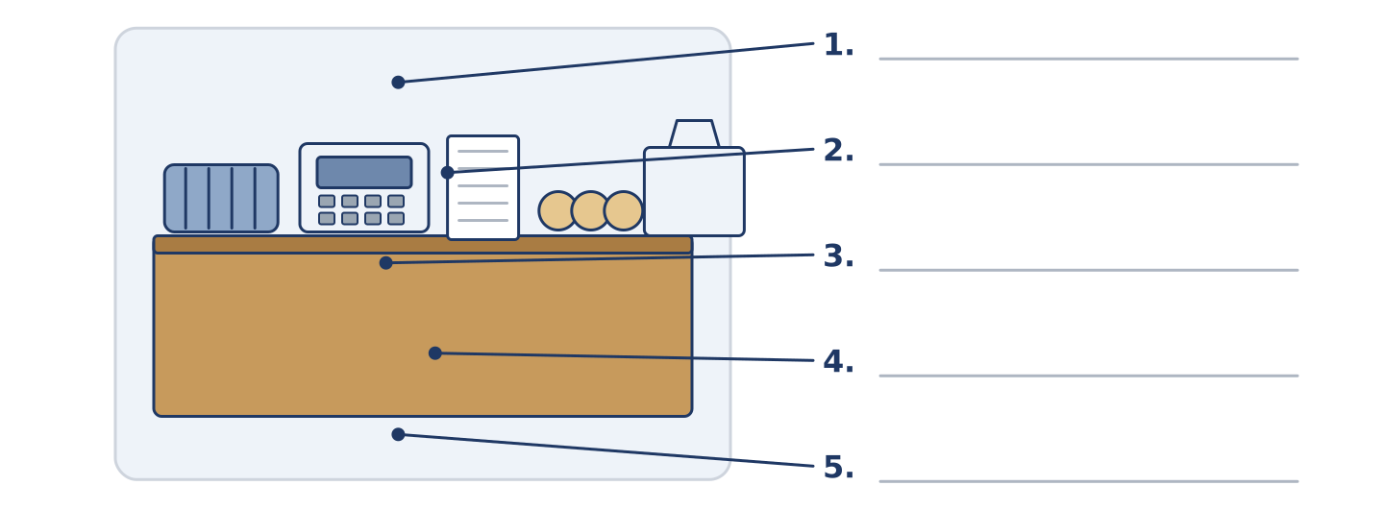
Figure 4.8 · At the till — write the correct word on each line.
Match the things at a till with their descriptions. One description is not needed. Write the letter.
Column A
1. | Basket | ____
2. | Till | ____
3. | Receipt | ____
4. | Change | ____
5. | Bag | ____
Column B
a) | the money you get back
b) | the machine where you pay
c) | what you carry the shopping home in
d) | the long space between two lines of shelves
e) | a light open bag you fill while you walk round
f) | the paper that shows what you paid
Part 1: Shopping — Multiple Choice
Read and choose the correct answer.
1. The money you get back when you pay too much is your…
○ A) receipt
○ B) change
○ C) basket
○ D) aisle
2. Bread from this morning is…
○ A) cheap
○ B) frozen
○ C) fresh
○ D) heavy
3. The long space between two lines of shelves is an…
○ A) aisle
○ B) entrance
○ C) till
○ D) basket
Part 1: Vocabulary Fill-in
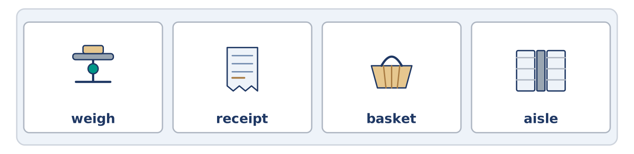
Figure 4.9 · The four words of the bank, in the order the task gives them.
Complete the sentences with the correct word.
Word bank: weigh | receipt | basket | aisle
- Keep the ______________________ , in case the milk is bad.
- Dani takes a ______________________ , because he only wants three things.
- They ______________________ the fruit at the till and the price comes up.
- The tea is in the second ______________________ , next to the coffee.
Part 1: Write About Your Shopping (short)
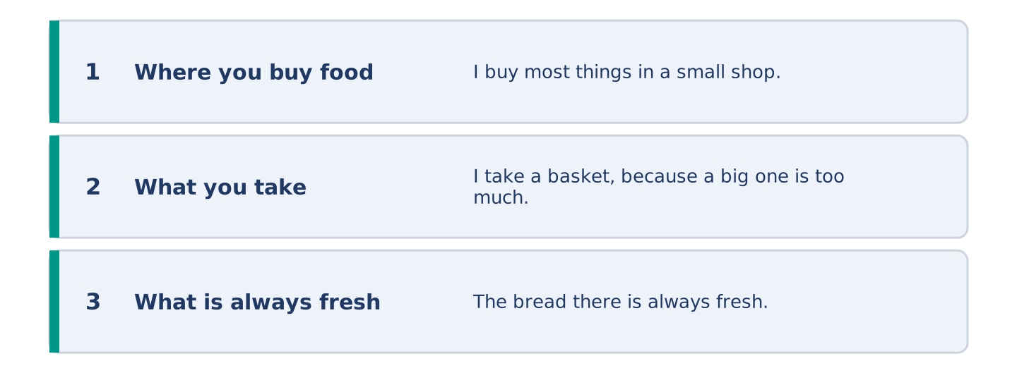
Figure 4.10 · The shape of your two or three sentences, with the model beside each step.
Write two or three sentences about where you buy food. Use three words from this unit.
Model — read this first:
I buy most things in a small shop at the end of my street. I take a basket, because a big one makes me buy too much. The bread there is always fresh, and I never keep the receipt.
Part 2 · Grammar — Countable and Uncountable, A, An, The
[CORE] Core track · pre-class input
Part 2: Notice
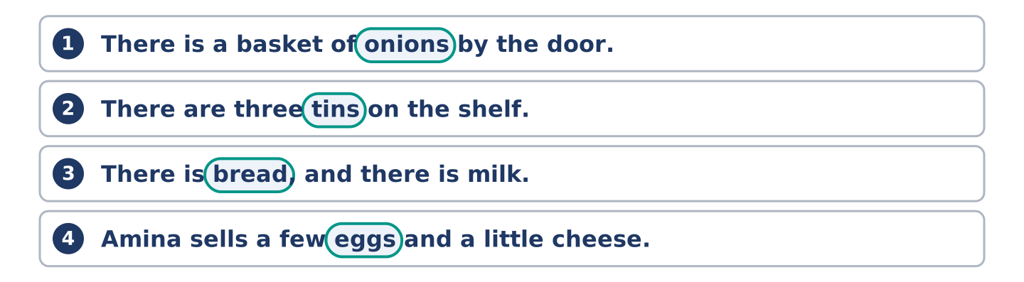
Figure 4.11 · Lines from the notice, with the target form ringed in each.
Read these lines about the shop. Underline the food words. Which ones can you count?
There is a basket of onions by the door. There are three tins on the shelf. There is bread, and there is milk, and there is not much meat. Amina sells a few eggs and a little cheese. She buys the bread from a shop two streets away.
You can count onions, tins and eggs. You cannot count bread, milk, meat or cheese: count the container or the piece.
Part 2: Grammar Focus Box
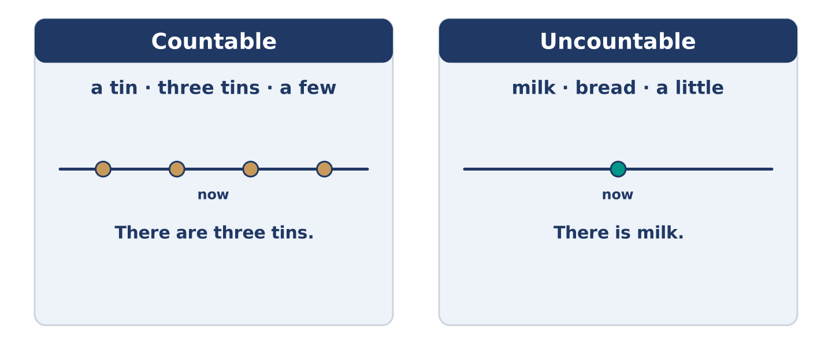
Figure 4.12 · Countable or uncountable: which words go with which.
 | Form | Use | Example
Countable | a tin · three tins | things you can count one by one | There are three tins.
Uncountable | milk · bread · rice | things you measure, never a | There is milk.
a few / a little | a few + countable, a little + uncountable | a small amount | a few eggs · a little cheese
a / an / the | a first time, the after that | which one we mean | a bakery → the bakery
Remember: say a bottle of milk, not a milk. The container is countable.
Watch out! ✗ I want a bread. → ✓ I want some bread. (bread is uncountable). ✗ There are a little tins. → ✓ There are a few tins. (tins are countable).
Part 2: Controlled Practice
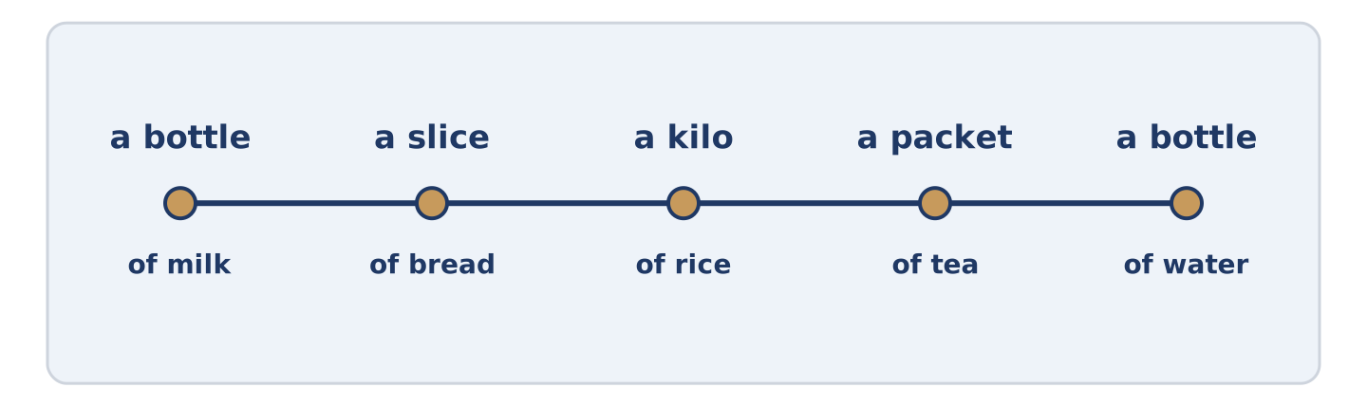
Figure 4.13 · One basket: what you count, and what you measure.
Write a, an, some or the. (0. is done.)
- Amina sells some cheese, but not much.
- Dani wants ______________________ onion for the rice.
- There is ______________________ milk in the fridge at the back.
- Yuki buys ______________________ bottle of water every morning.
- She keeps ______________________ receipt in her pocket.
Part 2: A Few or A Little?
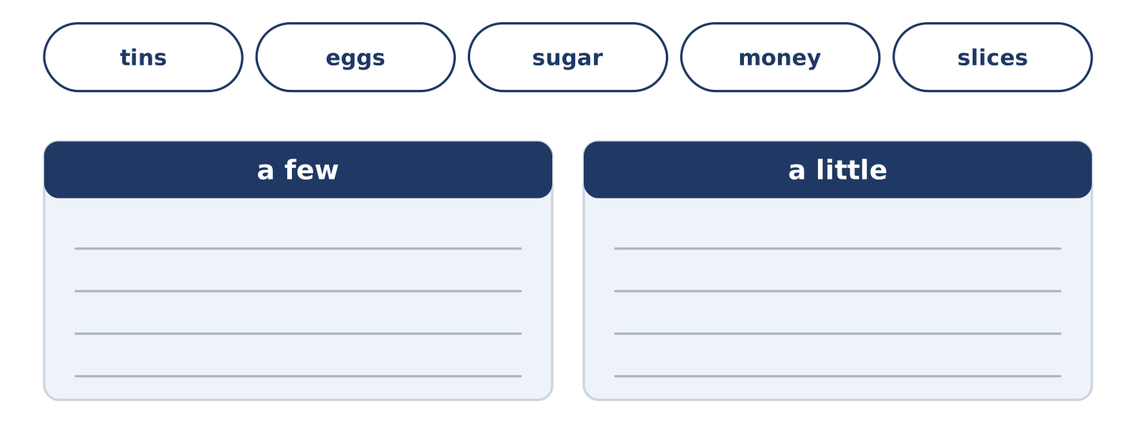
Figure 4.14 · The items of this task, and the bins they sort into.
Choose the correct words. (0. is done.)
- There are a few tins on the shelf. (a few / a little)
- Amina sells ______________________ (a few / a little) eggs every day.
- Put ______________________ (a few / a little) sugar in the tea.
- Dani has ______________________ (a few / a little) money until Friday.
- There are ______________________ (a few / a little) slices of bread left.
Part 2: Correct the Sentence
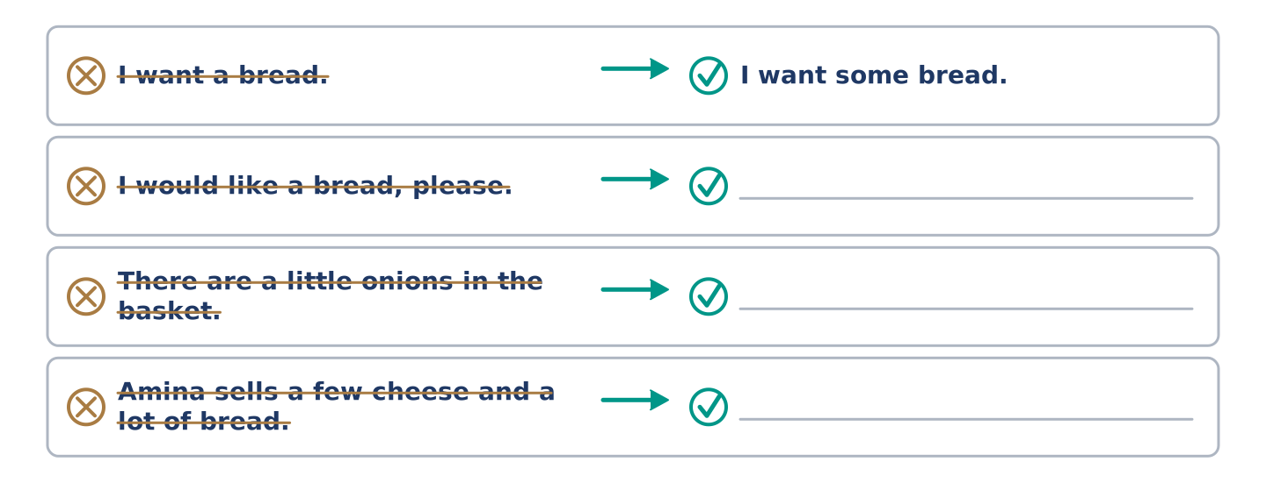
Figure 4.15 · One correction done for you, and the rest to write.
Each sentence has one grammar mistake. Write the correct sentence.
- I would like a bread, please.
- There are a little onions in the basket.
- Amina sells a few cheese and a lot of bread.
- Yuki buys a water every morning.
Part 2: Freer Practice
Write two sentences about your kitchen: one countable food, one uncountable.
Part 2: Grammar Review
Choose the correct sentence.
1. Which sentence is correct in a shop?
○ A) I want a bread, please.
○ B) I want some bread, please.
○ C) I want a few bread, please.
○ D) I want breads, please.
2. Which sentence counts correctly?
○ A) There are a little tins on the shelf.
○ B) There is a few tins on the shelf.
○ C) There are a few tin on the shelf.
○ D) There are a few tins on the shelf.
→ Harvest: you will see a few, a little and the articles again in the Part 5 reading. Watch for them.
Part 3 · Listening
[CORE] Core track · pre-class input · scripts printed inline
Part 3: In the Corner Shop Again
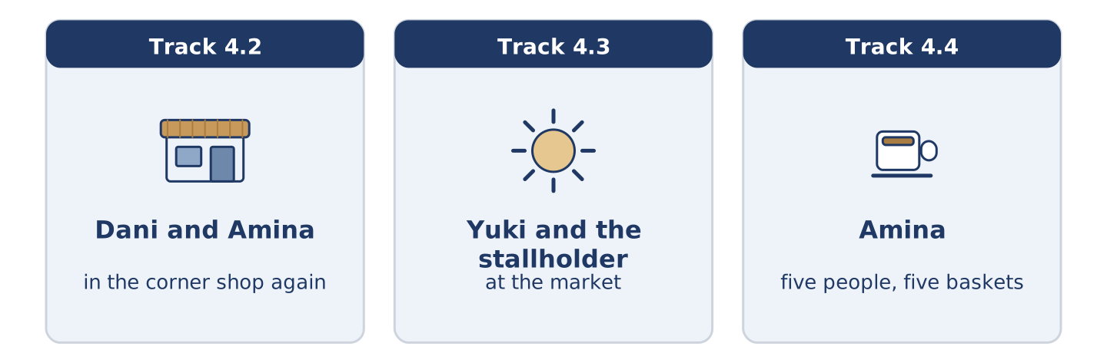
Figure 4.16 · The three listenings: who is speaking, and what about.
🔊 Audio Track 4.2
Before you listen: what do you say when a shop does not have what you want?
Dani: Have you got any rice? Amina: A little. It’s at the back, behind the tins. Dani: And eggs? Amina: A few. Six, I think. Dani: I’ll take four. Amina: Take six. You always come back on Wednesday for the other two. Dani: That’s true. Amina: And there’s fresh bread. It’s still warm. Dani: Then I’ll take that as well, and I came in for rice.
While you listen: write True, False, or Not Given. (0. is done.)
- Dani wants rice. — True
- There are a lot of eggs. ____
- The bread is fresh. ____
- Dani comes in every Wednesday. ____
Useful phrases: Have you got any…? · A little · A few · I’ll take…
Part 3: At the Market
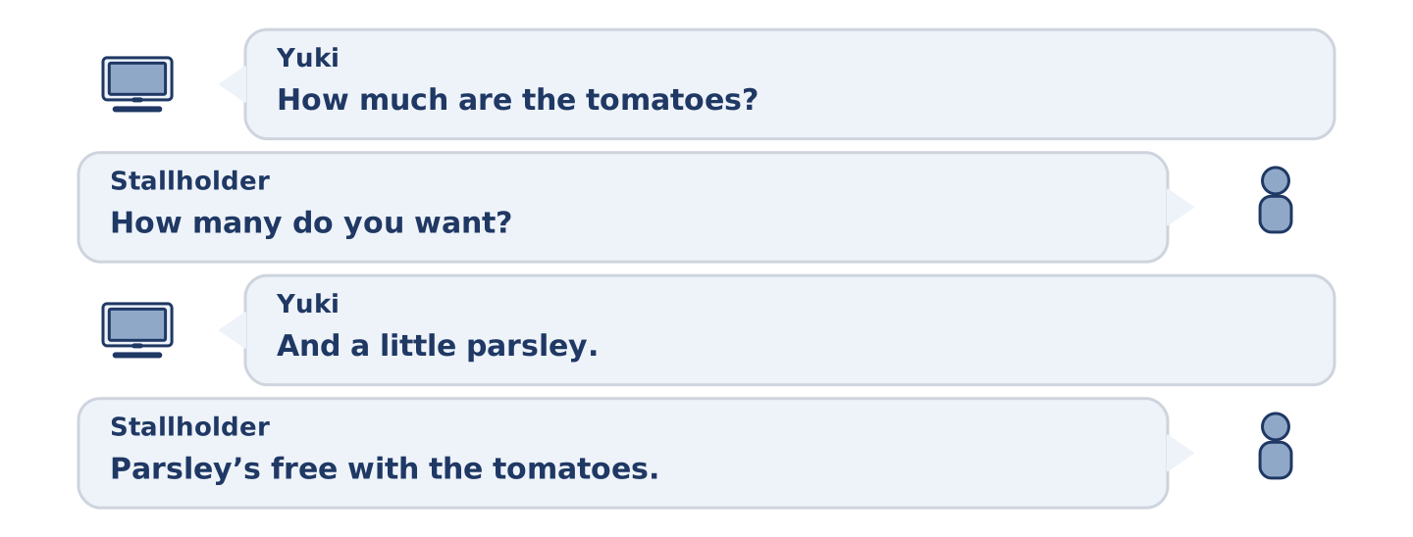
Figure 4.17 · The second listening, turn by turn.
🔊 Audio Track 4.3
Before you listen: how do you ask for an amount at a market?
Yuki: How much are the tomatoes? Stallholder: Two a kilo. How many do you want? Yuki: Half a kilo, please. And a little parsley. Stallholder: Parsley’s free with the tomatoes. Anything else? Yuki: Some lemons. Three. Stallholder: That’s three fifty. Yuki: Here’s five. Stallholder: And there’s your change and your receipt. Mind the bag — the lemons are at the bottom.
While you listen: answer the questions. (0. is done.)
- What does Yuki ask about first? — The tomatoes.
- How much are the tomatoes a kilo?
- What is free with the tomatoes?
- How much change does Yuki get?
Part 3: Five People, Five Baskets
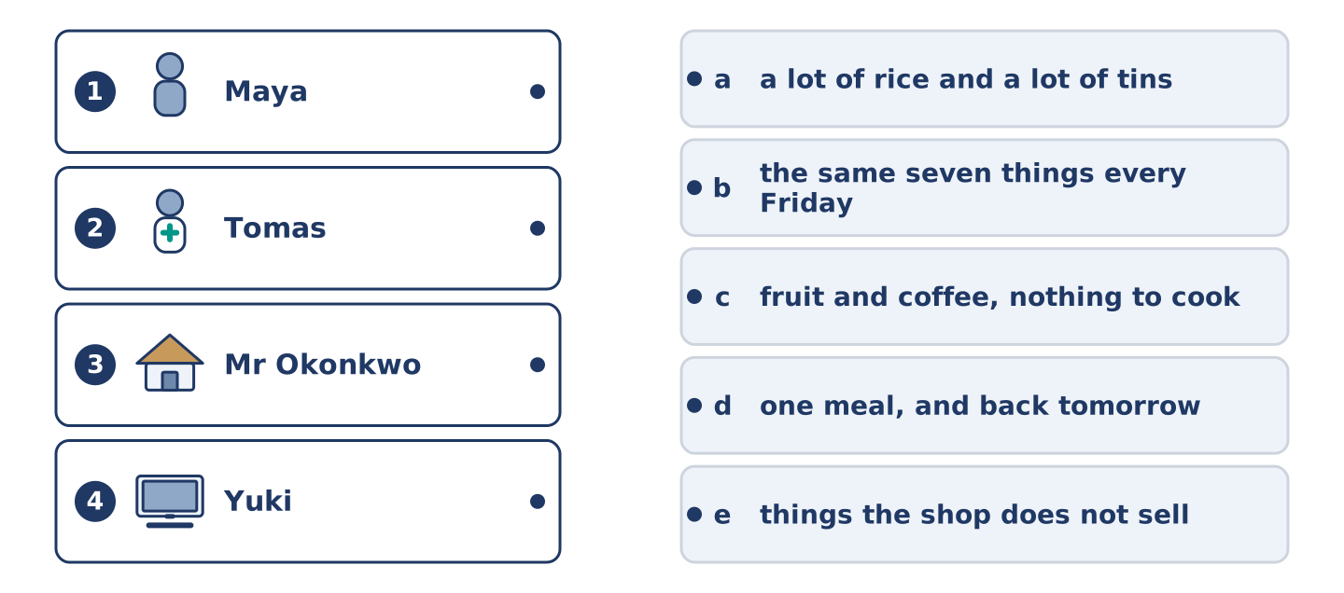
Figure 4.18 · Four on the left, five on the right, and one spare.
🔊 Audio Track 4.4
Before you listen: what does somebody’s shopping tell you about them?
Amina: You learn a lot from a basket. Maya buys fruit and coffee and nothing that needs cooking. Tomas buys a lot of rice and a lot of tins, because he eats at four in the morning. Dani buys for one meal and comes back tomorrow; he has no fridge worth the name. Mr Okonkwo buys the same seven things every Friday, and the year before that as well. Yuki buys things I do not sell, asks me where to find them, and then brings me some to taste.
While you listen: match each person with their basket. One basket is not needed. (0. is done.)
- Amina → she watches the baskets.
Useful phrases: ___ buys… · a lot of… · nothing that…
Column A
1. | Maya | ____
2. | Tomas | ____
3. | Mr Okonkwo | ____
4. | Yuki | ____
Column B
a) | a lot of rice and a lot of tins
b) | the same seven things every Friday
c) | fruit and coffee, nothing to cook
d) | one meal, and back tomorrow
e) | things the shop does not sell
Part 4 · Speaking
[CORE] Core track · in-class output
Part 4: Talking About Food
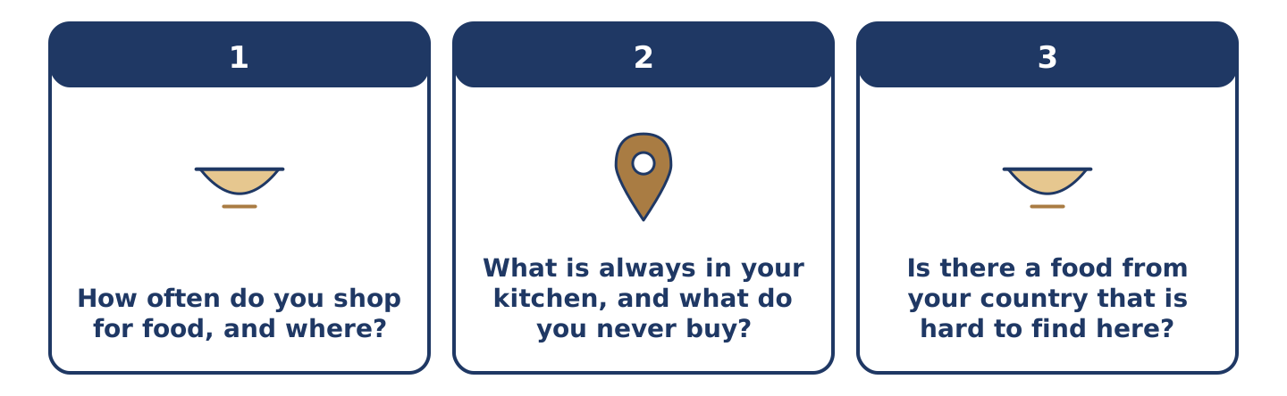
Figure 4.19 · The three questions as cards, to take one at a time.
Work with a partner. Ask and answer these questions.
- How often do you shop for food, and where?
- What is always in your kitchen, and what do you never buy?
- Is there a food from your country that is hard to find here?
Useful language: I buy… every… · There is always… · There is not much… · a few… · a little…
Part 4: Find the Difference (pairwork)
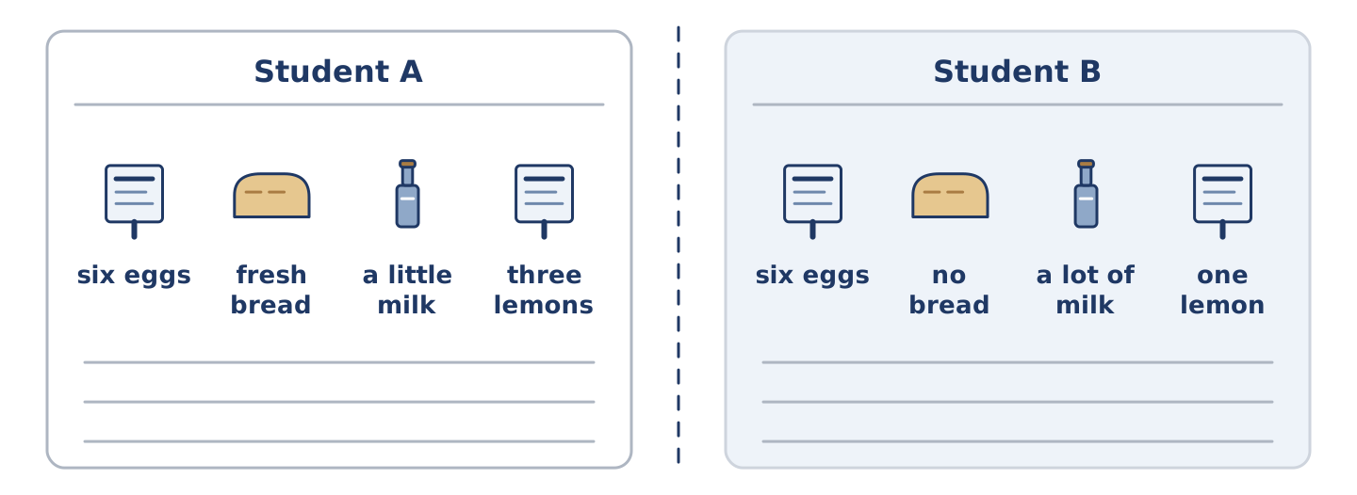
Figure 4.20 · Student A’s facts and Student B’s, with a fold between them.
Student A and Student B each have a shopping basket. Ask questions and find three differences.
Useful questions: How many eggs are there? · Is there any bread? · How much milk have you got? · What is at the bottom?
Student A — your basket: six eggs · fresh bread · a little milk · three lemons.
Student B — your basket: six eggs · no bread · a lot of milk · one lemon.
Part 4: At the Market
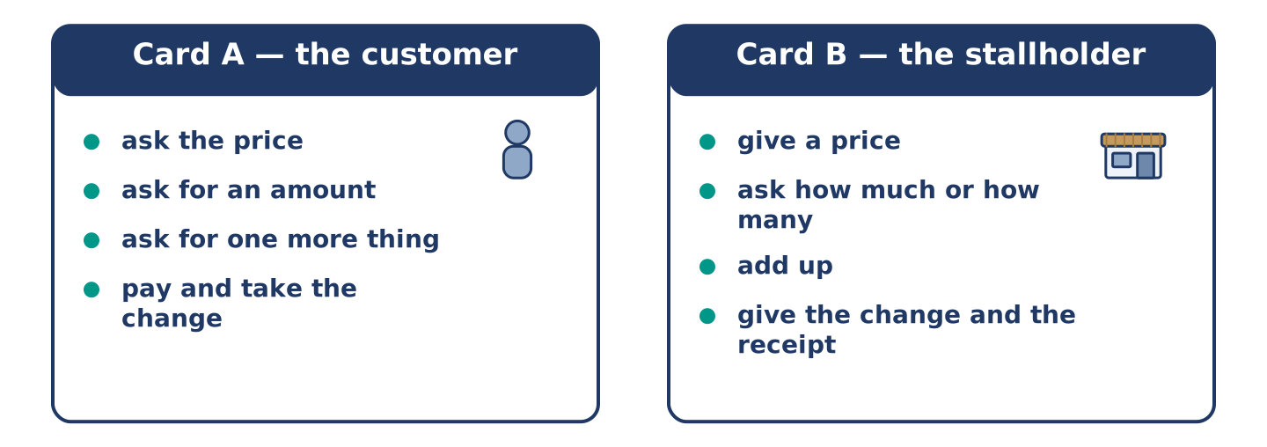
Figure 4.21 · Card A and Card B: what each of you has to say.
Work in pairs. Read the model, then use the cards.
Model exchange:
A: How much is the cheese? — B: Four a kilo. How much do you want? — A: A little. A quarter of a kilo. — B: Anything else? — A: A few tomatoes. Six. — B: That’s five twenty. — A: Here’s six. — B: And your change. Keep the receipt.
Useful language: How much is…? · How many do you want? · A little · A few · Anything else? · Here’s…
Card A — the customer: ask the price · ask for an amount · ask for one more thing · pay and take the change.
Card B — the stallholder: give a price · ask how much or how many · add up · give the change and the receipt.
Your turn: run the dialogue, then swap roles.
Stretch [PLUS]: the customer has not got enough money — take something out of the basket, politely.
Part 4: Mini-Presentation
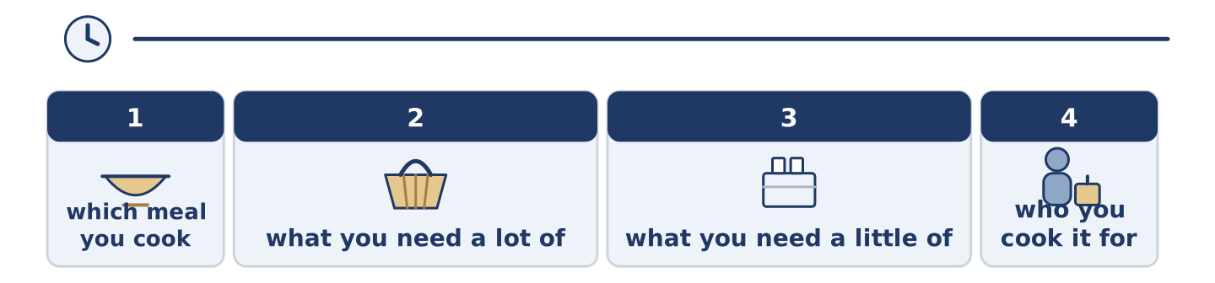
Figure 4.22 · The one-minute talk as three beats, each as wide as its share.
Prepare a short talk (about one minute). Describe one meal you cook: what you need a lot of, what you need a little of, and who you cook it for.
Part 5 · Reading
[CORE] Core track · pre-class input
Part 5: What a Small Shop Is For
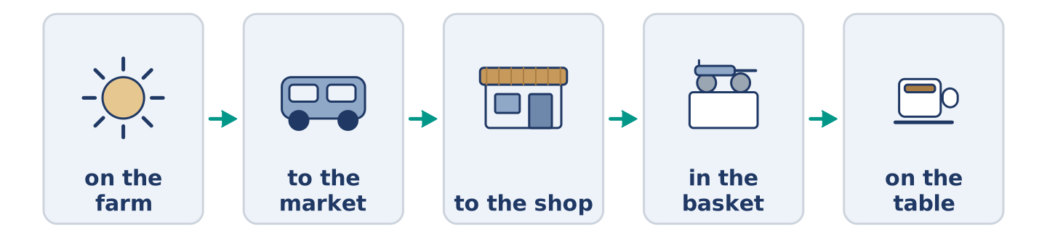
Figure 4.23 · From the farm to the basket, step by step.
Before you read: why do small shops stay open when big ones are cheaper?
Gloss: supermarket = a very big food shop · stock = the things a shop has to sell · credit = buying now and paying later
A small shop cannot win on price. A supermarket buys ten thousand bottles of milk and a corner shop buys thirty. So the corner shop pays more for each one. It cannot win on choice either: there is one kind of rice, not eleven. What a small shop has is everything else. It is open when you need one thing at seven in the morning. It knows your name, and sometimes it knows you are good for it until Friday. That is a kind of credit no supermarket offers. It carries the stock the street actually eats. The street says what that is, slowly, by buying and not buying. Amina says the shop is not really a shop. It is a list of what four hundred people want, written down in boxes.
Answer the multiple-choice questions. (0. is done.)
- Can a small shop win on price? — No, it cannot.
1. Why does a corner shop pay more for each bottle of milk?
○ A) Because the milk is fresher
○ B) Because it buys only thirty
○ C) Because the shop is small
○ D) Because it opens early
2. What kind of credit does a small shop offer?
○ A) A card you pay with
○ B) Cheaper prices on Friday
○ C) Knowing that you will pay later
○ D) Free bread for neighbours
3. What does Amina say the shop really is?
○ A) A list of what four hundred people want
○ B) A small supermarket
○ C) A place to meet people
○ D) A business that cannot win
Part 5: Vocabulary in Context
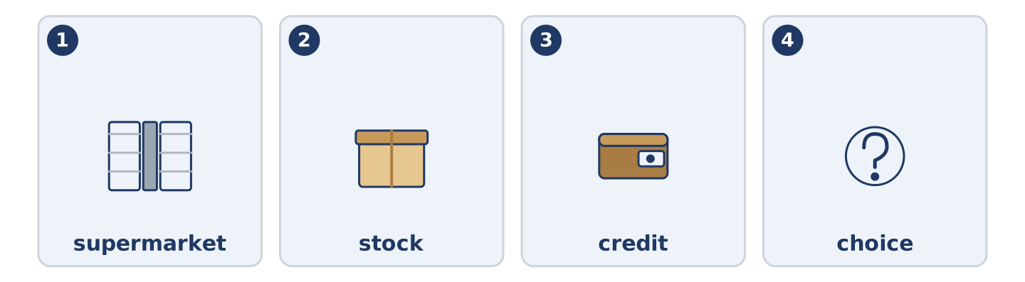
Figure 4.24 · The four words from the reading, drawn.
Match each word from the text with its meaning. One meaning is not needed. Write the letter.
Column A
1. | supermarket | ____
2. | stock | ____
3. | credit | ____
4. | choice | ____
Column B
a) | the things a shop has to sell
b) | buying now and paying later
c) | a very big food shop
d) | how many different things you can pick from
e) | the paper that shows what you paid
Part 5: Breakfast Around the World
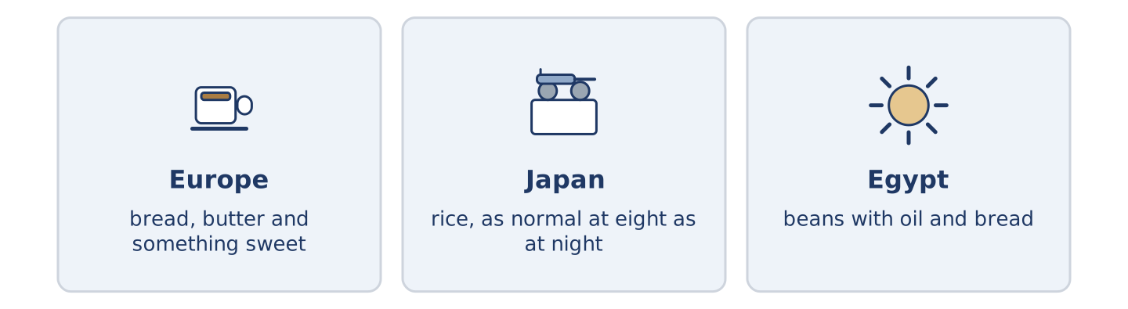
Figure 4.25 · The first meal of the day in three places.
Before you read: what do you eat in the first hour of the day?
Gloss: savoury = salty, not sweet · staple = the food people eat most days
Breakfast is the meal that travels worst. In much of Europe it is sweet: bread, butter, something with sugar in it, and coffee. In Japan it is often savoury, and rice is as normal at eight in the morning as at eight at night. In Egypt a common breakfast is beans with oil and bread. It is a staple, it costs very little, and it keeps you going until the afternoon. Visitors find other people’s breakfasts stranger than other people’s dinners. The first meal is the one we learn first, and we never quite stop expecting it.
Answer the questions. (0. is done.)
- Which meal does the text say travels worst? — Breakfast.
- What is a common breakfast in much of Europe?
- What is as normal at eight in the morning as at night in Japan?
- What does the Egyptian breakfast do until the afternoon?
Part 6 · Writing
[CORE] Core track · in-class / homework
Part 6: Describe a Meal You Cook (50–70 words)
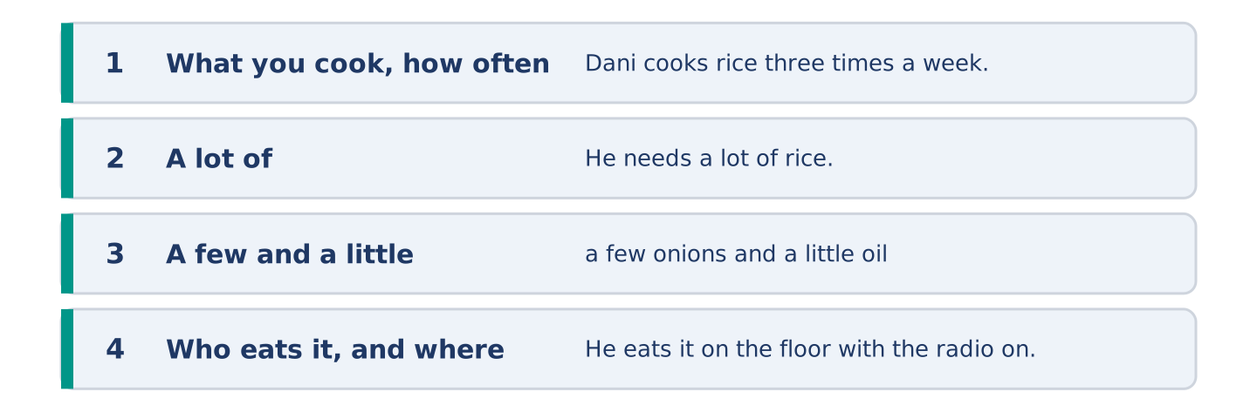
Figure 4.26 · The shape of the paragraph you are about to write.
Describe one meal. Say what you need a lot of, what you need a little of, and who eats it.
Model — read this first:
Dani cooks rice with onions about three times a week. He needs half a kilo of rice, a few onions and a little oil, and that is almost everything. He adds some tomatoes if Amina has them. It takes half an hour, and he eats it on the floor with the radio on, because there is only one chair in the flat. (62 words)
Plan (fill in, then write): I cook ___ about ___ a week. I need a lot of ___, a few ___ and a little ___. It takes ___. I eat it ___.
Word bank: a lot of | a few | a little | some | there is | there are
Check before you finish: ☐ one countable food with a few? ☐ one uncountable food with a little? ☐ who eats it? ☐ 50–70 words?
Part 6: Small Shop or Big Shop? (50–70 words)
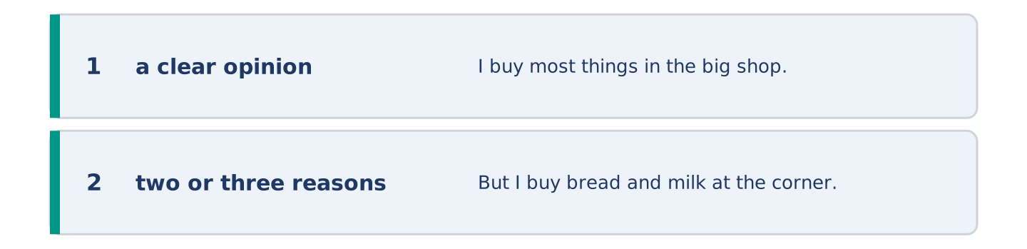
Figure 4.27 · The shape of the opinion paragraph, step by step.
Where is it better to buy food — a small shop or a big one? Give your opinion and two or three reasons.
Model — read this first:
I buy most things in the big shop, because it is cheaper and there is more choice. But I buy bread and milk at the corner, because they are fresh and because the big shop is twenty minutes away. In my opinion the answer is both, and the corner shop is the one I would miss. (56 words)
Word bank: I think… because… | cheaper | more choice | however | in my opinion
Check before you finish: ☐ a clear opinion? ☐ two or three reasons? ☐ 50–70 words?
Part 6: A Shopping Message (50–70 words)
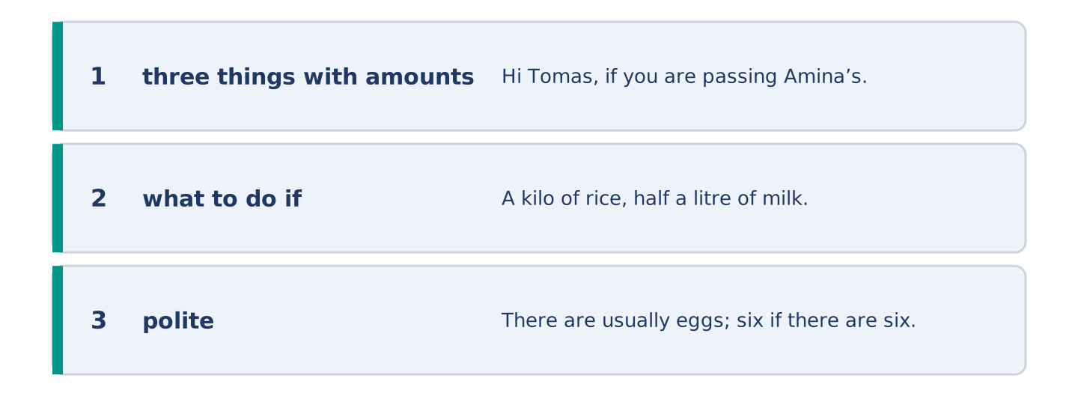
Figure 4.28 · The moves of the message, with a line of the model for each.
Somebody is going to the shop for you. Write them a short message: what to buy, how much, and what to do if there is none.
Model — read this first:
Hi Tomas, if you are passing Amina’s, could you get a few things? A kilo of rice, half a litre of milk and a little cheese — any kind. There are usually eggs; six if there are six. If there is no cheese, do not worry. Keep the receipt. I can pay you tonight. Maya (55 words)
Plan (fill in, then write): If you are passing ___, could you get ___? A ___ of ___, and a little ___. If there is no ___, ___. ___
Check before you finish: ☐ three things with amounts? ☐ what to do if there is none? ☐ polite? ☐ 50–70 words?
Part 6: Reflection — A Food I Miss (40–60 words)
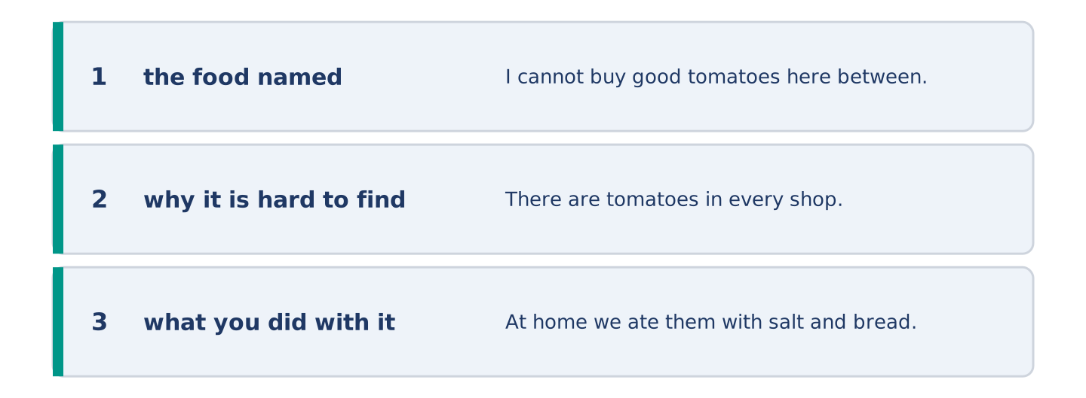
Figure 4.29 · The reflection, step by step.
Write about a food you cannot easily buy where you are now.
Model — read this first:
I cannot buy good tomatoes here between November and May. There are tomatoes in every shop, but they taste of water. At home we ate them with salt and bread and nothing else, and that is not a dish you can make with a bad tomato. (46 words)
Check before you finish: ☐ the food named? ☐ why it is hard to find? ☐ what you did with it? ☐ 40–60 words?
Part 7 · Real-World File — Shopping and Money
[PLUS] Plus track (optional) · stronger learners
7A: Phrase Bank
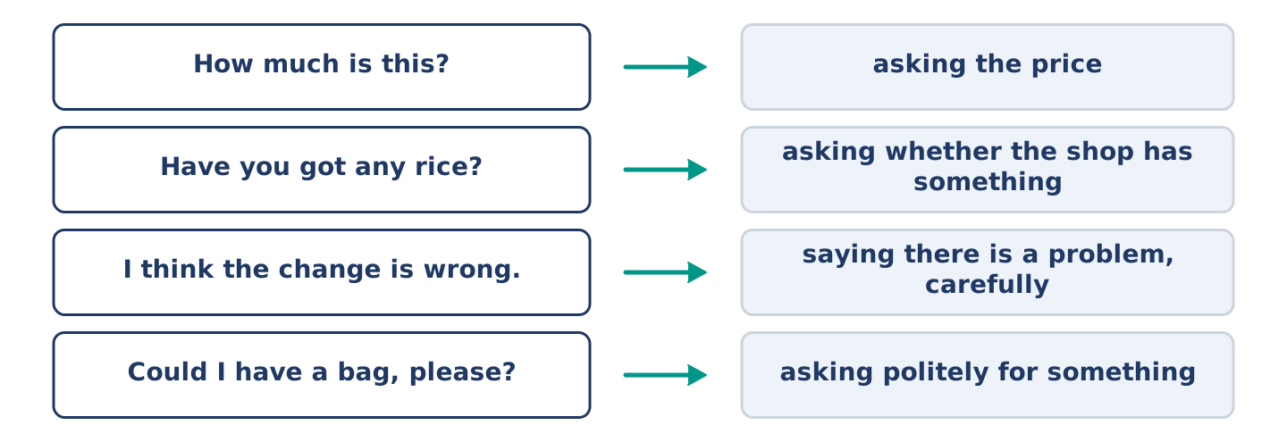
Figure 4.30 · What you say in a shop, and what each thing does.
Match what a person says with its purpose. One purpose is not needed. Write the letter.
Column A
1. | “How much is this?” | ____
2. | “Have you got any rice?” | ____
3. | “I think the change is wrong.” | ____
4. | “Could I have a bag, please?” | ____
Column B
a) | asking whether the shop has something
b) | asking politely for something
c) | asking the price
d) | saying there is a problem, carefully
e) | asking where the aisle is
7B: A Problem at the Till
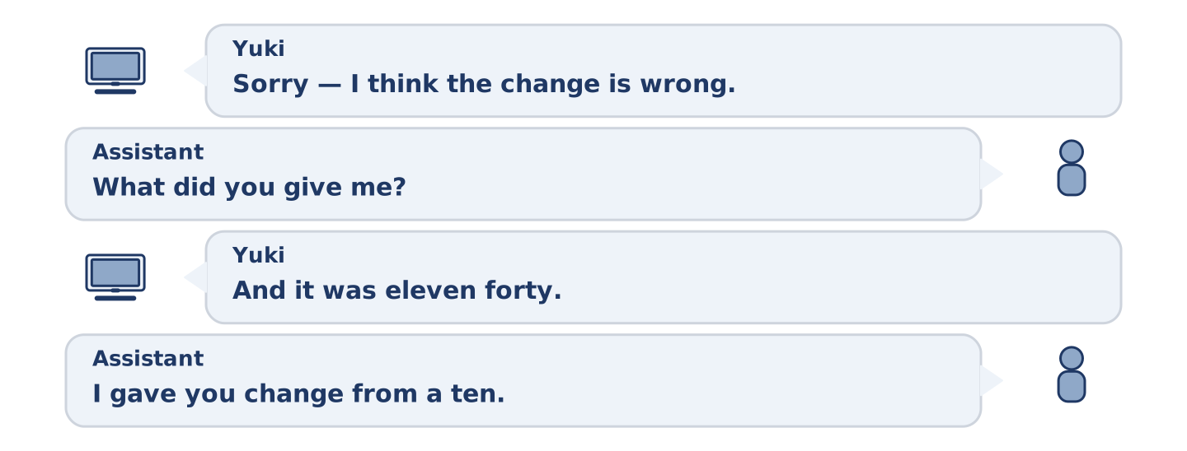
Figure 4.31 · The 7B exchange: who takes each turn.
🔊 Audio Track 4.5
Before you read: what do you do when a price is wrong?
Yuki: Sorry — I think the change is wrong. Assistant: Let me look. What did you give me? Yuki: A twenty. And it was eleven forty. Assistant: And I gave you… ah. I gave you change from a ten. I am sorry. Yuki: It is easy to do. Assistant: Here is the rest. Ten. Do check the receipt as well — the tomatoes went through twice. Yuki: So they did. Thank you for looking.
Answer the questions. (0. is done.)
- What does Yuki think is wrong? — The change.
- How much did Yuki give?
- What mistake did the assistant make?
- What else was wrong on the receipt?
7C: Controlled Practice — When Something Is Wrong
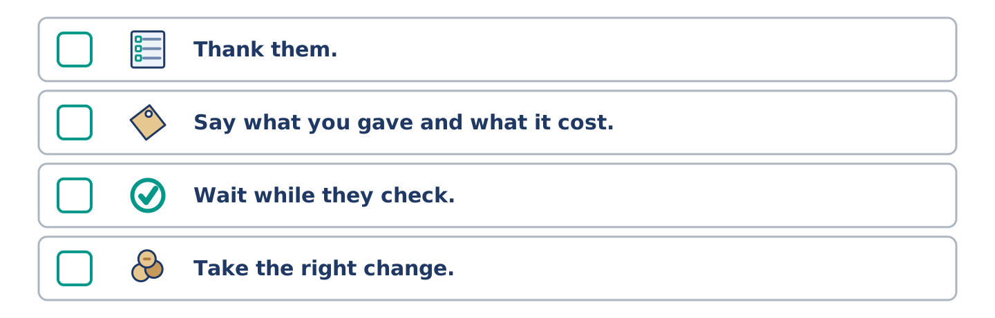
Figure 4.32 · The steps still to be numbered, as the task prints them.
Put the steps in order. Number them 1–5. (0. is done.)
- Say politely that you think there is a problem. — 1
____ Thank them.
____ Say what you gave and what it cost.
____ Wait while they check.
____ Take the right change.
7D: Role-Play — Sorting It Out
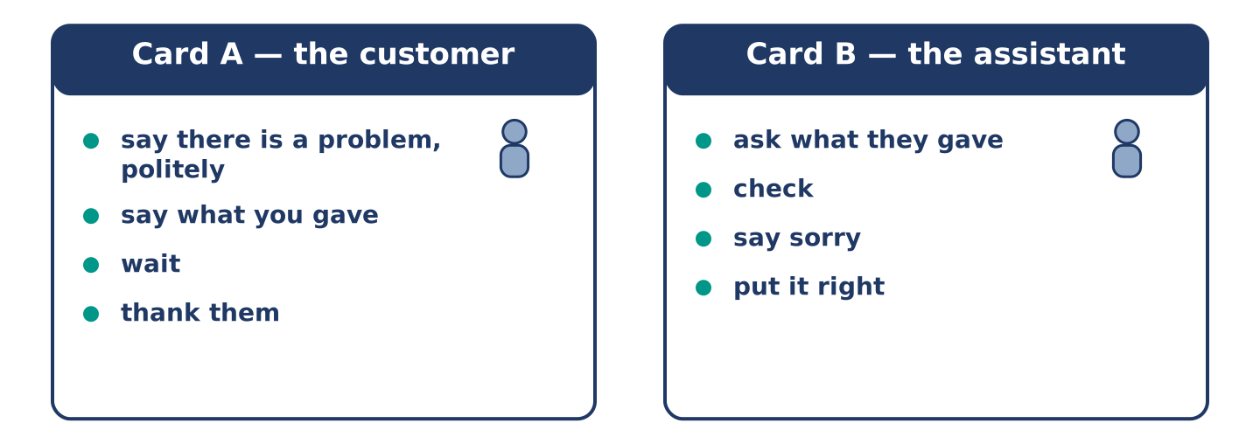
Figure 4.33 · The 7D cards: what each of you has to say.
In pairs. One is the customer; one works at the till. Use the model and cards.
Model exchange: A: Sorry — I think the change is wrong. — B: Let me look. What did you give me? — A: A twenty, and it was eleven forty. — B: Ah. I gave you change from a ten. I am sorry. — A: It is easy to do. — B: Here is the rest.
Card A — the customer: say there is a problem, politely · say what you gave · wait · thank them.
Card B — the assistant: ask what they gave · check · say sorry · put it right.
Stretch [PLUS]: the assistant is sure there is no mistake — stay polite and ask them to check once more.
7E: Writing — A Message About a Receipt (50–80 words)
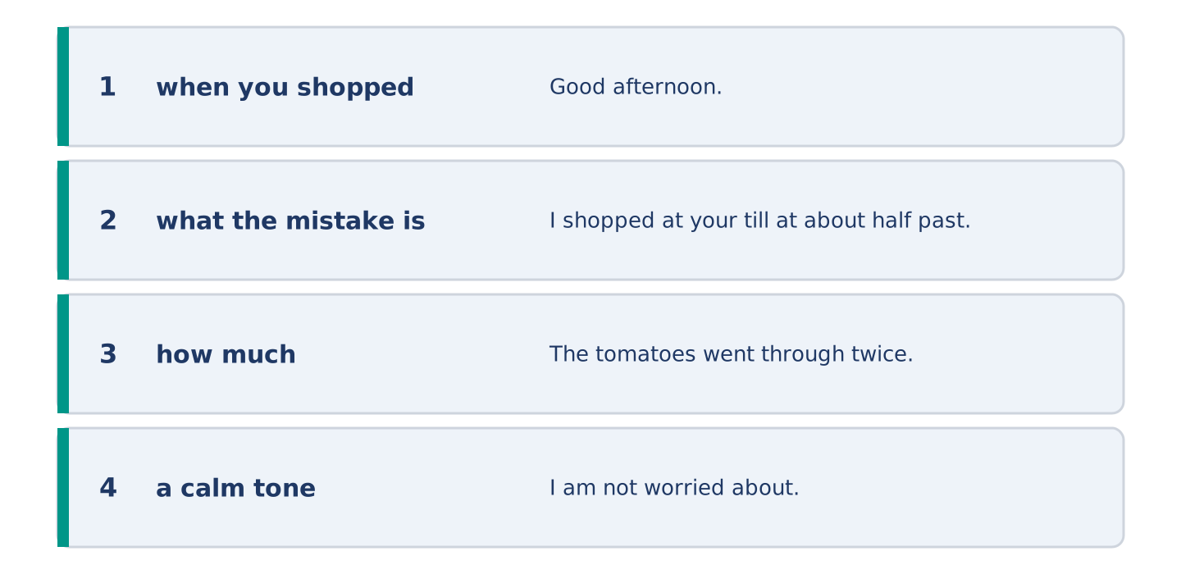
Figure 4.34 · The Part 7 note, with the model beside each line.
You got home and found a mistake on your receipt. Write a short message to the shop.
Model — read this first:
Good afternoon. I shopped at your till at about half past five today and then I looked at my receipt. The tomatoes went through twice, so I paid two forty too much. I am not worried about it, but I am in most mornings and I can come by. Could you put it right when I do? Thank you. Yuki Tanaka, flat 5 (63 words)
Check before you finish: ☐ when you shopped? ☐ what the mistake is? ☐ how much? ☐ a calm tone? ☐ 50–80 words?
Part 8 · Global Story — The Shop With No Prices
[PLUS] Plus track · pre-read / discuss
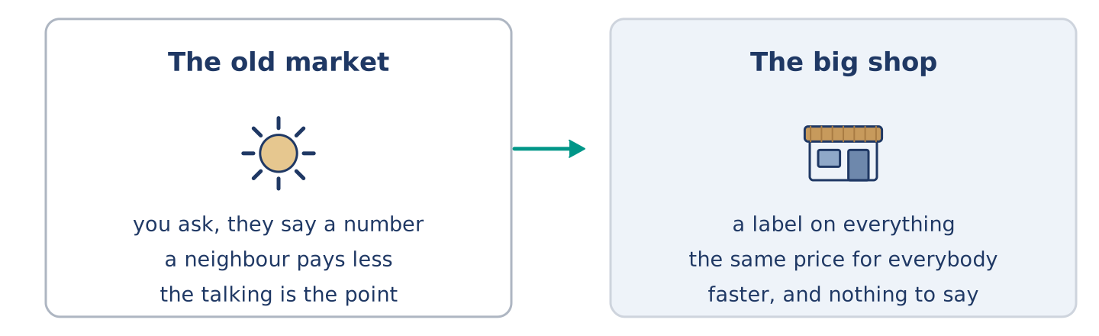
Figure 4.35 · The old market and the new one.
Before you read: can a shop work without a price on anything?
Gloss: haggle = to argue about a price until both people agree · fixed price = a price that does not change · label = a small paper with the price on it
In an old market in Fez, in Morocco, almost nothing has a price on it. You ask, the seller says a number, you say another number, and somewhere between the two you both stop. Visitors hate this. They want a label. But the system is older than labels and it does something a label cannot: it sets a different price for a different buyer. A neighbour pays less than a stranger. A family buying for a wedding pays less for more. The fixed price arrived with big shops, because a shop with four hundred products and six assistants cannot haggle four hundred times a day. It was faster. It was fairer in one way and less fair in another, and almost nobody noticed what we gave up. In Fez, they say the number is not the point. The talking is.
Answer the questions. (0. is done.)
- Where is the market? — In Fez, in Morocco.
- What do visitors want that the market does not have?
- Who pays less in that market?
- Why did big shops need a fixed price?
Part 8: Vocabulary in Context
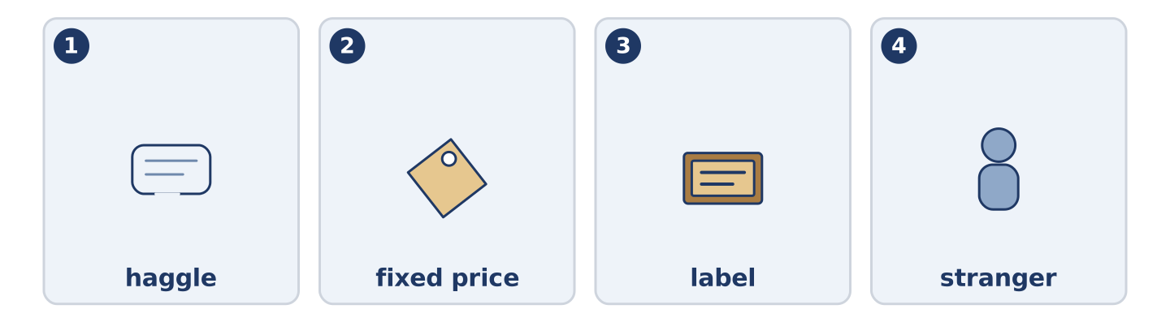
Figure 4.36 · The four words from the global story, drawn.
Match each word with its meaning. One meaning is not needed. Write the letter.
Column A
1. | haggle | ____
2. | fixed price | ____
3. | label | ____
4. | stranger | ____
Column B
a) | a small paper with the price on it
b) | a price that does not change
c) | somebody you do not know
d) | to argue about a price until both people agree
e) | the things a shop has to sell
Part 8: Discussion
Talk with a partner. Use the frames.
Discussion frames: “This is similar to where I live because…” · “This is different from where I live because…” · “I think the most important thing is… because…”
Part 9 · Close to Home — The Book Under the Till
[PLUS] Plus track · pre-read / decide
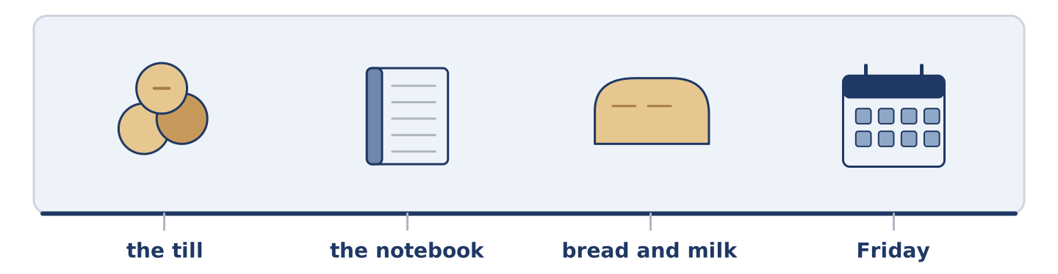
Figure 4.37 · The close-to-home reading, drawn along one street.
Before you read: should a shop let people pay later?
There is a notebook under Amina’s till, and it is older than the till. In it there are names and small numbers. Nobody calls it credit. A man with no money until Friday takes bread and milk. Amina writes two eighty next to his name, and on Friday she crosses the line out. It works because the street is small and because almost everybody comes back. Almost. Twice in eleven years somebody moved away without paying. Both times Amina closed the page and said nothing to anybody. Her son thinks the book is a bad idea and wants her to stop. He is probably right about the money. He is wrong about what the book is for, and she cannot find the words to tell him.
Answer the questions. (0. is done.)
- Where is the notebook? — Under Amina’s till.
- What does Amina write in the notebook?
- What happened twice in eleven years?
- What does Amina’s son want?
Part 9: Decision Task
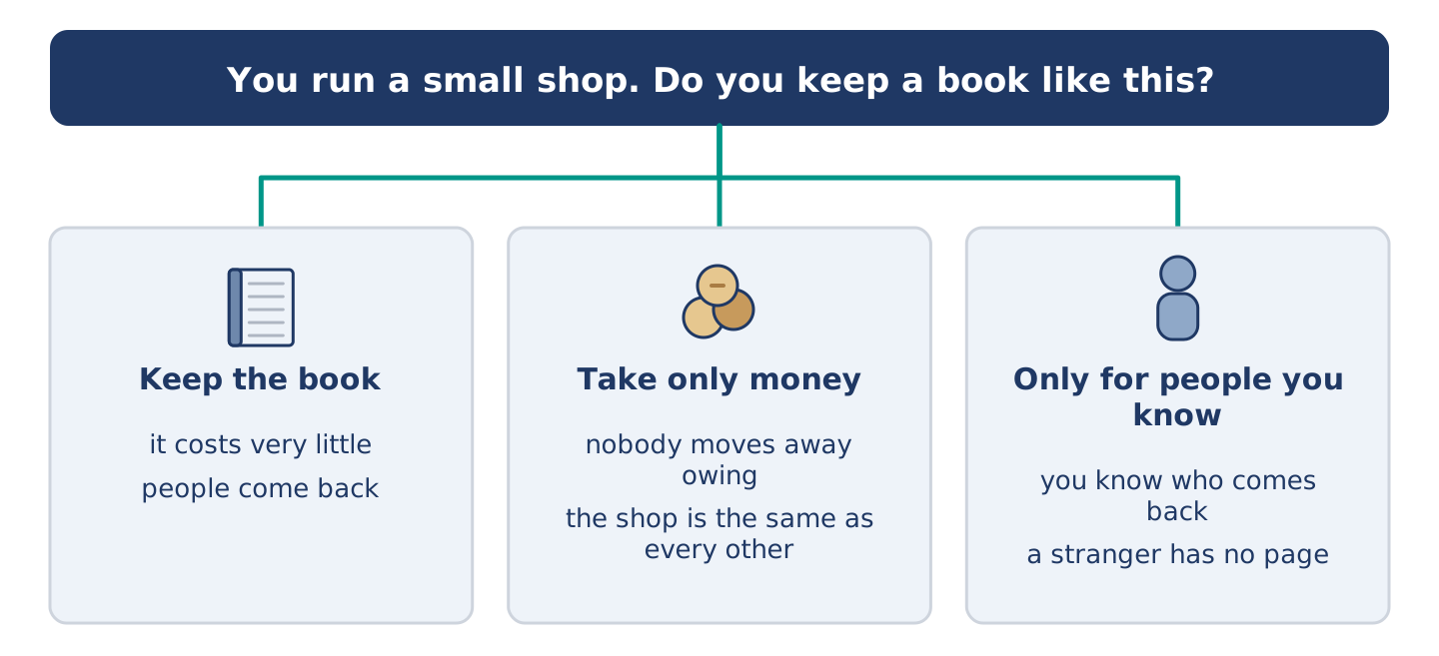
Figure 4.38 · Three ways to decide, and what each one costs.
You run a small shop. Should you (a) keep a book like Amina’s, (b) stop it and take only money, or (c) keep it but only for people you have known a long time? Decide and explain. Use the frame.
Answer frame: “I think I should ___ because ___. Also, ___. This is better than ___ because ___.”
Model — read this first:
I think I should keep the book, because it costs very little. It is why people come to me and not to the big shop. Also, two bad weeks in eleven years is not very many. This is better than stopping it. The day I stop, the shop is the same as every other shop, only smaller. (57 words)
Phrase bank: I think I should… · because… · Also,… · This is better than… · In my opinion…
Part 10 · Review and Can-Do
[CORE + PLUS] · homework / self-study
Part 10: Spiral Review
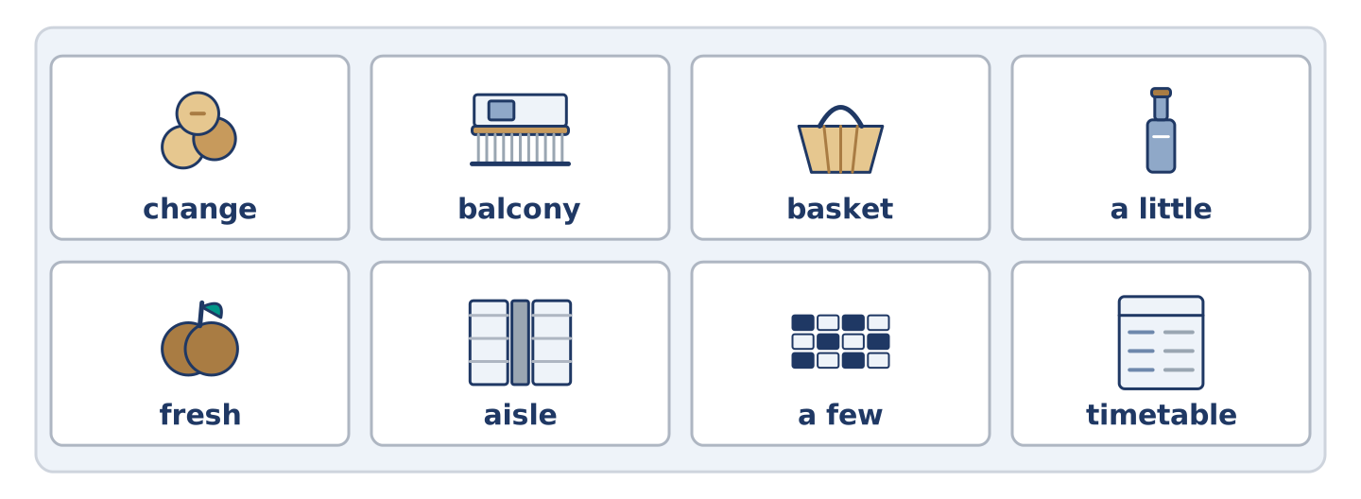
Figure 4.39 · The eight words of the review bank, in bank order.
Complete the review. (0. is done.)
- The paper that shows what you paid is the receipt.
Word bank: change | balcony | basket | a little | fresh | aisle | a few | timetable
- A light open bag you fill while you walk round is a ______________________ .
- The long space between two lines of shelves is an ______________________ .
- Bread made this morning is ______________________ .
- The money you get back when you pay too much is your ______________________ .
- There are ______________________ eggs left — four or five.
- Put ______________________ sugar in the tea, not much.
- (from Unit 3) A list of the times buses come is a ______________________ .
- (from Unit 2) A small outside floor with a wall is a ______________________ .
Part 10: Can-Do
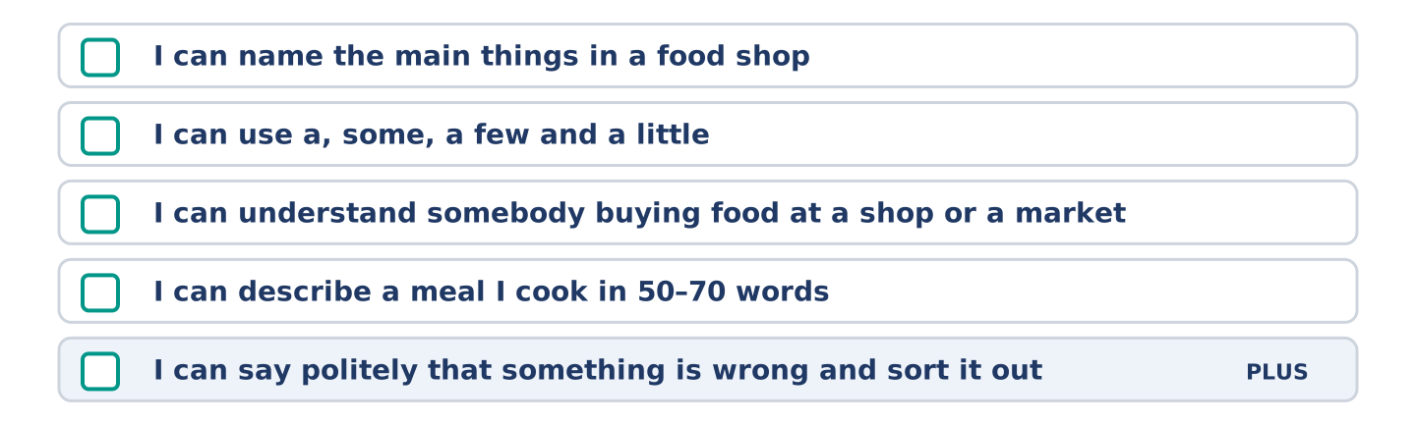
Figure 4.40 · What you can do at the end of this unit.
Can-Do checklist
☐ I can name the main things in a food shop.
☐ I can use countable and uncountable nouns with a, some, a few and a little.
☐ I can understand somebody buying food at a shop or a market.
☐ I can describe a meal I cook in 50–70 words.
☐ I can say politely that something is wrong and sort it out (Plus).
Part 10: Glossary
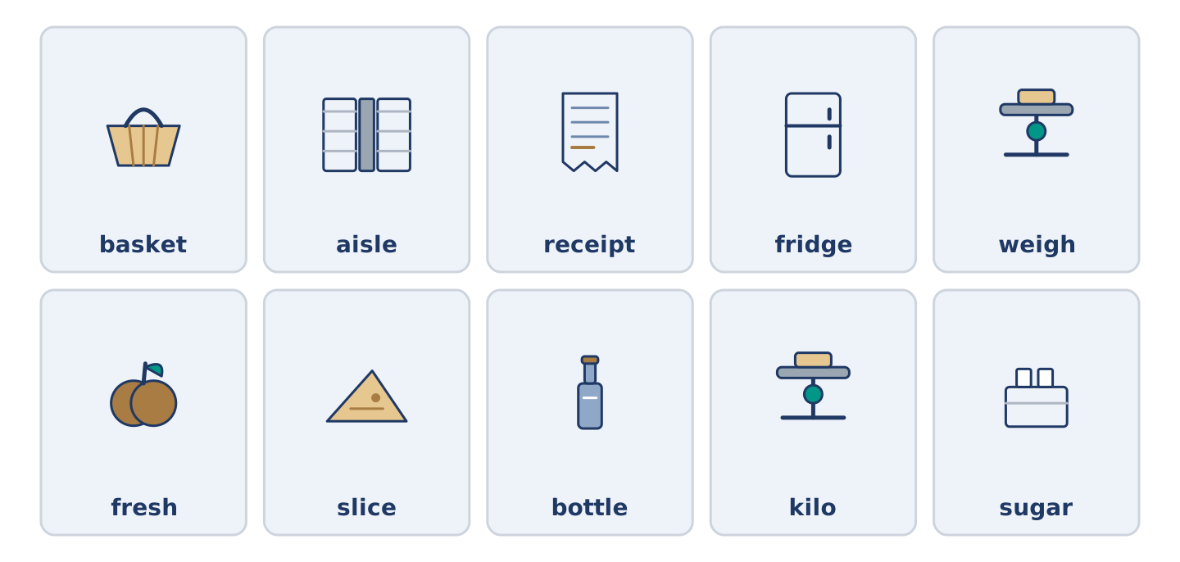
Figure 4.41 · All ten glossary words of Unit 4, one card each.
Unit 4 glossary (10 words)
basket · aisle · receipt · fridge · weigh · fresh · slice · bottle · kilo · sugar

