Unit 5: Last Weekend
English for Daily Life · Level: A2 · Tracks: [CORE] Warm-Up + Parts 1–6 · [PLUS] Parts 7–10
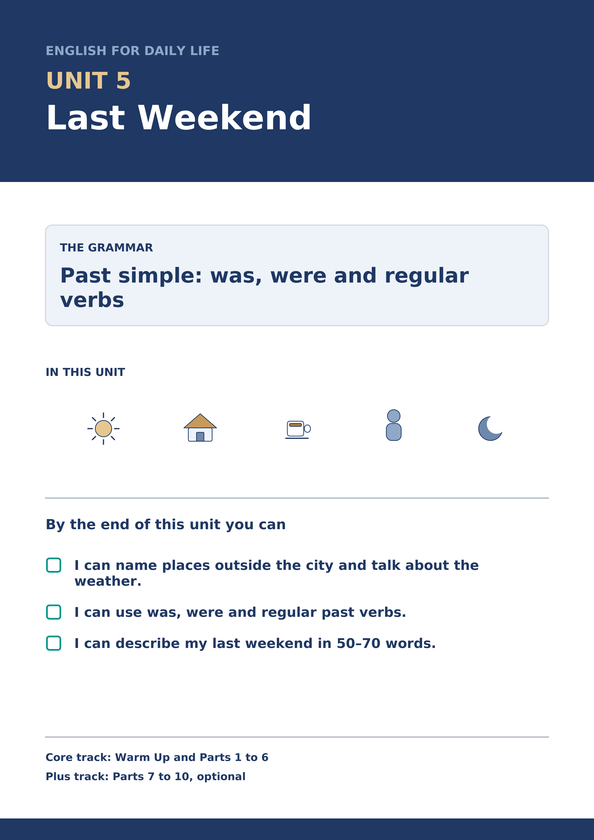
Warm Up
[CORE] Core track · in-class starter
Warm-up: Weekend Words and Meanings
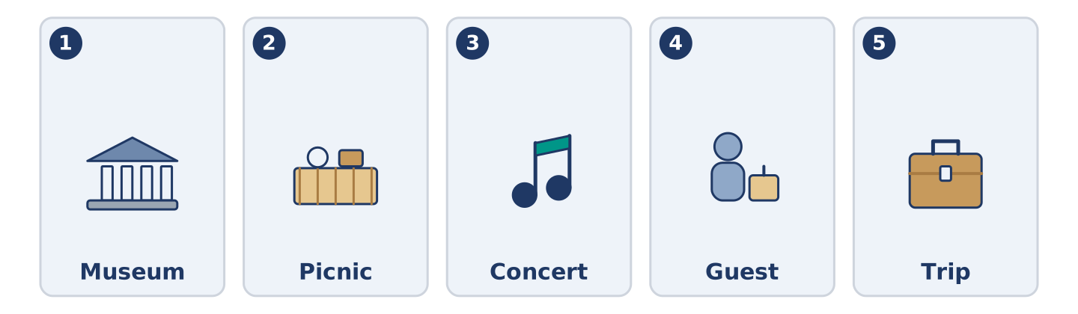
Figure 5.2 · The five warm-up words, and the thing each one means.
Match the words with their meanings. One meaning is not needed. Write the letter.
Column A
1. | Museum | ____
2. | Picnic | ____
3. | Concert | ____
4. | Guest | ____
5. | Trip | ____
Column B
a) | a short journey to a place and back
b) | a meal you eat outside, sitting on the ground
c) | a building where you look at old or beautiful things
d) | a visitor to your home, for a short time
e) | an evening where people play music for other people
f) | the paper that shows what you paid
Warm-up: Talking About the Weekend
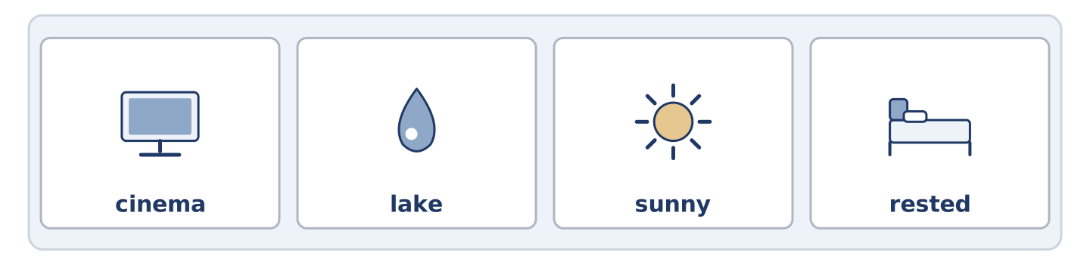
Figure 5.3 · The word bank for this task, in the order it is printed.
Complete the sentences using the words in the word bank.
Word bank: cinema | lake | sunny | rested
- On Saturday it was ______________________ , so everybody was outside.
- Dani went to the ______________________ and fell asleep in the film. On Friday he wanted a concert and the tickets were gone.
- Maya walked round the ______________________ in the park with Yuki.
- Tomas ______________________ all day, because he worked four nights.
Warm-up: Alder Street on Sunday
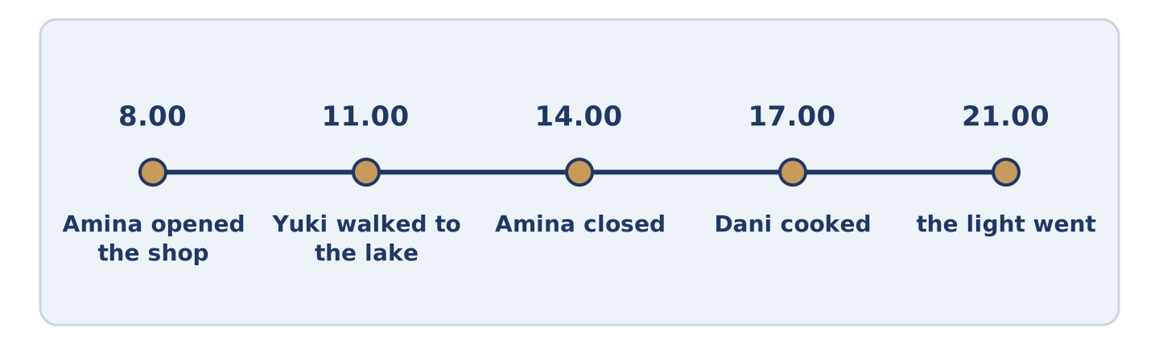
Figure 5.4 · Alder Street last Sunday, hour by hour.
Read the text and choose the correct answer.
Last Sunday was warm. Amina opened the shop at eight and closed it at two, which she only does in summer. Mr Okonkwo carried a chair outside and stayed there until the light went. Amina watched him from her door and said she envied him. Dani cooked for four people and three of them came. The fourth sent a message at nine. Yuki walked to the lake and photographed a bird. She could not name it. It was a quiet Sunday, and nobody remembers it now. That is most of what a Sunday is for.
1. What time did Amina close the shop?
○ A) At two
○ B) At four
○ C) At eight
○ D) She did not close
2. How many people came to Dani’s?
○ A) Four
○ B) Nobody
○ C) Two
○ D) Three
Part 1 · Vocabulary and Terminology
[CORE] Core track · pre-class input
Part 1: Weekend and Weather Terms
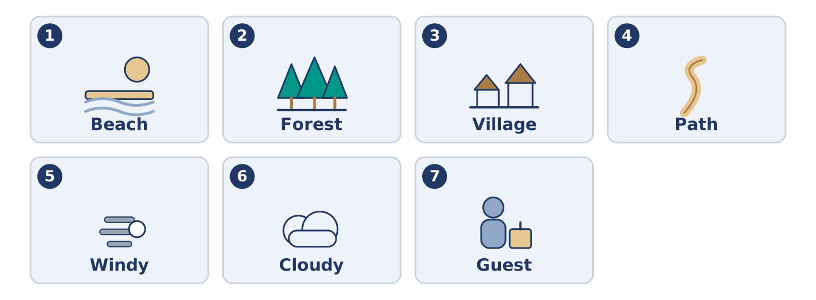
Figure 5.5 · The seven words of Column A, and what each one is.
Match the words with their meanings. One meaning is not needed. (0. is done for you.)
- Countryside → the land outside towns, with fields, trees and few buildings.
Column A
1. | Beach | ____
2. | Forest | ____
3. | Village | ____
4. | Path | ____
5. | Windy | ____
6. | Cloudy | ____
7. | Guest | ____
Column B
a) | a very small town
b) | with a lot of trees close together
c) | a meal you eat outside
d) | a visitor to your home, for a short time
e) | the sand or stones beside the sea
f) | with a strong moving air
g) | with grey sky and no sun
h) | a narrow way you walk along, not a road
Gloss: path = a narrow way you walk along · countryside = the land outside towns · village = a very small town
Part 1: Pronunciation
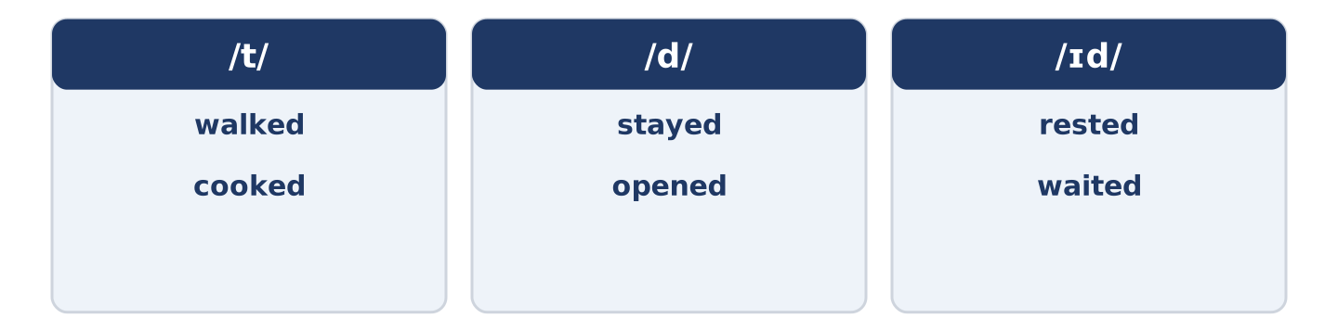
Figure 5.6 · Where the stress falls in 0 words of this unit.
🔊 Audio Track 5.1
Listen and practise the -ed ending. Say each pair aloud.
walked — /t/
cooked — /t/
stayed — /d/
opened — /d/
rested — /ɪd/
waited — /ɪd/
Then listen again. The -ed ending has three sounds and only one spelling. After /t/ or /d/ it becomes a whole new beat: rested is two beats, waited is two. Everywhere else it is a single sound stuck on the end, and walked is still one beat.
Part 1: Six Places People Went
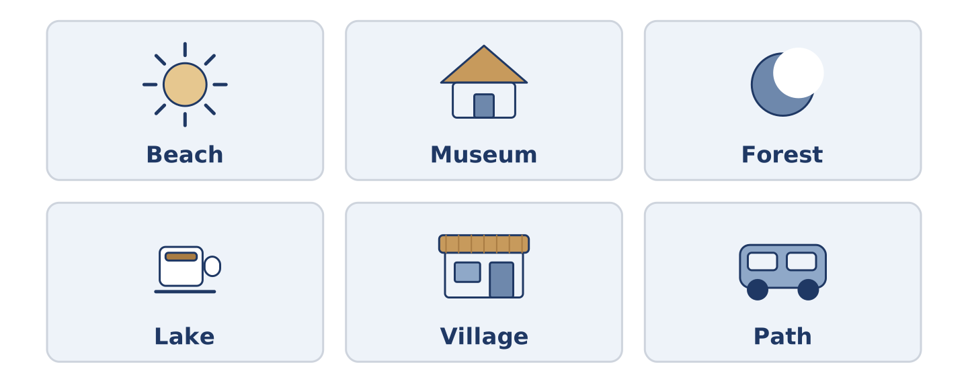
Figure 5.7 · Six places and what people did there.
Complete the table. Write what you do there and the weather you want for it. (0. is done.)
Place | What you do there | Weather you want
Beach | swim, sit, eat | (example)
Museum
Forest
Lake
- Beach — swim, sit, eat — sunny and not windy.
Think about a weekend you remember. Some places need weather and some do not. There is more than one right answer, and you should be ready to say why you chose yours.
Part 1: Out of the City
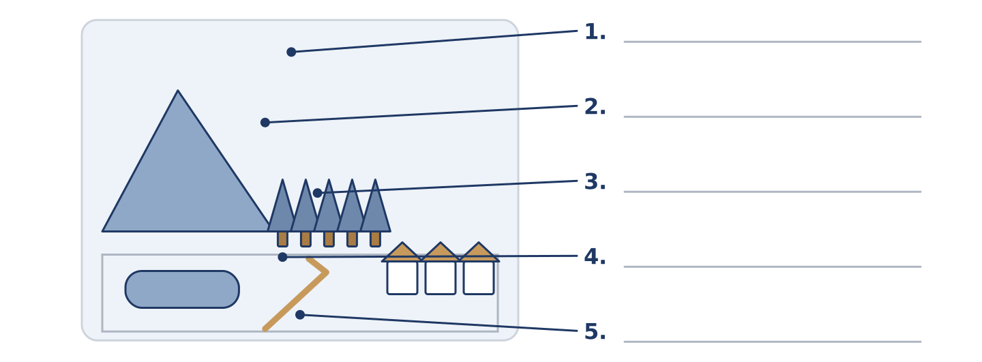
Figure 5.8 · Out of the city — write the correct word on each line.
Match the things outside a city with their descriptions. One description is not needed. Write the letter.
Column A
1. | Hill | ____
2. | Lake | ____
3. | Forest | ____
4. | Path | ____
5. | Village | ____
Column B
a) | a narrow way you walk along
b) | high ground, lower than a mountain
c) | a very small town
d) | water with land all round it
e) | the sand beside the sea
f) | a lot of trees close together
Part 1: The Weekend — Multiple Choice
Read and choose the correct answer.
1. A meal you eat outside, sitting on the ground, is a…
○ A) picnic
○ B) concert
○ C) trip
○ D) museum
2. Water with land all round it is a…
○ A) beach
○ B) path
○ C) lake
○ D) forest
3. Somebody who comes to your home for a short time is a…
○ A) village
○ B) hill
○ C) picnic
○ D) guest
Part 1: Vocabulary Fill-in
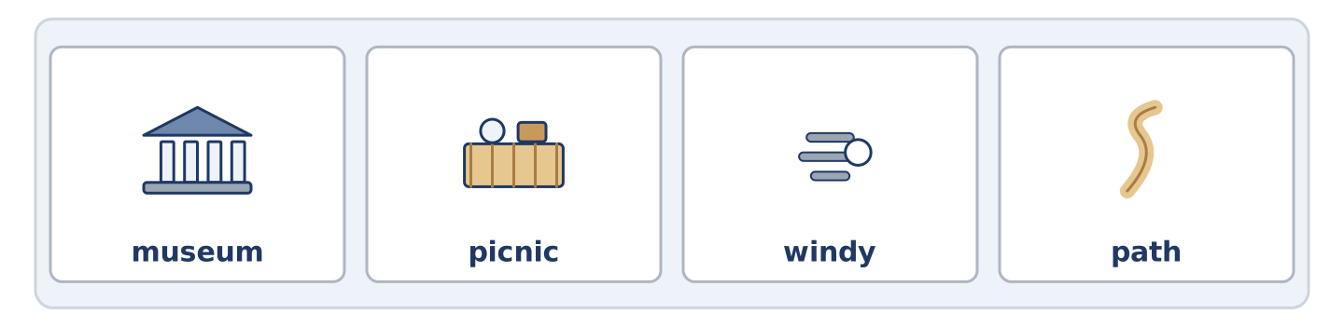
Figure 5.9 · The four words of the bank, in the order the task gives them.
Complete the sentences with the correct word.
Word bank: museum | picnic | windy | path
- It was too ______________________ for the beach, so they went to the forest.
- The ______________________ was free on Sunday, so it was full of families. Last month there was a concert there.
- They carried the ______________________ up the hill and ate it at the top.
- The ______________________ was wet, and Dani walked into the lake.
Part 1: Write About Last Weekend (short)
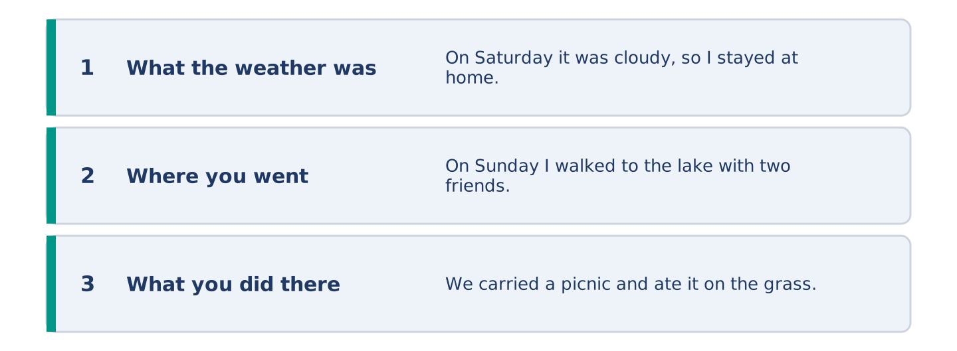
Figure 5.10 · The shape of your two or three sentences, with the model beside each step.
Write two or three sentences about last weekend. Use three words from this unit.
Model — read this first:
On Saturday it was cloudy, so I stayed at home and cooked. Cloudy days suit me. On Sunday the sun arrived and I walked to the lake with two friends. We carried a picnic and ate it on the grass, and nobody wanted to go home. (46 words)
Part 2 · Grammar — Past Simple: Was, Were and Regular Verbs
[CORE] Core track · pre-class input
Part 2: Notice
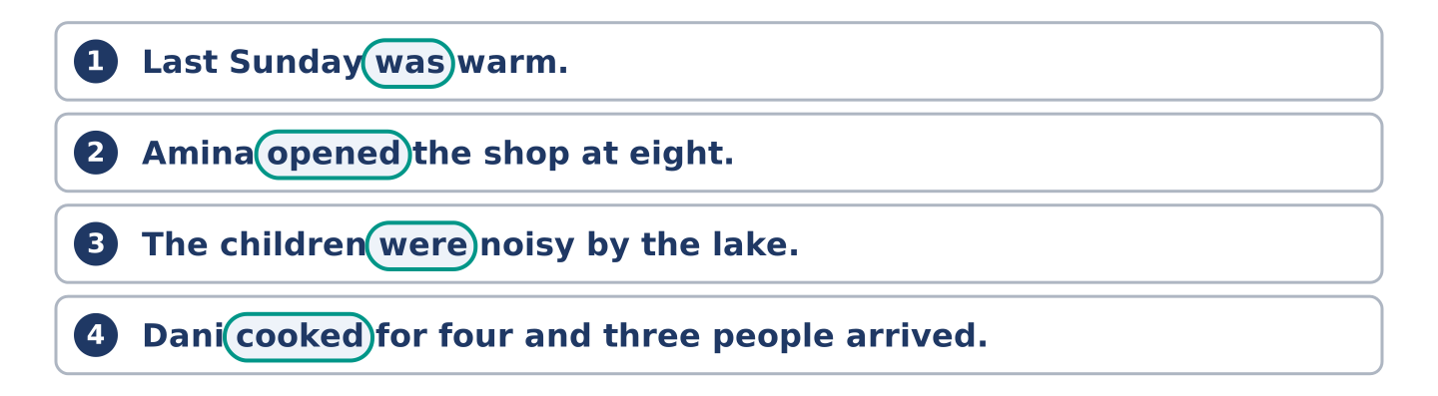
Figure 5.11 · Lines from the notice, with the target form ringed in each.
Read these lines about last Sunday. Underline the past verbs. Which are was or were?
Last Sunday was warm. Amina opened the shop at eight. Mr Okonkwo carried a chair outside and stayed there all afternoon. The children were noisy by the lake. Dani cooked for four and three people arrived. It was a quiet day.
Was and were say what something was like. The other verbs say what somebody did, and they all end in -ed.
Part 2: Grammar Focus Box
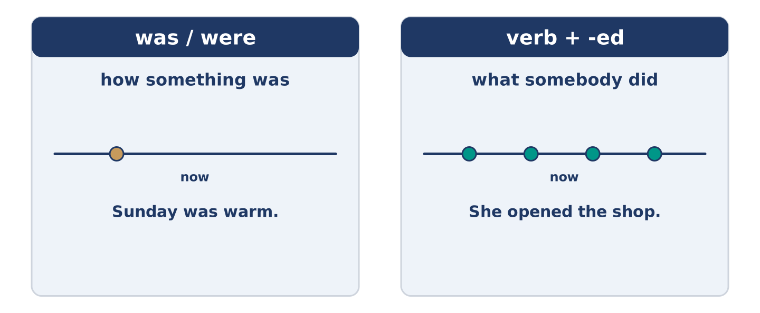
Figure 5.12 · Then and now: the same verbs, one step back.
 | Form | Use | Example
was / were | I/he/she/it was · you/we/they were | how something was | Sunday was warm.
Regular past | verb + -ed, every person | what somebody did | She opened the shop.
Negative | did not + the plain verb | what did not happen | She did not open.
Question | did + person + plain verb | asking about then | Did she open?
Remember: after did and did not, the verb loses its -ed: did you walk?, not did you walked?
Watch out! ✗ I was walk to the lake. → ✓ I walked to the lake. (one past, not two). ✗ Did you walked? → ✓ Did you walk? (did has the past already).
Part 2: Controlled Practice
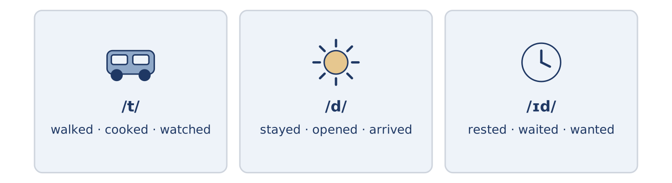
Figure 5.13 · Last Sunday on a line: what happened, and when.
Write the past simple. (0. is done.)
- Amina opened the shop at eight. (open)
- Mr Okonkwo ______________________ (carry) a chair outside.
- The children ______________________ (be) noisy by the lake.
- Dani ______________________ (cook) for four people.
- It ______________________ (be) a quiet Sunday.
Part 2: Was, Were or -ed?
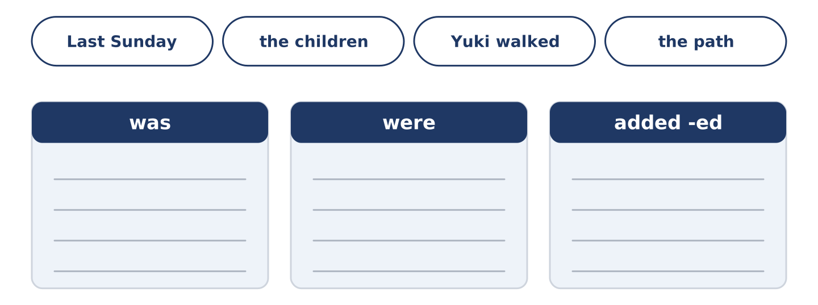
Figure 5.14 · The items of this task, and the bins they sort into.
Choose the correct form. (0. is done.)
- Last Sunday was warm. (was / were)
- The children ______________________ (was / were) by the lake all afternoon.
- Yuki ______________________ (walked / was walk) to the lake and back.
- The path ______________________ (was / were) wet after the rain.
- Three people ______________________ (arrived / was arrive) at Dani’s.
Part 2: Correct the Sentence
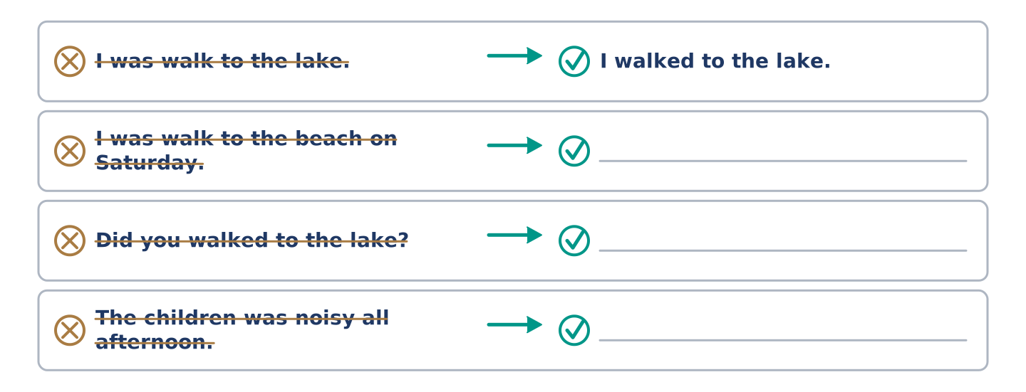
Figure 5.15 · One correction done for you, and the rest to write.
Each sentence has one grammar mistake. Write the correct sentence.
- I was walk to the beach on Saturday.
- Did you walked to the lake?
- The children was noisy all afternoon.
- Dani not cooked on Sunday.
Part 2: Freer Practice
Write two sentences about your own last weekend: one with was or were, one with an -ed verb.
Part 2: Grammar Review
Choose the correct past-simple sentence.
1. Which sentence is a correct question?
○ A) Did you walked to the lake?
○ B) Did you walk to the lake?
○ C) You did walk to the lake?
○ D) Did you walking to the lake?
2. Which sentence is correct about the weather?
○ A) Sunday was warm.
○ B) Sunday was warmed.
○ C) Sunday warmed.
○ D) Sunday were warm.
→ Harvest: you will see the past simple again in the Part 5 reading. Watch for the -ed endings.
Part 3 · Listening
[CORE] Core track · pre-class input · scripts printed inline
Part 3: What Did You Do?
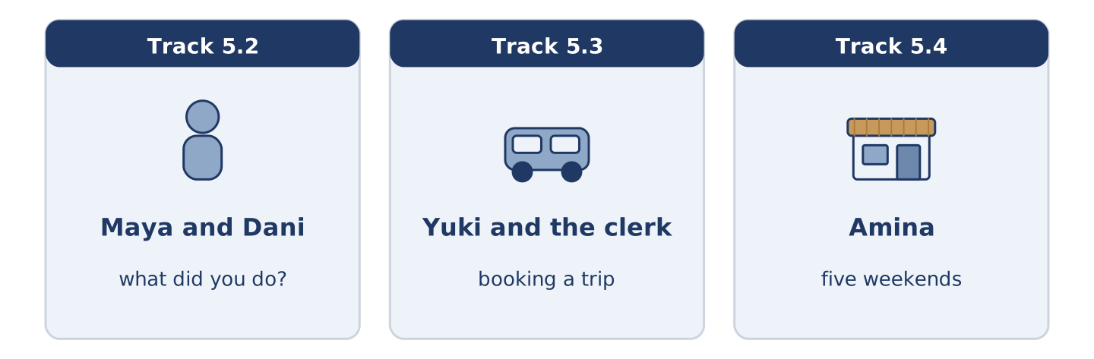
Figure 5.16 · The three listenings: who is speaking, and what about.
🔊 Audio Track 5.2
Before you listen: what is the first question people ask on a Monday?
Maya: So what did you do? Dani: Nothing. I cooked for four people and three of them turned up. Maya: That’s not nothing. Dani: It was a lot of rice. What about you? Maya: I walked to the lake with Yuki. It was windy, but it was warm. Dani: Did you swim? Maya: In November? No. One man did swim. We watched, and we decided he was braver than us.
While you listen: write True, False, or Not Given. (0. is done.)
- Dani cooked for four people. — True
- Three people came to Dani’s. ____
- Maya and Yuki swam in the lake. ____
- Maya goes to the lake every weekend. ____
Useful phrases: What did you do? · It was… · Did you…? · That’s not nothing.
Part 3: Booking a Trip
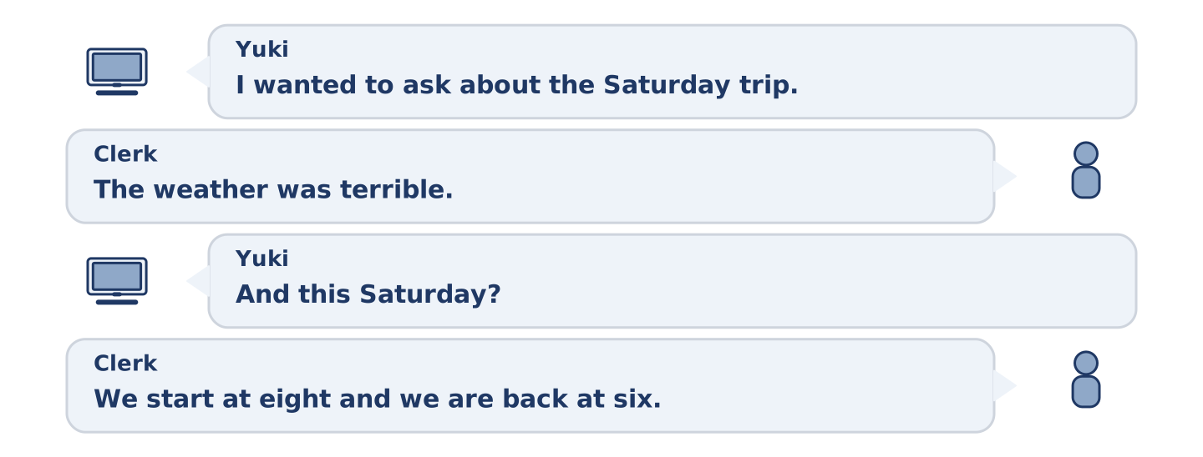
Figure 5.17 · The second listening, turn by turn.
🔊 Audio Track 5.3
Before you listen: what do you ask before you book a day trip?
Yuki: I wanted to ask about the Saturday trip. Did it run last week? Clerk: No, it did not. The weather was terrible. Yuki: And this Saturday? Clerk: It looks fine. We start at eight and we are back at six. Yuki: Is lunch included? Clerk: No. Most people carry a picnic. There is a village halfway with a shop, but it closed in the spring. Yuki: Then I carry one. Two places, please.
While you listen: answer the questions. (0. is done.)
- Which trip is Yuki asking about? — The Saturday trip.
- Why did last week’s trip not run?
- What time does the trip come back?
- What happened to the shop in the village?
Part 3: Five Weekends
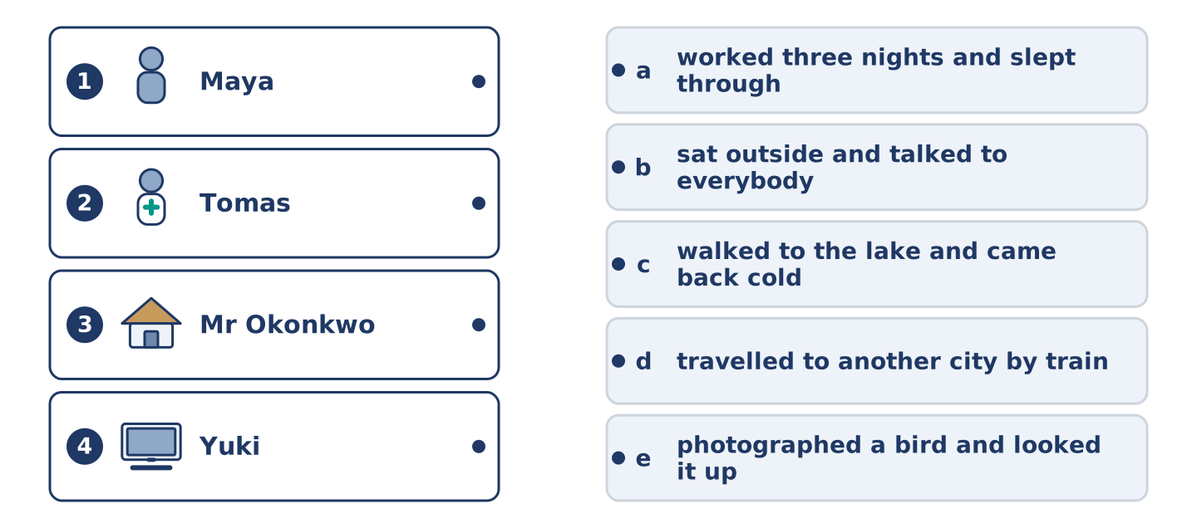
Figure 5.18 · Four on the left, five on the right, and one spare.
🔊 Audio Track 5.4
Before you listen: how different are five people’s weekends in one building?
Amina: Five flats, five weekends. Maya walked to the lake and came back cold and pleased. She says she wants to go again, and that her sister wants to come too. Tomas worked Friday, Saturday and Sunday nights, and slept through all the daylight there was. Maya said she heard him come in at six. Dani cooked too much and invited too few. Amina says she knew it before he started. Mr Okonkwo sat outside with a chair and a newspaper and talked to everybody. Yuki photographed a bird and then spent an hour looking it up.
While you listen: match each person with their weekend. One weekend is not needed. (0. is done.)
- Amina → she watched all of it from the shop.
Useful phrases: ___ walked… · ___ worked… · ___ sat outside and…
Column A
1. | Maya | ____
2. | Tomas | ____
3. | Mr Okonkwo | ____
4. | Yuki | ____
Column B
a) | worked three nights and slept through the day
b) | sat outside and talked to everybody
c) | walked to the lake and came back cold
d) | travelled to another city by train
e) | photographed a bird and looked it up
Part 4 · Speaking
[CORE] Core track · in-class output
Part 4: Talking About Last Weekend
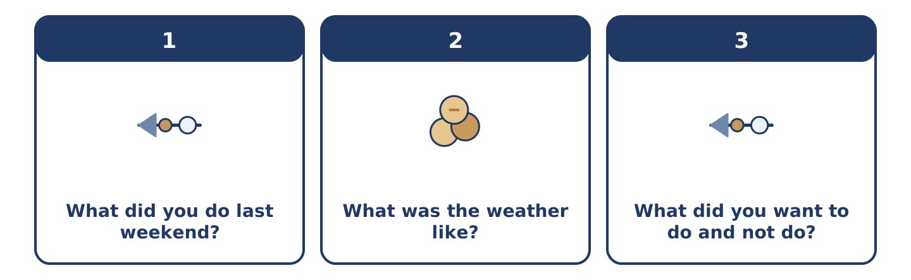
Figure 5.19 · The three questions as cards, to take one at a time.
Work with a partner. Ask and answer these questions.
- What did you do last weekend? Was it a normal one?
- What was the weather like? Did it change your plans?
- What did you want to do and not do?
Useful language: I walked… · It was… · We decided to… · I wanted to… but… · Did you…?
Part 4: Find the Difference (pairwork)
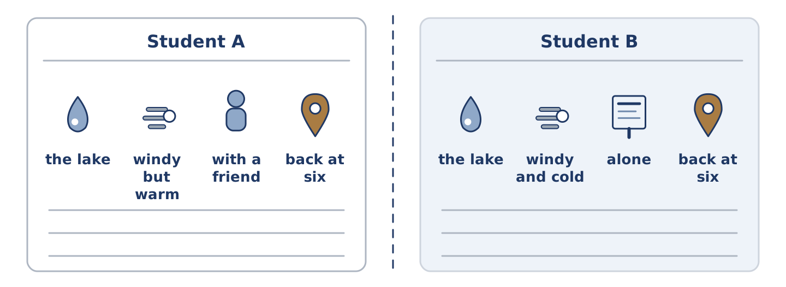
Figure 5.20 · Student A’s facts and Student B’s, with a fold between them.
Student A and Student B each had a different Saturday. Ask questions and find three differences.
Useful questions: Where did you go? · What was the weather like? · Who did you go with? · What time did you come back?
Student A — your Saturday: the lake · windy but warm · with a friend · back at six.
Student B — your Saturday: the lake · windy and cold · alone · back at six.
Part 4: Telling the Story
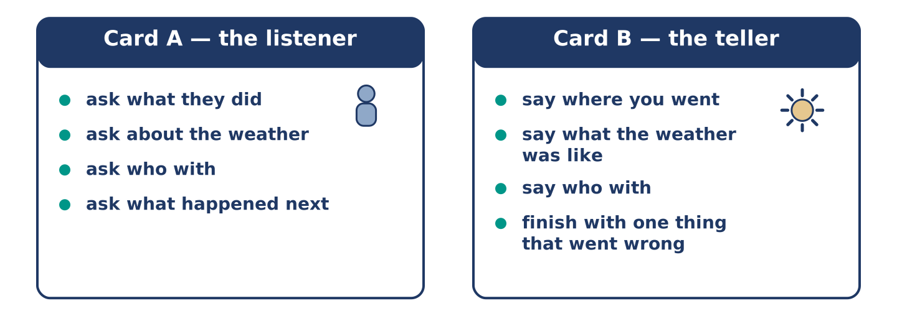
Figure 5.21 · Card A and Card B: what each of you has to say.
Work in pairs. Read the model, then use the cards.
Model exchange:
A: So what did you do at the weekend? — B: I walked to the lake. It was windy, but it was warm. — A: Did you go alone? — B: No, with Yuki. We carried a picnic and ate it on a bench. — A: And then? — B: Then it rained, and we walked home fast.
Useful language: What did you do…? · I walked… · It was… · Did you…? · And then?
Card A — the listener: ask what they did · ask about the weather · ask who with · ask what happened next.
Card B — the teller: say where you went · say what the weather was like · say who with · finish the story with one thing that went wrong.
Your turn: run the dialogue, then swap roles.
Stretch [PLUS]: the weekend was dull and there is nothing to tell — make two minutes out of it anyway.
Part 4: Mini-Presentation
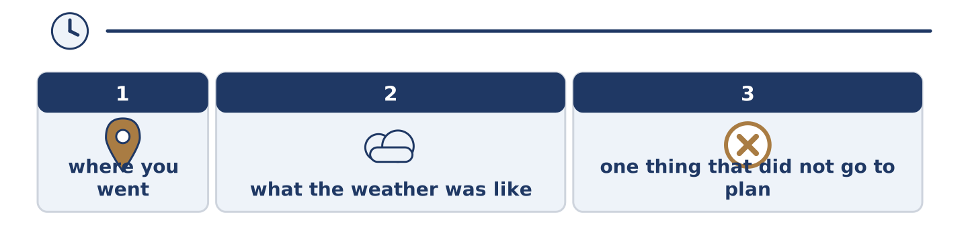
Figure 5.22 · The one-minute talk as three beats, each as wide as its share.
Prepare a short talk (about one minute). Describe a day out you remember: where you went, what the weather was like, and one thing that did not go to plan.
Part 5 · Reading
[CORE] Core track · pre-class input
Part 5: Who Invented the Weekend
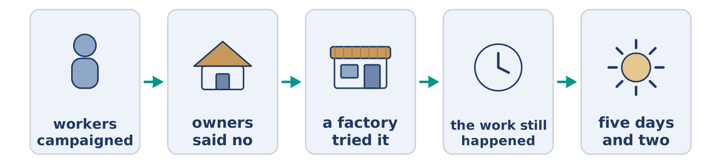
Figure 5.23 · One Saturday, from morning to night.
Before you read: has there always been a weekend?
Gloss: factory = a big building where people make things · campaign = a long effort to change something · agreement = when people decide something together · refuse = to say no
The weekend is not very old. For most of history people rested on one day, and in many places they worked on the other six. The two-day weekend arrived with factories, and it arrived slowly. Workers campaigned for it and owners said no. Then one or two factories tried it. They found something surprising: two rested days produced as much work in five as tired days produced in six. After that the argument changed. In time most of Europe and North America settled on five days and two. Almost nobody now remembers that it was ever a fight. Tomas works nights and sleeps through Saturday. He is a reminder: the weekend was always an agreement, never a fact about the world.
Answer the multiple-choice questions. (0. is done.)
- Is the weekend very old? — No, it is not.
1. How many days did people usually rest for in the past?
○ A) Two
○ B) None
○ C) One
○ D) Three
2. What did one or two factories discover?
○ A) That workers wanted more money
○ B) That six days were better
○ C) That nobody noticed
○ D) That rested workers produced as much in five days
3. What does Tomas remind us of?
○ A) That the weekend was an agreement
○ B) That nights are hard
○ C) That factories were noisy
○ D) That Saturday is the best day
Part 5: Vocabulary in Context
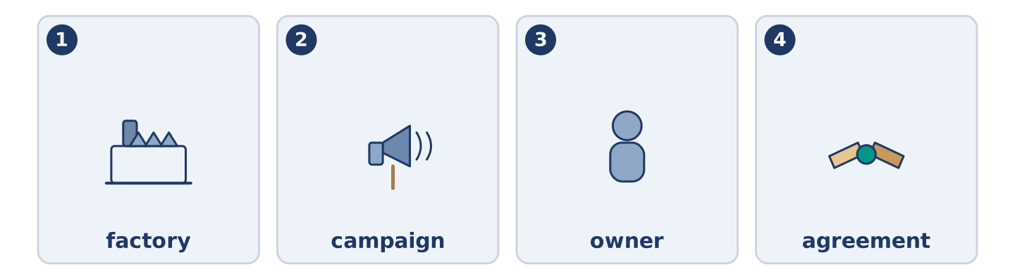
Figure 5.24 · The four words from the reading, drawn.
Match each word from the text with its meaning. One meaning is not needed. Write the letter.
Column A
1. | factory | ____
2. | campaign | ____
3. | owner | ____
4. | agreement | ____
Column B
a) | a long effort to change something
b) | the person something belongs to
c) | a big building where things are made
d) | when people decide something together
e) | a narrow way you walk along
Part 5: Days Off Around the World
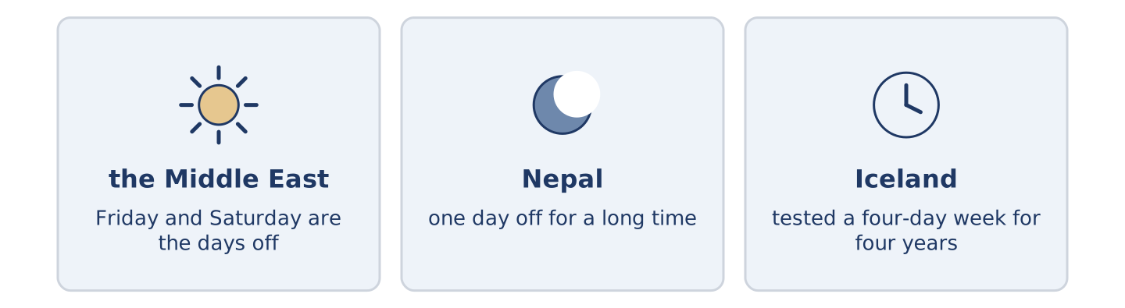
Figure 5.25 · The days off in three places.
Before you read: is the weekend Saturday and Sunday everywhere?
Gloss: day off = a day when you do not work · public holiday = a day when almost everybody is free
The weekend is not Saturday and Sunday everywhere. In much of the Middle East the days off are Friday and Saturday, because Friday is the day of prayer. In Nepal there was one day off for a long time, on Saturday, and the country only added a second recently. Iceland tested a four-day week for four years. The people in the trial did not want to go back. Each country drew its own line between work and the rest of life. Nobody drew the same one.
Answer the questions. (0. is done.)
- Is the weekend Saturday and Sunday everywhere? — No, it is not.
- Which days are off in much of the Middle East?
- How many days off did Nepal have for a long time?
- What did Iceland test, and for how long?
Part 6 · Writing
[CORE] Core track · in-class / homework
Part 6: Describe Last Weekend (50–70 words)
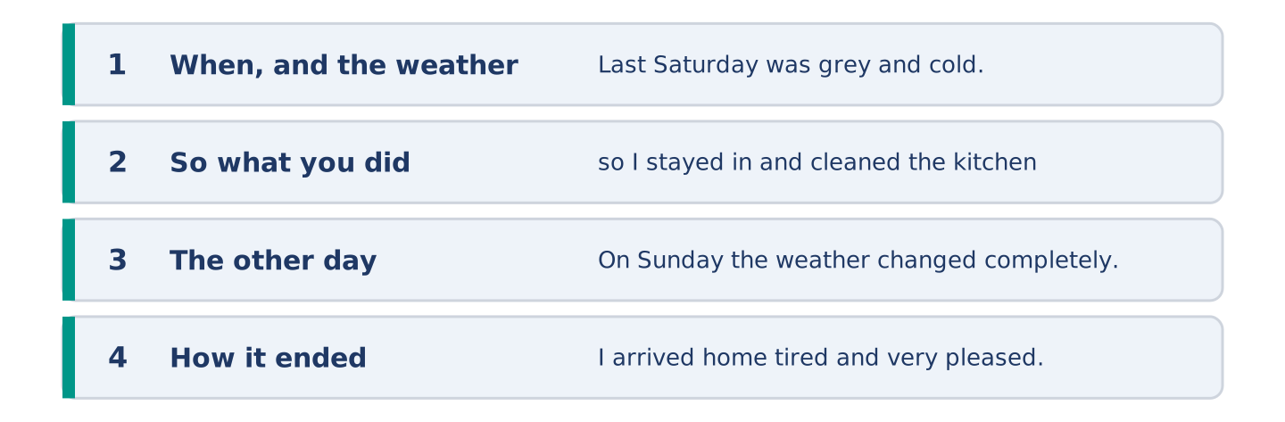
Figure 5.26 · The shape of the paragraph you are about to write.
Describe your last weekend. Say what the weather was like and what you did.
Model — read this first:
Last Saturday was grey and cold, so I stayed in and cleaned the kitchen, which needed it. On Sunday the weather changed completely. I walked to the lake with a friend and we carried a picnic. It was windy on the water and warm out of it, and we stayed until the light went. I arrived home tired and very pleased. (61 words)
Plan (fill in, then write): Last ___ was ___, so I ___. On ___ I ___. It was ___. We ___ until ___. I arrived home ___.
Word bank: was | were | walked | cooked | stayed | arrived
Check before you finish: ☐ one was or were? ☐ three -ed verbs? ☐ the weather? ☐ 50–70 words?
Part 6: The Best Kind of Weekend (50–70 words)
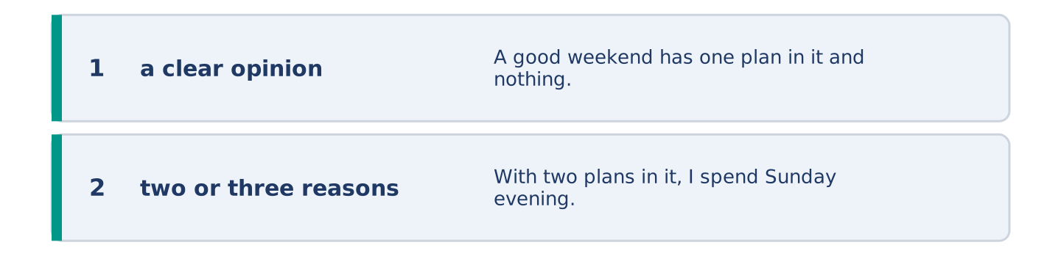
Figure 5.27 · The shape of the opinion paragraph, step by step.
What makes a good weekend? Give your opinion and two or three reasons.
Model — read this first:
A good weekend has one plan in it and nothing else. With two plans in it, I spend Sunday evening tired and cross. One walk, one meal with somebody, and a lot of hours with nothing in them at all. People say they want an exciting weekend. I think they want a calm Monday. (54 words)
Word bank: I think… because… | one plan | too much | however | in my opinion
Check before you finish: ☐ a clear opinion? ☐ two or three reasons? ☐ 50–70 words?
Part 6: A Message After a Visit (50–70 words)
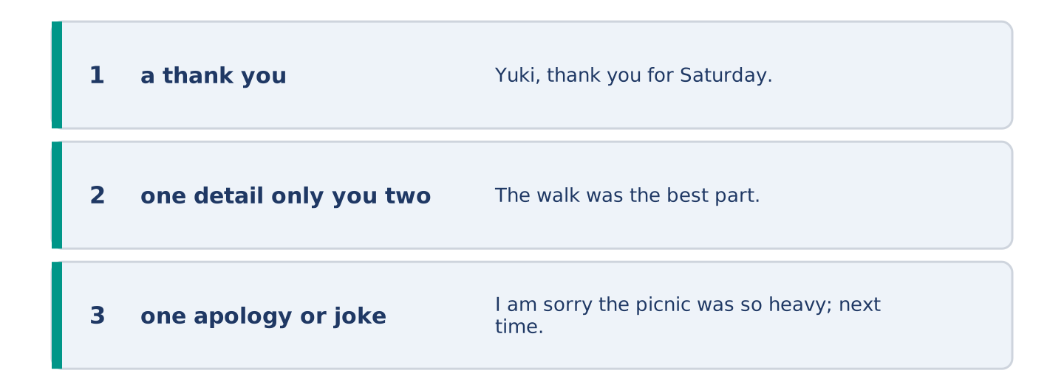
Figure 5.28 · The moves of the message, with a line of the model for each.
Somebody was your guest last weekend. Write them a short message afterwards.
Model — read this first:
Yuki, thank you for Saturday. The walk was the best part, even though the path was wet and we both nearly went into the lake. I am sorry the picnic was so heavy; next time I carry less bread and more of everything else. The photograph of the bird arrived this morning and it is on my wall. (58 words)
Plan (fill in, then write): ___, thank you for ___. The ___ was the best part, even though ___. I am sorry ___. ___
Check before you finish: ☐ a thank you? ☐ one detail only you two would know? ☐ one apology or joke? ☐ 50–70 words?
Part 6: Reflection — A Weekend I Remember (40–60 words)
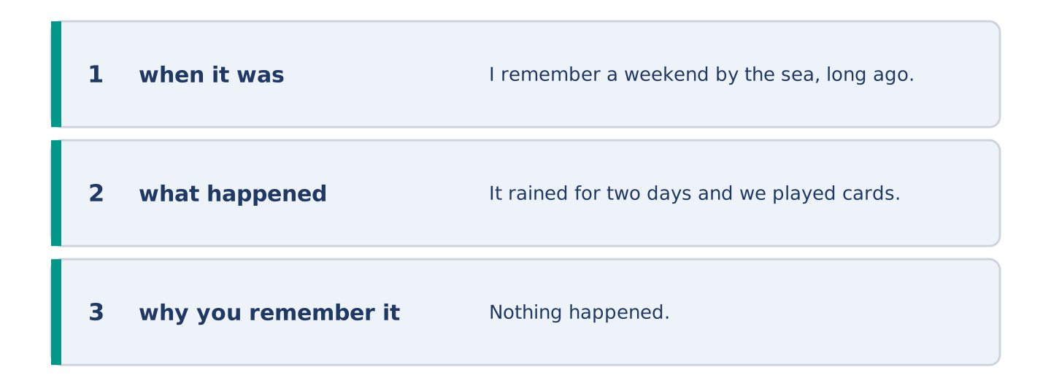
Figure 5.29 · The reflection, step by step.
Write about one weekend you still remember, and why.
Model — read this first:
I remember a weekend by the sea, long ago. It rained for two days and we played cards in a cold room and laughed until we could not speak. Nothing happened. I had better weekends that year and I cannot remember one of them. (44 words)
Check before you finish: ☐ when it was? ☐ what happened? ☐ why you remember it? ☐ 40–60 words?
Part 7 · Real-World File — Plans That Change
[PLUS] Plus track (optional) · stronger learners
7A: Phrase Bank
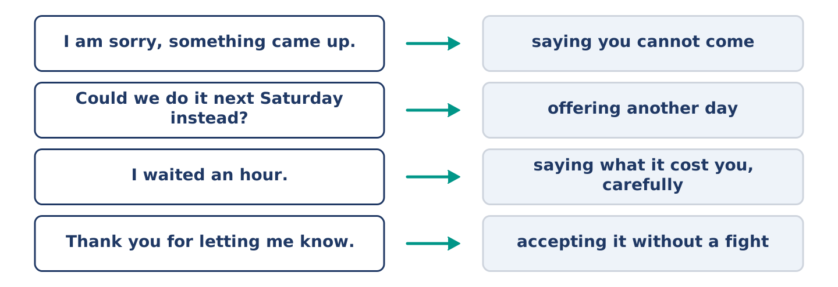
Figure 5.30 · What you say when a plan changes, and what each thing does.
Match what a person says with its purpose. One purpose is not needed. Write the letter.
Column A
1. | “I am sorry, something came up.” | ____
2. | “Could we do it next Saturday instead?” | ____
3. | “I waited an hour.” | ____
4. | “Thank you for letting me know.” | ____
Column B
a) | offering another day
b) | accepting it without a fight
c) | saying you cannot come
d) | asking for a refund
e) | saying what it cost you, carefully
7B: The Trip That Did Not Happen
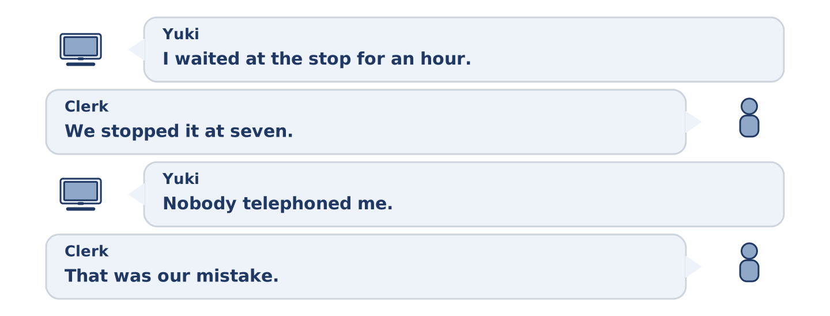
Figure 5.31 · The 7B exchange: who takes each turn.
🔊 Audio Track 5.5
Before you read: what do you say when somebody has wasted your morning?
Yuki: I waited at the stop for an hour. Nobody came. Clerk: I am very sorry. We stopped it at seven. The driver was ill. Yuki: Nobody telephoned me. Clerk: No. We only had your email, and I think it went to the wrong place. That was our mistake. Yuki: It was a cold hour. Clerk: I know. Shall I move you to next Saturday and take off the cost of this one? Yuki: Yes. Thank you for being straight about it.
Answer the questions. (0. is done.)
- How long did Yuki wait? — An hour.
- Why did the trip not run?
- Why did nobody telephone Yuki?
- What does the clerk offer?
7C: Controlled Practice — When a Plan Falls Through
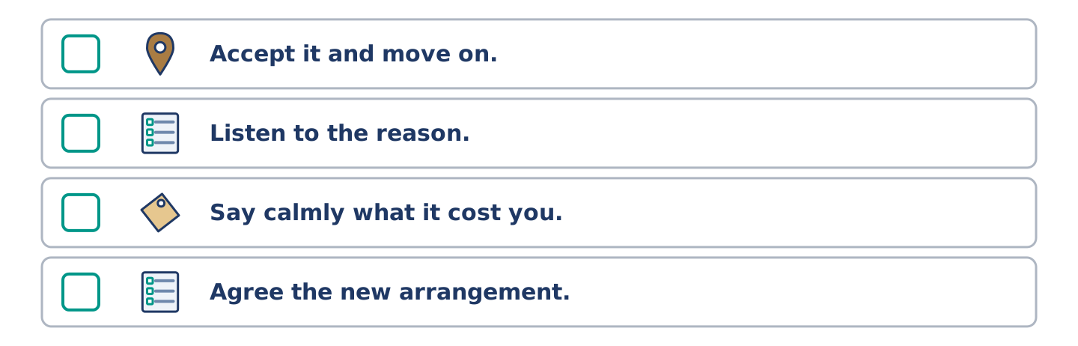
Figure 5.32 · The steps still to be numbered, as the task prints them.
Put the steps in order. Number them 1–5. (0. is done.)
- Say what happened to you. — 1
____ Accept it and move on.
____ Listen to the reason.
____ Say calmly what it cost you.
____ Agree the new arrangement.
7D: Role-Play — Sorting Out a Lost Morning
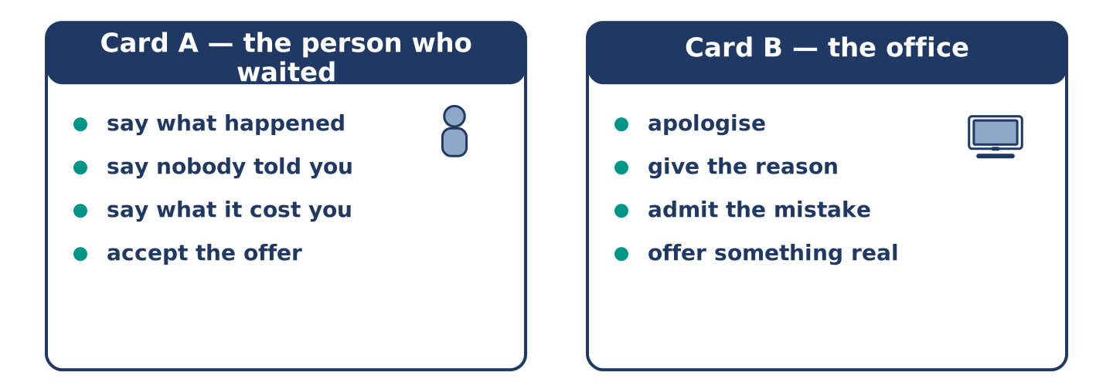
Figure 5.33 · The 7D cards: what each of you has to say.
In pairs. One waited; one works in the office. Use the model and cards.
Model exchange: A: I waited an hour and nobody came. — B: I am very sorry. We stopped it at seven. — A: Nobody told me. — B: That was our mistake. — A: It was a cold hour. — B: I know. Shall I move you to next Saturday and take off the cost? — A: Yes, thank you.
Card A — the person who waited: say what happened · say nobody told you · say what it cost you · accept the offer.
Card B — the office: apologise · give the reason · admit the mistake · offer something real.
Stretch [PLUS]: the office offers nothing at all — ask for something, once, and then decide what to do.
7E: Writing — A Message About a Lost Morning (50–80 words)
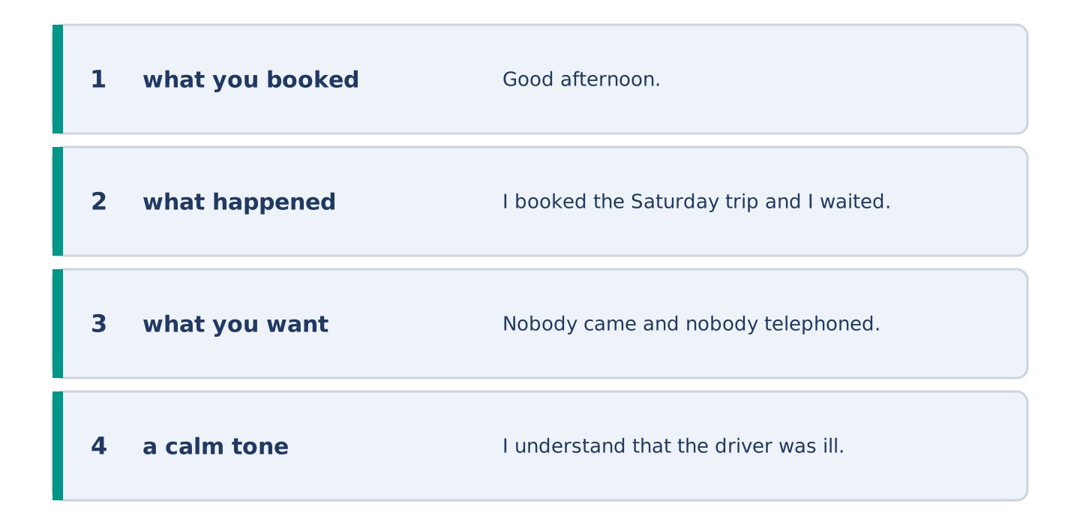
Figure 5.34 · The Part 7 note, with the model beside each line.
A plan did not happen and nobody told you. Write a short, calm message about it.
Model — read this first:
Good afternoon. I booked the Saturday trip and I waited at the stop from eight until nine. Nobody came and nobody telephoned. I understand that the driver was ill and that these things happen, but I gave you a number as well as an email. Could you move me to next Saturday? And please use the number next time. Thank you. Yuki Tanaka (63 words)
Check before you finish: ☐ what you booked? ☐ what happened? ☐ what you want? ☐ a calm tone? ☐ 50–80 words?
Part 8 · Global Story — The Country That Tried a Shorter Week
[PLUS] Plus track · pre-read / discuss
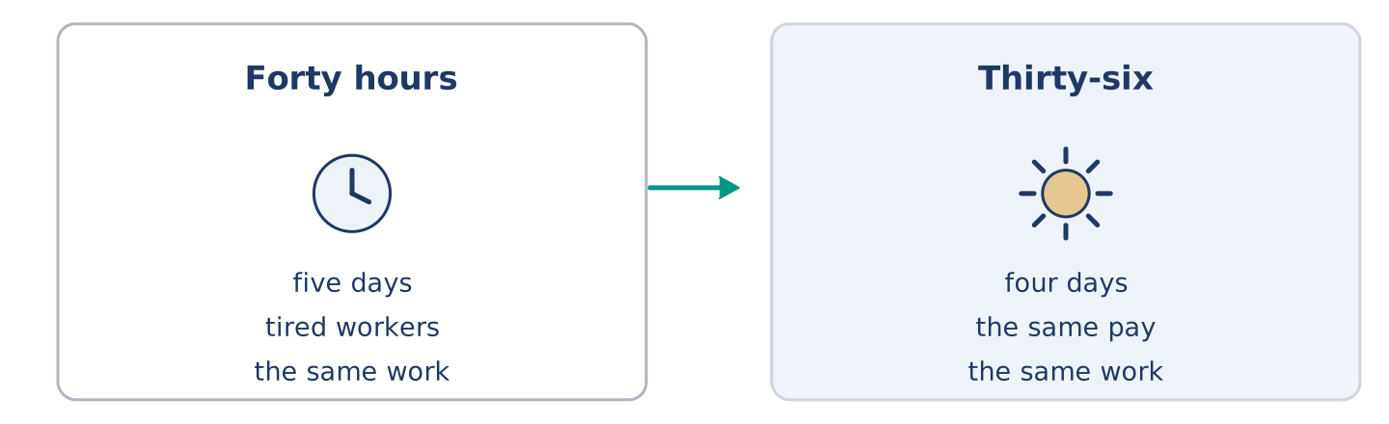
Figure 5.35 · Five days, and then four.
Before you read: would you work four days for the same money?
Gloss: trial = a test over a period of time · productivity = how much work gets done in an hour · burnout = being so tired from work that you cannot work well · union = a group that speaks for workers
Over four years Iceland ran one of the largest trials of a shorter working week. About one worker in every one hundred took part: nurses, office staff, people in schools and in city offices. They moved from forty hours to thirty-five or thirty-six, and they kept the same pay. One nurse said she got her Thursdays back. The question everybody asked was obvious. Would the work still get done? It did. Productivity stayed the same or improved in almost every place of work, and the reports showed a large drop in worry and burnout. The trial ended, and then something more interesting happened. The unions used the results, and in a few years most workers in the country won shorter hours. Iceland did not prove that four days suits everybody. It proved that the five-day week was a choice, and that a country can change its mind.
Answer the questions. (0. is done.)
- Which country ran the trial? — Iceland.
- How many hours did the workers move to?
- What happened to productivity?
- What did the unions do with the results?
Part 8: Vocabulary in Context
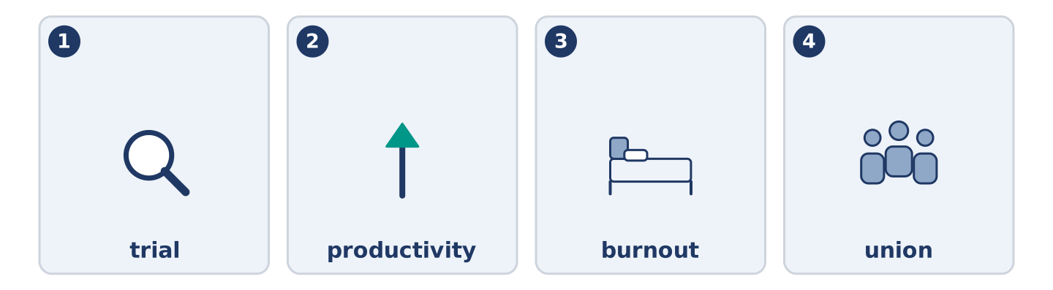
Figure 5.36 · The four words from the global story, drawn.
Match each word with its meaning. One meaning is not needed. Write the letter.
Column A
1. | trial | ____
2. | productivity | ____
3. | burnout | ____
4. | union | ____
Column B
a) | how much work gets done in an hour
b) | a group that speaks for workers
c) | a test over a period of time
d) | being so tired from work that you cannot work well
e) | a day when almost everybody is free
Part 8: Discussion
Talk with a partner. Use the frames.
Discussion frames: “This is similar to where I live because…” · “This is different from where I live because…” · “I think the most important thing is… because…”
Part 9 · Close to Home — Tomas and the Saturday He Missed
[PLUS] Plus track · pre-read / decide
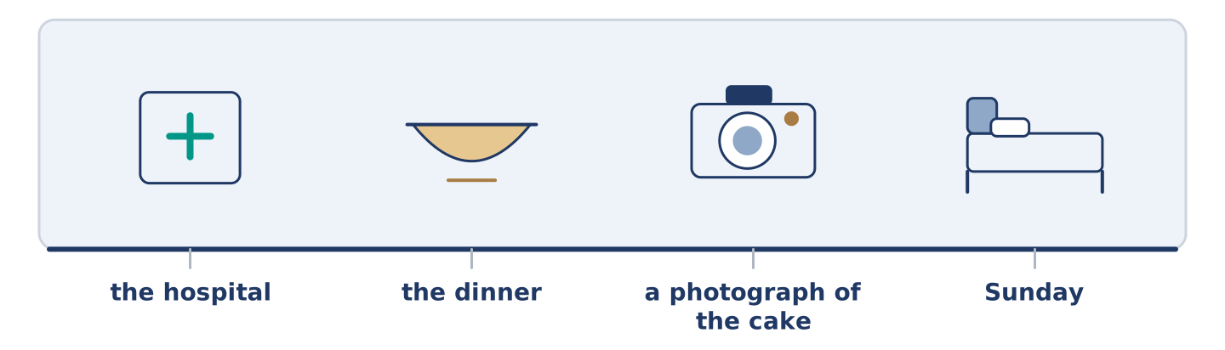
Figure 5.37 · The close-to-home reading, drawn along one street.
Before you read: what does a person lose when they work while everybody rests?
Tomas worked eleven of the last twelve Saturday nights. He does not complain about it, because he chose the hours and because the pay is better. But last Saturday was Maya’s birthday, and the dinner was at eight, and he was at the hospital by seven. He sent a message and a photograph of the cake. Everybody understood, and he went to work anyway. On Sunday he slept until four. Maya left him a plate of the dinner and did not wake him, and she says she would do it again. Mr Okonkwo was outside in his chair. In forty years of teaching, he said, he never once worked a Saturday. He does not know how anybody manages it. Tomas said he manages it by not counting. Then he asked what time the shop closed and went to buy milk. That was his weekend.
Answer the questions. (0. is done.)
- How many of the last twelve Saturday nights did Tomas work? — Eleven.
- Why does Tomas not complain about the hours?
- What did Tomas send instead of coming to the dinner?
- What did Mr Okonkwo say about his own forty years?
Part 9: Decision Task
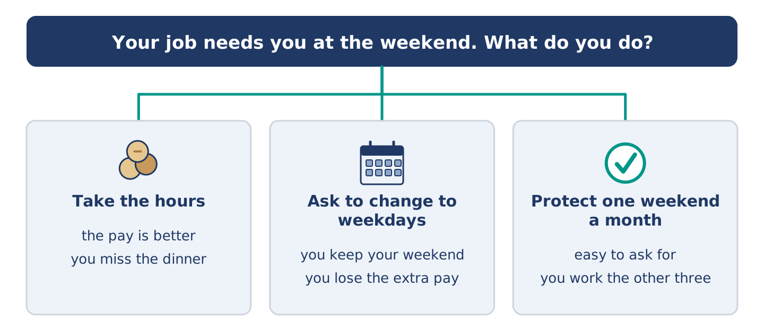
Figure 5.38 · Three ways to decide, and what each one costs.
Your job needs you at the weekend, and your friends are free then. Should you (a) take the hours and the better pay, (b) ask to change to weekdays, or (c) keep the hours but protect one weekend a month? Decide and explain. Use the frame.
Answer frame: “I think I should ___ because ___. Also, ___. This is better than ___ because ___.”
Model — read this first:
I think I should keep the hours but protect one weekend a month, because the money matters and so do the people. Also, one weekend is easy to ask for and hard to refuse. This is better than changing to weekdays, because I would lose the extra pay and I would miss the quiet of a night shift. (58 words)
Phrase bank: I think I should… · because… · Also,… · This is better than… · In my opinion…
Part 10 · Review and Can-Do
[CORE + PLUS] · homework / self-study
Part 10: Spiral Review
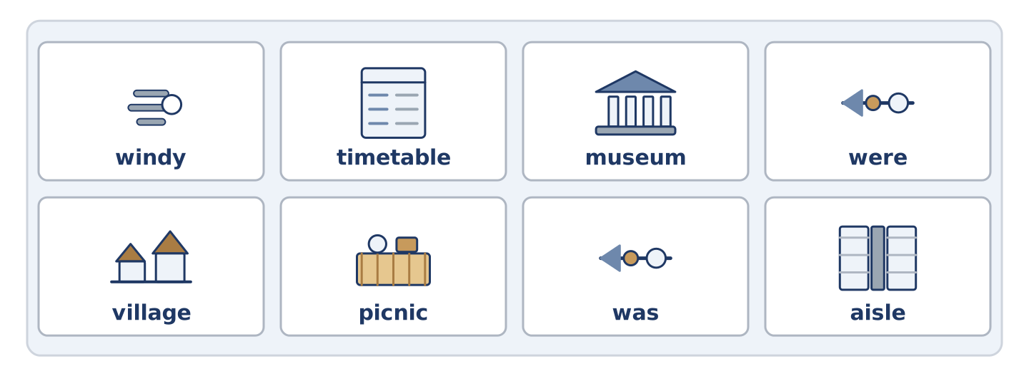
Figure 5.39 · The eight words of the review bank, in bank order.
Complete the review. (0. is done.)
- A narrow way you walk along is a path.
Word bank: windy | timetable | museum | were | village | picnic | was | aisle
- A building where you look at old or beautiful things is a ______________________ .
- A meal you eat outside, on the ground, is a ______________________ .
- A very small town is a ______________________ .
- With a strong moving air, the weather is ______________________ .
- Last Sunday ______________________ warm. (one day)
- The children ______________________ noisy by the lake. (more than one)
- (from Unit 4) The long space between two lines of shelves is an ______________________ .
- (from Unit 3) A list of the times buses come is a ______________________ .
Part 10: Can-Do
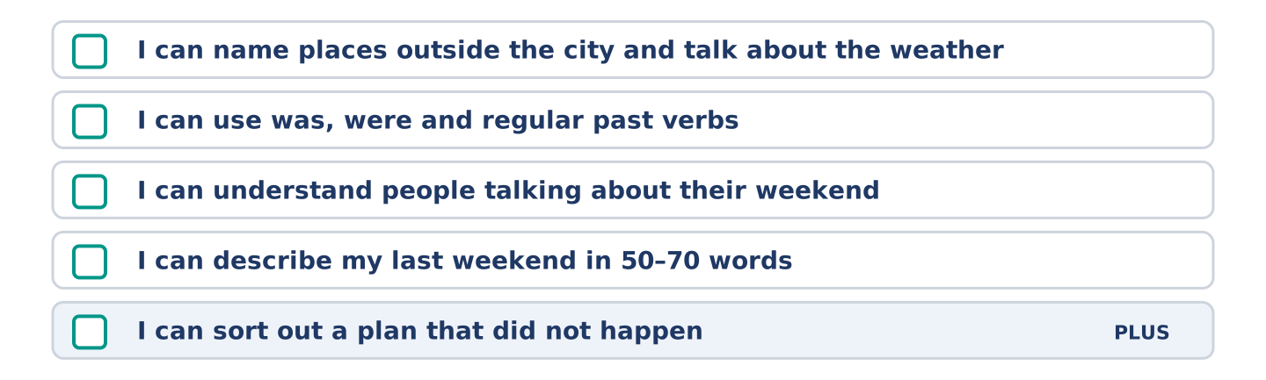
Figure 5.40 · What you can do at the end of this unit.
Can-Do checklist
☐ I can name places outside the city and talk about the weather.
☐ I can use was, were and regular past verbs.
☐ I can understand people talking about their weekend.
☐ I can describe my last weekend in 50–70 words.
☐ I can sort out a plan that did not happen (Plus).
Part 10: Glossary
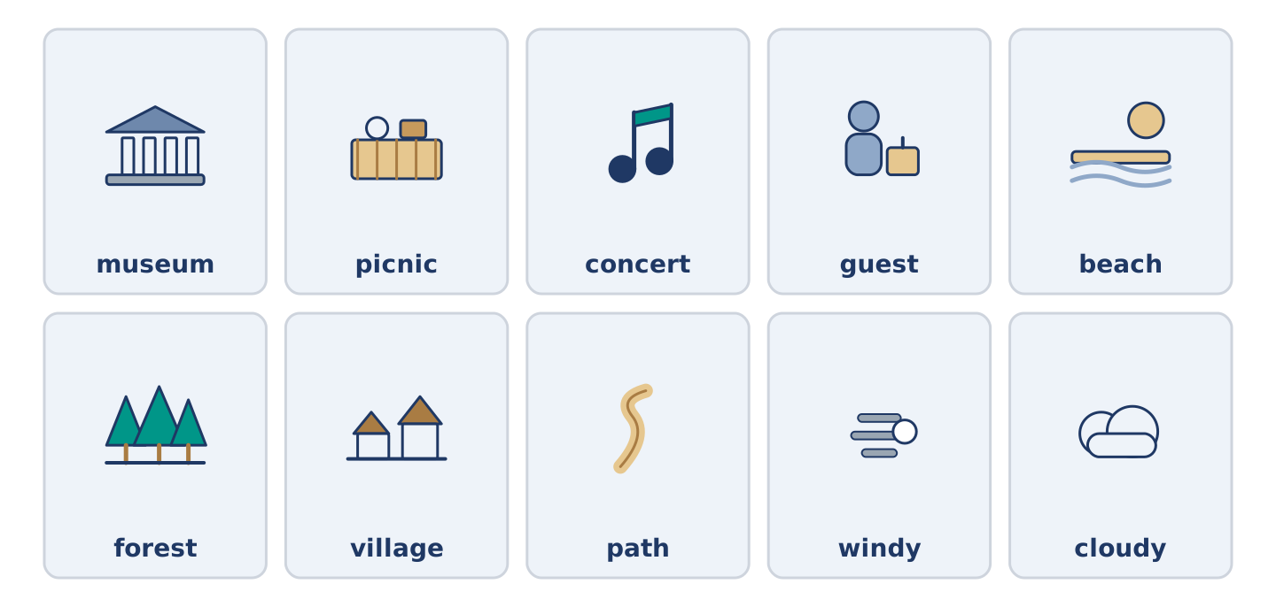
Figure 5.41 · All ten glossary words of Unit 5, one card each.
Unit 5 glossary (10 words)
museum · picnic · concert · guest · beach · forest · village · path · windy · cloudy

