Unit 10: Doing and Making
English for Daily Life · Level: A2 · Tracks: [CORE] Warm-Up + Parts 1–6 · [PLUS] Parts 7–10
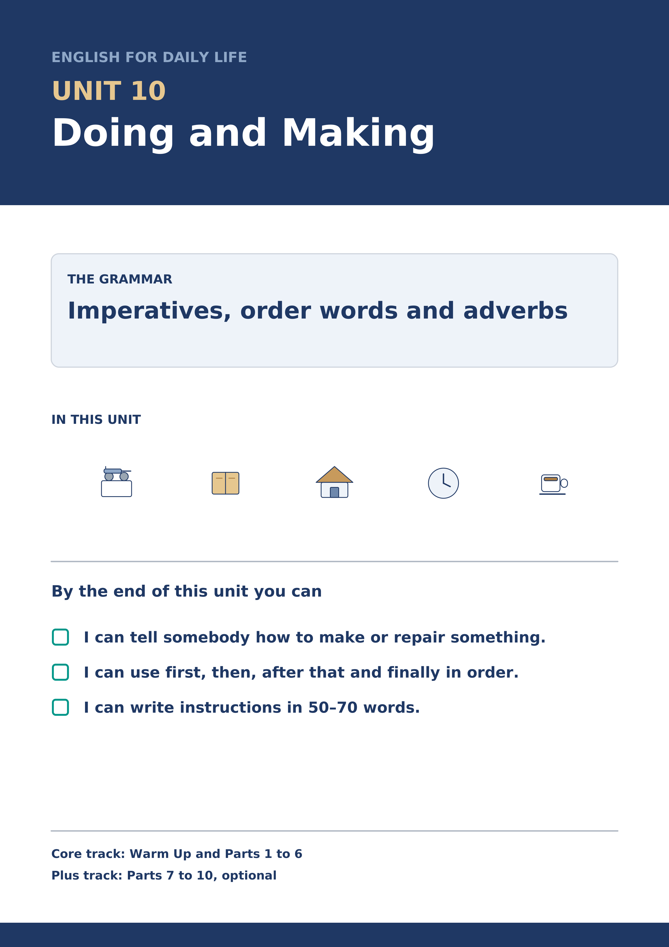
Warm Up
[CORE] Core track · in-class starter
Warm-up: Words for Doing and Making
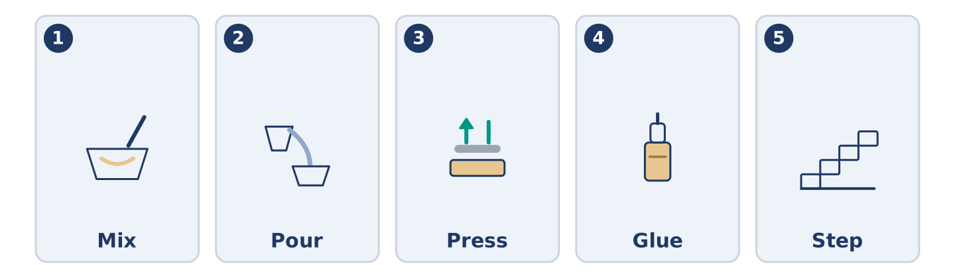
Figure 10.2 · The five warm-up words, and the thing each one means.
Match the words with their meanings. One meaning is not needed. Write the letter.
Column A
1. | Mix | ____
2. | Pour | ____
3. | Press | ____
4. | Glue | ____
5. | Step | ____
Column B
a) | to push down on something with your hand
b) | one of the things you do, in order
c) | to put two or more things together and turn them
d) | to stick two things so that they hold
e) | to tip a liquid out of one thing into another
f) | to cut something into two equal halves
Warm-up: Saying How Somebody Does It
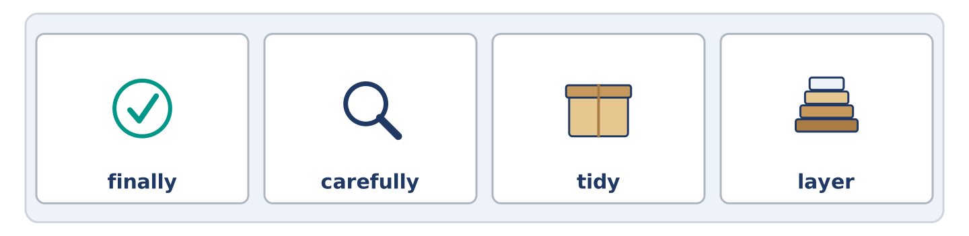
Figure 10.3 · The word bank for this task, in the order it is printed.
Complete the sentences using the words in the word bank.
Word bank: finally | carefully | tidy | layer
- Mr Okonkwo works slowly and very ______________________ , and he never has to start again.
- Dani cooks well and leaves a kitchen nobody could call ______________________ .
- Put one ______________________ of paper down, then the glue, then the next.
- Wait for it to dry, and ______________________ turn the whole thing over.
Warm-up: Six People, Six Things They Make
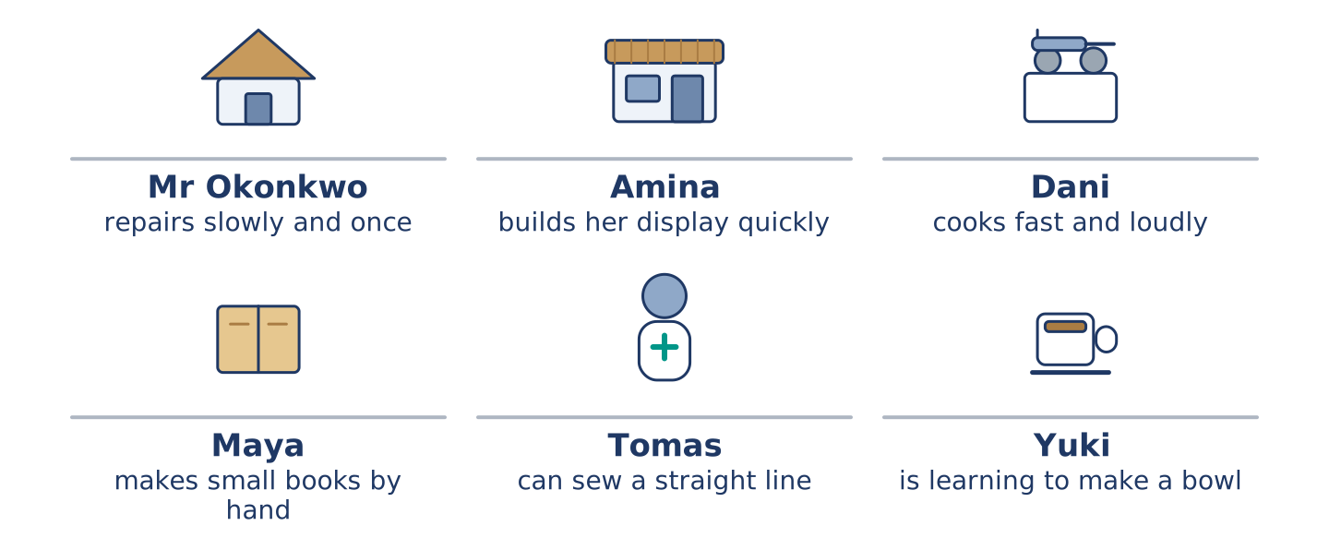
Figure 10.4 · What each of them makes or repairs, and how.
Read the text and choose the correct answer.
Everybody at number 14 makes something, and they all do it differently. Mr Okonkwo works slowly and carefully, and what he repairs outlasts everybody who stood and watched. Amina builds her window display quickly, because the shop is open while she works. Dani cooks fast and loudly and cleans up badly. Maya makes small books by hand, one at a time. Tomas can sew a straight line because his work taught him. Yuki is learning to make a bowl, and she threw the first four away.
1. Who repairs slowly and carefully?
○ A) Amina
○ B) Dani
○ C) Mr Okonkwo
○ D) Tomas
2. Why does Amina build her display quickly?
○ A) She does not like the work
○ B) She is not very good at it
○ C) Somebody is waiting for it
○ D) The shop is open while she works
Part 1 · Vocabulary and Terminology
[CORE] Core track · pre-class input
Part 1: Words for Making and Repairing
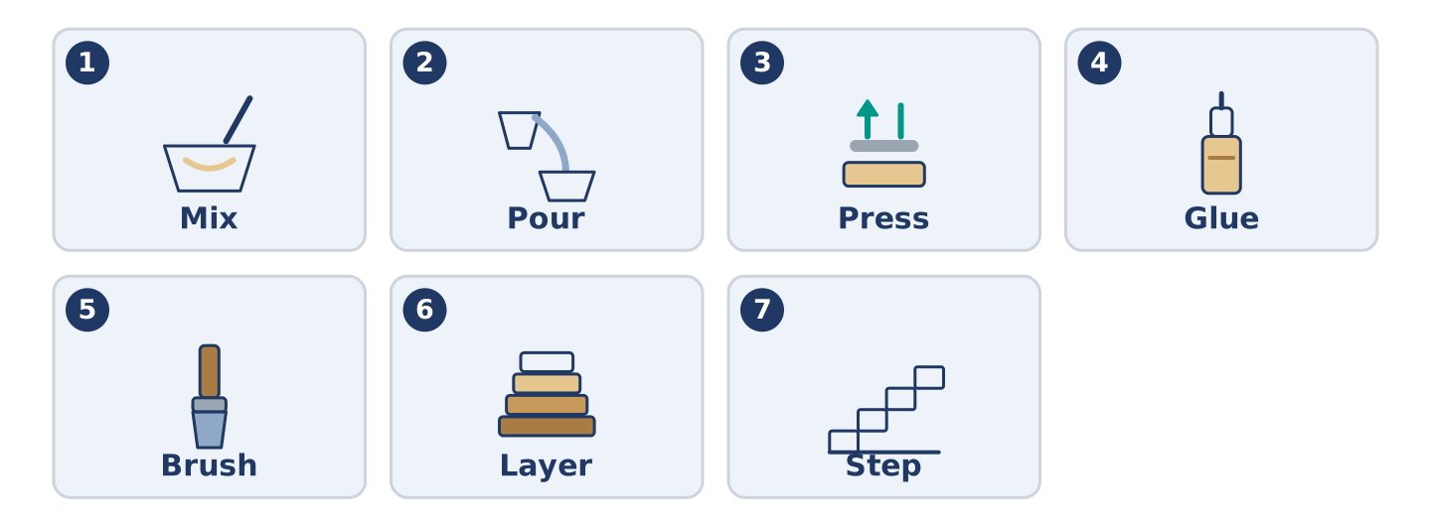
Figure 10.5 · The seven words of Column A, and what each one is.
Match the words with their meanings. One meaning is not needed. (0. is done for you.)
- Tidy → to put things back where they belong, so the place is clear.
Column A
1. | Mix | ____
2. | Pour | ____
3. | Press | ____
4. | Glue | ____
5. | Brush | ____
6. | Layer | ____
7. | Step | ____
Column B
a) | to put two or more things together and turn them
b) | one of the things you do, in order
c) | a thin flat covering, with another one over it
d) | to stick two things so that they hold
e) | to tip a liquid out of one thing into another
f) | to move a brush across something
g) | to push down on something with your hand
h) | to weigh something before you buy it
Gloss: layer = a thin flat covering, with another one over it · glue = something that sticks two things together · step = one of the things you do, in order · instruction = a sentence telling you what to do · edge = the line where something stops
Part 1: Pronunciation
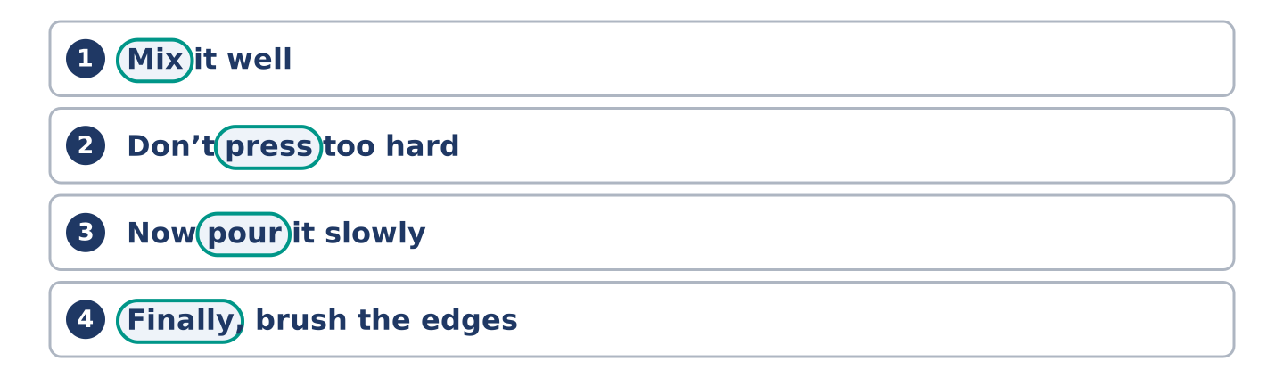
Figure 10.6 · Where the stress falls in 0 words of this unit.
🔊 Audio Track 10.1
Listen to these instructions. Say each one aloud, then say it to a partner.
Mix it well — the verb comes first and takes the beat
Don’t press too hard — the beat moves onto the verb again
Now pour it slowly — now is small, pour is big
Finally, brush the edges — two beats, one for each
An instruction in English starts with its verb, and the verb takes the beat. That is how a listener knows it is an instruction and not a statement. Say the verb clearly and the small words around it quickly, and your partner can follow you with their hands while you talk.
Part 1: Four Things People Make
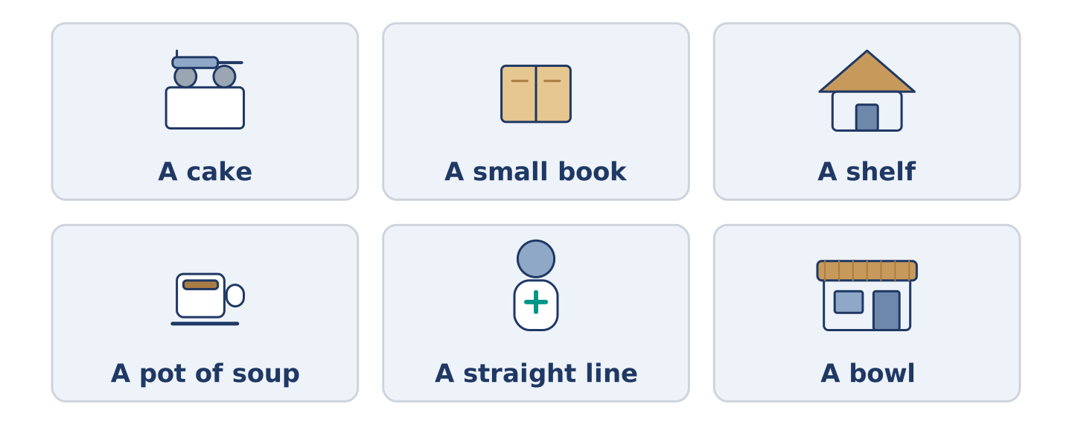
Figure 10.7 · Four things people make, and what each one needs.
Complete the table. Write what you need and the first step. (0. is done.)
What you make | What you need | The first step
A cake | a bowl, a spoon, an oven | (example)
A small book
A shelf
A teapot of soup
- A cake — a bowl, a spoon, an oven — mix the dry things first.
Think about something you have made. There is more than one right answer; be ready to say why.
Part 1: Order the Steps
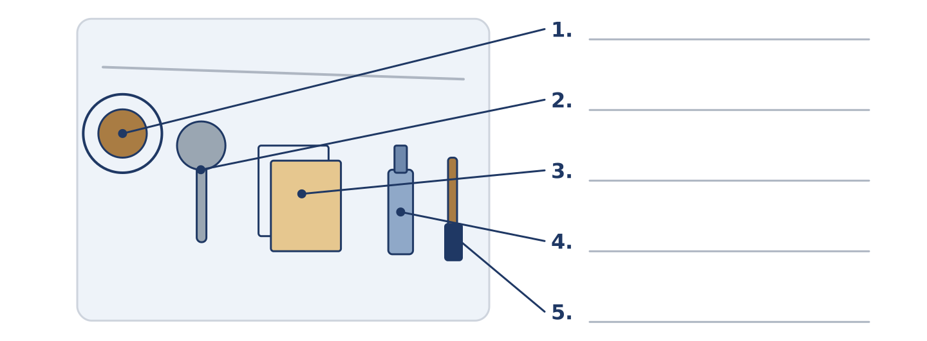
Figure 10.8 · The order of work — write the correct word on each line.
Match the order words with what they do. One meaning is not needed. Write the letter.
Column A
1. | First | ____
2. | Then | ____
3. | After that | ____
4. | Finally | ____
5. | While | ____
Column B
a) | the step that comes straight after the one before
b) | at the same time as something else
c) | the step before everything else
d) | one more step, later in the order
e) | the step that comes before the one before
f) | the last step of all
Part 1: Making — Multiple Choice
Read and choose the correct answer.
1. To put two or more things together and turn them is to…
○ A) mix
○ B) press
○ C) pour
○ D) brush
2. A thin flat covering, with another one over it, is a…
○ A) step
○ B) brush
○ C) layer
○ D) glue
3. The word for the last step of all is…
○ A) first
○ B) finally
○ C) while
○ D) then
Part 1: Vocabulary Fill-in
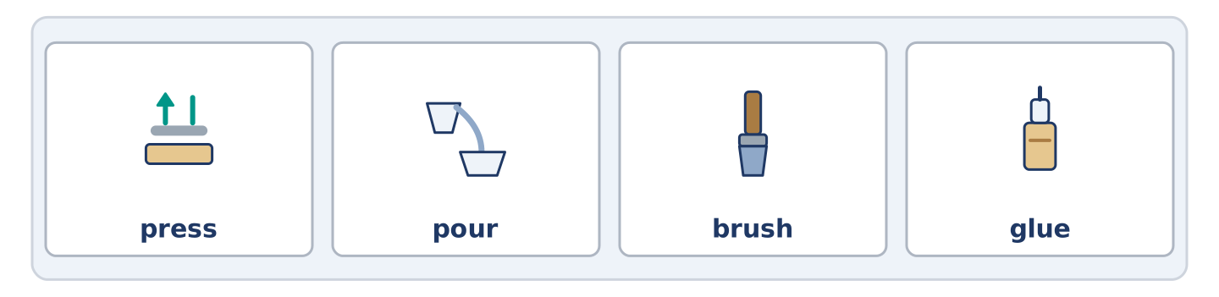
Figure 10.9 · The four words of the bank, in the order the task gives them.
Complete the sentences with the correct word.
Word bank: press | pour | brush | glue
- ______________________ the water slowly, or it goes everywhere.
- ______________________ the two edges together and count to twenty.
- Use a little ______________________ , not a lot; a lot takes a day to dry.
- ______________________ the dust off before you start.
Part 1: Write Instructions (short)
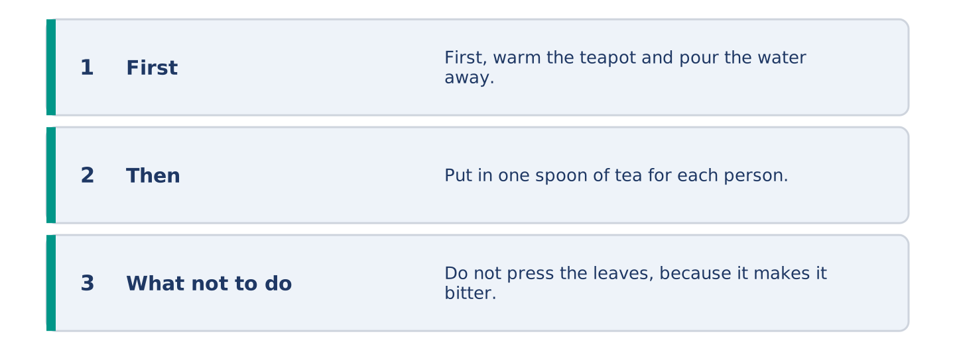
Figure 10.10 · The shape of your two or three sentences, with the model beside each step.
Write two or three sentences telling somebody how to make something simple. Use three words from this unit.
Model — read this first:
First, warm the teapot and pour the water away. Put in one spoon of tea for each person and pour the water on. Wait four minutes, and do not press the leaves, because pressing them makes it bitter. (38 words)
Part 2 · Grammar — Imperatives, Sequencers and Adverbs
[CORE] Core track · pre-class input
Part 2: Notice
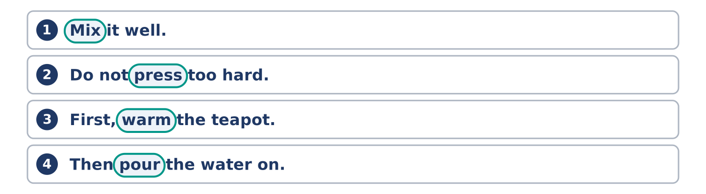
Figure 10.11 · Lines from the notice, with the target form ringed in each.
Read these lines. Underline the verbs that give an order. Which words give the order, which say when, and which say how?
Mix it well. Do not press too hard. First, warm the teapot. Then pour the water on. After that, wait four minutes. Finally, brush the edges carefully. Work slowly and you only do it once.
Three of these say when. Two say how. The rest give the order itself.
Part 2: Grammar Focus Box
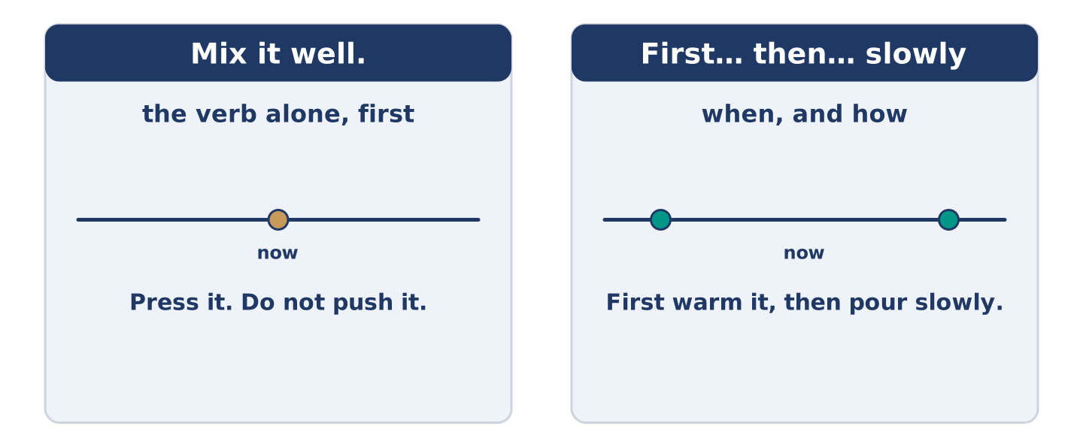
Figure 10.12 · An order, a sequence and a manner: three jobs, three places in the sentence.
 | Form | Use | Example
imperative | the verb alone, no subject | telling somebody to do it | Mix it well.
negative | do not + the verb alone | telling them not to | Do not press too hard.
order words | first, then, after that, finally | the order of the steps | First, warm the teapot.
adverbs | adjective + -ly | how to do it | Pour it slowly.
Remember: an instruction has no you: Mix it well, not You mix it well.
Watch out! ✗ Don’t to press it. → ✓ Do not press it. (no to after do not). ✗ Pour it careful. → ✓ Pour it carefully. (an adverb, not an adjective, after the verb).
Part 2: Controlled Practice
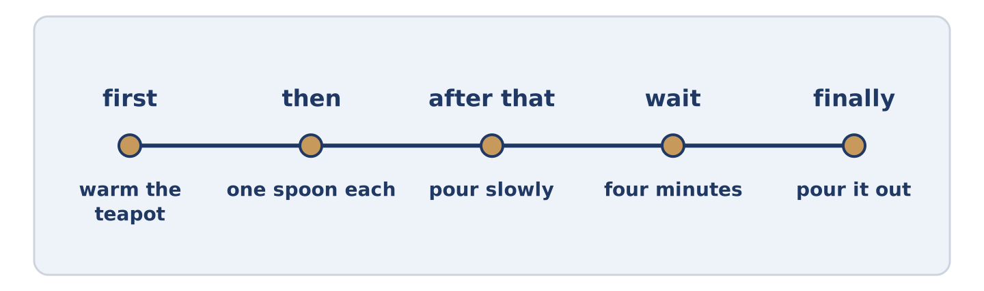
Figure 10.13 · One job, from the first step to the last.
Complete with first, then, after that, finally or do not. (0. is done.)
- First, warm the teapot.
- ______________________ pour the water on.
- ______________________ , wait four minutes.
- ______________________ press the leaves.
- ______________________ , pour it out.
Part 2: Order, When or How?
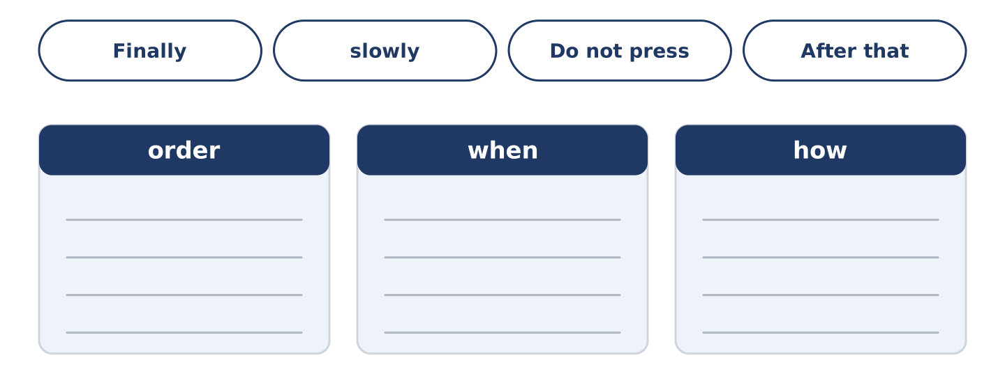
Figure 10.14 · The items of this task, and the bins they sort into.
Write order, when or how. (0. is done.)
- Mix it well. — order
- Finally, brush the edges. ____________
- Work slowly. ____________
- Do not press too hard. ____________
- After that, wait four minutes. ____________
Part 2: Correct the Sentence
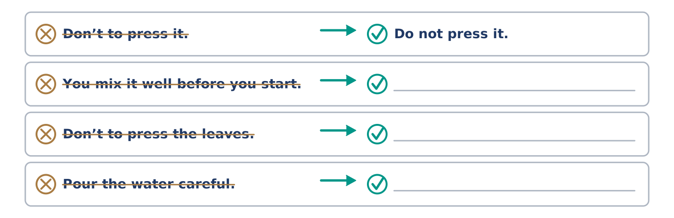
Figure 10.15 · One correction done for you, and the rest to write.
Each sentence has one grammar mistake. Write the correct sentence.
- You mix it well before you start.
- Don’t to press the leaves.
- Pour the water careful.
- After that you leave it dry.
Part 2: Freer Practice
Write two instructions for somebody in your kitchen: one telling them to do something, one telling them not to.
Part 2: Grammar Review
Choose the correct sentence.
1. Which instruction is correct?
○ A) You press the two edges together.
○ B) To press the two edges together.
○ C) Pressing the two edges together.
○ D) Press the two edges together.
2. Which sentence says how to do it?
○ A) Pour the water first.
○ B) Pour the water after that.
○ C) Pour the water carefully.
○ D) Pour the water finally.
→ Harvest: you will see imperatives and order words again in the Part 5 reading. Watch for them.
Part 3 · Listening
[CORE] Core track · pre-class input · scripts printed inline
Part 3: A First Lesson in Making Something
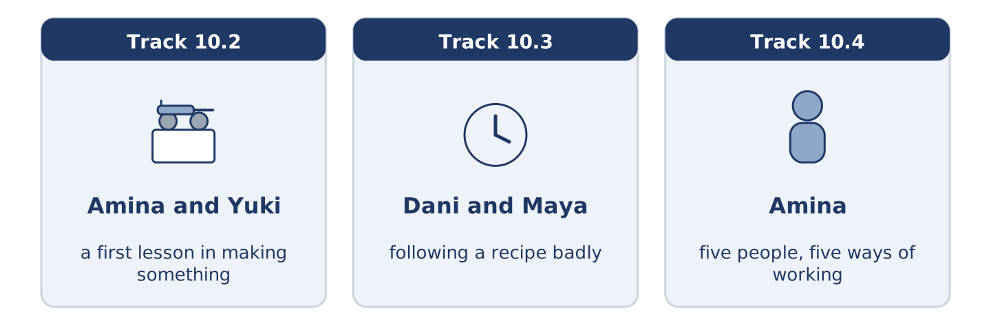
Figure 10.16 · The three listenings: who is speaking, and what about.
🔊 Audio Track 10.2
Before you listen: who taught you to make the first thing you ever made?
Amina: Right. Wash your hands, then dry them properly. Yuki: They are dry. Amina: They aren’t. Flour sticks to wet hands and then nothing works. Now, mix the dry things first. Yuki: All of them? Amina: All of them, and mix them well. Then pour in the water, slowly, with the other hand turning. Yuki: It’s too wet. Amina: It’s meant to be. Don’t add flour, whatever you do. Everybody adds flour and everybody is wrong.
While you listen: write True, False, or Not Given. (0. is done.)
- Amina tells Yuki to wash her hands. — True
- Amina says to mix the wet things first. ____
- Amina tells her not to add flour. ____
- Yuki made this with her mother. ____
Useful phrases: Wash your hands · mix the dry things first · pour it slowly · Don’t add…
Part 3: Following a Recipe Badly
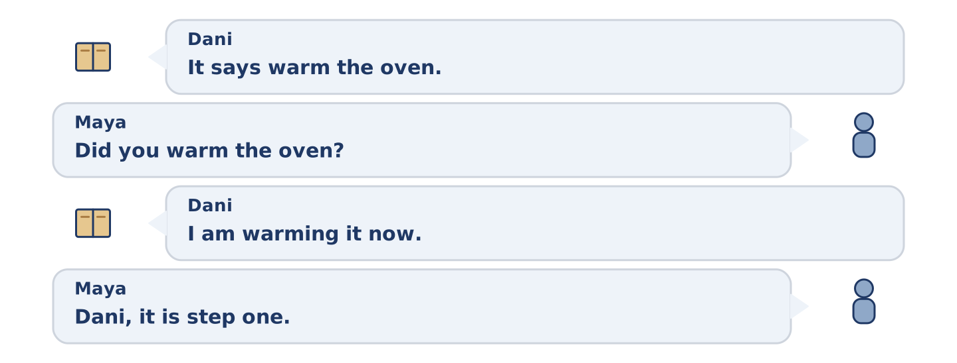
Figure 10.17 · The second listening, turn by turn.
🔊 Audio Track 10.3
Before you listen: do you read all of a recipe before you start?
Dani: It says warm the oven. Maya: Did you warm the oven? Dani: I am warming it now. Maya: Dani, it is step one. Dani: It is step one of thirteen and I am on step four. Maya: What is step four? Dani: Pour it into the dish. Maya: Which dish? Dani: There is a dish in step two. Maya: So read step two. Dani: I read all of them at the start. Maya: You looked at all of them.
Answer the questions. (0. is done.)
- What does step one say? — Warm the oven.
- Which step is Dani on?
- What does step four tell him to do?
- What does Maya say he did at the start?
Part 3: Five People, Five Ways of Working
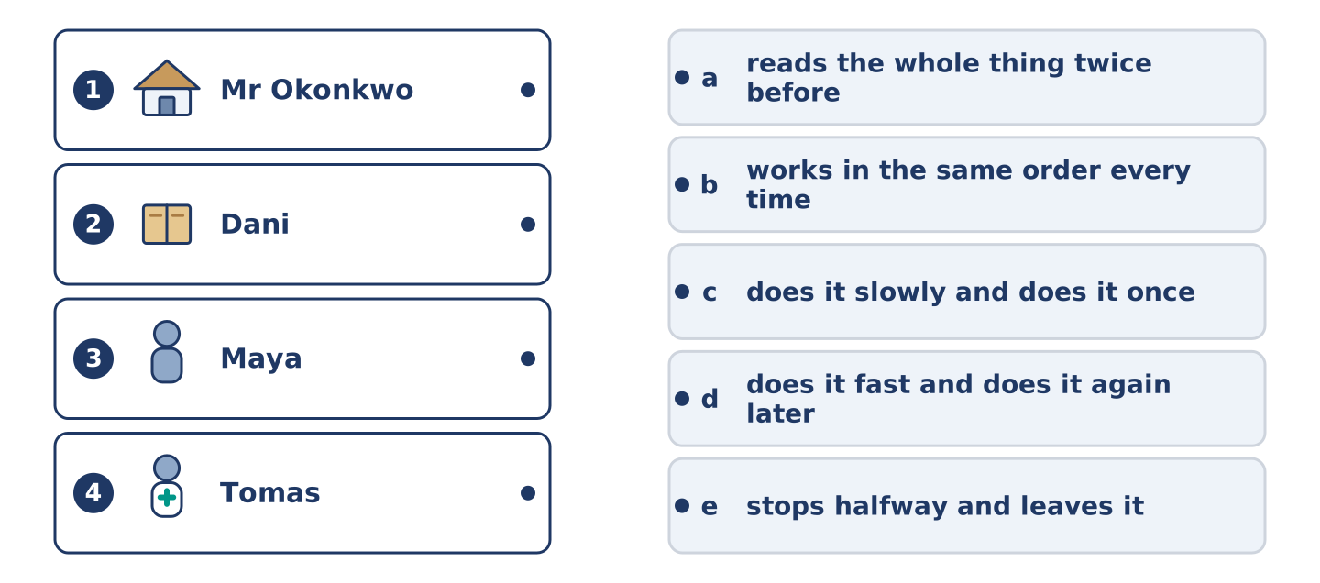
Figure 10.18 · Four on the left, five on the right, and one spare.
🔊 Audio Track 10.4
Before you listen: do you work quickly and repair it later, or slowly and once?
Amina: I watch them all come through the shop, and every one of them works differently. Mr Okonkwo does it slowly and does it once. Dani does it fast and does it again on Sunday. Maya reads the whole thing twice before she touches anything. Tomas works in the same order every time, because that is how they taught him. Yuki asks me first, and I never mind, because asking first is cheaper than starting again.
While you listen: match each person with the way they work. One is not needed. (0. is done.)
- Amina → she watches them all come through.
Useful phrases: ___ does it once · ___ reads it twice · ___ asks first
Column A
1. | Mr Okonkwo | ____
2. | Dani | ____
3. | Maya | ____
4. | Tomas | ____
Column B
a) | reads the whole thing twice before starting
b) | works in the same order every time
c) | does it slowly and does it once
d) | does it fast and does it again later
e) | stops halfway and leaves it
Part 4 · Speaking
[CORE] Core track · in-class output
Part 4: How You Make Things
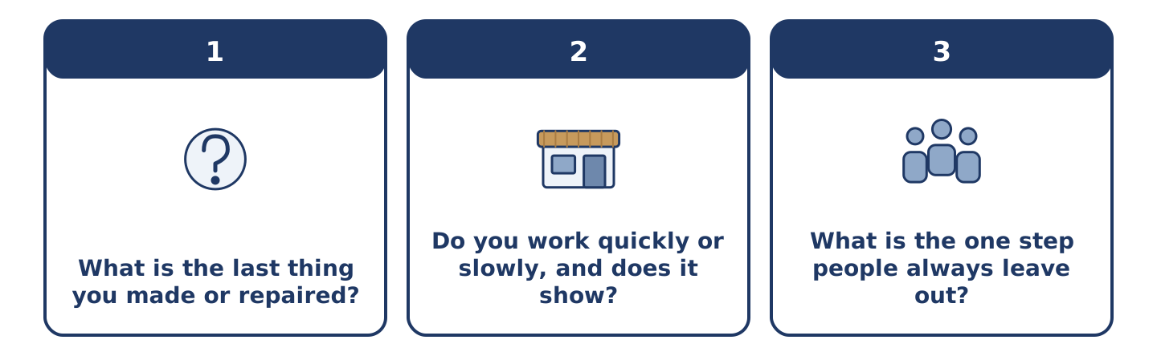
Figure 10.19 · The three questions as cards, to take one at a time.
Work with a partner. Ask and answer these questions.
- What is the last thing you made or repaired?
- Do you work quickly or slowly, and does it show?
- What is the one step people always leave out?
Useful language: First I… · Then I… · carefully · Don’t…
Part 4: Find the Difference (pairwork)
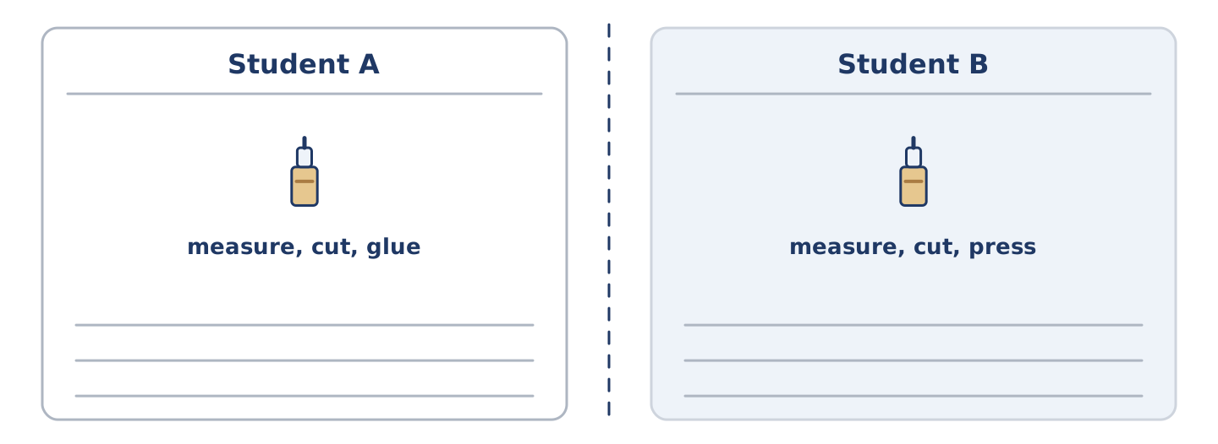
Figure 10.20 · Student A’s facts and Student B’s, with a fold between them.
Student A and Student B each have the steps for the same job, in a different order. Ask questions and find three differences.
Useful questions: What is step one? · What comes after that? · Do you press it or glue it? · Is that the last step?
Student A — your steps: measure, cut, glue, press, leave it to dry.
Student B — your steps: measure, cut, press, glue, brush the edges.
Part 4: Teaching Somebody a Job
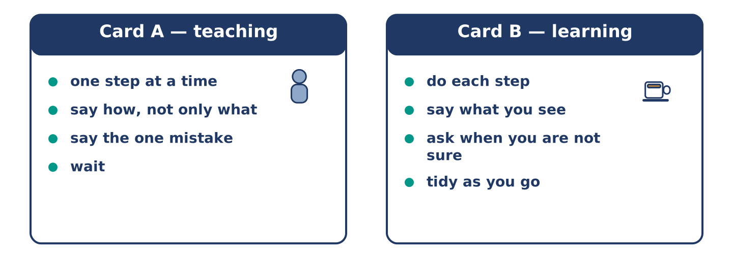
Figure 10.21 · Card A and Card B: what each of you has to say.
Work in pairs. Read the model, then use the cards.
Model exchange:
A: Right — wash your hands and dry them properly. — B: They are dry. — A: They are not. Now mix the dry things first. — B: All of them? — A: All of them. Then pour the water in slowly. — B: It is too wet. — A: It is meant to be. Don’t add flour.
Useful language: Right… · First… · Then… · Don’t…
Card A — teaching: one step at a time · say how, not only what · say the one mistake everybody makes · wait.
Card B — learning: do each step · say what you see · ask when you are not sure · do not run ahead.
Your turn: run the dialogue, then swap roles.
Stretch [PLUS]: your partner did the step wrong — say so without taking it off them.
Part 4: Mini-Presentation
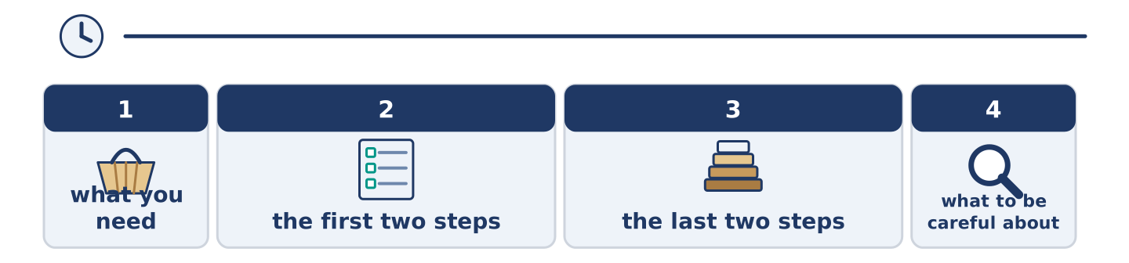
Figure 10.22 · The one-minute talk as 0 beats, each as wide as its share.
Prepare a short talk (about one minute). Teach the class to make or repair something, in four steps.
Part 5 · Reading
[CORE] Core track · pre-class input
Part 5: Why Instructions Are So Hard to Write
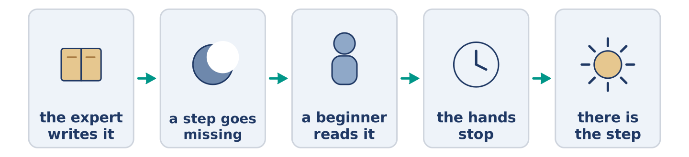
Figure 10.23 · One job, written badly and written well.
Before you read: have you ever followed instructions that left a step out?
Gloss: expert = somebody with years of practice · obvious = so clear that nobody says it · assume = to think something is true without checking · draft = an early try, before the last one
Ask an expert to write down how they do a thing, and watch them leave steps out. They are not being lazy. The missing steps are the ones they stopped seeing years ago, because the hand does them without asking. A baker writes knead the dough and assumes everybody knows how hard. A carpenter writes fix the shelf to the wall and never says which goes in first. The step that is obvious to the writer is the one the reader needs most. The best instructions in the world are usually written by somebody who learned the job last year and still remembers not knowing. Give the first draft to a beginner and watch their hands, not their face. The place where the hands stop is the missing step.
Answer the multiple-choice questions. (0. is done.)
- What do experts do when they write instructions? — They leave steps out.
1. Why do experts leave steps out?
○ A) They stopped seeing those steps years ago
○ B) They are lazy
○ C) They want to keep the skill
○ D) They write too fast
2. Who writes the best instructions?
○ A) The fastest worker
○ B) The oldest expert
○ C) A teacher
○ D) Somebody who learned the job last year
3. What does the text say to watch?
○ A) Their face
○ B) Their hands
○ C) The clock
○ D) The first step
Part 5: Vocabulary in Context
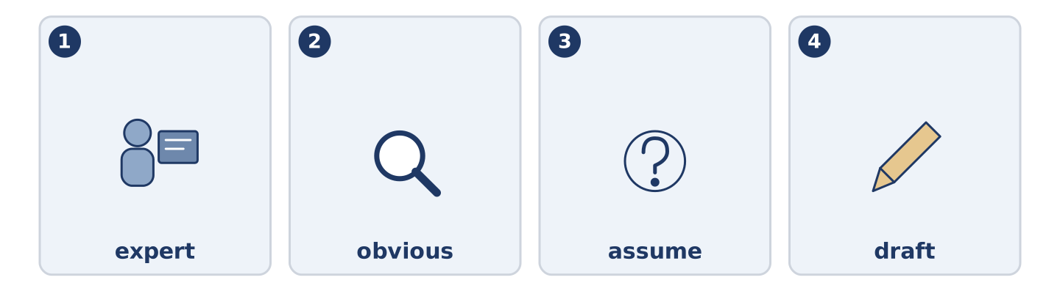
Figure 10.24 · The four words from the reading, drawn.
Match each word from the text with its meaning. One meaning is not needed. Write the letter.
Column A
1. | expert | ____
2. | obvious | ____
3. | assume | ____
4. | draft | ____
Column B
a) | so clear that nobody says it
b) | somebody with years of practice
c) | an early try at something, before the last one
d) | to think something is true without checking
e) | the last step of all
Part 5: Three Ways of Writing an Instruction
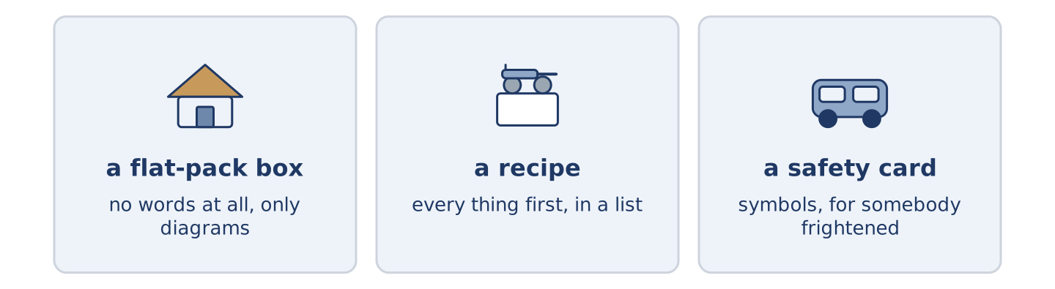
Figure 10.25 · Three kinds of instruction, and who each one is for.
Before you read: can an instruction work with no words at all?
Gloss: diagram = a drawing that explains · translate = to put into another language · symbol = a small picture that stands for a word · recipe = written steps for cooking one thing
People build an instruction in very different ways. A flat-pack company in Sweden decided years ago to use no words at all, only diagrams. The same box goes to fifty countries, and nobody wants to translate it fifty times. A recipe does the opposite. It names every thing first, in a list, and only then tells you what to do. Nothing is missing by the time your hands are too dirty to turn a page. The safety card in the seat in front of you uses symbols and almost no reading. It has to work for a frightened person in a hurry. Each one chose its form from its reader. That is the whole art of it.
Answer the questions. (0. is done.)
- Do all instructions use words? — No, they do not.
- Why does the flat-pack company use only diagrams?
- What does a recipe name first?
- Why does the safety card use symbols?
Part 6 · Writing
[CORE] Core track · in-class / homework
Part 6: How to Make Something (50–70 words)
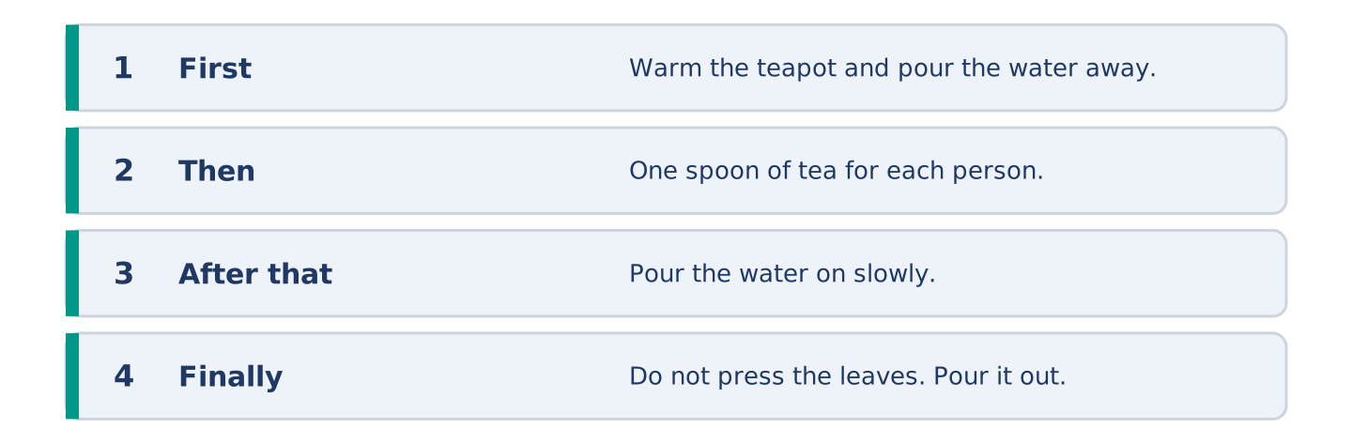
Figure 10.26 · The shape of the instructions you are about to write.
Write instructions for something simple you can make. Use order words and at least two -ly words.
Model — read this first:
First, warm the teapot with hot water and pour the water away. Put in one spoon of tea for each person, then pour the boiling water on slowly. Leave it for four minutes. Do not press the leaves, however late you are, because pressing them makes the whole teapot bitter. Finally, pour it out and drink it while it is hot. (61 words)
Plan (fill in, then write): First, ___. Then ___. After that, ___. Do not ___. Finally, ___.
Word bank: first | then | after that | finally | carefully | do not
Check before you finish: ☐ four steps in order? ☐ two adverbs? ☐ one do not? ☐ 50–70 words?
Part 6: Quickly or Slowly? (50–70 words)
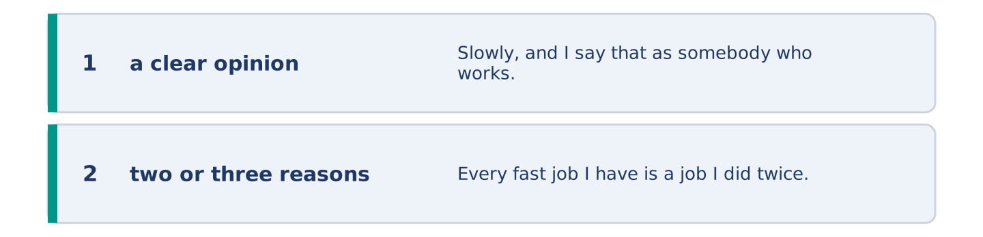
Figure 10.27 · The shape of the opinion paragraph, step by step.
Is it better to work quickly and repair it later, or slowly and once? Give your opinion and two or three reasons.
Model — read this first:
Slowly, and I say that as somebody who works quickly. Every fast job I have is a job I did twice. The second time is never quicker than doing it properly was, and it is always at a worse moment. The only real argument for speed is that a slow job is sometimes never finished at all. (57 words)
Word bank: I think… because… | quickly | however | in my opinion | it depends on
Check before you finish: ☐ a clear opinion? ☐ two or three reasons? ☐ 50–70 words?
Part 6: Instructions That Went Wrong (50–70 words)
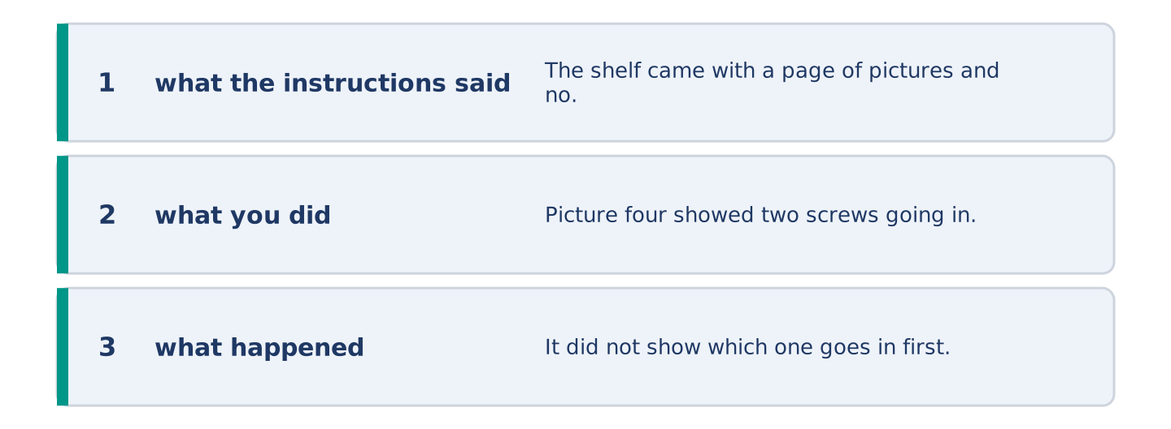
Figure 10.28 · The moves of the message, with a line of the model for each.
Write about a time you followed instructions and it went wrong. Say what the instructions said and what happened.
Model — read this first:
The shelf came with a page of pictures and no words. Picture four showed two screws going in. It did not show which one goes in first, and I chose wrongly. The shelf held for a week and then came off the wall at four in the morning, carefully taking the paint with it. (54 words)
Plan (fill in, then write): The instructions said ___. I ___. Then ___. In the end ___.
Check before you finish: ☐ what the instructions said? ☐ what you did? ☐ what happened? ☐ 50–70 words?
Part 6: Reflection — Something I Can Make (40–60 words)
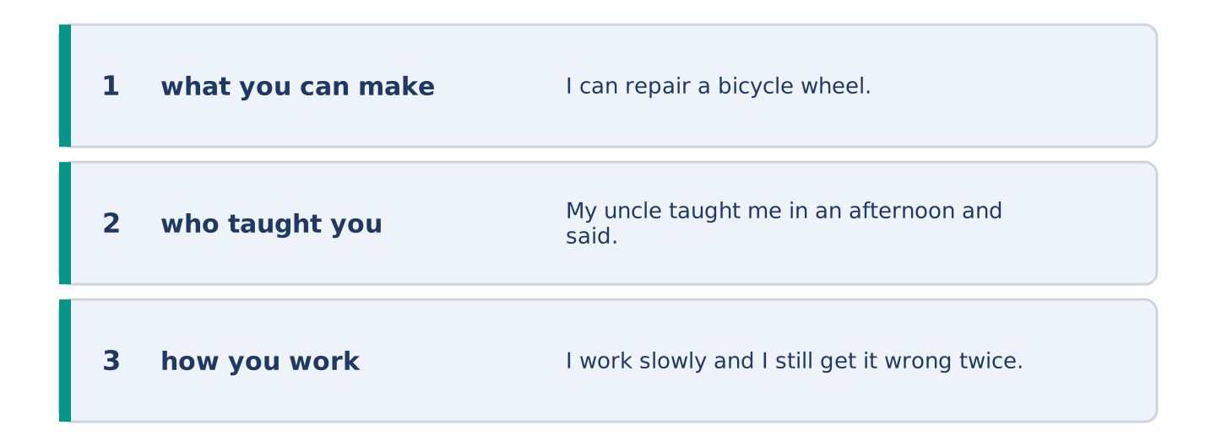
Figure 10.29 · The reflection, step by step.
Write about one thing you can make or repair. Say who taught you and how you work.
Model — read this first:
I can repair a bicycle wheel, badly but well enough to get home. My uncle taught me in an afternoon and said nothing the whole time except again. I work slowly and I still get it wrong twice. The wheel always turns in the end. (45 words)
Check before you finish: ☐ what you can make? ☐ who taught you? ☐ how you work? ☐ 40–60 words?
Part 7 · Real-World File — Following and Giving Instructions
[PLUS] Plus track (optional) · stronger learners
7A: Phrase Bank
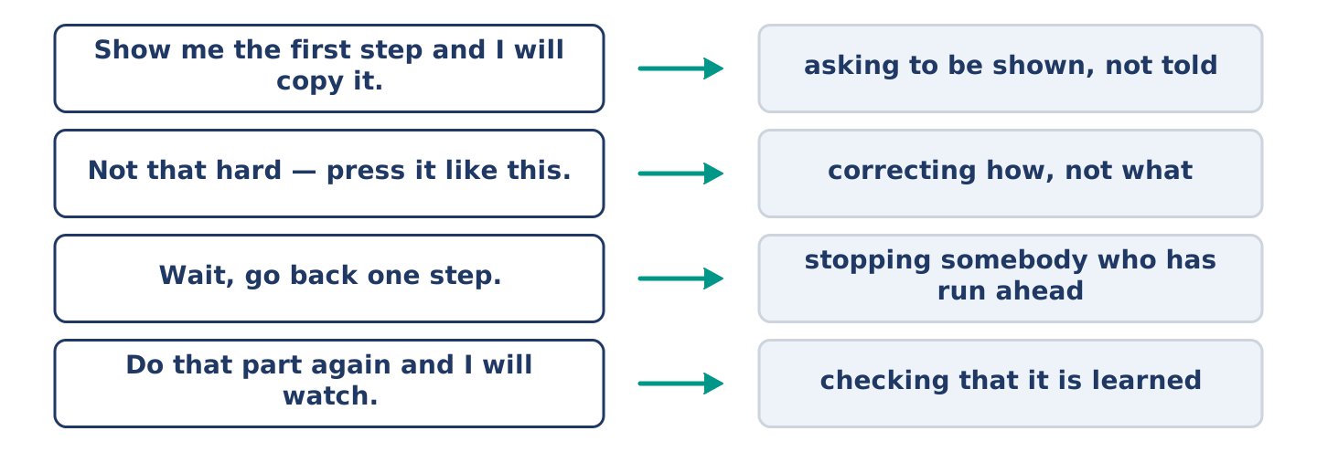
Figure 10.30 · What you say while you teach or learn a job, and what each line does.
Match what a person says with its purpose. One purpose is not needed. Write the letter.
Column A
1. | “Show me the first step and I will copy it.” | ____
2. | “Not that hard — press it like this.” | ____
3. | “Wait, go back one step.” | ____
4. | “Do that part again while I watch.” | ____
Column B
a) | correcting how, not what
b) | asking to be shown, not told
c) | asking how much it costs
d) | stopping somebody who has run ahead
e) | checking that it is learned
7B: Teaching and Being Taught
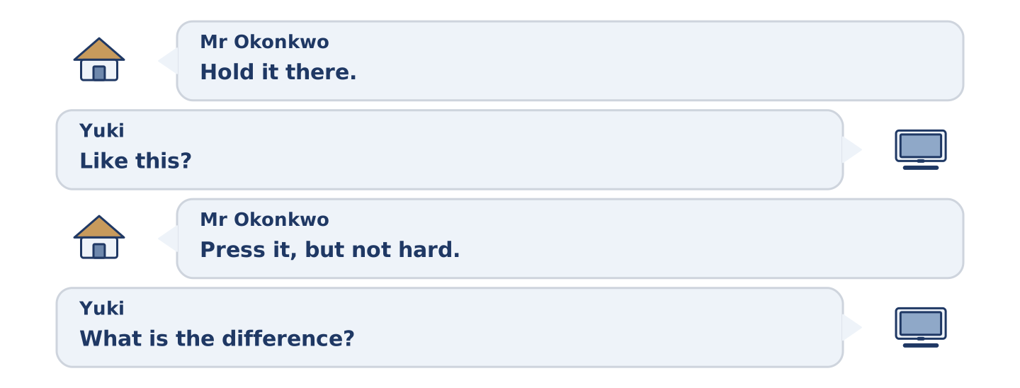
Figure 10.31 · The 7B exchange: who takes each turn.
🔊 Audio Track 10.5
Before you read: is it harder to teach a job or to be taught one?
Mr Okonkwo: Hold it there. No — there. Yuki: Like this? Mr Okonkwo: Press it, but not hard. You are pushing. Yuki: What is the difference? Mr Okonkwo: Press is your hand. Push is your arm. Yuki: Oh. Mr Okonkwo: Now you have it. Do that part again while I watch. Yuki: Why can’t you just tell me? Mr Okonkwo: I did tell you. It took four minutes. Your hands took eleven seconds.
Answer the questions. (0. is done.)
- What does Mr Okonkwo tell Yuki to do first? — Hold it in the right place.
- What is Yuki doing wrong?
- How does he explain the difference?
- Why does he ask her to do it again?
7C: Controlled Practice — Teaching a Job Well
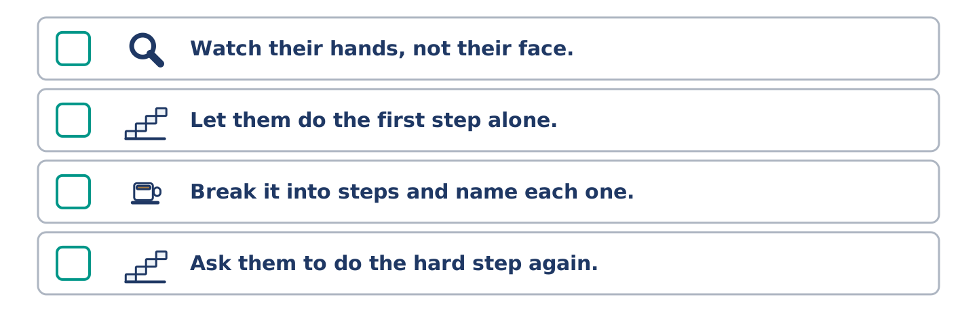
Figure 10.32 · The steps still to be numbered, as the task prints them.
Put the steps in order. Number them 1–5. (0. is done.)
- Show the whole job once, quickly. — 1
____ Watch their hands, not their face.
____ Let them do the first step alone.
____ Break it into steps and name each one.
____ Ask them to do the hard step again.
7D: Role-Play — Teaching a Job
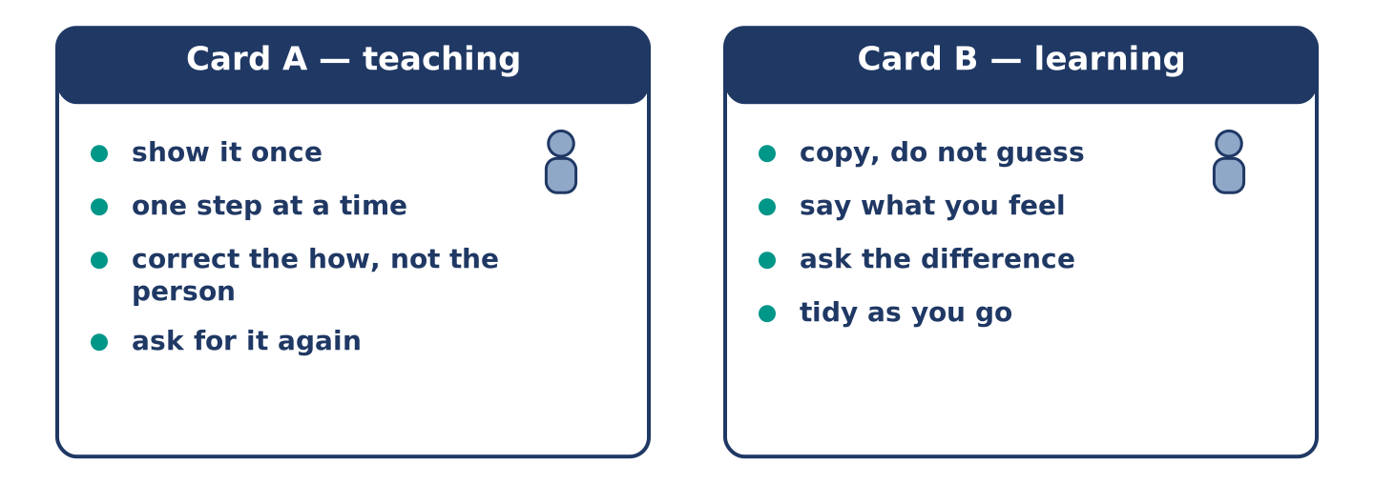
Figure 10.33 · The 7D cards: what each of you has to say.
In pairs. One teaches a simple job; one learns it. Use the model and cards.
Model exchange: A: Hold it there. — B: Like this? — A: Press it, but not hard. You are pushing. — B: What is the difference? — A: Press is your hand. Push is your arm. — B: Oh. — A: Now do that part again and I will watch.
Card A — teaching: show it once · one step at a time · correct the how, not the person · ask for it again.
Card B — learning: copy, do not guess · say what you feel · ask the difference · tidy as you go.
Stretch [PLUS]: your learner does it a different way and it works — decide whether to correct them.
7E: Writing — Instructions for a Complete Beginner (50–80 words)
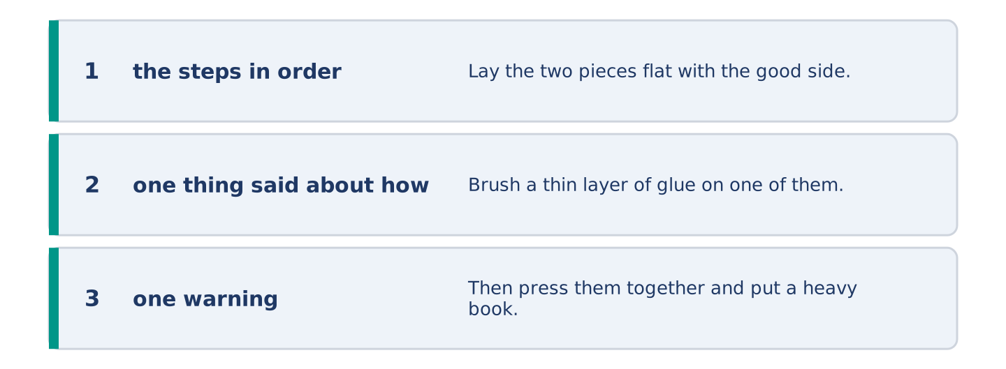
Figure 10.34 · The Part 7 note, with the model beside each line.
Write instructions for a job you know, for somebody doing it the first time.
Model — read this first:
Lay the two pieces flat with the good side down. Brush a thin layer of glue on one of them only, right to the edges, and count slowly to sixty while it stops shining. Then press them together and put a heavy book on top. Leave it until the morning. Do not move it to look at it, because that is how everybody loses a first attempt. (67 words)
Check before you finish: ☐ the steps in order? ☐ one thing said about how, not what? ☐ one warning? ☐ 50–80 words?
Part 8 · Global Story — The Street Laid by Hand
[PLUS] Plus track · pre-read / discuss
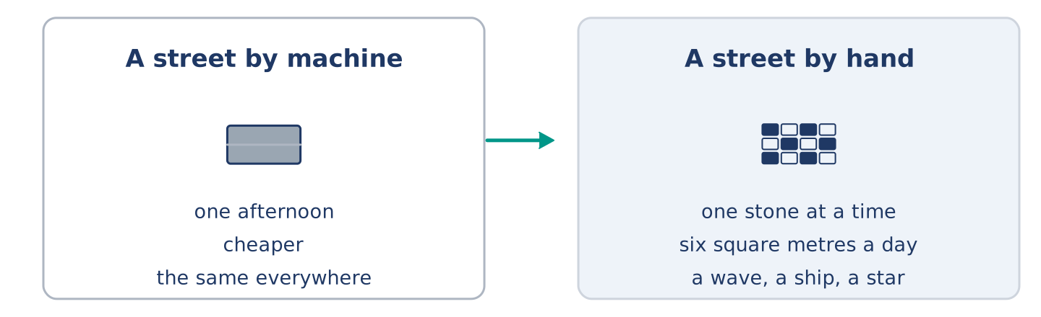
Figure 10.35 · A street laid by machine, and a street laid by hand.
Before you read: is anything near you still made by hand?
Gloss: craft = a skill of making things with your hands · trade = a job you learn by doing it beside somebody · design = the shape or pattern somebody planned
Most of a city goes down by machine in an afternoon. In Portugal the famous black and white streets go down one small stone at a time, by hand, on somebody’s knees. The worker cuts each stone to shape with a hammer, sets it into the bed, taps it level, and moves on. A good one lays perhaps six square metres in a day. The design is a wave, or a ship, or a star, and the worker reads it from a drawing the way a player reads music. It is slower than a machine and it costs more, and the cities keep doing it, because a machine street is the same street everywhere. They teach the trade the old way. A learner works on their knees beside somebody who laid stone for thirty years, and copies the hands rather than the words.
Answer the questions. (0. is done.)
- How does most of a city go down? — By machine, in an afternoon.
- What are the four things the worker does to each stone?
- Why do the cities keep doing it, when a machine is cheaper?
- How is the trade taught?
Part 8: Vocabulary in Context
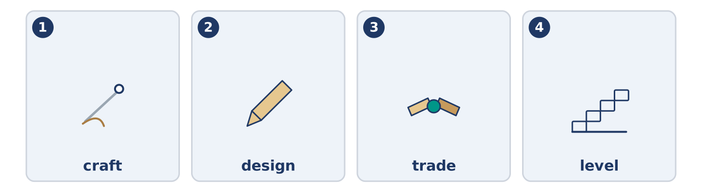
Figure 10.36 · The four words from the global story, drawn.
Match each word with its meaning. One meaning is not needed. Write the letter.
Column A
1. | craft | ____
2. | design | ____
3. | trade | ____
4. | level | ____
Column B
a) | the shape or pattern somebody planned
b) | flat, with no part higher than another
c) | a skill of making things with your hands
d) | a job you learn by doing it beside somebody
e) | a small picture that stands for a word
Part 8: Discussion
Talk with a partner. Use the frames.
Discussion frames: “This is similar to where I live because…” · “This is different from where I live because…” · “I think the most important thing is… because…”
Part 9 · Close to Home — The Sign That Is Still Upside Down
[PLUS] Plus track · pre-read / decide
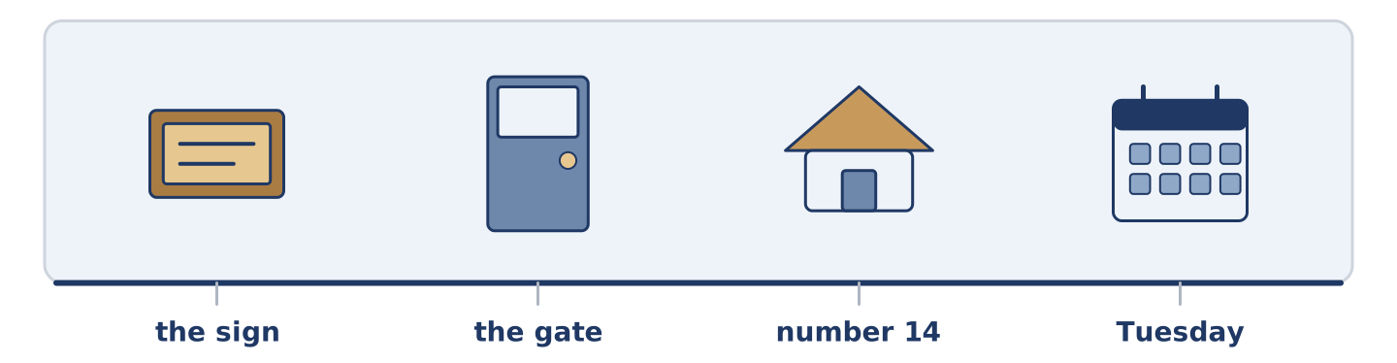
Figure 10.37 · The close-to-home reading, drawn along one street.
Before you read: whose job is it to put right something nobody else has noticed?
The 14 Dani painted and tied to the gate is still upside down. Everybody at number 14 saw it weeks ago. Nobody said anything, and the reasons are all different. Maya thinks it is Dani’s and therefore Dani’s to turn. Tomas noticed it on a Tuesday and meant to do it on the Wednesday. By the Thursday it was a thing he walked past. Mr Okonkwo nearly turned it the first evening, but he was not sure Dani had finished. Amina knows exactly whose it is and says nothing, because Dani made it at all, which is more than the rest of them did. Yuki is sure it is on purpose, and says so. Dani painted it, tied it on in the dark, and never once looked at it again.
Answer the questions. (0. is done.)
- What is still upside down? — The 14 Dani tied to the gate.
- Why did Tomas not turn it?
- Why did Mr Okonkwo leave it?
- What does Yuki think?
Part 9: Decision Task
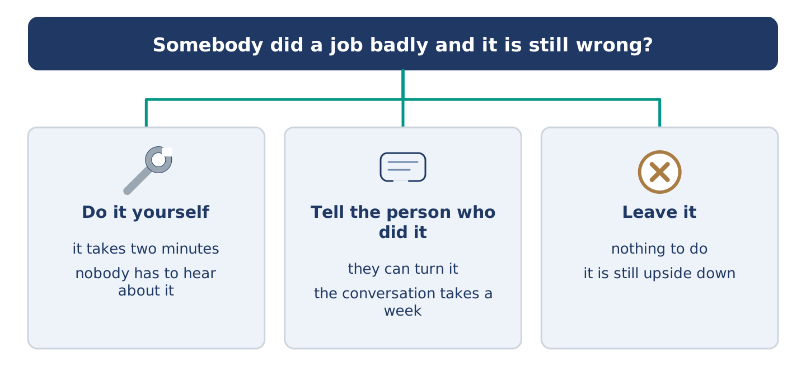
Figure 10.38 · Three ways to decide, and what each one costs.
Somebody near you did a job badly, and it is still wrong. Should you (a) do it yourself, (b) tell the person who did it, or (c) leave it? Decide and explain. Use the frame.
Answer frame: “I think I should ___ because ___. Also, ___. This is better than ___ because ___.”
Model — read this first:
I think I should do it myself, because it takes two minutes and the conversation takes a week. Also, nobody who made something badly enjoys hearing about it. This is better than telling Dani, because Dani made the sign at all, and the rest of us only walked past it. (50 words)
Phrase bank: I think I should… · because… · Also,… · This is better than… · In my opinion…
Part 10 · Review and Can-Do
[CORE + PLUS] · homework / self-study
Part 10: Spiral Review
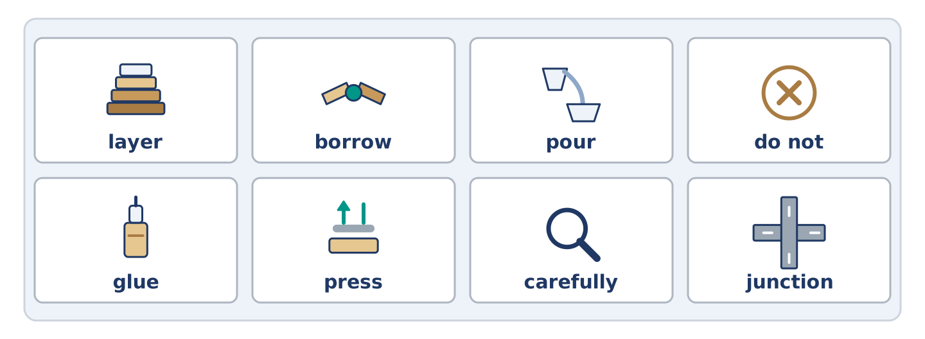
Figure 10.39 · The eight words of the review bank, in bank order.
Complete the review. (0. is done.)
- To put two or more things together and turn them is to mix.
Word bank: layer | borrow | pour | do not | glue | press | carefully | junction
- To tip a liquid out of one thing into another is to ______________________ .
- To push down on something with your hand is to ______________________ .
- Something that sticks two things together is ______________________ .
- A thin flat covering, with another one over it, is a ______________________ .
- Work slowly and ______________________ , and you only do it once.
- ______________________ press the leaves, however late you are.
- (from Unit 9) Where two or more roads meet is a ______________________ .
- (from Unit 8) To take something from somebody for a short time is to ______________________ .
Part 10: Can-Do
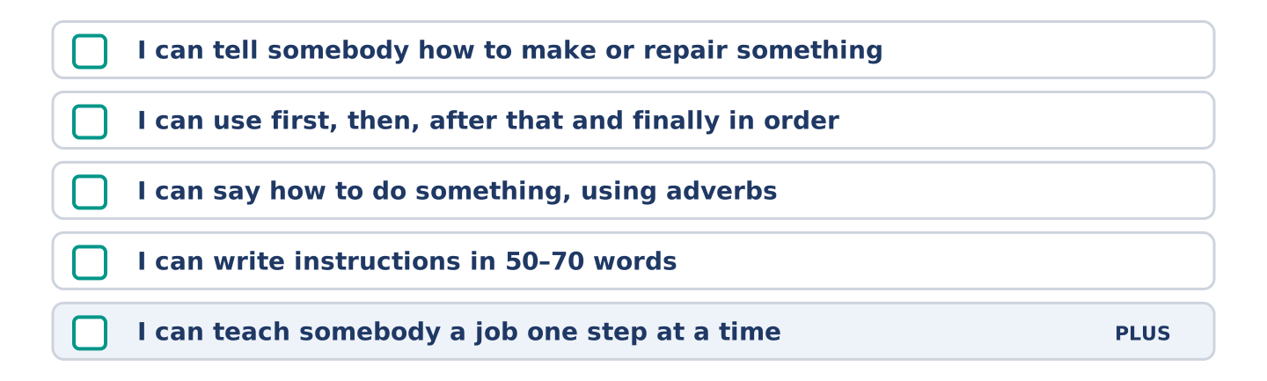
Figure 10.40 · What you can do at the end of this unit.
Can-Do checklist
☐ I can tell somebody how to make or repair something.
☐ I can use first, then, after that and finally in order.
☐ I can say how to do something, using adverbs.
☐ I can write instructions in 50–70 words.
☐ I can teach somebody a job one step at a time (Plus).
Part 10: Glossary
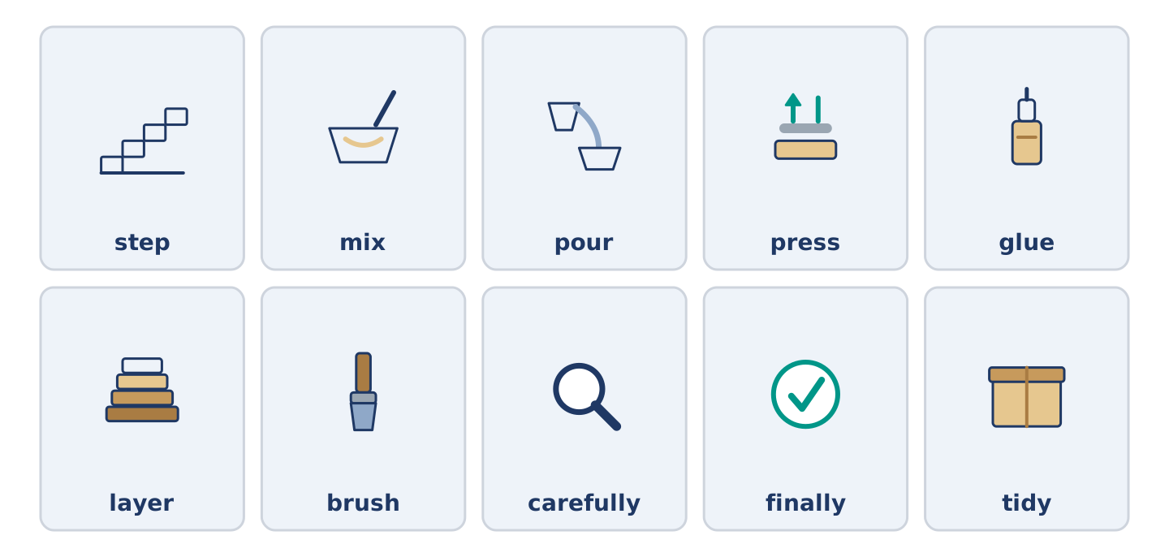
Figure 10.41 · All ten glossary words of Unit 10, one card each.
Unit 10 glossary (10 words)
step · mix · pour · press · glue · layer · brush · carefully · finally · tidy

