Unit 11: Plans and Arrangements
English for Daily Life · Level: A2 · Tracks: [CORE] Warm-Up + Parts 1–6 · [PLUS] Parts 7–10
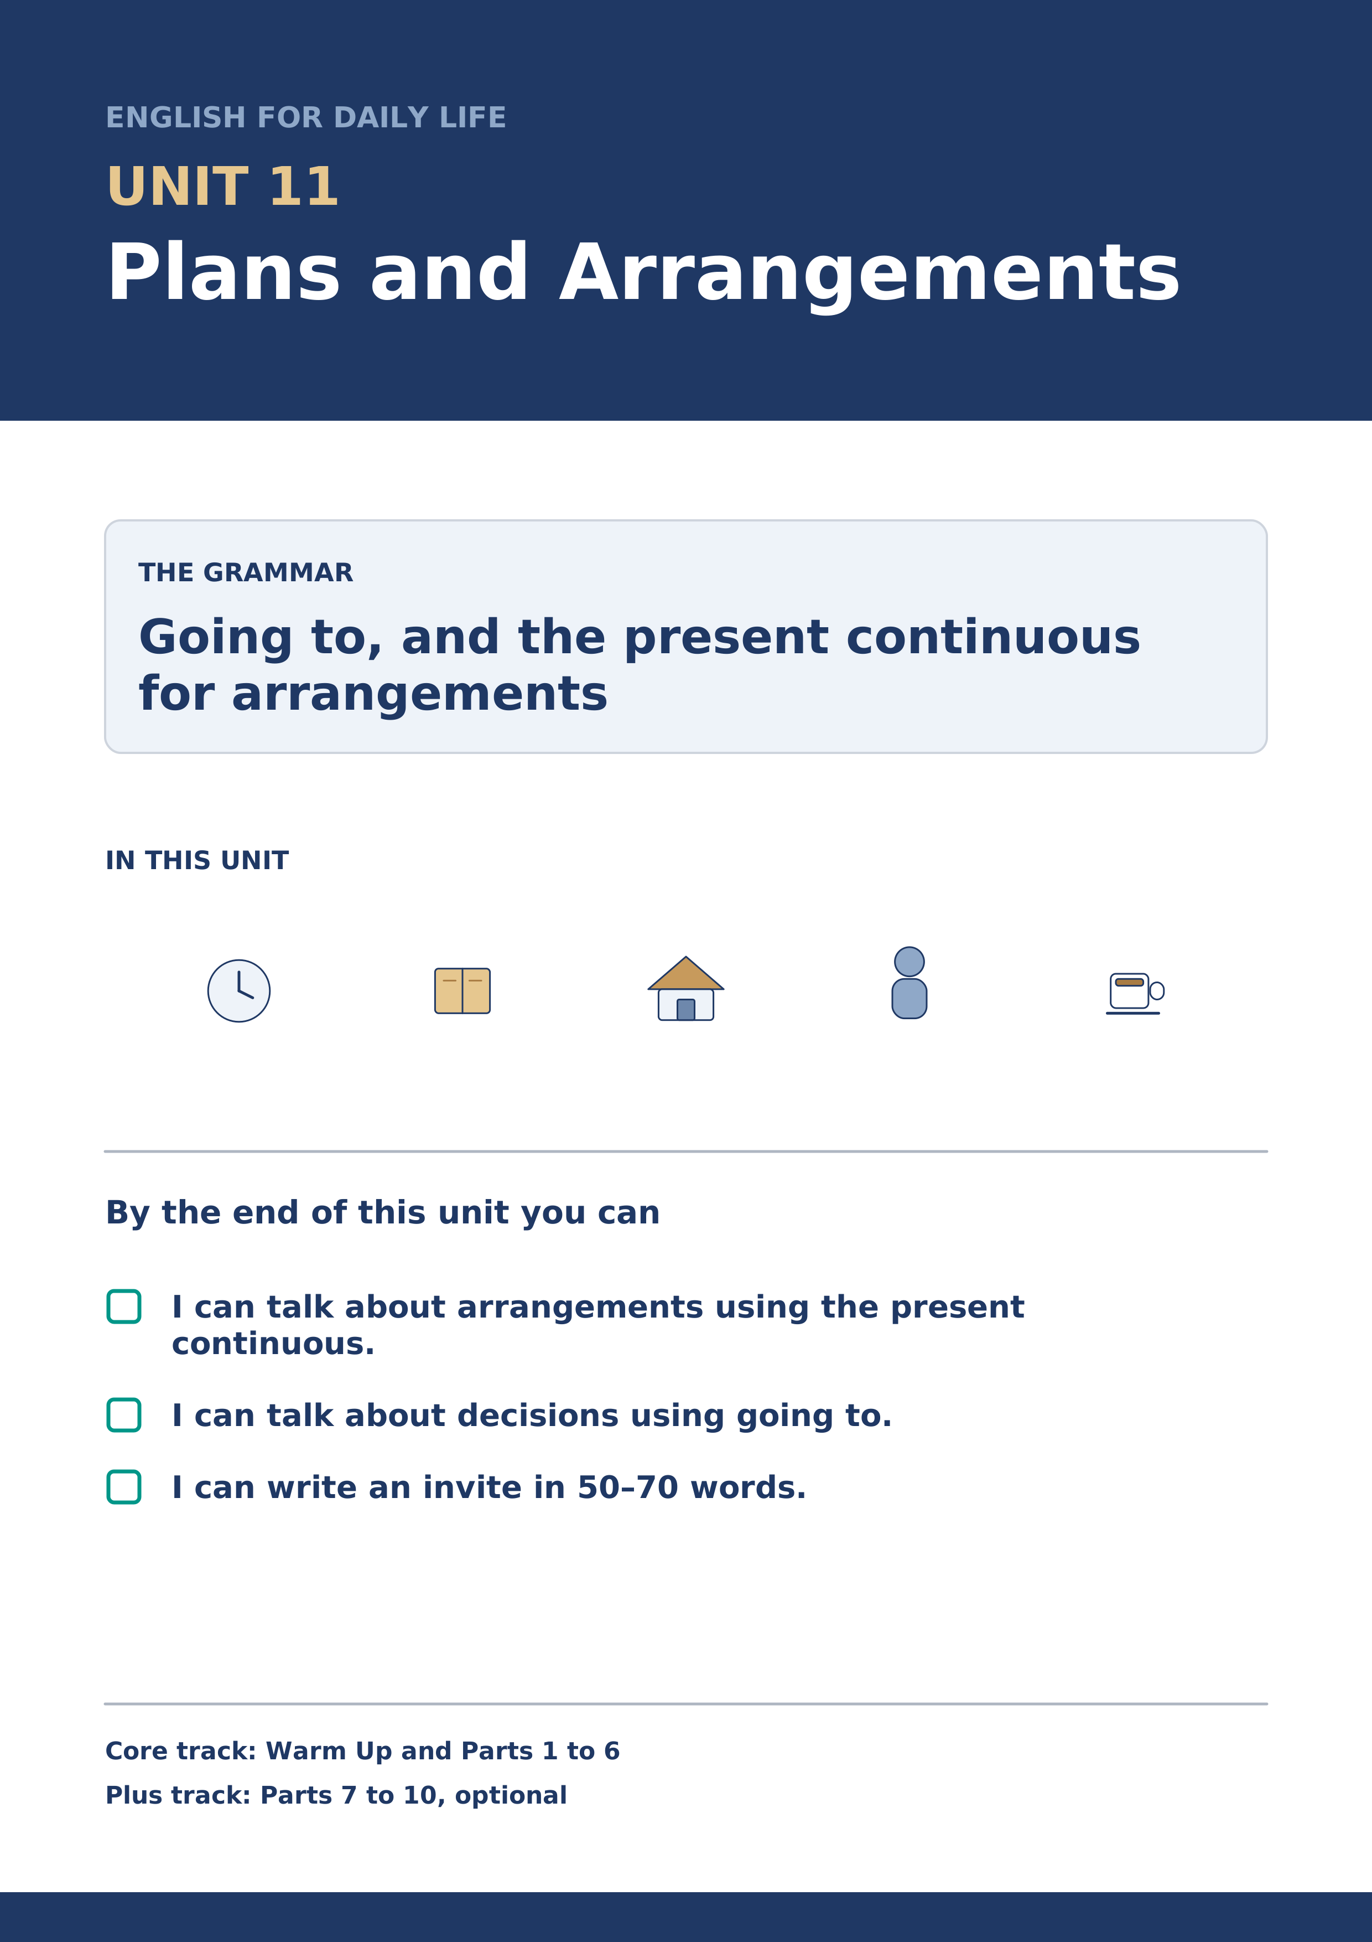
Warm Up
[CORE] Core track · in-class starter
Warm-up: Words for Plans
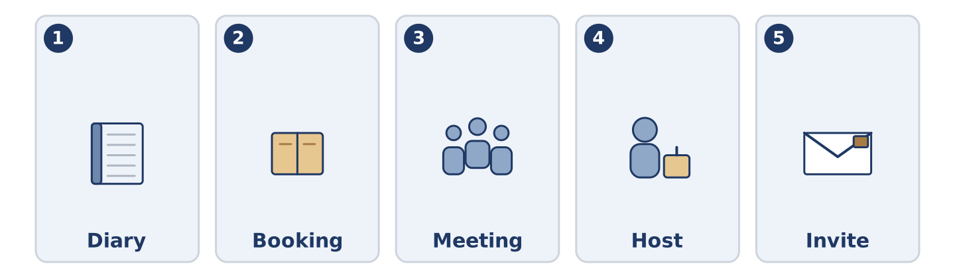
Figure 11.2 · The five warm-up words, and the thing each one means.
Match the words with their meanings. One meaning is not needed. Write the letter.
Column A
1. | Diary | ____
2. | Booking | ____
3. | Meeting | ____
4. | Host | ____
5. | Invite | ____
Column B
a) | to ask somebody to come
b) | the person whose home or evening it is
c) | a book where you write what you are doing and when
d) | a seat or a room you asked for before you came
e) | when people come together to talk about something
f) | the money you pay to belong to something
Warm-up: Talking About Next Week
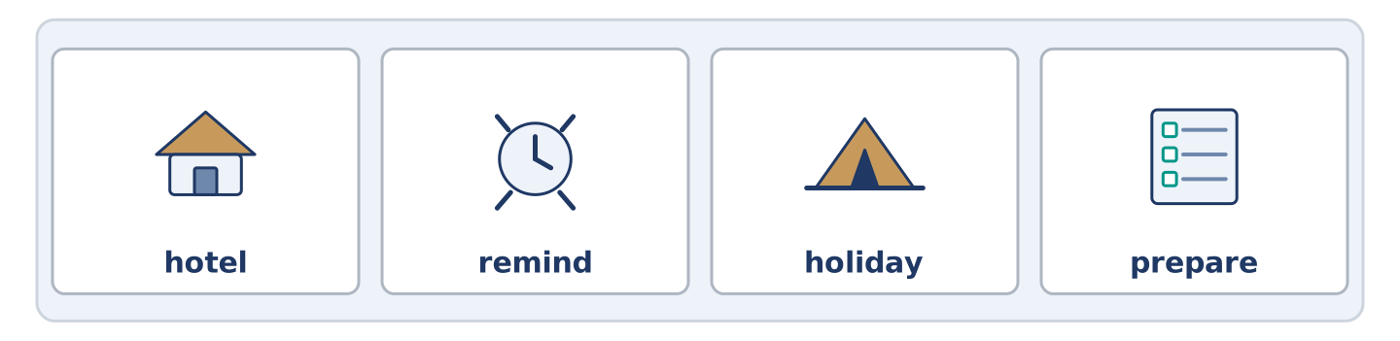
Figure 11.3 · The word bank for this task, in the order it is printed.
Complete the sentences using the words in the word bank.
Word bank: hotel | remind | holiday | prepare
- Amina is taking her first ______________________ in four years.
- Could you ______________________ me on Thursday? I forget everything.
- Yuki is going to ______________________ the food on Friday evening.
- Dani found a ______________________ by the station for eleven pounds a night. It has no lift.
Warm-up: Six People, Six Saturdays
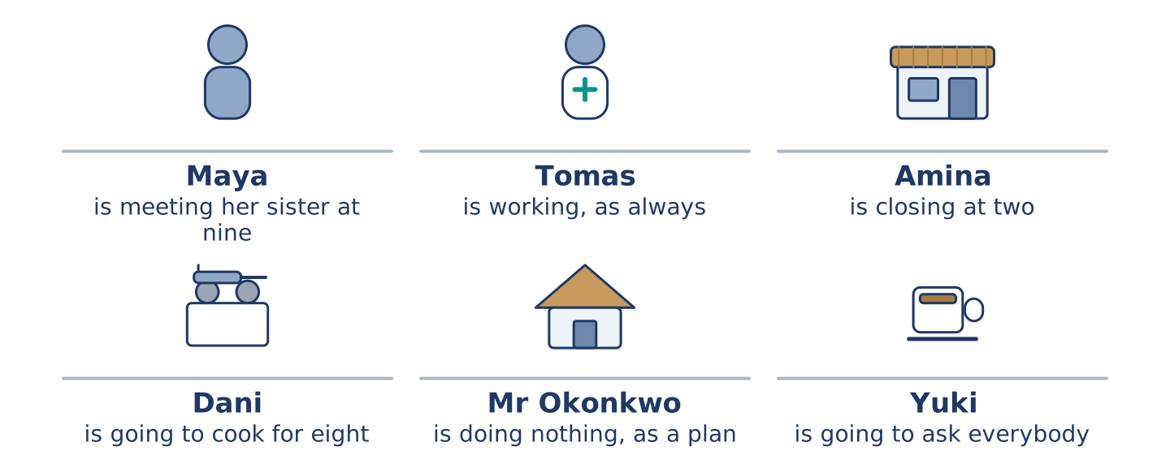
Figure 11.4 · What each of them is doing on Saturday, and what they are going to do.
Read the text and choose the correct answer.
Everybody at number 14 has a Saturday. Maya is meeting her sister at the station at nine. Tomas is working, because he is always working on a Saturday. Amina is closing the shop at two and going nowhere near a party. Dani is going to cook for eight people and told nobody yet. Mr Okonkwo is not doing anything, and he says that carefully, as a plan. Yuki is going to ask them all to come at seven, and she is going to ask today.
1. What is Maya doing at nine?
○ A) Working
○ B) Cooking for eight
○ C) Meeting her sister
○ D) Closing the shop
2. What is Mr Okonkwo doing on Saturday?
○ A) Nothing, and he means it
○ B) Going to the station
○ C) Working
○ D) Cooking
Part 1 · Vocabulary and Terminology
[CORE] Core track · pre-class input
Part 1: Words for Arrangements
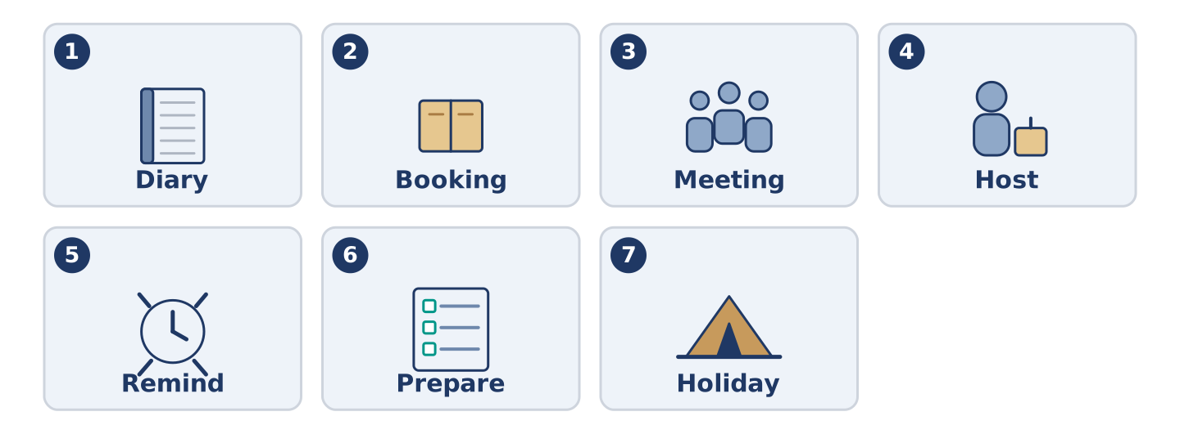
Figure 11.5 · The seven words of Column A, and what each one is.
Match the words with their meanings. One meaning is not needed. (0. is done for you.)
- Party → an evening when people come to one place to eat, talk and stay late.
Column A
1. | Diary | ____
2. | Booking | ____
3. | Meeting | ____
4. | Host | ____
5. | Remind | ____
6. | Prepare | ____
7. | Holiday | ____
Column B
a) | days away from work
b) | a seat or room asked for in advance
c) | to make somebody think of it again
d) | when people come together to talk about something
e) | a book where you write what you are doing
f) | to get everything ready first
g) | the person whose home or evening it is
h) | a thin flat covering, with another one over it
Gloss: diary = a book where you write what you are doing · booking = a seat or room asked for in advance · host = the person whose home or evening it is · arrange = to fix a time with somebody else
Part 1: Pronunciation
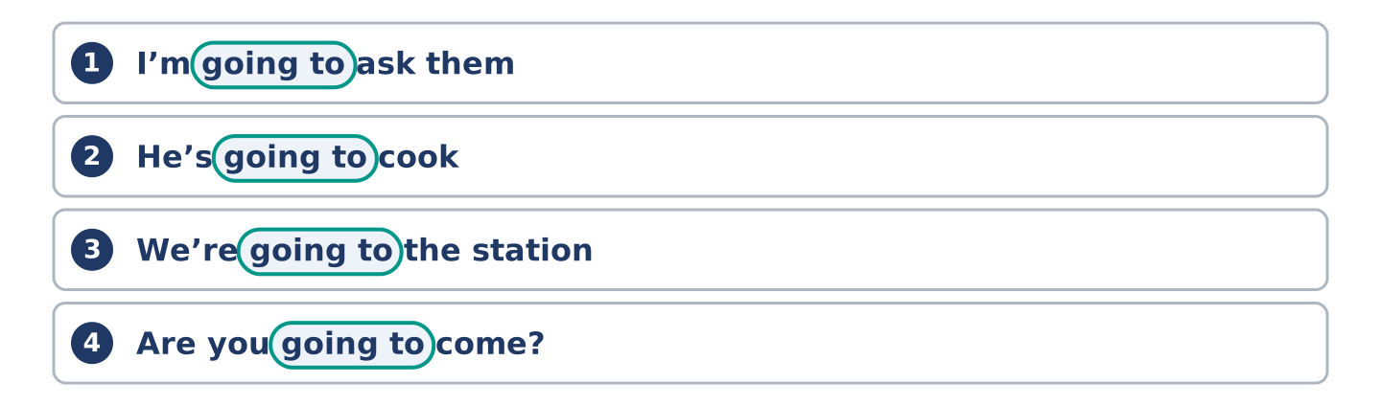
Figure 11.6 · Where the stress falls in 0 words of this unit.
🔊 Audio Track 11.1
Listen to going to. Say each one aloud, then say it to a partner.
I’m going to ask them — in speech this is one quick sound: /ˈɡənə/
He’s going to cook — the same again: he’s gonna cook
We’re going to the station — here it is slow and clear, because to is a place
Are you going to come? — quick again, because come is a verb
The rule is simple. When going to carries a verb, English runs it together. When it carries a place, it stays apart. Say all three words every time and you are understood, and you always sound like a book.
Part 1: Four Plans, Four Kinds
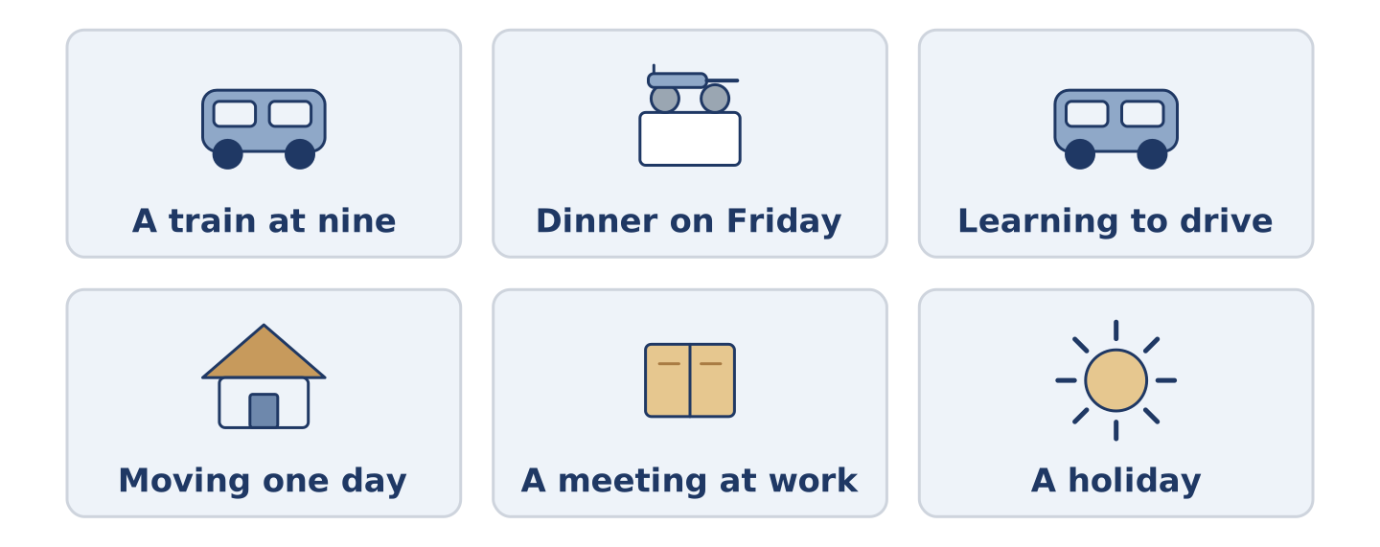
Figure 11.7 · Four kinds of plan, from the fixed to the half-decided.
Complete the table. Write how sure it is and how you say it. (0. is done.)
The plan | How sure is it? | How you say it
A train at nine, already paid | fixed, with a ticket | (example)
Dinner with a friend on Friday
Learning to drive this year
Moving to another city one day
- A train at nine, already paid — fixed, with a ticket — I am catching the nine o’clock.
Think about your own week. There is more than one right answer; be ready to say why.
Part 1: Sure, Half Sure, Not Sure

Figure 11.8 · How sure a plan is — write the correct word on each line.
Match the ways of talking about plans with how sure they are. One is not needed. Write the letter.
Column A
1. | I am meeting her at nine. | ____
2. | I am going to ask them. | ____
3. | I hope to go in the spring. | ____
4. | I might go. | ____
5. | I would like to, one day. | ____
Column B
a) | a wish, with no date
b) | decided, but nothing is booked
c) | arranged, with a time and a person
d) | a hope, with a rough time
e) | open, and it may not happen
f) | finished, and it went well
Part 1: Plans — Multiple Choice
Read and choose the correct answer.
1. A seat or a room you asked for before you came is a…
○ A) meeting
○ B) booking
○ C) diary
○ D) holiday
2. The person whose home or evening it is, is the…
○ A) guest
○ B) member
○ C) host
○ D) driver
3. To make somebody think of something again is to…
○ A) prepare
○ B) invite
○ C) book
○ D) remind
Part 1: Vocabulary Fill-in

Figure 11.9 · The four words of the bank, in the order the task gives them.
Complete the sentences with the correct word.
Word bank: invite | diary | party | meeting
- Write it in your ______________________ or you forget by Wednesday.
- Yuki wants to ______________________ the whole building, and she is nervous.
- There is a ______________________ at the school about the new crossing.
- Dani calls it dinner. Everybody else calls it a ______________________ .
Part 1: Write About Your Week (short)
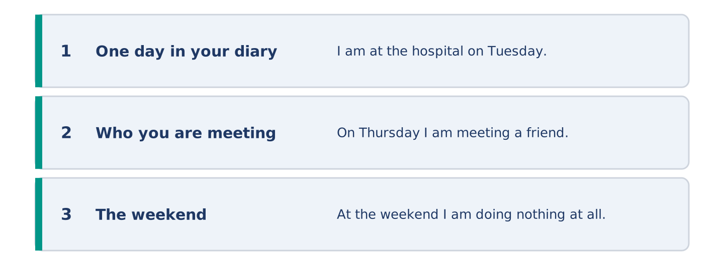
Figure 11.10 · The shape of your two or three sentences, with the model beside each step.
Write two or three sentences about your week. Use three words from this unit.
Model — read this first:
I am at the hospital on Tuesday, which is in my diary twice because I once forgot it. On Thursday I am meeting a friend who is never on time. At the weekend I am doing nothing at all. (39 words)
Part 2 · Grammar — Going To and the Present Continuous
[CORE] Core track · pre-class input
Part 2: Notice
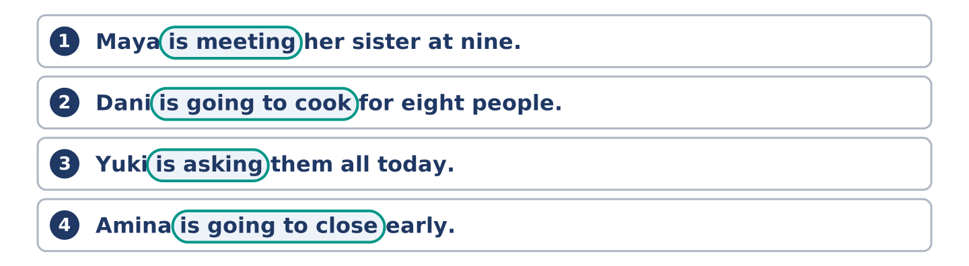
Figure 11.11 · Lines from the notice, with the target form ringed in each.
Read these lines. Underline the plans. Which are arranged with somebody, and which are only decided?
Maya is meeting her sister at nine. Dani is going to cook for eight people. Yuki is asking them all today. Amina is going to close early, probably. Tomas is working on Saturday. I am going to learn to drive this year.
Three of these carry a time or another person. Three are only a decision, and nothing more.
Part 2: Grammar Focus Box
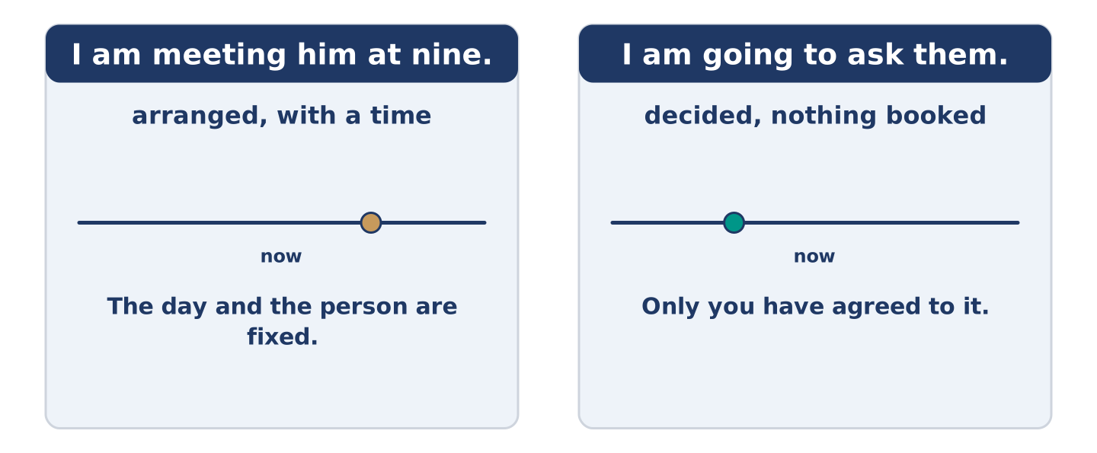
Figure 11.12 · Arranged, and only decided: two futures, two jobs.
 | Form | Use | Example
present continuous | am/is/are + -ing | an arrangement, with a time | I am meeting him at nine.
going to | am/is/are going to + verb | a decision, not yet arranged | I am going to cook for eight.
going to (evidence) | the same form | what you can already see | Look at that sky — it is going to rain.
negative | am/is/are not | both forms, the same way | I am not working on Saturday.
Remember: an arrangement needs another person or a time: I am meeting him at nine, not I am meeting one day.
Watch out! ✗ I going to cook. → ✓ I am going to cook. (going to always needs am, is or are). ✗ I will meet her at nine, it is arranged. → ✓ I am meeting her at nine. (English uses the continuous for arrangements).
Part 2: Controlled Practice
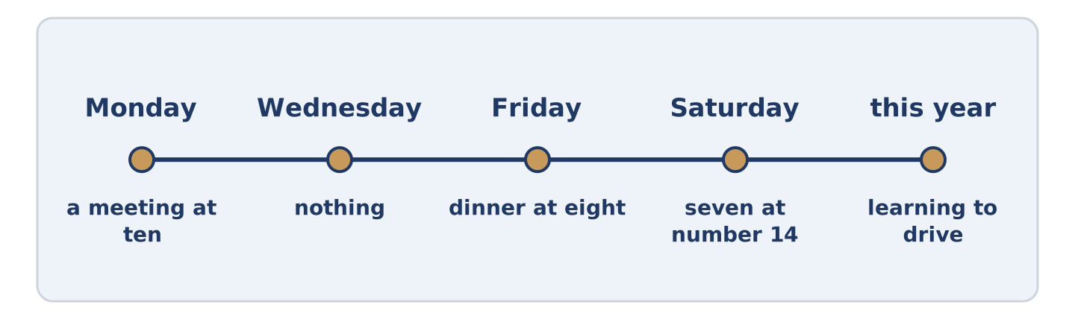
Figure 11.13 · One week, from Monday to Saturday.
Complete with the present continuous or going to. (0. is done.)
- Maya is meeting her sister at nine on Saturday. (arranged)
- Dani ______________________ cook for eight people. (decided)
- Tomas ______________________ at the hospital all weekend. (arranged)
- Yuki ______________________ ask everybody today. (decided)
- Amina ______________________ the shop at two. (arranged)
Part 2: Arranged or Decided?
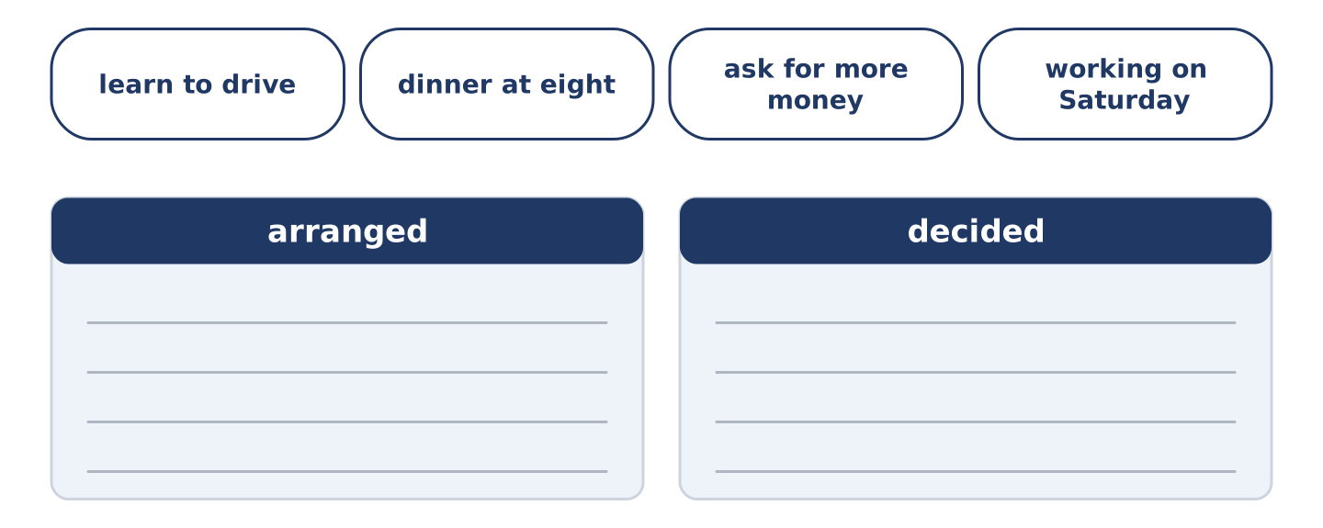
Figure 11.14 · The items of this task, and the bins they sort into.
Write arranged or decided. (0. is done.)
- I am meeting him at the station at nine. — arranged
- I am going to learn to drive this year. ____________
- We are having dinner at eight on Friday. ____________
- He is going to ask for more money. ____________
- He is working on Saturday. ____________
Part 2: Correct the Sentence
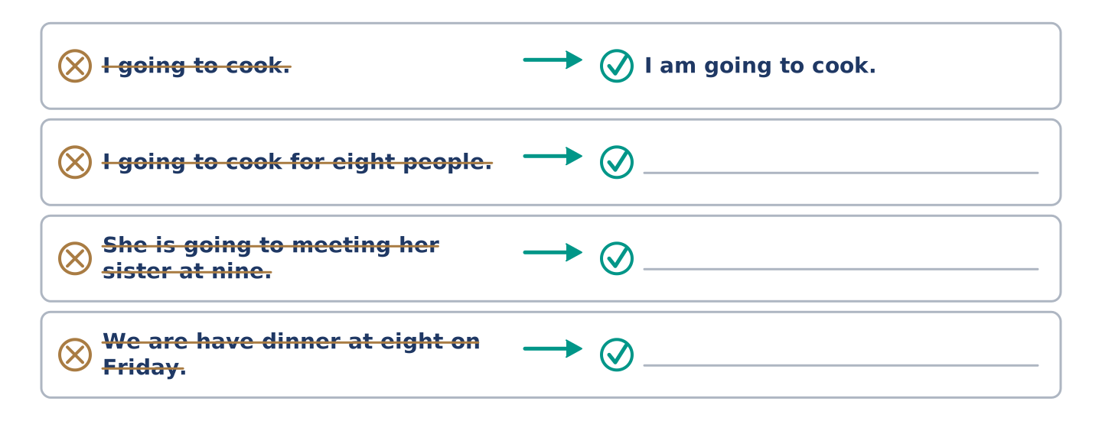
Figure 11.15 · One correction done for you, and the rest to write.
Each sentence has one grammar mistake. Write the correct sentence.
- I going to cook for eight people.
- She is going to meeting her sister at nine.
- We are have dinner at eight on Friday.
- He is going to works on Saturday.
Part 2: Freer Practice
Write two sentences about your week: one arrangement with a time, and one decision with no date.
Part 2: Grammar Review
Choose the correct sentence.
1. Which sentence is an arrangement?
○ A) I am going to see him sometime.
○ B) I am seeing him at nine on Friday.
○ C) I will see him, probably.
○ D) I see him at nine on Friday.
2. Which sentence is correct?
○ A) I going to ask them today.
○ B) I am going to asking them today.
○ C) I am going ask them today.
○ D) I am going to ask them today.
→ Harvest: you will see both futures again in the Part 5 reading. Watch for the times.
Part 3 · Listening
[CORE] Core track · pre-class input · scripts printed inline
Part 3: Arranging an Evening
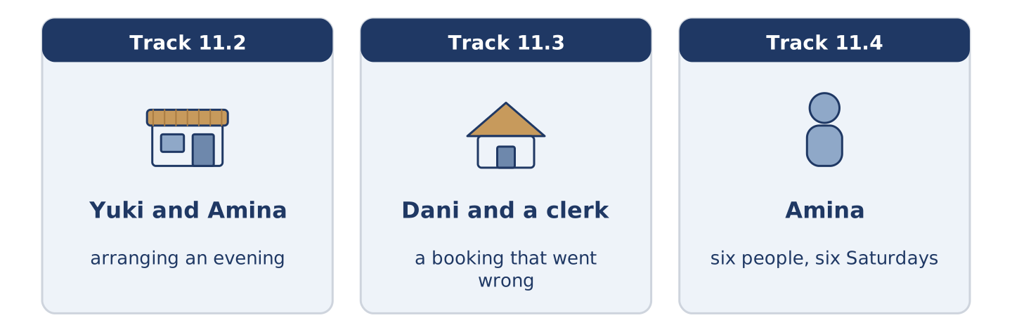
Figure 11.16 · The three listenings: who is speaking, and what about.
🔊 Audio Track 11.2
Before you listen: how far ahead do people in your country arrange an evening?
Yuki: Amina, are you doing anything on Saturday evening? Amina: I’m closing at two and then I’m doing nothing, which is the plan. Yuki: I’m going to ask everybody to come at seven. Amina: Everybody? Yuki: All five of you. Amina: Yuki, nobody in this building ever goes into anybody’s flat. Yuki: I know. That’s why I’m asking. Amina: Then I’m coming, and I’m bringing something, and don’t argue.
While you listen: write True, False, or Not Given. (0. is done.)
- Yuki is arranging something for Saturday evening. — True
- Amina is working on Saturday evening. ____
- Amina says she is bringing something. ____
- Yuki cooked for six people last year. ____
Useful phrases: Are you doing anything…? · I’m going to ask… · That’s why I’m asking · don’t argue
Part 3: A Booking That Went Wrong
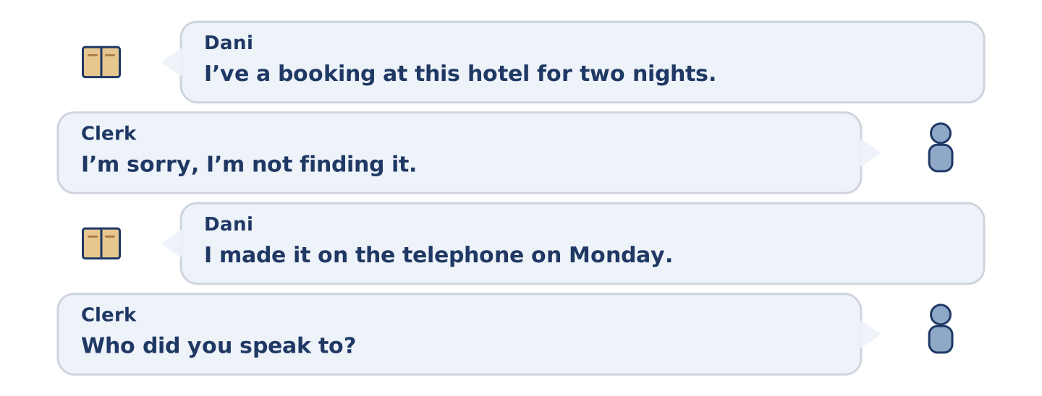
Figure 11.17 · The second listening, turn by turn.
🔊 Audio Track 11.3
Before you listen: what do you say when a booking is not there?
Dani: I’ve a booking at this hotel for two nights, the name is Rossi. Clerk: I’m sorry, I’m not finding it. Dani: I made it on the telephone on Monday. Clerk: Who did you speak to? Dani: A man. I didn’t ask. Clerk: Did you get a number? Dani: No. Clerk: Then I’m going to put you in a room anyway, because the hotel has one, and next time take the number. Dani: I’m going to write that on my hand.
Answer the questions. (0. is done.)
- How many nights is the booking for? — Two.
- When did Dani make the booking?
- What did Dani not ask for?
- What does the clerk tell him to do next time?
Part 3: Six People, Six Saturdays
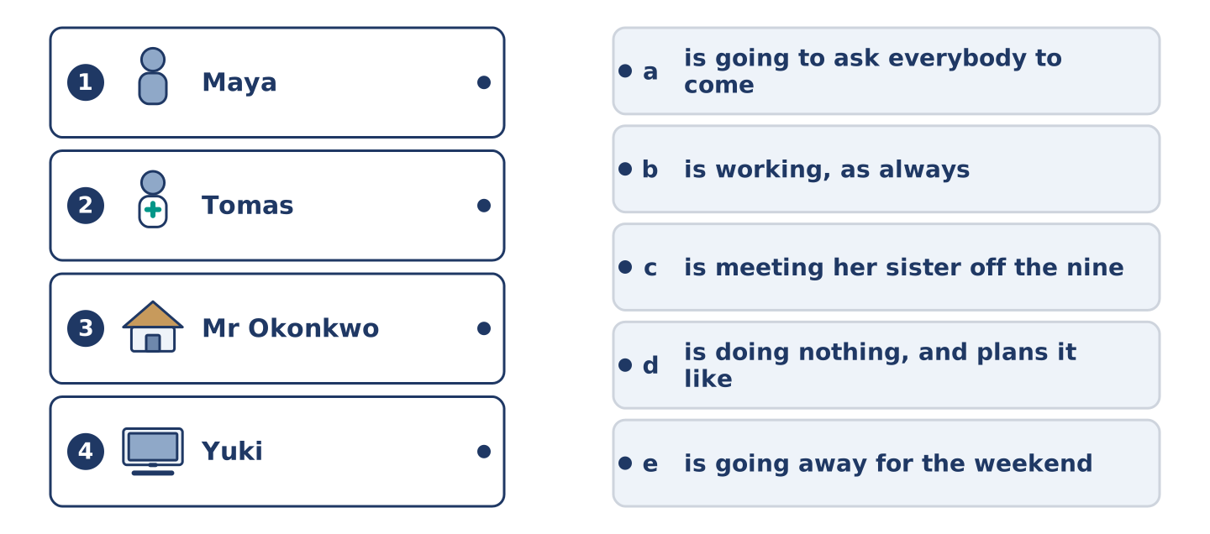
Figure 11.18 · Four on the left, five on the right, and one spare.
🔊 Audio Track 11.4
Before you listen: who in your street always knows what everybody is doing?
Amina: I know everybody’s Saturday, and I never ask. Maya is meeting her sister off the nine o’clock, and she’s already nervous about it. Tomas is working, because Tomas is always working. Dani is going to cook, and he is not saying how many people yet. Mr Okonkwo is doing nothing, and he plans it like a job. And Yuki is going to ask us all to come at seven, and I’m going to say yes before she finishes the sentence.
While you listen: match each person with their Saturday. One is not needed. (0. is done.)
- Amina → she knows and never asks.
Useful phrases: ___ is meeting her sister · ___ is working · ___ is going to cook
Column A
1. | Maya | ____
2. | Tomas | ____
3. | Mr Okonkwo | ____
4. | Yuki | ____
Column B
a) | is going to ask everybody to come at seven
b) | is working, as always
c) | is meeting her sister off the nine o’clock
d) | is doing nothing, and plans it like a job
e) | is going away for the weekend
Part 4 · Speaking
[CORE] Core track · in-class output
Part 4: Your Week
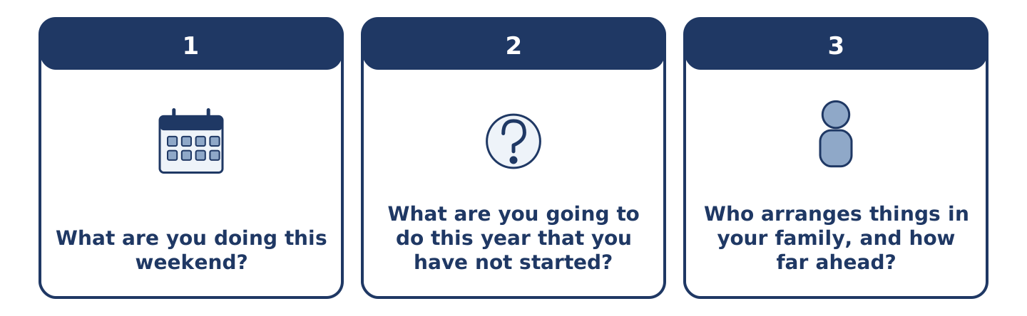
Figure 11.19 · The three questions as cards, to take one at a time.
Work with a partner. Ask and answer these questions.
- What are you doing this weekend?
- What are you going to do this year that you have not started?
- Who arranges things in your family, and how far ahead?
Useful language: I’m meeting… · I’m going to… · on Friday at… · nothing at all
Part 4: Find the Difference (pairwork)
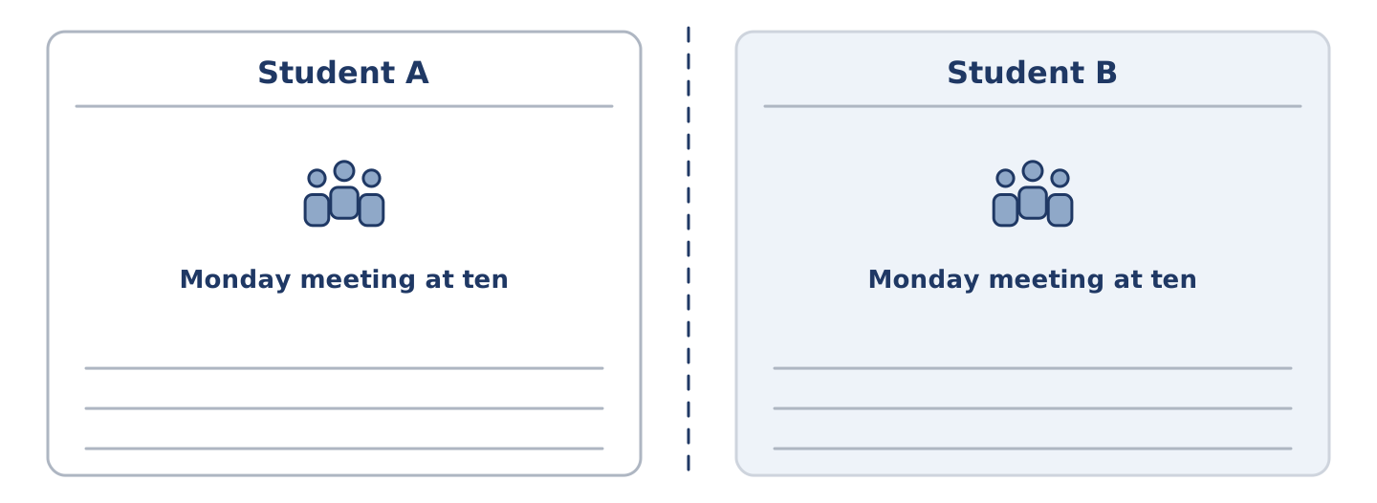
Figure 11.20 · Student A’s facts and Student B’s, with a fold between them.
Student A and Student B each have a week in a diary. Ask questions and find three differences.
Useful questions: What are you doing on Monday? · Are you free on Thursday? · Who are you meeting? · What time?
Student A — your week: Monday meeting at ten, Wednesday free, Friday dinner at eight, Saturday nothing.
Student B — your week: Monday meeting at ten, Wednesday hospital, Friday free, Saturday nothing.
Part 4: Arranging Something Together
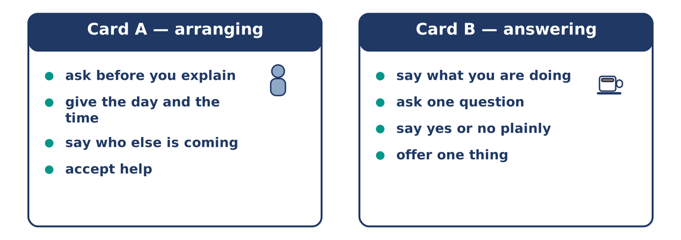
Figure 11.21 · Card A and Card B: what each of you has to say.
Work in pairs. Read the model, then use the cards.
Model exchange:
A: Are you doing anything on Saturday evening? — B: Nothing at all. Why? — A: I’m going to ask everybody to come at seven. — B: Everybody? — A: All of them. — B: Then I’m coming, and I’m bringing something. — A: There is no need. — B: I know. Seven.
Useful language: Are you doing anything…? · Nothing at all · I’m going to… · I’m bringing…
Card A — arranging: ask before you explain · give the day and the time · say who else is coming to the party · accept help.
Card B — answering: say what you are doing · ask one question · say yes or no plainly · offer to bring one thing.
Your turn: run the dialogue, then swap roles.
Stretch [PLUS]: you cannot come, and the real reason is awkward — say no without inventing anything.
Part 4: Mini-Presentation
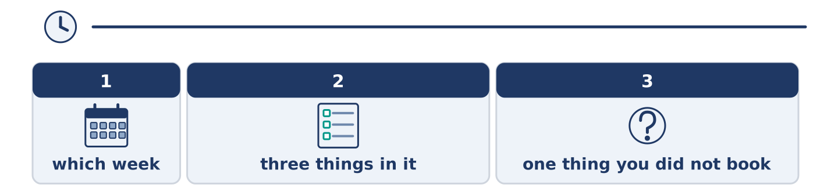
Figure 11.22 · The one-minute talk as two beats, each as wide as its share.
Prepare a short talk (about one minute). Describe one week you have arranged: three things in it, and one thing you decided but did not book.
Part 5 · Reading
[CORE] Core track · pre-class input
Part 5: How Far Ahead Do People Plan?
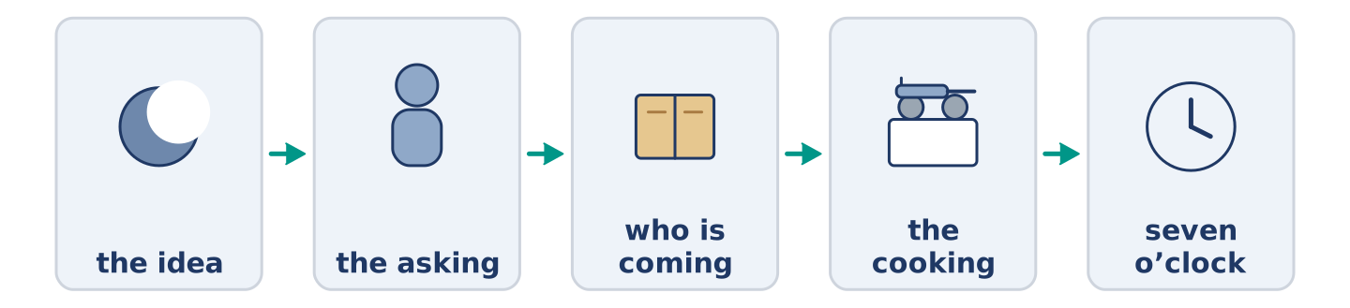
Figure 11.23 · One invite, from the idea to the evening itself.
Before you read: is a plan made a month ahead a kinder plan or a colder one?
Gloss: spontaneous = done without planning · notice = how much warning somebody gets · calendar = where people keep their dates · compliment = something kind said about you
Ask somebody in one country to dinner next Tuesday and they say yes. Ask somebody in another country the same thing and they look in a calendar and offer you a date five weeks away. Neither of them is being rude. In some places people fix an evening the same afternoon, and a plan a month old feels cold by the time it arrives. In others, short notice means you were not somebody’s first thought, and a date far ahead is a compliment. The trouble starts when the two kinds of person live in the same street. One is hurt by the diary; the other is hurt by the doorbell. Both of them meant well, and neither of them said so.
Answer the multiple-choice questions. (0. is done.)
- What do the two people do when they are asked to dinner? — One says yes; the other looks in a calendar.
1. What does a date five weeks away mean in some countries?
○ A) That you are not wanted
○ B) That the person is busy and rude
○ C) That you are a compliment and were planned for
○ D) That the evening is cancelled
2. In other places, how is an evening usually arranged?
○ A) The same afternoon
○ B) A month ahead
○ C) By letter
○ D) Never
3. What does the text say starts the trouble?
○ A) The food
○ B) The money
○ C) The weather
○ D) The two kinds of person in one street
Part 5: Vocabulary in Context
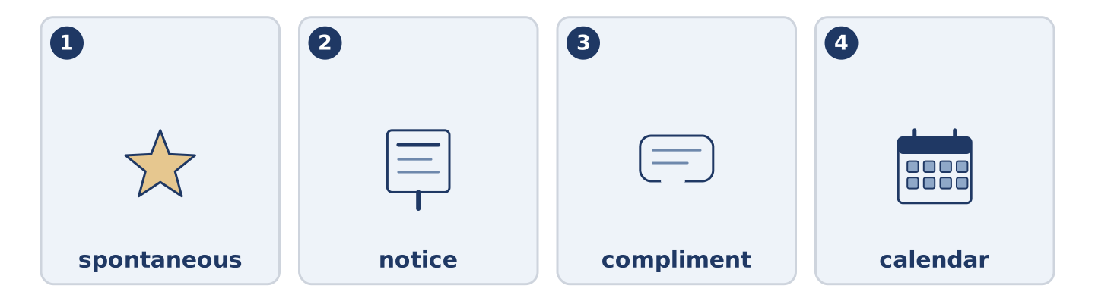
Figure 11.24 · The four words from the reading, drawn.
Match each word from the text with its meaning. One meaning is not needed. Write the letter.
Column A
1. | spontaneous | ____
2. | notice | ____
3. | compliment | ____
4. | calendar | ____
Column B
a) | how much warning somebody gets
b) | something kind that is said about you
c) | done without planning
d) | where people keep their dates
e) | the money you pay to belong
Part 5: Three Ways of Keeping a Week
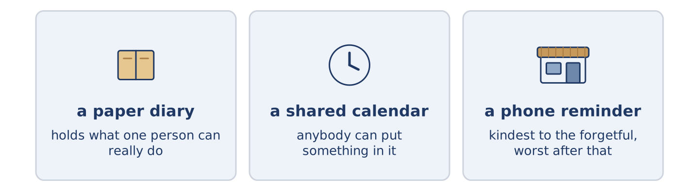
Figure 11.25 · Three ways people keep track of what they are doing.
Before you read: where do you keep what you are doing next week?
Gloss: paper diary = a book you write in by hand · shared = used by more than one person · reminder = a note that comes back to you later
People keep a week in very different ways, and the way shapes the week. A paper diary holds about as much as a person can really do, because the page runs out. A shared calendar at work holds far more, and anybody can put something in it. That is why a Thursday fills up with other people’s ideas. A phone reminder is the kindest of the three to a forgetful person. It is the worst for anybody who then stops remembering at all. None of them is the right one. The question is only which kind of forgetting you can afford.
Answer the questions. (0. is done.)
- Do people keep a week in the same way? — No, they keep it very differently.
- Why does a paper diary hold about as much as a person can do?
- Why does a Thursday fill up in a shared calendar?
- Who is a phone reminder worst for?
Part 6 · Writing
[CORE] Core track · in-class / homework
Part 6: An Invitation (50–70 words)
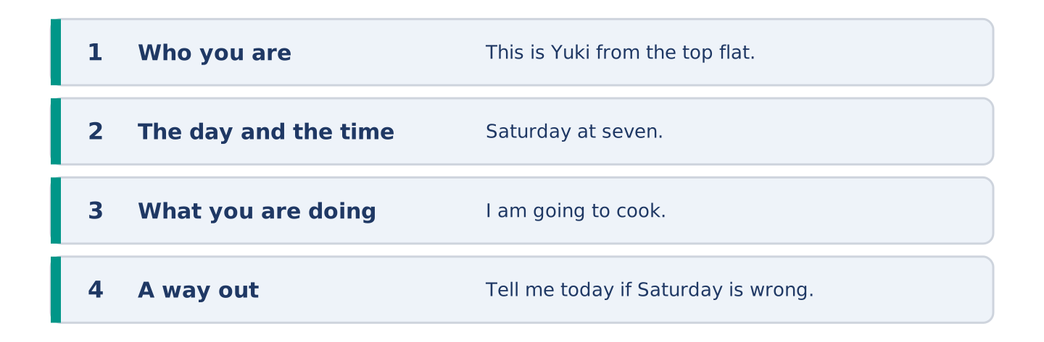
Figure 11.26 · The shape of the message you are about to write.
Write a message inviting your neighbours to something at your home.
Model — read this first:
This is Yuki from the top flat. I am asking everybody at number 14 to come to mine on Saturday at seven. I am going to cook, and there is no need to bring anything, although I know some of you are going to. Come for an hour or come for the evening. Tell me today if Saturday is wrong, and I am happy to move it. (67 words)
Plan (fill in, then write): This is ___. I am asking ___ to ___ on ___ at ___. I am going to ___. ___ if ___.
Word bank: I am asking | at seven | there is no need | come for | tell me if
Check before you finish: ☐ who you are? ☐ the day and the time? ☐ what you are doing? ☐ 50–70 words?
Part 6: Plan Ahead or Decide Late? (50–70 words)
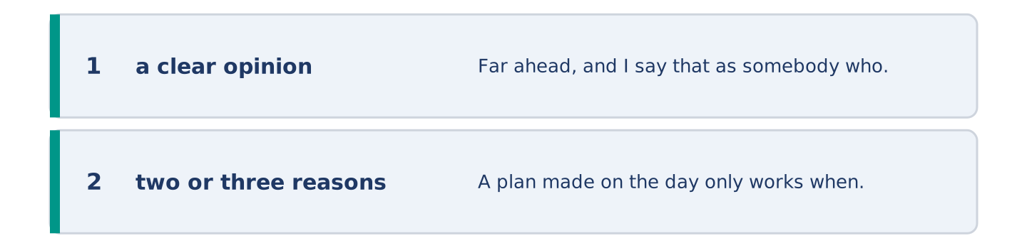
Figure 11.27 · The shape of the opinion paragraph, step by step.
Is it better to arrange things far ahead or to decide on the day? Give your opinion and two or three reasons.
Model — read this first:
Far ahead, and I say that as somebody who hates diaries. A plan made on the day only works when everybody is free, and people stop asking the never-free. Four weeks is long enough for anybody to say no honestly. The cost is that you lose the evening nobody planned, which was always the best one. (56 words)
Word bank: I think… because… | ahead | however | in my opinion | it depends on
Check before you finish: ☐ a clear opinion? ☐ two or three reasons? ☐ 50–70 words?
Part 6: Changing an Arrangement (50–70 words)
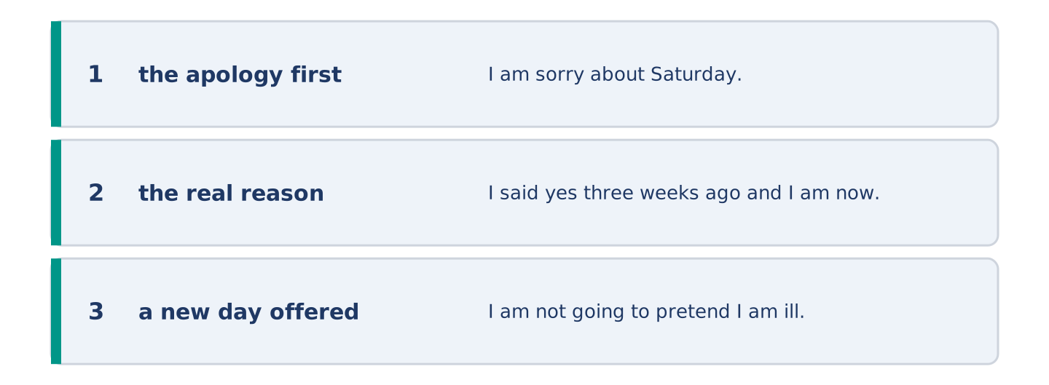
Figure 11.28 · The moves of the message, with a line of the model for each.
You cannot come to something you agreed to. Write the message you send.
Model — read this first:
I am sorry about Saturday. I said yes three weeks ago and I am now working that evening, which I did not know then. I am not going to pretend I am ill, because you would hear it. Can we do the Saturday after? I am free all day and I am going to keep it free. (57 words)
Plan (fill in, then write): I am sorry about ___. I ___, and ___. Can we ___? I am ___.
Check before you finish: ☐ the apology first? ☐ the real reason? ☐ a new day offered? ☐ 50–70 words?
Part 6: Reflection — Something I Keep Not Doing (40–60 words)
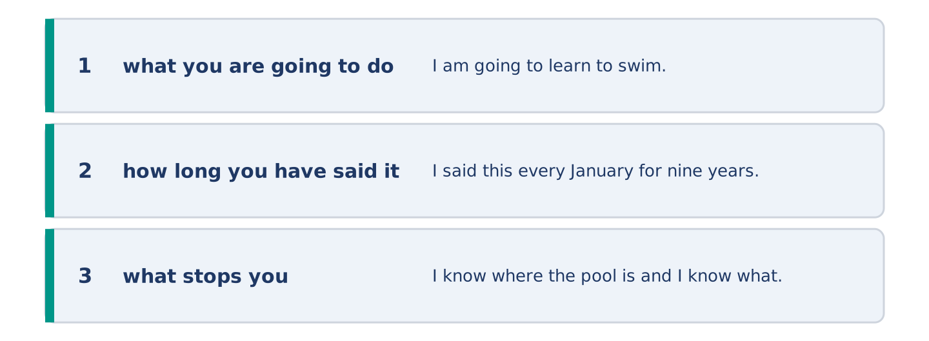
Figure 11.29 · The reflection, step by step.
Write about something you are always going to do and never start.
Model — read this first:
I am going to learn to swim. I said this every January for nine years and I say it with the same face every time. I know where the pool is and I know what it costs. What I do not have is a Tuesday evening I am willing to give up. (52 words)
Check before you finish: ☐ what you are going to do? ☐ how long you have said it? ☐ what stops you? ☐ 40–60 words?
Part 7 · Real-World File — Making and Changing Arrangements
[PLUS] Plus track (optional) · stronger learners
7A: Phrase Bank
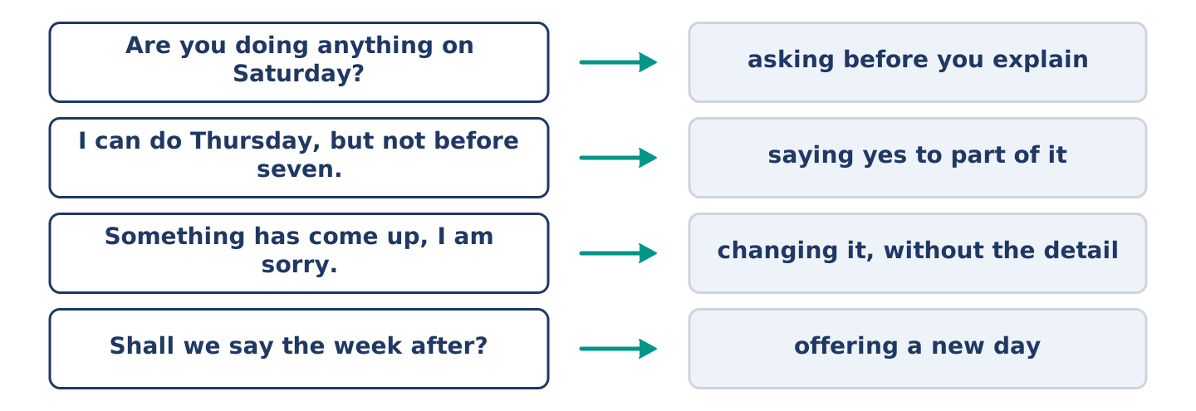
Figure 11.30 · What you say when you arrange or change something, and what each line does.
Match what a person says with its purpose. One purpose is not needed. Write the letter.
Column A
1. | “Are you doing anything on Saturday?” | ____
2. | “I can do Thursday, but not before seven.” | ____
3. | “Something has come up, I am sorry.” | ____
4. | “Shall we say the week after?” | ____
Column B
a) | offering a new day
b) | asking before you explain
c) | asking how much it costs
d) | changing it, without the detail
e) | saying yes to part of it
7B: A Booking Nobody Can Find
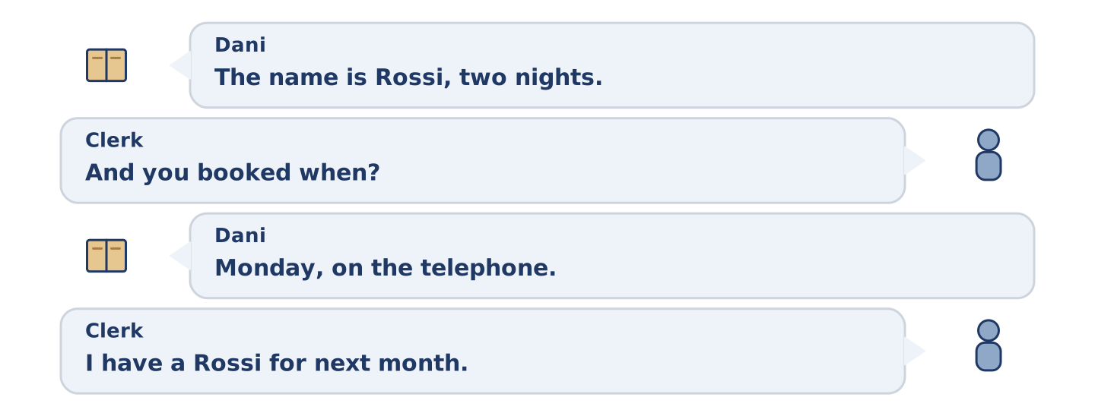
Figure 11.31 · The 7B exchange: who takes each turn.
🔊 Audio Track 11.5
Before you read: who keeps the number when you book something by telephone?
Dani: The name is Rossi, two nights. Clerk: And you booked when? Dani: Monday, on the telephone. Clerk: I have a Rossi for next month. Dani: That is not me. Or it is me, and the man wrote it wrong. Clerk: Did he read it back to you? Dani: I do not remember. Clerk: That is the part that matters. I am going to give you a room tonight, and I am going to put a note on the other one.
Answer the questions. (0. is done.)
- How many nights did Dani book? — Two.
- What does the clerk find in the system?
- What does the clerk say is the part that matters?
- What is the clerk going to do about the other booking?
7C: Controlled Practice — Making a Booking Well
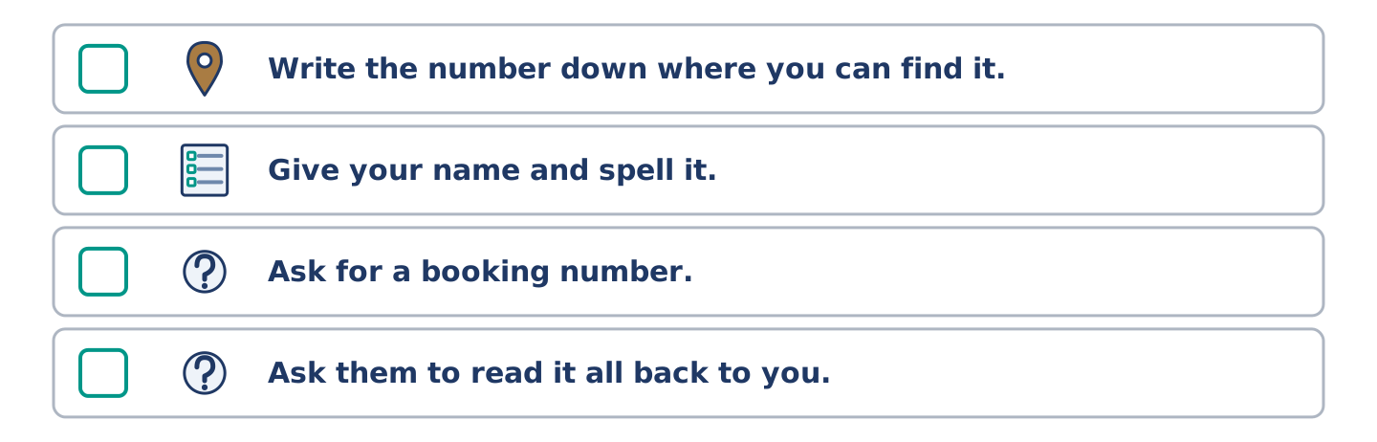
Figure 11.32 · The steps still to be numbered, as the task prints them.
Put the steps in order. Number them 1–5. (0. is done.)
- Say what you want and for when. — 1
____ Write the number down where you can find it.
____ Give your name and spell it.
____ Ask for a booking number.
____ Ask them to read it all back to you.
7D: Role-Play — Changing an Arrangement
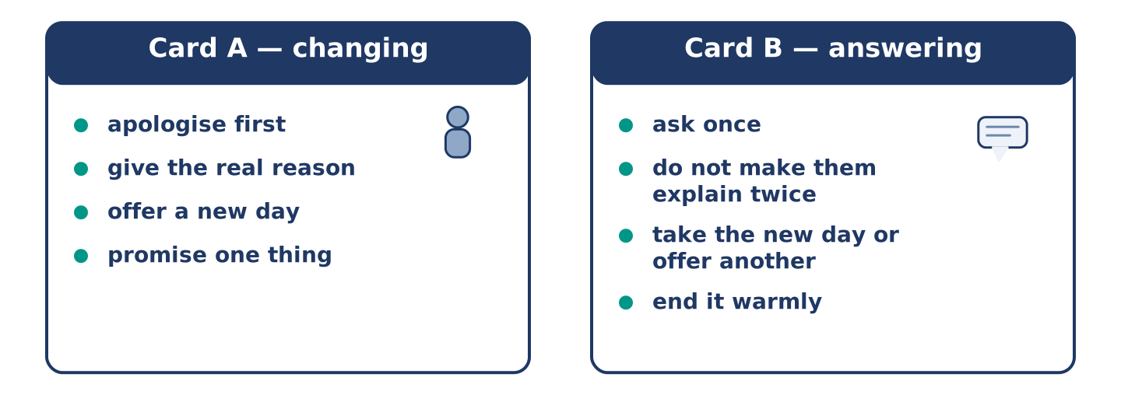
Figure 11.33 · The 7D cards: what each of you has to say.
In pairs. One has to change something; one has to answer. Use the model and cards.
Model exchange: A: I am sorry, I cannot do Saturday. — B: What has happened? — A: I am working, and I only found out today. — B: That is a shame. — A: Shall we say the week after? — B: The week after is good. — A: I am going to keep it free.
Card A — changing: apologise first · give the real reason · offer a new day · promise one thing.
Card B — answering: ask once · do not make them explain twice · take the new day or offer another · end it warmly.
Stretch [PLUS]: it is the third time you have changed it — say so yourself before they do.
7E: Writing — Arranging Something with Four People (50–80 words)
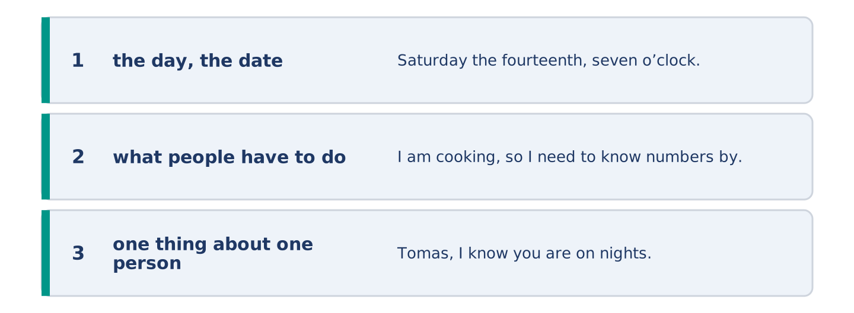
Figure 11.34 · The Part 7 note, with the model beside each line.
Write one message that arranges something with four people at once.
Model — read this first:
Saturday the fourteenth, seven o’clock, at mine. I am cooking, so I need to know numbers by Thursday, and after Thursday I am going to take it that you are coming. Tomas, I know you are on nights, so come late or come next time. There is no dress code and there is no present. Answer this one message and not me alone. (63 words)
Check before you finish: ☐ the day, the date and the time? ☐ what people have to do? ☐ one thing about one person? ☐ 50–80 words?
Part 8 · Global Story — The Huts That Nobody Books
[PLUS] Plus track · pre-read / discuss
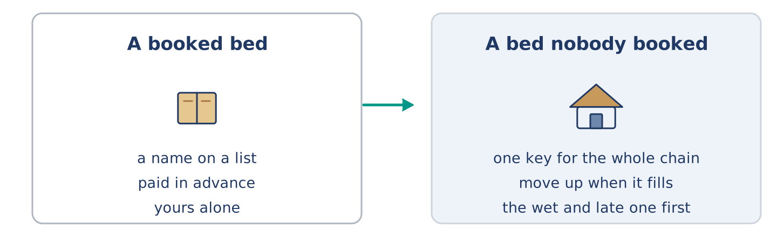
Figure 11.35 · A booked bed, and a bed nobody booked.
Before you read: can a thing work better with no booking at all?
Gloss: shelter = a small building that keeps the weather off · key = the thing that opens a lock · trust = believing that people do what they should
In the mountains of Norway there is a chain of small shelters, a day’s walk apart. For most of them there is no booking at all. You buy one key, once, and it opens every door in the chain. You walk in, you take a bed, you write your name in the book, and you pay later. If the shelter is full when you arrive, nobody turns you away. The people already there move up, and the last one in sleeps on the floor. The rule everybody knows is the one about weather. If somebody arrives wet and late, the bed goes to them. It works because the plan is the walk and not the bed. Somebody taking the last bed one week carries a stove for a stranger the next.
Answer the questions. (0. is done.)
- How far apart are the shelters? — About a day’s walk.
- What does one key open?
- What happens if a shelter is full?
- What is the rule everybody knows?
Part 8: Vocabulary in Context
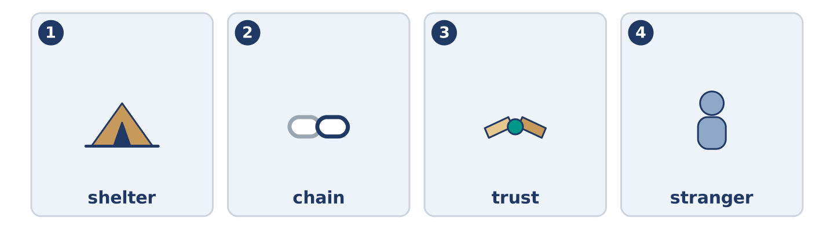
Figure 11.36 · The four words from the global story, drawn.
Match each word with its meaning. One meaning is not needed. Write the letter.
Column A
1. | shelter | ____
2. | chain | ____
3. | trust | ____
4. | stranger | ____
Column B
a) | a line of things joined one after another
b) | somebody you do not know
c) | a small building that keeps the weather off
d) | believing that people do what they should
e) | where people keep their dates
Part 8: Discussion
Talk with a partner. Use the frames.
Discussion frames: “This is similar to where I live because…” · “This is different from where I live because…” · “I think the most important thing is… because…”
Part 9 · Close to Home — The Saturday Nobody Had Arranged
[PLUS] Plus track · pre-read / decide
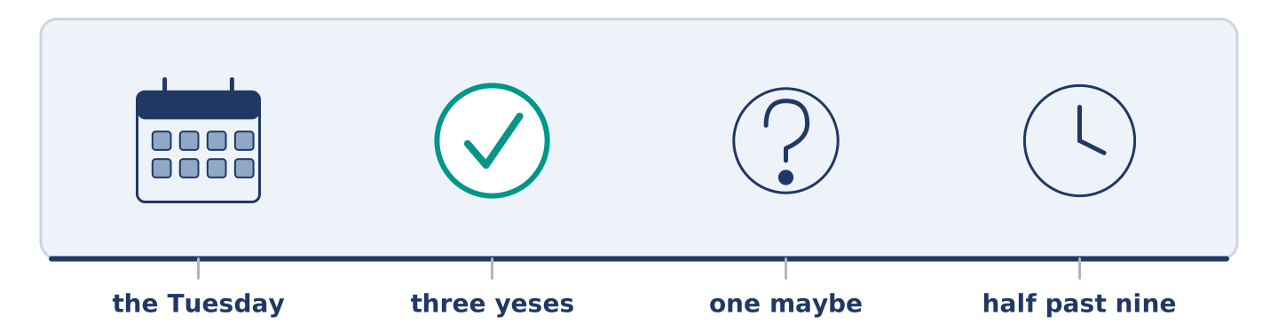
Figure 11.37 · The close-to-home reading, drawn along one street.
Before you read: is it harder to ask people in or to go to somebody else’s door?
Yuki asked all five of them on the Tuesday, and by Wednesday evening she had three yeses, one maybe and nothing at all from Tomas. Amina said yes before the sentence was finished. Dani said yes and then asked what he could cook, which was not the offer anybody wanted. Maya said yes and then quietly moved her sister to the Sunday. Mr Okonkwo said he would see, which from him is a yes with the door left open. Tomas said nothing for two days, because Tomas was on nights and did not read his phone. On Saturday he came at half past nine, straight off a shift, still in the wrong shoes, and stayed until one.
Answer the questions. (0. is done.)
- When did Yuki ask everybody? — On the Tuesday.
- What did Dani ask after he said yes?
- What did Maya quietly move?
- Why did Tomas say nothing for two days?
Part 9: Decision Task
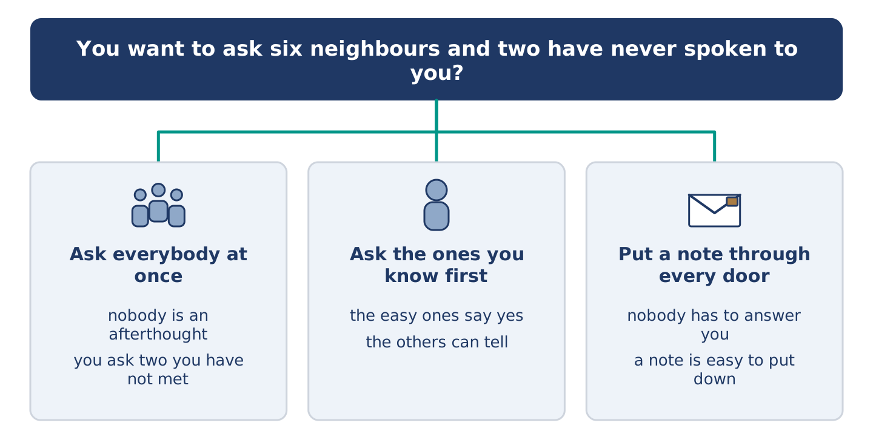
Figure 11.38 · Three ways to decide, and what each one costs.
You want to ask six neighbours to something and two have never spoken to you. Should you (a) ask everybody at once, (b) ask the ones you know first, or (c) put a note through every door? Decide and explain. Use the frame.
Answer frame: “I think I should ___ because ___. Also, ___. This is better than ___ because ___.”
Model — read this first:
I think I should ask everybody at once, because asking the easy ones first turns the others into an afterthought, and they can tell. Also, one message means nobody wonders who else was on the list. This is better than a note through the door, because a note is easy to put down and never answer. (56 words)
Phrase bank: I think I should… · because… · Also,… · This is better than… · In my opinion…
Part 10 · Review and Can-Do
[CORE + PLUS] · homework / self-study
Part 10: Spiral Review
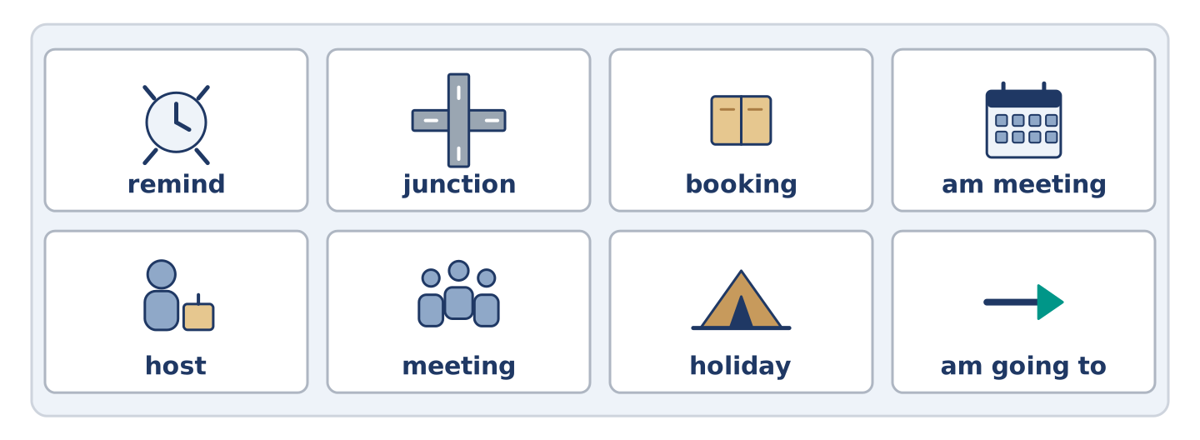
Figure 11.39 · The eight words of the review bank, in bank order.
Complete the review. (0. is done.)
- A book where you write what you are doing and when is a diary.
Word bank: remind | junction | booking | am meeting | host | meeting | holiday | am going to
- A seat or a room you asked for before you came is a ______________________ .
- When people come together to talk about something, it is a ______________________ .
- The person whose home or evening it is, is the ______________________ .
- To make somebody think of something again is to ______________________ .
- Days away from work, usually away from home, are a ______________________ .
- I ______________________ him at nine on Friday. (arranged)
- I ______________________ learn to drive this year. (decided)
- (from Unit 9) Where two or more roads meet is a ______________________ .
Part 10: Can-Do
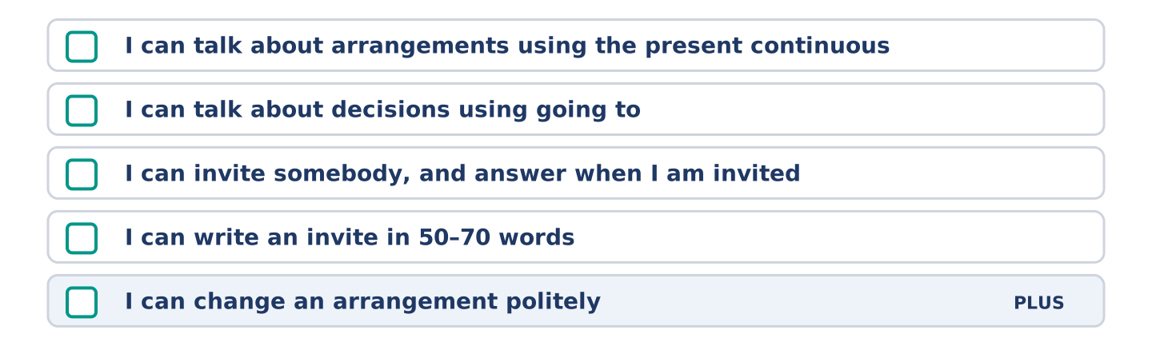
Figure 11.40 · What you can do at the end of this unit.
Can-Do checklist
☐ I can talk about arrangements using the present continuous.
☐ I can talk about decisions using going to.
☐ I can invite somebody, and answer when I am invited.
☐ I can write an invite in 50–70 words.
☐ I can change an arrangement politely (Plus).
Part 10: Glossary
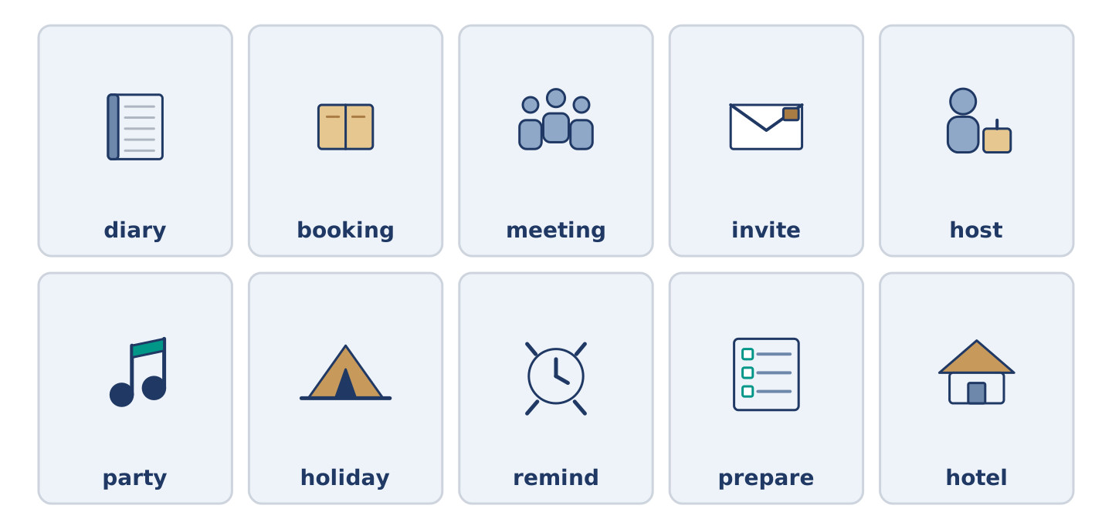
Figure 11.41 · All ten glossary words of Unit 11, one card each.
Unit 11 glossary (10 words)
diary · booking · meeting · invite · host · party · holiday · remind · prepare · hotel

