Unit 12: Weather and What Might Happen
English for Daily Life · Level: A2 · Tracks: [CORE] Warm-Up + Parts 1–6 · [PLUS] Parts 7–10
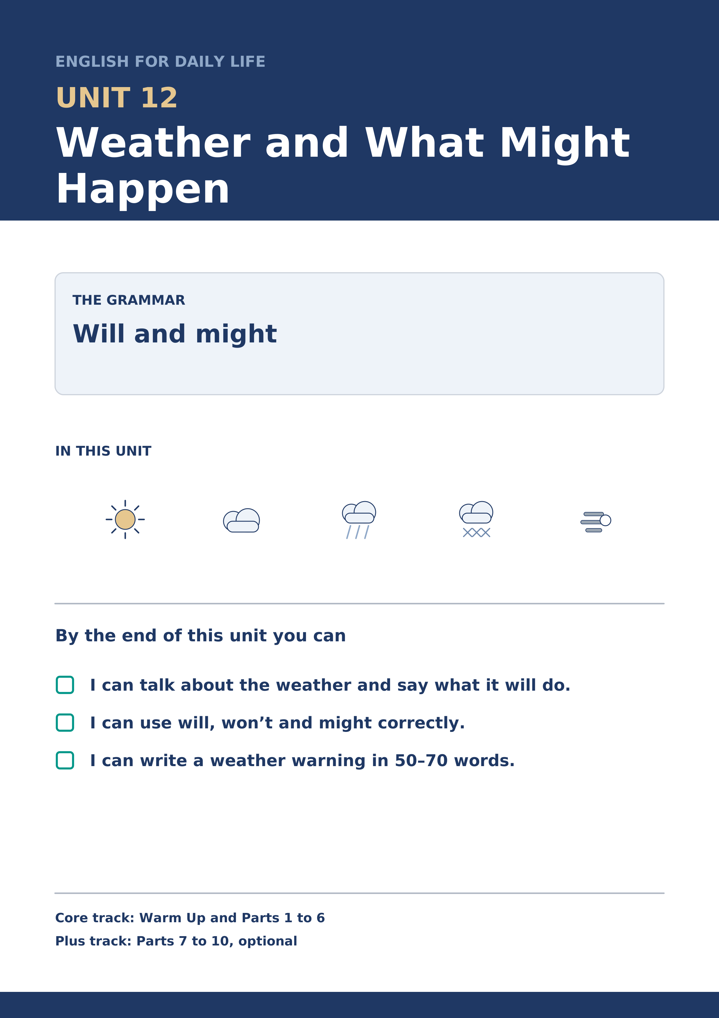
Warm Up
[CORE] Core track · in-class starter
Warm-up: Weather Words
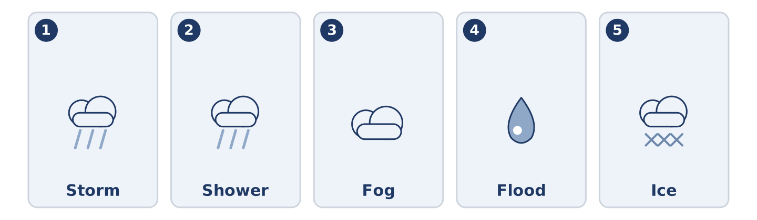
Figure 12.2 · The five warm-up words, and the thing each one means.
Match the words with their meanings. One meaning is not needed. Write the letter.
Column A
1. | Storm | ____
2. | Shower | ____
3. | Fog | ____
4. | Flood | ____
5. | Ice | ____
Column B
a) | thick cloud at ground level, so you see almost nothing
b) | short heavy rain that stops again
c) | water over roads and into houses
d) | strong wind and heavy rain together
e) | water that has gone hard with cold
f) | days away from work, usually away from home
Warm-up: Talking About the Weather
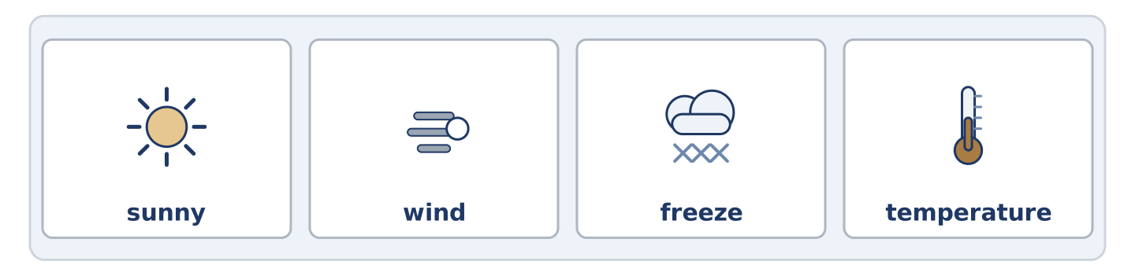
Figure 12.3 · The word bank for this task, in the order it is printed.
Complete the sentences using the words in the word bank.
Word bank: sunny | wind | freeze | temperature
- The ______________________ is going up all week, which nobody expected.
- Put the bike inside tonight, because the ______________________ is getting stronger.
- It will be ______________________ on Saturday, and Amina says she will believe it then.
- If it goes below zero the water in that pipe will ______________________ .
Warm-up: Six People, Six Forecasts
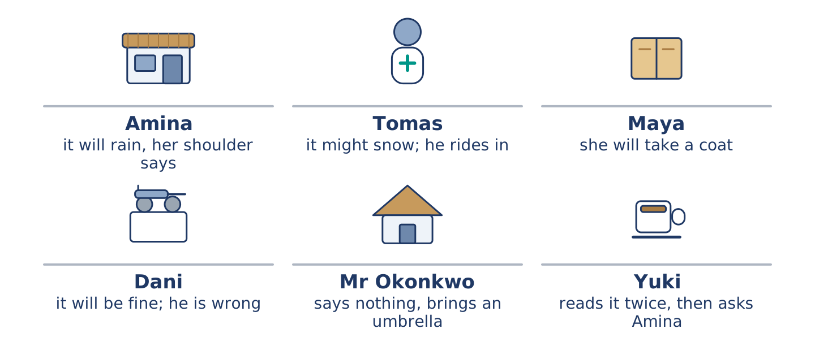
Figure 12.4 · What each of them thinks the weather will do.
Read the text and choose the correct answer.
Everybody at number 14 has a weather rule. Amina says it will rain because her shoulder says so, and her shoulder is right more often than the radio. Tomas says it might snow and he will ride in anyway. Maya says she will take a coat and she always takes a coat. Dani says it will be fine, and Dani is wrong about this every single week. Mr Okonkwo says nothing and brings an umbrella. Yuki reads the forecast twice and then asks Amina.
1. Whose shoulder is right more often than the radio?
○ A) Amina’s
○ B) Maya’s
○ C) Yuki’s
○ D) Dani’s
2. What does Mr Okonkwo do?
○ A) He reads the forecast twice
○ B) He says nothing and brings an umbrella
○ C) He rides in anyway
○ D) He says it will be fine
Part 1 · Vocabulary and Terminology
[CORE] Core track · pre-class input
Part 1: Words for Weather
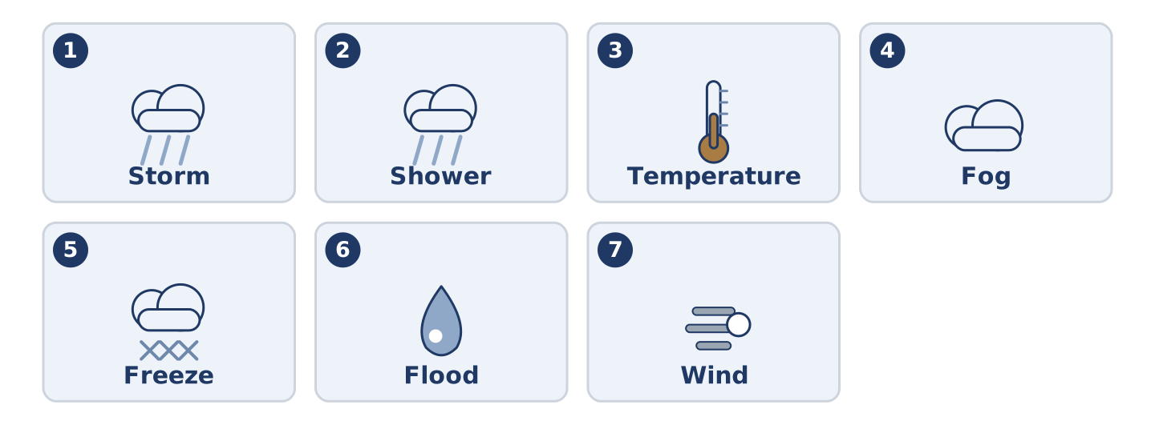
Figure 12.5 · The seven words of Column A, and what each one is.
Match the words with their meanings. One meaning is not needed. (0. is done for you.)
- Degree → one step on the scale that says how hot or cold it is.
Column A
1. | Storm | ____
2. | Shower | ____
3. | Temperature | ____
4. | Fog | ____
5. | Freeze | ____
6. | Flood | ____
7. | Wind | ____
Column B
a) | thick cloud at ground level
b) | air that is moving, sometimes hard
c) | short heavy rain that stops again
d) | to go hard with cold
e) | how hot or cold something is
f) | strong wind and heavy rain together
g) | water over roads and into houses
h) | a seat or room asked for in advance
Gloss: fog = thick cloud at ground level · flood = water over roads and into houses · freeze = to go hard with cold
Part 1: Pronunciation
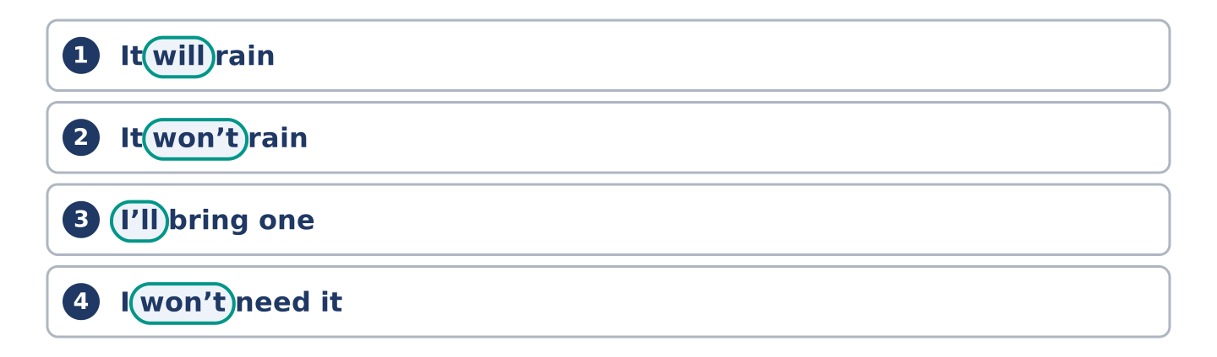
Figure 12.6 · Where the stress falls in 0 words of this unit.
🔊 Audio Track 12.1
Listen to will and won’t. Say each pair aloud.
It will rain — in speech will drops to one sound: it’ll rain
It won’t rain — won’t never drops, and the sound is long: /wəʊnt/
I’ll bring one — I will becomes I’ll, almost one letter
I won’t need it — long again, and clear
This is the same trap as can and can’t in Unit 8. The yes-form almost disappears and the no-form stands up and shouts. Say will strongly in the middle of a sentence and an English ear listens for a not that never comes.
Part 1: Four Kinds of Weather
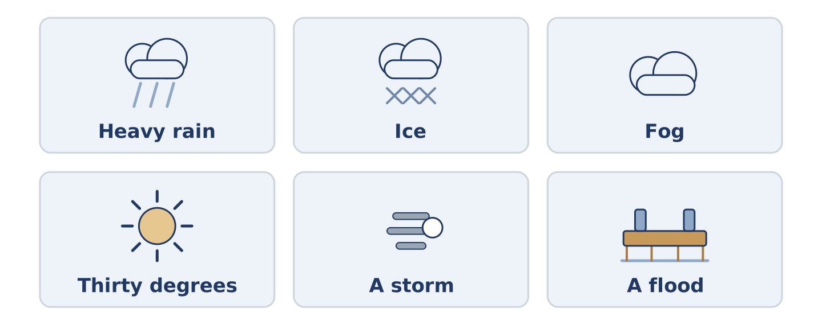
Figure 12.7 · Four kinds of weather, and what people do about each.
Complete the table. Write what you take and what you cancel. (0. is done.)
The weather | What you take | What you cancel
Heavy rain all day | a coat and dry shoes | (example)
Ice on the roads
Fog in the morning
Thirty degrees
- Heavy rain all day — a coat and dry shoes — nothing; you go anyway.
Think about where you live. There is more than one right answer; be ready to say why.
Part 1: How Sure Is It?
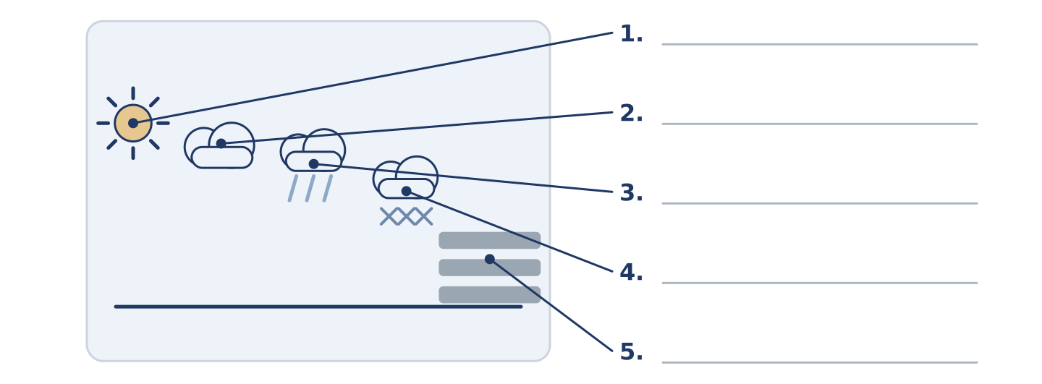
Figure 12.8 · How sure a forecast is — write the correct word on each line.
Match the ways of talking about the future with how sure they are. One is not needed. Write the letter.
Column A
1. | It will rain. | ____
2. | It might rain. | ____
3. | It will probably rain. | ____
4. | It won’t rain. | ____
5. | It might not rain. | ____
Column B
a) | sure it is not going to happen
b) | possible, and possible the other way too
c) | sure it is going to happen
d) | likely, but not certain
e) | possible that it does not happen
f) | it happened and it was heavy
Part 1: Weather — Multiple Choice
Read and choose the correct answer.
1. Thick cloud at ground level is…
○ A) fog
○ B) a shower
○ C) a storm
○ D) ice
2. Water over roads and into houses is a…
○ A) shower
○ B) wind
○ C) flood
○ D) degree
3. Short heavy rain that stops again is a…
○ A) fog
○ B) shower
○ C) storm
○ D) flood
Part 1: Vocabulary Fill-in
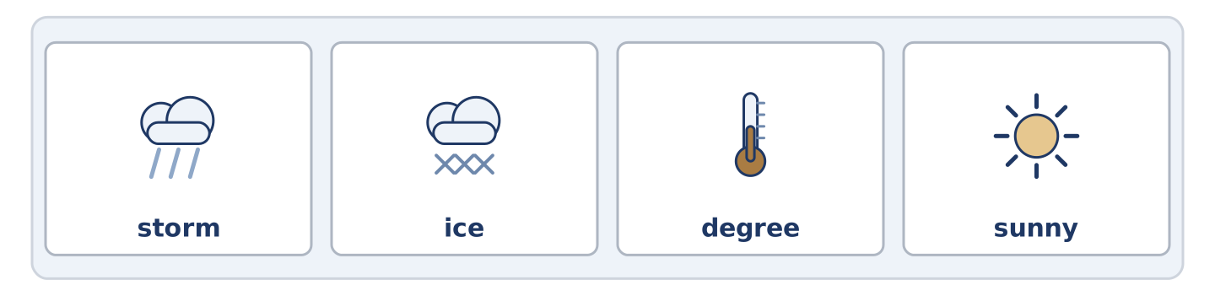
Figure 12.9 · The four words of the bank, in the order the task gives them.
Complete the sentences with the correct word.
Word bank: storm | ice | degree | sunny
- There is ______________________ on the steps, so hold the rail.
- It is one ______________________ above zero and the sky is white.
- The ______________________ took three tiles off the roof at number 8.
- Two ______________________ days in March, and the whole street is outside.
Part 1: Write About Your Weather (short)
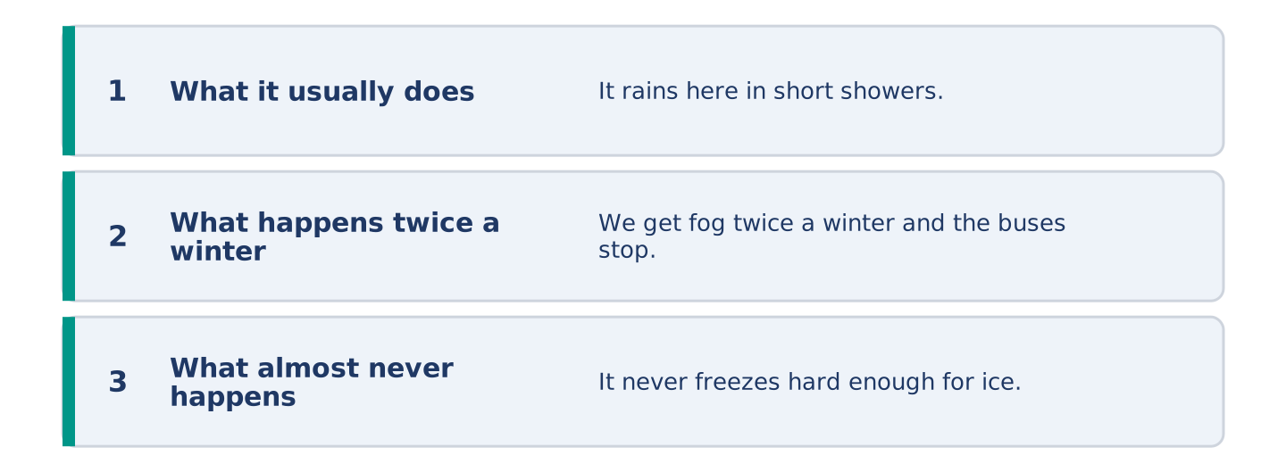
Figure 12.10 · The shape of your two or three sentences, with the model beside each step.
Write two or three sentences about the weather where you live. Use three words from this unit.
Model — read this first:
It rains here in short showers and then the sun comes out and nobody believes it. We get fog twice a winter and the buses stop. It never freezes hard enough for ice on the roads, so the one year it did, nobody could drive at all. (47 words)
Part 2 · Grammar — Will and Might
[CORE] Core track · pre-class input
Part 2: Notice
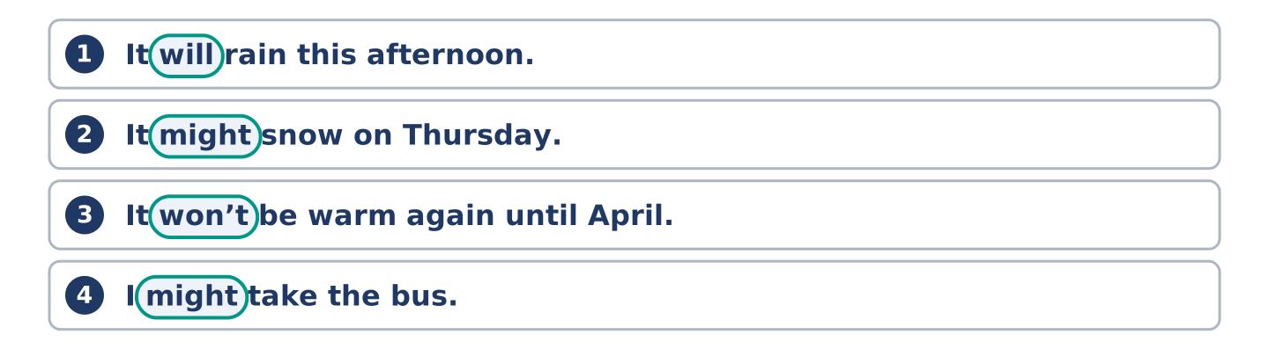
Figure 12.11 · Lines from the notice, with the target form ringed in each.
Read these lines. Underline will, won’t and might. Which are sure, and which are only possible?
It will rain this afternoon. It might snow on Thursday. It won’t be warm again until April. I will take a coat. I might take the bus. With ice on the hill, the buses won’t run.
Three of these are sure. Two are only possible. One is a decision made while speaking.
Part 2: Grammar Focus Box
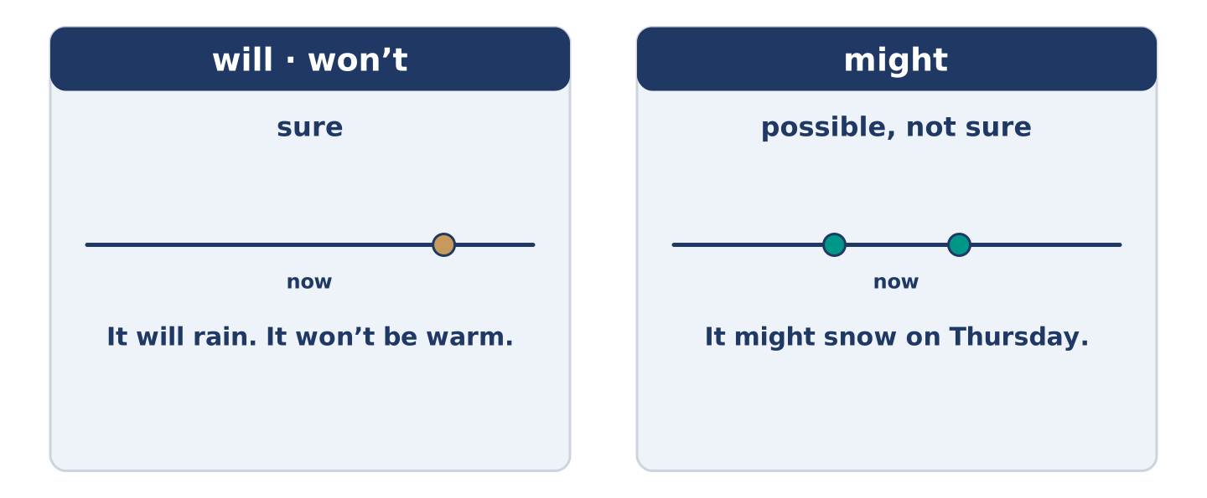
Figure 12.12 · Sure and possible: two words, two jobs.
 | Form | Use | Example
will | will + plain verb | sure about the future | It will rain this afternoon.
won’t | will not + plain verb | sure it does not happen | It won’t be warm until April.
might | might + plain verb | possible, not sure | It might snow on Thursday.
will (deciding) | the same form | a decision made as you speak | Fine — I will take a coat.
Remember: will and might never take to: it might rain, not it might to rain.
Watch out! ✗ It will to rain. → ✓ It will rain. (no to after will). ✗ Maybe it will perhaps rain. → ✓ It might rain. (one word for possible is enough).
Part 2: Controlled Practice
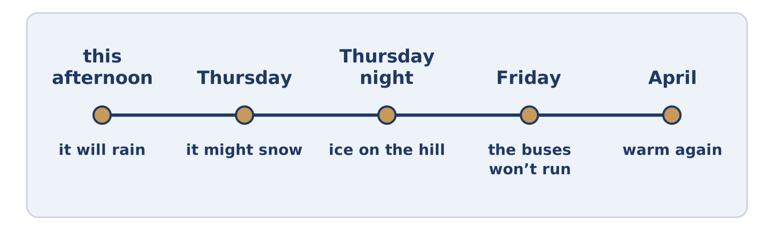
Figure 12.13 · One week of forecasts, from sure to possible.
Complete with will, won’t or might. (0. is done.)
- The forecast says it will rain this afternoon.
- It ______________________ snow on Thursday, but nobody is sure.
- It ______________________ be warm again until April.
- I think I ______________________ take a coat.
- If there is ice on the hill, the buses ______________________ run.
Part 2: Sure or Possible?
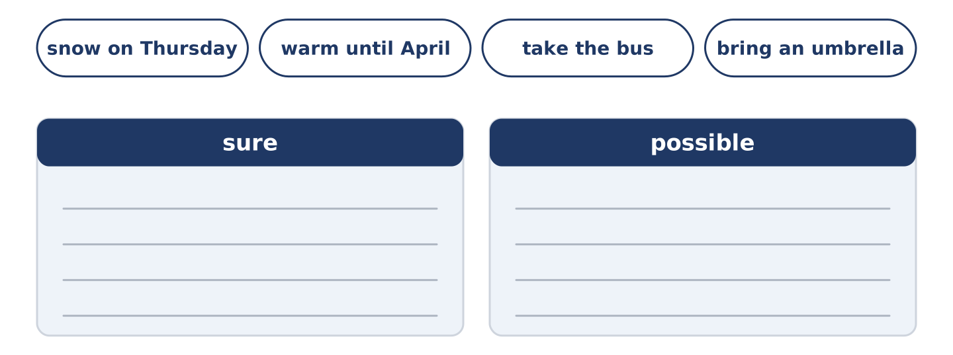
Figure 12.14 · The items of this task, and the bins they sort into.
Write sure or possible. (0. is done.)
- It will rain this afternoon. — sure
- It might snow on Thursday. ____________
- It won’t be warm until April. ____________
- I might take the bus. ____________
- I will bring an umbrella. ____________
Part 2: Correct the Sentence
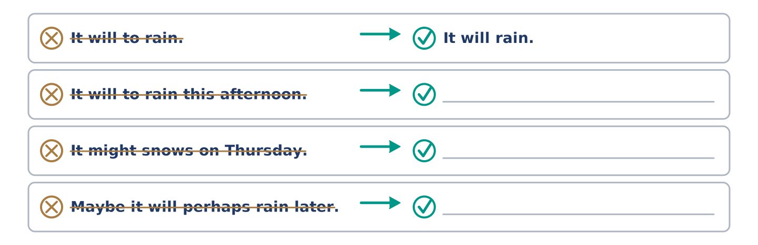
Figure 12.15 · One correction done for you, and the rest to write.
Each sentence has one grammar mistake. Write the correct sentence.
- It will to rain this afternoon.
- It might snows on Thursday.
- Maybe it will perhaps rain later.
- The buses not will run in ice.
Part 2: Freer Practice
Write two sentences about tomorrow: one you are sure about, and one that is only possible.
Part 2: Grammar Review
Choose the correct sentence.
1. Which sentence says it is only possible?
○ A) It will snow on Thursday.
○ B) It won’t snow on Thursday.
○ C) It is snowing on Thursday.
○ D) It might snow on Thursday.
2. Which sentence about the future is right?
○ A) It might rain later.
○ B) It will to rain later.
○ C) It might to rain later.
○ D) It will rains later.
→ Harvest: you will see will and might again in the Part 5 reading. Watch for how sure each one is.
Part 3 · Listening
[CORE] Core track · pre-class input · scripts printed inline
Part 3: The Shoulder and the Radio
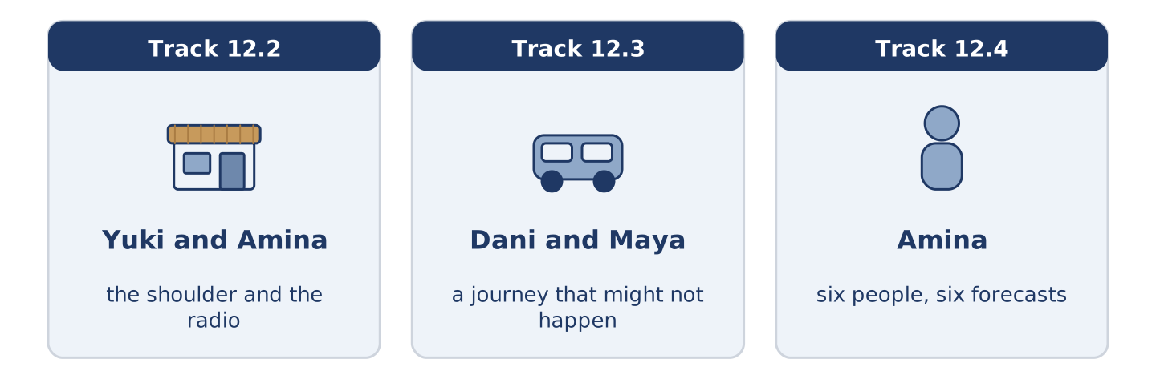
Figure 12.16 · The three listenings: who is speaking, and what about.
🔊 Audio Track 12.2
Before you listen: who do you believe about the weather?
Yuki: The forecast says sun all weekend. Amina: It’ll rain on Saturday. Yuki: It says sun. Amina: My shoulder says rain, and my shoulder was here long before that radio. Yuki: So do I take the washing in? Amina: Take it in. Say I’m wrong — then you’ve dry washing in a dry flat, and nobody ever died of that. Yuki: And Sunday? Amina: Sunday might be lovely. I’m not promising.
While you listen: write True, False, or Not Given. (0. is done.)
- The forecast says sun all weekend. — True
- Amina thinks it will rain on Saturday. ____
- Amina is sure about Sunday. ____
- Amina was right about last weekend. ____
Useful phrases: The forecast says… · It’ll rain on… · So do I…? · I’m not promising.
Part 3: A Journey That Might Not Happen
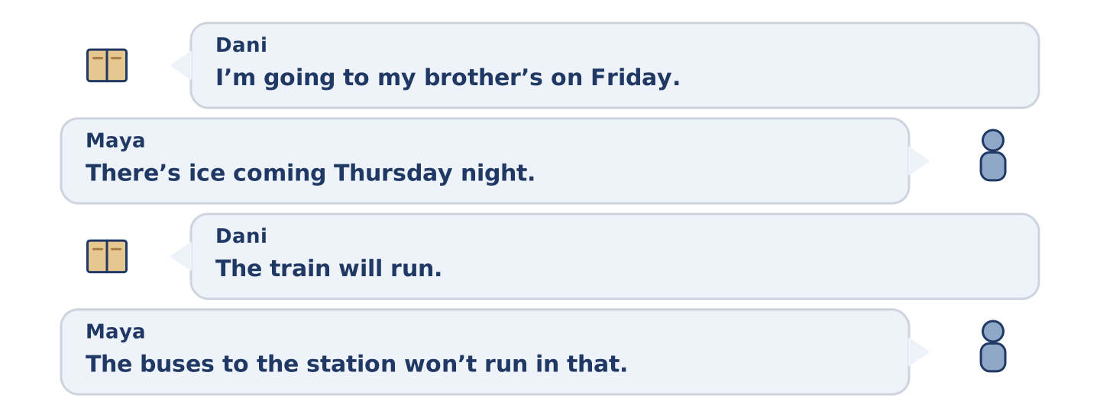
Figure 12.17 · The second listening, turn by turn.
🔊 Audio Track 12.3
Before you listen: what do you do when the weather might stop a journey?
Dani: I’m going to my brother’s on Friday. Maya: There’s ice coming Thursday night. Dani: The train will run. Maya: The train might run. The buses to the station won’t run in that. Dani: Then I’ll walk to the station. Maya: It’s forty minutes and it’s all downhill, and downhill is the part that breaks people. Dani: I’ll go Thursday afternoon instead. Maya: There. That took one minute.
Answer the questions. (0. is done.)
- When is Dani going to his brother’s? — On Friday.
- What does Maya say is coming on Thursday night?
- What does Maya say about the buses to the station?
- What does Dani decide in the end?
Part 3: Six People, Six Forecasts
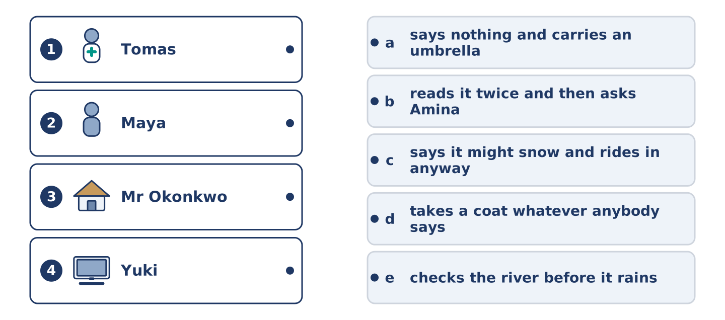
Figure 12.18 · Four on the left, five on the right, and one spare.
🔊 Audio Track 12.4
Before you listen: is there somebody in your street who is always wrong about the weather?
Amina: I hear all six forecasts before nine every morning. Tomas says it might snow and goes out on the bike all the same. Maya takes a coat whatever anybody says, and she is never cold and never right. Dani says it will be fine, and I stopped telling him years ago. Mr Okonkwo says nothing at all and carries an umbrella, which is the only honest answer. And Yuki reads it twice, then comes down and asks me.
While you listen: match each person with their forecast. One is not needed. (0. is done.)
- Amina → she hears all six before nine.
Useful phrases: ___ goes out regardless · ___ takes a coat · ___ carries an umbrella
Column A
1. | Tomas | ____
2. | Maya | ____
3. | Mr Okonkwo | ____
4. | Yuki | ____
Column B
a) | says nothing and carries an umbrella
b) | reads it twice and then asks Amina
c) | says it might snow and rides in anyway
d) | takes a coat whatever anybody says
e) | checks the river before it rains
Part 4 · Speaking
[CORE] Core track · in-class output
Part 4: What the Weather Does to You
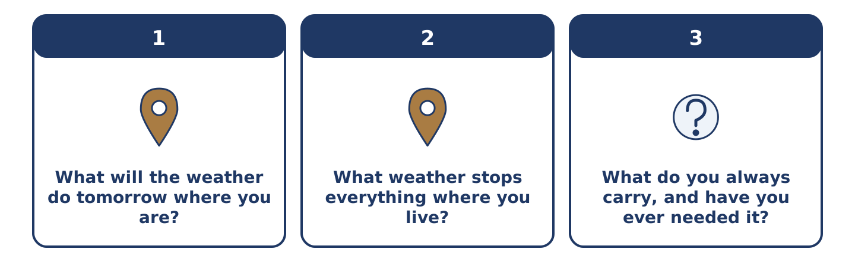
Figure 12.19 · The three questions as cards, to take one at a time.
Work with a partner. Ask and answer these questions.
- What will the weather do tomorrow where you are?
- What weather stops everything where you live?
- What do you always carry, and have you ever needed it?
Useful language: It will… · It might… · It won’t… · probably
Part 4: Find the Difference (pairwork)
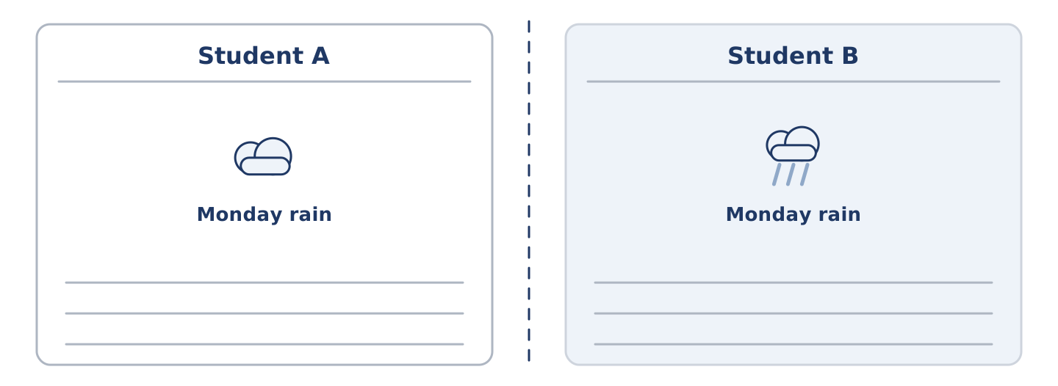
Figure 12.20 · Student A’s facts and Student B’s, with a fold between them.
Student A and Student B each have a forecast for the same week. Ask questions and find three differences.
Useful questions: What will it do on Monday? · Will it rain on Wednesday? · How many degrees on Friday? · Might it snow?
Student A — your forecast: Monday rain, Wednesday sun, Friday nine degrees, Saturday fog.
Student B — your forecast: Monday rain, Wednesday showers, Friday two degrees, Saturday fog.
Part 4: Deciding What to Do About the Weather
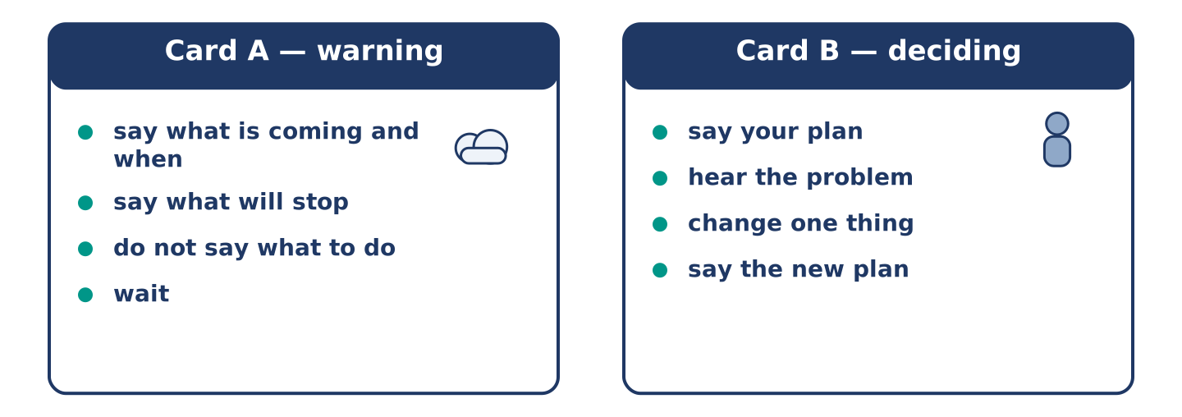
Figure 12.21 · Card A and Card B: what each of you has to say.
Work in pairs. Read the model, then use the cards.
Model exchange:
A: There is ice coming on Thursday night. — B: The train will run. — A: The train might run. The buses won’t. — B: Then I will walk. — A: It is forty minutes and it is all downhill. — B: Then I will go on Thursday afternoon. — A: That took one minute.
Useful language: There is … coming · It might… · It won’t… · Then I will…
Card A — warning: say what is coming and when · say what will stop · do not tell them what to do · wait.
Card B — deciding: say your plan · hear the problem · change one thing · say the new plan out loud.
Your turn: run the dialogue, then swap roles.
Stretch [PLUS]: the other person will not change the plan and the weather is genuinely dangerous — say so once more, and then stop.
Part 4: Mini-Presentation
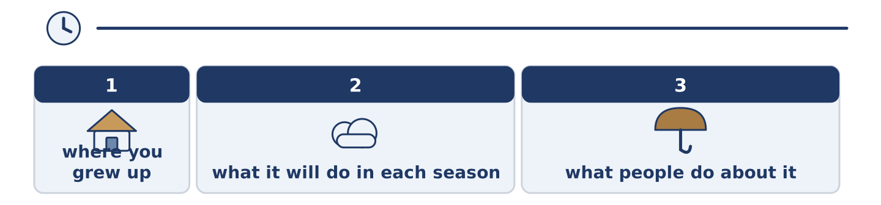
Figure 12.22 · The one-minute talk as two beats, each as wide as its share.
Prepare a short talk (about one minute). Describe the weather where you grew up: what it will do in each season, and what people do about it.
Part 5 · Reading
[CORE] Core track · pre-class input
Part 5: Why Nobody Believes the Forecast
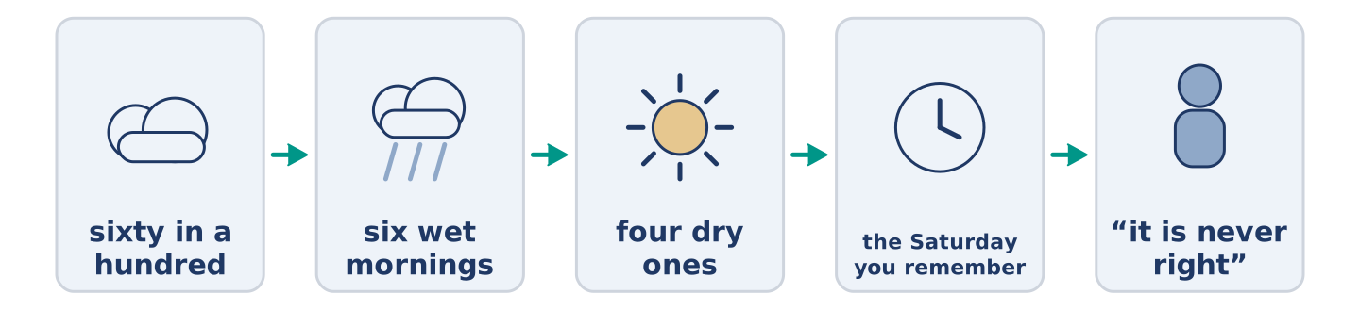
Figure 12.23 · One forecast, from the measurement to the morning.
Before you read: do you believe the forecast where you live?
Gloss: forecast = what somebody says the weather will do · percentage = how many out of a hundred · wrong = not right
A forecast that says sixty in a hundred for rain is right far more often than people think. People still call it no use at all. The reason is simple and it is about us. Sixty in a hundred means that on six mornings out of ten like this one, it rains. Today may be one of the four dry ones, and the forecast was still not wrong. It never promised anything. But a person does not remember six wet mornings. A person remembers the one Saturday they called off, and the sun that came out at eleven. Forecasters know this, and the good ones say probably and might as often as the language allows. The audience then says they never give a straight answer, which is the first complaint again.
Answer the multiple-choice questions. (0. is done.)
- What does the text say about a sixty-in-a-hundred forecast? — It is right far more often than people think.
1. What does sixty in a hundred for rain mean?
○ A) It will rain for sixty minutes
○ B) On six mornings out of ten like this one, it rains
○ C) Sixty parts of the country get rain
○ D) The forecaster is sixty in a hundred sure of everything
2. What does a person remember?
○ A) The six wet mornings
○ B) Every forecast of the year
○ C) The one Saturday they called off
○ D) The temperature
3. What do the good forecasters say?
○ A) Nothing at all
○ B) It will be fine
○ C) The exact hour
○ D) Probably and might
Part 5: Vocabulary in Context
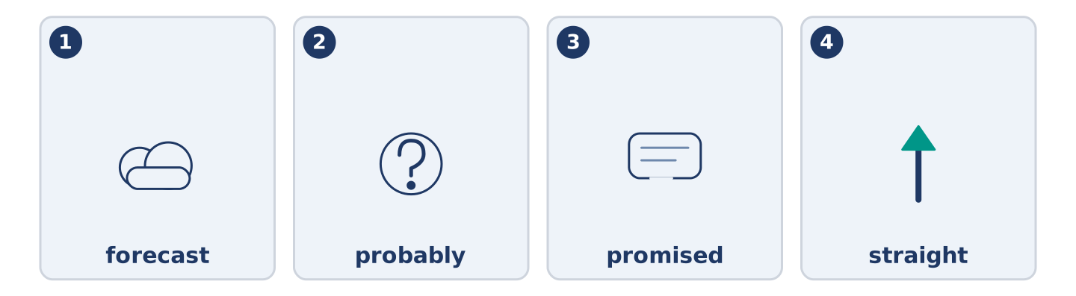
Figure 12.24 · The four words from the reading, drawn.
Match each word from the text with its meaning. One meaning is not needed. Write the letter.
Column A
1. | forecast | ____
2. | probably | ____
3. | promised | ____
4. | straight | ____
Column B
a) | said that something was sure
b) | what somebody says the weather will do
c) | plain, with nothing held back
d) | likely, but not certain
e) | water that has gone hard with cold
Part 5: Three Places and Their Weather
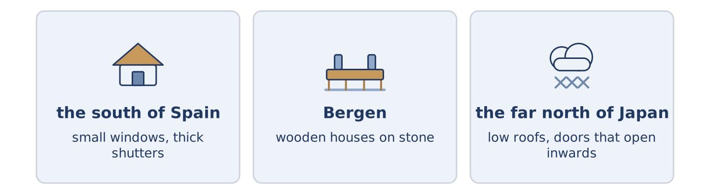
Figure 12.25 · Three places, and the one thing the weather does to each.
Before you read: does the weather where you live change what people build?
Gloss: shutter = a cover you close over a window · roof = the top of a building · season = one of the parts of the year
Weather builds houses, and not only in the sunny half of the world. In the south of Spain the windows are small and the shutters are thick, because for four months the sun is what you keep out. In Bergen it rains about two hundred and thirty days a year. The old wooden houses stand on stone, because wood that sits in water does not last. In the far north of Japan the roofs run almost to the ground and the doors open inwards. A door that opens into the street will meet two metres of snow one morning. None of these are for show. Every one of them is somebody losing an argument with the sky and writing it down in wood.
Answer the questions. (0. is done.)
- What does the text say weather does? — It builds houses.
- Why are the windows small in the south of Spain?
- Why do the old houses in Bergen stand on stone?
- Why do the doors open inwards in the far north of Japan?
Part 6 · Writing
[CORE] Core track · in-class / homework
Part 6: A Weather Warning (50–70 words)
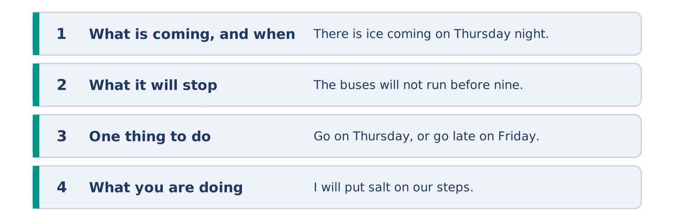
Figure 12.26 · The shape of the warning you are about to write.
Bad weather is coming. Write a short message warning your neighbours.
Model — read this first:
There is ice coming on Thursday night and Friday morning will be bad. The hill will be the worst part, and the buses probably will not run before nine. Going anywhere early? Go on Thursday, or go late on Friday. I will put salt on our steps and on number 8’s. Nobody needs to thank me. (56 words)
Plan (fill in, then write): There is ___ coming on ___. ___ will be the worst part. If you ___, ___. I will ___.
Word bank: there is … coming | it will | it won’t | probably | if you are
Check before you finish: ☐ what is coming and when? ☐ what it will stop? ☐ one piece of advice? ☐ 50–70 words?
Part 6: Does the Weather Change People? (50–70 words)
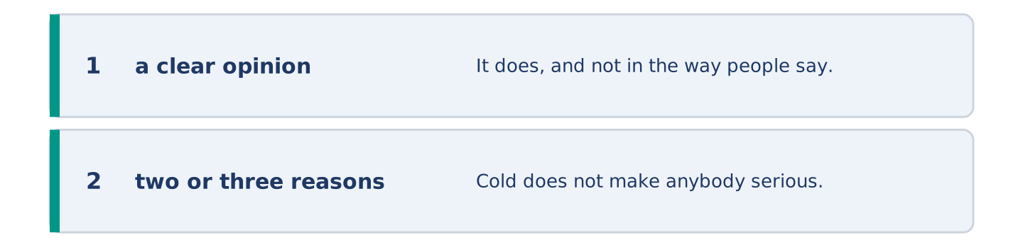
Figure 12.27 · The shape of the opinion paragraph, step by step.
Does the weather where you live change what people are like? Give your opinion and two or three reasons.
Model — read this first:
It does, and not in the way people say. Cold does not make anybody serious. What it does is take the street away for five months, so nobody runs into anybody, and every meeting has to be fixed first. In a hot country the street is the living room. Here the living room is the living room, and you need a reason to be in it. (66 words)
Word bank: I think… because… | however | in my opinion | it depends on | probably
Check before you finish: ☐ a clear opinion? ☐ two or three reasons? ☐ 50–70 words?
Part 6: A Day the Weather Changed Everything (50–70 words)
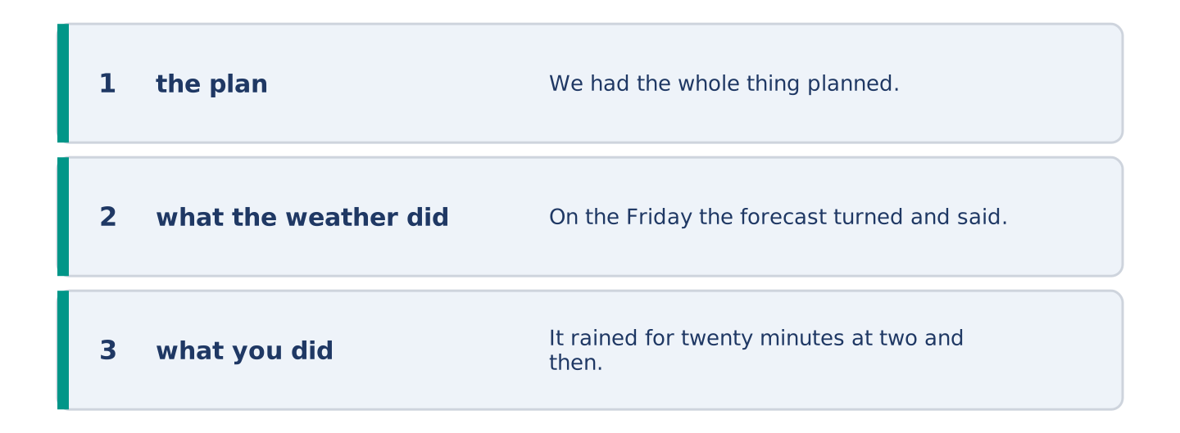
Figure 12.28 · The moves of the message, with a line of the model for each.
Write about a day when the weather changed your plans. Say what happened and what you did.
Model — read this first:
We had the whole thing planned for the Saturday, outside, forty people. On the Friday the forecast turned and said storm, and we moved everything into a hall that smelled of soap. It rained for twenty minutes at two and then stopped for good. Everybody said it was lovely. I am still cross about it. (55 words)
Plan (fill in, then write): We planned ___. Then ___. So we ___. In the end ___.
Check before you finish: ☐ the plan? ☐ what the weather did? ☐ what you did? ☐ 50–70 words?
Part 6: Reflection — The Weather I Would Choose (40–60 words)
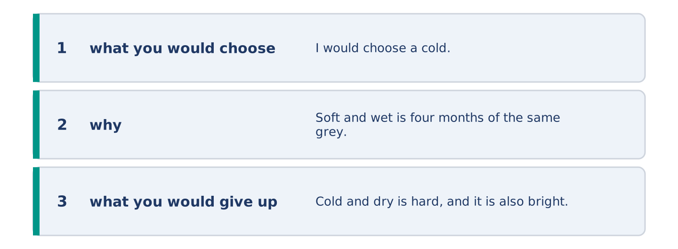
Figure 12.29 · The reflection, step by step.
Write about the weather you would choose to live in, and why.
Model — read this first:
I would choose a cold, dry winter over a soft wet one, and I know that sounds strange. Soft and wet is four months of the same grey Tuesday. Cold and dry is hard, and it is also bright, and the year moves through it instead of sitting still in it. (51 words)
Check before you finish: ☐ what you would choose? ☐ why? ☐ what you would give up? ☐ 40–60 words?
Part 7 · Real-World File — Warnings and Forecasts
[PLUS] Plus track (optional) · stronger learners
7A: Phrase Bank
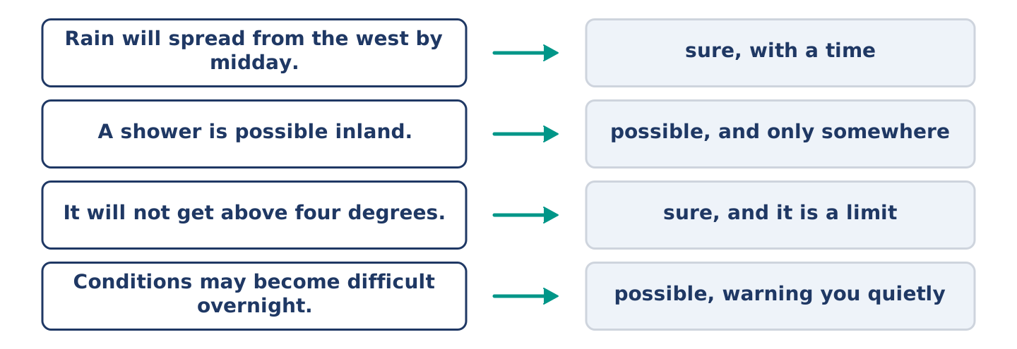
Figure 12.30 · What a forecast says, and how sure each line is.
Match what a forecast says with how sure it is. One is not needed. Write the letter.
Column A
1. | “Rain will spread from the west by midday.” | ____
2. | “A shower is possible inland.” | ____
3. | “It will not get above four degrees.” | ____
4. | “Conditions may become difficult overnight.” | ____
Column B
a) | possible, and they are warning you quietly
b) | sure, and it is a limit
c) | how much it will cost
d) | sure, with a time
e) | possible, and only somewhere
7B: A Warning Nobody Took
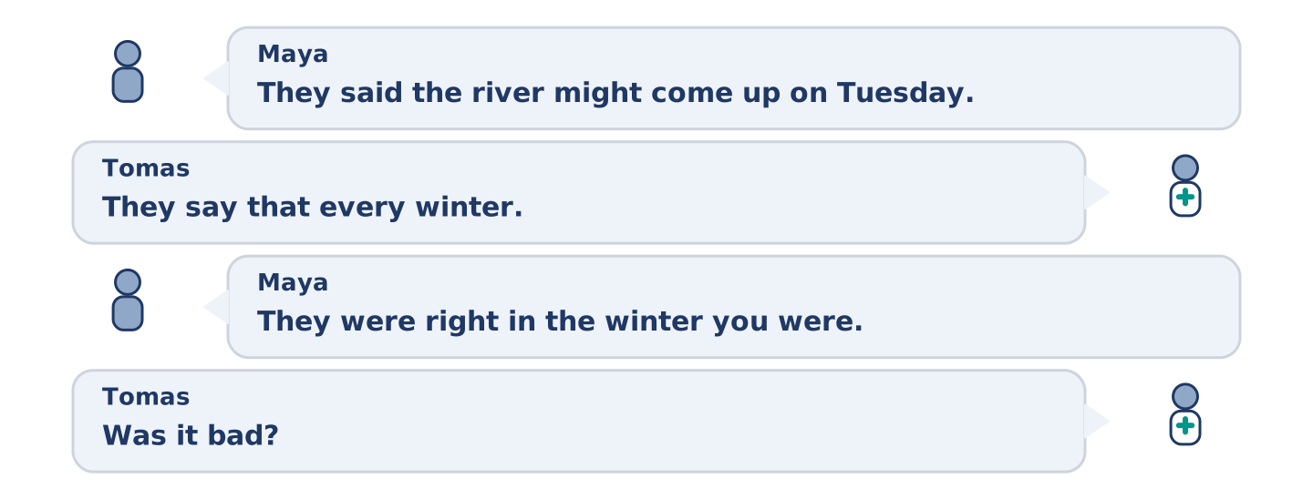
Figure 12.31 · The 7B exchange: who takes each turn.
🔊 Audio Track 12.5
Before you read: when did you last ignore a warning?
Maya: They said the river might come up on Tuesday. Tomas: They say that every winter. Maya: They were right in the winter you were in Norway. Tomas: Was it bad? Maya: It came into the shop and Amina lost two days. Tomas: Nobody mentioned that to me. Maya: Nobody here tells anybody anything until it is a story. Tomas: So what will you do? Maya: I will move my books off the floor tonight, and I will feel stupid on Wednesday.
Answer the questions. (0. is done.)
- What did they say might happen on Tuesday? — The river might come up.
- What happened the winter Tomas was in Norway?
- What does Maya say about how word travels in the street?
- What is Maya going to do tonight?
7C: Controlled Practice — Giving a Warning Well
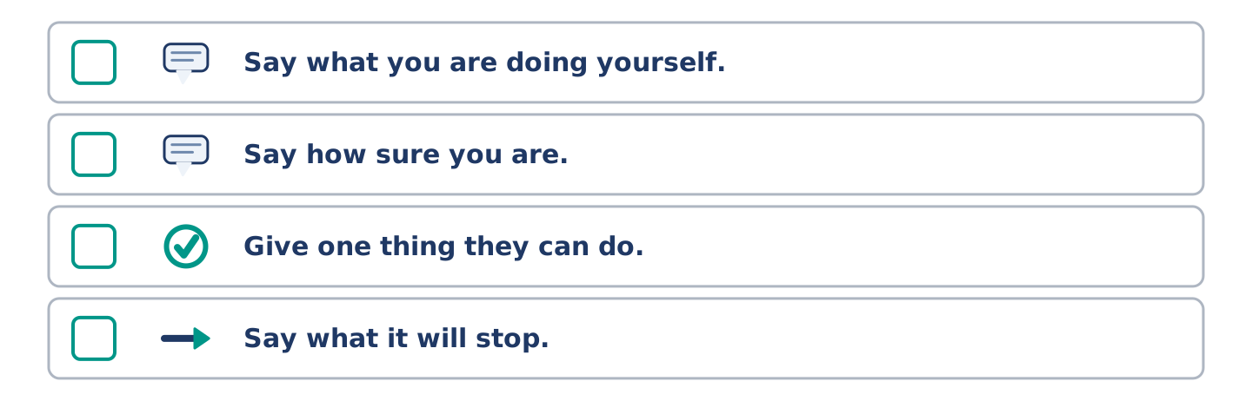
Figure 12.32 · The steps still to be numbered, as the task prints them.
Put the steps in order. Number them 1–5. (0. is done.)
- Say what is coming and when. — 1
____ Say what you are doing yourself.
____ Say how sure you are.
____ Give one thing they can do.
____ Say what it will stop.
7D: Role-Play — Warning Somebody Who Is Not Worried
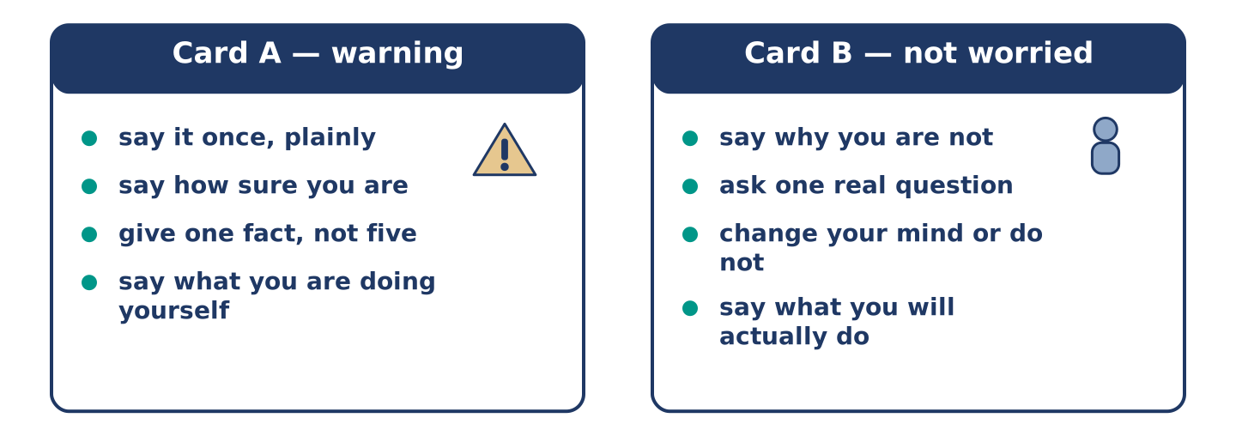
Figure 12.33 · The 7D cards: what each of you has to say.
In pairs. One warns; one is not worried. Use the model and cards.
Model exchange: A: They said the river might come up on Tuesday. — B: They say that every winter. — A: They were right two winters ago. — B: Was it bad? — A: It came into the shop. — B: Nobody told me. — A: I am moving my books off the floor tonight.
Card A — warning: say it once, plainly · say how sure you are · give one fact, not five · say what you are doing yourself.
Card B — not worried: say why you are not · ask one real question · change your mind or do not · say what you will actually do.
Stretch [PLUS]: you warned them, they did nothing, and it happened — speak to them the next day without saying you told them so.
7E: Writing — A Warning for a Whole Street (50–80 words)
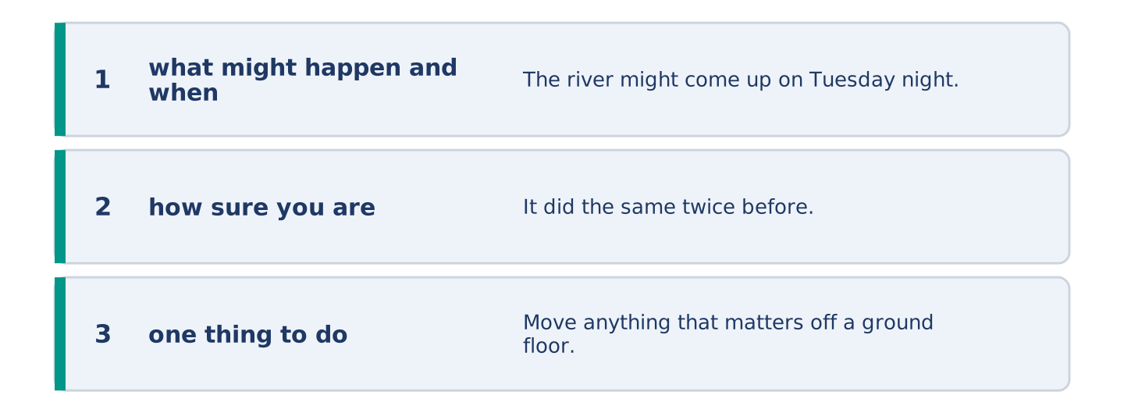
Figure 12.34 · The Part 7 note, with the model beside each line.
Write a notice for your street about weather that is coming.
Model — read this first:
The river might come up on Tuesday night. It did the same twice before, and both times it was the Tuesday nobody believed. Move anything that matters off a ground floor this evening. It takes ten minutes, and you feel silly for about a day. The shop will stay open. I will put a note on the door if anything changes. (61 words)
Check before you finish: ☐ what might happen and when? ☐ how sure you are? ☐ one thing to do? ☐ 50–80 words?
Part 8 · Global Story — The Day the Rain Is Due
[PLUS] Plus track · pre-read / discuss
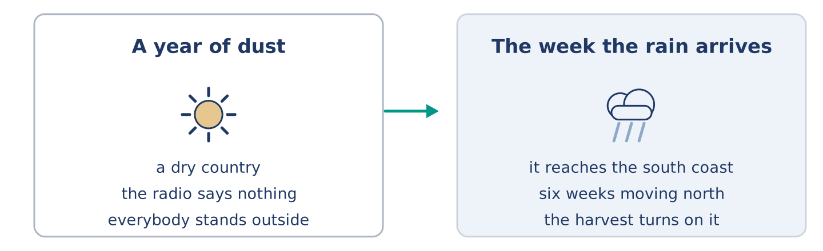
Figure 12.35 · A year of dust, and the week the rain arrives.
Before you read: can a whole country wait for one day of weather?
Gloss: monsoon = the season of heavy rain that comes once a year · harvest = the crops people cut and bring in · dam = a wall that holds water back
In India the rain has a date. The monsoon arrives on the south coast around the first of June and moves north over six weeks. The day it reaches each place goes round the whole country. People stand outside for it. Parents send the children out into it. The radio carries the day it reaches each city, the way it carries a result. The whole year of work turns on whether it is early, late or thin. A late monsoon means a small harvest, and a small harvest means a hard winter in villages a thousand miles from any newspaper. Nothing in Europe compares. The nearest thing is a bad winter, and a bad winter only costs you a week.
Answer the questions. (0. is done.)
- When does the monsoon arrive on the south coast? — Around the first of June.
- How long does it take to move north across the country?
- What happens when it reaches each place?
- What does a late monsoon mean?
Part 8: Vocabulary in Context
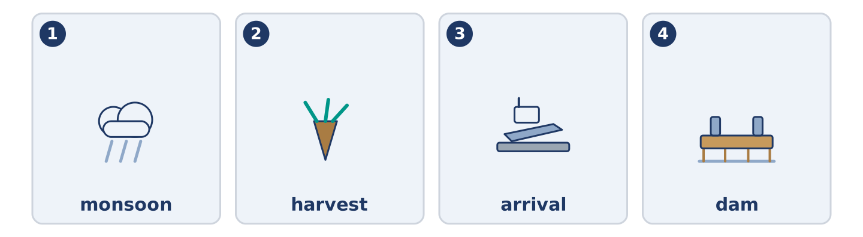
Figure 12.36 · The four words from the global story, drawn.
Match each word with its meaning. One meaning is not needed. Write the letter.
Column A
1. | monsoon | ____
2. | harvest | ____
3. | arrival | ____
4. | dam | ____
Column B
a) | the moment something gets here
b) | a wall that holds water back
c) | the season of heavy rain that comes once a year
d) | the crops people cut and bring in
e) | a cover you close over a window
Part 8: Discussion
Talk with a partner. Use the frames.
Discussion frames: “This is similar to where I live because…” · “This is different from where I live because…” · “I think the most important thing is… because…”
Part 9 · Close to Home — The Tuesday the River Came Up
[PLUS] Plus track · pre-read / decide
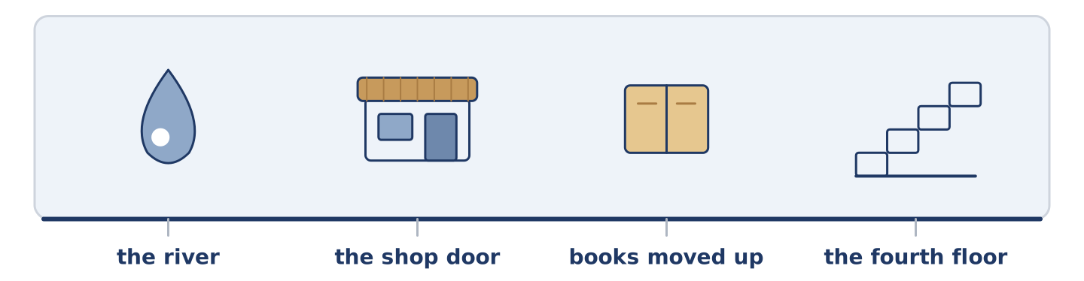
Figure 12.37 · The close-to-home reading, drawn along one street.
Before you read: who warns a street, and who listens?
The river came up on a Tuesday two winters ago, and almost nobody at number 14 believed it would. Amina lost two days of trade and a freezer. Maya moved her books up and felt silly all Monday evening, and clever by Wednesday. Dani slept through the whole thing on the first floor. Mr Okonkwo lives on the fourth floor and lost nothing at all. He went down at six in the morning and stood at the shop door with Amina for an hour, saying nothing. There was nothing to say, and leaving was worse. Tomas was in Norway. Yuki had not moved in yet. When they tell her about it now, each of them tells it differently, and all five are true.
Answer the questions. (0. is done.)
- When did the river come up? — On a Tuesday two winters ago.
- What did Amina lose?
- How did Maya feel on Monday evening, and on Wednesday?
- What did Mr Okonkwo do at six in the morning?
Part 9: Decision Task
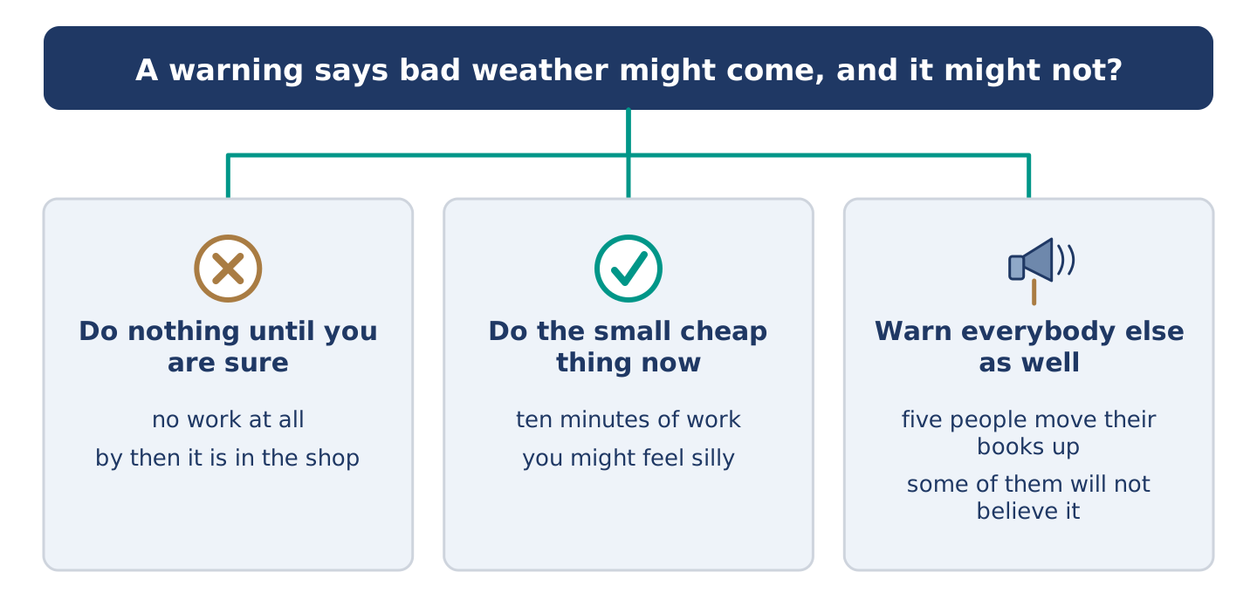
Figure 12.38 · Three ways to decide, and what each one costs.
A warning says bad weather might come, and it might not. Should you (a) do nothing until you are sure, (b) do the small cheap thing now, or (c) warn everybody else as well? Decide and explain. Use the frame.
Answer frame: “I think I should ___ because ___. Also, ___. This is better than ___ because ___.”
Model — read this first:
I think I should do the small cheap thing now, because ten minutes of work buys me the whole week without thinking about it. Also, the cost of being wrong is that I feel silly, which is nothing. This is better than waiting until I am sure, because by the time anybody is sure it is already in the shop. (60 words)
Phrase bank: I think I should… · because… · Also,… · This is better than… · In my opinion…
Part 10 · Review and Can-Do
[CORE + PLUS] · homework / self-study
Part 10: Spiral Review
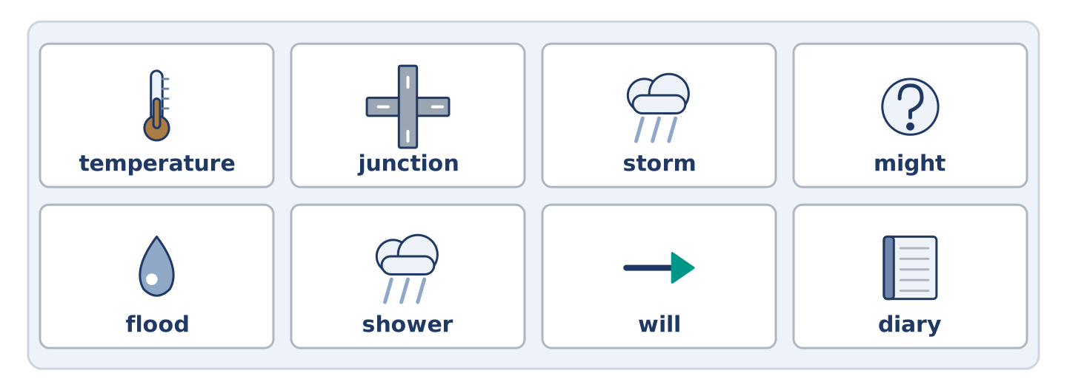
Figure 12.39 · The eight words of the review bank, in bank order.
Complete the review. (0. is done.)
- Thick cloud at ground level is fog.
Word bank: temperature | junction | storm | might | flood | shower | will | diary
- Strong wind and heavy rain together is a ______________________ .
- Short heavy rain that stops again is a ______________________ .
- Water over roads and into houses is a ______________________ .
- How hot or cold something is, is the ______________________ .
- The forecast says it ______________________ rain this afternoon. (sure)
- It ______________________ snow on Thursday. (possible)
- (from Unit 11) A book where you write what you are doing is a ______________________ .
- (from Unit 9) Where two or more roads meet is a ______________________ .
Part 10: Can-Do
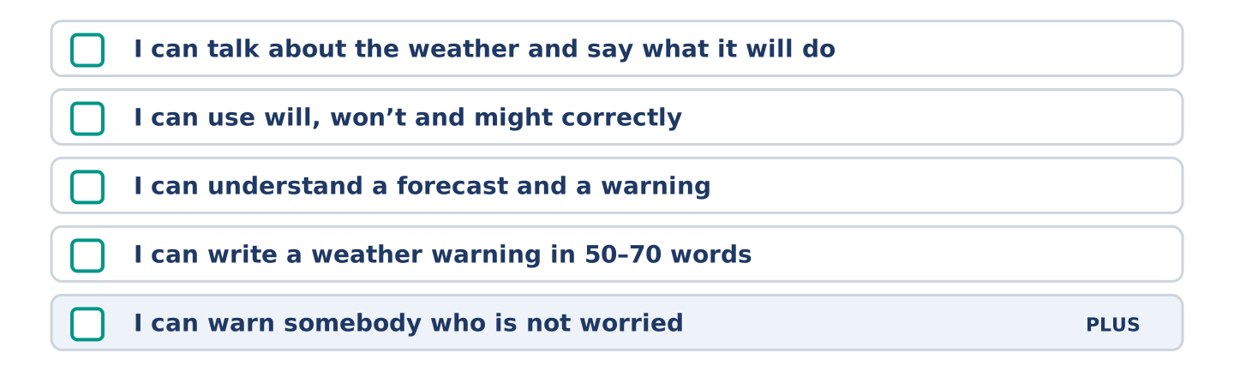
Figure 12.40 · What you can do at the end of this unit.
Can-Do checklist
☐ I can talk about the weather and say what it will do.
☐ I can use will, won’t and might correctly.
☐ I can understand a forecast and a warning.
☐ I can write a weather warning in 50–70 words.
☐ I can warn somebody who is not worried (Plus).
Part 10: Glossary
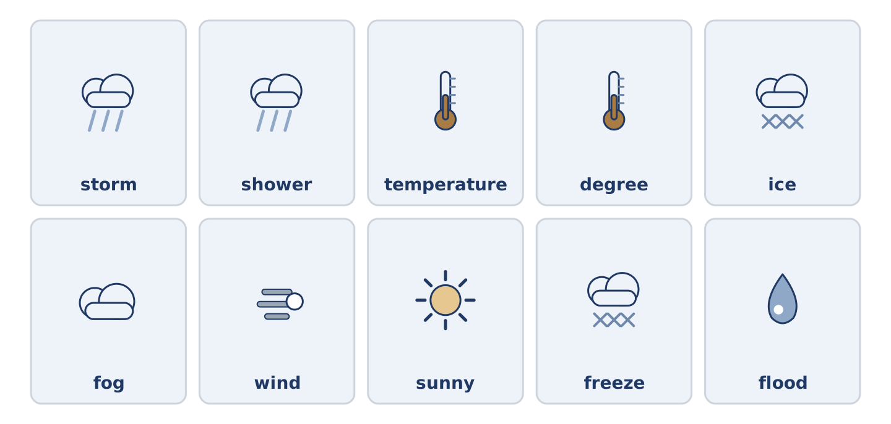
Figure 12.41 · All ten glossary words of Unit 12, one card each.
Unit 12 glossary (10 words)
storm · shower · temperature · degree · ice · fog · wind · sunny · freeze · flood

