Unit 14: Health and Feeling Better
English for Daily Life · Level: A2 · Tracks: [CORE] Warm-Up + Parts 1–6 · [PLUS] Parts 7–10
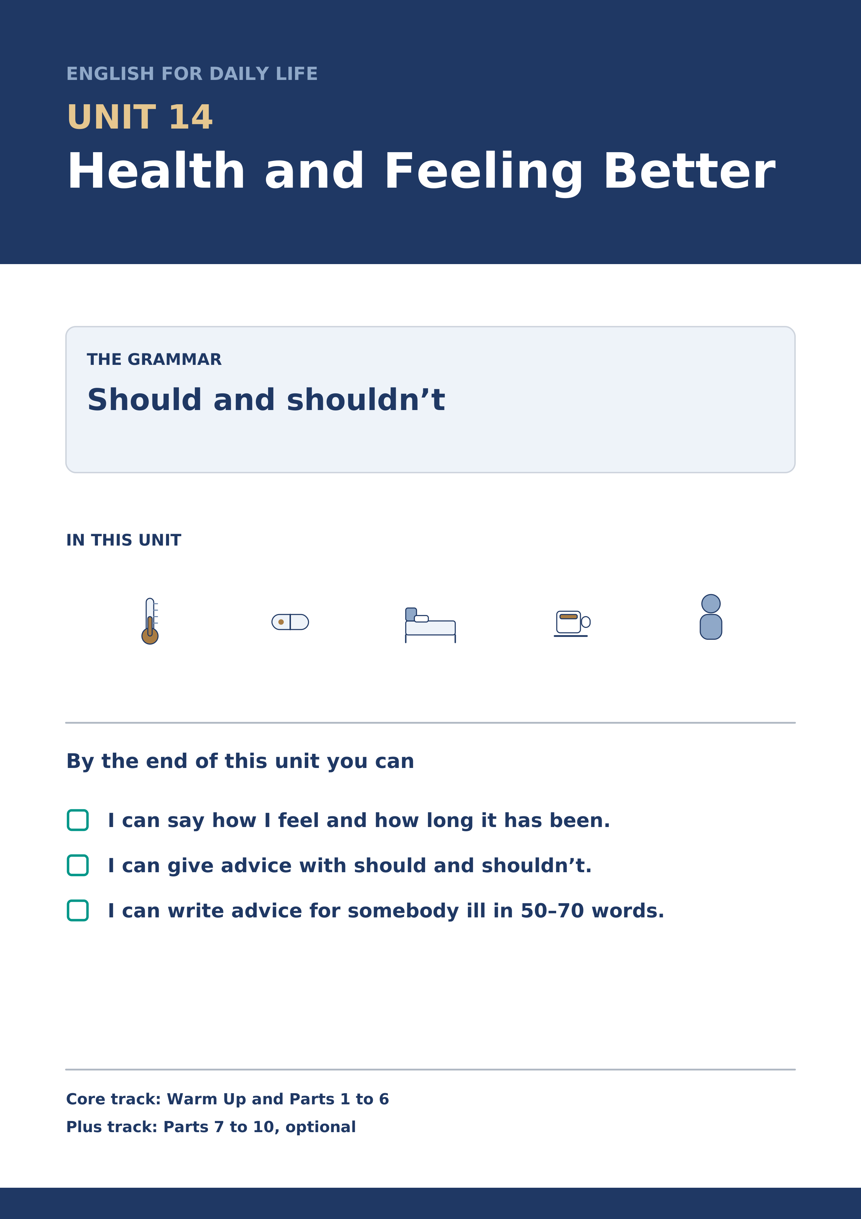
Warm Up
[CORE] Core track · in-class starter
Warm-up: Words for Not Feeling Well
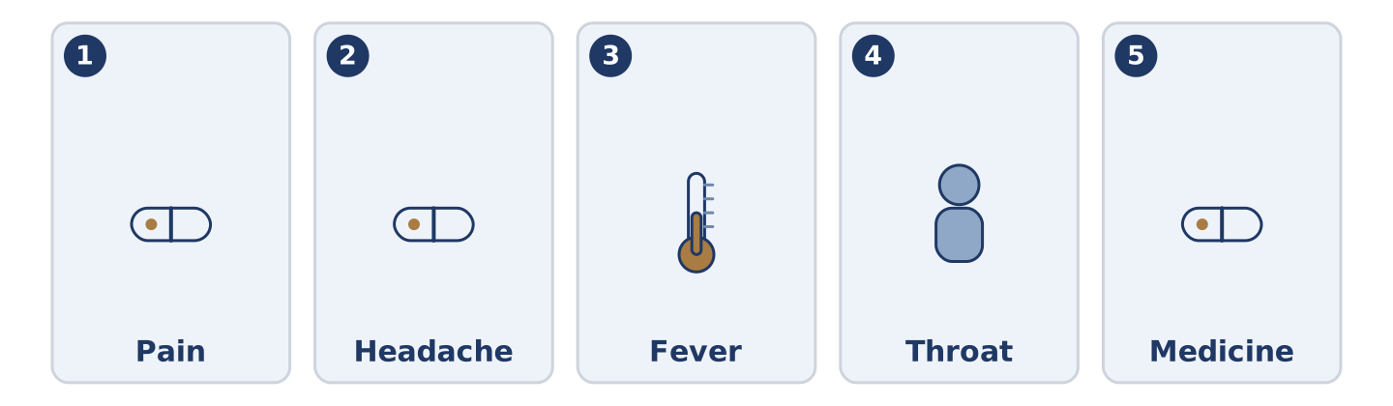
Figure 14.2 · The five warm-up words, and the thing each one means.
Match the words with their meanings. One meaning is not needed. Write the letter.
Column A
1. | Pain | ____
2. | Headache | ____
3. | Fever | ____
4. | Throat | ____
5. | Medicine | ____
Column B
a) | a pain in your head
b) | the part inside your neck that food and air go down
c) | what you take to get better
d) | the feeling when part of you hurts
e) | when your body is much too hot
f) | the money you pay to go in or to belong
Warm-up: Giving Advice
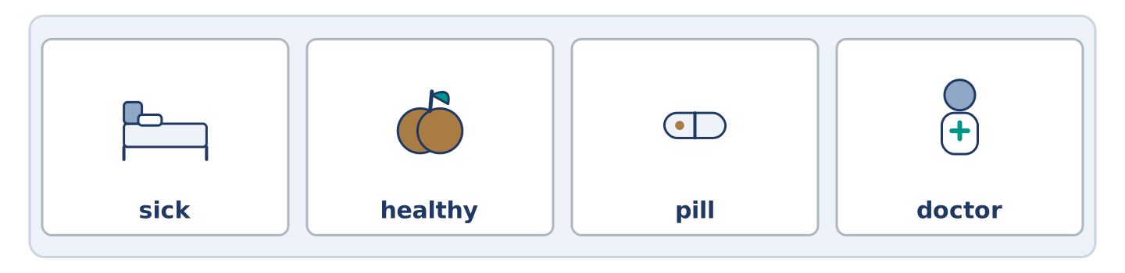
Figure 14.3 · The word bank for this task, in the order it is printed.
Complete the sentences using the words in the word bank.
Word bank: sick | healthy | pill | doctor
- You should see a ______________________ if it is still there on Monday.
- Tomas says one ______________________ , with food, and never two pills at once.
- Dani says he is never ______________________ , and he was in bed all week being sick.
- Maya is the ______________________ one and she is the one who worries.
Warm-up: Six People, Six Kinds of Advice
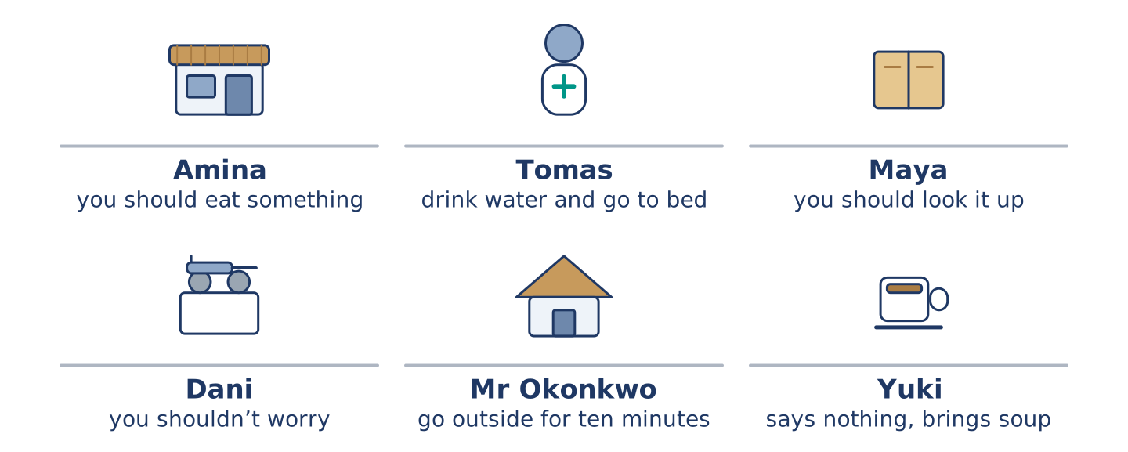
Figure 14.4 · What each of them says you should do.
Read the text and choose the correct answer.
Everybody at number 14 has advice and none of it agrees. Amina says you should eat something, whatever is wrong with you. Tomas says you should drink water and go to bed, and he is a nurse, so people listen. Maya says you should look it up, which is never good advice at two in the morning. Dani says you shouldn’t worry, and says it about everything. Mr Okonkwo says you should go outside for ten minutes. Yuki says nothing and quietly brings soup.
1. Who says you should drink water and go to bed?
○ A) Amina
○ B) Mr Okonkwo
○ C) Tomas
○ D) Maya
2. What does Yuki do?
○ A) She says nothing and brings soup
○ B) She says you shouldn’t worry
○ C) She tells you to look it up
○ D) She tells you to go outside
Part 1 · Vocabulary and Terminology
[CORE] Core track · pre-class input
Part 1: Words for Health
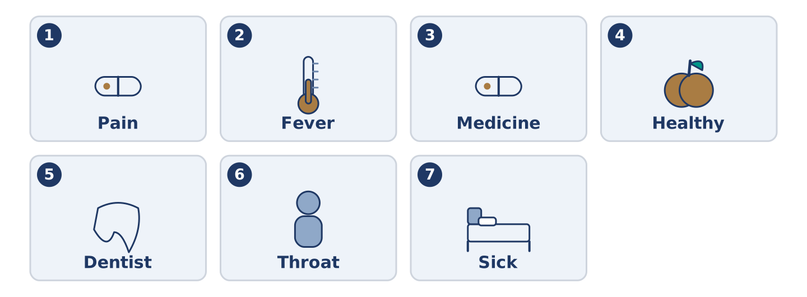
Figure 14.5 · The seven words of Column A, and what each one is.
Match the words with their meanings. One meaning is not needed. (0. is done for you.)
- Rest → to stop and do nothing, so that your body can mend itself.
Column A
1. | Pain | ____
2. | Fever | ____
3. | Medicine | ____
4. | Healthy | ____
5. | Dentist | ____
6. | Throat | ____
7. | Sick | ____
Column B
a) | not well; your body is not working properly
b) | the doctor who looks after your teeth
c) | the feeling when part of you hurts
d) | strong and well, and likely to stay so
e) | when your body is much too hot
f) | what you take to get better
g) | the part inside your neck that food and air go down
h) | clothes that say what your job is
Gloss: fever = when your body is much too hot · dentist = the doctor who looks after your teeth · healthy = strong and well, and likely to stay so · chemist = the shop that sells medicine, and the person in it
Part 1: Pronunciation
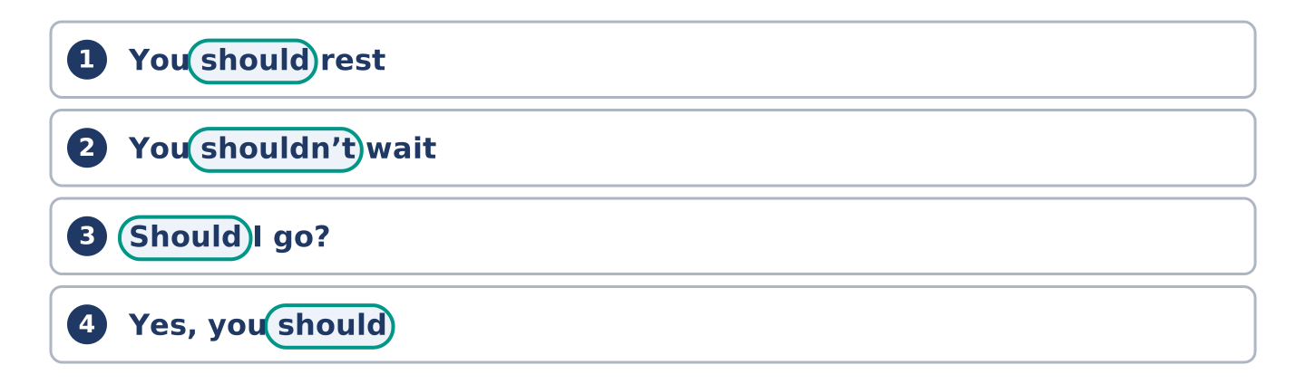
Figure 14.6 · Where the stress falls in 0 words of this unit.
🔊 Audio Track 14.1
Listen to should and shouldn’t. Say each pair aloud.
You should rest — the l says nothing: /ʃʊd/, never /ʃʊld/
You shouldn’t wait — the l says nothing here either: /ˈʃʊdn̩t/
Should I go? — weak at the front of a question: /ʃəd aɪ ɡəʊ/
Yes, you should — strong at the end: /ʃʊd/
That quiet l surprises nearly everybody, because it is sitting there in the spelling. It is the same letter doing the same nothing in could and would. Three words, one rule, and almost no learner is ever told it.
Part 1: Four Problems, Four Answers
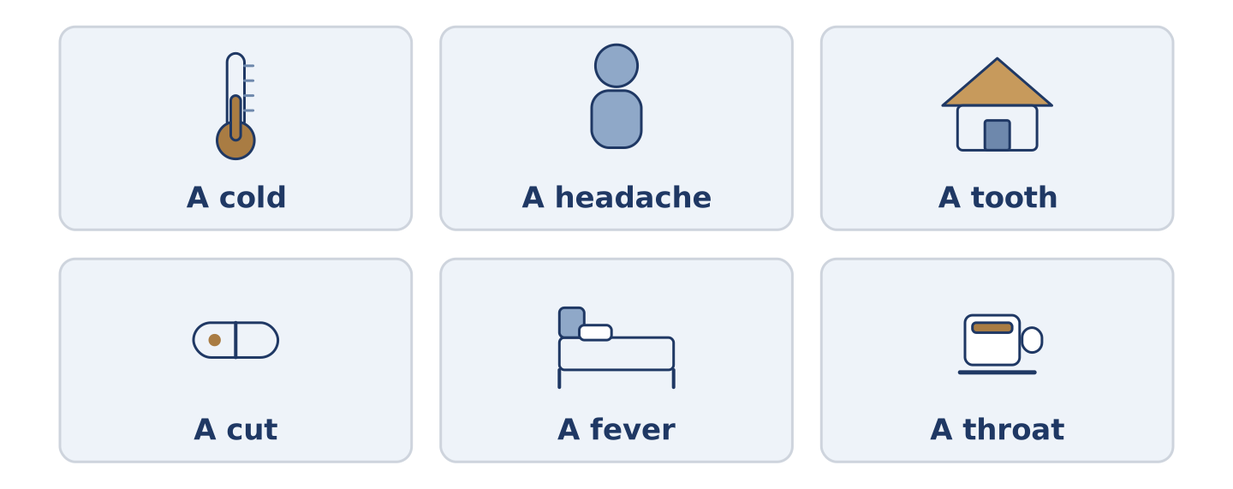
Figure 14.7 · Four everyday problems, and what people usually say about each.
Complete the table. Write what you should do and when to see a doctor. (0. is done.)
The problem | What you should do | When to see a doctor
A cold | rest, drink, wait | (example)
A headache that keeps coming back
A tooth that hurts at night
A cut that is not healing
- A cold — rest, drink, wait — if it is still there after two weeks.
Think about where you live. There is more than one right answer; be ready to say why.
Part 1: Should, Shouldn’t or Had Better Not?
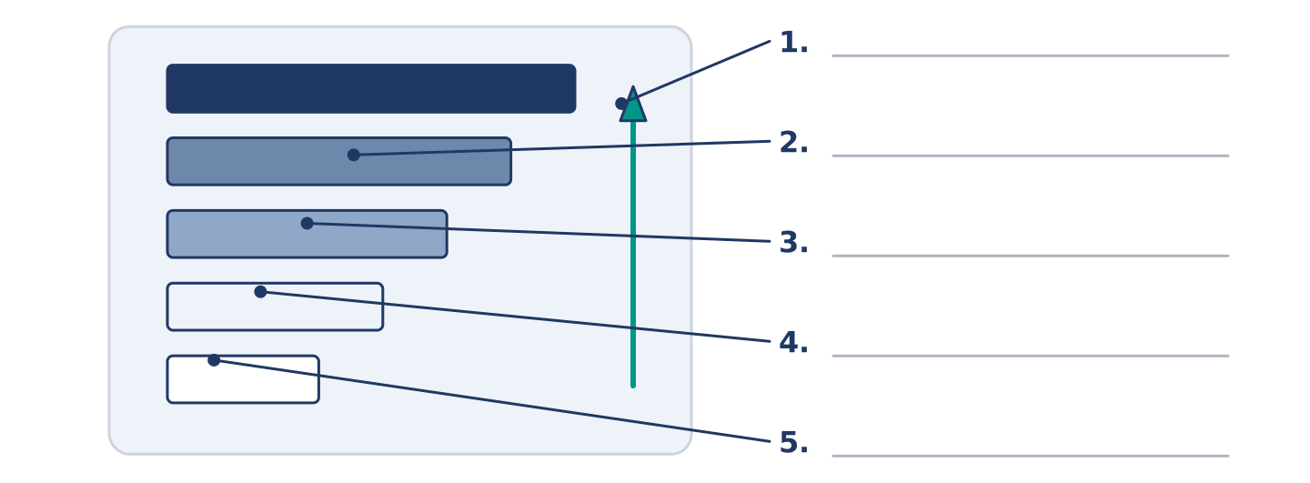
Figure 14.8 · How strong the advice is — write the correct word on each line.
Match the advice with how strong it is. One is not needed. Write the letter.
Column A
1. | You should drink more water. | ____
2. | You shouldn’t go to work. | ____
3. | You could try a warm drink. | ____
4. | You must see somebody today. | ____
5. | You don’t have to stay in bed. | ____
Column B
a) | advice against doing it
b) | one idea among several, and no pressure
c) | not advice at all; it is necessary
d) | ordinary advice for doing it
e) | you may get up if you want to
f) | somebody did it and felt worse
Part 1: Health — Multiple Choice
Read and choose the correct answer.
1. When your body is much too hot, you have a…
○ A) pain
○ B) fever
○ C) headache
○ D) throat
2. The doctor who looks after your teeth is a…
○ A) nurse
○ B) guard
○ C) member
○ D) dentist
3. What you take to get better is…
○ A) a pain
○ B) a fever
○ C) medicine
○ D) a throat
Part 1: Vocabulary Fill-in
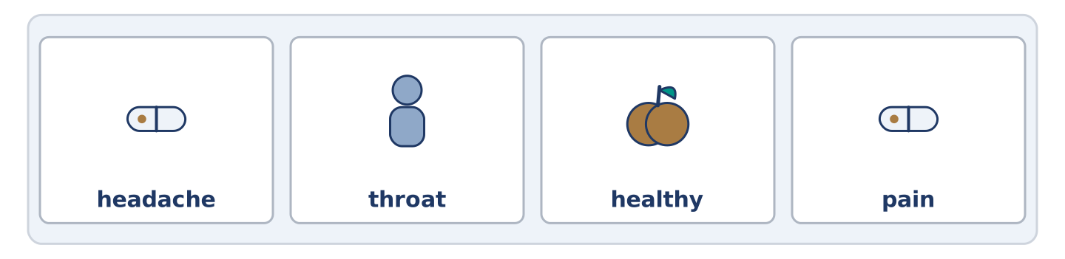
Figure 14.9 · The four words of the bank, in the order the task gives them.
Complete the sentences with the correct word.
Word bank: headache | throat | healthy | pain
- My ______________________ hurts and I can hardly swallow.
- She has had a ______________________ since Tuesday and she is still at work.
- There is a sharp ______________________ here when I turn my head.
- He eats well, walks everywhere and is the least ______________________ person I know.
Part 1: Write Some Advice (short)
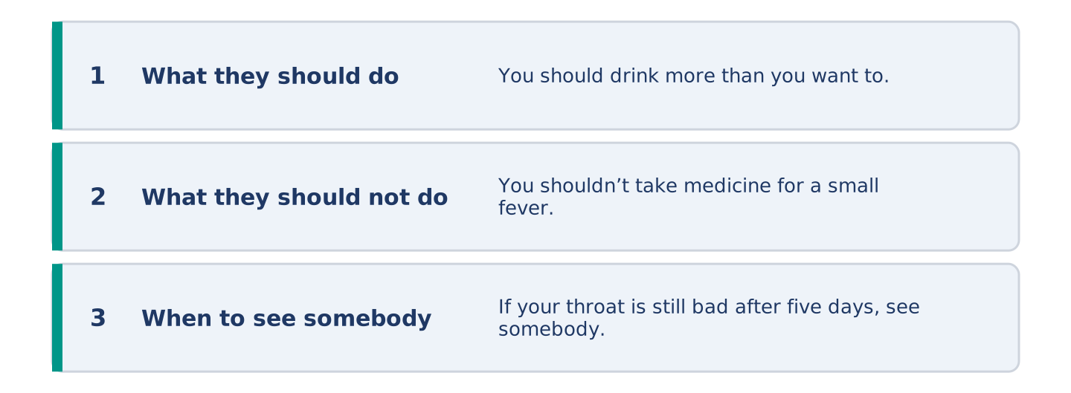
Figure 14.10 · The shape of your two or three sentences, with the model beside each step.
Write two or three sentences of advice for somebody with a cold. Use three words from this unit.
Model — read this first:
You should drink more than you want to and sleep more than you think you need. You shouldn’t take medicine for a fever under thirty-eight degrees; the fever is doing something. If your throat is still bad after five days, see somebody. (42 words)
Part 2 · Grammar — Should and Shouldn’t
[CORE] Core track · pre-class input
Part 2: Notice
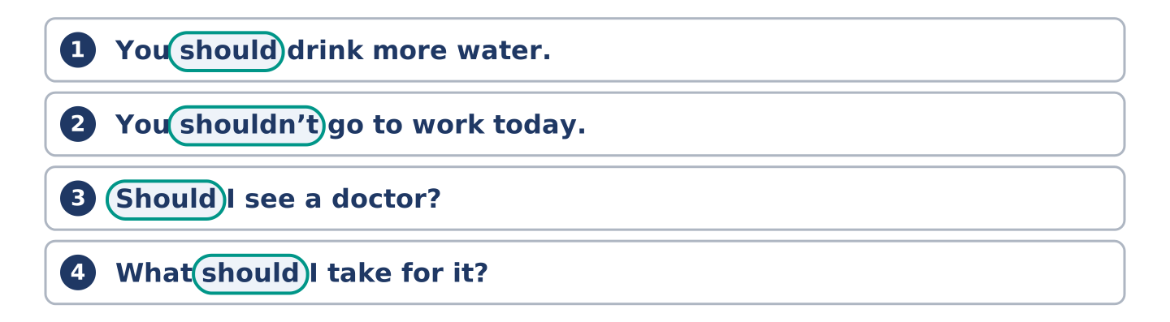
Figure 14.11 · Lines from the notice, with the target form ringed in each.
Read these lines. Underline should and shouldn’t. Which give advice, and which ask for it?
You should drink more water. You shouldn’t go to work today. Should I see a doctor? You should see somebody if it gets worse. I shouldn’t have another coffee. What should I take for it?
Four of these give advice. Two ask for it.
Part 2: Grammar Focus Box
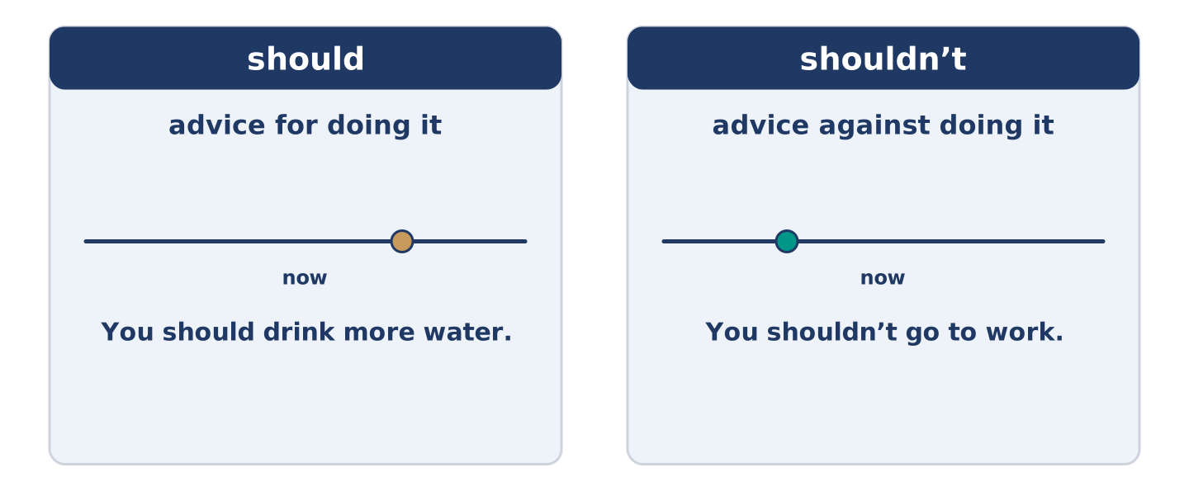
Figure 14.12 · Advice, advice against, and asking for it.
 | Form | Use | Example
should | should + plain verb | advice for doing it | You should drink more water.
shouldn’t | should not + plain verb | advice against doing it | You shouldn’t go to work.
Should I…? | a question | asking for advice | Should I see a doctor?
I should / I shouldn’t | about yourself | advice you give yourself | I shouldn’t have another coffee.
Remember: should never takes to: you should rest, not you should to rest.
Watch out! ✗ You should to rest. → ✓ You should rest. (no to after should). ✗ You don’t should go. → ✓ You shouldn’t go. (should makes its own negative).
Part 2: Controlled Practice
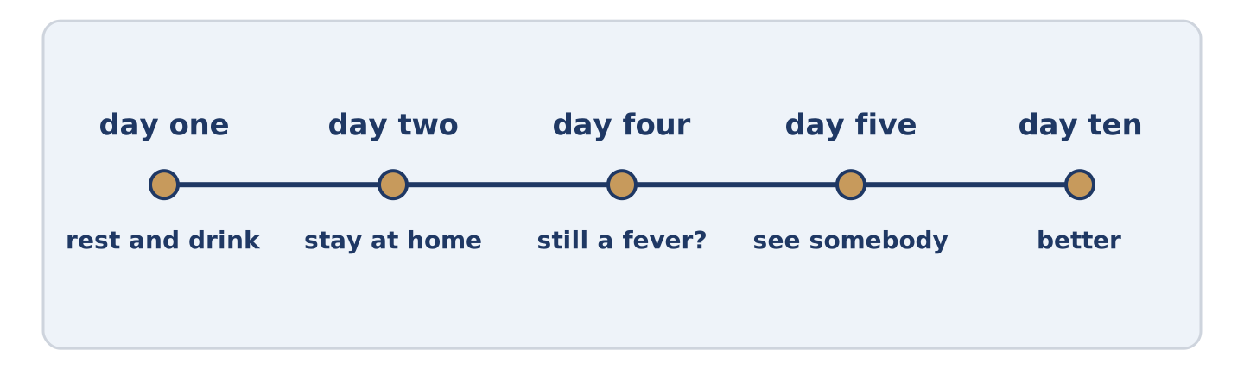
Figure 14.13 · One cold, from the first day to the tenth.
Complete with should or shouldn’t. (0. is done.)
- You should drink more water.
- You ______________________ go to work with a fever.
- You ______________________ see somebody if it gets worse.
- You ______________________ take medicine you found in a drawer.
- ______________________ I stay in bed, or get up?
Part 2: Advice, Advice Against, or Asking?
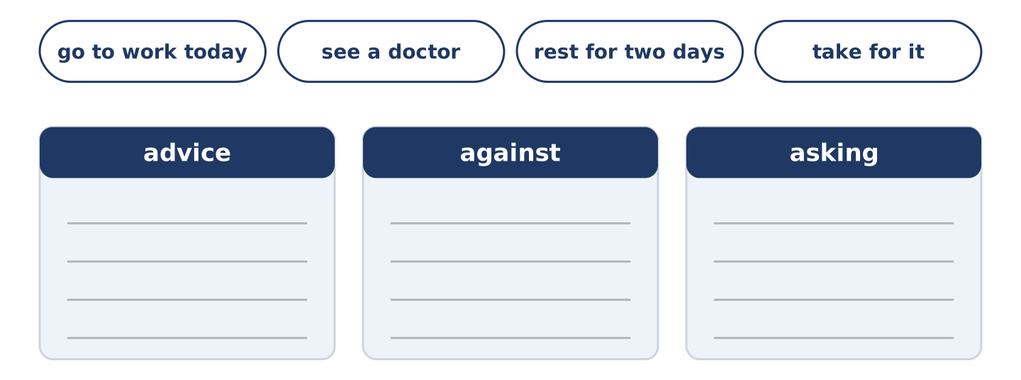
Figure 14.14 · The items of this task, and the bins they sort into.
Write advice, against or asking. (0. is done.)
- You should drink more water. — advice
- You shouldn’t go to work today. ____________
- Should I see a doctor? ____________
- You should rest for two days. ____________
- What should I take for it? ____________
Part 2: Correct the Sentence
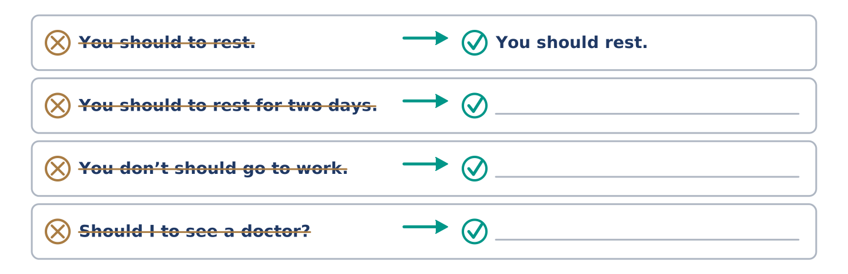
Figure 14.15 · One correction done for you, and the rest to write.
Each sentence has one grammar mistake. Write the correct sentence.
- You should to rest for two days.
- You don’t should go to work.
- Should I to see a doctor?
- He shoulds drink more water.
Part 2: Freer Practice
Write two pieces of advice for somebody who never sleeps enough: one should and one shouldn’t.
Part 2: Grammar Review
Choose the correct sentence.
1. Which sentence gives advice against something?
○ A) You shouldn’t go to work today.
○ B) You don’t should go to work today.
○ C) You should not to go to work today.
○ D) You mustn’t go to work today.
2. Which sentence asks for advice?
○ A) I should see a doctor.
○ B) You should see a doctor.
○ C) I shouldn’t see a doctor.
○ D) Should I see a doctor?
→ Harvest: you will see should and shouldn’t again in the Part 5 reading. Watch for who is giving the advice.
Part 3 · Listening
[CORE] Core track · pre-class input · scripts printed inline
Part 3: Asking the Nurse Next Door
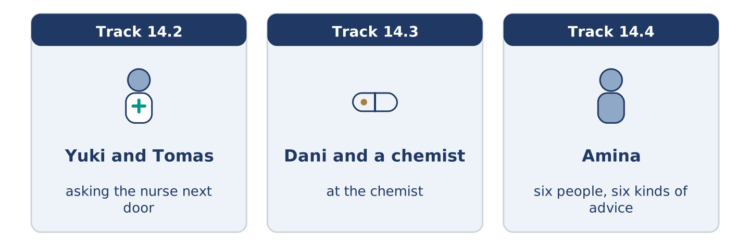
Figure 14.16 · The three listenings: who is speaking, and what about.
🔊 Audio Track 14.2
Before you listen: do you ask a friend before you ask a doctor?
Yuki: Tomas, you’re a nurse. Tomas: I am, and I’m going to say the same thing I always say. Yuki: Which is? Tomas: That I can’t tell you what is wrong with you on a staircase. Yuki: It’s only a headache. Tomas: Then you should drink more water and sleep, and you shouldn’t look it up. Yuki: And if it is still there on Friday? Tomas: Then it is not only a headache, and you should see somebody. Yuki: That is what I wanted.
While you listen: write True, False, or Not Given. (0. is done.)
- Yuki asks Tomas about a headache. — True
- Tomas says he can tell her what is wrong. ____
- Tomas says she should drink more water. ____
- Yuki has had this headache before. ____
Useful phrases: You’re a nurse · It’s only a… · you should… · you shouldn’t…
Part 3: At the Chemist
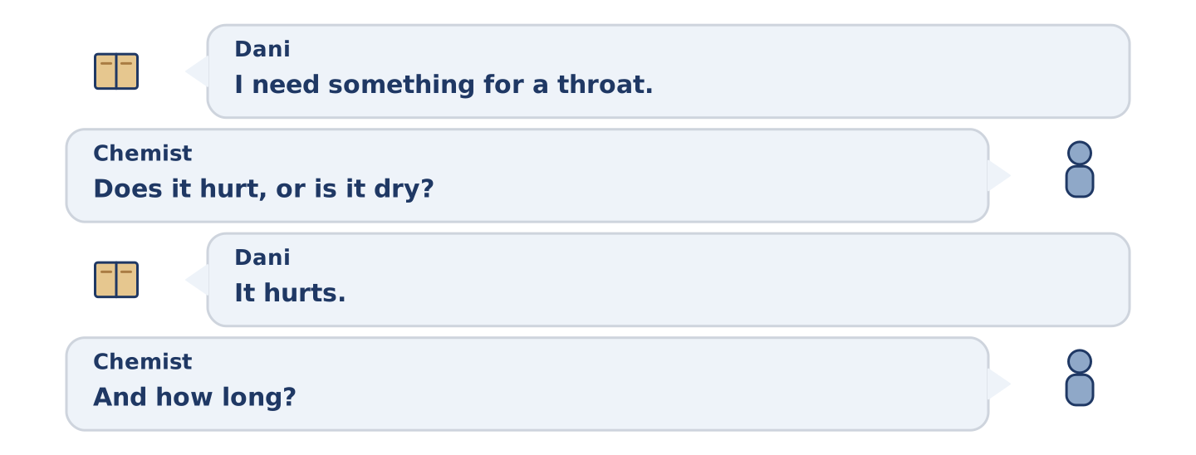
Figure 14.17 · The second listening, turn by turn.
🔊 Audio Track 14.3
Before you listen: what do you ask for when you do not know the word?
Dani: I need something for a throat. Chemist: Does it hurt, or is it dry? Dani: It hurts. Chemist: And how long? Dani: Four days. Chemist: Four days is fine. Six and you should see a doctor. Dani: What should I take? Chemist: Honestly, warm water and salt. You could buy the pills in the blue box, and they work, and they cost nine. Dani: And the salt is free. Chemist: The salt is in your kitchen.
Answer the questions. (0. is done.)
- What does Dani need something for? — A throat that hurts.
- How long has it been?
- At how many days should he see a doctor?
- What does the chemist say he could use instead?
Part 3: Six People, Six Kinds of Advice
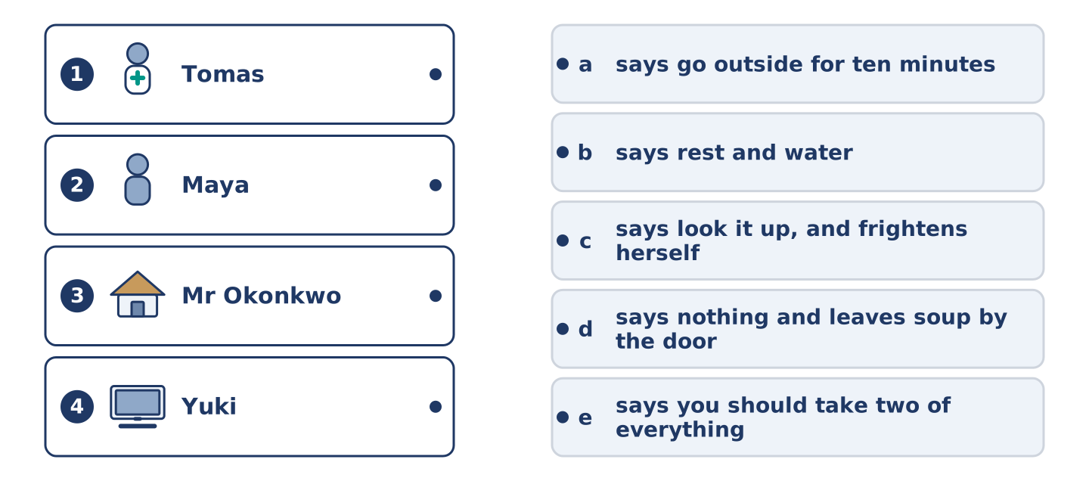
Figure 14.18 · Four on the left, five on the right, and one spare.
🔊 Audio Track 14.4
Before you listen: whose advice do you actually take?
Amina: I get told how to feel better about four times a week. Tomas says rest and water, which is right and is never what anybody wants to hear. Maya says look it up, and she frightened herself twice doing it. Dani says you shouldn’t worry and never worried about anything in his life. Mr Okonkwo says go outside for ten minutes, which works more often than it has any right to. And Yuki says nothing at all and leaves soup by the door.
While you listen: match each person with their advice. One is not needed. (0. is done.)
- Amina → she gets told four times a week.
Useful phrases: ___ says rest and water · ___ says look it up · ___ leaves soup
Column A
1. | Tomas | ____
2. | Maya | ____
3. | Mr Okonkwo | ____
4. | Yuki | ____
Column B
a) | says go outside for ten minutes
b) | says rest and water
c) | says look it up, and frightens herself
d) | says nothing and leaves soup by the door
e) | says you should take two of everything
Part 4 · Speaking
[CORE] Core track · in-class output
Part 4: Advice You Give and Take
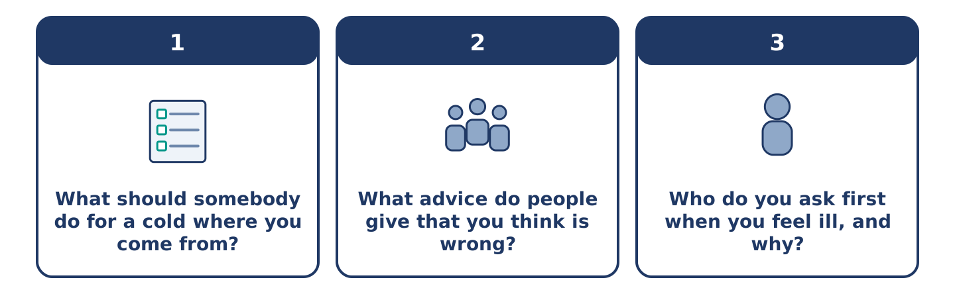
Figure 14.19 · The three questions as cards, to take one at a time.
Work with a partner. Ask and answer these questions.
- What should somebody do for a cold where you come from?
- What advice do people give that you think is wrong?
- Who do you ask first when you feel ill, and why?
Useful language: You should… · You shouldn’t… · Should I…? · it depends
Part 4: Find the Difference (pairwork)
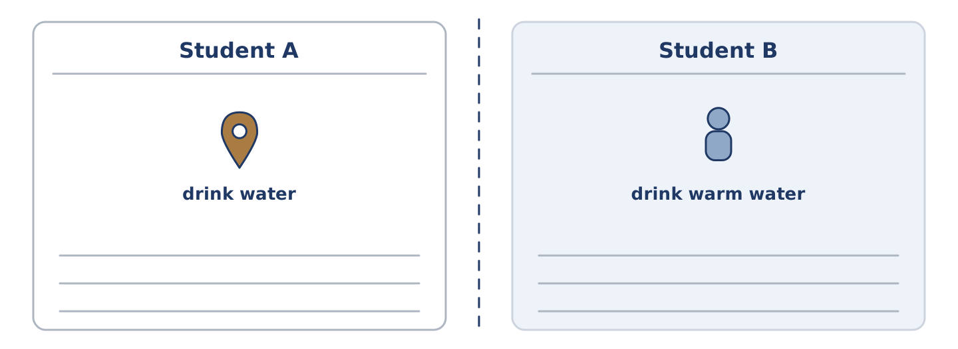
Figure 14.20 · Student A’s facts and Student B’s, with a fold between them.
Student A and Student B each have advice for the same problem. Ask questions and find three differences.
Useful questions: What should I drink? · Should I stay in bed? · Should I take anything? · When should I see somebody?
Student A — your advice: drink water, stay in bed, take nothing, see somebody after five days.
Student B — your advice: drink warm water with salt, get up and move, take nothing, see somebody after five days.
Part 4: Asking for Advice
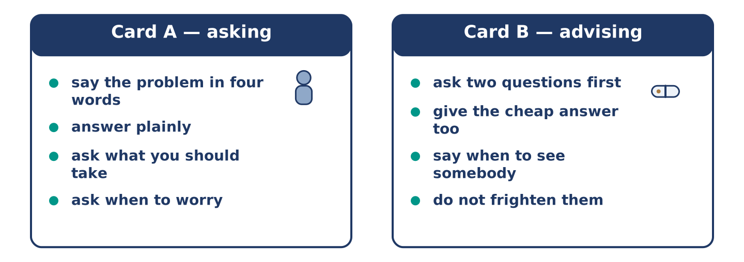
Figure 14.21 · Card A and Card B: what each of you has to say.
Work in pairs. Read the model, then use the cards.
Model exchange:
A: I need something for a throat. — B: Does it hurt, or is it dry? — A: It hurts. — B: And how long? — A: Four days. — B: Four days is fine. Six and you should see a doctor. — A: What should I take? — B: Warm water and salt, honestly.
Useful language: I need something for… · How long? · you should… · you could…
Card A — asking: say the problem in four words · answer the questions plainly · ask what you should take · ask when to worry.
Card B — advising: ask two questions first · give the cheap answer as well · say when they should see somebody · do not frighten them.
Your turn: run the dialogue, then swap roles.
Stretch [PLUS]: the person in front of you should see a doctor today and does not want to — say so without alarming them.
Part 4: Mini-Presentation
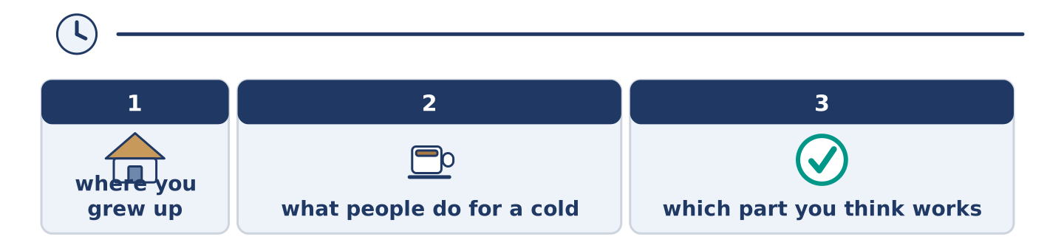
Figure 14.22 · The one-minute talk as 0 beats, each as wide as its share.
Prepare a short talk (about one minute). Describe what people do for a cold where you grew up, and say which part you think works.
Part 5 · Reading
[CORE] Core track · pre-class input
Part 5: Why We Ask the Wrong People
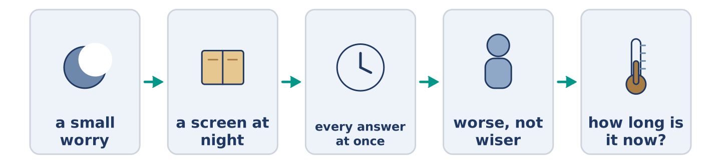
Figure 14.23 · One small worry, from Tuesday to Friday.
Before you read: who do you ask first, and is that the right person?
Gloss: symptom = a sign that something is wrong with your body · harmless = not able to hurt you · reassure = to say something that stops a person worrying
Almost nobody asks a doctor first. They ask a friend, a sister, a shop, and most of all they ask a screen, usually at night and usually alone. The screen is very good at listing everything a symptom could mean. It gives the terrible things the same calm face as the harmless ones. Somebody already a little afraid gets to the end of that list no wiser at all. They only feel worse. What a friend does, and a screen cannot, is reassure badly and ask one good question: how long is it now? That question sorts almost everything. It is the first thing the chemist asks and the second thing the doctor asks, and the list never asks it at all.
Answer the multiple-choice questions. (0. is done.)
- Who do almost all people ask first? — Not a doctor; a friend, a sister, a shop or a screen.
1. What does the text say a screen is good at?
○ A) Asking how long it is now
○ B) Listing everything a symptom could mean
○ C) Telling you to sleep
○ D) Finding you a doctor
2. How does a person feel after reading the list?
○ A) Wiser
○ B) Calm
○ C) Worse
○ D) Better
3. What is the one good question?
○ A) How long is it now?
○ B) Where does it hurt?
○ C) How old are you?
○ D) Did you eat today?
Part 5: Vocabulary in Context
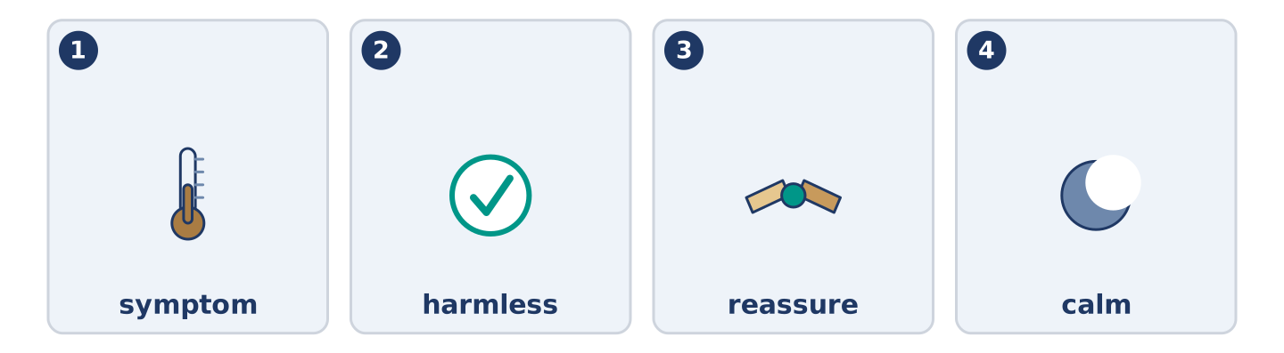
Figure 14.24 · The four words from the reading, drawn.
Match each word from the text with its meaning. One meaning is not needed. Write the letter.
Column A
1. | symptom | ____
2. | harmless | ____
3. | reassure | ____
4. | calm | ____
Column B
a) | not able to hurt you
b) | quiet, and not frightened
c) | a sign that something is wrong with your body
d) | to say something that stops a person worrying
e) | the doctor who looks after your teeth
Part 5: Three Things People Get Right Without Knowing Why
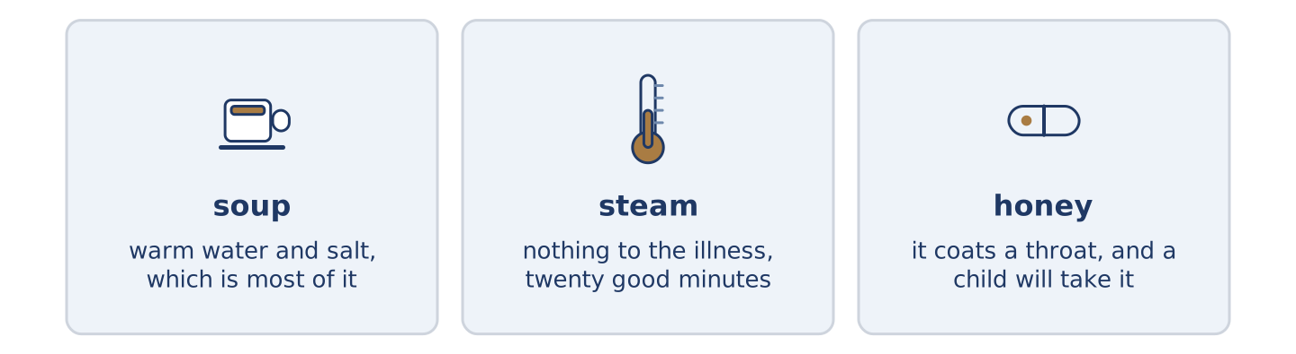
Figure 14.25 · Three old habits, and what each one turns out to do.
Before you read: which old remedy in your family actually works?
Gloss: remedy = an old answer to a small illness · steam = hot water turning into air · honey = the sweet thing bees make · cough = the sharp noise a bad chest makes
Some old remedies survive because they work, and not for the reason anybody gave. Chicken soup was said to feed the blood. What it really does is get warm water and salt into somebody who stopped drinking, and that is most of the problem with a cold. Steam over a bowl was said to drive the illness out. It does nothing to the illness and a great deal to a blocked nose for twenty minutes, which is enough. Honey for a cough is the strangest of the three, because it beats most of what you can buy. The reason seems to be that it coats a throat that hurts. It also tastes good enough that a child will take it. Three remedies, three wrong reasons, three results.
Answer the questions. (0. is done.)
- Do old remedies survive for the reasons people gave? — No, often not.
- What does chicken soup really do?
- What does steam do, and for how long?
- Why does honey work for a cough?
Part 6 · Writing
[CORE] Core track · in-class / homework
Part 6: Advice for Somebody Ill (50–70 words)
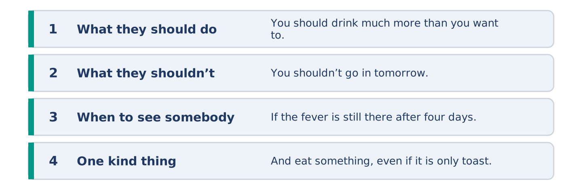
Figure 14.26 · The shape of the advice you are about to write.
A friend has written to say they feel ill. Write back with advice.
Model — read this first:
You should drink much more than you want to, and keep a cup by the bed so you do not have to decide each time. You shouldn’t go in tomorrow, whatever you are telling yourself about Thursday. If the fever is still there after four days, see somebody. And eat something, even if it is only toast and you do not want it. (63 words)
Plan (fill in, then write): You should ___. You shouldn’t ___. If ___, ___. And ___.
Word bank: you should | you shouldn’t | if it is still | see somebody | rest
Check before you finish: ☐ two should sentences? ☐ one shouldn’t? ☐ when to see a doctor? ☐ 50–70 words?
Part 6: Should People Work When They Are Ill? (50–70 words)
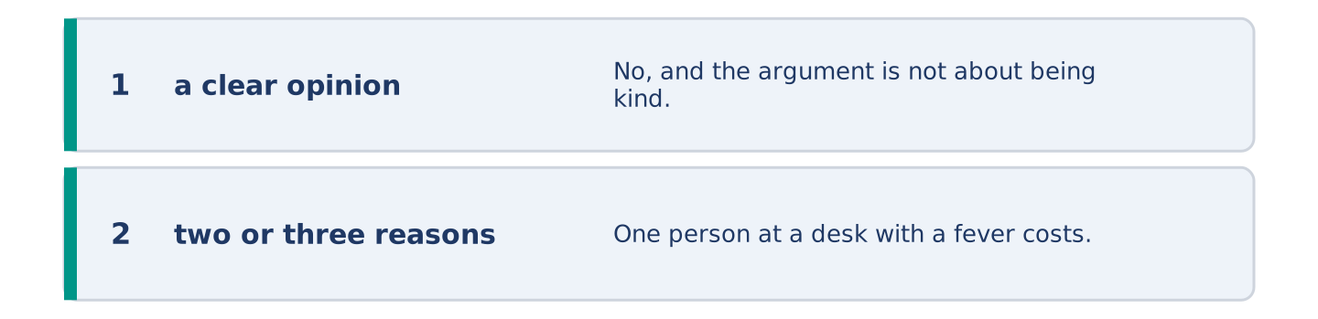
Figure 14.27 · The shape of the opinion paragraph, step by step.
Should people go to work when they are ill? Give your opinion and two or three reasons.
Model — read this first:
No, and the argument is not about being kind. One person at a desk with a fever costs an office four more people the following week, which anybody can count. The reason people go in anyway is that nobody above them ever stays at home, so everybody reads the room correctly and comes in coughing. (55 words)
Word bank: I think… because… | however | in my opinion | it depends on | should
Check before you finish: ☐ a clear opinion? ☐ two or three reasons? ☐ 50–70 words?
Part 6: Advice You Were Given (50–70 words)
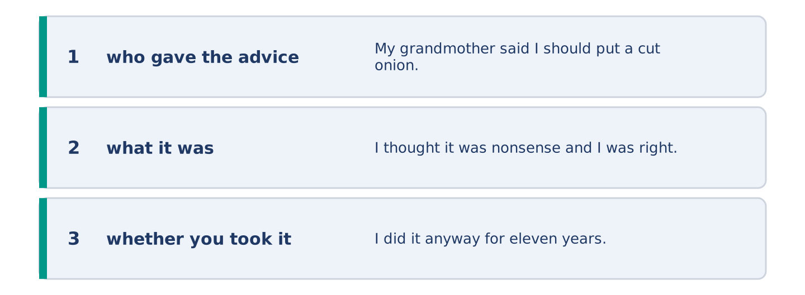
Figure 14.28 · The moves of the message, with a line of the model for each.
Write about advice somebody gave you about your health. Say whether you took it.
Model — read this first:
My grandmother said I should put a cut onion in the room when anybody had a cold. I thought it was nonsense and I was right; it does nothing at all. I did it anyway for eleven years. The smell of it meant somebody was looking after me, and that part was not nonsense. (54 words)
Plan (fill in, then write): ___ said I should ___. I thought ___. ___ anyway, because ___.
Check before you finish: ☐ who gave the advice? ☐ what it was? ☐ whether you took it? ☐ 50–70 words?
Part 6: Reflection — Advice I Give and Do Not Take (40–60 words)
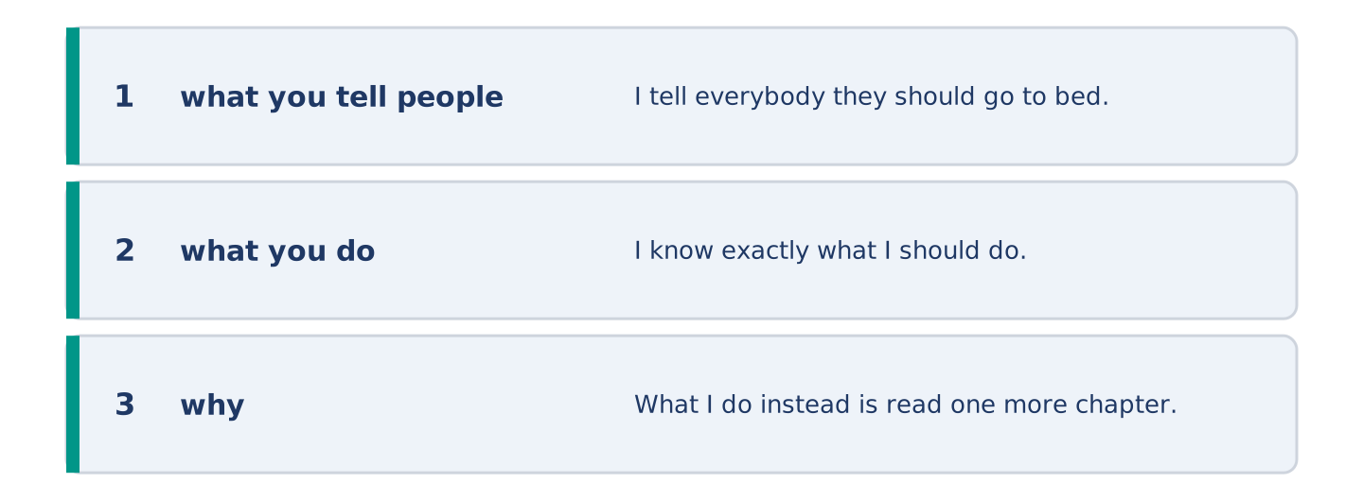
Figure 14.29 · The reflection, step by step.
Write about advice you give other people and never take yourself.
Model — read this first:
I tell everybody they should go to bed earlier, and I say it with real feeling, and I am always the last one awake. I know exactly what I should do. What I do instead is read one more chapter, which is exactly the decision I was making at nine years old. (52 words)
Check before you finish: ☐ what you tell people? ☐ what you do? ☐ why? ☐ 40–60 words?
Part 7 · Real-World File — At the Chemist and the Surgery
[PLUS] Plus track (optional) · stronger learners
7A: Phrase Bank
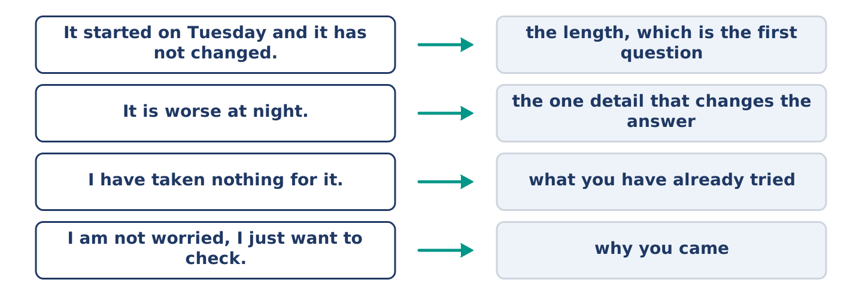
Figure 14.30 · What you say about how you feel, and what each line does.
Match what a person says with its purpose. One purpose is not needed. Write the letter.
Column A
1. | “It started on Tuesday and it has not changed.” | ____
2. | “It is worse at night.” | ____
3. | “I have taken nothing for it.” | ____
4. | “I am not worried, I just want to check.” | ____
Column B
a) | saying what you have already tried
b) | giving the one detail that changes the answer
c) | how much it will cost
d) | giving the length, which is the first question
e) | telling them why you came
7B: The Appointment You Nearly Did Not Make
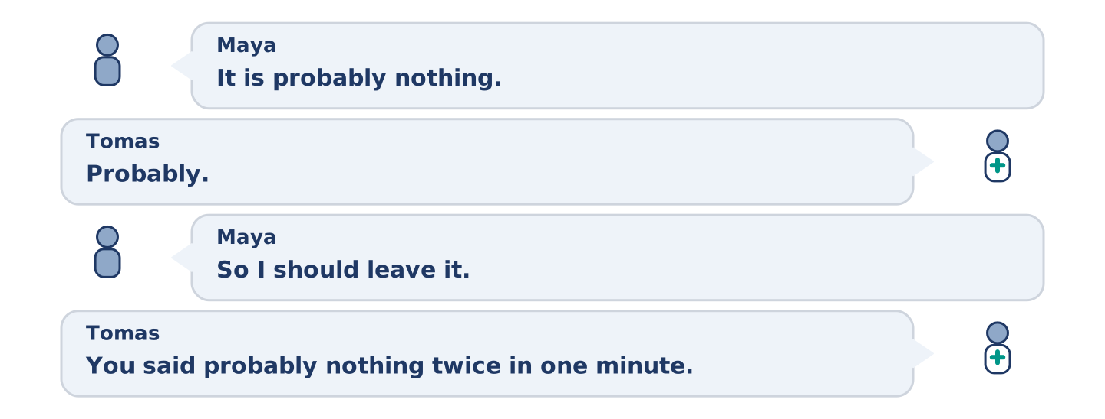
Figure 14.31 · The 7B exchange: who takes each turn.
🔊 Audio Track 14.5
Before you read: how long do you wait before you make an appointment?
Maya: It is probably nothing. Tomas: Probably. Maya: So I should leave it. Tomas: You said probably nothing twice in one minute. Maya: That is not an answer. Tomas: It is the whole answer. Anybody who truly thinks it is nothing does not mention it twice. Maya: You are being annoying. Tomas: I am being a nurse. Make the appointment and be wrong; being wrong takes twenty minutes.
Answer the questions. (0. is done.)
- What does Maya say twice? — That it is probably nothing.
- What does Tomas notice about what she said?
- What does Tomas say about people who think it is nothing?
- What does Tomas tell her to do?
7C: Controlled Practice — Describing How You Feel
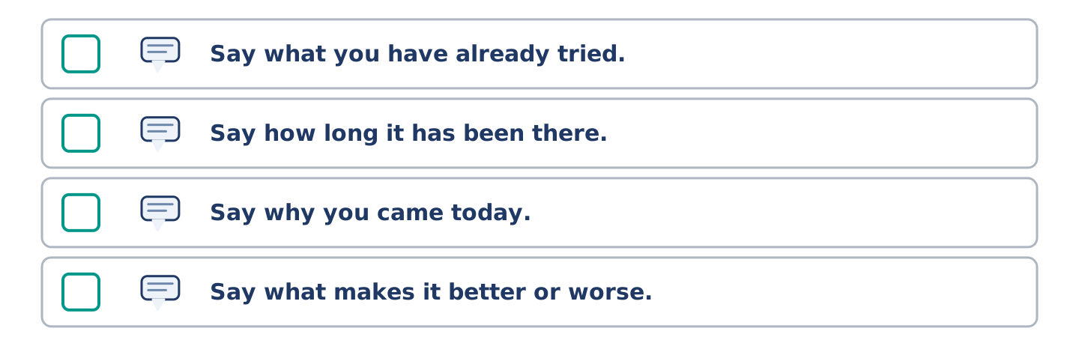
Figure 14.32 · The steps still to be numbered, as the task prints them.
Put the steps in order. Number them 1–5. (0. is done.)
- Say what is wrong, in one short sentence. — 1
____ Say what you have already tried.
____ Say how long it has been there.
____ Say why you came today.
____ Say what makes it better or worse.
7D: Role-Play — Asking Whether It Is Worth Asking
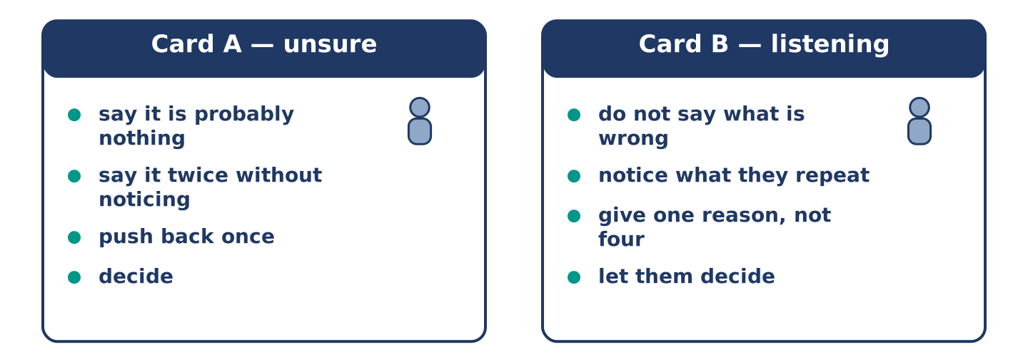
Figure 14.33 · The 7D cards: what each of you has to say.
In pairs. One thinks it is nothing; one is not sure. Use the model and cards.
Model exchange: A: It is probably nothing. — B: Probably. — A: So I should leave it. — B: You have said probably twice. — A: That is not an answer. — B: It is the whole answer. — A: I will make the appointment.
Card A — unsure: say it is probably nothing · say it twice without noticing · push back once · decide.
Card B — listening: do not say what is wrong · notice what they repeat · give one reason, not four · let them decide.
Stretch [PLUS]: they decide not to go and you think they should — say it once more, and then let it be their decision.
7E: Writing — A Note to a Doctor’s Desk (50–80 words)
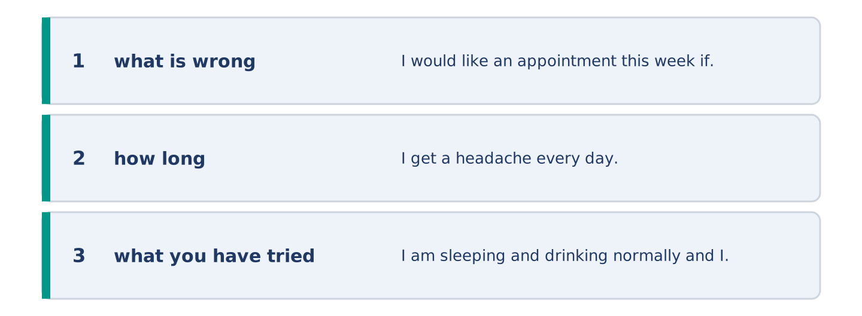
Figure 14.34 · The Part 7 note, with the model beside each line.
Write a short note asking for an appointment, saying what is wrong.
Model — read this first:
I would like an appointment this week if there is one. I get a headache every day, always worse in the afternoon, and nothing shifts it. I am sleeping and drinking normally and I took nothing for it. I am not worried; I would like somebody to say it is nothing. Mornings are easier for me than afternoons. (58 words)
Check before you finish: ☐ what is wrong, in one sentence? ☐ how long? ☐ what you have tried? ☐ 50–80 words?
Part 8 · Global Story — The Country That Asks First
[PLUS] Plus track · pre-read / discuss
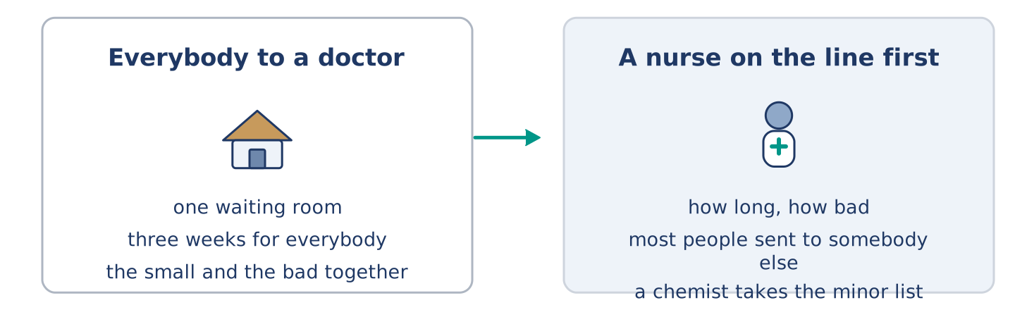
Figure 14.35 · A waiting room, and a telephone line.
Before you read: should the first person you see about your health be a doctor?
Gloss: triage = sorting people by how urgent they are · pharmacist = the person who knows what is in every box · minor = small, and not dangerous
In New Zealand a great deal of the first conversation happens before anybody sees a doctor. A nurse on a telephone line takes the call, asks how long and how bad, and sends most people somewhere other than a waiting room. A pharmacist handles a long list of minor things without an appointment at all. The idea behind it is simple. The hardest part of medicine is not treating people, it is sorting them. Sorting does not need the most expensive person in the building. It upsets people at first. Nobody enjoys hearing that their problem is small, even when it is. A year in, the same people are the ones who argue hardest for it.
Answer the questions. (0. is done.)
- Who takes the first call? — A nurse on a telephone line.
- What does the nurse ask?
- What does a pharmacist handle without an appointment?
- Why does it upset people at first?
Part 8: Vocabulary in Context
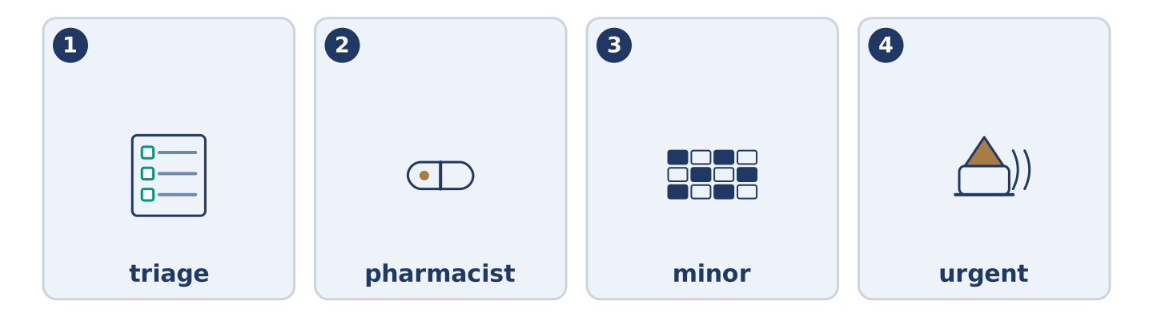
Figure 14.36 · The four words from the global story, drawn.
Match each word with its meaning. One meaning is not needed. Write the letter.
Column A
1. | triage | ____
2. | pharmacist | ____
3. | minor | ____
4. | urgent | ____
Column B
a) | small, and not dangerous
b) | needing to happen now
c) | sorting people by how urgent they are
d) | the person who knows what is in every box
e) | hot water turning into air
Part 8: Discussion
Talk with a partner. Use the frames.
Discussion frames: “This is similar to where I live because…” · “This is different from where I live because…” · “I think the most important thing is… because…”
Part 9 · Close to Home — The Week Everybody Had It
[PLUS] Plus track · pre-read / decide
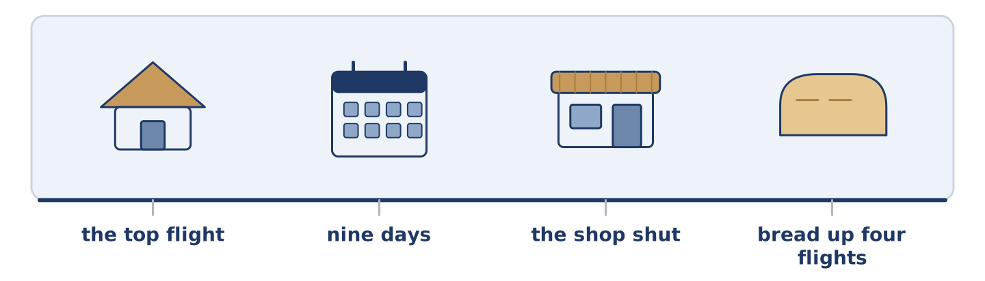
Figure 14.37 · The close-to-home reading, drawn along one street.
Before you read: who looks after a street when everybody in it is ill?
It went through number 14 in nine days and it took them in order, from the top down. Yuki first, then Maya, then Dani, and then Amina, who shut the shop for the only two days she has shut it in eleven years. Tomas did not get it at all, which he said was the hospital and everybody else said was simply unfair. Mr Okonkwo did not get it either, and at seventy-one he was the one carrying bread up four flights to people half his age. On the ninth day Amina opened again and found five people waiting, every one of them buying soup. Nobody said one word about it, which at number 14 is how a thing gets marked and remembered.
Answer the questions. (0. is done.)
- How long did it take to go through number 14? — Nine days.
- Who got it first?
- What did Amina do for two days?
- What was Mr Okonkwo doing at seventy-one?
Part 9: Decision Task
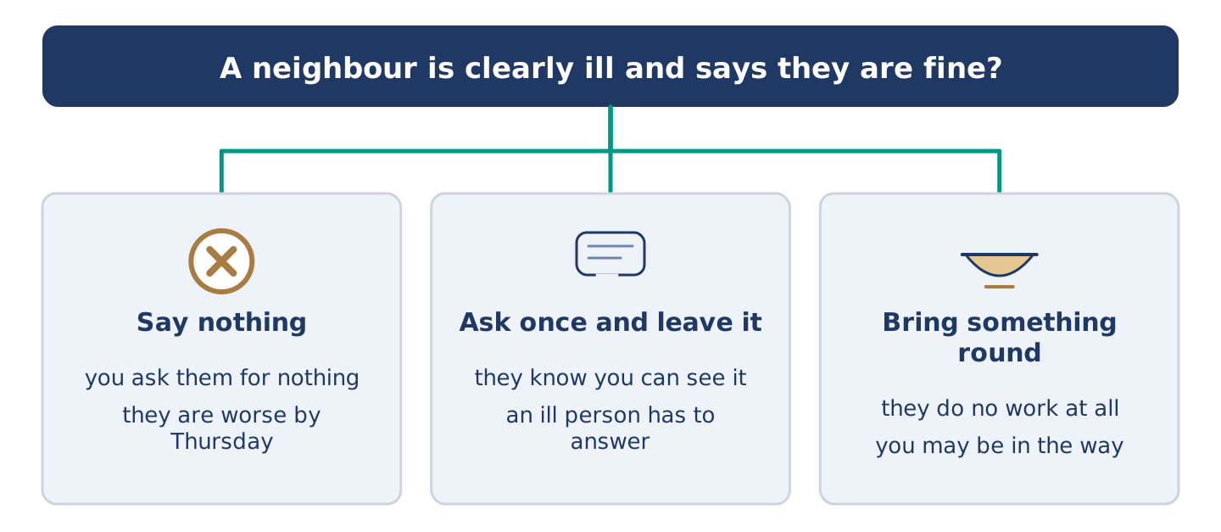
Figure 14.38 · Three ways to decide, and what each one costs.
A neighbour is clearly ill and says they are fine. Should you (a) say nothing, (b) ask once and leave it, or (c) bring something round without asking? Decide and explain. Use the frame.
Answer frame: “I think I should ___ because ___. Also, ___. This is better than ___ because ___.”
Model — read this first:
I think I should bring something round without asking, because asking an ill person a question makes them do work. Also, you can walk past soup on a doorstep, and you cannot walk past a conversation. This is better than asking once and leaving it. The fine-on-Tuesday people are usually worse by Thursday and still saying it. (57 words)
Phrase bank: I think I should… · because… · Also,… · This is better than… · In my opinion…
Part 10 · Review and Can-Do
[CORE + PLUS] · homework / self-study
Part 10: Spiral Review
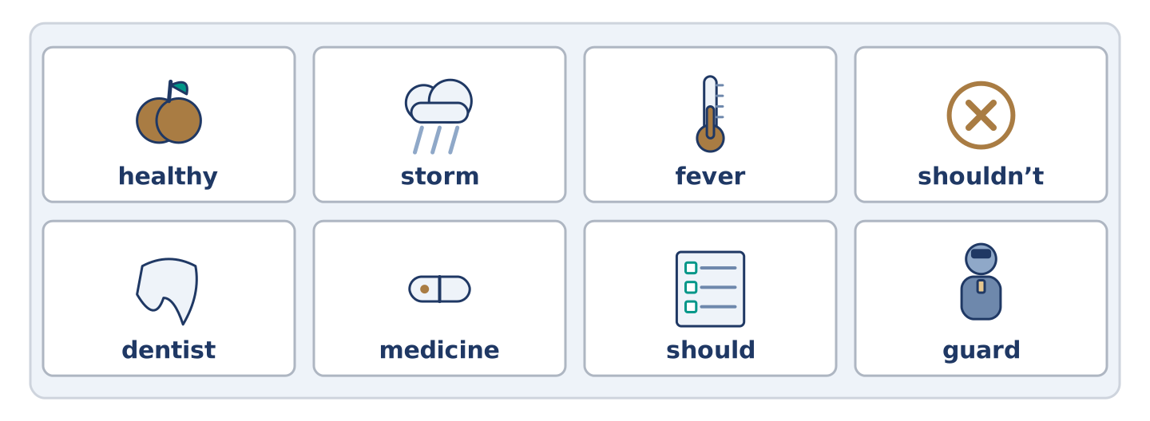
Figure 14.39 · The eight words of the review bank, in bank order.
Complete the review. (0. is done.)
- The feeling when part of you hurts is pain.
Word bank: healthy | storm | fever | shouldn’t | dentist | medicine | should | guard
- When your body is much too hot, you have a ______________________ .
- What you take to get better is ______________________ .
- The doctor who looks after your teeth is a ______________________ .
- Strong and well, and likely to stay so, is ______________________ .
- You ______________________ drink more water. (advice)
- You ______________________ go to work with a fever. (advice against)
- (from Unit 13) Somebody whose job is to watch a place is a ______________________ .
- (from Unit 12) Strong wind and heavy rain together is a ______________________ .
Part 10: Can-Do
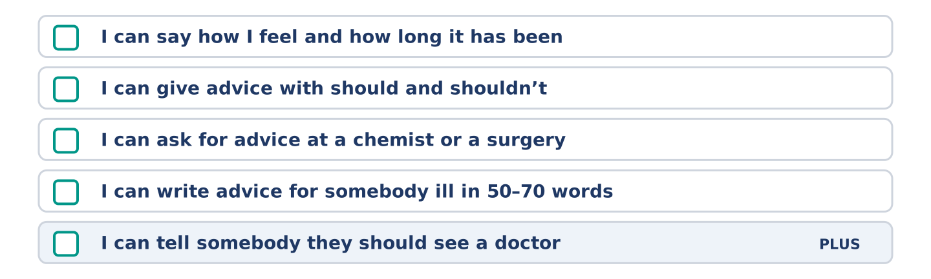
Figure 14.40 · What you can do at the end of this unit.
Can-Do checklist
☐ I can say how I feel and how long it has been.
☐ I can give advice with should and shouldn’t.
☐ I can ask for advice at a chemist or a surgery.
☐ I can write advice for somebody ill in 50–70 words.
☐ I can tell somebody they should see a doctor (Plus).
Part 10: Glossary
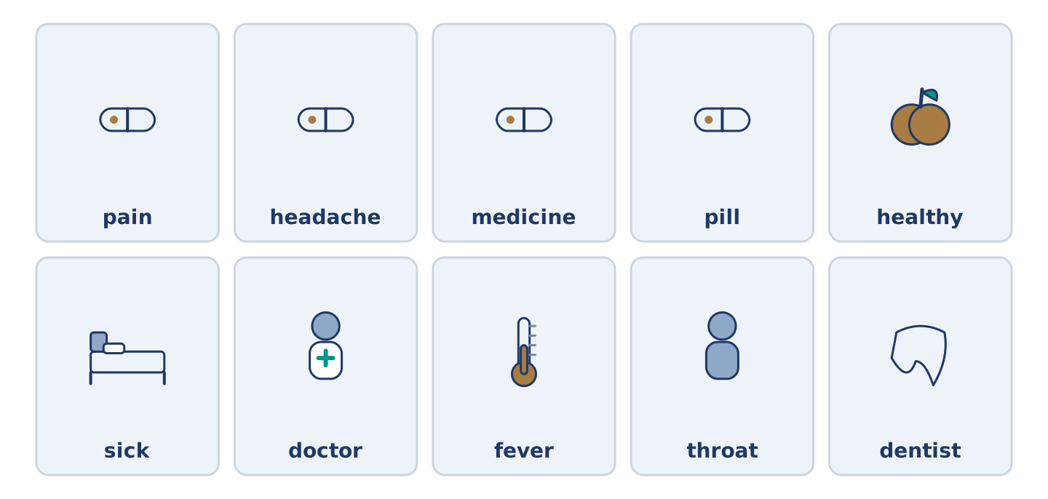
Figure 14.41 · All ten glossary words of Unit 14, one card each.
Unit 14 glossary (10 words)
pain · headache · medicine · pill · healthy · sick · doctor · fever · throat · dentist

