Unit 15: Experiences
English for Daily Life · Level: A2 · Tracks: [CORE] Warm-Up + Parts 1–6 · [PLUS] Parts 7–10
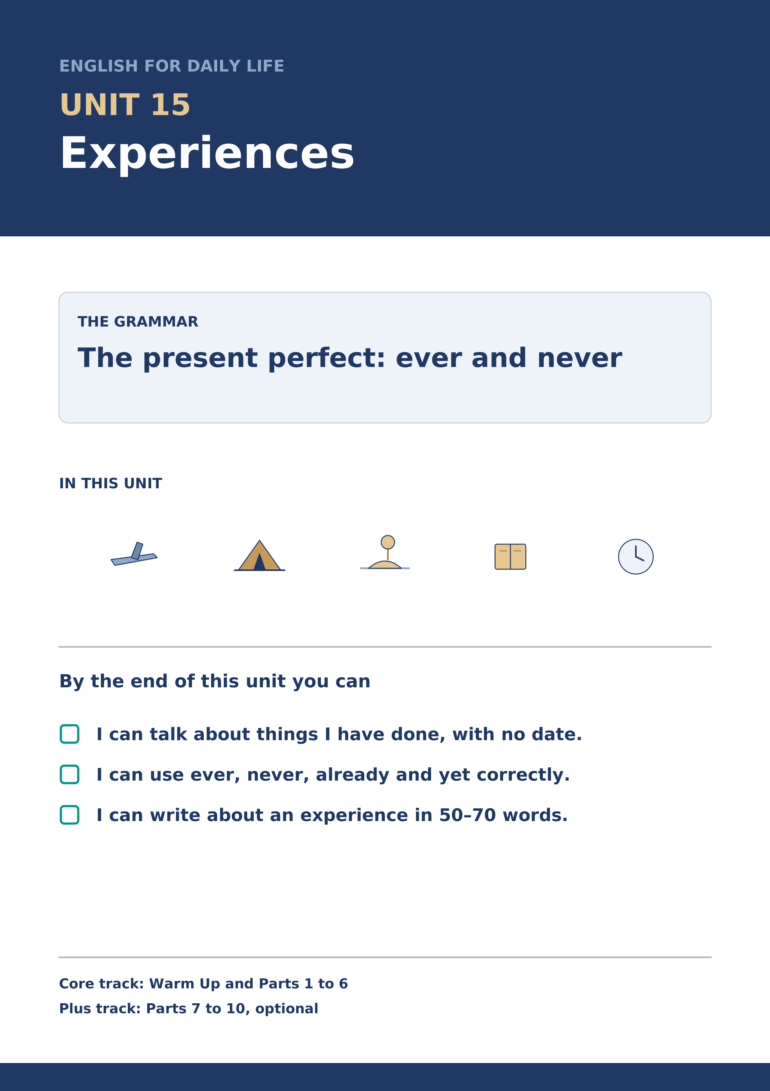
Warm Up
[CORE] Core track · in-class starter
Warm-up: Words for Things You Have Done
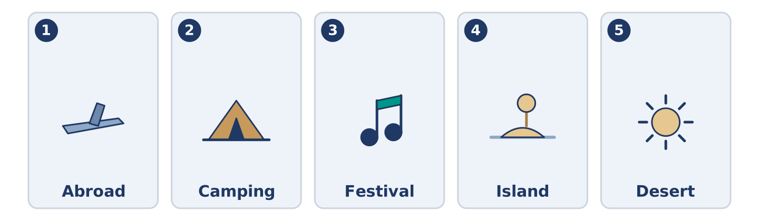
Figure 15.2 · The five warm-up words, and the thing each one means.
Match the words with their meanings. One meaning is not needed. Write the letter.
Column A
1. | Abroad | ____
2. | Camping | ____
3. | Festival | ____
4. | Island | ____
5. | Desert | ____
Column B
a) | land with water all round it
b) | sleeping outside, in a tent or a van
c) | in another country
d) | a very dry place where almost nothing grows
e) | days of music or food, usually once a year
f) | the money you pay to go in or to belong
Warm-up: Talking About Experiences

Figure 15.3 · The word bank for this task, in the order it is printed.
Complete the sentences using the words in the word bank.
Word bank: memory | adventure | tour | experience
- Yuki has never had a bad ______________________ on a night bus, which surprises everybody.
- Dani calls one wrong turn in a city an ______________________ , and he means it.
- Mr Okonkwo has a clear ______________________ of a shop that closed before Maya was born.
- Amina has been on exactly one ______________________ of anything, and it was of a factory.
Warm-up: Six People, Six Experiences
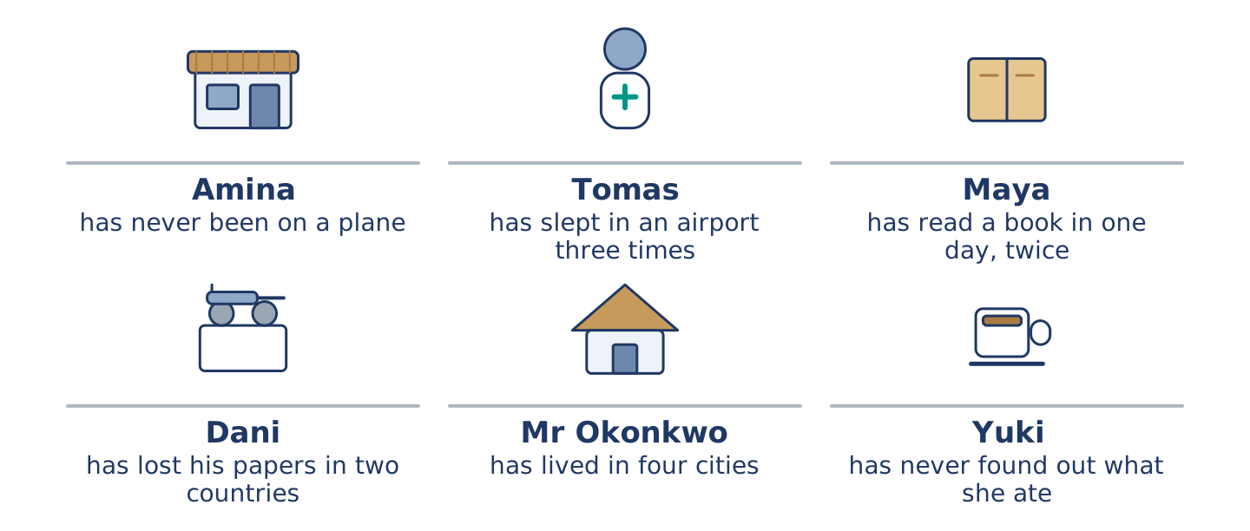
Figure 15.4 · What each of them has done, and what nobody has done at all.
Read the text and choose the correct answer.
Everybody at number 14 has done something the others have not. Amina has never been on a plane and says she has never wanted to. Tomas has slept in an airport three times. Maya has read a book in one day, twice. Dani has lost his papers in two countries. Mr Okonkwo has lived in four cities and will not say which he liked. Yuki has eaten something she still cannot name, in a market, and she has never found out what it was.
1. Who has never been on a plane?
○ A) Amina
○ B) Yuki
○ C) Maya
○ D) Tomas
2. What has Dani done?
○ A) Slept in an airport
○ B) Lived in four cities
○ C) Lost his papers in two countries
○ D) Read a book in one day
Part 1 · Vocabulary and Terminology
[CORE] Core track · pre-class input
Part 1: Words for Experiences
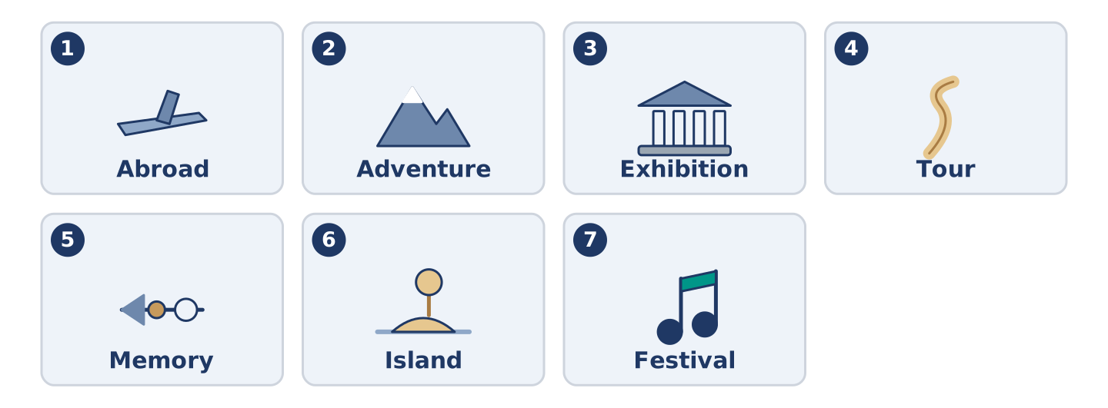
Figure 15.5 · The seven words of Column A, and what each one is.
Match the words with their meanings. One meaning is not needed. (0. is done for you.)
- Experience → something that happened to you, and that you still carry.
Column A
1. | Abroad | ____
2. | Adventure | ____
3. | Exhibition | ____
4. | Tour | ____
5. | Memory | ____
6. | Island | ____
7. | Festival | ____
Column B
a) | a walk round a place with somebody explaining it
b) | something you keep in your head from before
c) | in another country
d) | days of music or food, usually once a year
e) | a room of things put out for people to look at
f) | land with water all round it
g) | something that happens to you that you did not plan
h) | a sign that something is wrong with your body
Gloss: exhibition = a room of things put out for people to look at · tour = a walk round a place with somebody explaining it · abroad = in another country
Part 1: Pronunciation
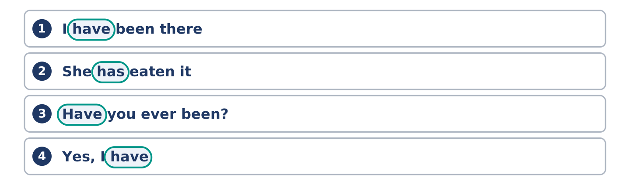
Figure 15.6 · Where the stress falls in 0 words of this unit.
🔊 Audio Track 15.1
Listen to have and has in the present perfect. Say each one aloud.
I have been there — in speech it is one sound: I’ve been there
She has eaten it — the same: she’s eaten it
Have you ever been? — weak at the front: /həv juː/
Yes, I have — strong at the end, and never shortened
The rule is the same one as will in Unit 12 and can in Unit 8 of the first book. In the middle of a sentence the helping word almost disappears. At the end of a short answer it stands up. English does this to every one of them, and a learner who hears it once stops needing to be told.
Part 1: Four Experiences, Four Answers
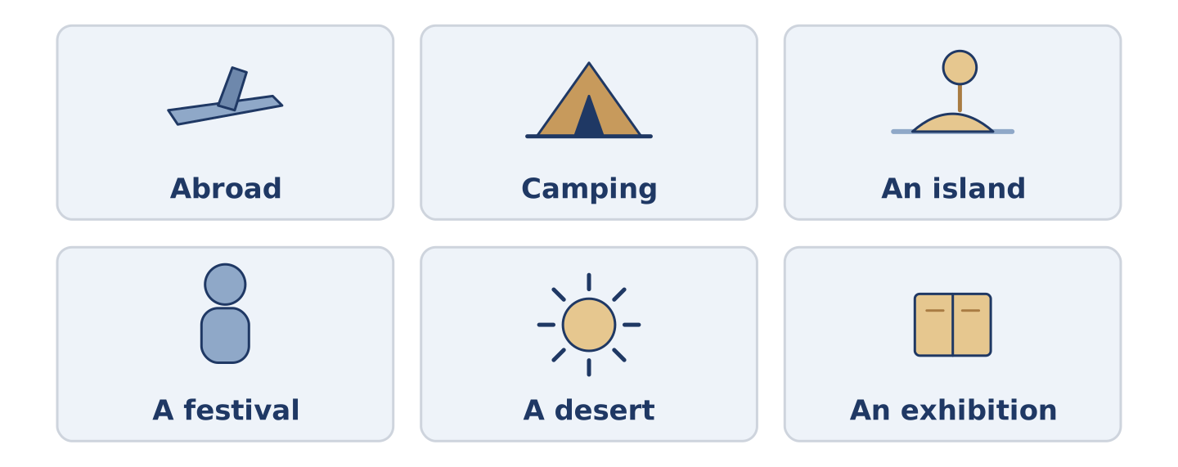
Figure 15.7 · Four things people have done, and how often.
Complete the table. Write how many times and what you remember. (0. is done.)
The experience | How many times? | What you remember
Slept outside | once | (example)
Been abroad
Eaten something you could not name
Been to a festival
- Slept outside — once — that it was far colder than anybody said.
Think about your own life. There is more than one right answer; be ready to say why.
Part 1: Ever, Never, Already or Yet?

Figure 15.8 · Four small words that change the question — write the correct word on each line.
Match the words with what they do. One is not needed. Write the letter.
Column A
1. | ever | ____
2. | never | ____
3. | already | ____
4. | yet | ____
5. | twice | ____
Column B
a) | not once, in your whole life
b) | sooner than the other person expected
c) | two times, and no more
d) | at any time in your life, in a question
e) | up to now, in a question or a negative
f) | one time, a long while ago
Part 1: Experiences — Multiple Choice
Read and choose the correct answer.
1. In another country is…
○ A) a tour
○ B) a desert
○ C) an island
○ D) abroad
2. A room of things put out for people to look at is an…
○ A) exhibition
○ B) island
○ C) adventure
○ D) experience
3. Land with water all round it is an…
○ A) desert
○ B) island
○ C) abroad
○ D) festival
Part 1: Vocabulary Fill-in

Figure 15.9 · The four words of the bank, in the order the task gives them.
Complete the sentences with the correct word.
Word bank: desert | camping | memory | festival
- They went ______________________ twice and bought a flat the following year.
- My first ______________________ is of a kitchen floor and a dog.
- There is a ______________________ in the square every August and nobody can park.
- He has crossed a ______________________ on a bus and says it was mostly boring.
Part 1: Write About an Experience (short)
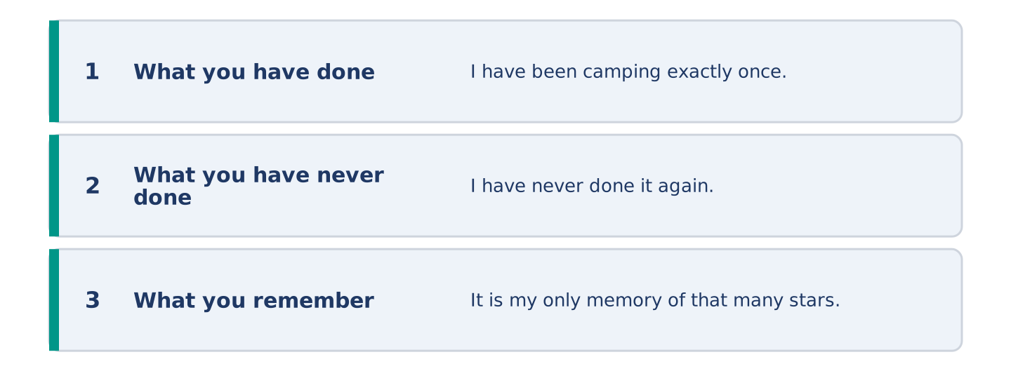
Figure 15.10 · The shape of your two or three sentences, with the model beside each step.
Write two or three sentences about something you have done. Use three words from this unit.
Model — read this first:
I have been camping exactly once and I have never done it again. We went to an island in April, which everybody said was too early, and everybody was right. It is my clearest memory of being cold and my only memory of that many stars. (46 words)
Part 2 · Grammar — The Present Perfect
[CORE] Core track · pre-class input
Part 2: Notice
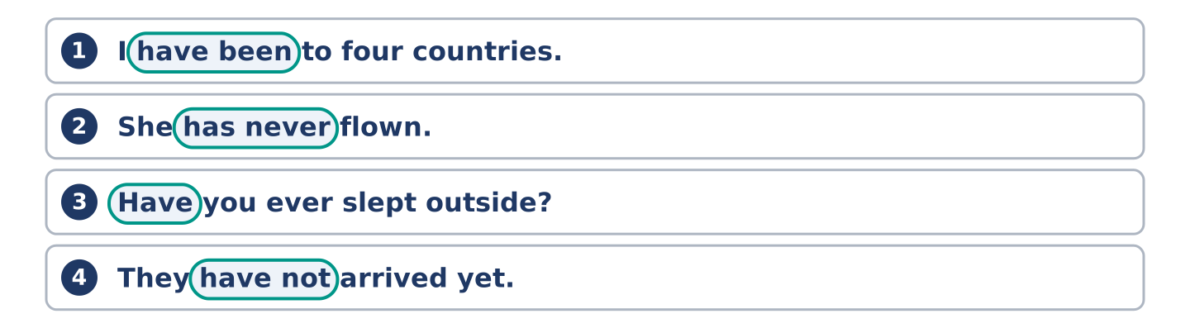
Figure 15.11 · Lines from the notice, with the target form ringed in each.
Read these lines. Underline have and has. Which ask about a whole life, and which say it never happened?
I have been to four countries. She has never flown. Have you ever slept outside? He has already eaten. They have not arrived yet. I have lost a travel papers twice.
Two of these are questions or answers about a whole life. Two use a small word that moves the meaning. Two simply state an experience.
Part 2: Grammar Focus Box
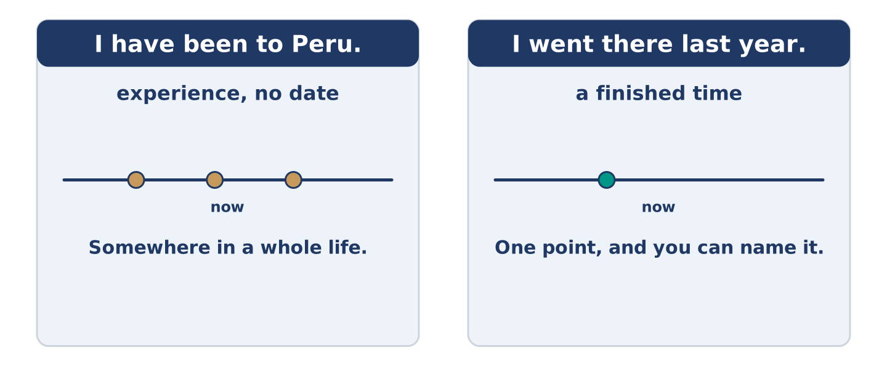
Figure 15.12 · A whole life up to now, and a finished moment.
 | Form | Use | Example
have / has + past participle | I have been, she has gone | experience, with no date | I have been to four countries.
ever | in questions | at any time in your life | Have you ever slept outside?
never | in statements | not once, in your whole life | She has never flown.
already / yet | already in statements, yet in questions and negatives | sooner than expected, or up to now | He has already eaten. They have not arrived yet.
Remember: the present perfect never takes a finished date: I have been to Peru, not I have been to Peru last year.
Watch out! ✗ I have been there last year. → ✓ I went there last year. (a finished date takes the past simple). ✗ Have you ever went? → ✓ Have you ever been? (the third form, not the past).
Part 2: Controlled Practice
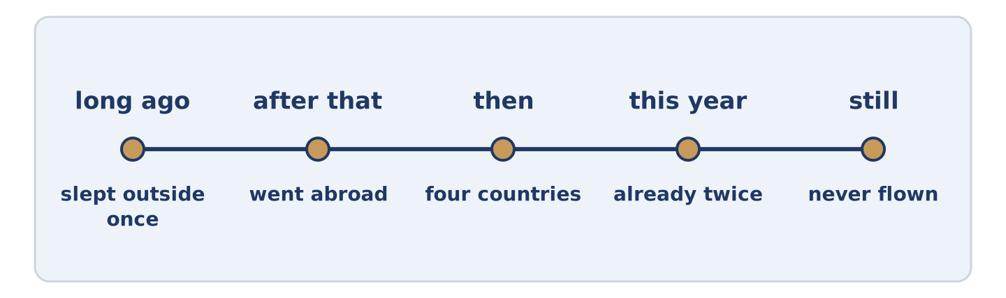
Figure 15.13 · One life, and the things in it with no date.
Complete with the present perfect. (0. is done.)
- I have been to four countries. (be)
- She ______________________ never ______________________ . (fly)
- ______________________ you ever ______________________ outside? (sleep)
- He ______________________ already ______________________ . (eat)
- They ______________________ not arrived yet. (have)
Part 2: Experience or Finished Time?
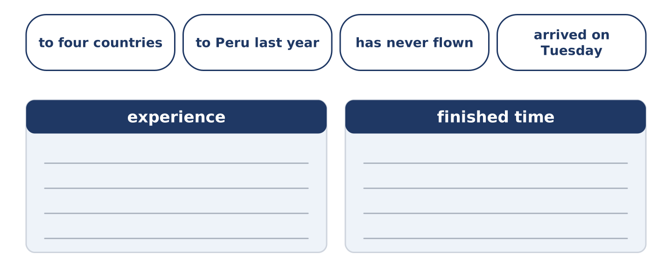
Figure 15.14 · The items of this task, and the bins they sort into.
Write experience or finished time. (0. is done.)
- I have been to four countries. — experience
- I went to Peru last year. ____________
- She has never flown. ____________
- We arrived on Tuesday. ____________
- Have you ever slept outside? ____________
Part 2: Correct the Sentence
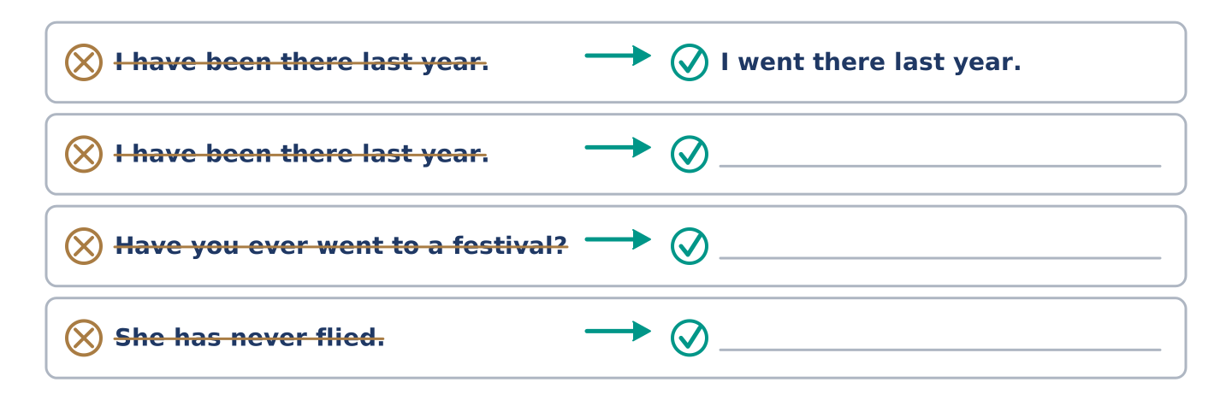
Figure 15.15 · One correction done for you, and the rest to write.
Each sentence has one grammar mistake. Write the correct sentence.
- I have been there last year.
- Have you ever went to a festival?
- She has never flied.
- He have already eaten.
Part 2: Freer Practice
Write two sentences about yourself: one thing you have done, and one thing you have never done.
Part 2: Grammar Review
Choose the correct sentence.
1. Which sentence is correct?
○ A) I have been to Peru last year.
○ B) I have went to Peru.
○ C) I have been to Peru.
○ D) I have be to Peru.
2. Which question asks about a whole life?
○ A) Did you sleep outside last night?
○ B) Are you sleeping outside?
○ C) Will you sleep outside?
○ D) Have you ever slept outside?
→ Harvest: you will see the present perfect again in the Part 5 reading. Watch for the sentences with no date in them.
Part 3 · Listening
[CORE] Core track · pre-class input · scripts printed inline
Part 3: Have You Ever?
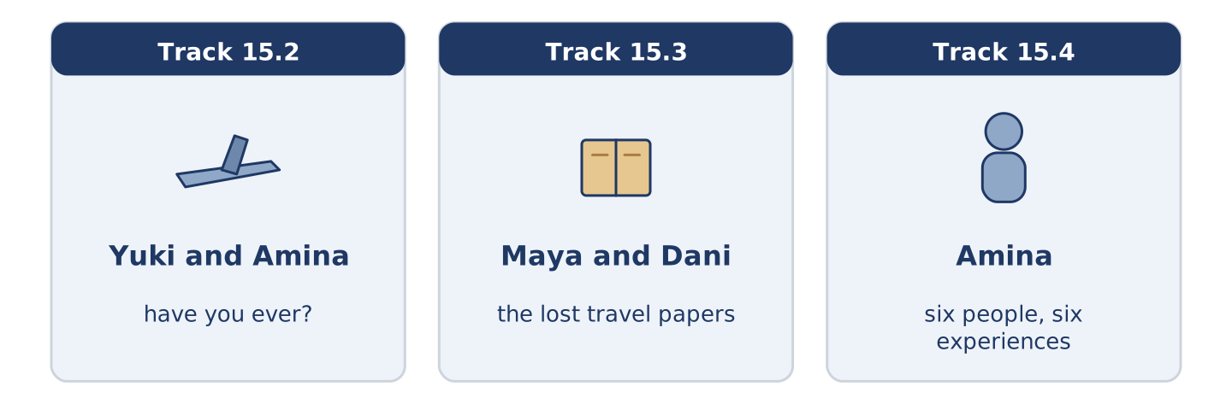
Figure 15.16 · The three listenings: who is speaking, and what about.
🔊 Audio Track 15.2
Before you listen: what is the most ordinary thing you have never done?
Yuki: Have you ever been on a plane? Amina: Never. Yuki: Not once? Amina: Not once, and nobody believes it. Yuki: Have you wanted to? Amina: No, and that’s the part people can’t manage. They can manage the fact. They can’t manage that I don’t mind. Yuki: My mother’s the same about the sea. Amina: Then your mother and I would get on, and neither of us would go anywhere.
While you listen: write True, False, or Not Given. (0. is done.)
- Amina has never been on a plane. — True
- Amina says she has wanted to fly. ____
- Yuki says her mother is the same about the sea. ____
- Amina has been on a boat. ____
Useful phrases: Have you ever…? · Never. · Not once. · My mother is the same.
Part 3: The Passport Story
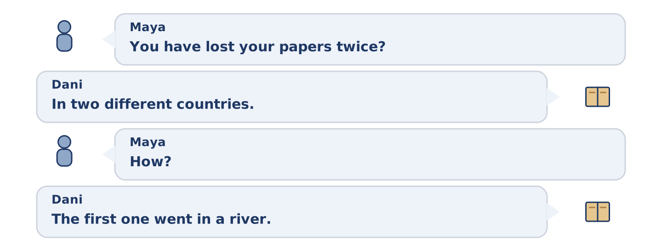
Figure 15.17 · The second listening, turn by turn.
🔊 Audio Track 15.3
Before you listen: did you ever lose something important while travelling?
Maya: You have lost your papers twice? Dani: In two different countries, which I think is worse. Maya: How? Dani: The first one went in a river. Maya: And the second? Dani: The second one is the bad one. I put it somewhere I would remember. Maya: Where? Dani: That’s the whole story. I’ve never found it and I’ve never stopped looking. Maya: It’s in a book. Dani: It’s in a book. I know it’s in a book.
Answer the questions. (0. is done.)
- How many times has Dani lost his papers? — Two.
- What happened to the first one?
- What did Dani do with the second one?
- What does Maya think happened to it?
Part 3: Six People, Six Experiences
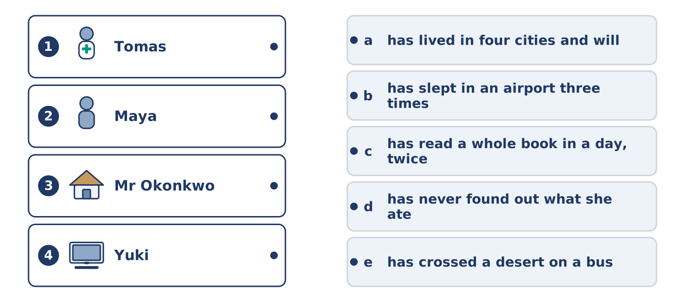
Figure 15.18 · Four on the left, five on the right, and one spare.
🔊 Audio Track 15.4
Before you listen: who do you know who has done the most, and does it show?
Amina: You find out what people have done sideways, never by asking. Tomas has slept in an airport three times and mentions it like a bus stop. Maya has read a whole book in a day, twice, and both times were in one terrible winter. Dani has lost two of his papers and tells it as a joke. Mr Okonkwo has lived in four cities and will not tell you which one he liked, and everybody has asked him. And Yuki once ate something in a market and has never found out what it was.
While you listen: match each person with their experience. One is not needed. (0. is done.)
- Amina → she finds out by accident.
Useful phrases: ___ has slept in an airport · ___ has lived in four cities · ___ has never found out
Column A
1. | Tomas | ____
2. | Maya | ____
3. | Mr Okonkwo | ____
4. | Yuki | ____
Column B
a) | has lived in four cities and will not say which
b) | has slept in an airport three times
c) | has read a whole book in a day, twice
d) | has never found out what she ate
e) | has crossed a desert on a bus
Part 4 · Speaking
[CORE] Core track · in-class output
Part 4: Things You Have Done
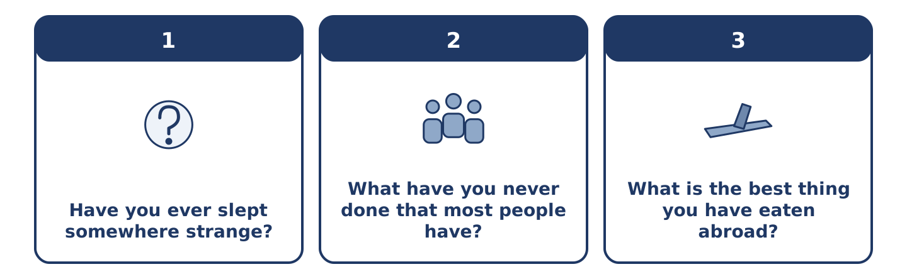
Figure 15.19 · The three questions as cards, to take one at a time.
Work with a partner. Ask and answer these questions.
- Have you ever slept somewhere strange?
- What have you never done that most people have?
- What is the best thing you have eaten abroad?
Useful language: Have you ever…? · I have never… · Once, in… · Not yet.
Part 4: Find the Difference (pairwork)
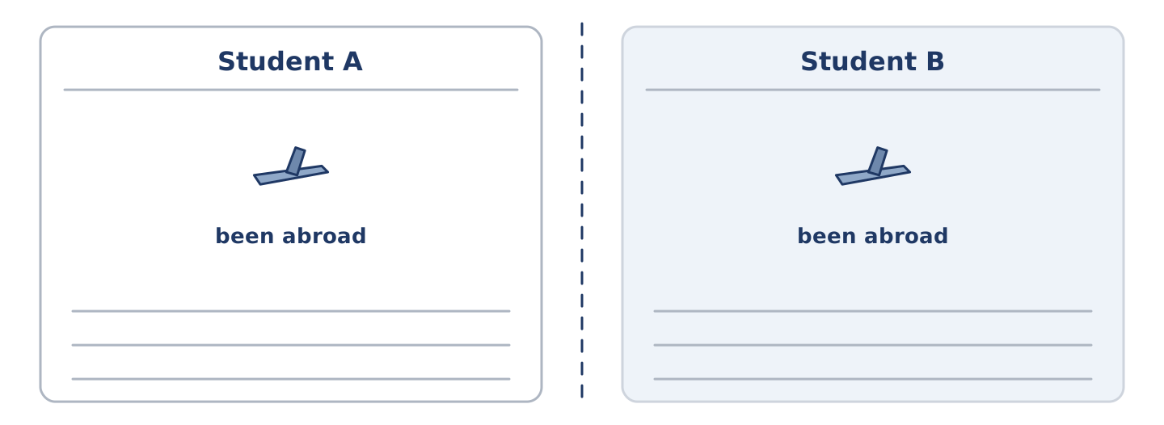
Figure 15.20 · Student A’s facts and Student B’s, with a fold between them.
Student A and Student B each have a list of experiences. Ask questions and find three differences.
Useful questions: Have you ever been abroad? · Have you ever slept outside? · How many times? · Have you flown?
Student A — you have: been abroad, slept outside once, never flown, been to two festivals.
Student B — you have: been abroad, slept outside many times, flown, been to two festivals.
Part 4: Finding Something in Common
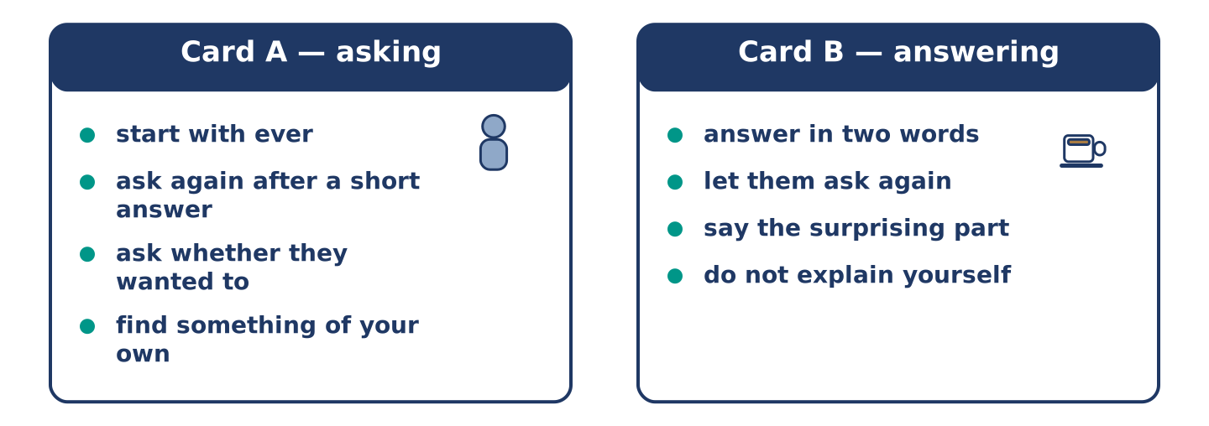
Figure 15.21 · Card A and Card B: what each of you has to say.
Work in pairs. Read the model, then use the cards.
Model exchange:
A: Have you ever been on a plane? — B: Never. — A: Not once? — B: Not once, and nobody believes it. — A: Have you wanted to? — B: No, and that is the part people cannot manage. — A: My mother is the same about the sea.
Useful language: Have you ever…? · Never. · Not once. · So have I.
Card A — asking: start with ever · ask again when the answer is short · ask whether they wanted to · find something of your own.
Card B — answering: answer in two words · let them ask again · say the surprising part · do not explain yourself.
Your turn: run the dialogue, then swap roles.
Stretch [PLUS]: you have done almost nothing on the other person’s list — talk about it without apologising for it once.
Part 4: Mini-Presentation
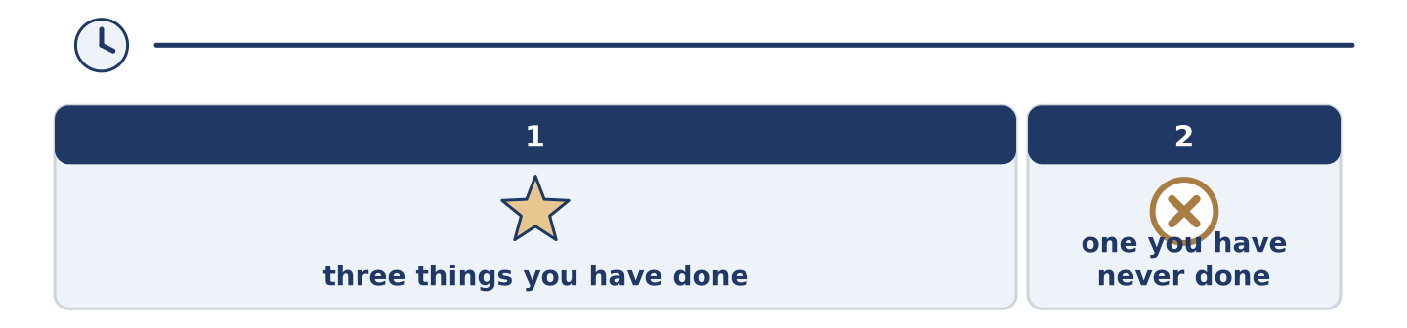
Figure 15.22 · The one-minute talk as 0 beats, each as wide as its share.
Prepare a short talk (about one minute). Describe three things you have done and one you have never done.
Part 5 · Reading
[CORE] Core track · pre-class input
Part 5: Why We Remember the Difficult Ones
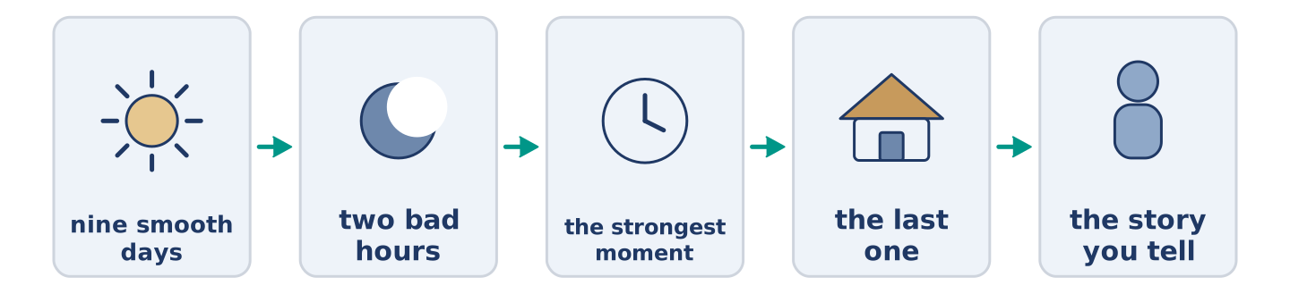
Figure 15.23 · One holiday, and the three days anybody still talks about.
Before you read: which of your holidays do you actually tell people about?
Gloss: smooth = with nothing going wrong · peak = the strongest moment of something · ending = how a thing finishes
Ask somebody about a holiday and they tell you about the boat that broke down. Nobody tells you about the nine smooth days. This is not only a story habit. People remember a long experience by two moments: the strongest one, and the last one. The nine quiet days leave almost nothing behind, and the two bad hours leave a shape. That is why a difficult trip with a good ending stays in the head as a good trip. A smooth week that ends in an argument at an airport does not. It also explains why people go back to the places where something went wrong. They are not going back for the trouble. They are going back for the only days their memory bothered to keep.
Answer the multiple-choice questions. (0. is done.)
- What do people tell you about a holiday? — The boat that broke down.
1. Which two moments do people remember?
○ A) The strongest and the last
○ B) The first and the last
○ C) The cheapest and the longest
○ D) The quiet ones
2. How is a difficult trip with a good ending remembered?
○ A) As a bad trip
○ B) Not at all
○ C) As a good trip
○ D) As an expensive trip
3. Why do people go back to places where something went wrong?
○ A) Because it was cheap
○ B) Because those are the days their memory kept
○ C) Because they want more trouble
○ D) Because the boat is better now
Part 5: Vocabulary in Context
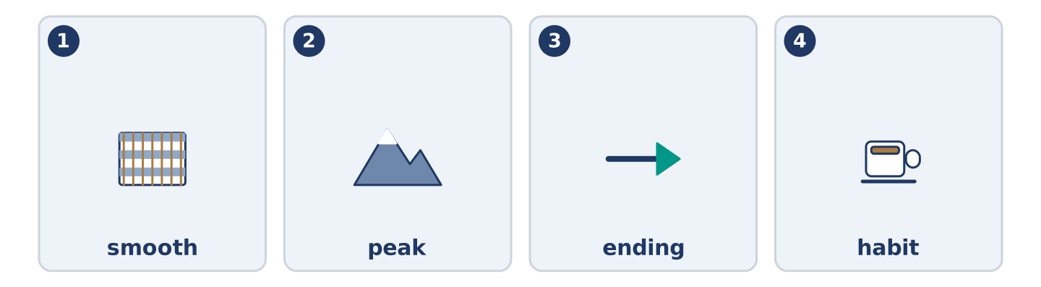
Figure 15.24 · The four words from the reading, drawn.
Match each word from the text with its meaning. One meaning is not needed. Write the letter.
Column A
1. | smooth | ____
2. | peak | ____
3. | ending | ____
4. | habit | ____
Column B
a) | how a thing finishes
b) | something you do without deciding to
c) | with nothing going wrong
d) | the strongest moment of something
e) | land with water all round it
Part 5: Three Places People Travel a Long Way to See
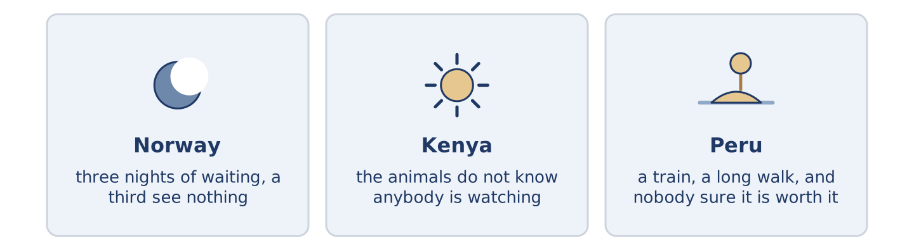
Figure 15.25 · Three places, and what people go there for.
Before you read: is there a place you would cross a continent to see?
Gloss: northern lights = coloured light in a very cold night sky · migration = animals moving a long way together, every year · ruins = what is left of an old building
Some places people travel for days to reach, and the reason is never only the view. In the far north of Norway people wait three nights in the cold for the northern lights. About a third of them see nothing at all and come back anyway. In Kenya the migration crosses the same river every year, and the animals do not know anybody is watching, which is most of the point. In Peru there are ruins at the end of a train ride and a long walk. Almost nobody gets there without hearing, twice, that it is not worth the climb. All three have something in common. You cannot be sure of any of them, and that is why people go.
Answer the questions. (0. is done.)
- Is the reason only the view? — No, it never is.
- How many of the people waiting in Norway see nothing?
- What do the animals in Kenya not know?
- What do all three places have in common?
Part 6 · Writing
[CORE] Core track · in-class / homework
Part 6: The Best Thing You Have Done (50–70 words)
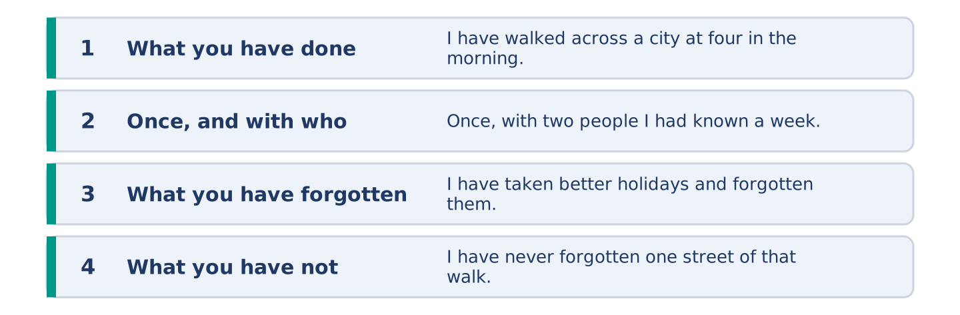
Figure 15.26 · The shape of the piece you are about to write.
Write about the best thing you have ever done. Say when, and what you remember.
Model — read this first:
I have walked across a city at four in the morning, once, with two people I had known for a week. We had missed the last train and there was no money for anything else. I have taken better holidays and I have forgotten all of them. I have never forgotten one street of that walk. (56 words)
Plan (fill in, then write): I have ___. We ___. I have ___ and ___. I have never ___.
Word bank: I have | I have never | once | already | the best thing
Check before you finish: ☐ two present-perfect sentences? ☐ one never? ☐ what you remember? ☐ 50–70 words?
Part 6: Is Travel the Best Way to Learn? (50–70 words)
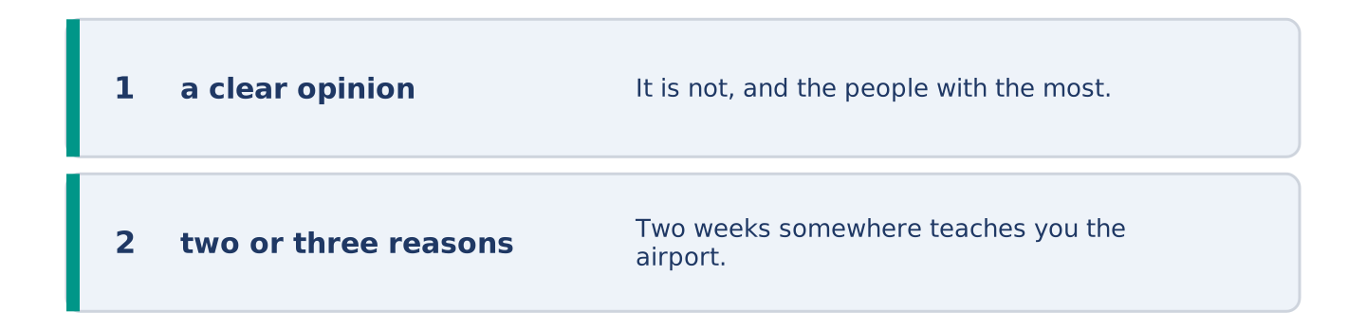
Figure 15.27 · The shape of the opinion paragraph, step by step.
Is travelling the best way to learn about the world? Give your opinion and two or three reasons.
Model — read this first:
It is not, and the people with the most stamps in their papers say so most loudly. Two weeks somewhere teaches you the airport, the old town and the price of water. What teaches you a country is having to deal with it: a bank, a rent, a hospital. Nobody puts that in a holiday. (55 words)
Word bank: I think… because… | however | in my opinion | it depends on | have travelled
Check before you finish: ☐ a clear opinion? ☐ two or three reasons? ☐ 50–70 words?
Part 6: Something You Have Never Done (50–70 words)
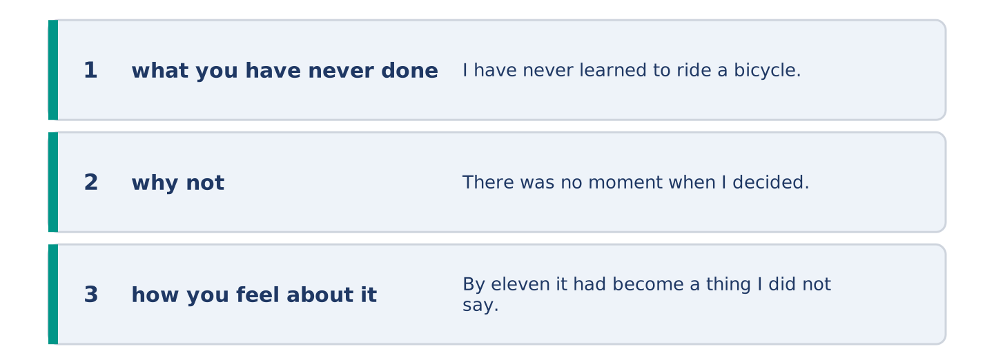
Figure 15.28 · The moves of the message, with a line of the model for each.
Write about something ordinary that you have never done. Say why not.
Model — read this first:
I have never learned to ride a bicycle. There was no moment when I decided not to; there was simply never an afternoon when somebody held the back of one. By eleven it had become a thing I did not say out loud. By thirty it was a small funny story that I tell badly. (55 words)
Plan (fill in, then write): I have never ___. There was ___. By ___ it had become ___.
Check before you finish: ☐ what you have never done? ☐ why not? ☐ how you feel about it? ☐ 50–70 words?
Part 6: Reflection — A Memory That Will Not Go (40–60 words)
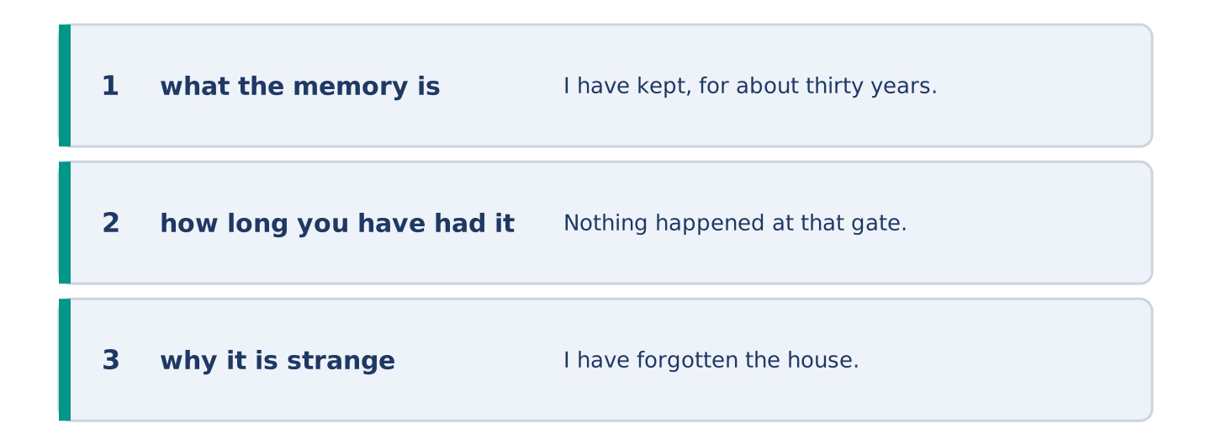
Figure 15.29 · The reflection, step by step.
Write about one small memory you have kept for no reason.
Model — read this first:
I have kept, for about thirty years, the sound of one gate. Nothing happened at that gate. I have forgotten the house, the street and most of the people. The gate is still there every time I hear a similar one, which is a strange thing for a head to choose. (51 words)
Check before you finish: ☐ what the memory is? ☐ how long you have had it? ☐ why it is strange? ☐ 40–60 words?
Part 7 · Real-World File — Telling and Asking About Experiences
[PLUS] Plus track (optional) · stronger learners
7A: Phrase Bank
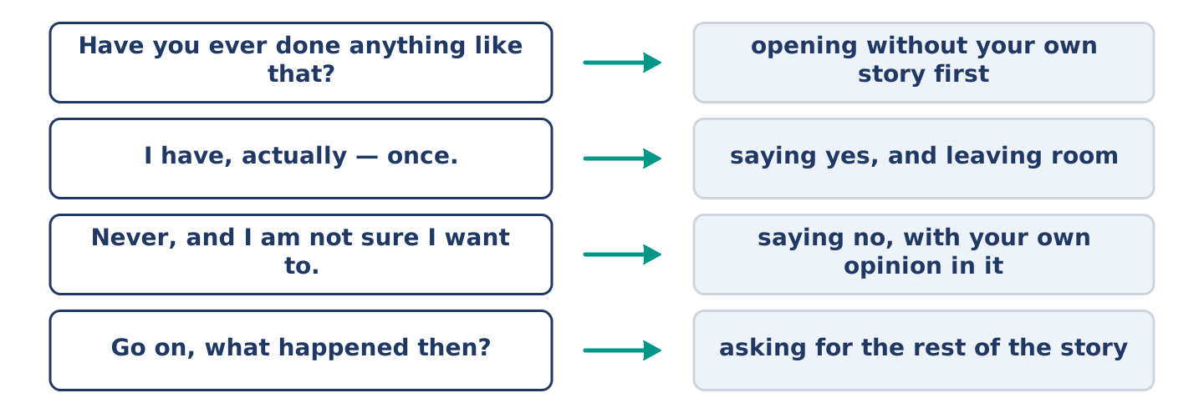
Figure 15.30 · What you say about an experience, and what each line does.
Match what a person says with its purpose. One purpose is not needed. Write the letter.
Column A
1. | “Have you ever done anything like that?” | ____
2. | “I have, actually — once.” | ____
3. | “Never, and I am not sure I want to.” | ____
4. | “Go on, what happened then?” | ____
Column B
a) | saying no, with your own opinion in it
b) | asking for the rest of the story
c) | how much it will cost
d) | opening the subject without telling your own story first
e) | saying yes, and leaving room for them to ask
7B: The Thing Nobody Has Asked About
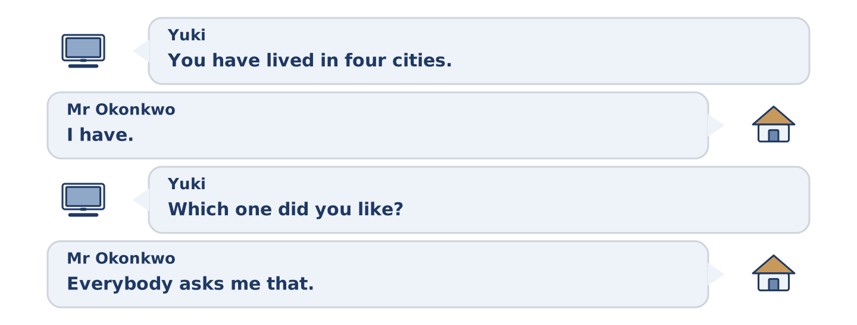
Figure 15.31 · The 7B exchange: who takes each turn.
🔊 Audio Track 15.5
Before you read: is there something about you that nobody has ever asked?
Yuki: You have lived in four cities. Mr Okonkwo: I have. Yuki: Which one did you like? Mr Okonkwo: Everybody asks me that. Yuki: And what do you say? Mr Okonkwo: Nothing, usually. Yuki: Why? Mr Okonkwo: Because the honest answer is the third one, and the third one is where I was unhappy. Then I have to explain that, and we are forty minutes in and nobody is enjoying it.
Answer the questions. (0. is done.)
- How many cities has Mr Okonkwo lived in? — Four.
- What does everybody ask him?
- What does he usually say?
- Why does he not answer?
7C: Controlled Practice — Telling a Story Well
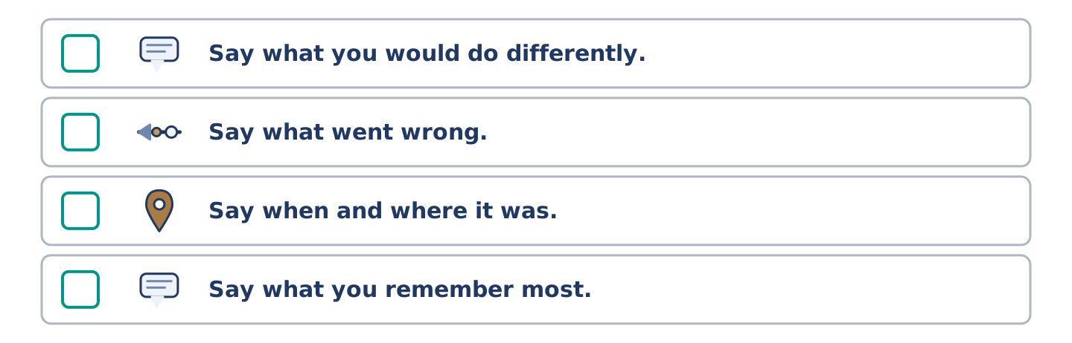
Figure 15.32 · The steps still to be numbered, as the task prints them.
Put the steps in order. Number them 1–5. (0. is done.)
- Say what it was, in one sentence. — 1
____ Say what you would do differently.
____ Say what went wrong.
____ Say when and where it was.
____ Say what you remember most.
7D: Role-Play — Asking About a Life
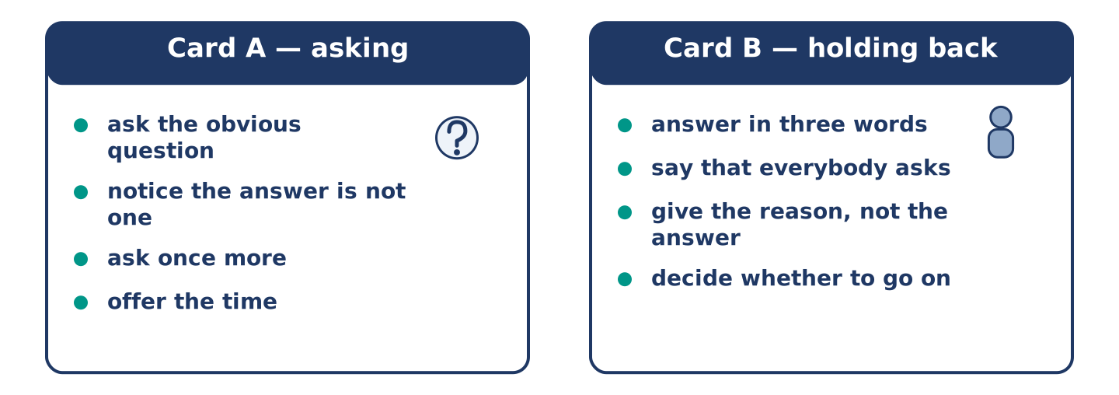
Figure 15.33 · The 7D cards: what each of you has to say.
In pairs. One asks; one does not want to answer fully. Use the model and cards.
Model exchange: A: You have lived in four cities. — B: I have. — A: Which did you like? — B: Everybody asks that. — A: And? — B: And the honest answer takes forty minutes. — A: I have forty minutes.
Card A — asking: ask the obvious question · notice the answer is not one · ask once more · offer the time.
Card B — holding back: answer in three words · say that everybody asks · give the reason, not the answer · decide whether to go on.
Stretch [PLUS]: they ask about the one experience you never discuss — turn the question without lying and without hurting them.
7E: Writing — An Experience, for Somebody Who Was Not There (50–80 words)
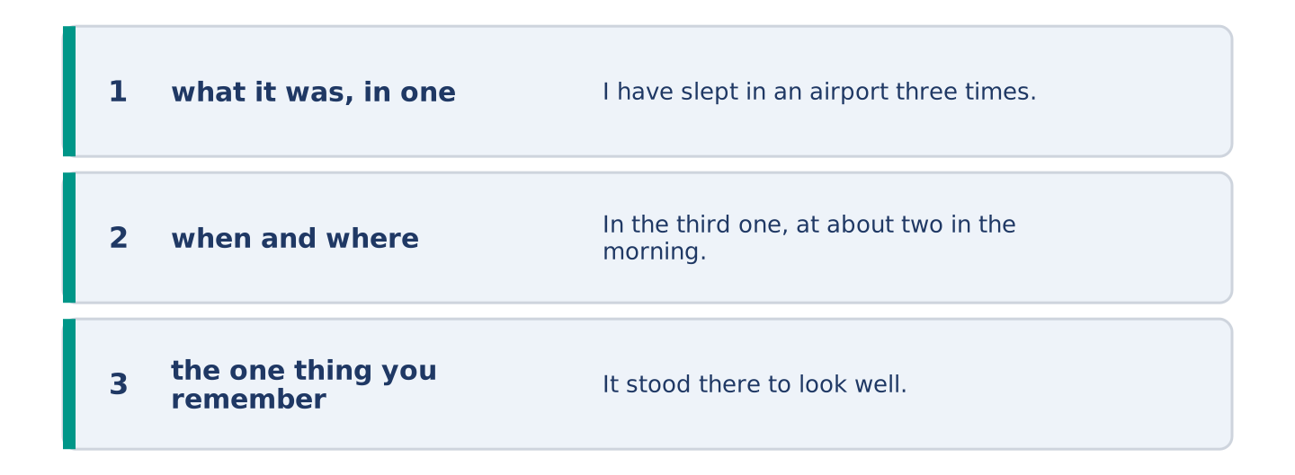
Figure 15.34 · The Part 7 note, with the model beside each line.
Write about one experience for somebody who was not there.
Model — read this first:
I have slept in an airport three times and only one of them was interesting. In the third one, at about two in the morning, somebody started playing a piano. It stood there to look well, and nobody ever played it. About forty of us sat up. Nobody made a sound at the end, because any noise would have made it a show, and it was not one. (68 words)
Check before you finish: ☐ what it was, in one sentence? ☐ when and where? ☐ the one thing you remember? ☐ 50–80 words?
Part 8 · Global Story — The Visitors Who Came Before You
[PLUS] Plus track · pre-read / discuss
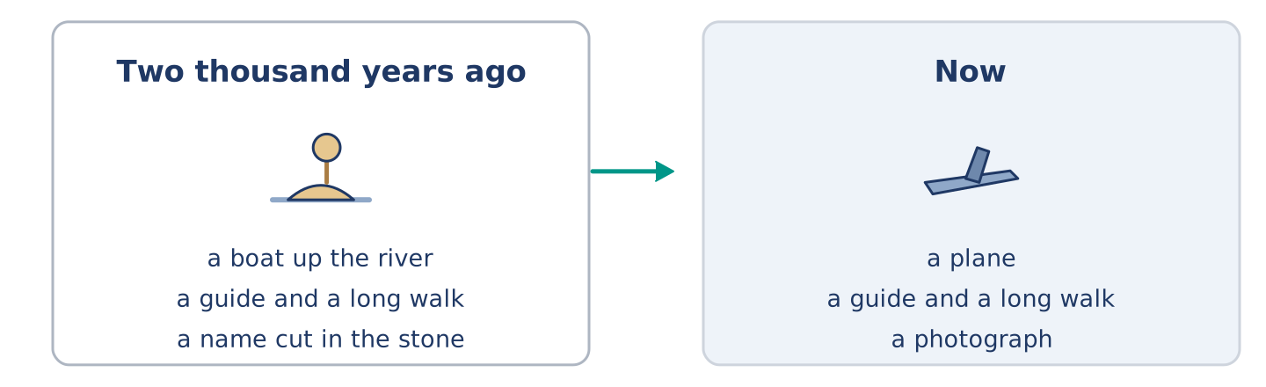
Figure 15.35 · A wall of names, and the people who left them.
Before you read: how old do you think the habit of visiting an old place is?
Gloss: ancient = very, very old · temple = a building people built for a god · visitor = somebody who comes to see a place
In Egypt there are temples with names cut into the stone by visitors, and the names are two thousand years old. Greek and Roman travellers came up the river to look at buildings that were already ancient when they arrived. They paid a guide, they walked round, and then a good many of them wrote their own name on a wall. One of them added that he had seen it and had not thought much of it. The buildings those visitors came to see were older to them than they are to us. Nothing about the trip has changed much either. There is the boat, the guide, the long walk in the heat, and the name on the wall, which we now call a photograph.
Answer the questions. (0. is done.)
- How old are the names cut into the stone? — About two thousand years.
- Who came up the river to look at the buildings?
- What did many of them do on a wall?
- What does the text say we do instead of writing a name?
Part 8: Vocabulary in Context
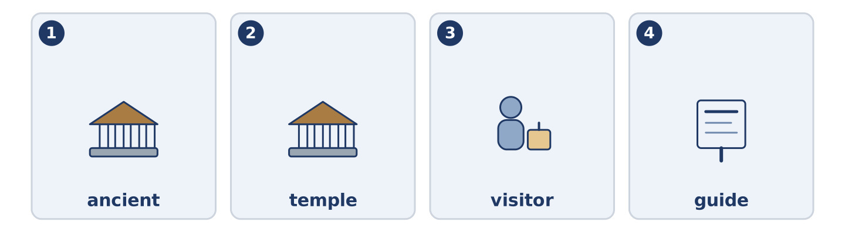
Figure 15.36 · The four words from the global story, drawn.
Match each word with its meaning. One meaning is not needed. Write the letter.
Column A
1. | ancient | ____
2. | temple | ____
3. | visitor | ____
4. | guide | ____
Column B
a) | somebody who shows a place to people and explains it
b) | very, very old
c) | somebody who comes to see a place
d) | a building people built for a god
e) | animals moving a long way together, every year
Part 8: Discussion
Talk with a partner. Use the frames.
Discussion frames: “This is similar to where I live because…” · “This is different from where I live because…” · “I think the most important thing is… because…”
Part 9 · Close to Home — What Nobody at Number 14 Has Done
[PLUS] Plus track · pre-read / decide
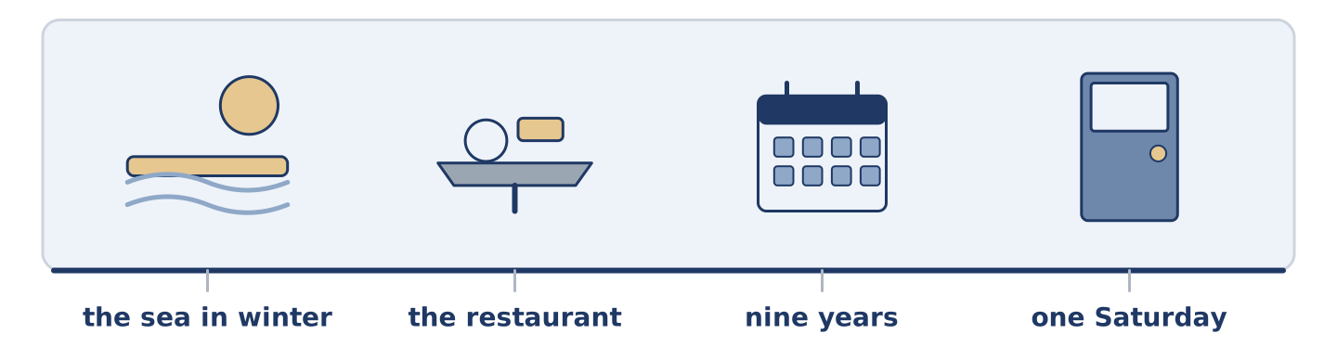
Figure 15.37 · The close-to-home reading, drawn along one street.
Before you read: what has everybody you know done, except you?
Six people have lived at number 14 for years and between them they have done a great deal. There are three things not one of them has done. None of them has ever been to the sea in winter, which Mr Okonkwo says is the only time it is worth going. None of them has eaten in the restaurant at the end of the street. It has been there nine years and all six of them walk past it daily. And none of them has ever been in another one of the six flats, except Yuki’s, on one Saturday in the spring. The restaurant is what bothers Yuki. She has asked twice and both times everybody said yes and nobody picked a day.
Answer the questions. (0. is done.)
- How many things has nobody at number 14 done? — Three.
- When does Mr Okonkwo say the sea is worth going to?
- How long has the restaurant been there?
- What happened both times Yuki asked?
Part 9: Decision Task
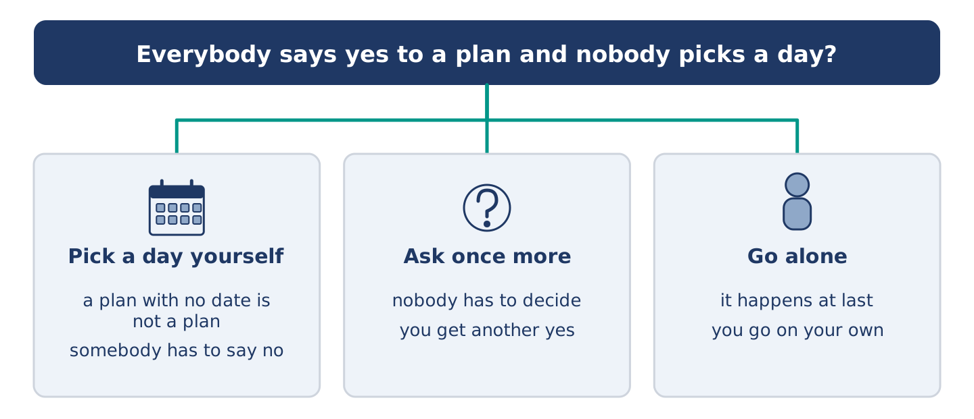
Figure 15.38 · Three ways to decide, and what each one costs.
Everybody says yes to a plan and nobody picks a day. Should you (a) pick a day yourself, (b) ask once more and then let it go, or (c) go alone? Decide and explain. Use the frame.
Answer frame: “I think I should ___ because ___. Also, ___. This is better than ___ because ___.”
Model — read this first:
I think I should pick a day myself, because a plan with no date is not a plan and everybody knows it. Also, people find it easier to say no to a Thursday than to an idea. This is better than asking once more. Asking again gets another yes, and another yes is what the plan already has too much of. (61 words)
Phrase bank: I think I should… · because… · Also,… · This is better than… · In my opinion…
Part 10 · Review and Can-Do
[CORE + PLUS] · homework / self-study
Part 10: Spiral Review
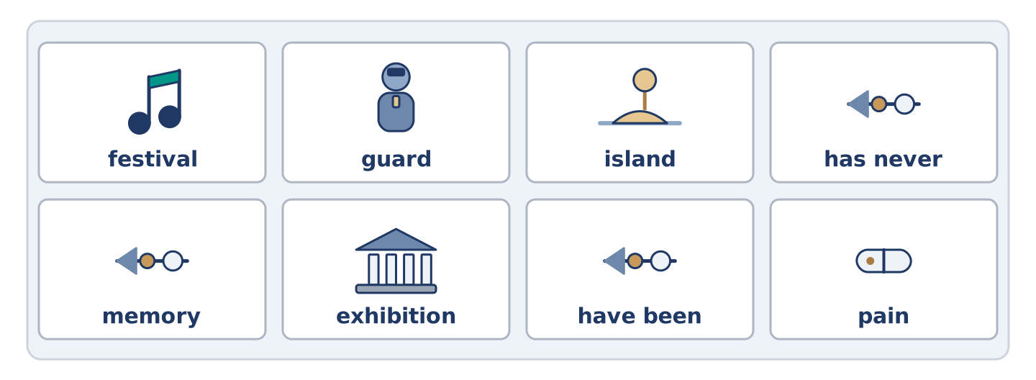
Figure 15.39 · The eight words of the review bank, in bank order.
Complete the review. (0. is done.)
- In another country is abroad.
Word bank: festival | guard | island | has never | memory | exhibition | have been | pain
- Land with water all round it is an ______________________ .
- A room of things put out for people to look at is an ______________________ .
- Something you keep in your head from before is a ______________________ .
- Days of music or food, usually once a year, is a ______________________ .
- I ______________________ to four countries. (experience)
- She ______________________ flown. (not once in her life)
- (from Unit 14) The feeling when part of you hurts is ______________________ .
- (from Unit 13) Somebody whose job is to watch a place is a ______________________ .
Part 10: Can-Do
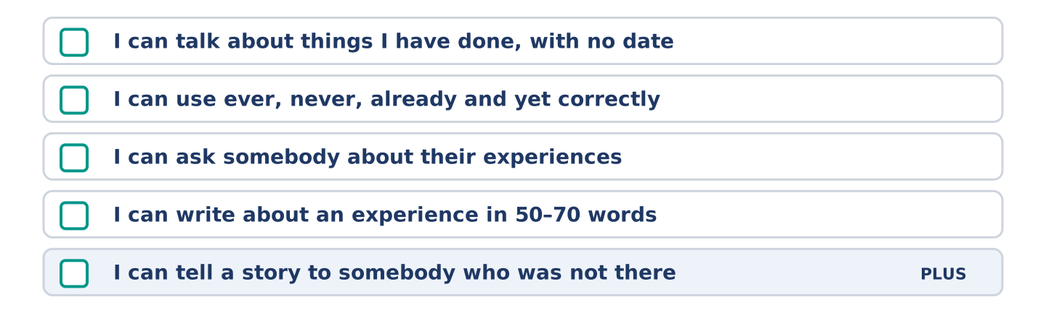
Figure 15.40 · What you can do at the end of this unit.
Can-Do checklist
☐ I can talk about things I have done, with no date.
☐ I can use ever, never, already and yet correctly.
☐ I can ask somebody about their experiences.
☐ I can write about an experience in 50–70 words.
☐ I can tell a story to somebody who was not there (Plus).
Part 10: Glossary
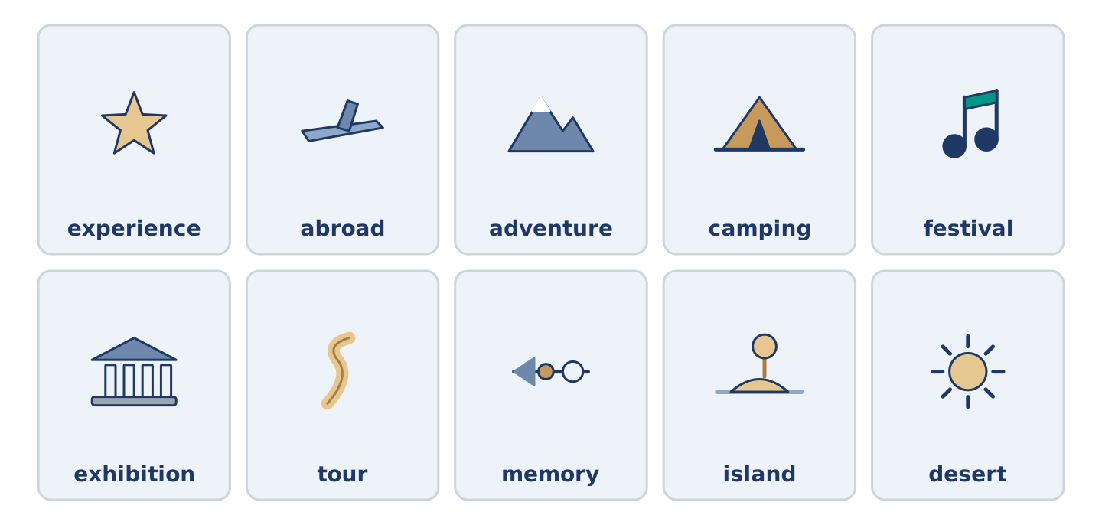
Figure 15.41 · All ten glossary words of Unit 15, one card each.
Unit 15 glossary (10 words)
experience · abroad · adventure · camping · festival · exhibition · tour · memory · island · desert

