Unit 1: The Night the Power Went Out
English for Daily Life · Level: B1 · Tracks: [CORE] Warm-Up + Parts 1–6 · [PLUS] Parts 7–10
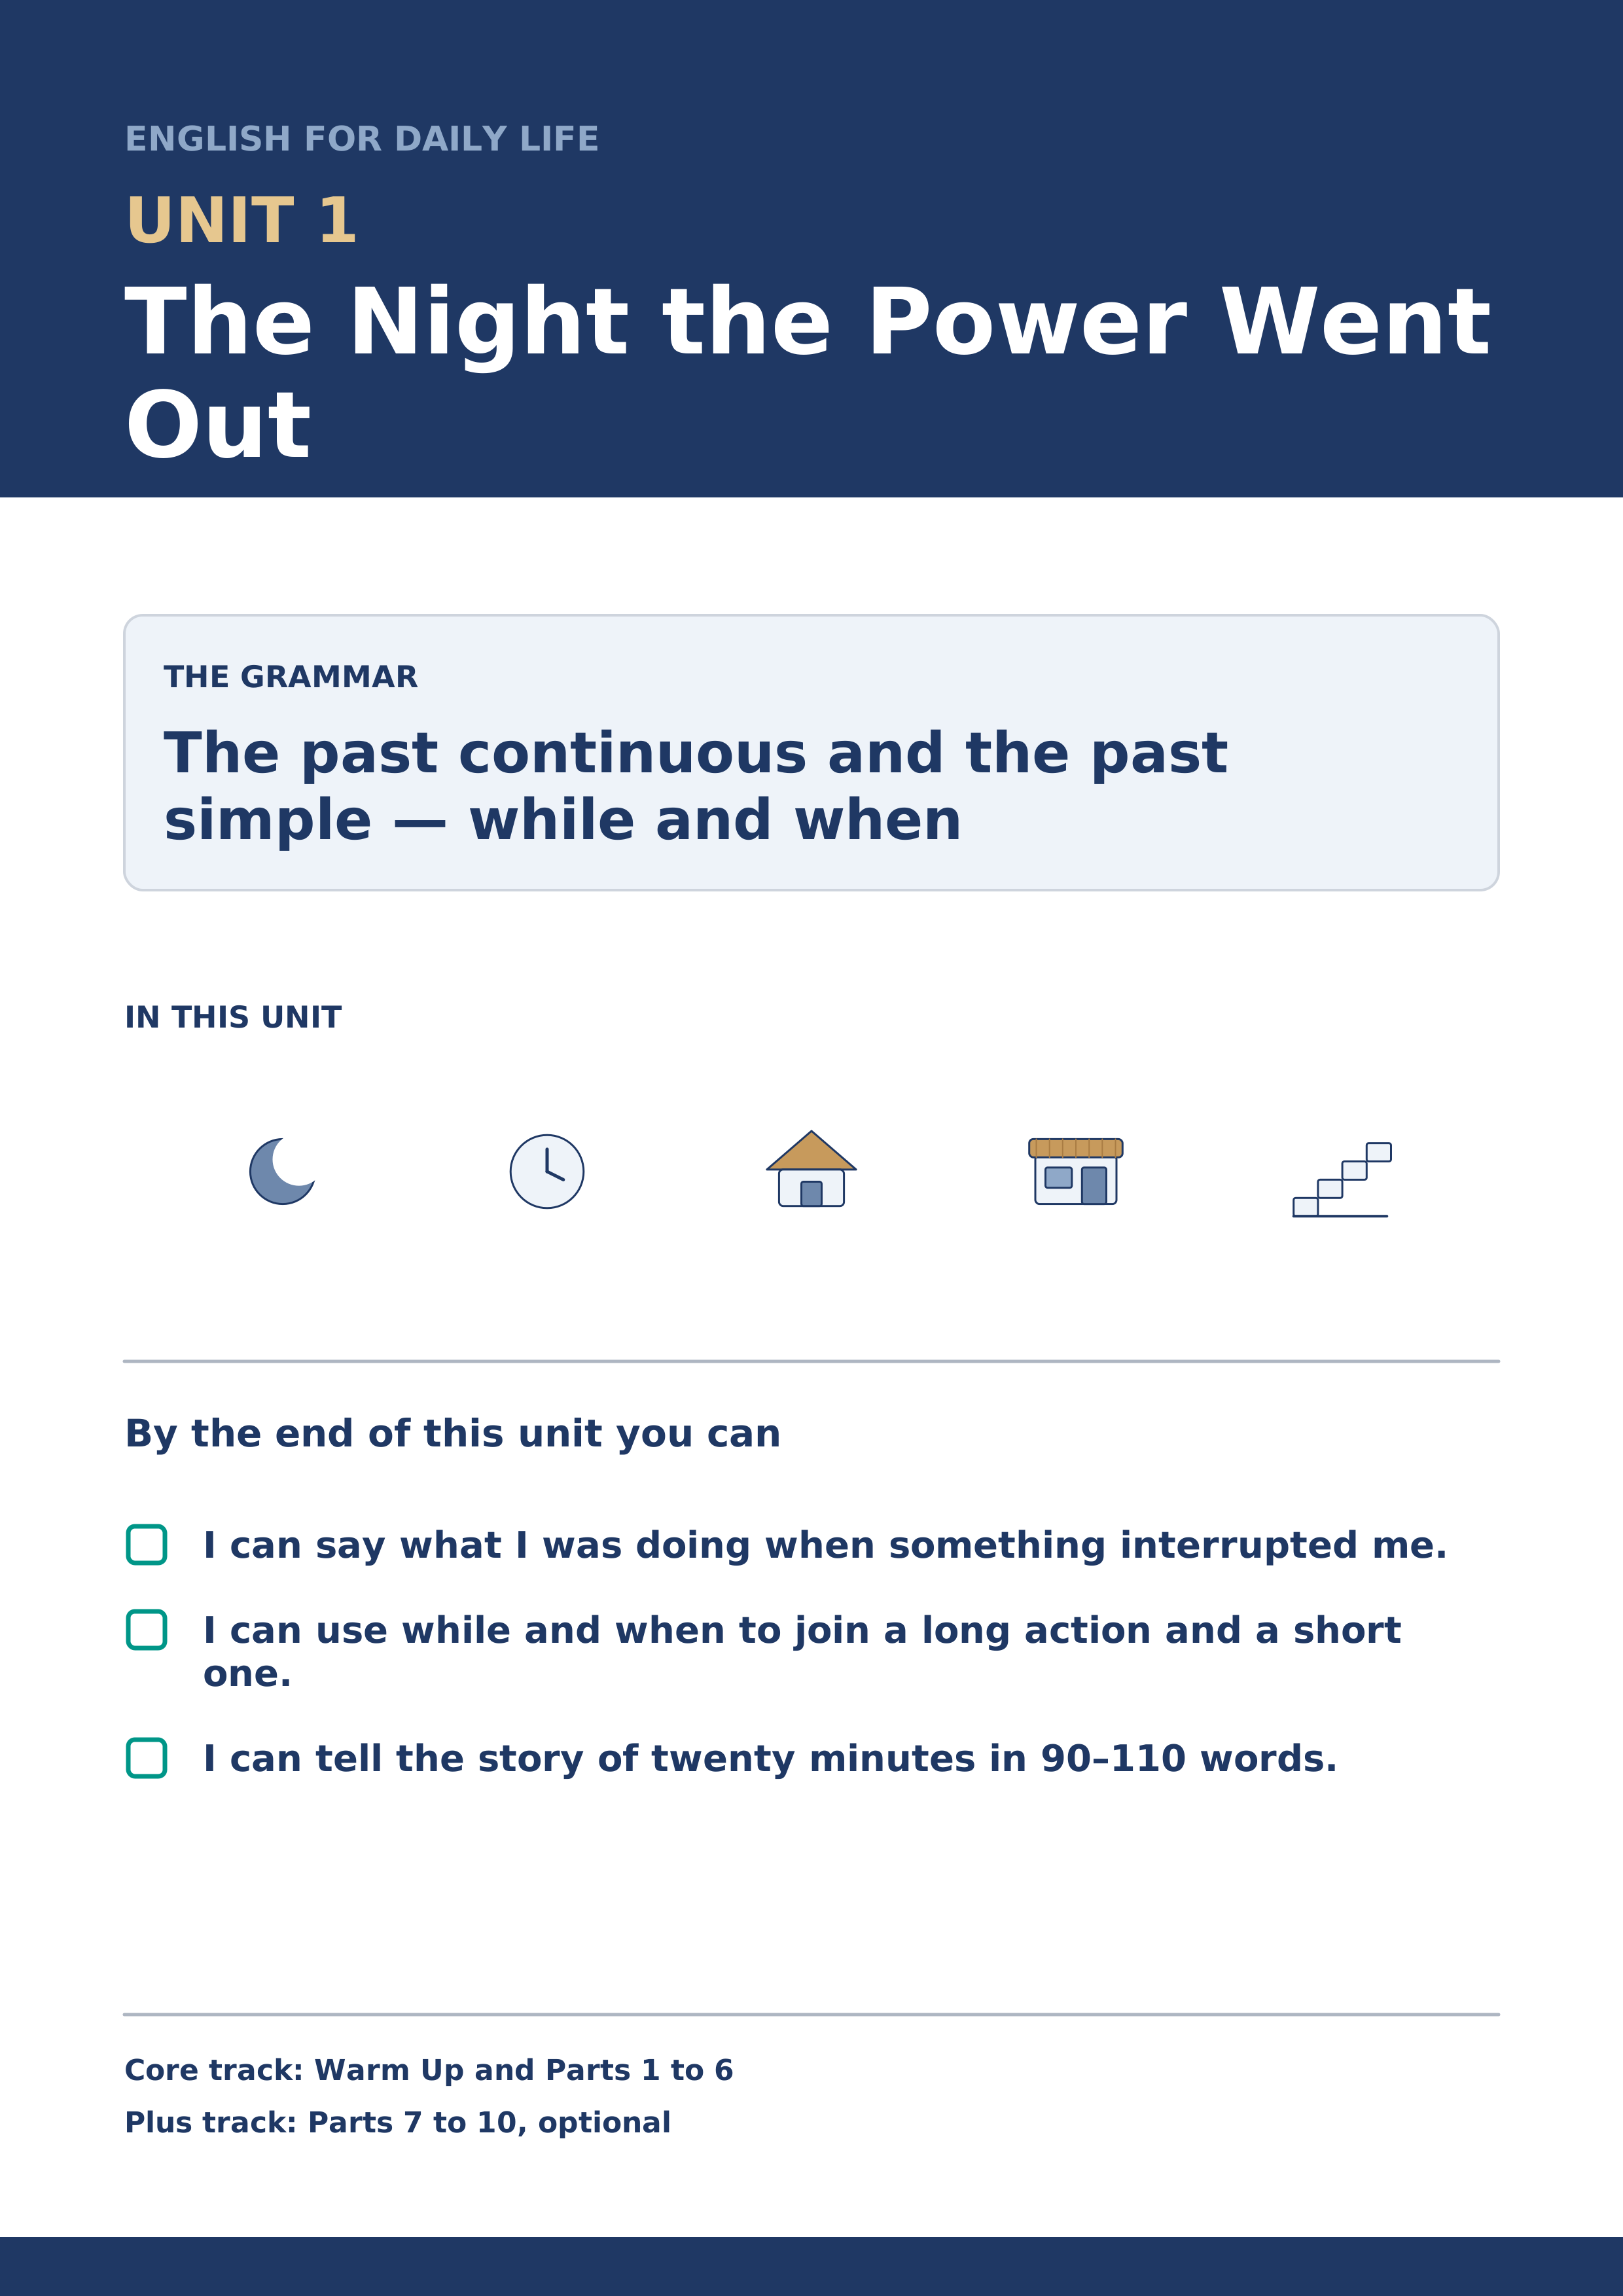
Warm Up
[CORE] Core track · in-class starter
Warm-up: Words for a Dark Evening
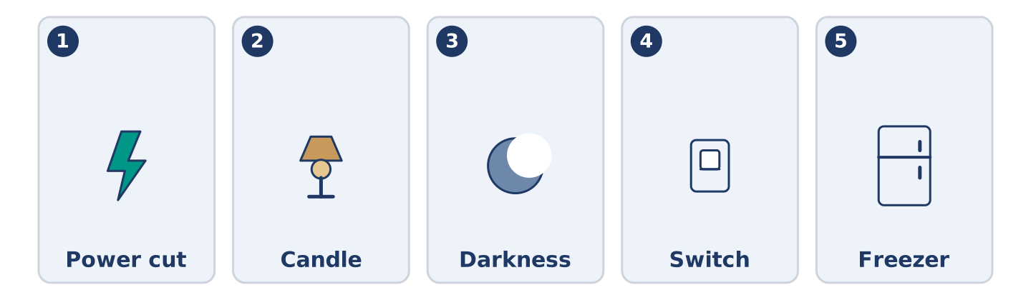
Figure 1.2 · The five warm-up words, and the thing each one means.
Match the words with their meanings. One meaning is not needed. Write the letter.
Column A
1. | Power cut | ____
2. | Candle | ____
3. | Darkness | ____
4. | Switch | ____
5. | Freezer | ____
Column B
a) | the small thing on the wall that turns a light on and off
b) | a period when the electricity stops working for everybody
c) | the state of a place where there is no light at all
d) | a cupboard that keeps food frozen until you want it
e) | a stick of wax with a flame at the top, used when there is no lamp
f) | the wire that carries electricity into a building
Warm-up: Talking About That Evening
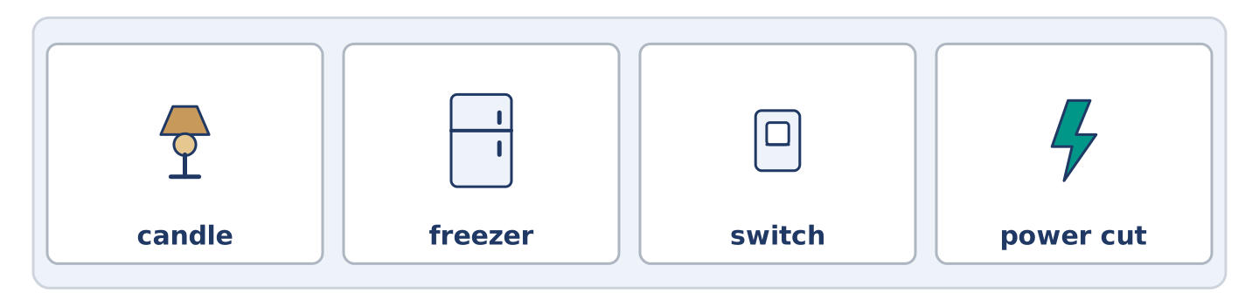
Figure 1.3 · The word bank for this task, in the order it is printed.
Complete the sentences using the words in the word bank.
Word bank: candle | freezer | switch | power cut
- Amina was serving a customer when the ______________________ started, and the shop went black in a second.
- Tomas pressed every ______________________ in the corridor before he understood that the whole street was dark.
- Maya was looking for a ______________________ in the kitchen drawer while everybody else was shouting on the stairs.
- Nobody opened the ______________________ for two days afterwards, in case the food inside was still frozen.
Warm-up: Six People, One Tuesday Evening
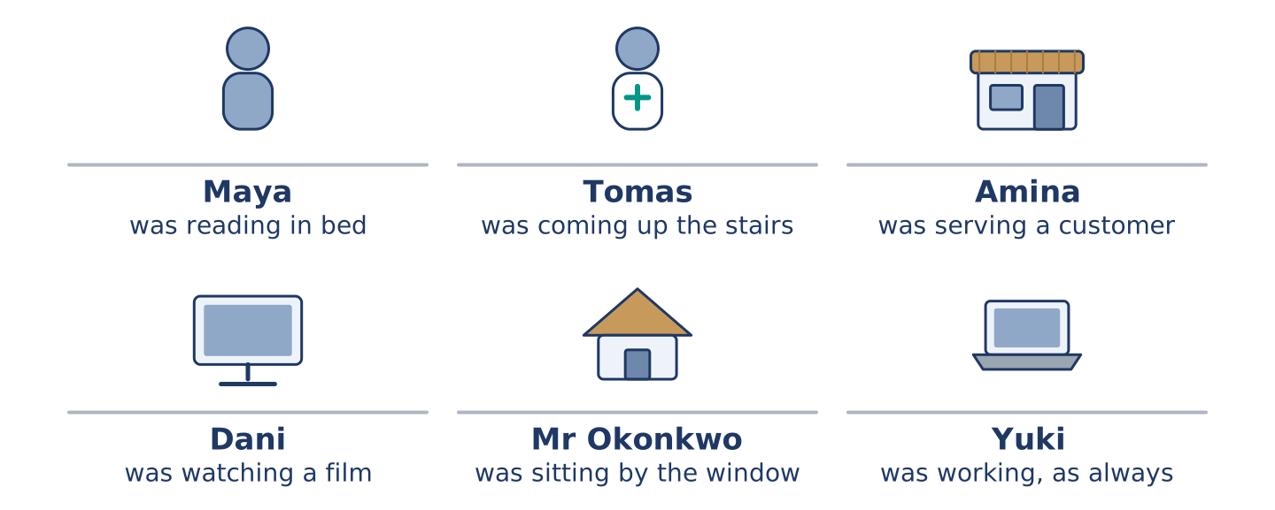
Figure 1.4 · Number 14 at twenty past seven, and what each of them was doing.
Read the text and choose the correct answer.
At twenty past seven on a Tuesday in November, every light at 14 Alder Street went out at the same moment. Nobody at number 14 was ready for it. Maya was reading in bed, because she had the evening off for once, and she sat in the dark for a full minute before she moved. Tomas was coming up the stairs with two bags of shopping, and he put them down where he stood rather than risk the last four steps. Amina was at the till with three people waiting. She kept the shop open by candle until the last of them left. Dani was halfway through a film, and he swore loudly enough for the whole building to hear him. Mr Okonkwo was already sitting in his chair by the window. He noticed nothing unusual for several minutes, and said so afterwards without any embarrassment. Yuki was working, as Yuki usually is. She lost an hour of it.
1. What was Tomas doing when the lights went out?
○ A) Carrying shopping upstairs
○ B) Watching a film
○ C) Serving a customer
○ D) Reading in bed
2. Why did Mr Okonkwo notice nothing for several minutes?
○ A) He was asleep in his chair
○ B) He was sitting in the dark already
○ C) He was out of the building
○ D) He was listening to the radio Part 1 · Vocabulary and Terminology
[CORE] Core track · pre-class input
Part 1: Words for Electricity and Buildings
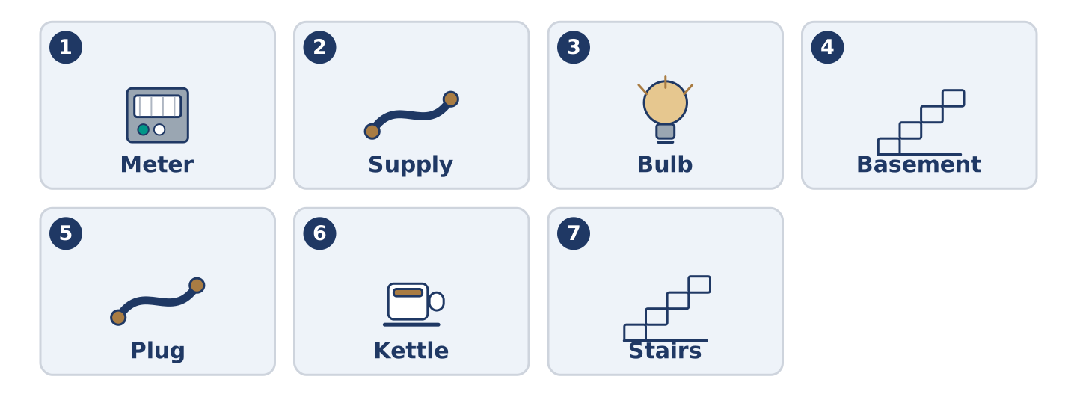
Figure 1.5 · The seven words of Column A, and what each one is.
Match the words with their meanings. One meaning is not needed. (0. is done for you.)
Gloss: meter — the box that counts how much electricity a flat has used · supply — the electricity, water or gas coming into a building · bulb — the glass part of a lamp that gives the light · basement — the floor of a building below the street
- Electricity → the power that arrives at a building and makes everything in it work.
Column A
1. | Meter | ____
2. | Supply | ____
3. | Bulb | ____
4. | Basement | ____
5. | Plug | ____
6. | Kettle | ____
7. | Stairs | ____
Column B
a) | the steps between one floor of a building and the next
b) | the box that counts how much a flat has used
c) | what you push into the wall to connect something
d) | the glass part of a lamp, which gives out the light
e) | the gas, water or electricity arriving at a building
f) | a machine that boils water for tea or coffee
g) | the floor of a building below the level of the street
h) | the small room where a generator is kept
Part 1: Pronunciation
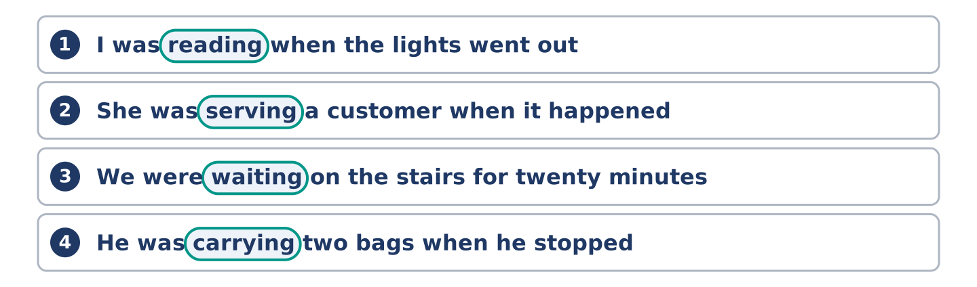
Figure 1.6 · Where the stress falls in 0 words of this unit.
🔊 Audio Track 1.1
Listen and repeat. In each line, the beat falls on the words in bold.
I was READing when the LIGHTS went OUT.
She was SERVing a CUStomer when it HAPPened.
We were WAITing on the STAIRS for TWENty MINutes.
He was CARRying two BAGS when he STOPPED.
was and were almost never carry the beat. In ordinary speech was becomes /wəz/ and were becomes /wə/. At speed a learner listening for them hears nothing at all, so listen for the -ing instead. The -ing tells you the sentence is about something in the middle of happening, and it is the part that is easy to hear.
Part 1: What Kind of Word Is It?
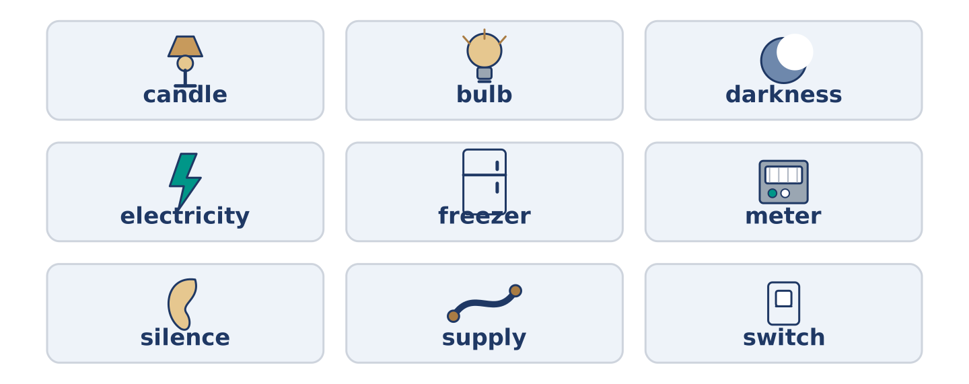
Figure 1.7 · Things you can touch, and things you cannot.
Write yes or no beside each word. (0. is done for you.)
- candle → something you can touch.
The word | Can you touch it?
candle | yes
bulb | ____
darkness | ____
electricity | ____
freezer | ____
meter | ____
silence | ____
supply | ____
switch | ____
Words: bulb | darkness | electricity | freezer | meter | silence | supply | switch
Part 1: Where Is Each One?
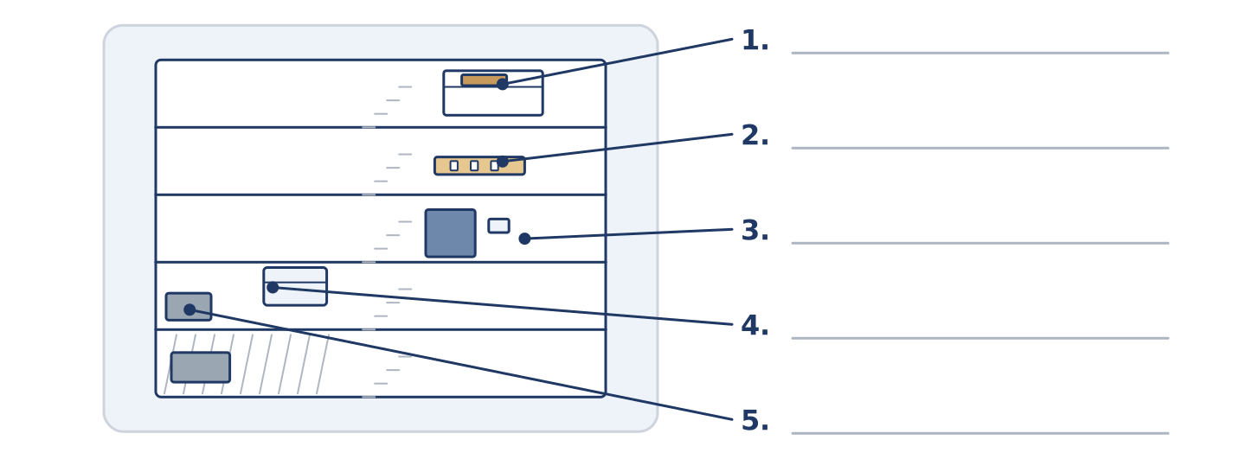
Figure 1.8 · The building in section — write the correct word beside each place.
Match each thing with where you would look for it, working down the building from the top. One place is not needed. Write the letter.
Column A
1. | The spare bulbs | ____
2. | The candles | ____
3. | The switch | ____
4. | The freezer | ____
5. | The meter | ____
Column B
a) | in the corner of Amina’s shop, humming all day
b) | in the hall, in a grey box beside the front door
c) | on the top shelf of the cupboard, still in the box
d) | in the kitchen drawer, under the string and the batteries
e) | on the wall beside the door of every room
f) | in a locked cupboard in the basement, behind the bikes
Part 1: Electricity and Buildings — Multiple Choice
Choose the correct answer.
1. The box that counts how much electricity a flat has used is the…
○ A) meter
○ B) plug
○ C) switch
○ D) bulb
2. A floor below the level of the street is a…
○ A) landing
○ B) staircase
○ C) basement
○ D) balcony
3. When the electricity stops for a whole street, there is a…
○ A) switch
○ B) supply
○ C) meter
○ D) power cut
Part 1: Vocabulary Fill-in
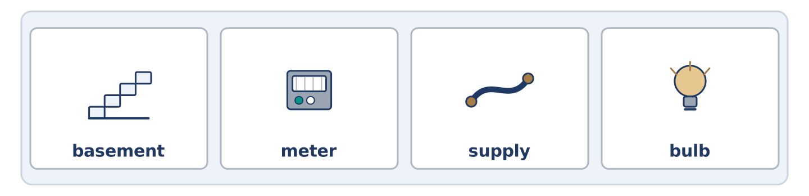
Figure 1.9 · The four words of the bank, in the order the task gives them.
Complete the sentences using the words in the word bank.
Word bank: basement | meter | supply | bulb
- The engineer was still reading the ______________________ when Amina came down with a candle and two questions.
- Dani changed the ______________________ twice before anybody told him that the problem was the whole street.
- They found the cupboard in the ______________________ , but nobody at number 14 had a key for it.
- The ______________________ came back at ten past nine, and three televisions started talking at once.
Part 1: Write About an Evening Without Electricity (short)
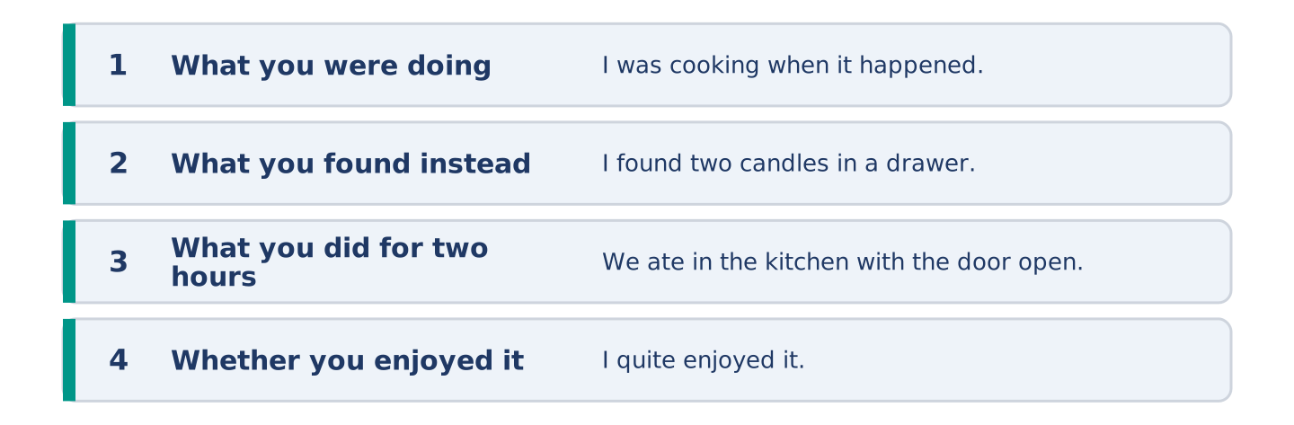
Figure 1.10 · The shape of your two or three sentences, with the model beside each step.
Model — read this first:
We lost the electricity for about two hours last winter. I was cooking when it happened, so half of the food was ready and half was not. I found two candles in a drawer, and we ate in the kitchen with the door open, because the kitchen was the warmest room. My brother was complaining the entire time, but I quite enjoyed it. Nobody was looking at a screen for once, and we talked for much longer than we usually do. (80 words)
Write 60–80 words about an evening when you had no electricity, or an evening when you had no internet. Say what you were doing when it stopped, and what you did instead. Part 2 · Grammar — Past Continuous vs Past Simple
[CORE] Core track · pre-class input
Part 2: Notice
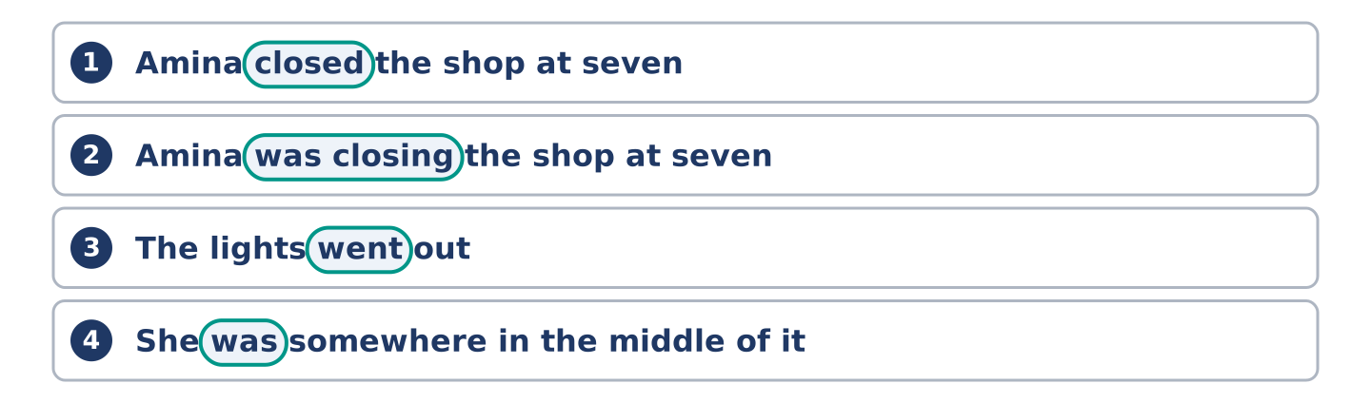
Figure 1.11 · Lines from the notice, with the target form ringed in each.
Read the two sentences. What is the difference between them?
Amina closed the shop at seven, and then the lights went out.
Amina was closing the shop at seven when the lights went out.
In the first sentence the shop was already shut before the darkness arrived, so the two events stand in a row, one after the other. In the second sentence she was somewhere in the middle of shutting it, and the darkness interrupted her, so the two events cross. Nothing in the vocabulary has changed, and nothing about the time has changed. What has changed is whether the action was finished or still going on, and in English that difference lives inside the verb.
Part 2: Grammar Focus Box
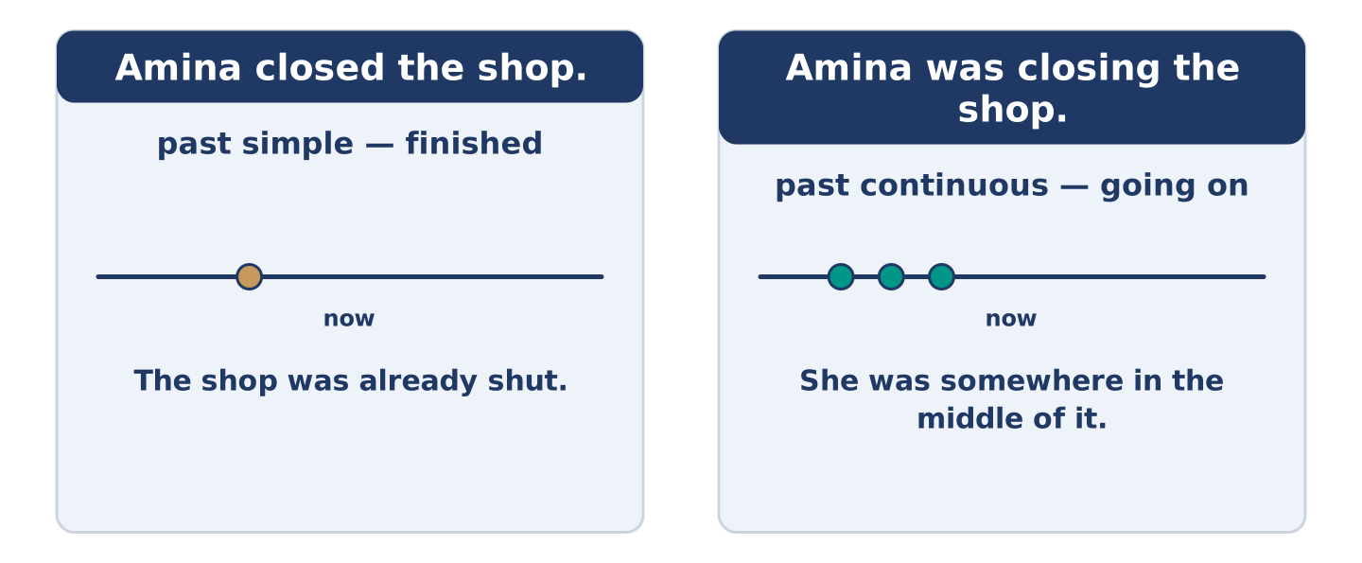
Figure 1.12 · Finished, and still going on: two pasts, two jobs.
 | Form | Use | Example
past simple | verb + -ed, or irregular | the thing that happened, and finished | The lights went out at 7.20.
past continuous | was/were + -ing | the longer action, in the middle of happening | She was closing the shop.
when | + past simple | introduces the short, finished action | I was reading when it happened.
while | + past continuous | introduces the longer background action | While I was reading, it happened.
negative | was/were not + -ing | the background that was not happening | He was not listening to the radio.
Remember: some verbs are almost never used in the continuous, however long the action lasted — know, believe, understand, belong, own, need, want, hear, see, like, hate. I was knowing the answer is not English, and the past simple is what you want instead.
Watch out! ✗ While Tomas was standing on the stairs, Dani was shouting, and then the lights was going out. → ✓ …and then the lights went out. (the thing that interrupts is past simple). ✗ I was understanding the problem. → ✓ I understood the problem.
Part 2: Controlled Practice
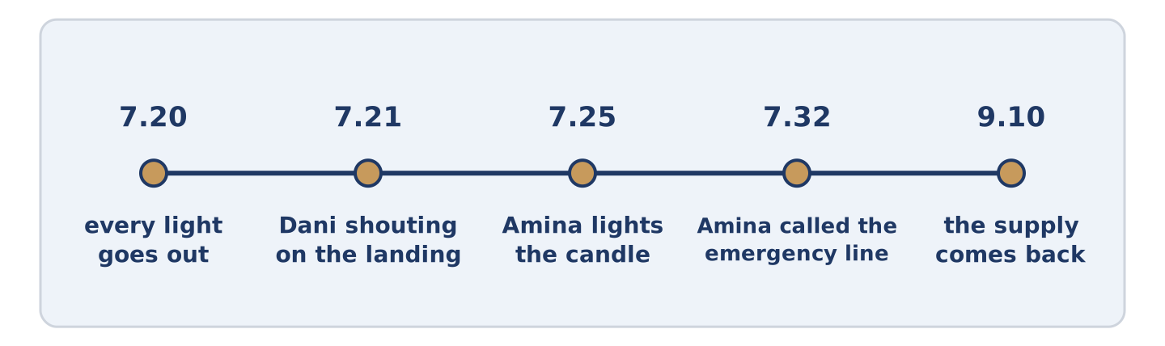
Figure 1.13 · One evening, from twenty past seven to ten past nine.
Put the verb into the past simple or the past continuous. (0. is done for you.)
- Maya was reading (read) in bed when the lights went (go) out.
- Tomas ______________________ (come) up the stairs when the whole building ______________________ (go) dark.
- While Amina ______________________ (serve) a customer, the till ______________________ (stop) working.
- Dani ______________________ (watch) a film when the screen suddenly ______________________ (turn) black.
- Mr Okonkwo ______________________ (sit) by the window and ______________________ (not notice) anything for several minutes.
Part 2: Interrupted or Finished?
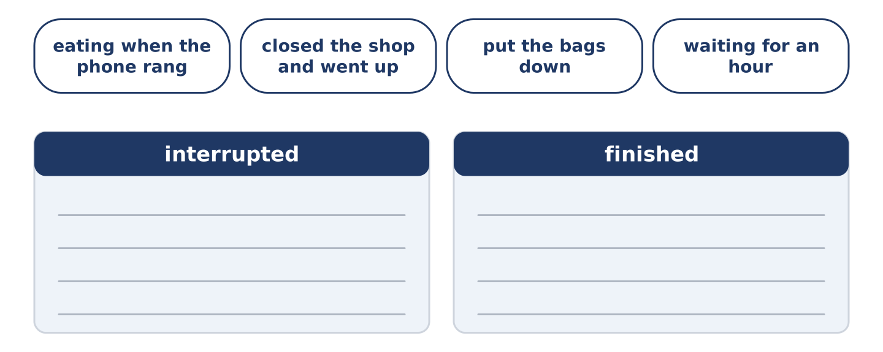
Figure 1.14 · The items of this task, and the bins they sort into.
Write interrupted or finished for each sentence. (0. is done for you.)
- I was walking home when it started to rain. — interrupted
The sentence | Interrupted or finished?
I was walking home when it started to rain. | interrupted
She closed the shop and went upstairs. | ____
They were eating when the phone rang. | ____
He put the bags down on the landing. | ____
We were waiting for the engineer for an hour. | ____
Part 2: Correct the Sentence
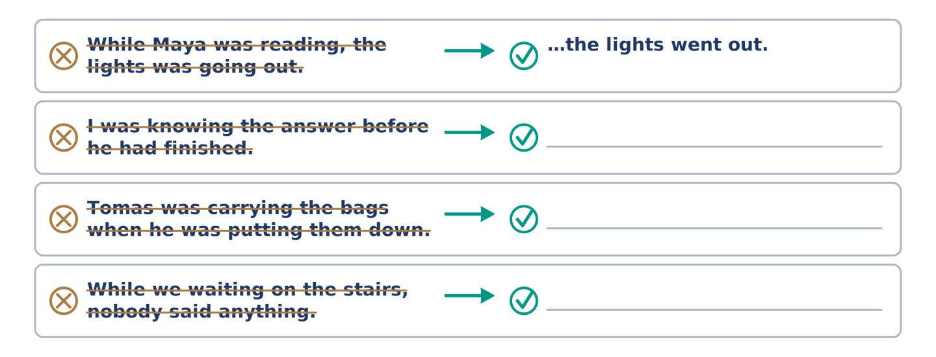
Figure 1.15 · One correction done for you, and the rest to write.
One word is wrong in each sentence. Write the sentence correctly.
- While Maya was reading, the lights was going out.
- I was knowing the answer before he had finished the question.
- Tomas was carrying the bags when he was putting them down.
- While we waiting on the stairs, nobody said anything useful.
Part 2: Freer Practice
Write two sentences about last Tuesday evening. Use when in one and while in the other.
Part 2: Grammar Review
Choose the correct answer.
1. Which sentence says that the shop was already shut?
○ A) Amina was closing the shop when the lights went out
○ B) Amina closed the shop, and then the lights went out
○ C) While Amina was closing the shop, the lights went out
○ D) Amina was shutting the shop as the lights went out
2. Which sentence is not possible in English?
○ A) I was standing on the landing
○ B) I was waiting for the engineer
○ C) I was understanding the problem
○ D) I was looking for a candle
→ Harvest: you will meet the past continuous again in the Part 5 reading, where it does most of the work of telling the story, and in the Part 3 recordings, where you have to hear it rather than read it. Part 3 · Listening
[CORE] Core track · pre-class input · scripts printed inline
Part 3: Tomas Tells It From the Stairs
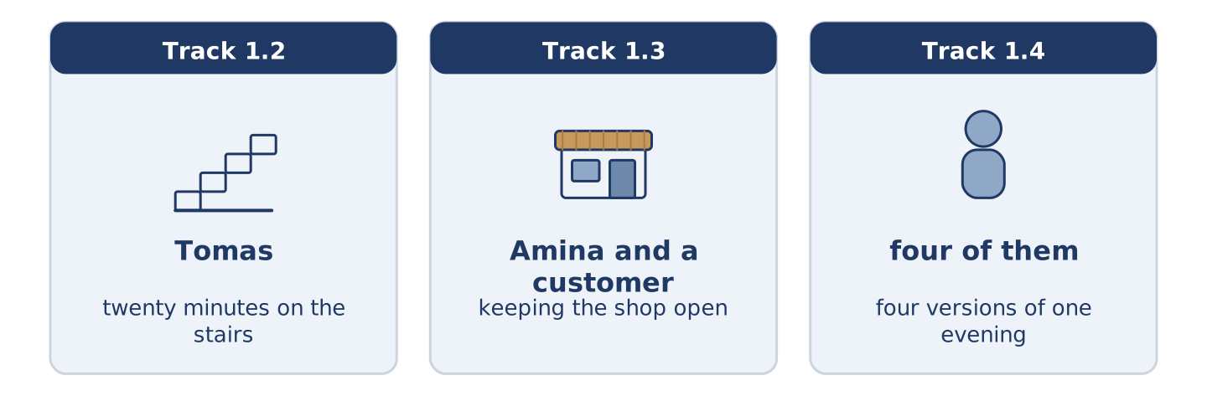
Figure 1.16 · The three listenings: who is speaking, and about what.
🔊 Audio Track 1.2
Before you listen: Tomas was carrying shopping when the lights went out. Think about what is dangerous about a staircase in the dark.
Useful language: halfway up · I could not see a thing · I stayed where I was · it took about twenty minutes
I was coming up from the shop with two bags, and I was about halfway up the second flight when everything went off at once. Not one light — every light. The hum of the lift stopped as well, and that is the part I actually noticed. I stopped on the step I was standing on, and I did not move for a while. A staircase you have climbed a thousand times is a different staircase in the dark. I put the bags down beside the wall and stood there with one hand on the rail. After a minute I heard Dani shouting on the floor above. That told me it wasn’t only our flat. Then Amina called up from the shop door, and that told me it wasn’t only the building. I’m a nurse, and most accidents happen to people in a hurry in a place they know well. I hear that sentence twice a year. Somebody came past me with a phone held out in front of them, and asked whether I was all right. I stayed exactly where I was until somebody arrived with a candle.
Mark each statement True, False, or Not Given. (0. is done for you.)
- Tomas was carrying shopping when the lights went out. — True
- Tomas was on the first flight of stairs when the power failed.
- The first thing Tomas noticed was the sound of the lift stopping.
- Tomas had an accident on the stairs that evening.
Part 3: Amina Keeps the Shop Open
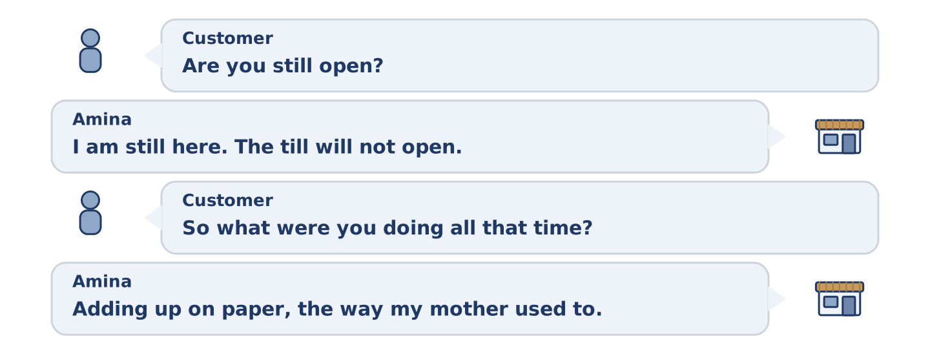
Figure 1.17 · The second listening, turn by turn.
🔊 Audio Track 1.3
Before you listen: Amina had three customers in the shop. Think about what a shopkeeper cannot do without electricity.
CUSTOMER: Are you still open?
AMINA: I’m still here. Whether I’m open is a different question. The till won’t open and I can’t weigh anything.
CUSTOMER: So what were you doing in the dark all that time?
AMINA: Adding up on paper, the way my mother used to. I was serving this gentleman when it happened, and he was holding a basket. Neither of us said anything for about five seconds. Then I found the candle I keep behind the counter for exactly this.
CUSTOMER: You keep a candle behind the counter?
AMINA: I’ve kept one there for nineteen years. Tonight is the fourth time I’ve needed it.
CUSTOMER: And the freezer?
AMINA: The freezer is the only thing I was really worried about, and I didn’t open it once. A full freezer stays cold for a day if you leave it shut, and an empty one doesn’t. That is why I keep mine full.
Answer the questions. (0. is done for you.)
- What was Amina doing when the power went out? — She was serving a customer.
- Why could Amina not sell anything properly?
- How long has Amina kept a candle behind the counter?
- What did Amina do about the freezer, and why?
Part 3: Four People, Four Versions
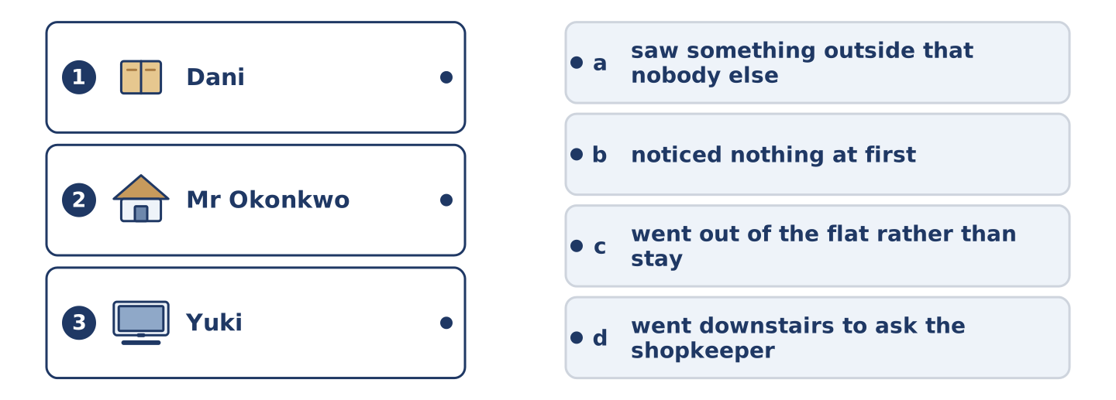
Figure 1.18 · Three on the left, four on the right, and one spare.
🔊 Audio Track 1.4
Before you listen: four people at number 14 describe the same twenty minutes, and no two accounts agree.
Useful language: as far as I remember · the first thing I knew · it must have been about · I did not realise until later
MAYA: I was reading in bed with the lamp on, and then I was reading nothing at all. It took me a second to work out why. I thought the bulb had gone. I lay there for a full minute doing nothing whatever, and I’m not proud of that.
DANI: I was forty minutes into a film and I shouted something I’m not going to repeat. Then I went out onto the landing, because shouting on your own in the dark is much worse than shouting at other people in the dark.
MR OKONKWO: I was sitting by the window, as I always do at that hour. The street lamps outside were still on for a few seconds after our lights went, and nobody else seems to have seen that. I didn’t mention it, because nobody asked me, and I was perfectly comfortable.
YUKI: I was working, and the laptop kept going on its battery, so for about half a minute I didn’t realise anything was wrong. Then I looked up and the whole flat was black. I lost an hour of work and a good deal of patience.
While you listen: match each speaker with what they said. One statement is not needed. (0. is done for you.)
- Maya → thought at first that one lamp had failed.
Column A
1. | Dani | ____
2. | Mr Okonkwo | ____
3. | Yuki | ____
Column B
a) | saw something outside that nobody else reported
b) | noticed nothing at first, because a battery was still working
c) | went out of the flat rather than stay in the dark alone
d) | went downstairs to ask the shopkeeper what had happened
Part 4 · Speaking
[CORE] Core track · in-class output
Part 4: What Were You Doing?
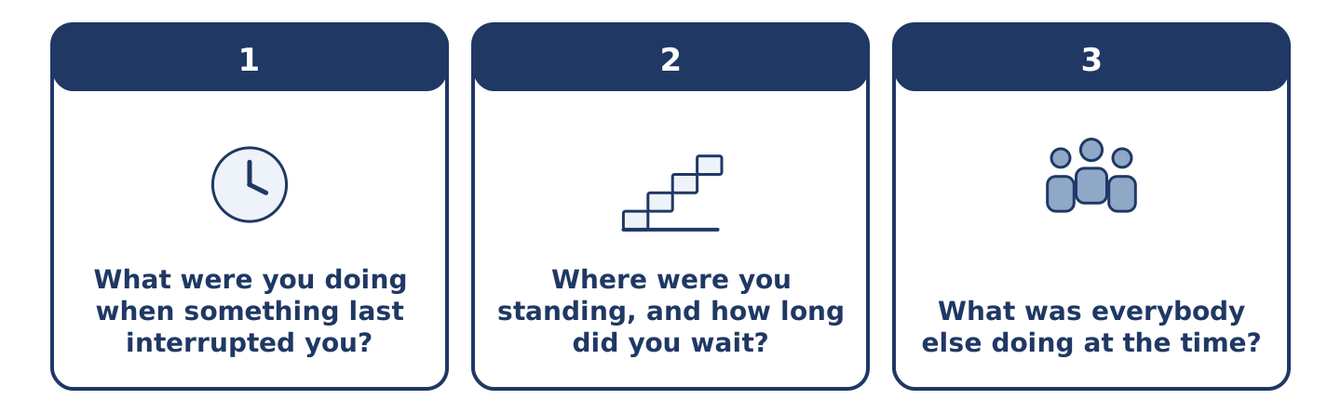
Figure 1.19 · The three questions as cards, to take one at a time.
Useful questions: What were you doing when it happened? · Where were you standing? · How long were you waiting? · What was everybody else doing?
Talk to a partner. Describe a moment when something interrupted you — a power cut, a phone call, a knock at the door, a delay. Say what you were doing, what interrupted it, and what you did next. Ask your partner at least three questions about theirs.
Part 4: Find the Difference (pairwork)
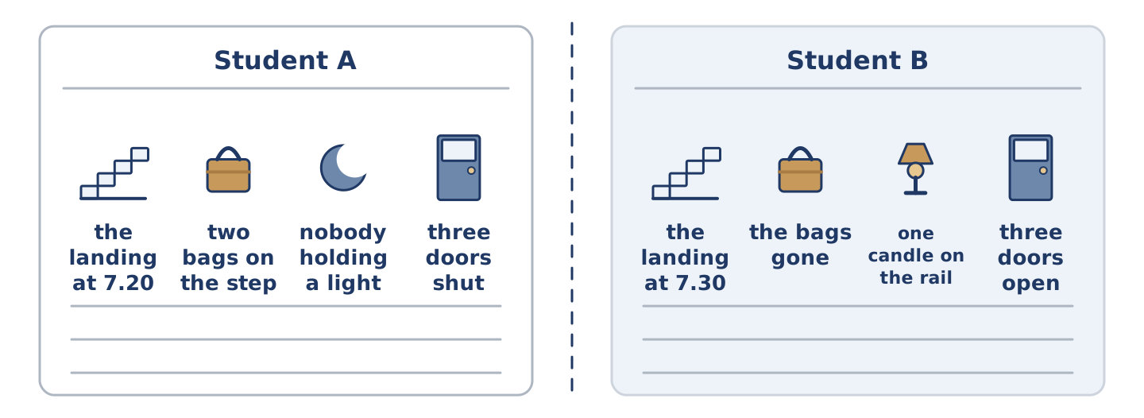
Figure 1.20 · Student A’s facts and Student B’s, with a fold between them.
Useful language: in my picture · in mine · so yours is different · neither of us has
Student A has a picture of the landing at twenty past seven. Student B has a picture of the same landing ten minutes later. Do not look at each other’s picture. Describe what people were doing and find four differences. Use the past continuous for what was going on, and the past simple for anything that had finished by then.
Part 4: The Meeting About the Power Cut
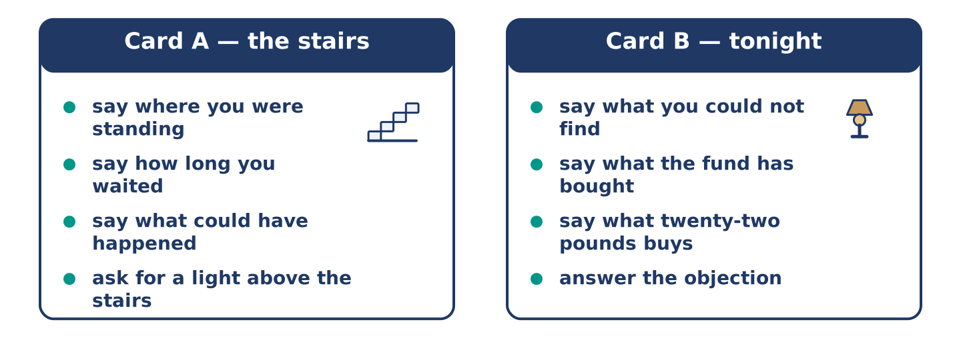
Figure 1.21 · Card A and Card B: what each of you has to argue.
Useful language: can I just say · that is not quite what happened · as I remember it · could we agree that
Three weeks later, the people at number 14 are in Amina’s shop. They are deciding whether to buy anything for the next power cut. There is sixty pounds in the building fund. A box of candles and two lamps costs about twenty. A small camping lamp for the stairs costs forty-five. A battery light above the staircase costs ninety, so the fund would have to wait another year.
Model exchange:
TOMAS: The problem was the stairs. I was standing on them for twenty minutes and I couldn’t see my own feet.
DANI: The problem was that nobody knew anything. I was shouting on the landing because it was the only way to find out whether it was just me.
AMINA: Then we’ve got two different problems and sixty pounds.
Work in groups of three or four. Take one role each and agree on what to buy. You must spend no more than sixty pounds, and everybody must say what they were doing that evening before they argue for anything.
Stretch [PLUS]: argue for waiting a year and buying the staircase light. You will have to persuade somebody who was stuck on those stairs in the dark that another winter is acceptable.
Part 4: Mini-Presentation
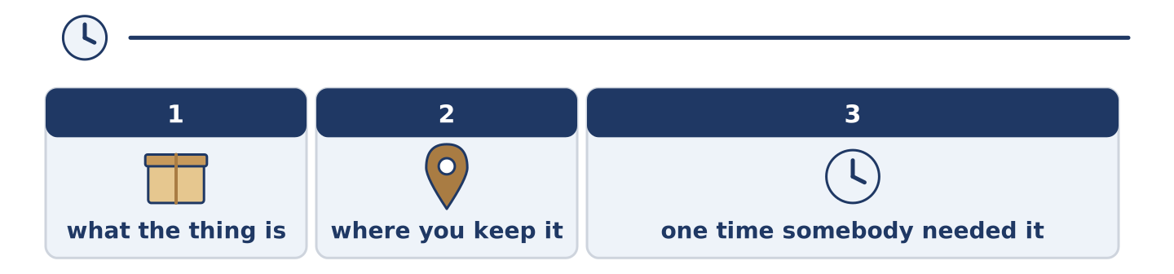
Figure 1.22 · The one-minute talk as 0 beats, each as wide as its share.
Speak for one minute. “The most useful thing to keep in a drawer.” Say what it is, where you would keep it, and describe one time when somebody you know needed it and it was not there. Part 5 · Reading
[CORE] Core track · pre-class input
Part 5: Why the Lights Go Out
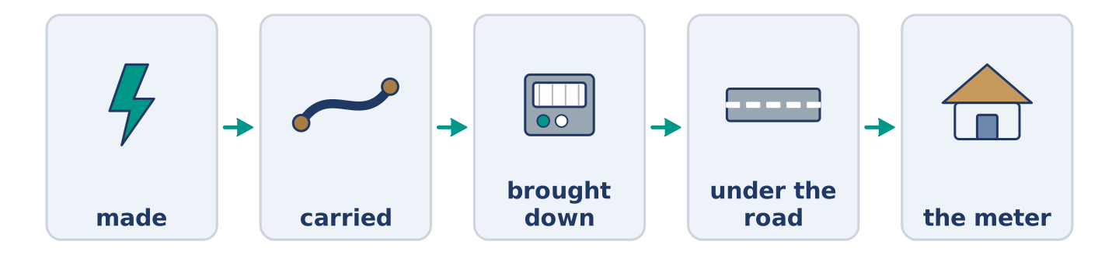
Figure 1.23 · From the power station to the meter in the hall, stage by stage.
Before you read: think about one thing that has to be true for the light in your room to be on at this moment.
Gloss: grid — the whole network of wires that carries electricity across a country · substation — a small building where the supply is changed before it reaches houses · demand — how much electricity everybody is using at one time · cable — a thick covered wire that carries electricity underground
The electricity arriving at a flat has travelled a long way to get there. Almost nobody thinks about any of it until the moment it stops. A power station somewhere else makes it, and the grid carries it across the country. A substation a few streets away brings it down to a safer level, and a cable under the road then takes it into a meter in the hall. Every one of those stages can fail, and several of them fail fairly often.
Most power cuts in a city are small and local, and an entirely ordinary accident starts almost all of them. Somebody was digging a hole for a new pipe and put a tool through a cable. Water was getting into a joint that was dry for thirty years. An engineer will say that a fault developed, and that sentence usually hides the same story: something got quietly worse for months, and then it stopped being quiet.
Demand starts the other kind of power cut. Nobody can store electricity easily, so the supply has to match the demand almost exactly, all of the time. Think of a very cold evening, when millions of people arrive home and turn on a light, a kettle and a heater inside the same twenty minutes. Demand then climbs faster than at any other hour. Control rooms bring more supply in to meet that climb, and when they cannot, they protect the grid by cutting one area off for a while.
What surprises most people is the speed at which a building becomes a difficult place to be, and lights are the least of it. Lifts halt between floors, and the door entry system fails completely. Freezers begin a slow climb towards the temperature at which the food inside them stops being safe, although a full freezer that nobody opens will hold its cold for about a day. The flats that manage are not the ones with the most equipment, but the ones where somebody knows where the candles are.
Choose the correct answer. (0. is done for you.)
- Where is the electricity supply brought down to a safer level? — At a substation.
1. According to the text, what is an engineer usually describing when they say a fault developed?
○ A) A problem that had been slowly getting worse
○ B) A sudden accident nobody could have expected
○ C) A deliberate decision taken in a control room
○ D) An unusually cold evening in winter
2. Why must the amount of electricity being made match the amount being used?
○ A) Because cables are expensive to replace
○ B) Because substations work at only one level
○ C) Because meters cannot count very high numbers
○ D) Because electricity is difficult to store
3. According to the text, which flats manage best during a power cut?
○ A) The ones with the fullest freezers
○ B) The ones where somebody knows where the candles are
○ C) The ones nearest the substation
○ D) The ones with the most equipment
Part 5: Vocabulary in Context
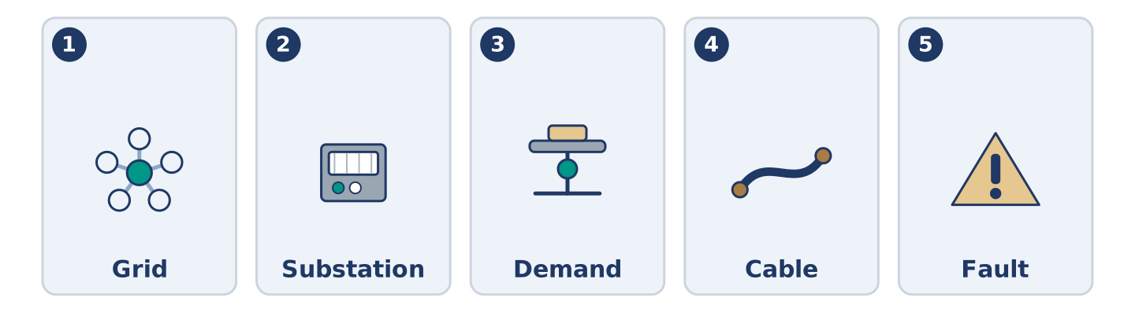
Figure 1.24 · The five words from the reading, drawn.
Match each word from the text with its meaning. One meaning is not needed. Write the letter.
Column A
1. | Grid | ____
2. | Substation | ____
3. | Demand | ____
4. | Cable | ____
5. | Fault | ____
Column B
a) | a small building where the supply is changed before it reaches houses
b) | something that has gone wrong inside a system
c) | the network of wires that carries electricity across a country
d) | how much electricity everybody is using at one moment
e) | the amount a household pays every three months
f) | a thick covered wire, usually under the ground
Part 5: Three Buildings, Three Tuesdays
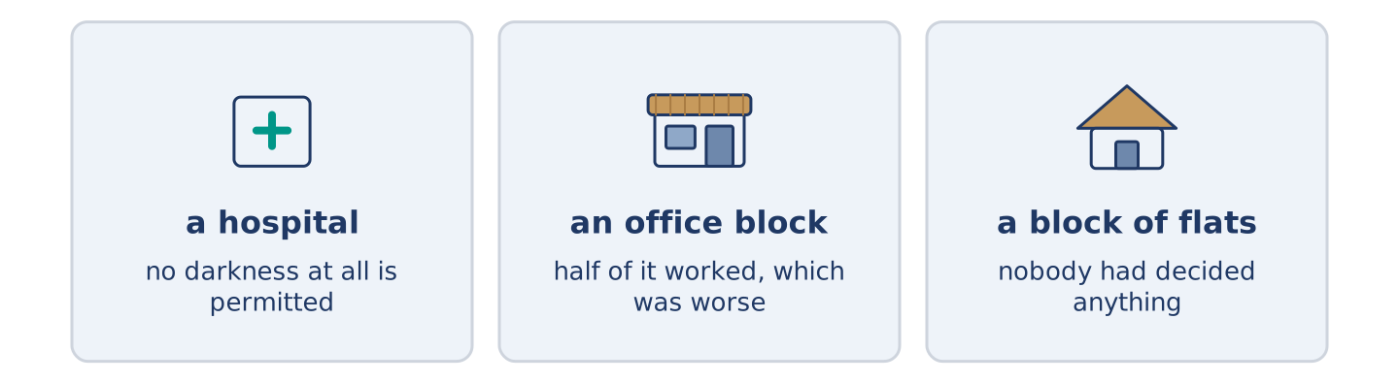
Figure 1.25 · Three buildings, and how many seconds of darkness each one allows.
Before you read: the same twenty minutes of darkness is a different twenty minutes depending on the building you happen to be standing in.
Gloss: generator — a machine that makes its own electricity when the supply fails · ward — a large room in a hospital with beds for several patients · backup — a second system kept ready in case the first one stops
The hospital. Nothing visible happened at all. The lights flickered for perhaps a second and then steadied, and a nurse taking somebody’s blood pressure at the time did not stop or look up. Two floors below, in a room nobody visits, a generator had started itself. A hospital is designed on the assumption that the supply will fail, so the question is never whether the lights will go out. It is the number of seconds of darkness the building is permitted, and on a ward the answer is none.
The office block. Half of it kept working and half of it did not, and that was worse than either. The lifts stopped, and the corridor lights came back on a backup circuit inside a minute. The air conditioning remained off for a further two hours. People who were in a meeting carried on having it, because nobody was willing to be the person who suggested going home. The building protected its own systems, but it did not protect the kettles, the screens or the doors.
The block of flats. Everything stopped, and nobody had ever decided that anything should be protected. At 14 Alder Street the whole event lasted an hour and fifty minutes. Two pieces of equipment mattered: one candle behind a shop counter, and a mobile with enough battery to inform six people that it was not just them.
Answer the questions. (0. is done for you.)
- What had started itself two floors below the ward? — A generator.
- Why was it worse for the office block that only half of it kept working?
- What were the people in the meeting doing while the air conditioning was off?
- What two pieces of equipment mattered at 14 Alder Street? Part 6 · Writing
[CORE] Core track · in-class / homework
Part 6: A Message to the Neighbours (90–110 words)
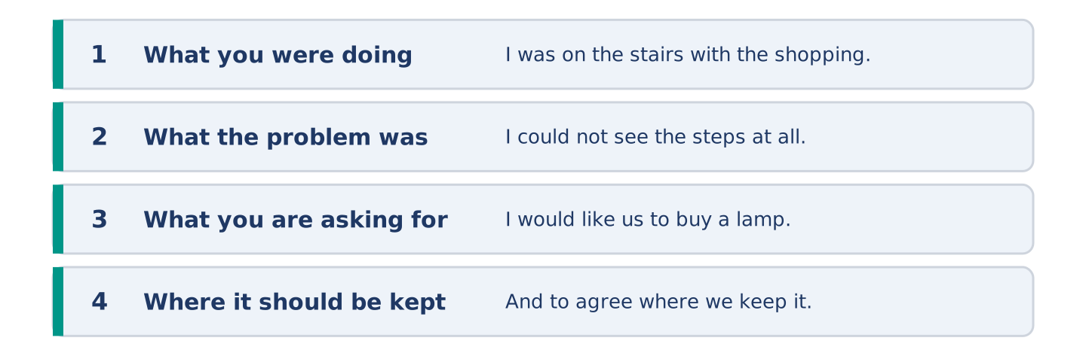
Figure 1.26 · The shape of the message you are about to write.
Write a message to the other people in your building about something you want them to agree to buy or do. Say what you were doing when the problem happened.
Model — read this first:
Hello everybody. I was on the stairs with the shopping when the power went out on Tuesday. I stood there for twenty minutes, because I could not see the steps at all. Several other people were out on the landings at the same time, all of us shouting to find out whether it was only our own flat. Nothing bad happened, but it easily could have. I would like us to buy a lamp for the staircase out of the building fund, and to agree where we keep it. Then the next person halfway up those stairs in the dark can reach something. Tomas, flat 3. (107 words)
Plan (fill in, then write): I was ___ when ___. The problem was ___. I would like us to ___. We should keep it ___.
Word bank: staircase | fund | agree | reach
Check before you finish: ☐ the past continuous at least twice? ☐ one clear thing you are asking for? ☐ where it should be kept? ☐ 90–110 words?
Part 6: Was the Power Cut Anybody’s Fault? (90–110 words)
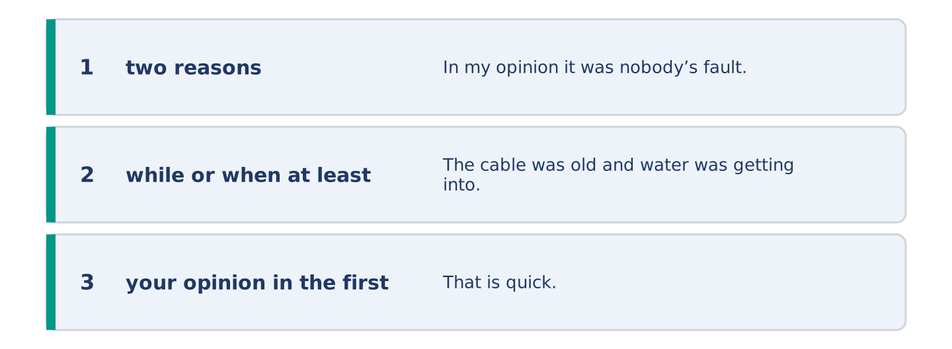
Figure 1.27 · The shape of the opinion paragraph, step by step.
Was the power cut anybody’s fault? Say what you think was really wrong, and give two reasons.
Model — read this first:
In my opinion it was nobody’s fault, and that is exactly the problem. The cable was old and water was getting into it, and the engineers found the fault within two hours. That is quick. What was wrong was not the power cut but the building. Nobody at number 14 kept a lamp, nobody held a key for the basement cupboard, and the only candle in the entire place belonged to the shop. A power cut is an accident. Twenty minutes with no light at all is a decision, and nobody remembers making it. (96 words)
Word bank: fault | decide | prepare | accident
Check before you finish: ☐ two reasons? ☐ while or when at least once? ☐ your opinion in the first sentence? ☐ 90–110 words?
Part 6: What Happened on the Stairs (90–110 words)
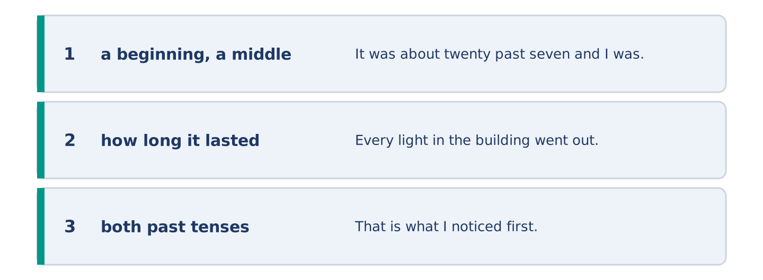
Figure 1.28 · The moves of the message, with a line of the model for each.
Tell the story of twenty minutes when you were somewhere dark, crowded, delayed or stuck. Use the past continuous for the background and the past simple for what happened.
Model — read this first:
It was about twenty past seven and I was carrying two bags up the second flight. Every light in the building went out at the same moment, and the hum of the lift stopped as well. That is what I noticed first. I put the bags down against the wall and stood still with one hand on the rail. I could hear Dani shouting upstairs and Amina calling from the shop door, so I knew it was not only our flat. I waited where I was for about twenty minutes, until somebody came up with a candle and we went the rest of the way together. (107 words)
Plan (fill in, then write): I was ___ when ___. What I noticed first was ___. I could hear ___. I waited ___ until ___.
Check before you finish: ☐ a beginning, a middle and an end? ☐ how long it lasted? ☐ both past tenses? ☐ 90–110 words?
Part 6: Reflection — The Thing I Never Get Round To (80–100 words)
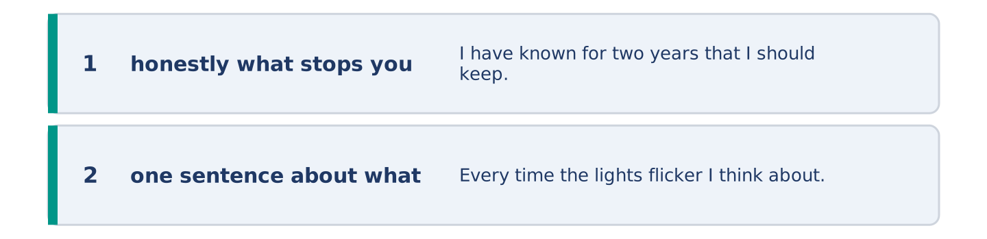
Figure 1.29 · The reflection, step by step.
Write about something sensible you keep meaning to do and never do. Say what stops you, and whether anything would change it.
Model — read this first:
I have known for two years that I should keep a lamp by the front door, and I still do not. Every time the lights flicker I think about it for ten seconds, and then the lights steady and I forget again. I think the reason is that the problem is rare and the solution is boring. Nobody has ever felt pleased about buying a lamp. I am going to use the power cut as my excuse, because an excuse is evidently what I was waiting for. (91 words)
Check before you finish: ☐ honestly what stops you? ☐ one sentence about what would change it? ☐ 80–100 words? Part 7 · Real-World File — Reporting a Power Cut
[PLUS] Plus track (optional) · stronger learners
7A: Phrase Bank
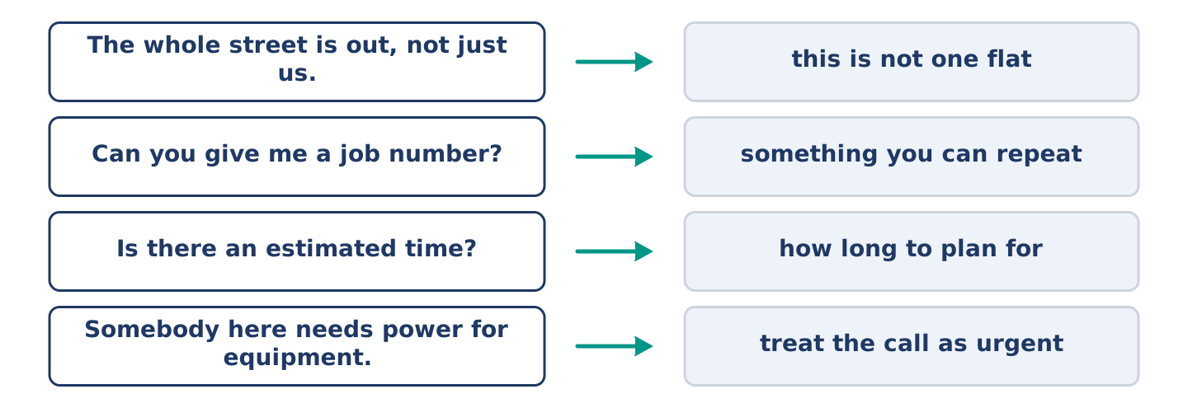
Figure 1.30 · What you say when you report a fault, and what each line does.
Match each phrase with when you would use it. One use is not needed. Write the letter.
Column A
1. | “The whole street is out, not just us.” | ____
2. | “Can you give me a job number?” | ____
3. | “Is there an estimated time for it coming back?” | ____
4. | “Somebody here needs power for medical equipment.” | ____
5. | “I am calling on behalf of the whole building.” | ____
Column B
a) | when you want the call treated as urgent
b) | when you are explaining why you, and not each neighbour, are calling
c) | when you want to know how much the repair will cost you
d) | when you are making clear that this is not a problem inside one flat
e) | when you want something you can quote if you have to call again
f) | when you want to know how long to plan for
7B: The Call to the Electricity Company
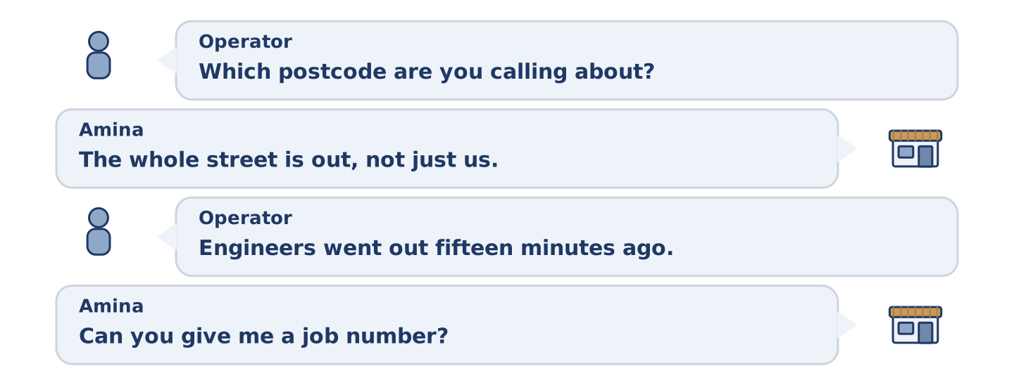
Figure 1.31 · The 7B exchange: who takes each turn.
🔊 Audio Track 1.5
Before you read: Amina is calling the emergency number while the shop is still dark. Think about what the person on the other end needs to know first.
OPERATOR: Emergency line. Which postcode are you calling about?
AMINA: It’s the postcode of 14 Alder Street. The whole street is out, not just us. I was serving a customer when it happened, at about twenty past seven.
OPERATOR: Thank you, that’s helpful. We’re already showing a fault in that area, so somebody reported it before you. Engineers went out about fifteen minutes ago.
AMINA: Is there an estimated time for it coming back?
OPERATOR: They were still looking for the fault when they last reported in, so I can’t give you a time yet. I’d plan for two hours and hope for one.
AMINA: Can you give me a job number? There are eleven people in this building and every one of them is going to ask me.
OPERATOR: Of course. Is there anybody at the address who needs power for medical equipment, or anybody who can’t manage the stairs?
AMINA: There’s a gentleman of seventy on the third floor. He doesn’t need equipment, but he doesn’t need a dark staircase either.
OPERATOR: I’ll put a note on the job. If it isn’t back inside two hours, call again and repeat that job number. The call then goes higher up the list.
Answer the questions. (0. is done for you.)
- What did the operator ask for first? — The postcode.
- Why could the operator not give an estimated time?
- Why did Amina want a job number?
- What does the operator say will happen if Amina calls again in two hours?
7C: Controlled Practice — Making the Call Well
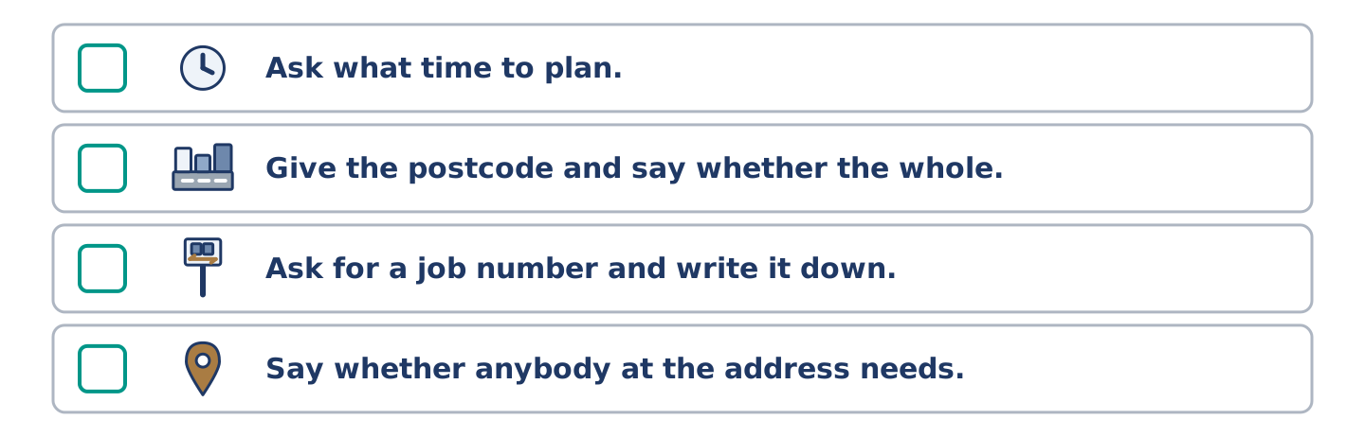
Figure 1.32 · The steps still to be numbered, as the task prints them.
Put the steps in order. Number them 1–5. (0. is done for you.)
- Find the emergency number before you need it, not during. — 1
____ Ask what time to plan for, and then plan for longer.
____ Give the postcode and say whether the whole street is affected.
____ Ask for a job number and write it down.
____ Say whether anybody at the address needs priority help.
7D: Role-Play — Telling the Building What You Know
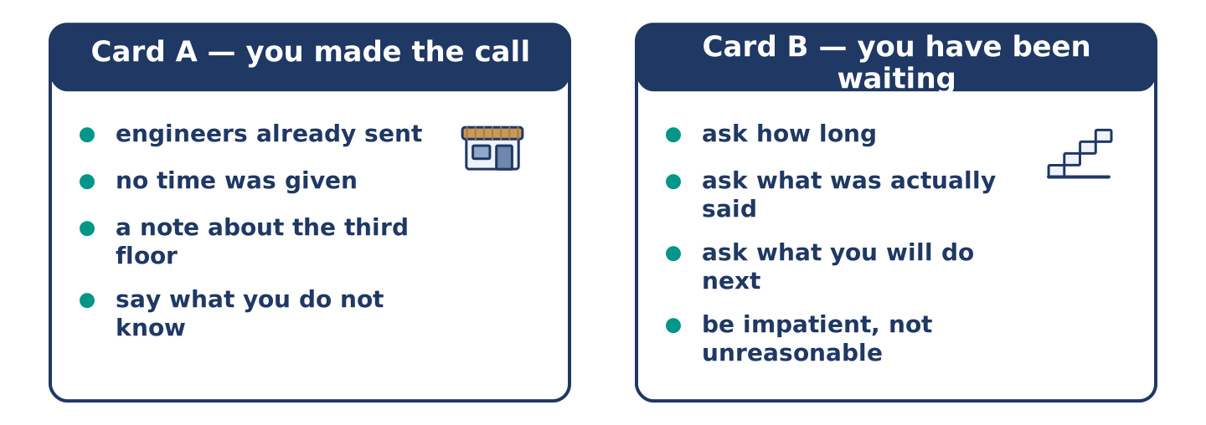
Figure 1.33 · The 7D cards: what each of you has to say.
Model exchange:
AMINA: I’ve just come off the phone. Engineers were already on their way before I called.
DANI: So how long?
AMINA: They wouldn’t say, because they were still looking for the fault. I’ve got a job number and I can call again at half past nine.
DANI: And in the meantime?
AMINA: In the meantime there’s one candle and a great many stairs. Nobody goes up or down them in a hurry.
Student A has made the call and has the job number, the rough estimate and the note about priority help. Student B has been waiting on a landing for twenty minutes and wants a straight answer. Take a role each. Student A must pass on three things accurately and admit the one thing they do not know. Student B must ask at least two questions, and may be impatient without being unreasonable.
Stretch [PLUS]: swap roles and do it again, with Student B as somebody who has already made the same call and was told something slightly different.
7E: Writing — A Note for the Noticeboard (100–120 words)
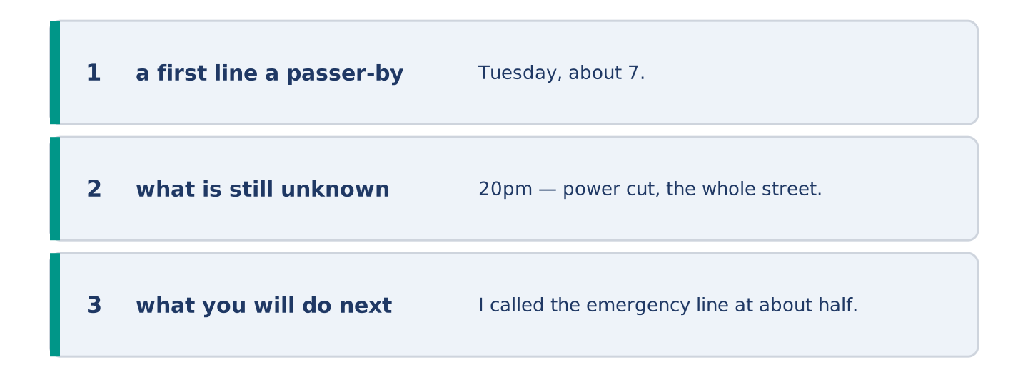
Figure 1.34 · The Part 7 note, with the model beside each line.
Write a note for a noticeboard in your building about something you have found out on everybody’s behalf — a repair, a delivery, a closure, a change to the bins. Say what you were told, what you were not told, and what you will do next.
Model — read this first:
Tuesday, about 7.20pm — power cut, the whole street, not just our building. I called the emergency line at about half past seven. Engineers were already out, because somebody reported it before I did. They were still looking for the fault when I called, so there was no estimated time, and the man on the phone suggested planning for two hours. I have the job number behind the shop counter if anybody needs it, and they have put a note on the job about the third floor. If the power is not back by half past nine, I will call again and repeat the job number. That evidently moves us up the list. Amina. (114 words)
Check before you finish: ☐ a first line a passer-by understands in three seconds? ☐ what is still unknown? ☐ what you will do next? ☐ 100–120 words? Part 8 · Global Story — The Night Buenos Aires Went Quiet
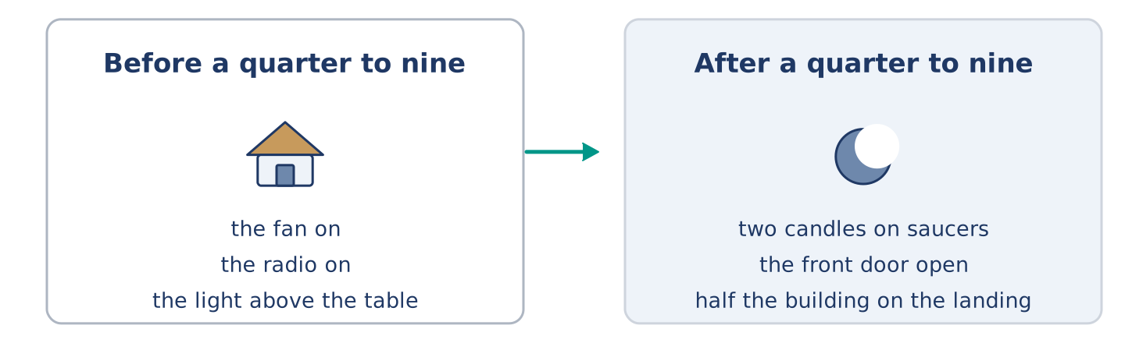
Figure 1.35 · The flat before a quarter to nine, and the flat after it.
[PLUS] Plus track · pre-read / discuss
Before you read: a city of three million people loses its electricity on the hottest evening of the year. Think about what stops first.
Gloss: heatwave — a long period of unusually hot weather · transformer — the equipment at a substation that changes the level of the supply · shift — the hours somebody works, for example from ten at night until six in the morning · saucer — a small plate that goes under a cup
Elena Vargas was eleven, and she was sitting on the kitchen floor of a flat in Buenos Aires, Argentina, because the floor was the only cool thing in it. It was a quarter to nine in the evening and still thirty-four degrees. Her mother was washing up, and her grandmother was listening to a radio programme she had followed every evening for forty years. The fan in the corner was achieving almost nothing. Then the fan stopped, and the radio stopped, and the light above the table stopped.
What Elena remembers is not the darkness. It is the silence that arrived with it. A city makes its own noise on a hot night — fans, televisions through open windows, the hum of a thousand machines keeping food cold. All of it went at once, and for a moment she could hear a dog three streets away and a woman laughing on a balcony. Those sounds were there every evening, and nobody in that flat had ever heard them before.
The heatwave was in its ninth day, and the transformers at a substation on the edge of the district were running hot the whole time. One of them failed at eight forty-three. The others were already working at their limit, so they could not take its share. Nine hundred thousand people lost their supply inside a minute.
Elena’s mother lit two candles and stood them on saucers, and then she did something that Elena still thinks about. She opened the front door. Within ten minutes half the building was out on the landing, and her grandmother was telling a long story about a power cut thirty years earlier. Nobody had asked to hear it and everybody listened. Down in the street, people were pulling chairs onto the path, because a flat without a fan is hotter than a path at ten o’clock.
Not everybody was outside. Elena’s uncle was starting a night shift at a bakery that could not bake. Four streets away, a man was standing in front of a wall of freezers in a supermarket, deciding how long he could wait before giving the food away. A queue was already forming outside, of people who had worked that out before he did.
The supply came back at twenty to two, district by district. Elena was asleep on the landing, and she says the sound of every television in the building coming on at once woke her. All of them were still tuned to whatever was playing at eight forty-three. She works for the grid now, and when new people ask her why she chose that job, she tells them about the silence.
Answer the questions. (0. is done for you.)
- Why was Elena sitting on the kitchen floor? — It was the only cool thing in the flat.
- What does Elena remember instead of the darkness?
- Why did the other transformers fail as well?
- What woke Elena on the landing?
Part 8: Vocabulary in Context
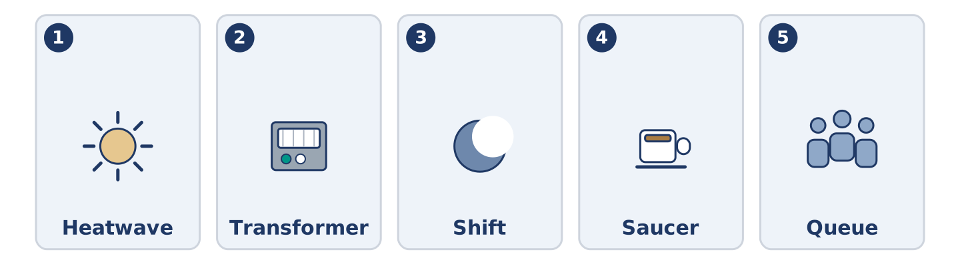
Figure 1.36 · The five words from the global story, drawn.
Match each word from the story with its meaning. One meaning is not needed. Write the letter.
Column A
1. | Heatwave | ____
2. | Transformer | ____
3. | Shift | ____
4. | Saucer | ____
5. | Queue | ____
Column B
a) | the hours somebody works, which may be at night
b) | a line of people waiting for something
c) | a long period of unusually hot weather
d) | the equipment that changes the level of the supply
e) | the room where a generator is kept
f) | a small plate that goes under a cup
Part 8: Discussion
Discussion frames: What I noticed about this story is… · The part I would find hardest is… · In my experience, people…
Talk in groups of three. Elena’s mother opened the front door. Was that the right thing to do, and what would happen in your building? Part 9 · Close to Home — Three Weeks Later at Number 14
[PLUS] Plus track · pre-read / decide
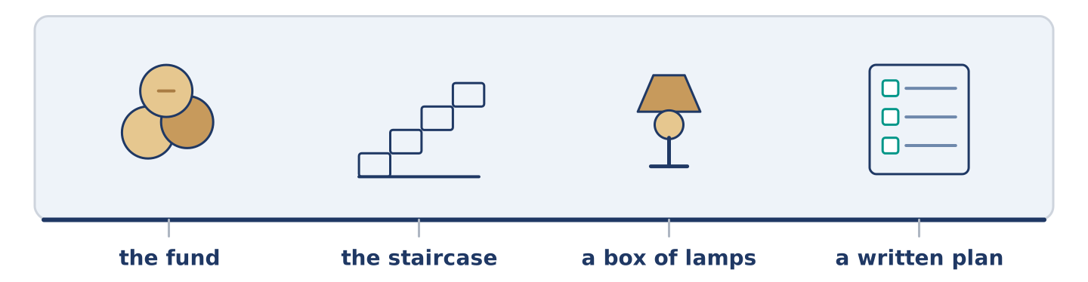
Figure 1.37 · The close-to-home reading, drawn along one street.
Before you read: the power cut lasted an hour and fifty minutes. The argument about it has now lasted three weeks.
There is sixty-one pounds in the building fund at 14 Alder Street, collected two pounds at a time, and it was originally meant for painting the front door. Since the power cut, nobody has mentioned the front door.
Tomas wants a light for the staircase. He was standing on the second flight for twenty minutes, with two bags of shopping and one hand on the rail. He makes a fair point: the staircase is the only part of the building where somebody could actually be hurt. A battery light above the stairs costs ninety pounds, and the fund would then have to wait until next autumn.
Dani wants lamps — one for each flat, in a box on the landing, twenty-two pounds for the lot. He points out that the fund has bought nothing in three years, and that a box of lamps is a thing you can put your hand on tonight. Tomas answers that a lamp in a box on a dark landing is a lamp you cannot find.
Amina does not want to spend the money at all. She was the only person in the building with a candle, and she has kept one behind the counter for nineteen years. Her view is that the problem was not equipment but that nobody had thought about it. She would rather the building spent nothing and agreed three things: the person who checks the basement cupboard, the person who holds a key, and the person who makes the phone call.
Mr Okonkwo was comfortable throughout and noticed nothing for several minutes. He has said that he will vote with whoever asks him last.
Answer the questions. (0. is done for you.)
- What was the building fund originally for? — Painting the front door.
- Why does Tomas think the staircase matters more than the flats?
- What is Dani’s main argument for the lamps?
- Why does Amina want to spend nothing?
Part 9: Decision Task
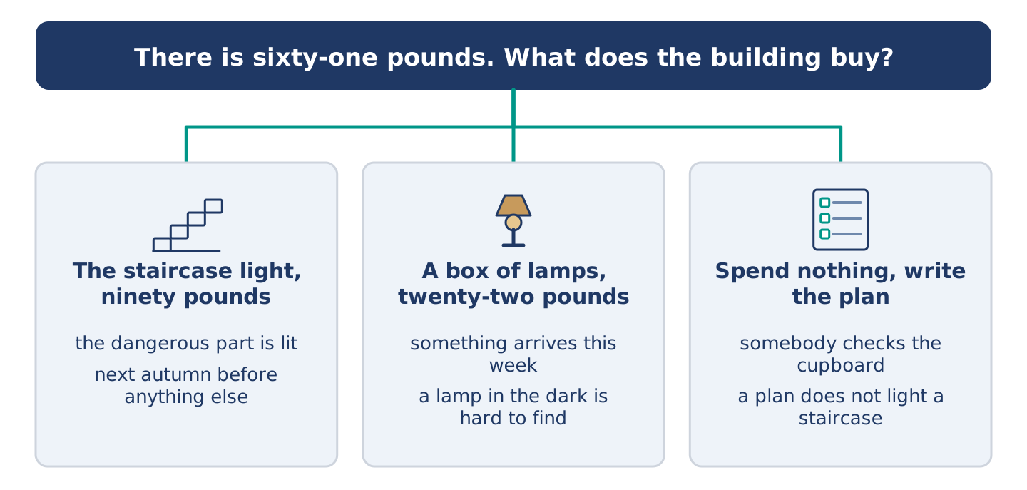
Figure 1.38 · Three ways to decide, and what each one costs.
Model — read this first:
I would buy the lamps and write the plan, and leave the staircase light for next year. Tomas has the strongest argument, because the stairs are where somebody gets hurt. But ninety pounds means another winter with nothing at all, and the next power cut will not wait for the fund, while twenty-two pounds buys something this week. I would also fix the lamp box to the wall, so that Tomas’s objection stops being true.
Answer frame: I would choose ______ , because ______ . The strongest argument against it is ______ , and my answer to that is ______ .
Decide. There is sixty-one pounds. Choose one:
(a) The staircase light at ninety pounds, with the fund waiting until next autumn.
(b) The box of lamps at twenty-two pounds, this week.
(c) Spend nothing, and agree a written plan instead.
Write 60–80 words. Say which you would choose, why, and what you would say to the person who disagrees most. Part 10 · Review and Can-Do
[CORE + PLUS] · homework / self-study
Part 10: Spiral Review
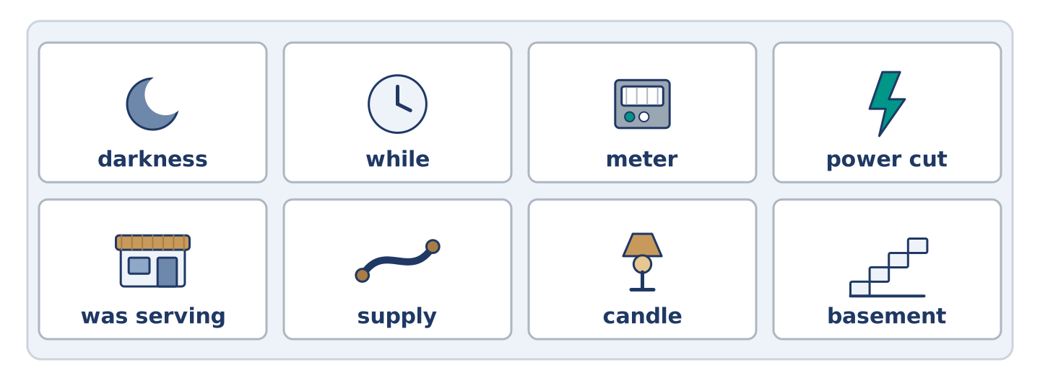
Figure 1.39 · The eight words of the review bank, in bank order.
Complete the sentences using the words in the word bank. (0. is done for you.)
Word bank: darkness | while | meter | power cut | was serving | supply | candle | basement
- Amina keeps a candle behind the counter and has done for nineteen years.
- The ______________________ on the whole street began at twenty past seven on a Tuesday evening.
- The engineer read the ______________________ in the hall before he went anywhere near the cupboard.
- Amina ______________________ a customer when every light in the shop went out at once.
- Nobody at number 14 had a key for the locked cupboard in the ______________________ .
- ______________________ Tomas was standing on the stairs, Dani was shouting on the landing above him.
- The ______________________ came back at ten past nine, and three televisions started talking at once.
- What Elena remembers is not the ______________________ but the silence that arrived with it.
Part 10: Can-Do
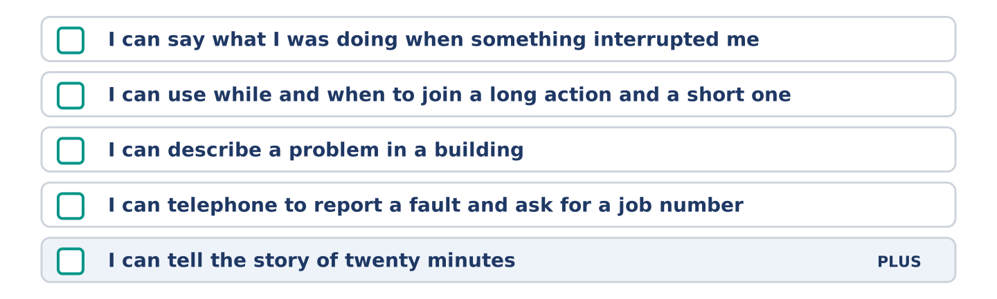
Figure 1.40 · What you can do at the end of this unit.
Can-Do checklist
☐ I can say what I was doing when something interrupted me, using the past continuous.
☐ I can use while and when to join a long action and a short one.
☐ I can describe a problem in a building and say what I want people to agree.
☐ I can telephone to report a fault and ask for a job number.
☐ I can tell the story of twenty minutes, using both past tenses. (Plus)
Part 10: Glossary
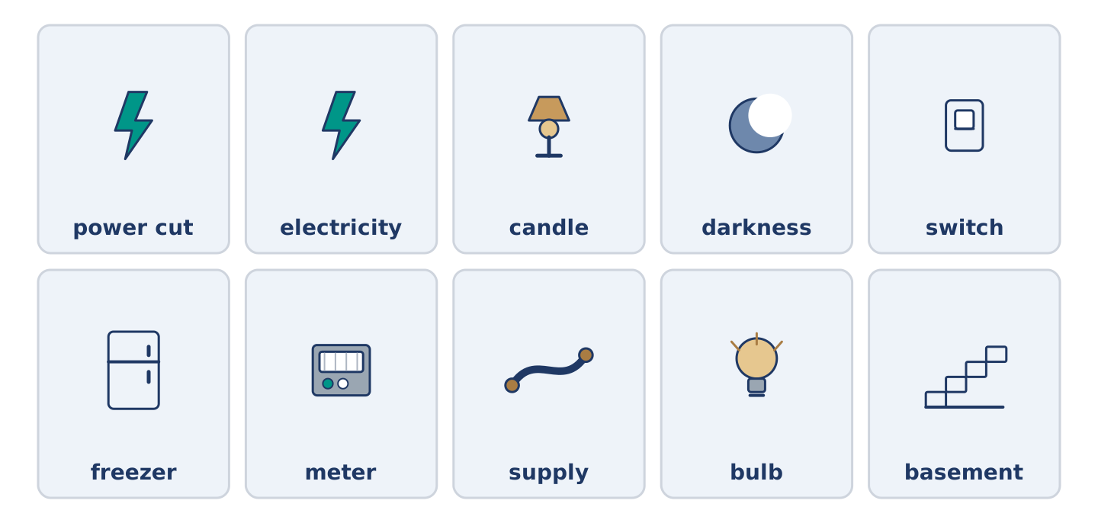
Figure 1.41 · All ten glossary words of Unit 1, one card each.
Unit 1 glossary (10 words)
power cut · electricity · candle · darkness · switch · freezer · meter · supply · bulb · basement

